output2.png
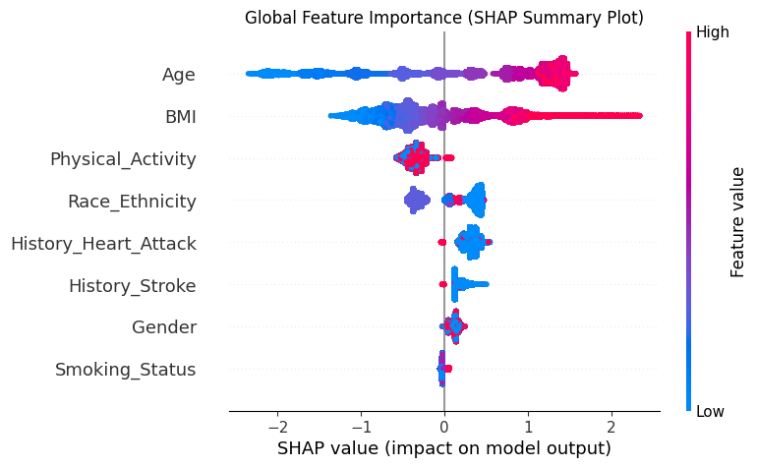

Figure_3A_Internal_Validation.png
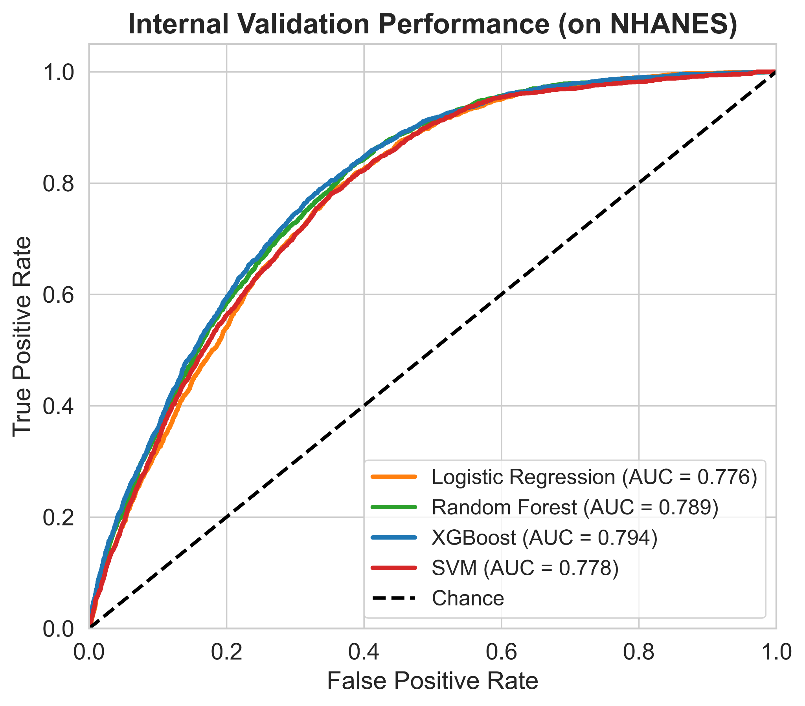

Figure_3B_External_Validation.png
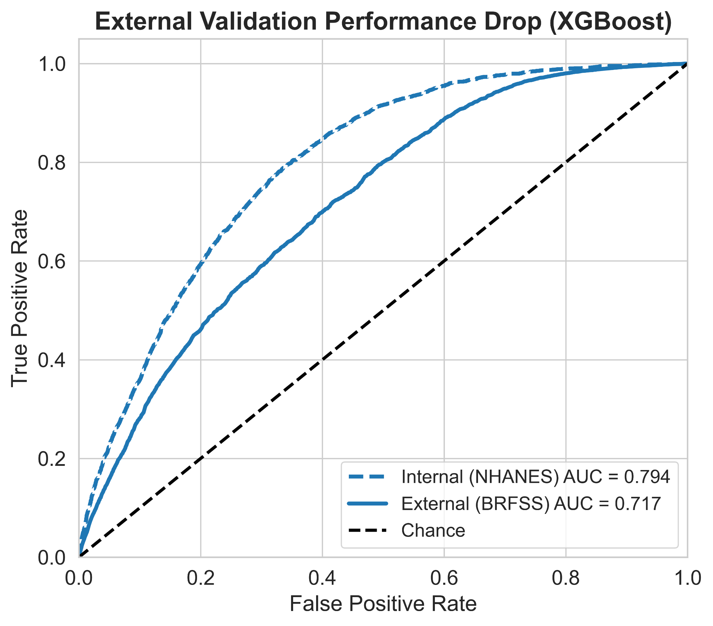

Figure_5_PR_Curves.png
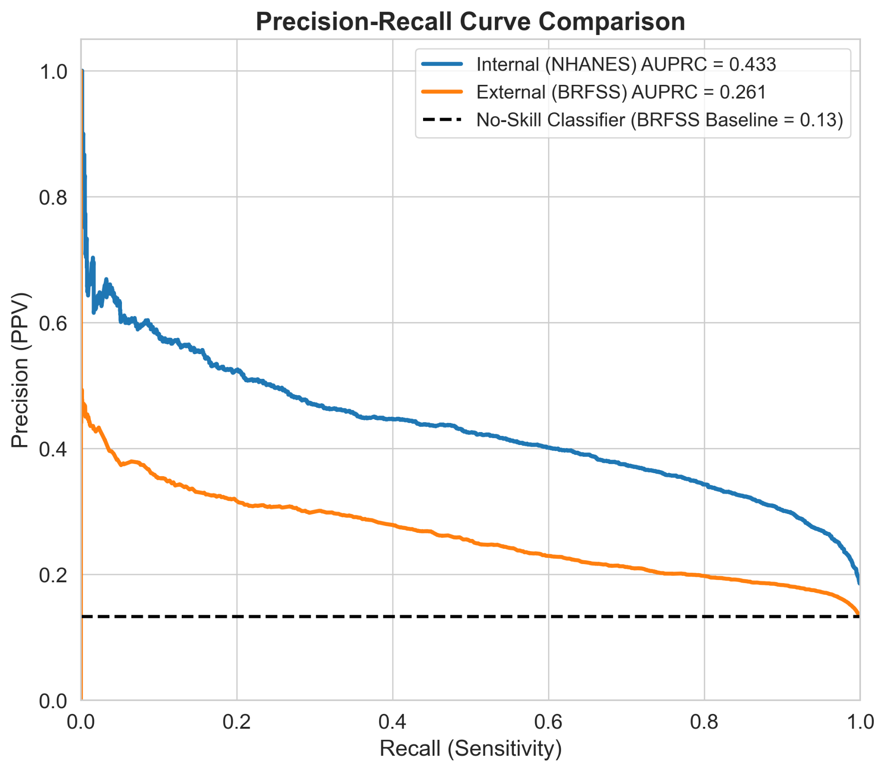

Figure_4_Confusion_Matrices.png
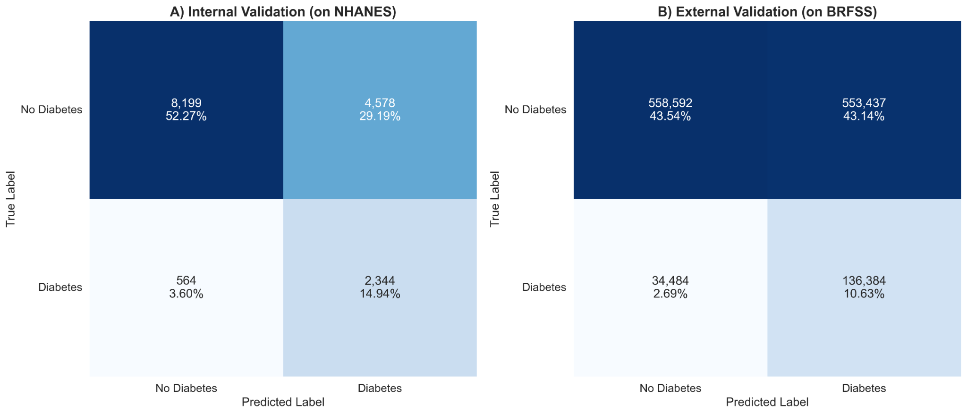

Figure_9_Fairness_Forest_Plot.png
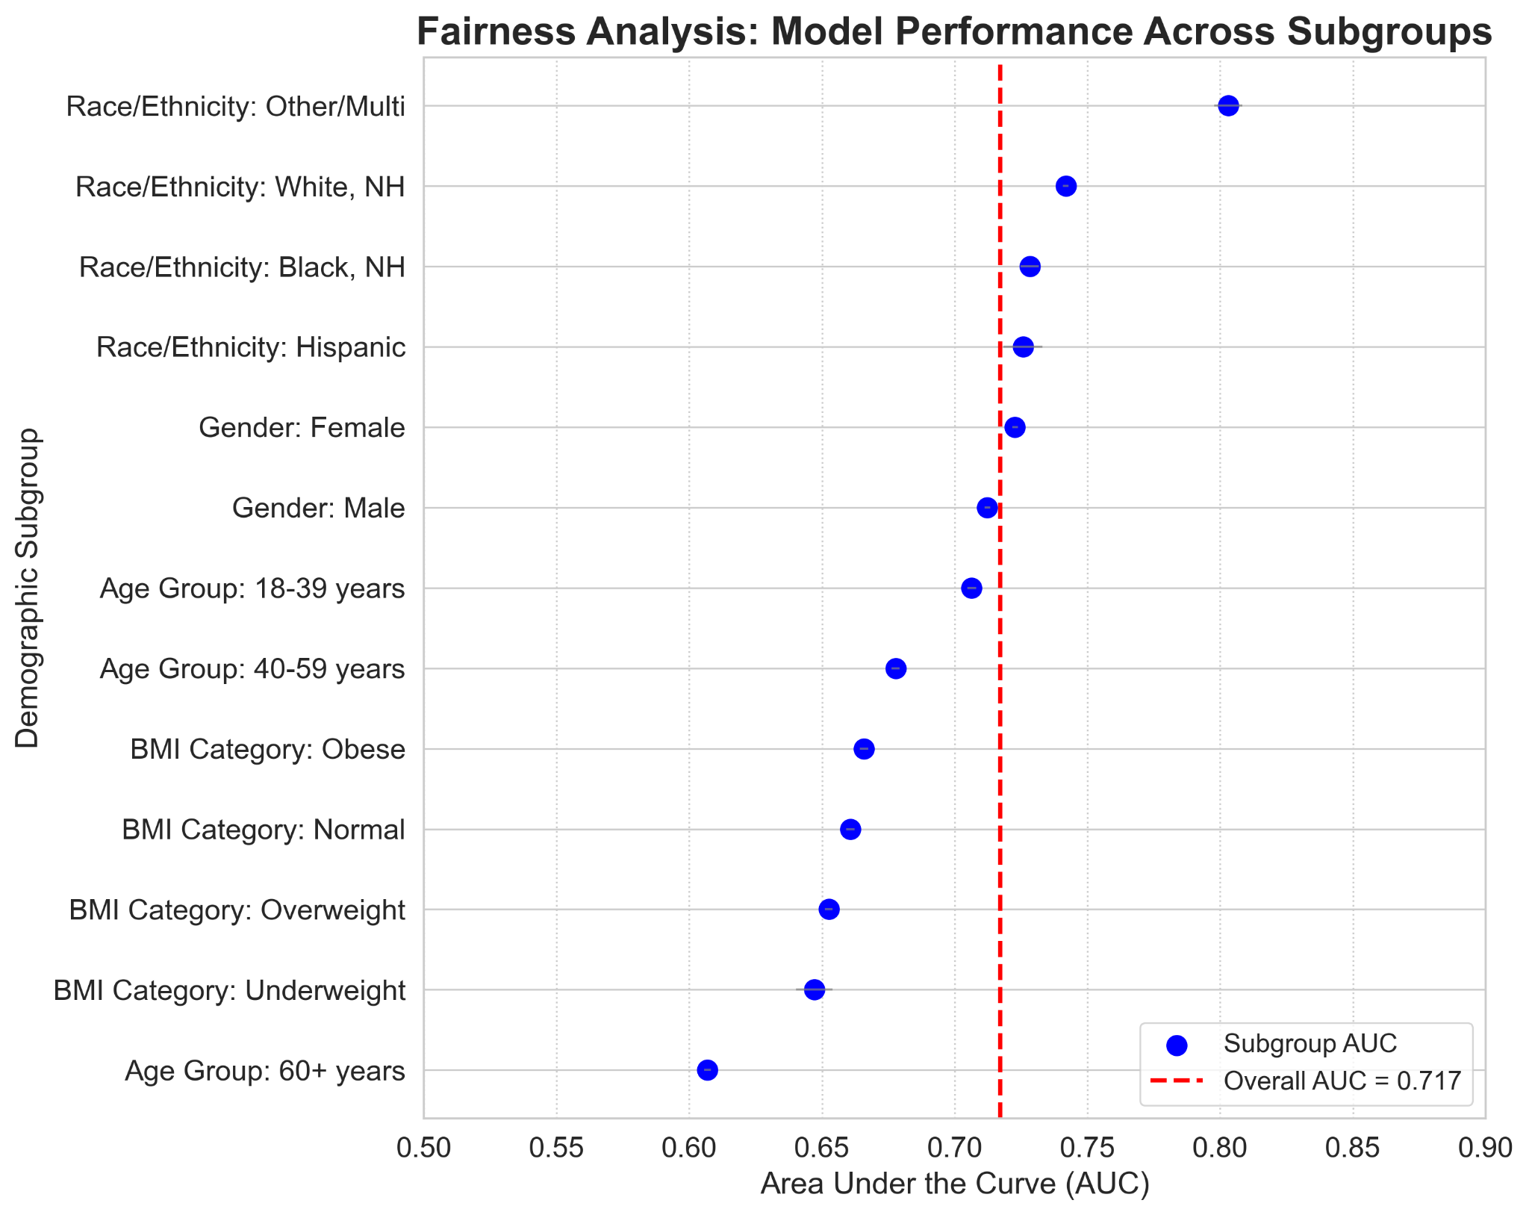

Figure_7_Calibration_Plot.png
