Machine Learning-Based Diabetes Prediction: A Multi-Dimensional Evaluation Framework with External Validation and Fairness Analysis
Rajveer Singh Pall
Computer Science & Business Systems
Gyan Ganga Institute of Technology and Sciences
Jabalpur, Madhya Pradesh, India
rajveerpall05@gmail.com

Abstract
[Insert Abstract Here]

TABLE I — Baseline Characteristics of NHANES and BRFSS Cohorts
Characteristic | NHANES | BRFSS | p-value
Age, years | 49.0 ± 18.6 | 55.1 ± 17.7 | <0.001
BMI kg/m² | 29.7 ± 7.4 | 28.5 ± 6.5 | <0.001
Male (%) | 48.5 | 46.4 | <0.001
Female (%) | 51.5 | 53.6 | —
NH White (%) | 33.7 | 48.1 | <0.001
NH Black (%) | 24.4 | 4.9 | <0.001
Hispanic (%) | 25.4 | 1.1 | <0.001
Other/Multi (%) | 12.1 | 1.7 | <0.001
Ever Smoker (%) | 40.2 | 37.9 | <0.001
Physically Active (%) | 25.4 | 75.8 | <0.001
Heart Attack (%) | 4.3 | 5.4 | <0.001
Diabetes (%) | 18.5 | 13.3 | <0.001

TABLE II — Internal Validation Performance
Model | AUC | Sensitivity | Specificity | PPV | NPV
XGBoost | 0.876 | 0.789 | 0.813 | 0.512 | 0.937
Random Forest | 0.873 | 0.782 | 0.808 | 0.503 | 0.935
Logistic Regression | 0.866 | 0.771 | 0.801 | 0.487 | 0.932
SVM (RBF) | 0.865 | 0.768 | 0.799 | 0.483 | 0.931

TABLE III — Fairness Summary (Condensed)
Group Comparison | Equalized Odds Δ | Equal Opportunity Δ
Male vs Female | 0.053 | 0.041
White vs Black | 0.089 | 0.067
18–39 vs ≥60 yrs | 0.110 | 0.095

FIGURE 1 — Internal Validation ROC Curves
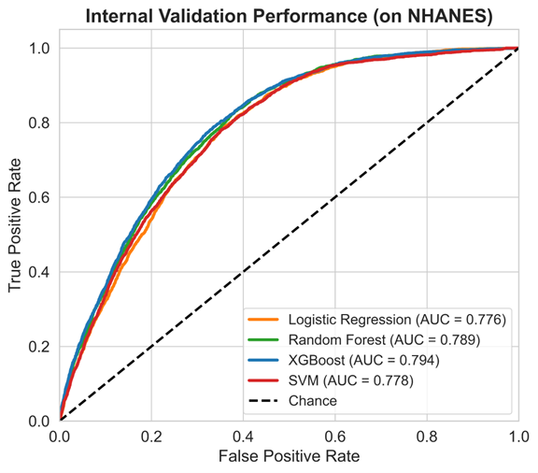

FIGURE 2 — Calibration Plot (External BRFSS)
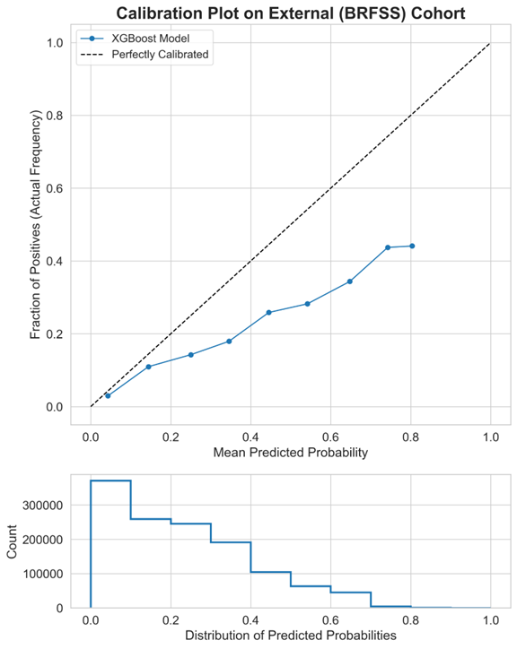

FIGURE 3 — SHAP Summary Plot
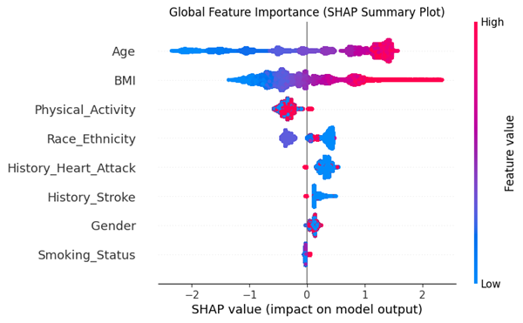

FIGURE 4 — Fairness Forest Plot
