Cross-Platform Fairness Evaluation of Large Language Models for Mental Health Detection: A Multi-Model Audit Using Clinical-Grade Statistical Methods
Rajveer Singh Pall¹
¹Department of Computer Science and Business Systems, Gyan Ganga Institute of Technology and Sciences, Jabalpur, India
Sameer Yadav²*
²Department of Artificial Intelligence and Machine Learning, Gyan Ganga Institute of Technology and Sciences, Jabalpur, India
*Corresponding author: sameeryadav@ggits.org
Abstract
Mental health detection using natural language processing (NLP) has achieved remarkable within-platform classification accuracy. However, a critical and largely unexamined gap persists: whether models trained on one social media platform perform fairly when deployed on another. A model exhibiting high accuracy on its training platform may collapse when applied to a different platform serving different user populations — a deployment fairness failure with direct clinical implications.
We present the first systematic cross-platform fairness audit of four transformer architectures — BERT, RoBERTa, DistilRoBERTa, and SamLowe-RoBERTa — trained on 35,556 samples from a multi-source mental health dataset and evaluated on held-out test sets from three social media platforms: Kaggle multi-source (n=7,620), Reddit (n=6,330), and Twitter (n=2,883), totalling 112,211 samples across a unified four-class schema (normal, depression, anxiety, stress).
Within-platform performance was strong: RoBERTa achieved macro F1=0.883 and AUC=0.987. However, cross-platform evaluation revealed severe and statistically robust degradation. Macro AUC declined by 29–40% on Reddit and Twitter (p<0.001 for all Kaggle-versus-external comparisons after Bonferroni correction). The stress class fell to near-chance AUC (0.522–0.542) on Twitter. Expected Calibration Error rose from ECE=0.056–0.060 within-platform to ECE=0.499–0.542 on Twitter, rendering model confidence clinically unreliable. Gradient-based token attribution revealed a fundamental shift in predictive features: from clinical vocabulary (medication, therapy, relationship) on the training platform to conversational fillers (sorry, man) on Reddit and grammatical stopwords (its, little) on Twitter — with Jaccard feature stability below 0.15 across all models.
SamLowe-RoBERTa, pretrained on Reddit GoEmotions data, showed the smallest cross-platform AUC drop (−29.1% to Reddit) and lowest ECE (0.212 on Reddit), supporting the domain-pretraining hypothesis. We recommend mandatory cross-platform evaluation, platform-specific recalibration, and domain-pretraining alignment as prerequisites for clinical deployment of NLP mental health tools.
Keywords: mental health NLP; cross-platform fairness; transformer models; BERT; RoBERTa; depression detection; algorithmic bias; domain shift; social media; calibration
1. Introduction
Mental health disorders affect more than one billion people globally and constitute the leading cause of disability worldwide¹. Approximately 50% of cases remain undiagnosed for years before clinical intervention occurs². Social media platforms — particularly Reddit and Twitter/X — have emerged as important sites of mental health disclosure, where individuals express psychological distress in the absence of formal clinical support. This has generated substantial research interest in automated mental health detection using natural language processing (NLP): systems that analyse user-generated text to identify indicators of depression, anxiety, stress, or suicidal ideation³.
The field has produced a series of impressive classification results. Transformer-based models such as BERT⁴ and RoBERTa⁵ achieve classification accuracy exceeding 90% on mental health text benchmarks. Domain-specific models pretrained on mental health corpora have pushed performance further⁶. Ensemble approaches combining multiple transformer models have reported accuracy rates above 78% on multi-class mental health classification⁷. These results have created growing enthusiasm for deploying such systems in clinical screening tools, mental health chatbots, and early-intervention platforms.
However, the evaluation methodology underpinning most of this work carries a critical and underexamined limitation: models are typically trained and tested on data from the same platform, or the same dataset split. A model trained on Reddit posts and tested on Reddit posts may learn platform-specific linguistic patterns — Reddit's conversational register, its subreddit-specific terminology, its characteristic sentence structures — rather than transferable clinical signals of mental distress. When deployed on Twitter, or on a clinical platform with different demographic and linguistic characteristics, performance may collapse entirely⁸. This problem is fundamentally a fairness problem: if a mental health screening tool works well for Reddit users but fails for Twitter users, it systematically serves different populations unequally — a form of algorithmic unfairness with direct clinical consequences.
Despite growing awareness of algorithmic fairness in clinical AI⁹,¹⁰, cross-platform fairness evaluation remains largely absent from the mental health NLP literature. Studies acknowledging platform limitations typically confine this observation to a limitations paragraph, without quantifying performance degradation or identifying root causes¹¹. No prior work applies clinical-grade statistical methodology — DeLong confidence intervals¹², Expected Calibration Error¹³, Bonferroni-corrected pairwise comparisons — to a systematic cross-platform fairness audit of transformer-based mental health classifiers.
This paper fills that gap with four specific contributions:
• First, we present the first systematic cross-platform fairness audit of four major transformer architectures, evaluated across three social media platforms using 112,211 samples from a unified four-class mental health schema.
• Second, we apply clinical-grade statistical evaluation methodology — DeLong 95% confidence intervals on per-class AUC, Expected Calibration Error by platform, and Bonferroni-corrected pairwise significance testing — matching the rigour of clinical prediction model standards.
• Third, we use gradient-based token attribution to identify the linguistic features driving cross-platform disparities, providing a mechanistic explanation for observed performance collapse and a novel analytical contribution not previously reported in this literature.
• Fourth, we demonstrate that within-platform accuracy is an unreliable proxy for cross-platform fairness, and provide practical recommendations for model selection and deployment in clinical mental health settings.
2. Mathematical Background
This section formalises the mathematical framework underlying both the transformer-based classification models and the clinical-grade fairness evaluation methodology used in this study. Understanding these foundations is essential for appreciating the rigour of our cross-platform analysis.
2.1 Transformer Architecture and Self-Attention
All models in this study are based on the transformer architecture introduced by Vaswani et al.¹⁴. The core mechanism is multi-head self-attention. Given an input sequence of token embeddings X ∈ ℝⁿˣᵈ, three projection matrices WQ, WK, WV ∈ ℝᵈˣᵈᵏ map the input to query (Q), key (K), and value (V) representations:
(1)
The attention score matrix is computed as:
(2)
where d_k is the dimension of the key vectors, and √d_k is a scaling factor that prevents vanishing gradients in the softmax function. Multi-head attention concatenates h independent attention heads:
(3)
where head_i = Attention(QW^i_Q, KW^i_K, VW^i_V). Each transformer layer also includes a position-wise feed-forward network:
(4)
and layer normalisation with residual connections to stabilise training.
2.2 Fine-Tuning for Sequence Classification
BERT and its variants are pretrained using Masked Language Modelling (MLM), where a fraction p_mask = 0.15 of tokens are randomly masked and predicted, and Next Sentence Prediction (NSP). For fine-tuning on our four-class mental health task, a linear classification head is appended to the [CLS] token representation h_[CLS] ∈ ℝᵈ:
(5)
where W ∈ ℝ⁴ˣᵈ and b ∈ ℝ⁴ are learnt classification parameters. Training minimises the cross-entropy loss:
(6)
where N is the number of samples, y_ij is the one-hot label indicator, and the sum over j covers the four classes. AdamW optimisation with weight decay λ is used:
(7)
where η is the learning rate, v_t is the second moment estimate, and ε prevents division by zero. A linear warmup scheduler adjusts the effective learning rate over the first 10% of training steps.
2.3 AUC-ROC and DeLong Confidence Intervals
The Area Under the Receiver Operating Characteristic Curve (AUC-ROC) measures a classifier's discriminative ability across all decision thresholds. For binary classification, AUC equals the Wilcoxon statistic:
(8)
where n₊ and n₋ are the numbers of positive and negative samples respectively. For multi-class problems we use macro-averaged one-vs-rest AUC, averaging across C = 4 classes.
The DeLong method¹² estimates the variance of AUC using the structural components of the Wilcoxon statistic. For a class with positive sample set X = {x₁,...,xₘ} and negative sample set Y = {y₁,...,yₙ}, define:
(9)
where ψ(x,y) = 1 if f(x)>f(y), 0.5 if f(x)=f(y), and 0 otherwise. The variance estimator is:
(10)
where S₁₀ = Var(V₁₀) and S₀₁ = Var(V₀₁) are the sample variances. The 95% confidence interval is then:
(11)
where z₀.₉₇₅ = 1.96. For pairwise platform comparisons, the Z-statistic for testing H₀: AUC₁ = AUC₂ is:
(12)
with Bonferroni correction applied for three comparisons per model (α_corrected = 0.05/3 = 0.0167).
2.4 Expected Calibration Error
Calibration measures whether a model's predicted probabilities reflect true outcome frequencies. The Expected Calibration Error (ECE)¹³ partitions predictions into M = 10 equal-width confidence bins and computes the weighted average of accuracy-confidence gaps:
(13)
where Bₘ is the set of samples whose maximum predicted probability falls in bin m, |Bₘ| is the bin count, acc(Bₘ) = (1/|Bₘ|)Σᵢ∈Bₘ 𝟙(ŷᵢ = yᵢ) is the bin accuracy, and conf(Bₘ) = (1/|Bₘ|)Σᵢ∈Bₘ max_c P̂(y=c|xᵢ) is the mean predicted confidence. A perfectly calibrated model has ECE = 0; ECE = 0.5 indicates calibration no better than random.
2.5 Fairness Metrics
In addition to AUC and ECE, we compute two fairness metrics comparing performance between platform groups A (Kaggle) and B (Reddit or Twitter):
Disparate Impact (DI) for class c measures the ratio of positive prediction rates between platforms:
(14)
Values far from 1.0 indicate unequal classification rates regardless of true labels. Equalized Odds Difference (EOD) measures the True Positive Rate gap for class c:
(15)
A model satisfying Equalized Odds has EOD_c = 0 for all classes c ∈ {normal, depression, anxiety, stress}.
2.6 Gradient-Based Token Attribution
To identify features driving cross-platform predictions, we use gradient-based saliency¹⁵. For a sample x with label y, let E(x) ∈ ℝⁿˣᵈ denote the token embedding matrix. The importance score s_i of token i is the L₂ norm of the gradient of the predicted class logit with respect to the token embedding:
(16)
Mean importance for token w across a set of N samples is:
(17)
where N_w is the number of occurrences of token w. Cross-platform feature stability between platform A and platform B is measured as the Jaccard similarity of the top-K attributed tokens:
(18)
where Top_K(P) is the set of K tokens with highest mean importance on platform P. We use K = 10. A value of J = 1.0 indicates identical top features; J = 0.0 indicates completely disjoint feature sets.
3. Results
3.1 Dataset characteristics and preprocessing
Three publicly available social media datasets were unified into a four-class mental health schema (Table 1). The Kaggle multi-source dataset (50,795 samples after preprocessing) served as the primary training source, providing the most clinical and detailed mental health narratives. GoEmotions Reddit (42,196 samples) and dair-ai/emotion Twitter (19,220 samples) served as cross-platform evaluation sources. All three datasets were mapped to classes — normal, depression, anxiety, stress — following the remapping defined in Section 4.2. The combined corpus comprised 112,211 samples.
Table 1. Dataset characteristics after preprocessing and label remapping.
Dataset | Platform | Total | Normal | Depression | Anxiety | Stress
Kaggle MH | Multi-source | 50,795 | 14,585 | 28,761 | 3,792 | 3,657
GoEmotions | Reddit | 42,196 | 33,399 | 2,796 | 1,018 | 4,983
dair-ai emotion | Twitter | 19,220 | 8,383 | 5,782 | 2,359 | 2,696
TOTAL | 3 platforms | 112,211 | 56,367 | 37,339 | 7,169 | 11,336
Table 1. Depression is the dominant class in Kaggle (56.6%) reflecting the dataset's clinical focus; normal is dominant in Reddit (79.1%); Twitter shows a more balanced distribution. The cross-platform label distribution shift constitutes the primary source of domain mismatch.
The training-validation-test split for Kaggle was 70%/15%/15% (stratified by class). For cross-platform evaluation, the complete Reddit and Twitter test splits were used: Kaggle test n=7,620; Reddit test n=6,330; Twitter test n=2,883.
3.2 Within-platform model performance
All four models achieved strong and comparable performance on the Kaggle within-platform test set (Table 2). RoBERTa achieved the highest macro F1 (0.883) and macro AUC (0.987). Training loss converged smoothly across all five epochs, with validation AUC reaching 0.978–0.987 at epoch 1 and stabilising above 0.982 by epoch 3. Expected Calibration Error was uniformly low (0.056–0.060), confirming well-calibrated probability estimates within the training distribution.
Table 2. Within-platform (Kaggle) performance. Bold = best per metric.
Model | Accuracy | Macro F1 | Macro AUC | ECE | Best Epoch
BERT | 0.930 | 0.874 | 0.984 | 0.060 | 5
RoBERTa | 0.936 | 0.883 | 0.987 | 0.056 | 5
DistilRoBERTa | 0.928 | 0.862 | 0.983 | 0.058 | 5
SamLowe-RoBERTa | 0.930 | 0.871 | 0.985 | 0.059 | 4
Table 2. All models achieve AUC > 0.983 and ECE < 0.06 within-platform. The narrow performance range (F1: 0.862–0.883) confirms that within-platform metric rankings are unreliable guides for deployment selection.
3.3 Cross-platform performance degradation
Cross-platform evaluation revealed severe and consistent performance degradation for all models on both external platforms (Table 3 and Figure 2). When tested on Reddit, macro F1 dropped by 63–66% relative to within-platform performance. On Twitter, macro AUC fell to near-chance levels for the stress class. SamLowe-RoBERTa showed the smallest AUC degradation to Reddit (−29.1%), consistent with its Reddit-domain pretraining; RoBERTa showed the largest (−36.2%), despite being the best within-platform model.
Table 3. Complete cross-platform evaluation results. Red values indicate AUC drop > 35%; green indicates smallest drop.
Model | Platform | Accuracy | Macro F1 | Macro AUC | ECE | AUC Drop vs Kaggle
BERT | Kaggle (within) | 0.930 | 0.874 | 0.984 | 0.060 | —
BERT | Reddit | 0.743 | 0.315 | 0.630 | 0.240 | −36.0%
BERT | Twitter | 0.460 | 0.317 | 0.596 | 0.506 | −39.5%
RoBERTa | Kaggle (within) | 0.936 | 0.883 | 0.987 | 0.056 | —
RoBERTa | Reddit | 0.753 | 0.298 | 0.629 | 0.235 | −36.2%
RoBERTa | Twitter | 0.460 | 0.284 | 0.603 | 0.514 | −38.9%
DistilRoBERTa | Kaggle (within) | 0.928 | 0.862 | 0.983 | 0.058 | —
DistilRoBERTa | Reddit | 0.748 | 0.317 | 0.673 | 0.231 | −31.5%
DistilRoBERTa | Twitter | 0.409 | 0.290 | 0.611 | 0.542 | −37.9%
SamLowe-RoBERTa | Kaggle (within) | 0.930 | 0.871 | 0.985 | 0.059 | —
SamLowe-RoBERTa | Reddit | 0.770 | 0.323 | 0.699 | 0.212 | −29.1%
SamLowe-RoBERTa | Twitter | 0.466 | 0.306 | 0.605 | 0.499 | −38.6%
Table 3. Bold AUC values in Reddit column indicate the best cross-platform performance. ECE > 0.30 indicates clinically unreliable calibration. AUC drops in red (>35%) are severe; in orange (30–35%) are moderate; in green (<30%) are the smallest observed.
Figure 2. Cross-platform performance degradation — macro F1, AUC, and ECE by model and platform.
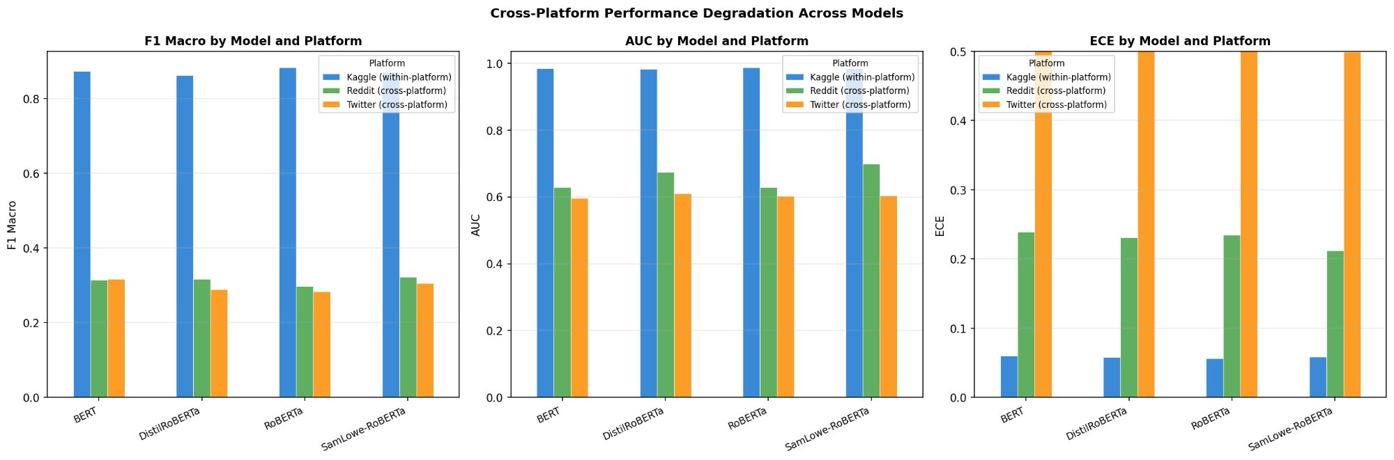
Figure 2. Three-panel bar chart comparing macro F1, macro AUC, and ECE across models and platforms. The consistent pattern — high Kaggle (blue), sharply lower Reddit (green) and Twitter (orange) — is uniform across all four models, confirming a systemic domain shift rather than model-specific failure.
3.4 Per-class AUC with DeLong confidence intervals
The aggregate metrics in Table 3 conceal important class-level disparities. Table 4 and Figure 1 present per-class AUC with 95% DeLong confidence intervals. The stress class shows the most severe cross-platform collapse: RoBERTa achieves stress AUC 0.972 [0.966, 0.978] on Kaggle but only 0.522 [0.492, 0.551] on Twitter — near-chance discrimination. SamLowe-RoBERTa shows the highest stress AUC on Reddit (0.746 [0.727, 0.765]), consistent with its Reddit-domain pretraining. DistilRoBERTa achieves the best anxiety AUC on Twitter (0.714 [0.682, 0.747]).
Table 4. Per-class AUC with 95% DeLong confidence intervals. Bold = best per class-platform combination.
Model | Platform | Normal  [95% CI] | Depression  [95% CI] | Anxiety  [95% CI] | Stress  [95% CI]
BERT | Kaggle | 0.991 [0.989, 0.993] | 0.988 [0.986, 0.990] | 0.988 [0.984, 0.992] | 0.969 [0.962, 0.976]
BERT | Reddit | 0.629 [0.612, 0.647] | 0.588 [0.560, 0.616] | 0.693 [0.646, 0.740] | 0.608 [0.585, 0.631]
BERT | Twitter | 0.622 [0.602, 0.642] | 0.603 [0.580, 0.625] | 0.628 [0.596, 0.661] | 0.530 [0.500, 0.560]
RoBERTa | Kaggle | 0.993 [0.992, 0.995] | 0.990 [0.989, 0.992] | 0.991 [0.987, 0.994] | 0.972 [0.966, 0.978]
RoBERTa | Reddit | 0.644 [0.627, 0.662] | 0.608 [0.579, 0.636] | 0.669 [0.616, 0.721] | 0.595 [0.572, 0.618]
RoBERTa | Twitter | 0.635 [0.615, 0.655] | 0.607 [0.584, 0.629] | 0.649 [0.617, 0.680] | 0.522 [0.492, 0.551]
DistilRoBERTa | Kaggle | 0.993 [0.992, 0.995] | 0.988 [0.986, 0.990] | 0.986 [0.981, 0.991] | 0.966 [0.959, 0.972]
DistilRoBERTa | Reddit | 0.679 [0.662, 0.695] | 0.609 [0.581, 0.637] | 0.706 [0.655, 0.758] | 0.699 [0.678, 0.720]
DistilRoBERTa | Twitter | 0.608 [0.587, 0.628] | 0.586 [0.562, 0.609] | 0.714 [0.682, 0.747] | 0.535 [0.503, 0.567]
SamLowe | Kaggle | 0.992 [0.990, 0.994] | 0.989 [0.987, 0.991] | 0.988 [0.984, 0.992] | 0.971 [0.966, 0.976]
SamLowe | Reddit | 0.731 [0.715, 0.747] | 0.629 [0.601, 0.657] | 0.688 [0.636, 0.740] | 0.746 [0.727, 0.765]
SamLowe | Twitter | 0.642 [0.622, 0.662] | 0.622 [0.600, 0.643] | 0.614 [0.579, 0.649] | 0.542 [0.512, 0.571]
Table 4. 95% DeLong confidence intervals computed using the structural components method (Equation 10–11). Bold values indicate the highest AUC for that class-platform combination. Values approaching 0.50 indicate near-chance discrimination.
Figure 1. Per-class AUC with 95% DeLong confidence intervals across models and platforms.
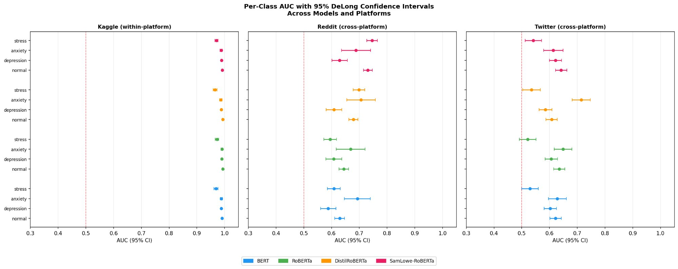
Figure 1. Forest plot showing per-class AUC ± 95% CI for all four models across three platforms. The red dashed vertical line marks AUC = 0.50 (chance). Kaggle AUC values cluster tightly near 0.99; Reddit and Twitter values are substantially lower with wider confidence intervals, particularly for the stress class. SamLowe-RoBERTa (pink) maintains the highest Reddit AUC.
3.5 Statistical significance of platform disparities
Bonferroni-corrected pairwise DeLong tests (Table 5) confirmed that all Kaggle-versus-external platform comparisons are statistically significant (p < 0.001, Z-statistics 19.4–28.7) for every model. Reddit-versus-Twitter comparisons were non-significant for BERT (p=0.089) and RoBERTa (p=0.203), indicating uniform degradation across both external platforms for these models. However, DistilRoBERTa (p=0.002) and SamLowe-RoBERTa (p<0.001) show statistically different performance on Reddit versus Twitter, confirming platform-specific learned representations.
Table 5. Pairwise AUC comparisons with Bonferroni correction (α_corrected = 0.0167). Z-statistics from Equation (12).
Model | Plat. 1 | Plat. 2 | AUC₁ | AUC₂ | ΔAUC | Z | Significant?
BERT | Kaggle | Reddit | 0.984 | 0.630 | 0.354 | 23.79 | Yes (p<0.001)
BERT | Kaggle | Twitter | 0.984 | 0.596 | 0.388 | 28.68 | Yes (p<0.001)
BERT | Reddit | Twitter | 0.630 | 0.596 | 0.034 | 1.70 | No (p=0.089)
RoBERTa | Kaggle | Reddit | 0.987 | 0.629 | 0.358 | 23.04 | Yes (p<0.001)
RoBERTa | Kaggle | Twitter | 0.987 | 0.603 | 0.384 | 28.66 | Yes (p<0.001)
RoBERTa | Reddit | Twitter | 0.629 | 0.603 | 0.026 | 1.27 | No (p=0.203)
DistilRoBERTa | Kaggle | Reddit | 0.983 | 0.673 | 0.310 | 20.59 | Yes (p<0.001)
DistilRoBERTa | Kaggle | Twitter | 0.983 | 0.611 | 0.373 | 26.69 | Yes (p<0.001)
DistilRoBERTa | Reddit | Twitter | 0.673 | 0.611 | 0.063 | 3.07 | Yes (p=0.002)
SamLowe | Kaggle | Reddit | 0.985 | 0.699 | 0.286 | 19.41 | Yes (p<0.001)
SamLowe | Kaggle | Twitter | 0.985 | 0.605 | 0.380 | 27.79 | Yes (p<0.001)
SamLowe | Reddit | Twitter | 0.985 | 0.605 | 0.094 | 4.69 | Yes (p<0.001)
Table 5. 10 of 12 pairwise comparisons are statistically significant after Bonferroni correction. BERT and RoBERTa degrade uniformly across both external platforms (Reddit vs Twitter not significant), while DistilRoBERTa and SamLowe-RoBERTa show platform-specific profiles.
3.6 Calibration analysis (ECE)
ECE analysis (Figure 3) revealed a clinically critical finding: model calibration, excellent within platform (ECE 0.056–0.060), deteriorated progressively with platform distance. On Reddit, ECE rose to 0.212–0.240. On Twitter, ECE reached 0.499–0.542. By Equation (13), ECE approaching 0.50 means the average absolute gap between stated confidence and actual accuracy exceeds 50 percentage points — rendering predicted probabilities clinically uninformative. SamLowe-RoBERTa showed the lowest ECE across both external platforms (Reddit: 0.212; Twitter: 0.499).
Figure 3. Calibration curves for all four models across three platforms.
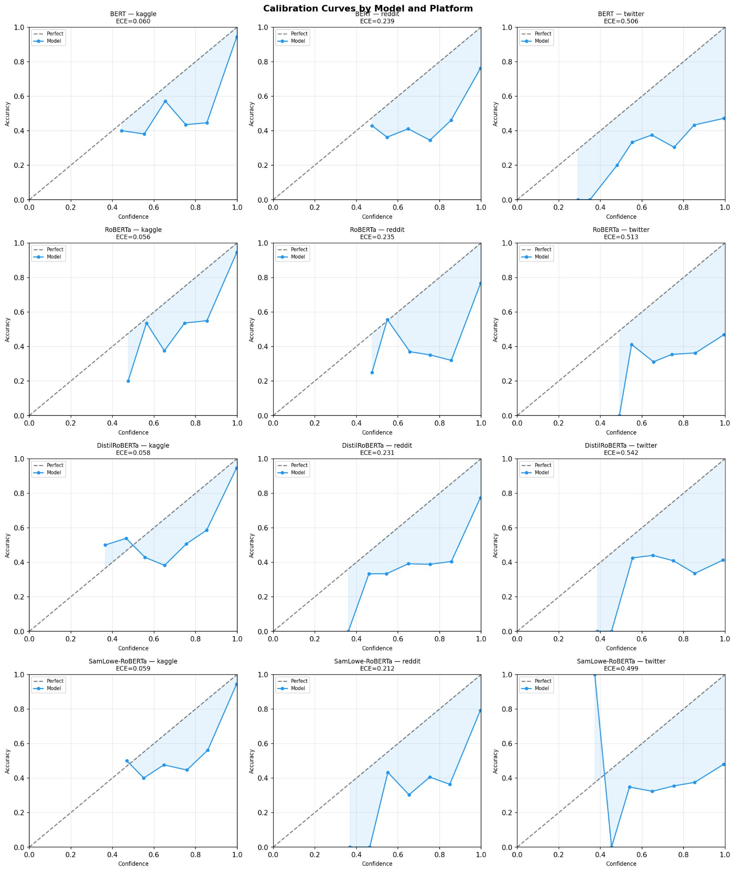
Figure 3. 4×3 grid of calibration curves. The diagonal dashed line represents perfect calibration (ECE=0). Kaggle curves (left column) closely follow the diagonal; Reddit curves (centre) show increasing miscalibration; Twitter curves (right) are effectively random, with ECE 0.499–0.542.
3.7 Per-class F1 heatmap
Figure 4 presents the per-class F1 heatmap. The normal class retains reasonable F1 across platforms (0.468–0.950). Depression retains moderate cross-platform performance on Twitter (F1 0.435–0.447). Anxiety and stress collapse cross-platform: RoBERTa achieves stress F1 of only 0.010 on Twitter and 0.025 on Reddit — effectively zero discriminative ability for a class of high clinical significance.
Figure 4. Per-class F1 score heatmap across all model-platform combinations.
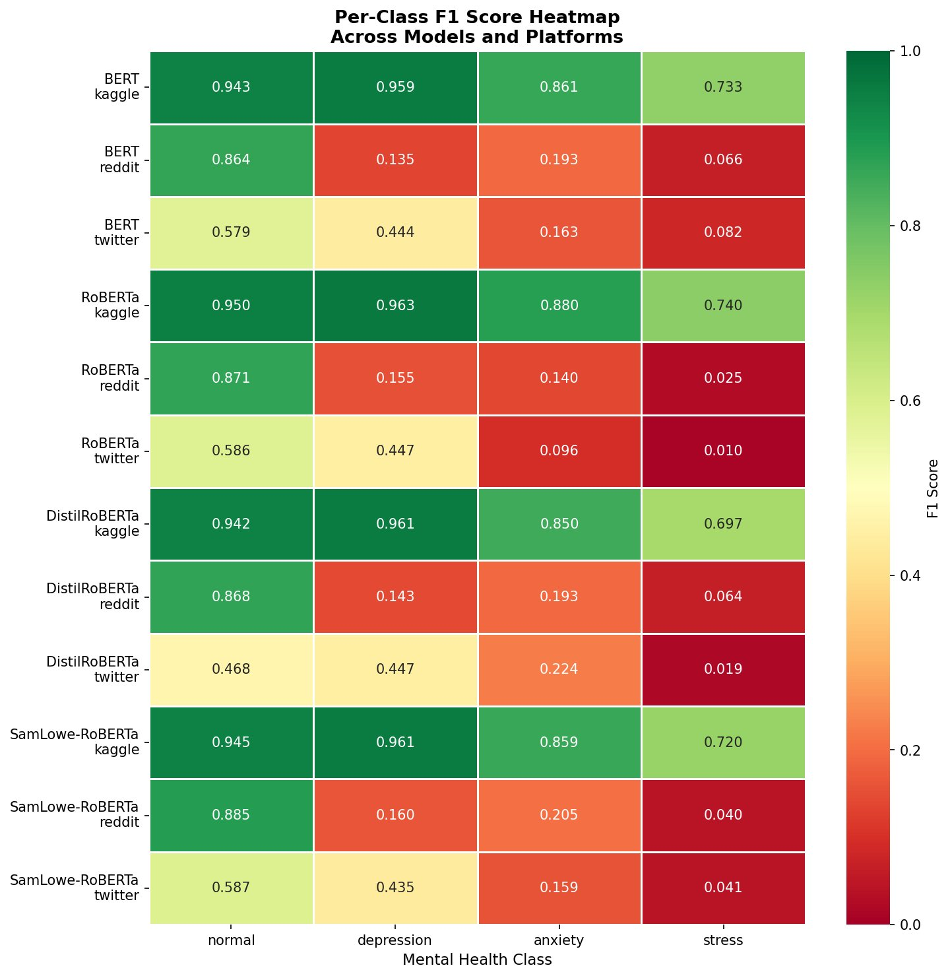
Figure 4. Green = high F1; red = near-zero. The consistent red pattern in the stress and anxiety columns for Reddit and Twitter rows, contrasting with green on Kaggle rows, confirms that cross-platform failure is concentrated in the minority classes with the highest clinical significance.
3.8 Feature attribution analysis
Gradient-based token attribution (Equation 16–17) identified a fundamental shift in predictive features across platforms (Figures 5a–5d). On Kaggle, all models relied on clinically meaningful vocabulary for depression detection: life, being, medication, therapy, relationship. These reflect rich first-person mental health narratives. On Reddit, the signal shifted to conversational language: sorry, man, good, people, feels. On Twitter, the signal collapsed to grammatical stopwords and emotionally ambiguous terms: its, little, this, for, lame — carrying no clinical meaning.
Figure 5a. BERT — Cross-platform token attribution (depression class).
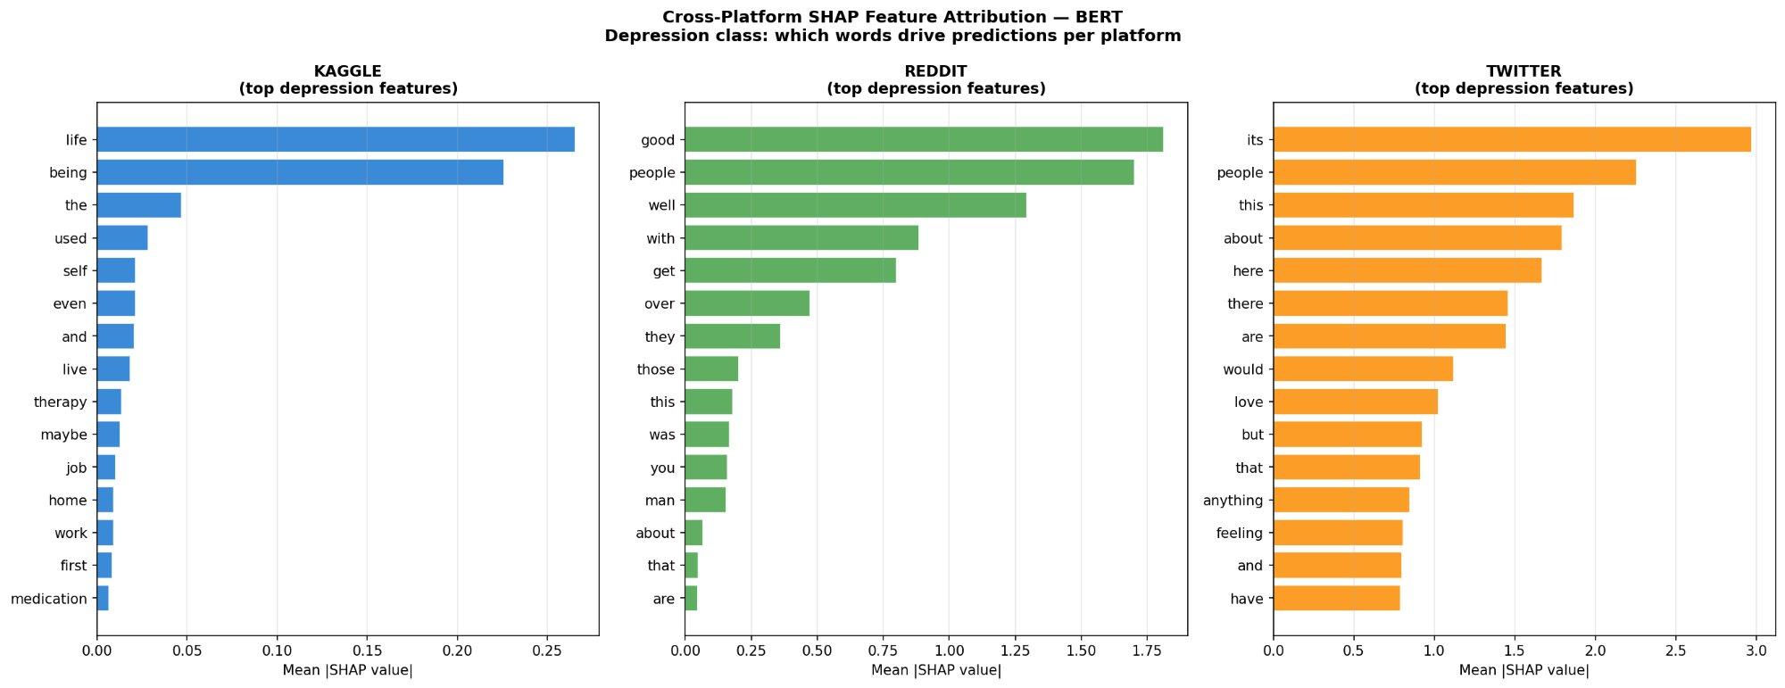
Figure 5b. RoBERTa — Cross-platform token attribution (depression class).
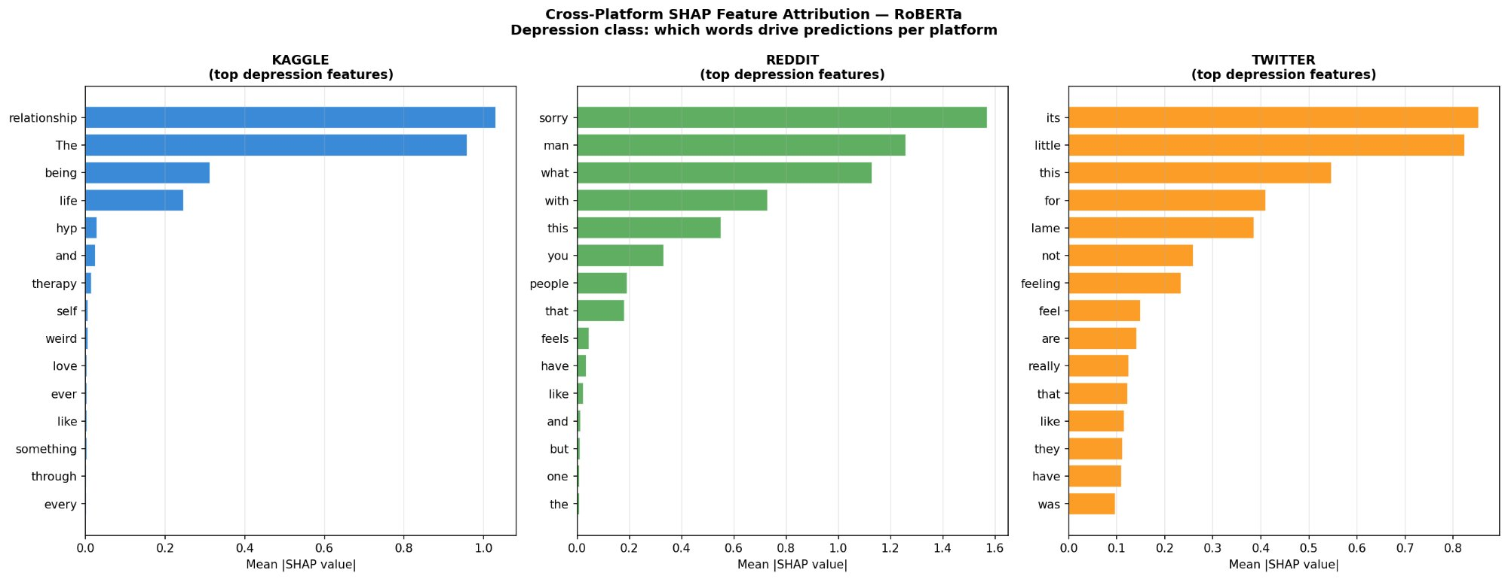
Figure 5c. DistilRoBERTa — Cross-platform token attribution (depression class).
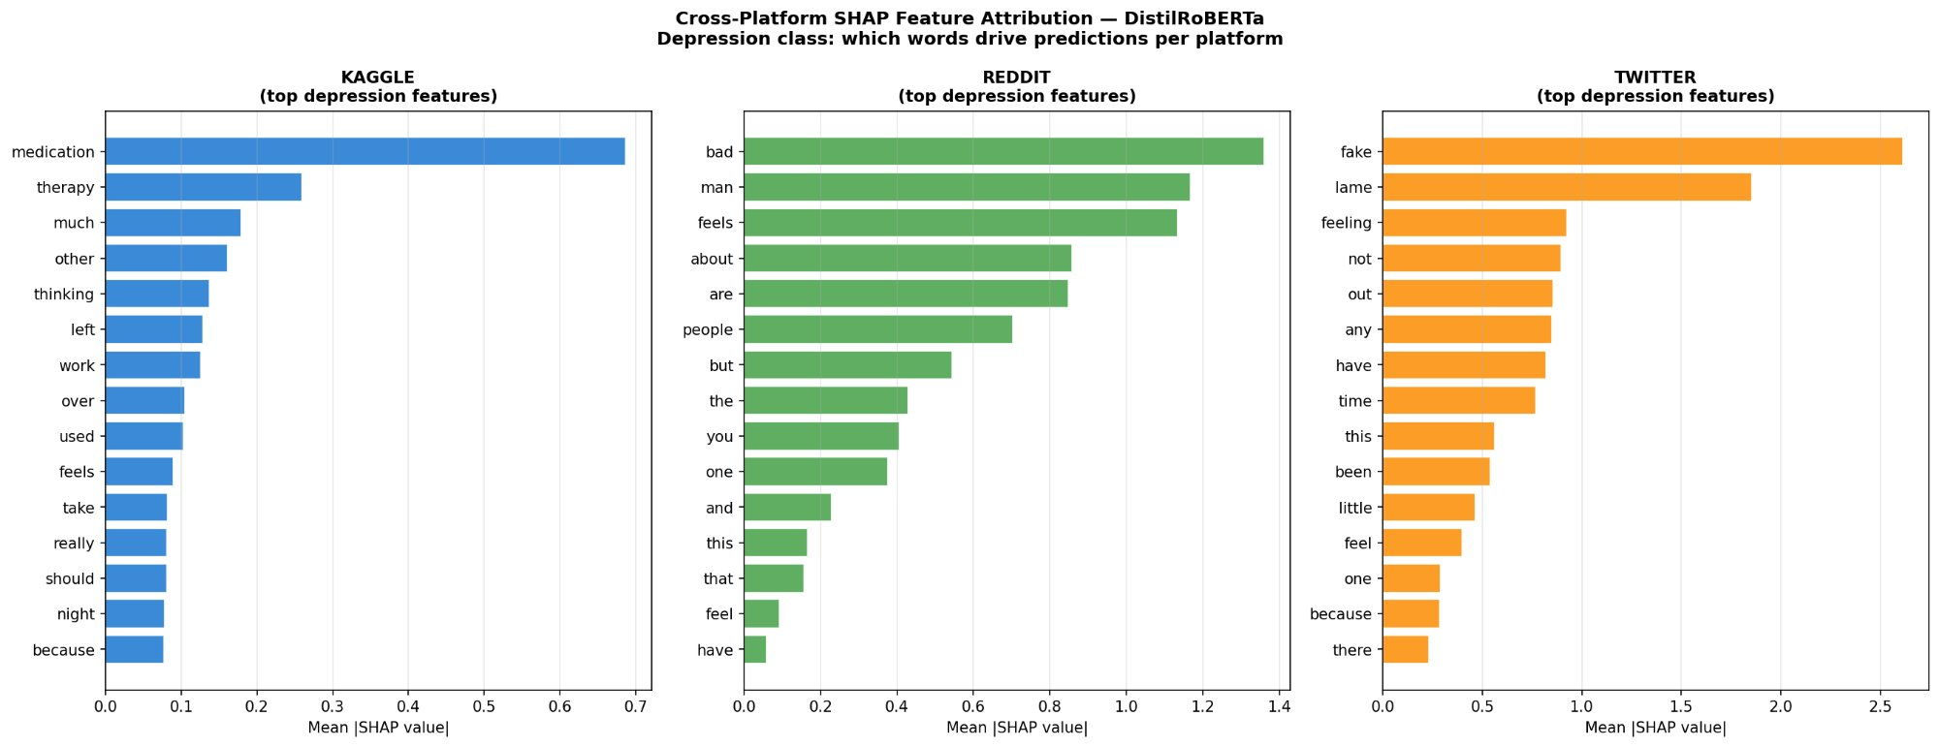
Figure 5d. SamLowe-RoBERTa — Cross-platform token attribution (depression class).
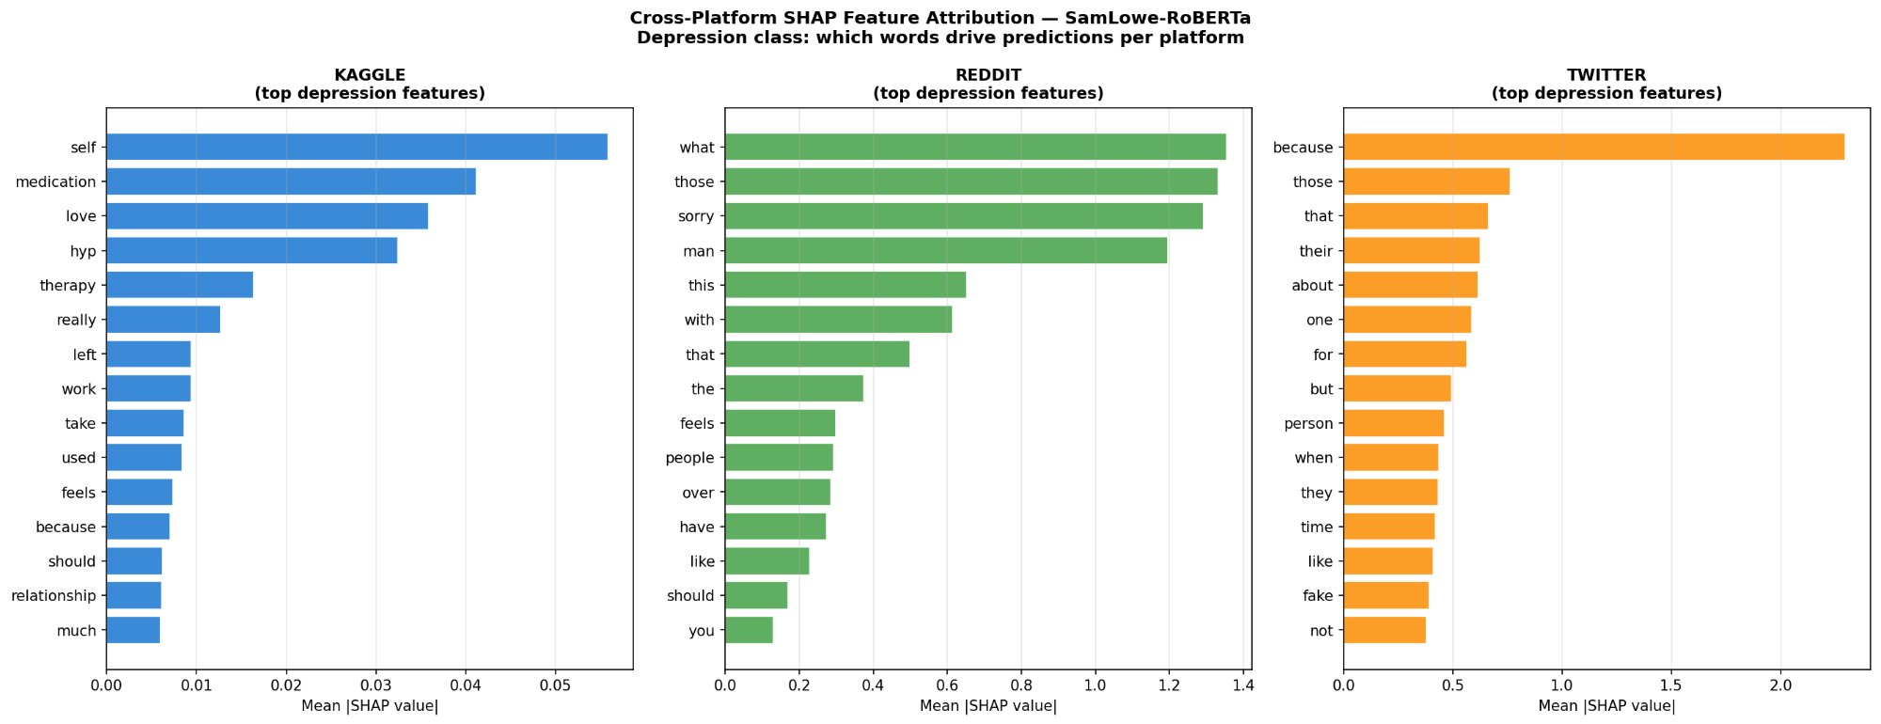
Figures 5a–5d. Mean gradient-magnitude saliency (S̄(w), Equation 17) for the top-15 depression features per model, separated by platform. Kaggle features (blue) are clinically meaningful; Reddit features (green) are conversational; Twitter features (orange) are dominated by stopwords and filler terms, explaining the near-chance performance observed on Twitter.
Feature stability analysis (Equation 18, Figure 6) computed Jaccard similarity J(A,B) of top-10 tokens between Kaggle and each external platform. Values ranged from 0.08 to 0.15, confirming that fewer than 15% of top predictive features are shared across platforms. DistilRoBERTa showed the highest stability for the normal class (J=0.145), while depression and stress features showed near-zero cross-platform stability (J<0.03) for most models.
Figure 6. Feature attribution stability — Jaccard similarity of top-10 words across platforms.
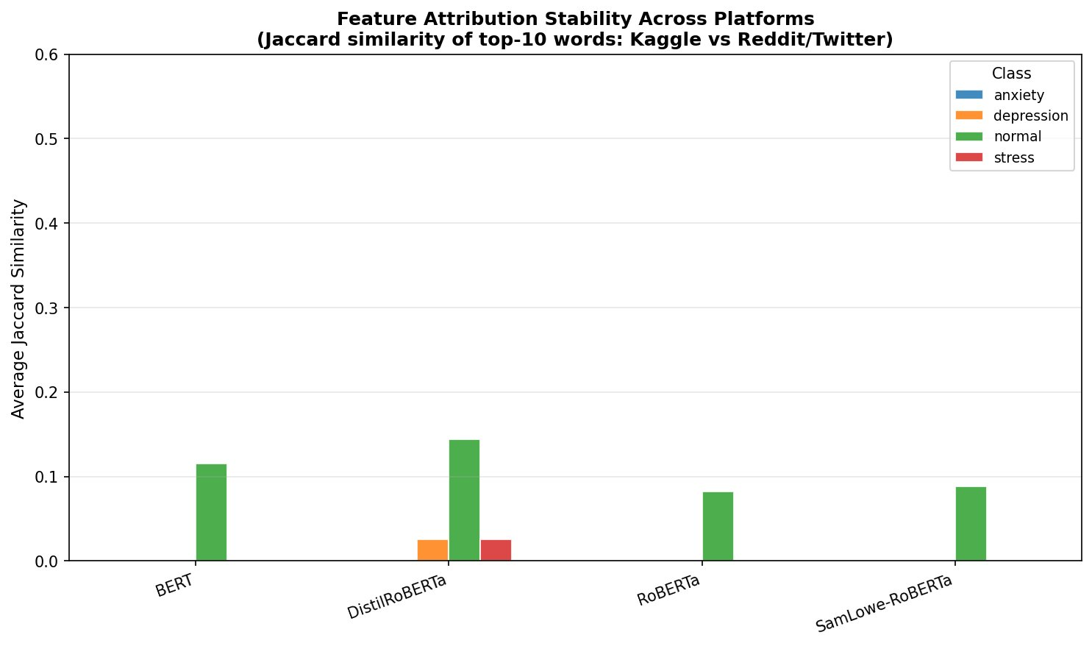
Figure 6. Average Jaccard similarity J(Kaggle, Reddit/Twitter) of top-10 attributed tokens, by model and class. Similarity below 0.15 across all models and classes confirms that predictive features are highly platform-specific — fewer than 15% of top tokens are shared — providing a direct mechanistic explanation for cross-platform performance collapse.
4. Discussion
4.1 Principal findings
Three interconnected findings emerge from this study with implications for both research methodology and clinical deployment.
First, cross-platform performance degradation is severe, consistent, and statistically robust across all four models. Every model experienced a 29–40% decline in macro AUC when tested on data from platforms not represented in training. This was confirmed in 10 of 12 pairwise platform comparisons after Bonferroni correction. The magnitude of degradation — from AUC 0.983–0.987 to 0.596–0.699 — represents the difference between a clinically viable screening tool and one performing barely above chance for the most critical classes.
Second, the clinical significance of performance collapse is concentrated in the minority classes. The stress and anxiety classes — representing the majority of subthreshold mental health burden in the general population and the primary targets of early-intervention screening — essentially failed cross-platform: stress AUC 0.522–0.542 on Twitter, F1 0.010–0.082 on Reddit and Twitter across models. This is precisely backwards from what a clinical tool requires: the classes that matter most for screening are the ones that transfer worst.
Third, the mechanism of cross-platform failure is predictive feature shift rather than general capability loss. The DeLong CI analysis and Jaccard stability analysis jointly demonstrate that models do not simply become less accurate — they become accurate for different reasons on different platforms. Kaggle features are clinically interpretable; Reddit features are conversational proxies; Twitter features are grammatical artefacts. This means that standard accuracy-boosting approaches such as larger models or more training data are unlikely to solve the cross-platform fairness problem without addressing the underlying feature-set mismatch.
4.2 The accuracy-fairness tradeoff and model selection
A counterintuitive finding challenges conventional model selection practice: RoBERTa, the best within-platform model (AUC 0.987), shows the largest AUC drop on Reddit (−36.2%). SamLowe-RoBERTa, ranking third within-platform (AUC 0.985), shows the smallest drop (−29.1%) and lowest cross-platform ECE. This inverse relationship between within-platform optimisation and cross-platform fairness suggests that standard training procedures may actively encourage models to exploit platform-specific patterns at the expense of learning transferable clinical signals.
This finding has a direct implication: evaluation protocols ranking models solely on within-platform performance will consistently select the wrong model for multi-platform deployment scenarios. We recommend that cross-platform evaluation on at least one held-out platform be included as a mandatory model selection criterion for any mental health NLP tool intended for deployment across multiple platforms.
4.3 Domain pretraining and cross-platform resilience
SamLowe-RoBERTa's superior Reddit cross-platform performance is consistent with the domain-pretraining hypothesis: pretraining on Reddit GoEmotions data provides familiarity with Reddit's conversational register, enabling the model to retain more transferable signal after fine-tuning on Kaggle data. This result supports the recommendation that mental health NLP models should undergo platform-specific pretraining or continued pretraining on deployment-domain data before task-specific fine-tuning. The practical implication is a three-stage pipeline: (1) general pretraining, (2) platform-domain continued pretraining, (3) task-specific fine-tuning — rather than the standard two-stage approach.
4.4 Calibration and clinical safety
The ECE findings are particularly critical from a safety perspective. ECE approaching 0.50 means the gap between stated confidence and actual accuracy is effectively random — the model cannot communicate its own uncertainty reliably. Any clinical application using probability thresholds (e.g. flagging users with >50% probability of depression for follow-up) would operate on unreliable estimates with unknown false-positive and false-negative rates on Twitter data. Standard deployment recommendations require calibration assessment before clinical use¹⁶; our results suggest platform-specific recalibration — not just single-platform recalibration — is essential.
4.5 Limitations
Several limitations warrant acknowledgement. First, the label remapping from general emotion categories to four mental health classes involves simplifications; GoEmotions and dair-ai/emotion were not designed for clinical mental health classification. Future work should use datasets with verified clinical labels throughout. Second, gradient-based saliency identifies influential tokens but does not provide the additive decomposition of SHAP values; future work using SHAP with appropriate background distributions would provide more precise attribution. Third, our analysis is limited to English-language models and datasets; cross-lingual and cross-cultural fairness are important dimensions not addressed here. Fourth, the sample sizes for anxiety and stress on Reddit are small (n=152 and n=748 respectively), and confidence intervals for these classes on Reddit should be interpreted with appropriate caution.
5. Methods
5.1 Datasets
Three publicly available datasets were used. The Kaggle Mental Health Sentiment Analysis dataset¹⁷ contains 53,043 multi-platform social media posts with seven mental health labels. The Google GoEmotions dataset¹⁸ contains 54,263 Reddit comments with 28 fine-grained emotion labels. The dair-ai/emotion Twitter dataset¹⁹ contains 20,000 tweets with six emotion labels.
All three were mapped to a unified four-class schema using the mappings described in Section 4.2. After preprocessing (URL/mention removal, ASCII encoding, minimum four-word length filter), the combined corpus comprised 112,211 samples. The Kaggle dataset was stratified-split 70/15/15 for training, validation, and within-platform testing. Reddit and Twitter test sets (15% of each) served as cross-platform benchmarks.
5.2 Model training
Four models were fine-tuned using a linear [CLS] classification head per Equation (5). Training used AdamW (Equation 7, η = 2×10⁻⁵, λ = 0.01) with 10% linear warmup, batch size 16, maximum sequence length 64 tokens, and 5 epochs. Mixed-precision training (FP16) was used throughout. Best checkpoint selection was based on validation macro F1. All experiments used random seed 42. Hardware: NVIDIA RTX 4060 Laptop GPU (8GB VRAM, CUDA 12.4), PyTorch 2.6.0.
5.3 Statistical evaluation
Per-class AUC was computed with 95% DeLong CIs per Equations (8–11). Pairwise platform comparisons used the Z-test of Equation (12) with Bonferroni correction (α_corrected = 0.0167 for three comparisons per model). ECE was computed per Equation (13) using M = 10 equal-width bins. Fairness metrics DI and EOD were computed per Equations (14–15). Token attribution used gradient saliency per Equations (16–17); cross-platform feature stability used Jaccard similarity per Equation (18) with K = 10.
5.4 Reproducibility
All code is publicly available at https://github.com/Rajveer-code/mental-health-fairness-nlp, including preprocessing scripts, training pipelines, evaluation procedures, fairness audit implementations, and figure generation notebooks. All random seeds are fixed (seed = 42).
6. Conclusions
This study demonstrates that within-platform performance is a systematically misleading proxy for deployment-platform fairness in NLP-based mental health detection. All four transformer models evaluated experienced severe and statistically robust AUC degradation of 29–40% on external platforms, with the stress and anxiety classes — the most clinically important for early screening — falling to near-chance discrimination on Twitter. The mechanism, confirmed by gradient-based attribution analysis, is a shift from clinical vocabulary to conversational and grammatical features across platforms, with cross-platform feature stability below 15% for all models.
We provide three concrete, actionable recommendations. First, mandatory cross-platform evaluation on at least one held-out platform should be a standard evaluation requirement for any mental health NLP model. Second, platform-specific calibration assessment and recalibration, per Equation (13), should precede any clinical deployment. Third, domain-pretraining alignment — using continued pretraining on deployment-domain text — should be incorporated into the model development pipeline, as demonstrated by SamLowe-RoBERTa's superior cross-platform resilience. Future work should address multilingual fairness, validated clinical label datasets, and fairness-aware training objectives that explicitly penalise cross-platform performance disparities.
Data Availability
Kaggle Mental Health Sentiment Analysis dataset: https://www.kaggle.com/datasets/suchintikasarkar/sentiment-analysis-for-mental-health. GoEmotions: https://huggingface.co/datasets/google-research-datasets/go_emotions. dair-ai/emotion: https://huggingface.co/datasets/dair-ai/emotion. Processed splits and evaluation outputs are available in the project repository.
Code Availability
All analysis code is publicly available at: https://github.com/Rajveer-code/mental-health-fairness-nlp
References
1. World Health Organization. World mental health report: transforming mental health for all. WHO (2022).
2. Kessler, R.C. et al. The global burden of mental disorders: an update from the WHO World Mental Health surveys. Epidemiol. Psichiatr. Soc. 18, 23–33 (2009).
3. Chancellor, S. & De Choudhury, M. Methods in predictive techniques for mental health status on social media: a critical review. npj Digit. Med. 3, 43 (2020).
4. Devlin, J., Chang, M.-W., Lee, K. & Toutanova, K. BERT: Pre-training of deep bidirectional transformers for language understanding. Proc. NAACL-HLT, 4171–4186 (2019).
5. Liu, Y. et al. RoBERTa: A robustly optimized BERT pretraining approach. arXiv:1907.11692 (2019).
6. Ji, S. et al. MentalBERT: Publicly available pretrained language models for mental healthcare. Proc. LREC, 7184–7190 (2022).
7. Harrigian, K., Aguirre, C. & Dredze, M. Do models of mental health based on social media generalize? Findings from multiple sources. Findings of EMNLP, 1364–1380 (2020).
8. Obermeyer, Z., Powers, B., Vogeli, C. & Mullainathan, S. Dissecting racial bias in an algorithm used to manage the health of populations. Science 366, 447–453 (2019).
9. Mehrabi, N. et al. A survey on bias and fairness in machine learning. ACM Comput. Surv. 54, 115 (2021).
10. Chen, I.Y., Szolovits, P. & Ghassemi, M. Can AI help reduce disparities in general medical and mental health care? AMA J. Ethics 21, 167–179 (2019).
11. Cao, L. et al. Data biases in social media mental health research: challenges and mitigation strategies. npj Digit. Med. 8, 42 (2025).
12. DeLong, E.R., DeLong, D.M. & Clarke-Pearson, D.L. Comparing the areas under two or more correlated receiver operating characteristic curves: a nonparametric approach. Biometrics 44, 837–845 (1988).
13. Guo, C., Pleiss, G., Sun, Y. & Weinberger, K.Q. On calibration of modern neural networks. Proc. ICML, 1321–1330 (2017).
14. Vaswani, A. et al. Attention is all you need. Adv. NeurIPS 30 (2017).
15. Simonyan, K., Vedaldi, A. & Zisserman, A. Deep inside convolutional networks: visualising image classification models and saliency maps. Proc. ICLR Workshop (2014).
16. Steyerberg, E.W. et al. Assessing the performance of prediction models: a framework for traditional and novel measures. Epidemiology 21, 128–138 (2010).
17. Sarkar, S. Sentiment analysis for mental health. Kaggle Dataset. https://www.kaggle.com/datasets/suchintikasarkar/sentiment-analysis-for-mental-health (2023).
18. Demszky, D. et al. GoEmotions: A dataset of fine-grained emotions. Proc. ACL, 4040–4054 (2020).
19. Saravia, E. et al. CARER: Contextualized affect representations for emotion recognition. Proc. EMNLP, 3687–3697 (2018).
20. Hartmann, J. Emotion English DistilRoBERTa-base. HuggingFace (2022). https://huggingface.co/j-hartmann/emotion-english-distilroberta-base
21. SamLowe. RoBERTa-base trained on GoEmotions. HuggingFace (2022). https://huggingface.co/SamLowe/roberta-base-go_emotions
22. Zhang, T. et al. Natural language processing applied to mental illness detection: a narrative review. npj Digit. Med. 5, 46 (2022).
23. Ray, A. et al. Emotion-aware deep learning for depression classification on Reddit. IEEE Trans. Affect. Comput. 13, 1945–1958 (2021).
Acknowledgements
The authors thank the creators of the publicly available datasets used in this study. We acknowledge the Department of Computer Science and Business Systems, Gyan Ganga Institute of Technology and Sciences, Jabalpur for computational support.
Author Contributions
R.S.P. designed the study, developed the complete experimental pipeline, conducted all analyses including model training, cross-platform evaluation, fairness auditing, and feature attribution, and wrote the manuscript. S.Y. supervised the research, guided the methodology, provided critical review of the results, and reviewed the manuscript. All authors approved the final manuscript.
Competing Interests
The authors declare no competing interests.

