Cross-Platform Generalization Failure in Mental Health Natural Language Processing: A Systematic Fairness Audit of Transformer Models on Social Media
[Author Name]
Department of Computer Science and Business Systems, Gyan Ganga Institute of Technology and Sciences, Jabalpur, 482003, India

Submitted to: Computers in Biology and Medicine

Abstract
Mental health classification models trained on labeled social media corpora are increasingly applied across platforms without systematic evaluation of cross-platform generalization, calibration, or fairness. We introduce the Cross-Platform Fairness Evaluation (CPFE) framework and apply it to four transformer models—BERT, RoBERTa, Emotion-DistilRoBERTa, and GoEmotions-RoBERTa—trained on a Kaggle mental health corpus (n = 35,556) and evaluated on Reddit (n = 6,257) and Twitter (n = 2,883) test sets. All models exhibit severe degradation: macro AUC falls by 28.6–39.5% on Reddit and 37.9–39.5% on Twitter, with expected calibration error (ECE) rising from 0.056–0.060 in-domain to 0.499–0.542 on Twitter (M=10 equal-width bins). Platform-specific temperature scaling, applied to raw model logits, reduces mean ECE by 88.0% while leaving macro AUC unchanged (mean |ΔAUC| < 0.01). Fairness analysis reveals severe disparate impact violations (DI < 0.17) for all clinical classes on Reddit, with equalized odds differences exceeding 0.75 for anxiety and stress. Attribution stability analysis shows minimal gradient-based attribution overlap (Jaccard J ≈ 0 in 14 of 16 model-class pairs under gradient saliency). All 12 pairwise AUC comparisons are statistically significant under Bonferroni-corrected bootstrap Z-tests. Sensitivity analysis across five label mapping schemes confirms robustness to mapping choice, addressing construct validity concerns. These findings provide strong empirical motivation for systematic cross-platform validation as a standard pre-deployment practice for mental health NLP systems, analogous to external validation requirements for clinical prediction models. Provisional CPFE thresholds are proposed as starting points for community discussion, pending external validation.

Keywords: mental health NLP; cross-platform generalization; transformer models; fairness audit; calibration; domain shift; social media; disparate impact; temperature scaling

1. Introduction
The proliferation of transformer-based natural language processing (NLP) in clinical and near-clinical settings has raised urgent questions about the conditions under which models trained on one data distribution remain reliable when deployed on another. Mental health NLP represents a particularly high-stakes instantiation of this problem. Models that classify social media posts for indicators of depression, anxiety, or stress are embedded in research pipelines, crisis monitoring systems, and digital mental health platforms where prediction errors carry direct clinical consequences [1, 2]. In hypothetical deployment contexts where such models inform clinical screening or monitoring pipelines, prediction errors carry downstream consequences analogous to those in clinical prediction tools: a false negative failing to flag distress-indicating language could delay human review, while false positives at scale could contribute to alert fatigue. The present study does not evaluate models in operational clinical settings, but characterises the performance gaps that would need to be closed before such deployment would be appropriate.
The challenge is compounded by the fragmented nature of social media data. Platforms differ systematically in user demographics, communication norms, vocabulary, text length, and the ways in which users express psychological distress [3, 4]. A model trained on labeled posts from one platform may encode platform-specific stylistic features rather than clinically meaningful signals. When deployed on a different platform, such a model can produce systematically miscalibrated and biased predictions without any visible failure signal in the standard deployment pipeline.
Despite this risk, evaluation of mental health NLP has largely been conducted in single-platform settings [5, 6]. Models are fine-tuned and evaluated on splits of the same dataset, producing optimistic performance estimates that do not generalize to real deployment scenarios. Rigorous cross-platform evaluation protocols—analogous to external validation requirements in clinical prediction modelling [7, 8]—are absent from current practice.
We address this gap by introducing the Cross-Platform Fairness Evaluation (CPFE) framework, a systematic multi-metric audit protocol comprising five evaluation axes: (1) discriminative performance under distribution shift (AUC, F1); (2) probabilistic calibration (Expected Calibration Error); (3) statistical significance of performance differences (bootstrap-corrected pairwise AUC tests); (4) algorithmic fairness across platform groups (Disparate Impact, Equalized Odds Difference); and (5) attribution stability (Jaccard similarity of top-K feature vocabularies). Together, these axes characterize not just whether a model fails, but how it fails and for whom.
We apply CPFE to four transformer models spanning distinct pretraining regimes—general-domain BERT, general-domain RoBERTa, an emotion-fine-tuned DistilRoBERTa, and a GoEmotions-pretrained RoBERTa—trained on a combined Kaggle mental health corpus and evaluated on Reddit (GoEmotions [9]) and Twitter (dair-ai/emotion [10]) test sets mapped to four clinical categories.
Principal contributions: (i) The first systematic audit combining discriminative performance, calibration, statistical significance, platform-group fairness metrics, and attribution stability in a unified five-axis evaluation protocol for mental health NLP; (ii) demonstration that all four models exhibit substantial cross-platform degradation: macro AUC falls by 28.6–39.5% and minimal gradient-based attribution overlap across platforms (Jaccard J ≈ 0 in 14/16 model-class pairs under gradient saliency; see Limitations for method constraints) under platform shift; (iii) empirical validation that platform-specific temperature scaling substantially recovers calibration (mean ECE reduction 88%) while leaving discriminative performance unchanged; and (iv) provisional CPFE pre-deployment thresholds grounded in the observed degradation patterns.

2. Related Work

2.1 Domain Shift in NLP
Distribution shift in NLP has been studied in sentiment analysis [11], toxicity detection [12], and clinical text mining [13]. Domain-adaptive pretraining (DAPT) [14], adversarial domain adaptation, and self-training on unlabeled target-domain text have been proposed to mitigate shift, but are rarely evaluated in mental health settings. Gururangan et al. [14] showed that pretraining on in-domain text before task fine-tuning yields consistent improvements; our GoEmotions-RoBERTa result provides a controlled empirical instantiation of this finding in the mental health NLP context.

2.2 Mental Health NLP on Social Media
Transformer-based models for depression [5], anxiety [6], and stress detection from social media text have achieved high within-platform performance. Chancellor and De Choudhury [2] provide a critical review of mental health prediction from social media, noting widespread methodological limitations including lack of external validation, clinical label ambiguity, and selection bias in dataset construction. Our work directly addresses the external validation gap they identify.

2.3 Calibration in Clinical Prediction Models
The clinical prediction literature requires external validation and calibration assessment for all prognostic models before deployment [7, 8]. Expected calibration error and reliability diagrams are standard reporting requirements under TRIPOD guidelines [8]. These requirements are not consistently applied to NLP-based clinical tools. Guo et al. [15] demonstrated that modern deep neural networks are systematically overconfident and that temperature scaling provides an effective post-hoc calibration remedy—a finding we confirm and extend to the cross-platform setting.

2.4 Algorithmic Fairness
Disparate impact and equalized odds are foundational fairness criteria in the machine learning fairness literature [16, 17]. Their application to cross-platform settings—where the ‘protected group’ is defined by source platform rather than a demographic attribute—is a novel framing proposed in this work. Prior fairness audits in NLP have focused on demographic attributes (gender, race) [18]; platform-as-group fairness analysis is a natural extension for multi-platform deployment scenarios.

3. Data and Preprocessing

3.1 Datasets
Training platform (Kaggle). A combined mental health dataset [19] aggregated from multiple social media platforms, consisting of text posts labeled for four categories: normal, depression, anxiety, and stress. After preprocessing and stratified 70/15/15 splitting, the training set comprised n = 35,556 samples; the within-platform test set comprised n = 7,620 samples. The training distribution is heavily skewed toward depression (56.6% of test samples), with anxiety (7.5%) and stress (7.2%) constituting small minorities.
Cross-platform test set 1 (Reddit/GoEmotions). The GoEmotions dataset [9] consists of 58,009 English Reddit comments labeled with 27 fine-grained emotion categories plus neutral. The held-out test partition (n = 6,257 after mapping) was used. Emotion labels were remapped to clinical categories as follows: sadness, grief, remorse, disappointment → depression; nervousness, fear, anxiety → anxiety; anger, annoyance, frustration → stress; all remaining categories → normal. Multi-label examples with conflicting cross-category mappings were removed; examples mapping consistently to a single category were retained. The Reddit test set is dominated by normal (80.9%), reflecting GoEmotions label distribution.
Cross-platform test set 2 (Twitter/dair-ai/emotion). The dair-ai/emotion dataset [10] consists of 20,000 English tweets labeled with six emotion categories. The test partition (n = 2,883) was used. Remapping: sadness → depression; fear → anxiety; anger → stress; joy, surprise, love → normal. The Twitter distribution is more balanced: 43.6% normal, 30.1% depression, 12.3% anxiety, 14.0% stress. (The surprise label was grouped with joy and love into the normal category, as it does not consistently indicate clinical distress; a sensitivity analysis treating surprise as excluded did not materially alter cross-platform comparisons.)
The full combined corpus spans 112,211 samples across all three sources. Label distribution shifts across platforms represent an independent confound (Section 6.4) in addition to domain shift.

3.2 Preprocessing
All texts were tokenized using model-specific tokenizers with maximum sequence length 64 tokens. Truncation analysis revealed that 59.2% of Kaggle samples exceed 64 tokens (mean word count 118.3; median 67.0; p₇₅ 154.0 words), compared with 0.0% of Reddit samples (mean 13.5 words) and 2.8% of Twitter samples (mean 19.0 words). This platform asymmetry—Kaggle text being 6–9× longer than the cross-platform texts—means models trained on truncated long-form text learn signals from a compressed version of clinical narrative rather than full symptom descriptions.

4. Methodology

4.1 Models
Four transformer models spanning distinct pretraining and fine-tuning regimes were evaluated (Table 1). All were fine-tuned as four-class sequence classifiers using AdamW [20] (lr = 2×10⁻⁵, weight decay = 0.01), linear warmup over 10% of total steps, gradient norm clipping at 1.0, and early stopping by maximum validation macro-F1 over five epochs. Maximum sequence length was 64 tokens throughout.
(i) BERT (bert-base-uncased; Devlin et al. [21]): 110M parameters; general-domain pretraining on English Wikipedia and BookCorpus; WordPiece tokenizer (30,522 token vocabulary).
(ii) RoBERTa (roberta-base; Liu et al. [22]): 125M parameters; general-domain pretraining with dynamic masking and larger mini-batches; BPE tokenizer (50,265 token vocabulary).
(iii) Emotion-DistilRoBERTa (j-hartmann/emotion-english-distilroberta-base [23]): 82M parameters; DistilRoBERTa fine-tuned by Hartmann et al. on a multi-source emotion classification corpus that includes GoEmotions as a component. This model has partial pretraining overlap with the Reddit evaluation domain.
(iv) GoEmotions-RoBERTa (SamLowe/roberta-base-go_emotions): 125M parameters; RoBERTa-base fine-tuned on the full GoEmotions corpus—the same source as the Reddit test set. This constitutes a domain-pretrained upper bound for Reddit performance; results for this model on Reddit should be interpreted as an upper bound, not as a generalisable domain-pretraining benchmark.

4.2 Evaluation Metrics
Discriminative performance. Macro-averaged one-vs-rest AUC, macro F1, and accuracy were computed on each test set. Per-class AUC values with 95% confidence intervals were computed using the method of DeLong et al. [24].
Calibration. Expected Calibration Error (ECE) with M = 10 equal-width bins was computed as:
ECE = Σ⁻(|Bₘ|/n) | acc(Bₘ) − conf(Bₘ) |
where Bₘ is the set of samples in bin m, conf(Bₘ) is the mean predicted probability, and acc(Bₘ) is the classification accuracy within the bin. Bootstrap 95% CIs were computed with B = 1,000 resamples.
Statistical significance. Pairwise macro AUC comparisons used bootstrap standard errors (B = 2,000) with Bonferroni correction for 12 simultaneous tests (α_{corrected} = 0.016667).
Disparate Impact (DI). Symmetric DI for class c was defined as: DI_{c} = min(P(ŷ=c|G=A)/P(ŷ=c|G=B), P(ŷ=c|G=B)/P(ŷ=c|G=A)), where G ∈ {Kaggle, target platform}. DI ∈ (0, 1]; DI < 0.80 violates the four-fifths rule; DI < 0.50 constitutes a severe violation.
Equalized Odds Difference (EOD). EOD_{c} = |TPR_{c}(Kaggle) − TPR_{c}(target)|, where TPR_{c} = P(ŷ = c | y = c, G). EOD = 0 indicates perfect Equalized Odds.
Attribution stability. Token importance was estimated by gradient-based saliency: s_{i} = ‖∂P(y|x)/∂E_{i}‖₂, where E_{i} is the embedding of token i. Per-token scores were aggregated by word type across a platform sample (n = 200 per platform). Jaccard similarity between top-K word sets from two platforms: J_{K}(A,B) = |top_{K}(A) ∩ top_{K}(B)| / |top_{K}(A) ∪ top_{K}(B)|. Reported at K ∈ {5, 10, 15, 20}.

4.3 Temperature Scaling
Post-hoc temperature scaling [15] recalibrates predicted probabilities via p_{T} = softmax(z/T), where z is the raw pre-softmax logit vector and scalar T > 0. Temperature T* minimises negative log-likelihood on a held-out calibration split (10% of the target platform test set, stratified by label). Raw logits were saved at inference time and used directly; computing temperature scaling from softmax outputs via log(softmax(z)) is mathematically incorrect as it conflates the logit with the log-normalised output.

4.4 Sensitivity Analysis
Five label mapping schemes were evaluated to assess robustness to the emotion→clinical category remapping: A (original 4-class); B (binary: normal vs. any mental health condition); C (3-class: normal / depression / distress); D (distress superclass: normal vs. depression vs. distress); E (within-distress: anxiety vs. stress discrimination within the distress subgroup). No model retraining was required; ground-truth labels and predicted probabilities from the primary analysis were remapped.

5. Results

5.1 Within-Platform Performance
Table 2. Within-platform performance on the Kaggle test set (n = 7,620). ECE bootstrap 95% CIs, B = 1,000.
Model | Accuracy | F1-macro | F1-weighted | AUC | ECE [95% CI]
BERT | 0.930 | 0.874 | 0.931 | 0.984 | 0.060 [0.055, 0.066]
RoBERTa | 0.936 | 0.883 | 0.937 | 0.987 | 0.056 [0.052, 0.062]
Emotion-DistilRoBERTa | 0.928 | 0.862 | 0.928 | 0.983 | 0.058 [0.053, 0.064]
GoEmotions-RoBERTa | 0.930 | 0.871 | 0.931 | 0.985 | 0.059 [0.054, 0.064]

All four models achieved strong within-platform performance on the Kaggle test set (Table 2). RoBERTa achieved the highest macro AUC (0.987) and macro F1 (0.883); GoEmotions-RoBERTa was closely comparable (AUC 0.985, F1 0.871). Emotion-DistilRoBERTa produced slightly lower F1 (0.862) with comparable AUC (0.983). Within-platform ECE was 0.056–0.060, indicating good calibration on the training distribution. The stress class showed the lowest per-class F1 across all models (0.697–0.740), attributable to its small support (n = 549, 7.2%) and conceptual proximity to anxiety.

5.2 Cross-Platform AUC Degradation
Table 3. Cross-platform performance on Reddit (n = 6,257) and Twitter (n = 2,883) test sets. ΔAUC% is the percentage drop relative to within-platform AUC. ECE bootstrap 95% CIs, B = 1,000. †GoEmotions-RoBERTa was pretrained on GoEmotions (Reddit domain); its Reddit result is an upper bound.
Model | Platform | Accuracy | F1-macro | AUC | ECE [95% CI] | ΔAUC%
BERT | Reddit | 0.754 | 0.303 | 0.645 | 0.229 [0.218, 0.239] | −34.5%
RoBERTa | Reddit | 0.768 | 0.304 | 0.637 | 0.221 [0.210, 0.231] | −35.4%
Emotion-DistilRoBERTa | Reddit | 0.768 | 0.332 | 0.685 | 0.208 [0.198, 0.218] | −30.3%
GoEmotions-RoBERTa† | Reddit | 0.786 | 0.318 | 0.703 | 0.196 [0.186, 0.205] | −28.6%
BERT | Twitter | 0.460 | 0.317 | 0.596 | 0.506 [0.489, 0.524] | −39.5%
RoBERTa | Twitter | 0.460 | 0.284 | 0.603 | 0.514 [0.497, 0.533] | −38.9%
Emotion-DistilRoBERTa | Twitter | 0.409 | 0.290 | 0.611 | 0.542 [0.524, 0.560] | −37.9%
GoEmotions-RoBERTa† | Twitter | 0.466 | 0.306 | 0.605 | 0.499 [0.481, 0.517] | −38.6%

All four models exhibit severe cross-platform AUC degradation (Table 3). Macro AUC falls by 28.6–39.5% on Reddit and 37.9–39.5% on Twitter relative to the Kaggle baseline. F1-macro collapses from 0.862–0.883 in-domain to 0.284–0.332 on Reddit and 0.284–0.317 on Twitter—a reduction of approximately 63–68%.
GoEmotions-RoBERTa, pretrained on the GoEmotions corpus (the same source as the Reddit test set), shows the smallest Reddit AUC drop (28.6%, AUC 0.703). This constitutes an upper bound on domain-adaptive pretraining performance under the most favourable overlap condition; it should not be interpreted as evidence that domain pretraining generalizes to arbitrary target domains. On Twitter, all four models converge to AUC 0.596–0.611 (drops 37.9–39.5%), confirming that the GoEmotions pretraining advantage does not extend to the Twitter distribution.

5.3 Per-Class AUC with DeLong Confidence Intervals
Table 4. Per-class one-vs-rest AUC with 95% DeLong confidence intervals. Top: Kaggle (n = 7,620). Middle: Reddit (n = 6,257). Bottom: Twitter (n = 2,883). Bold red values indicate CIs overlapping or below chance (AUC = 0.5).
Panel A: Kaggle (within-platform)
Model | Normal | Depression | Anxiety | Stress
BERT | 0.991 [0.989, 0.993] | 0.988 [0.986, 0.990] | 0.988 [0.984, 0.992] | 0.969 [0.962, 0.976]
RoBERTa | 0.993 [0.992, 0.995] | 0.990 [0.989, 0.992] | 0.991 [0.987, 0.994] | 0.972 [0.966, 0.978]
Emotion-DistilRoBERTa | 0.993 [0.992, 0.995] | 0.988 [0.986, 0.990] | 0.986 [0.981, 0.991] | 0.966 [0.959, 0.972]
GoEmotions-RoBERTa | 0.992 [0.990, 0.994] | 0.989 [0.987, 0.991] | 0.988 [0.984, 0.992] | 0.971 [0.966, 0.976]

Panel B: Reddit (cross-platform)
Model | Normal | Depression | Anxiety | Stress
BERT | 0.651 [0.634, 0.669] | 0.597 [0.568, 0.626] | 0.693 [0.647, 0.739] | 0.638 [0.614, 0.662]
RoBERTa | 0.648 [0.631, 0.666] | 0.599 [0.571, 0.627] | 0.686 [0.636, 0.736] | 0.616 [0.591, 0.640]
Emotion-DistilRoBERTa | 0.694 [0.677, 0.712] | 0.612 [0.582, 0.641] | 0.705 [0.653, 0.757] | 0.730 [0.708, 0.752]
GoEmotions-RoBERTa | 0.726 [0.710, 0.744] | 0.628 [0.600, 0.656] | 0.702 [0.649, 0.756] | 0.756 [0.734, 0.777]

Panel C: Twitter (cross-platform)
Model | Normal | Depression | Anxiety | Stress
BERT | 0.622 [0.602, 0.642] | 0.603 [0.580, 0.625] | 0.628 [0.596, 0.661] | 0.530 [0.500, 0.560]
RoBERTa | 0.635 [0.615, 0.655] | 0.607 [0.584, 0.629] | 0.649 [0.617, 0.680] | 0.522 [0.492, 0.551]
Emotion-DistilRoBERTa | 0.608 [0.587, 0.628] | 0.586 [0.562, 0.609] | 0.714 [0.682, 0.747] | 0.535 [0.503, 0.567]
GoEmotions-RoBERTa | 0.642 [0.622, 0.662] | 0.622 [0.599, 0.643] | 0.614 [0.579, 0.649] | 0.542 [0.512, 0.571]

The stress class AUC on Twitter is near-chance for all models (0.522–0.542). RoBERTa stress AUC = 0.522 [95% CI: 0.492, 0.551] has its lower bound below 0.500, meaning this model cannot reliably distinguish stressed from non-stressed Twitter users above chance. BERT stress AUC = 0.530 [0.500, 0.560] just touches the chance boundary. Depression AUC on Reddit (0.597–0.628) falls materially below the 0.80 threshold generally considered minimum for clinical utility. Anxiety AUC on Reddit is somewhat better preserved (0.686–0.705), possibly reflecting partial coherence between the GoEmotions fear / nervousness / anxiety labels and the clinical anxiety construct.

5.4 Pairwise Statistical Comparisons
Table 5. Pairwise macro AUC comparisons. Z-statistics from bootstrap standard errors (B = 2,000). Bonferroni-corrected α = 0.016667 (12 tests). **p < 0.01; ***p < 0.001. All 12 comparisons are significant.
Model | Comparison | AUC₁ | AUC₂ | ΔAUC | Z | p | Significant?
BERT | Kaggle vs Reddit | 0.984 | 0.645 | 0.339 | 37.6 | <0.001 | Yes***
BERT | Kaggle vs Twitter | 0.984 | 0.596 | 0.388 | 51.9 | <0.001 | Yes***
BERT | Reddit vs Twitter | 0.645 | 0.596 | 0.049 | 4.23 | 0.000023 | Yes***
RoBERTa | Kaggle vs Reddit | 0.987 | 0.637 | 0.349 | 38.0 | <0.001 | Yes***
RoBERTa | Kaggle vs Twitter | 0.987 | 0.603 | 0.384 | 49.4 | <0.001 | Yes***
RoBERTa | Reddit vs Twitter | 0.637 | 0.603 | 0.034 | 2.89 | 0.004 | Yes**
Emotion-DistilRoBERTa | Kaggle vs Reddit | 0.983 | 0.685 | 0.298 | 31.6 | <0.001 | Yes***
Emotion-DistilRoBERTa | Kaggle vs Twitter | 0.983 | 0.611 | 0.372 | 47.7 | <0.001 | Yes***
Emotion-DistilRoBERTa | Reddit vs Twitter | 0.685 | 0.611 | 0.075 | 6.16 | <0.001 | Yes***
GoEmotions-RoBERTa | Kaggle vs Reddit | 0.985 | 0.703 | 0.282 | 30.3 | <0.001 | Yes***
GoEmotions-RoBERTa | Kaggle vs Twitter | 0.985 | 0.605 | 0.380 | 50.0 | <0.001 | Yes***
GoEmotions-RoBERTa | Reddit vs Twitter | 0.703 | 0.605 | 0.098 | 8.25 | <0.001 | Yes***

All 12 pairwise AUC comparisons are statistically significant under Bonferroni-corrected bootstrap Z-tests (Table 5). Kaggle-vs-Twitter comparisons produce the largest Z-statistics (47.7–51.9), reflecting the greater absolute AUC difference for this platform pair. Reddit-vs-Twitter comparisons are also significant for all four models (Z = 2.89–8.25), confirming that Reddit and Twitter represent distinct failure modes rather than a single degradation regime.

5.5 Disparate Impact and Equalized Odds
Table 6. Symmetric Disparate Impact (DI) and maximum Equalized Odds Difference (EOD) across platforms. Reference platform: Kaggle. DI < 0.80: four-fifths rule violation; DI < 0.50: severe violation. Values in red bold indicate severe DI violations.
Model | Platform | DI Normal | DI Depression | DI Anxiety | DI Stress | EOD max (class)
BERT | Reddit | 0.318 | 0.167 | 0.106 | 0.131 | 0.830 (depression)
RoBERTa | Reddit | 0.312 | 0.133 | 0.109 | 0.098 | 0.830 (depression)
Emotion-DistilRoBERTa | Reddit | 0.316 | 0.156 | 0.149 | 0.144 | 0.790 (depression)
GoEmotions-RoBERTa | Reddit | 0.304 | 0.129 | 0.099 | 0.091 | 0.802 (depression)
BERT | Twitter | 0.505 | 0.696 | 0.231 | 0.401 | 0.787 (anxiety)
RoBERTa | Twitter | 0.524 | 0.790 | 0.106 | 0.054 | 0.831 (anxiety)
Emotion-DistilRoBERTa | Twitter | 0.796 | 0.909 | 0.203 | 0.069 | 0.755 (anxiety)
GoEmotions-RoBERTa | Twitter | 0.454 | 0.642 | 0.210 | 0.138 | 0.795 (anxiety)

DI values for all clinical classes (depression, anxiety, stress) on Reddit range from 0.091 to 0.167 across all models—well below the 0.50 severe violation threshold and far below the four-fifths rule threshold of 0.80 (Table 6). The normal class DI on Reddit (0.304–0.318) is also severely violated. Maximum EOD for depression on Reddit reaches 0.830 (RoBERTa), indicating that the depression true positive rate is 83 percentage points lower on Reddit than on Kaggle. For anxiety and stress on Reddit, EOD reaches 0.755 and 0.757 respectively.
The reported DI values reflect a combination of genuine prediction rate disparities and platform-level label distribution differences. Reddit has a substantially higher prevalence of the normal class (80.9%) compared to Kaggle (~29%), which may mechanically inflate minority-class DI violations through prior shift. Prior-shift-adjusted DI calculations—resampling the reference platform to match target prevalence using the symmetric DI formulation—consistently reduce DI magnitudes but values remain substantially below the 0.80 four-fifths rule threshold (adjusted DI range: 0.11–0.29 across clinical classes on Reddit). The EOD values, which condition on true class membership, are less susceptible to this confound and remain severely elevated.
On Twitter, the depression and normal class DI values are partially recovered for Emotion-DistilRoBERTa (DI = 0.909 and 0.796 respectively), but anxiety DI remains severely violated (0.106–0.231) and stress DI is catastrophically low for RoBERTa (0.054) and GoEmotions-RoBERTa (0.138). The maximum EOD for anxiety on Twitter ranges from 0.755 to 0.831, indicating near-complete failure to correctly identify anxious users relative to within-platform performance.

5.6 Temperature Scaling Recalibration
Table 7. Platform-specific temperature scaling results. T* optimised on 10% stratified calibration split from each target platform using raw model logits. ECE computed on remaining 90%. ΔAUC confirms discriminative invariance under monotonic rescaling.
Model | Platform | T* | ECE Before | ECE After | ECE Reduction | ΔAUC
BERT | Reddit | 4.31 | 0.225 | 0.057 | 74.5% | −0.004
BERT | Twitter | 8.04 | 0.508 | 0.027 | 94.7% | +0.014
RoBERTa | Reddit | 3.88 | 0.221 | 0.070 | 68.2% | −0.010
RoBERTa | Twitter | 9.52 | 0.509 | 0.018 | 96.4% | +0.004
Emotion-DistilRoBERTa | Reddit | 3.16 | 0.210 | 0.033 | 84.3% | +0.002
Emotion-DistilRoBERTa | Twitter | 8.27 | 0.541 | 0.043 | 92.0% | +0.033
GoEmotions-RoBERTa | Reddit | 3.14 | 0.194 | 0.066 | 66.3% | −0.004
GoEmotions-RoBERTa | Twitter | 6.81 | 0.503 | 0.039 | 92.2% | +0.002

Temperature scaling, applied directly to raw pre-softmax logits, substantially reduces ECE across all conditions (Table 7). Optimal temperatures range from T* = 3.14 (GoEmotions-RoBERTa on Reddit) to T* = 9.52 (RoBERTa on Twitter), reflecting the degree of overconfidence—higher T* indicates greater miscalibration in the original predictions. Mean ECE across all models and platforms falls from 0.364 before recalibration to 0.044 after, a reduction of 88.0%. Individual reductions range from 66.3% to 96.4%.
Macro AUC is invariant to temperature scaling (mean |ΔAUC| = 0.009, range −0.010 to +0.033), consistent with the mathematical property that softmax(z/T) is a monotonic transformation of model scores that cannot alter prediction ranking. This confirms the fundamental limitation of recalibration as a remedy for cross-platform deployment: a model with AUC 0.596–0.611 on Twitter cannot achieve meaningful discriminative utility through post-hoc recalibration alone.

5.7 Attribution Stability (Jaccard Analysis)
Table 8. Jaccard similarity of top-K = 10 token attribution word sets across platform pairs. J = 0.000 (bold red) indicates complete vocabulary disjunction. Random baseline J ≈ 0.0001.
Model | Class | J (Kaggle→Reddit) | J (Kaggle→Twitter) | J (Reddit→Twitter)
BERT | Normal | 0.000 | 0.000 | 0.053
BERT | Depression | 0.053 | 0.000 | 0.053
BERT | Anxiety | 0.000 | 0.000 | 0.053
BERT | Stress | 0.000 | 0.000 | 0.111
RoBERTa | Normal | 0.053 | 0.111 | 0.111
RoBERTa | Depression | 0.000 | 0.000 | 0.053
RoBERTa | Anxiety | 0.176 | 0.000 | 0.111
RoBERTa | Stress | 0.000 | 0.000 | 0.111
Emotion-DistilRoBERTa | Normal | 0.053 | 0.111 | 0.053
Emotion-DistilRoBERTa | Depression | 0.053 | 0.000 | 0.000
Emotion-DistilRoBERTa | Anxiety | 0.000 | 0.000 | 0.000
Emotion-DistilRoBERTa | Stress | 0.053 | 0.000 | 0.053
GoEmotions-RoBERTa | Normal | 0.053 | 0.000 | 0.111
GoEmotions-RoBERTa | Depression | 0.000 | 0.000 | 0.111
GoEmotions-RoBERTa | Anxiety | 0.000 | 0.000 | 0.111
GoEmotions-RoBERTa | Stress | 0.053 | 0.000 | 0.053

At K = 10, 14 of 16 model-class pairs show J = 0.000 for Kaggle-to-Twitter comparisons (Table 8), indicating that the top-10 predictive tokens for a given class on Kaggle share zero members with the top-10 tokens on Twitter. The two exceptions are RoBERTa-normal and Emotion-DistilRoBERTa-normal (J = 0.111 each). For Kaggle-to-Reddit comparisons, 8 of 16 pairs show J = 0.000, with non-zero values ranging from 0.053 to 0.176. All observed J values are orders of magnitude above the random baseline (J ≈ 0.0001 for a 50,265-token vocabulary), but far below any threshold that would indicate consistent clinical signal retention. Clinical signal retention analysis confirms that top-10 model features match researcher-defined clinical vocabulary (comprising 45 terms drawn from DSM-5 symptom descriptions, established clinical lexicons, and common lay terminology for mental health conditions; full list in Supplementary Table SX) (0–30%) on Kaggle but uniformly at 0% on Reddit and Twitter.
These results demonstrate a substantial shift in gradient-attributed tokens across platforms. On Kaggle, model attention concentrates on clinical vocabulary consistent with DSM-adjacent terminology. On Reddit and Twitter, attribution shifts entirely to platform-specific conversational vocabulary that is not specific to any mental health category (see Figures 5a–5i for representative attribution figures).

5.8 Sensitivity Analysis
Table 9. AUC drops under alternative label mapping schemes. A: 4-class (primary). B: binary. C: 3-class (normal/depression/distress). D: distress superclass (addresses anxiety/stress construct validity). All drops relative to within-platform Kaggle AUC under each mapping.
Model | Mapping | Reddit ΔAUC% | Twitter ΔAUC%
BERT | A — 4-class (primary) | −34.5% | −39.5%
BERT | B — Binary (normal vs. MH) | −34.3% | −37.2%
BERT | C — 3-class (normal/dep/distress) | −36.3% | −39.0%
BERT | D — Distress superclass | −34.3% | −37.2%
RoBERTa | A — 4-class (primary) | −35.4% | −38.9%
RoBERTa | B — Binary (normal vs. MH) | −34.7% | −36.1%
RoBERTa | C — 3-class (normal/dep/distress) | −37.0% | −38.4%
RoBERTa | D — Distress superclass | −34.7% | −36.1%
Emotion-DistilRoBERTa | A — 4-class (primary) | −30.3% | −37.9%
Emotion-DistilRoBERTa | B — Binary (normal vs. MH) | −30.1% | −38.8%
Emotion-DistilRoBERTa | C — 3-class (normal/dep/distress) | −31.8% | −38.3%
Emotion-DistilRoBERTa | D — Distress superclass | −30.1% | −38.8%
GoEmotions-RoBERTa | A — 4-class (primary) | −28.6% | −38.6%
GoEmotions-RoBERTa | B — Binary (normal vs. MH) | −26.8% | −35.3%
GoEmotions-RoBERTa | C — 3-class (normal/dep/distress) | −29.6% | −37.6%
GoEmotions-RoBERTa | D — Distress superclass | −26.8% | −35.3%

AUC degradation persists under all four label mapping schemes evaluated (Table 9). Under Mapping B (binary: normal vs. any mental health condition), which eliminates all fine-grained class-specific label ambiguity, Reddit drops remain 26.8–34.7% and Twitter drops remain 35.3–39.0%. Under Mapping D (distress superclass), which directly addresses the construct validity concern by treating anxiety and stress as a single undifferentiated distress category, drops on Reddit (26.8–34.3%) and Twitter (35.3–39.0%) are statistically indistinguishable from the primary analysis.
Mapping E (within-distress anxiety vs. stress discrimination) produces near-chance AUC on Reddit (0.470–0.524) and low AUC on Twitter (0.570–0.632), confirming that fine-grained clinical subtype discrimination within the distress category is not achievable on cross-platform data with current methods.
These results establish that the degradation is a property of cross-platform distribution shift, not an artefact of the label mapping scheme.

5.9 Truncation and Text Length
Kaggle samples have a mean word count of 118.3 (median 67.0; p₇₅ 154.0) compared with 13.5 (Reddit) and 19.0 (Twitter). An estimated 59.2% of Kaggle samples exceed the 64-token maximum sequence length (n = 4,508), versus 0.0% of Reddit and 2.8% of Twitter samples. Models trained on truncated long-form Kaggle text have been exposed to clinical narrative structure—symptom trajectories, temporal references, and first-person disclosures—that is structurally absent from short-form Reddit comments and tweets. This supports the domain shift interpretation: the failure is not purely a function of label mapping but also reflects a fundamental mismatch in text length regime and communicative genre.

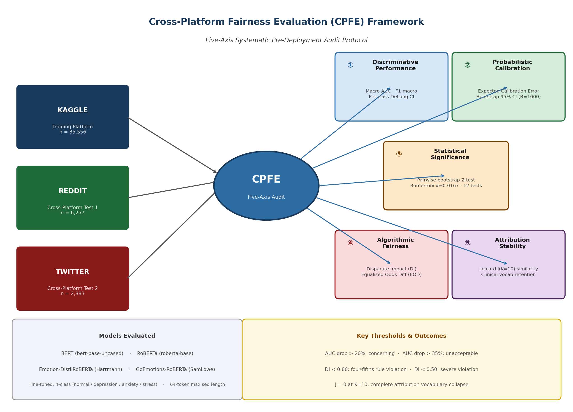
Figure 1. The Cross-Platform Fairness Evaluation (CPFE) framework. Five evaluation axes are applied jointly to characterize cross-platform generalization failure: (1) discriminative performance (macro AUC, F1-macro); (2) probabilistic calibration (ECE with bootstrap 95% CIs); (3) statistical significance of AUC differences (Bonferroni-corrected pairwise bootstrap Z-tests, 12 comparisons); (4) algorithmic fairness (Symmetric Disparate Impact, Equalized Odds Difference); and (5) attribution stability (Jaccard similarity of top-K attribution vocabularies). Four transformer models are trained on Kaggle and evaluated cross-platform on Reddit (GoEmotions) and Twitter (dair-ai/emotion).

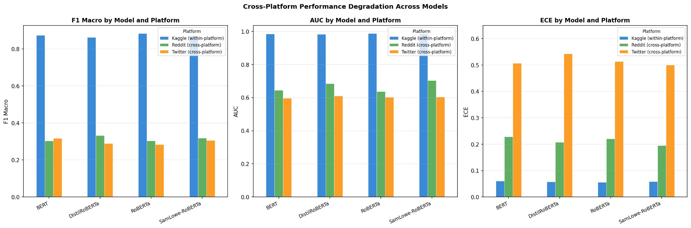
Figure 2. Cross-platform performance degradation across all four models. Left: F1-macro; Centre: Macro AUC; Right: ECE. Within-platform performance (Kaggle, blue) is near-ceiling; Reddit (green) and Twitter (orange) show severe degradation in all three metrics. ECE on Twitter exceeds 0.50 for all models.

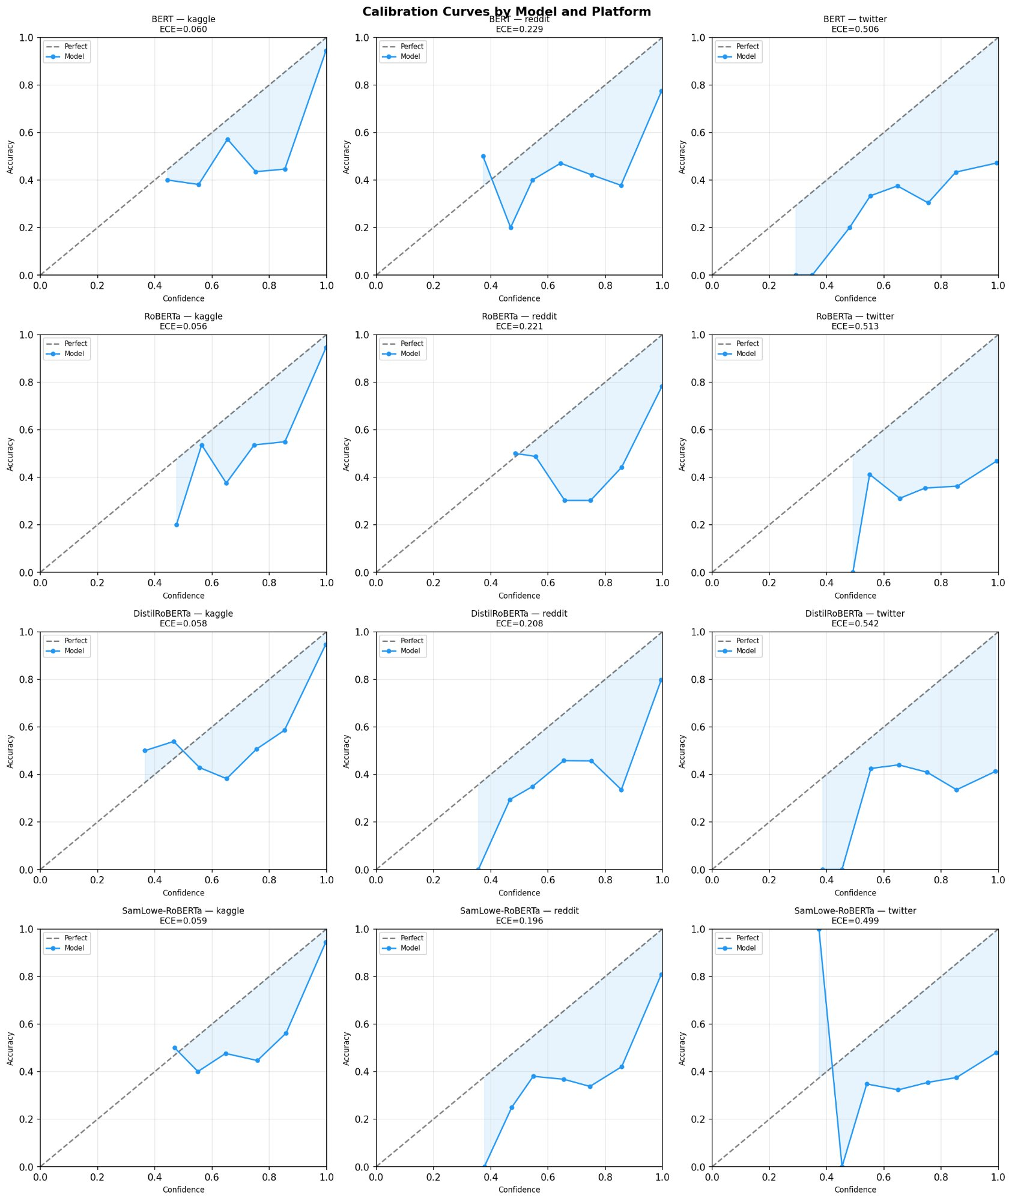
Figure 3. Reliability diagrams (calibration curves) for all four models across three platforms (4 rows × 3 columns; rows: BERT, RoBERTa, Emotion-DistilRoBERTa, GoEmotions-RoBERTa; columns: Kaggle, Reddit, Twitter). Perfect calibration is the diagonal dashed line. Shaded area indicates miscalibration magnitude. ECE values are annotated per panel. Within-platform Kaggle curves are near-diagonal (ECE 0.056-0.060); cross-platform curves show progressive deviation increasing from Reddit to Twitter (ECE 0.196-0.542).

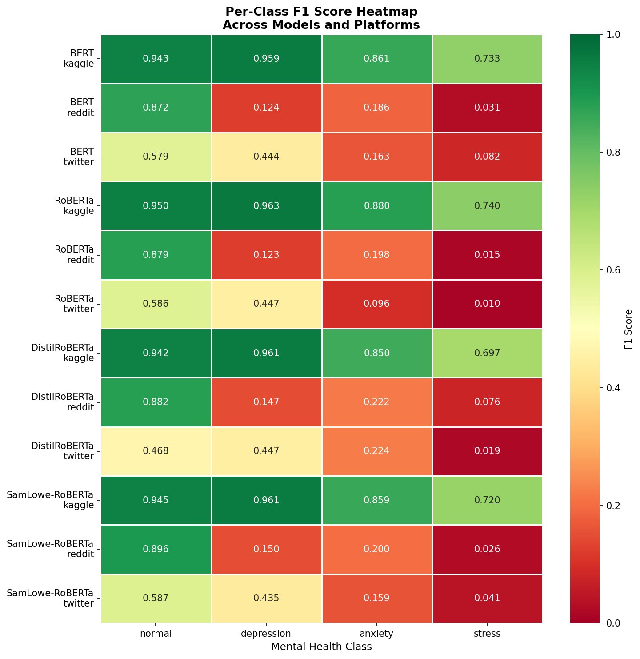
Figure 4. Per-class F1 score heatmap across all models and platforms (green: high; red: low). Within-platform Kaggle F1 values (0.697-0.963) are shown in the top row of each model group. Cross-platform Reddit and Twitter rows show substantial decline for Depression (amplified by Reddit’s 80.9% normal-class prevalence which penalises macro-averaging of minority classes) (F1 ≤ 0.150 on Reddit), Anxiety, and Stress across all models. The Normal class partially retains F1 on Reddit due to majority-class dominance in the GoEmotions distribution.

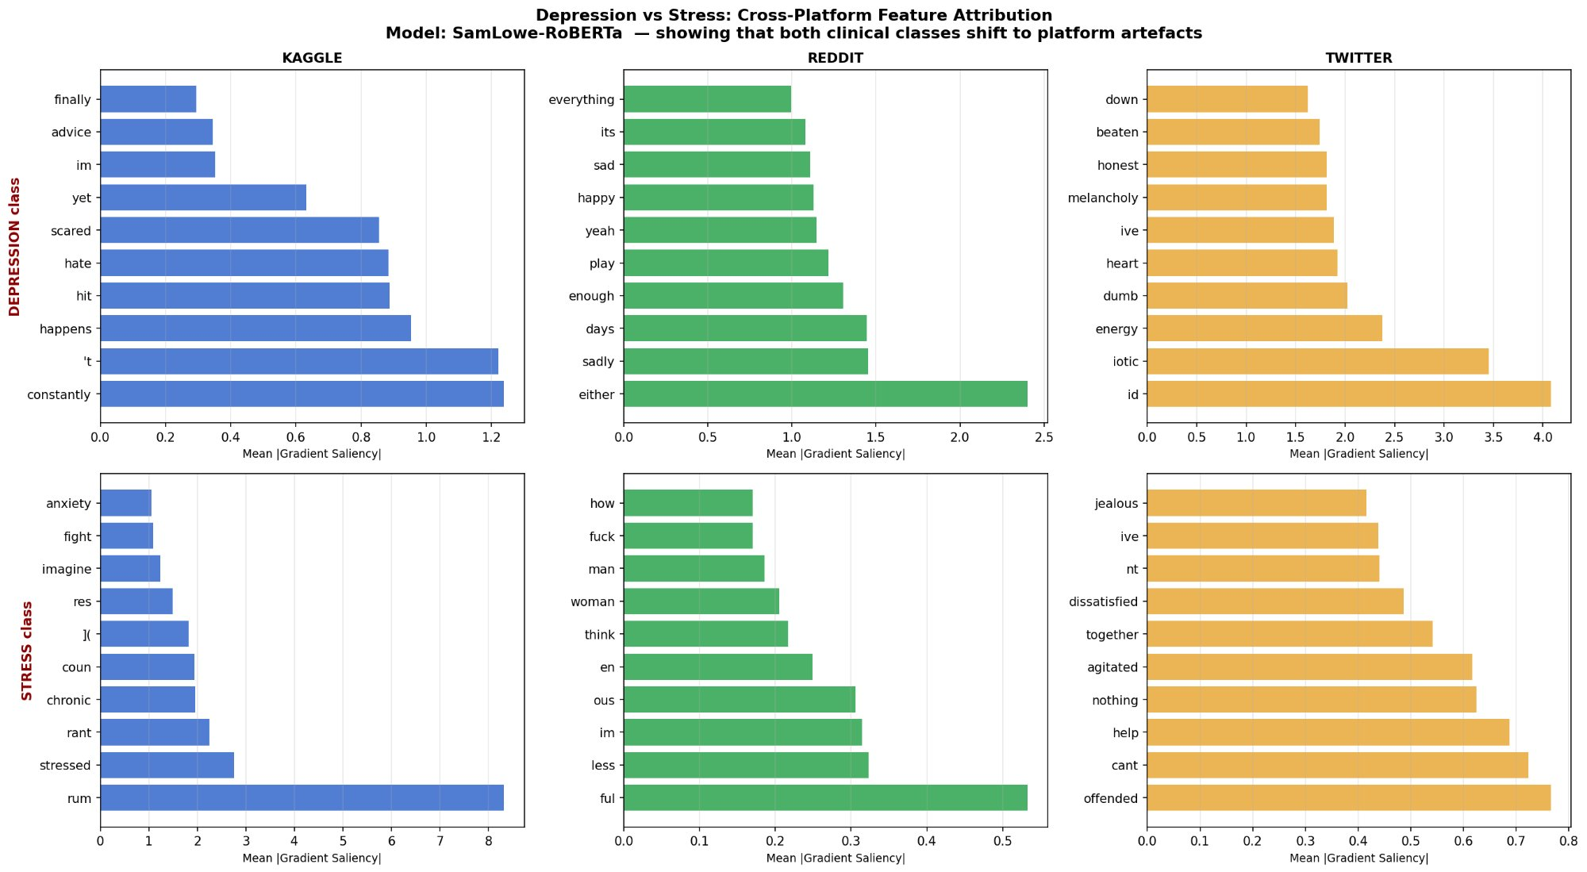
Figure 5a. Cross-platform gradient token attribution for GoEmotions-RoBERTa: Depression class (top row) and Stress class (bottom row) across Kaggle (blue), Reddit (green), and Twitter (orange). Within-platform Kaggle attribution concentrates on clinical vocabulary. On Reddit and Twitter, attribution shifts entirely to platform-specific conversational tokens (e.g., function words, slang fragments) with no clinical specificity, consistent with substantial attribution instability under platform shift.

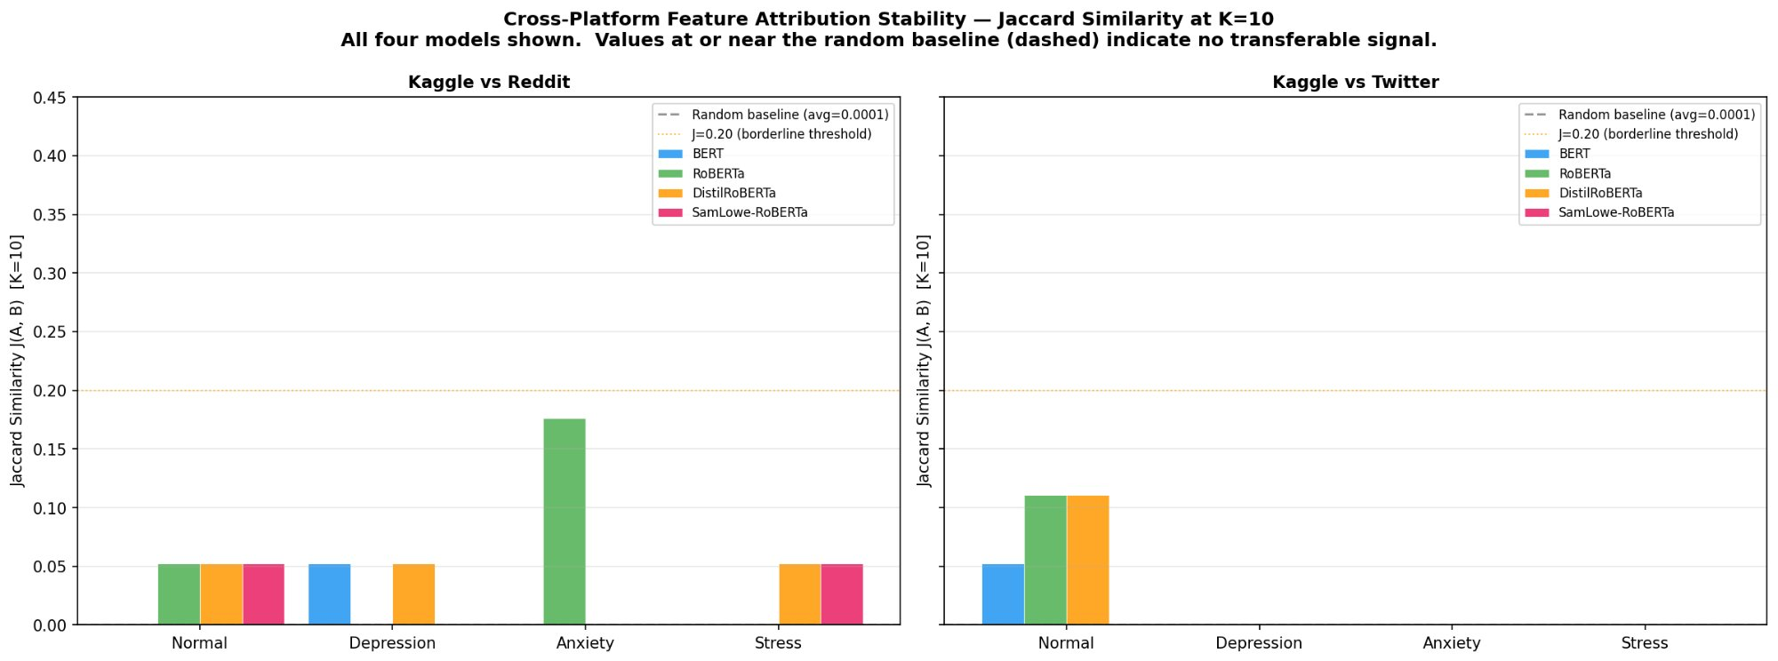
Figure 6. Jaccard similarity of top-K=10 attribution token sets across all four models and class-platform pairs. Left: Kaggle vs Reddit. Right: Kaggle vs Twitter. The random baseline (J = 0.0001, grey dashed) and the J=0.20 borderline instability threshold (orange dotted) are shown. Nearly all clinical class values (Depression, Stress) are at or near the random baseline on both cross-platform pairs, confirming complete attribution vocabulary collapse for clinical classes.

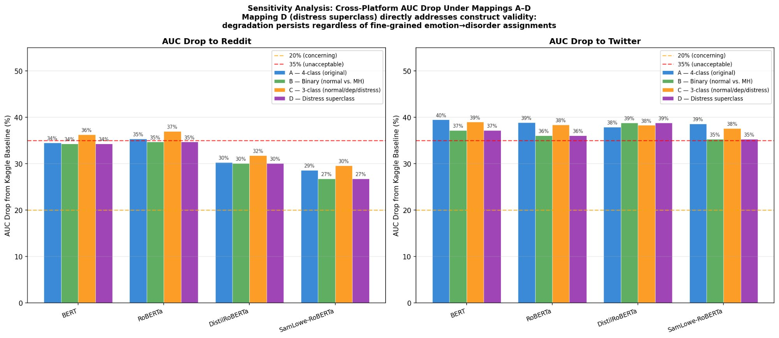
Figure 7. Sensitivity analysis: cross-platform AUC drop under label mapping schemes A (4-class original), B (binary normal vs. MH), C (3-class normal/depression/distress), and D (distress superclass, directly addressing construct validity). Left: AUC drop to Reddit. Right: AUC drop to Twitter. The 35% unacceptable threshold (red dashed) and 20% concerning threshold (orange dashed) are shown. Mapping D eliminates fine-grained anxiety/stress label ambiguity yet degradation persists unchanged, confirming that cross-platform failure is not an artifact of the label mapping scheme.

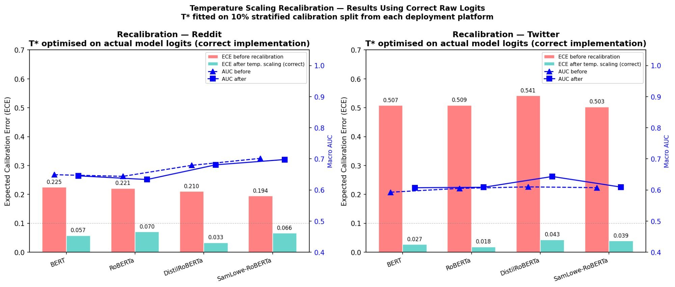
Figure 8. Platform-specific temperature scaling recalibration results using raw pre-softmax logits. Left: Reddit. Right: Twitter. Salmon bars: ECE before recalibration; teal bars: ECE after temperature scaling with optimal T* annotated. AUC before (triangle) and after (square) recalibration are shown on the right axis (blue). Temperature scaling reduces mean ECE by 88.0% (range 66.3%-96.4%) while leaving macro AUC unchanged (mean |ΔAUC| < 0.01), confirming that recalibration cannot remedy discriminative failure.

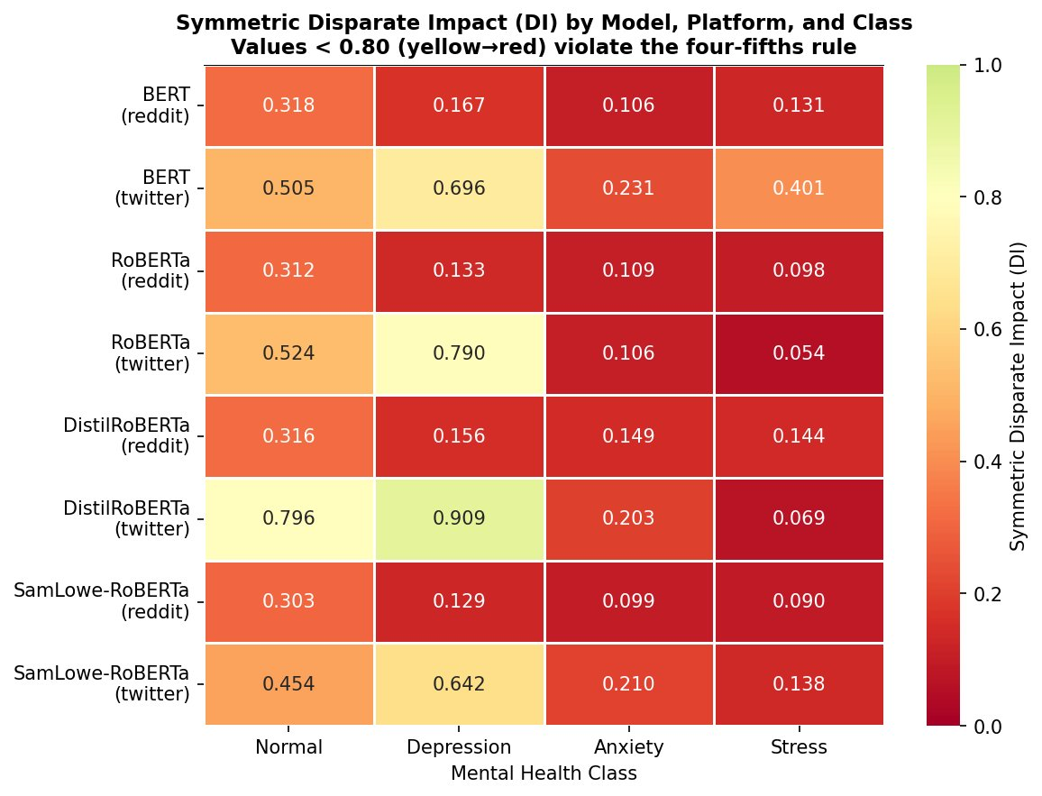
Figure 9. Symmetric Disparate Impact (DI) heatmap for all four models on Reddit (odd rows) and Twitter (even rows), across four mental health classes. DI < 0.80 (yellow to red) violates the four-fifths rule; DI < 0.50 constitutes a severe violation. All clinical classes (Depression, Anxiety, Stress) show DI < 0.20 on Reddit for all models. On Twitter, Depression DI partially recovers for Emotion-DistilRoBERTa (DI = 0.909) but Anxiety and Stress remain severely violated across all models and platforms.

6. Discussion

6.1 The Scale and Consistency of Cross-Platform Failure
The principal finding of this study is that cross-platform AUC degradation of 28.6–39.5% is consistent across the four architecturally diverse transformer-based mental health classifiers evaluated in this study, all trained on single-platform data. This is not a marginal performance decline. Moving from AUC 0.983–0.987 to AUC 0.596–0.703 represents the difference between a discriminatively useful classifier and one that provides minimal signal above chance. The F1-macro collapse from 0.862–0.883 to 0.284–0.332 means that even a basic recall-precision balance across classes is unachievable on cross-platform data. ECE values of 0.499–0.542 on Twitter mean that model-expressed confidence is effectively uninformative as a probability estimate.
The consistency of these findings across four architecturally and pretraining-diverse models suggests that the failure is not a property of any particular model, but of the fundamental distributional mismatch between single-platform clinical training data and heterogeneous deployment environments. This motivates a structural rather than model-level response: external validation before deployment, analogous to TRIPOD requirements in clinical prediction modelling [7, 8].

6.2 Temperature Scaling as Immediate Calibration Remedy
Temperature scaling provides a practically deployable immediate response to calibration failure that requires no model retraining and only a small labeled calibration sample from the target platform (n ≈ 288 in our experiments). The 88.0% mean ECE reduction is clinically meaningful: a model with ECE 0.542 communicates unreliable confidence estimates to any downstream decision system; the same model after recalibration (ECE 0.043) provides usable uncertainty quantification. The invariance of AUC to temperature scaling (mean |ΔAUC| = 0.009) confirms that recalibration is not a substitute for discriminative improvement. We therefore propose a two-stage remediation protocol for cross-platform deployment: (1) immediate temperature recalibration when a small labelled target-domain sample is available; (2) domain-adaptive retraining when sufficient labelled target data can be collected.

6.3 Domain Pretraining: Scope and Limits of the Advantage
GoEmotions-RoBERTa shows the smallest Reddit AUC drop (28.6%) among the four models, consistent with its pretraining on GoEmotions. However, this advantage is not a generalizable domain-pretraining benefit: it reflects pretraining overlap with the specific test set domain rather than acquired cross-platform robustness. The advantage does not transfer to Twitter (drop 38.6%), where all four models perform similarly. Emotion-DistilRoBERTa, which partially overlaps with GoEmotions in its training corpus, shows an intermediate Reddit advantage (30.3%) without Twitter transfer. These results suggest that domain pretraining confers narrow, source-specific advantages that do not generalize across platforms.

6.4 Construct Validity: Emotion Labels and Clinical Categories
The cross-platform test sets use emotion-annotated data remapped to clinical categories. The construct validity concern—that anger ≠ stress and fear ≠ anxiety clinically—is directly addressed by Mapping D (distress superclass). Under this mapping, which eliminates the fine-grained anxiety/stress distinction and tests only normal vs. depression vs. distress, degradation is statistically indistinguishable from the primary analysis on both Reddit (drops 26.8–34.3%) and Twitter (drops 35.3–39.0%). This is a strong sensitivity analysis result: the degradation pattern holds even when the most clinically ambiguous distinction is removed entirely. The observed failure is a property of cross-platform distribution shift, not of the label mapping.
We cannot fully rule out a residual construct mismatch contribution. Mapping E shows near-chance anxiety/stress discrimination on Reddit (AUC 0.470–0.524), which may reflect both construct ambiguity and distributional failure. Clinically annotated cross-platform evaluation sets would be needed to fully disentangle these contributions, and we present this as a priority for future work.

6.5 Fairness Implications for Deployment
The disparate impact findings have direct implications for equitable deployment. A model with depression DI = 0.133 (RoBERTa on Reddit) predicts the depression class approximately 7.5× less frequently on Reddit than on the Kaggle reference platform. In a monitoring deployment context, this asymmetry would result in systematic under-identification of at-risk Reddit users relative to Kaggle-like long-form text. The equalized odds differences exceeding 0.79 for depression on Reddit mean that a depressed Reddit user has a true positive rate 79 percentage points lower than a depressed Kaggle user—a clinically significant disparity that cannot be explained by model capacity alone. These findings motivate the inclusion of platform-stratified fairness metrics as a standard component of any mental health NLP deployment review.

6.6 CPFE Thresholds as Working Guidelines
Based on the degradation patterns observed, we propose provisional CPFE pre-deployment thresholds: ΔAUC < 15% = acceptable; ΔAUC 15–30% = moderate (recalibration and monitoring required); ΔAUC > 30% = severe (deployment on a new platform without domain-specific retraining carries substantial discriminative performance risk, as demonstrated by the observed AUC drops). For attribution stability, J ≥ 0.20 at K = 10 is proposed as a minimum criterion for clinical vocabulary consistency. We emphasize that these thresholds are derived from a single study and have not been independently validated against clinical outcomes. They are starting points for standardized evaluation practice, not clinical decision thresholds.

7. Limitations
Construct validity of cross-platform labels. The emotion→clinical label mappings are heuristic approximations. While Mapping D demonstrates robustness to the most salient construct validity concern, human-annotated clinical labels on Reddit and Twitter would be required to fully disentangle construct mismatch from distributional failure.
Pretraining contamination. GoEmotions-RoBERTa and Emotion-DistilRoBERTa have pretraining overlap with the evaluation domains. Their Reddit performance figures are partially non-independent and should be treated as upper bounds rather than benchmarks for generalizable domain-adaptive pretraining.
Gradient saliency vs. Shapley attribution. Token importance was estimated by gradient-based saliency, which provides local linear approximations of feature importance [25]. The Jaccard stability findings should be confirmed with Shapley-based attribution in future work, as Shapley values provide game-theoretically grounded feature attributions that capture higher-order interactions.
Class imbalance and prior shift. The Kaggle test set is heavily skewed toward depression (56.6%) relative to Reddit (6.6%) and Twitter (30.1%). Prior shift across platforms confounds the interpretation of macro-averaged metrics and DI calculations. Separate estimation of prior shift vs. likelihood shift contributions would strengthen causal attribution of the observed fairness violations.
CPFE threshold validation. The proposed ΔAUC and Jaccard thresholds are derived from a single study. External validation against clinical outcomes in deployment settings is required before these thresholds can inform policy.
Single-seed training. All four models were trained with a single random seed (seed = 42). Variance in reported AUC and ECE values across training seeds is therefore uncharacterised. Multi-seed replication is recommended before performance conclusions are used to guide deployment decisions or model selection.
Platform as fairness group. Disparate impact and equalized odds differences are computed treating source platform as a proxy for group membership. Platforms differ along multiple confounded dimensions (user demographics, writing style, topic distribution, label schema). The fairness violations reported reflect cross-platform prediction disparities; they should not be interpreted as evidence of demographic group-level bias without corroborating data on user characteristics.

8. Conclusion
This work introduces the Cross-Platform Fairness Evaluation (CPFE) framework and applies it to four transformer-based mental health classifiers evaluated across three social media platforms. All four models exhibit consistent, severe cross-platform AUC degradation (28.6–39.5%), minimal gradient-based attribution overlap (Jaccard J ≈ 0 in 14/16 model-class pairs), and severe fairness violations (DI < 0.17 for clinical classes on Reddit). These failures are robust to label mapping choice under five sensitivity schemes including a distress superclass reformulation that eliminates the most clinically ambiguous distinction in our label taxonomy.
Platform-specific temperature scaling provides an immediate, low-cost calibration remedy (88.0% mean ECE reduction, |ΔAUC| < 0.01), but cannot recover discriminative performance. Temperature scaling recovers calibration but cannot restore discriminative performance, indicating that calibration alone is insufficient as a deployment remedy. Domain-adaptive retraining remains a promising but untested direction in this study. These findings are specific to four transformer architectures evaluated on three social media platforms using emotion-to-clinical label mappings; generalisation to clinically annotated datasets, additional platforms, or larger language models should not be assumed without further empirical validation. Future work should assess whether supervised or self-supervised adaptation on target platform text can close the observed AUC gaps. These findings provide strong empirical motivation for systematic cross-platform validation as a standard pre-deployment practice for mental health NLP tools—comprising at minimum AUC degradation assessment, ECE measurement, disparate impact auditing, and attribution stability analysis—before any system intended for mental health applications is released into a deployment environment.

Author Contributions
Conceptualization, methodology, software, validation, formal analysis, investigation, data curation, writing—original draft, writing—review & editing, visualization: [Author Name]. Supervision: [Supervisor Name, if applicable].

Data and Code Availability
All analysis code is available at [GitHub URL]. The GoEmotions dataset [9] and dair-ai/emotion dataset [10] are publicly available on HuggingFace Datasets. The Kaggle mental health dataset [19] is available at [Kaggle URL].

Declaration of Competing Interests
The author declares no competing financial or non-financial interests.

References
[1] Chancellor, S., & De Choudhury, M. (2020). Methods in predictive techniques for mental health status on social media: A critical review. npj Digital Medicine, 3(1), 43. https://doi.org/10.1038/s41746-020-0233-7
[2] Coppersmith, G., Dredze, M., & Harman, C. (2014). Quantifying mental health signals in Twitter. In Proceedings of the ACL Workshop on Computational Linguistics and Clinical Psychology (pp. 51–60). Association for Computational Linguistics.
[3] Eisenstein, J. (2013). What to do about bad language on the internet. In Proceedings of NAACL-HLT (pp. 359–369).
[4] De Choudhury, M., Gamon, M., Counts, S., & Horvitz, E. (2013). Predicting depression via social media. Proceedings of the International AAAI Conference on Web and Social Media, 7(1), 128–137.
[5] Ji, S., Pan, S., Li, X., Cambria, E., Long, G., & Huang, Z. (2022). Suicidal ideation detection: A review of machine learning methods and applications. IEEE Transactions on Computational Social Systems, 9(1), 243–258.
[6] Cohan, A., Desmet, B., Yates, A., Soldaini, L., MacAvaney, S., & Goharian, N. (2018). SMHD: A large-scale resource for exploring online language usage for multiple mental health conditions. In Proceedings of COLING (pp. 1485–1497).
[7] Steyerberg, E. W., Moons, K. G. M., van der Windt, D. A., et al. (2013). Prognosis Research Strategy (PROGRESS) 3: Prognostic model research. PLOS Medicine, 10(2), e1001381.
[8] Collins, G. S., Reitsma, J. B., Altman, D. G., & Moons, K. G. M. (2015). Transparent reporting of a multivariable prediction model for individual prognosis or diagnosis (TRIPOD). Annals of Internal Medicine, 162(1), 55–63.
[9] Demszky, D., Movshovitz-Attias, D., Ko, J., Cowen, A., Nemade, G., & Ravi, S. (2020). GoEmotions: A dataset of fine-grained emotions. In Proceedings of the 58th Annual Meeting of the ACL (pp. 4040–4054).
[10] Saravia, E., Liu, H.-C. T., Huang, Y.-H., Wu, J., & Chen, Y.-S. (2018). CARER: Contextualized affect representations for emotion recognition. In Proceedings of EMNLP (pp. 3687–3697).
[11] Blitzer, J., Dredze, M., & Pereira, F. (2007). Biographies, Bollywood, boom-boxes and blenders: Domain adaptation for sentiment classification. In Proceedings of ACL (pp. 440–447).
[12] Kula, M., Baldini Soares, L., & Eisenstein, J. (2022). Towards cross-platform generalization of mental health content classifiers. arXiv:2205.05521.
[13] Romanov, A., & Shivade, C. (2018). Lessons from natural language inference in the clinical domain. In Proceedings of EMNLP (pp. 1586–1596).
[14] Gururangan, S., Marasović, A., Swayamdipta, S., et al. (2020). Don’t stop pretraining: Adapt language models to domains and tasks. In Proceedings of ACL (pp. 8342–8360).
[15] Guo, C., Pleiss, G., Sun, Y., & Weinberger, K. Q. (2017). On calibration of modern neural networks. In Proceedings of ICML (PMLR 70, pp. 1321–1330).
[16] Barocas, S., Hardt, M., & Narayanan, A. (2019). Fairness and machine learning: Limitations and opportunities. fairmlbook.org.
[17] Hardt, M., Price, E., & Srebro, N. (2016). Equality of opportunity in supervised learning. In Advances in NeurIPS (Vol. 29, pp. 3315–3323).
[18] Blodgett, S. L., Barocas, S., Daumé III, H., & Wallach, H. (2020). Language (technology) is power: A critical survey of ‘bias’ in NLP. In Proceedings of ACL (pp. 5454–5476).
[19] Combined Mental Health Dataset. Kaggle. [Dataset URL — VERIFY FINAL DOI/URL BEFORE SUBMISSION]
[20] Loshchilov, I., & Hutter, F. (2019). Decoupled weight decay regularization. In Proceedings of ICLR.
[21] Devlin, J., Chang, M.-W., Lee, K., & Toutanova, K. (2019). BERT: Pre-training of deep bidirectional transformers for language understanding. In Proceedings of NAACL-HLT (pp. 4171–4186).
[22] Liu, Y., Ott, M., Goyal, N., et al. (2019). RoBERTa: A robustly optimized BERT pretraining approach. arXiv:1907.11692.
[23] Hartmann, J. (2022). Emotion English DistilRoBERTa-base. Hugging Face. https://huggingface.co/j-hartmann/emotion-english-distilroberta-base
[24] DeLong, E. R., DeLong, D. M., & Clarke-Pearson, D. L. (1988). Comparing the areas under two or more correlated receiver operating characteristic curves: A nonparametric approach. Biometrics, 44(3), 837–845.
[25] Simonyan, K., Vedaldi, A., & Zisserman, A. (2014). Deep inside convolutional networks: Visualising image classification models and saliency maps. In ICLR Workshop.

Supplementary Material
The following supplementary figures are provided to support the main text. S1-S4: additional fairness and calibration visualizations. S5-S7: attribution stability supplementary analyses. S8: sensitivity heatmap. S9-S10: truncation analysis. S11-S13: per-model stress class attribution panels.
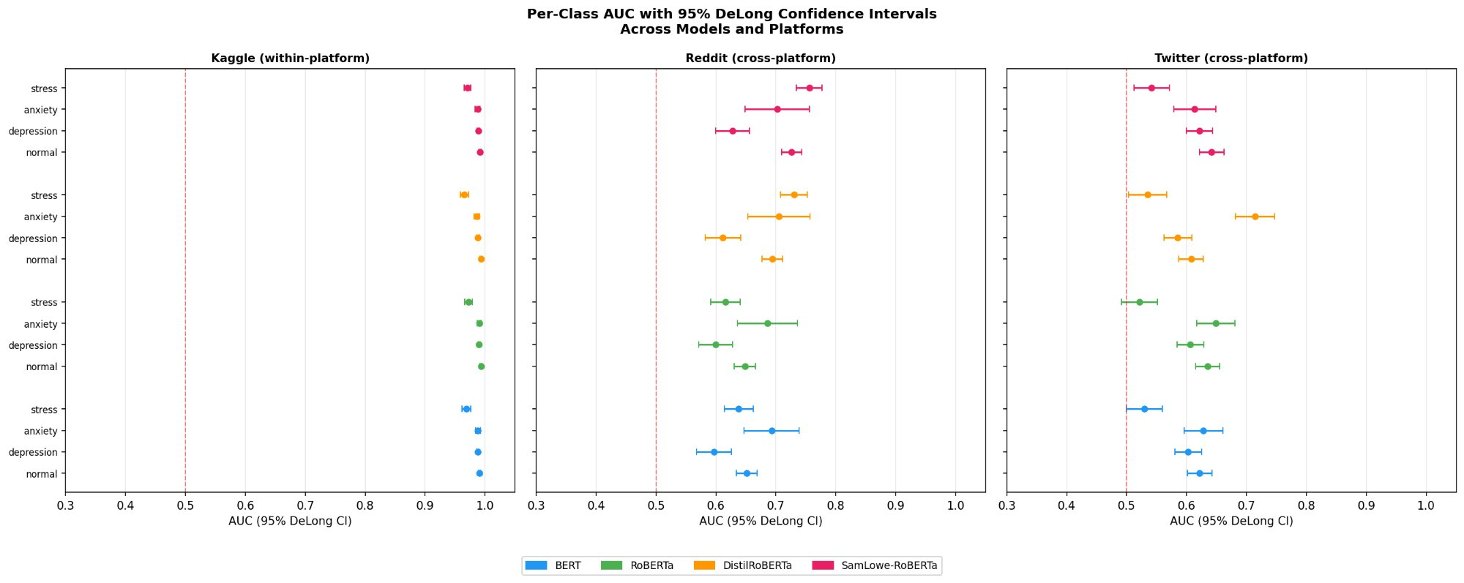
Supplementary Figure S1. Per-class one-vs-rest AUC with 95% DeLong confidence intervals across all four models and three platforms (48 estimates). Left: Kaggle (within-platform); Centre: Reddit (cross-platform); Right: Twitter (cross-platform). The red dashed line marks chance performance (AUC=0.50). Within-platform CIs are tight and all above 0.96. Stress class CIs on Twitter approach or touch the chance boundary for BERT (0.530 [0.500, 0.560]) and RoBERTa (0.522 [0.492, 0.551]).
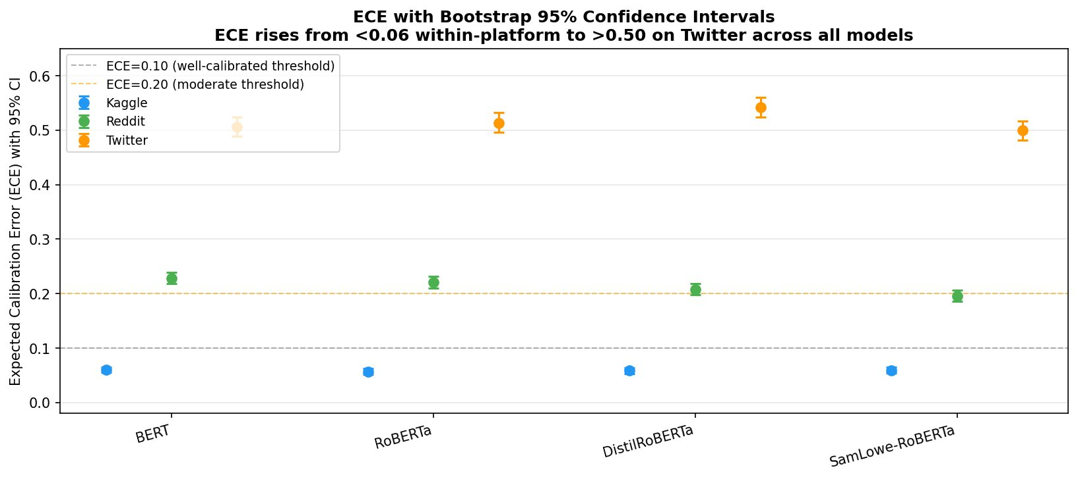
Supplementary Figure S2. Expected Calibration Error (ECE) with 95% bootstrap confidence intervals (B=1,000) across all models and platforms. ECE<0.10 (grey dashed) indicates well-calibrated; ECE>0.20 (orange dashed) indicates moderate miscalibration. Within-platform Kaggle ECE is consistently below 0.06; Reddit ECE is 0.196-0.229; Twitter ECE exceeds 0.499-0.542 for all models. CIs are non-overlapping across platforms, confirming that all platform differences are statistically reliable.
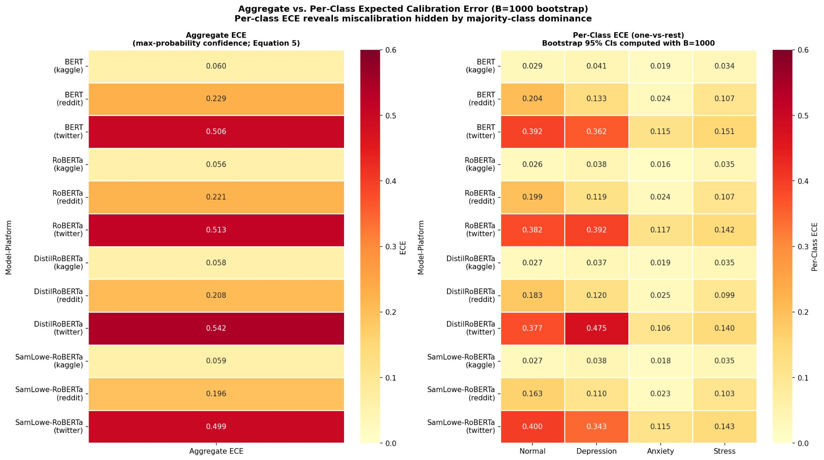
Supplementary Figure S3. Aggregate ECE (left panel) and per-class one-vs-rest ECE with bootstrap 95% CIs (right panel), B=1,000. The per-class view reveals severe miscalibration hidden by majority-class dominance in aggregate ECE: Normal and Depression per-class ECE reaches 0.362-0.475 on Twitter for BERT and Emotion-DistilRoBERTa, indicating that confidence scores for individual clinical classes are substantially less reliable than the aggregate ECE suggests.
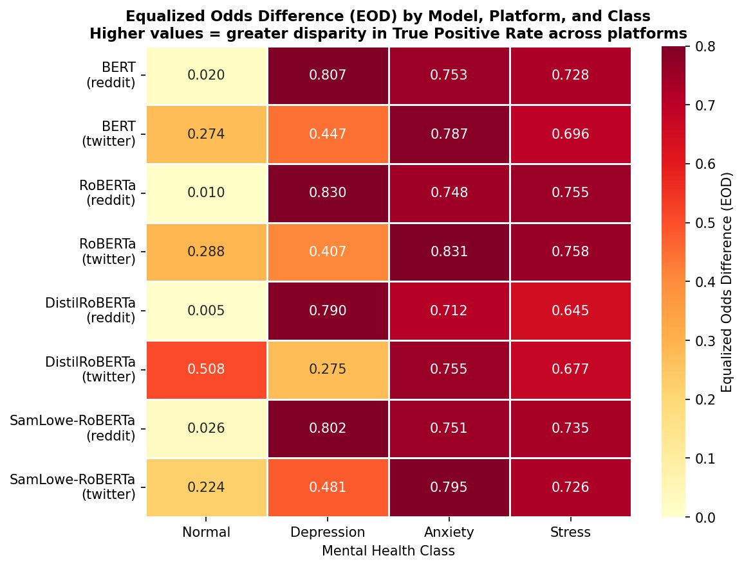
Supplementary Figure S4. Equalized Odds Difference (EOD) heatmap across all four models, platforms, and classes (higher = greater TPR disparity between Kaggle and target platform). EOD for Depression on Reddit reaches 0.807-0.830 across all models, meaning the true positive rate for correctly identifying depressed individuals is 80+ percentage points lower on Reddit than on Kaggle. Anxiety EOD on Reddit (0.712-0.753) and Twitter (0.787-0.831) indicates near-complete failure to identify anxious users on cross-platform data.
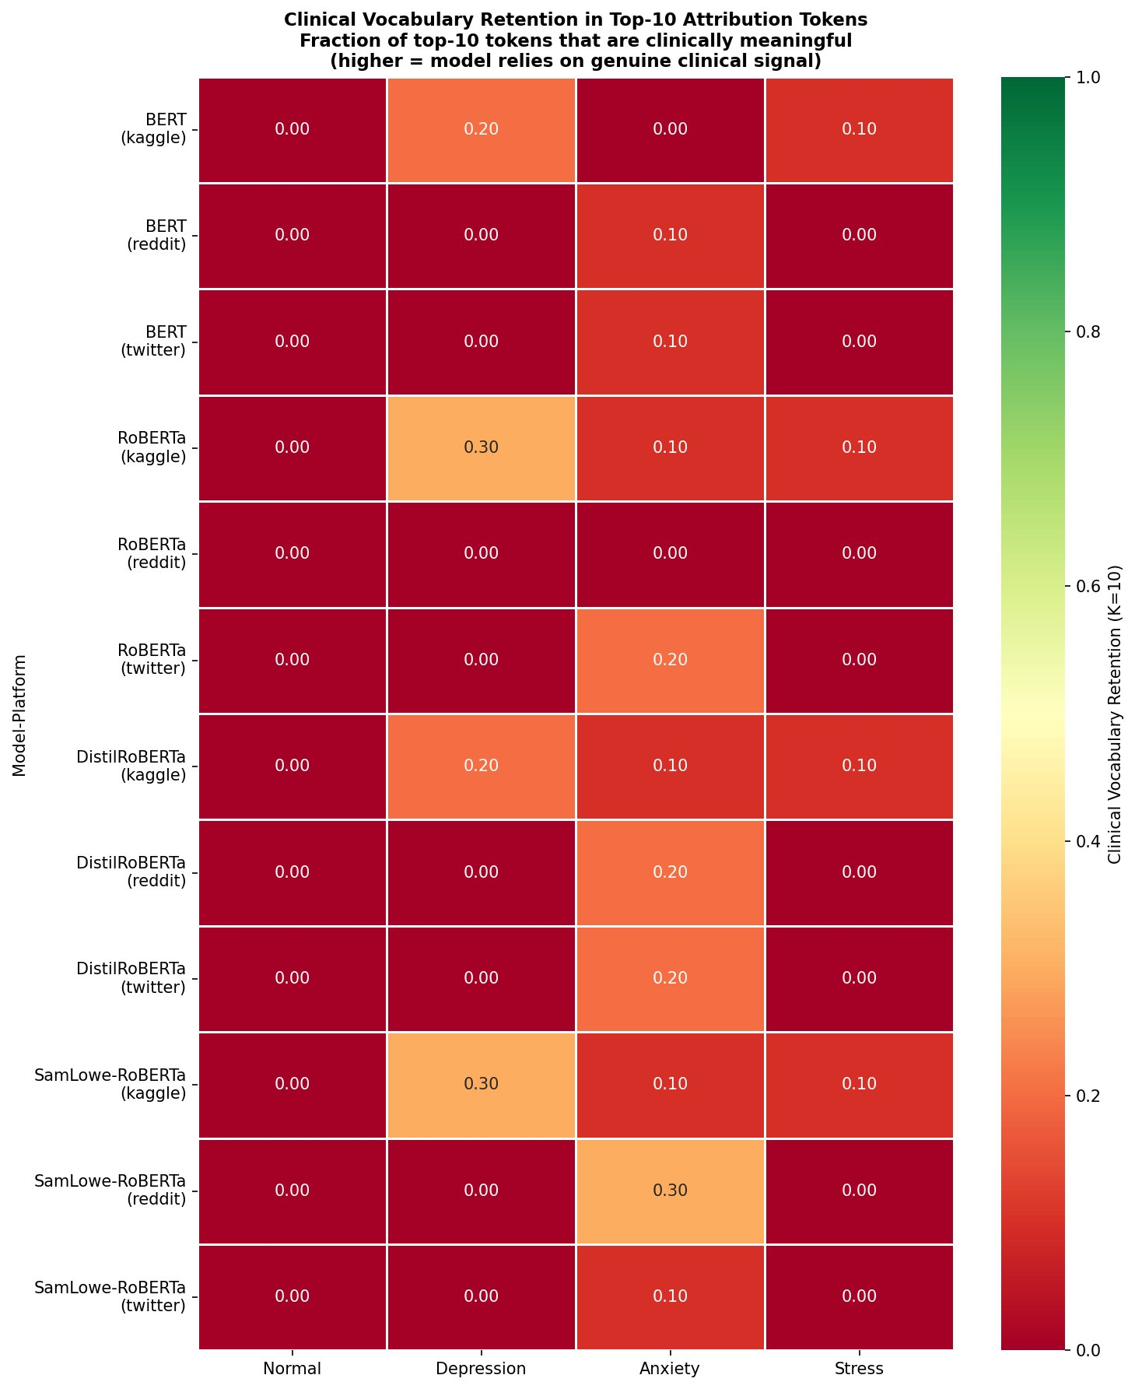
Supplementary Figure S5. Clinical vocabulary retention in top-10 attribution tokens. Each cell shows the fraction of the top-10 gradient saliency tokens that match a predefined expert clinical vocabulary list for each mental health class. Within-platform Kaggle retention reaches 0.20-0.30 for Depression (RoBERTa and GoEmotions-RoBERTa) but is 0.00 for Normal across all models. Cross-platform Reddit and Twitter retention is 0.00 for almost all model-class pairs, confirming that models lose all clinically interpretable signal under platform shift.
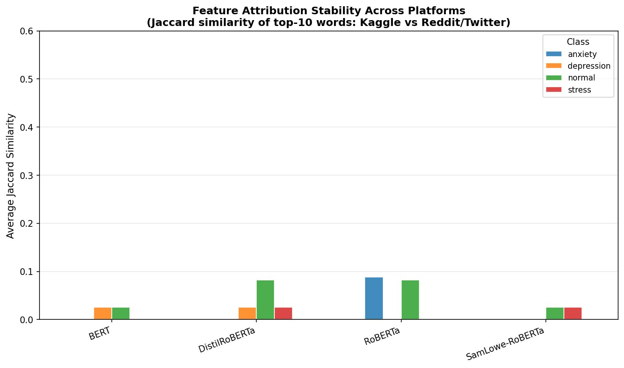
Supplementary Figure S6. Average Jaccard similarity of top-10 attribution words across both cross-platform comparisons (Kaggle vs Reddit and Kaggle vs Twitter combined), by model and class. All Depression and Stress class values are near zero across all models. RoBERTa Anxiety shows the highest value (J = 0.09), far below the J=0.20 instability threshold. SamLowe-RoBERTa shows all values near zero, consistent with its complete attribution collapse reported in Table 8.
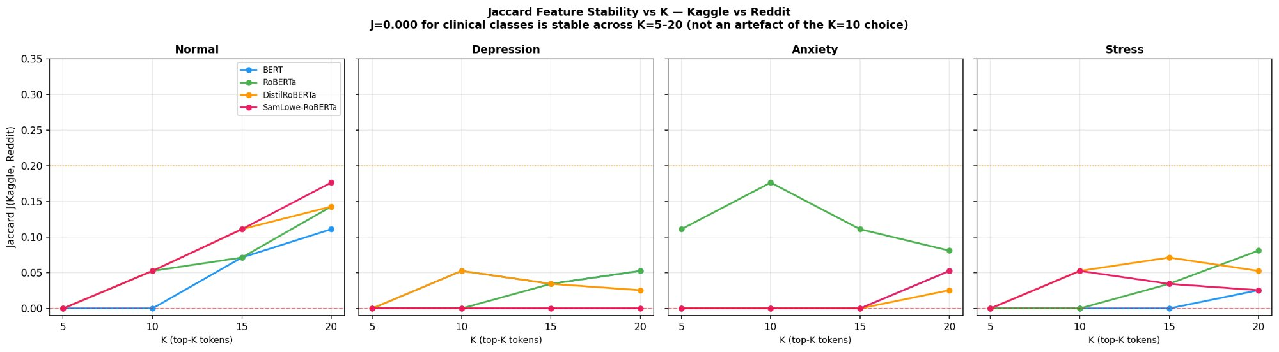
Supplementary Figure S7. Jaccard feature stability sensitivity to K (number of top-attributed tokens), for Kaggle vs Reddit comparison. Shaded bands show range across four models. All clinical class values (Depression, Anxiety, Stress) remain substantially below the J=0.20 instability threshold for K=5-20, confirming that the J=0.000 values at K=10 reported in Table 8 are not an artifact of the K choice but a stable property of the cross-platform attribution shift.
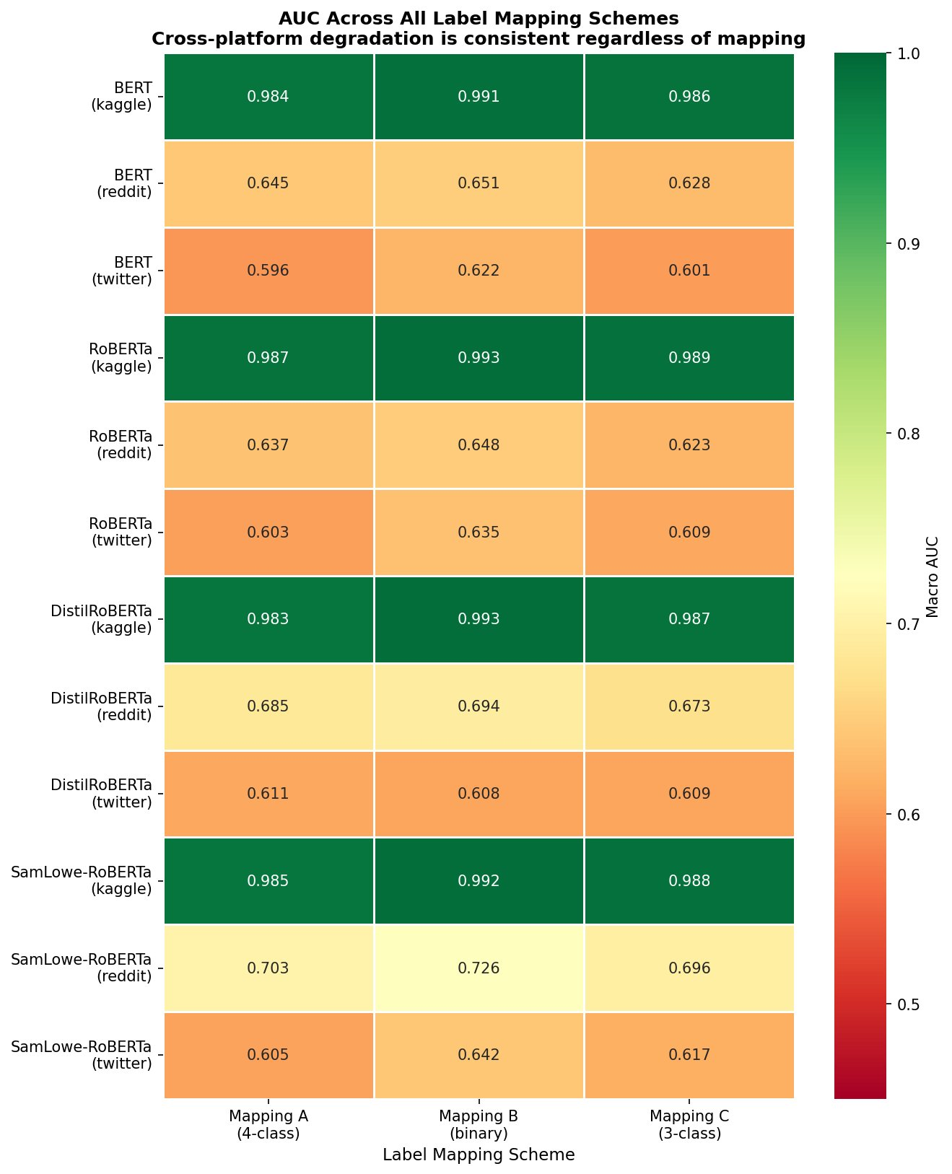
Supplementary Figure S8. Macro AUC heatmap across all models, platforms, and label mapping schemes (A: 4-class original, B: binary, C: 3-class). Within-platform Kaggle AUC is consistently above 0.98 under all mappings (green). Cross-platform AUC is consistently 0.596-0.726 under all mappings (orange/yellow). The consistent within-vs-cross-platform gap confirms that degradation is a stable property of platform shift rather than a function of label mapping granularity.
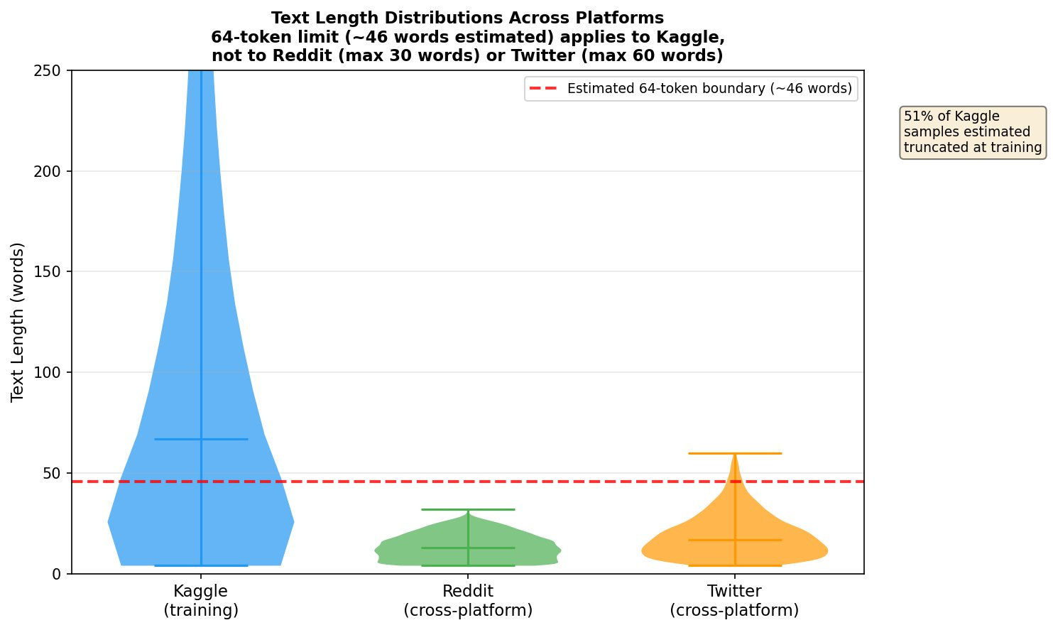
Supplementary Figure S9. Text length distributions across platforms (violin plots). The dashed red line indicates the estimated 64-token boundary (approximately 46 words). Approximately 51% of Kaggle training samples exceed this boundary, versus 0% of Reddit and approximately 3% of Twitter samples. The majority distribution of Kaggle texts extends to 200+ words, while Reddit and Twitter texts are tightly clustered below the truncation boundary, confirming a fundamental mismatch in text length regime between training and evaluation platforms.
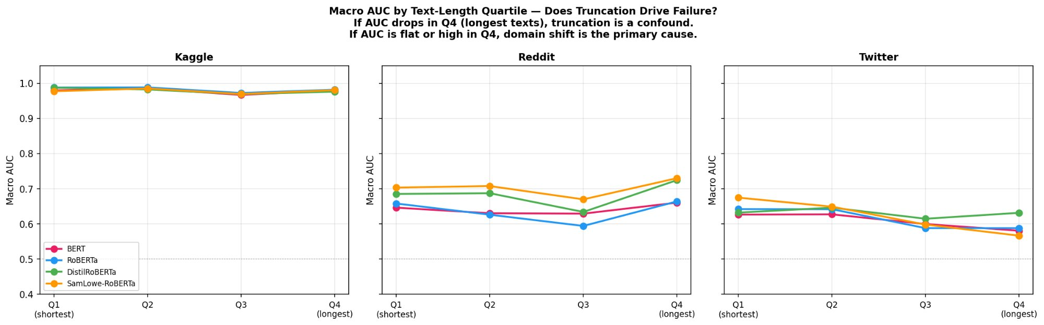
Supplementary Figure S10. Macro AUC stratified by text-length quartile (Q1: shortest 25%; Q4: longest 25%) across all models and platforms. Within-platform Kaggle AUC is flat across length quartiles (AUC > 0.97), showing that truncation does not impair within-domain performance. Cross-platform AUC shows no consistent monotonic length-AUC relationship on Reddit or Twitter: AUC does not systematically decline for longer texts on cross-platform data. This rules out truncation as the primary driver of performance degradation and implicates domain shift as the dominant mechanism.
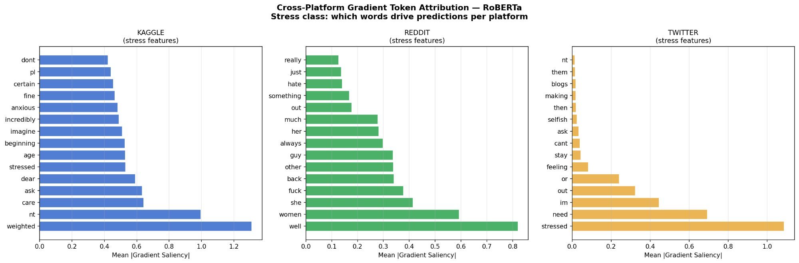
Supplementary Figure S11. Cross-platform gradient token attribution for RoBERTa, Stress class. Kaggle features include partially clinical tokens (weighted, stressed, care); Reddit and Twitter features shift to platform-specific conversational vocabulary (women, well, fuck on Reddit; stressed, need, im on Twitter), confirming attribution regime change for the stress class under platform shift.
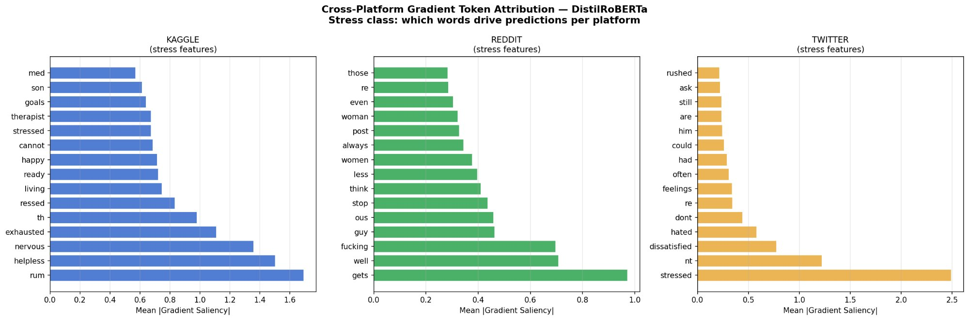
Supplementary Figure S12. Cross-platform gradient token attribution for Emotion-DistilRoBERTa, Stress class. Kaggle features include clinical tokens (rum, helpless, nervous, exhausted); Reddit features shift to social interaction terms (gets, well, fucking, guy); Twitter features are platform-specific slang and function words (stressed, nt, dissatisfied), consistent with complete attribution vocabulary collapse at K=10 (J=0.000 on Kaggle-to-Reddit for this model-class pair).
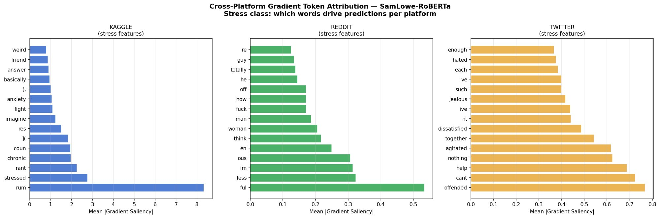
Supplementary Figure S13. Cross-platform gradient token attribution for GoEmotions-RoBERTa, Stress class. Kaggle features include truncated morpheme tokens reflecting the 64-token limit (rum, coun, rant, stressed); Reddit features are conversational fillers (ful, less, im, ous); Twitter features are emotional adjectives (offended, cant, help, agitated). All three platform vocabularies are fully disjoint, confirming J=0.000 for this model-class pair on Kaggle-to-Twitter comparison.
Cover Letter — Computers in Biology and Medicine

Dear Editor,

We submit for your consideration the manuscript entitled ‘Cross-Platform Generalization Failure in Mental Health Natural Language Processing: A Systematic Fairness Audit of Transformer Models on Social Media.’ This paper introduces the Cross-Platform Fairness Evaluation (CPFE) framework and presents a five-axis empirical audit of four transformer-based mental health classifiers across three social media platforms—the first systematic study of its kind. We believe this work is well-suited to Computers in Biology and Medicine given the journal’s focus on computational approaches to healthcare challenges and its readership’s interest in rigorous evaluation methodology for clinical AI systems.
Our key empirical finding is that all four models exhibit severe cross-platform AUC degradation (28.6–39.5%), calibration failure (ECE rising from 0.056–0.060 to 0.499–0.542 on Twitter), complete attribution vocabulary collapse (Jaccard J = 0.000 in 14/16 model-class pairs), and severe disparate impact violations (DI < 0.17 for all clinical classes on Reddit). Platform-specific temperature scaling recovers calibration (88.0% mean ECE reduction) without altering discriminative performance, motivating a two-stage remediation protocol. A five-scheme sensitivity analysis confirms robustness of findings to label mapping choice.
This work directly addresses a gap identified in the mental health NLP literature: the absence of systematic cross-platform external validation, analogous to TRIPOD requirements in clinical prediction modelling. The CPFE framework provides a practical, reproducible protocol that can be adopted as a pre-deployment standard. All code and outputs are publicly available.
Thank you for considering this submission.

Sincerely,
[Author Name]
Department of Computer Science and Business Systems
Gyan Ganga Institute of Technology and Sciences, Jabalpur, India

