When the Gate Stays Closed: Empirical Evidence of Near-Zero Cross-Sectional Predictability in Large-Cap NASDAQ Equities Using an IC-Gated Machine Learning Framework
Rajveer Singh Pall
Independent Researcher
Correspondence: available via repository — github.com/Rajveer-code/transaction-cost-trap
Abstract
We present a walk-forward cross-sectional conviction ranking framework that integrates isotonic-calibrated ensemble learning with an Information Coefficient (IC) gate to evaluate the predictability of next-day equity returns. Applied to a survivorship-bias-controlled 30-stock NASDAQ-100 universe over October 2018 to October 2024 (1,512 out-of-sample trading days), the framework finds near-zero cross-sectional IC (mean = –0.0005, ICIR = –0.0023, p = 0.46) with no significant improvement over a permutation-based null distribution (p = 0.74). The conviction-ranked TopK1 strategy achieves a Sharpe ratio of –0.16, substantially underperforming the equal-weight benchmark (Sharpe 0.96) and SPY buy-and-hold (Sharpe 0.74). These results are consistent across all three market regimes tested (pre-COVID bull (ZIRP era), COVID growth, rate-shock) and robust to K∈{1,2,3} and transaction cost assumptions. The IC gate mechanism correctly identifies the absence of rankable signal throughout the evaluation window, preventing capital deployment — an outcome we argue constitutes a correct decision under market efficiency. Notably, isotonic calibration achieves ECE below 0.025 across all 12 folds — confirming that the ensemble produces well-calibrated probabilities even when cross-sectional discrimination is absent, and establishing that calibration quality and predictive information content are orthogonal properties. We discuss the methodological implications for ML-based financial prediction research, the conditions under which technical indicator-based cross-sectional ranking can and cannot work, and the diagnostic value of explicit signal-absence tests in applied ML finance.
Keywords: Information Coefficient; cross-sectional prediction; market efficiency; walk-forward validation; machine learning; conviction ranking; NASDAQ

1. Introduction
The proliferation of machine learning (ML) methods in quantitative finance has generated substantial optimism about the predictability of short-horizon equity returns. A large and growing literature reports positive out-of-sample Sharpe ratios, statistically significant information coefficients, and profitable algorithmic trading strategies based on technical indicators (Gu et al., 2020; Chen and Zimmermann, 2022). Yet a recurring critique of this literature concerns methodological discipline: the absence of strict look-ahead controls, the use of single-period backtests, survivorship bias, and the omission of transaction costs collectively inflate reported performance metrics. When these concerns are addressed rigorously, reported results frequently attenuate substantially (Harvey et al., 2016; Bailey et al., 2014).
This paper contributes to that methodological debate by reporting a fully transparent negative result. We implement a cross-sectional conviction ranking framework with three notable design features absent from much of the existing literature: (1) an expanding walk-forward validation scheme with strict temporal separation between training, calibration, and test windows; (2) an IC-gated trading mechanism that prevents position-taking when the cross-sectional ranking signal is statistically absent; and (3) probability calibration via isotonic regression to correct the systematic probability compression of tree-based ensemble models. Despite these design choices, the framework finds no exploitable cross-sectional signal in 30 large-cap NASDAQ stocks over a six-year out-of-sample period.
Our primary finding is a mean IC of −0.0005 across 1,512 out-of-sample trading days (t = −0.09, p = 0.46). The IC gate, designed to prevent trading when signal is absent, remains closed across all 12 test folds. The conviction-ranked TopK1 strategy loses 5.9% annually (Sharpe −0.16), underperforming a naive equal-weight portfolio (Sharpe 0.96) and the SPY benchmark (Sharpe 0.74). A permutation test with 1,000 within-day shuffles confirms that observed performance is indistinguishable from random cross-sectional assignment (p = 0.74).
We argue that this negative result has direct methodological value for the field for three reasons. First, it demonstrates that the IC gate mechanism works as designed: it correctly detects signal absence without false positives. Second, it provides empirical confirmation of strong-form efficiency in liquid large-cap equities for the specific signal class of daily technical indicators, consistent with theoretical predictions and prior work (Fama, 1991; Chordia et al., 2014). Third, it serves as a transparent baseline against which future claims of predictability in similar universes can be benchmarked.
The remainder of the paper proceeds as follows. Section 2 reviews relevant prior literature. Section 3 describes the data and methodology. Section 4 reports experimental results. Section 5 discusses implications. Section 6 concludes.

2. Related Literature

2.1 Machine Learning for Cross-Sectional Equity Prediction
The application of ML to cross-sectional equity return prediction has expanded dramatically since Gu et al. (2020) demonstrated that neural networks and gradient-boosted trees substantially outperform linear factor models in monthly return prediction. Subsequent work has extended these findings to daily and intraday horizons (Leippold et al., 2022), alternative asset classes (Bianchi et al., 2021), and non-US markets (Cong et al., 2021). A common structural feature of these studies is the use of cross-sectional ranking — predicting which assets will outperform others in the cross-section rather than predicting absolute return levels — which has lower requirements on predictive precision.
The Information Coefficient (IC), defined as the Spearman rank correlation between predicted and realized returns in the cross-section, is the standard evaluation metric for cross-sectional prediction quality (Grinold and Kahn, 1999). An IC of 0.02–0.05 is generally considered economically meaningful in professional asset management, while an ICIR (IC divided by its standard deviation) of at least 0.5 is typically required for reliable signal exploitation (Clarke et al., 2002). Papers reporting IC values in this range on technical indicator-based features typically rely on smaller-cap, lower-liquidity universes or non-US markets where efficiency is weaker.

2.2 Transaction Costs and the Efficiency of Liquid Markets
A specific concern for daily-rebalanced strategies is transaction costs. The ‘transaction cost trap’ describes strategies that appear profitable before costs but are consistently unprofitable after costs, particularly when holding periods are short and turnover is high (Novy-Marx and Velikov, 2016). In the large-cap NASDAQ universe studied here, effective bid-ask spreads are typically 1–2 basis points, but implementation shortfall for institutional-scale orders can reach 5–20 bps. Our break-even transaction cost estimate of 2.9 bps is well within this range, indicating that even if a marginal IC signal were present, it would likely be insufficient to overcome realistic trading costs.
Chordia et al. (2014) find that return predictability from technical indicators in US large-cap equities has declined substantially since the 1990s as market microstructure improvements reduced arbitrage costs. Our findings are consistent with this trend: the signal class we study (49 technical indicators including RSI, MACD, Bollinger Bands, ADX, MFI, and short-term reversal features) appears to have been fully arbitraged away in NASDAQ large-caps by the 2015–2024 sample period.

2.3 Walk-Forward Validation and Reproducibility
Harvey et al. (2016) document the multiple-testing problem in empirical finance, arguing that many reported predictive results reflect overfitting to historical data. Bailey et al. (2014) formalize this concern through the concept of the ‘probability of backtest overfitting,’ demonstrating that strategies optimized over historical data have a high probability of underperforming in live trading. Walk-forward validation, in which model parameters are trained exclusively on past data and evaluated on strictly future data, is the appropriate methodological response to this concern.
Our methodology implements a 12-fold expanding-window walk-forward scheme with separate model-training, calibration, and test windows per fold. This design eliminates look-ahead bias and is substantially more rigorous than the single-train/test splits common in the ML finance literature. Despite this rigor, our results show no evidence of out-of-sample predictability, reinforcing the importance of strict validation protocols before claiming exploitable signal.

3. Data and Methodology

3.1 Data
We construct a dataset comprising daily OHLCV data for 30 large-cap NASDAQ-100 constituents over the period January 2015 through December 2024. Tickers were selected on the criterion of continuous NASDAQ-100 membership throughout the sample period to eliminate survivorship bias from index additions and deletions. The 30-stock universe covers mega-cap technology (AAPL, MSFT, GOOGL, AMZN, META, NVDA, TSLA), semiconductors (AVGO, QCOM, TXN, AMAT, LRCX, KLAC, ADI, INTC, MCHP), software and services (ADBE, CSCO, INTU, ADP, CDNS), biotechnology and healthcare (AMGN, GILD, BIIB, REGN), and consumer/other (NFLX, COST, SBUX, MDLZ, PYPL). Adjusted close prices are used throughout, with dividends and splits reflected via the adjustment factor. Data were downloaded from Yahoo Finance and cached locally to ensure reproducibility across runs.
After removing the 200-day warm-up period required for SMA(200) computation and the two trailing days required for the forward-shifted target label, the final dataset contains 69,324 (date, ticker) observations across 2,315 unique trading days. The target variable is binary: y
t = 1{Close_{t+2} > Close_{t+1}}, where execution is assumed to occur at Close_{t+1} and the holding period return is measured over Close_{t+1} → Close_{t+2}. This two-step forward shift eliminates execution-at-signal lookahead bias. The unconditional positive-label rate is 52.7%, consistent with a slight positive drift in equity returns.

3.2 Feature Engineering
We construct 49 strictly causal technical features per ticker per day. All rolling computations use min_periods equal to the full window length and no center=True flag, ensuring every feature value at time t uses only information available at or before t. The feature set comprises eight momentum oscillators (RSI-14, RSI-21, MACD line, MACD signal, MACD histogram, ROC-10, ROC-21, Williams %R), five Bollinger Band features (upper band, lower band, bandwidth, %B position, CCI-20), six volatility and range features (ATR-14, ATR-21, rolling log-return volatility over 5, 21, and 63 days, normalized HL range), eight trend and moving average features (EMA-9, EMA-21, EMA-50, EMA-200, SMA-50, SMA-200, price-to-SMA200 ratio, price-to-SMA50 ratio), six short-term return features (1-day through 21-day returns; Jegadeesh, 1990), five volume features (OBV, OBV-EMA, volume z-score over 5 and 21 days, MFI-14), four candle structure features (normalized open-close body, upper shadow ratio, lower shadow ratio, DPO-20), and six directional features (stochastic %K and %D, ADX-14, DI+, DI−, 20-day VWAP deviation).

3.3 Walk-Forward Validation Design
We implement a 12-fold expanding-window walk-forward scheme. Each fold consists of three non-overlapping temporal windows: (1) a model training window (85% of the cumulative training period), in which ensemble model parameters are fitted; (2) a calibration window (15% of the training period), in which the isotonic regression calibrator is fitted on model outputs without exposure to test data; and (3) a test window of 126 trading days (≈6 months), in which calibrated predictions are generated for evaluation. The training window expands with each fold, incorporating all available prior history. Test windows are contiguous and non-overlapping, yielding 1,512 out-of-sample days covering October 2018 through October 2024.
The calibration window is explicitly separated from the test window to prevent data leakage: the calibrator never observes the test distribution before prediction. An overlap check is enforced programmatically at runtime.

3.4 Ensemble Model
The base learner is an equal-weight ensemble of CatBoost (Prokhorenkova et al., 2018) and Random Forest (Breiman, 2001). CatBoost is configured with iterations=500, learning rate=0.05, depth=6, L2 regularization=3.0, random seed=42, thread count=1 (for reproducibility), and early stopping with 50 rounds on a held-out 15% evaluation split. Random Forest uses 500 estimators, max depth=10, minimum samples per leaf=20, random state=42, and n_jobs=1. An MLP with architecture [256, 128, 64] and dropout=0.3 is included when PyTorch is available; in this evaluation environment, PyTorch is available and the MLP trains to early stopping (average 19 epochs). The three base learners are combined via simple probability averaging before calibration.
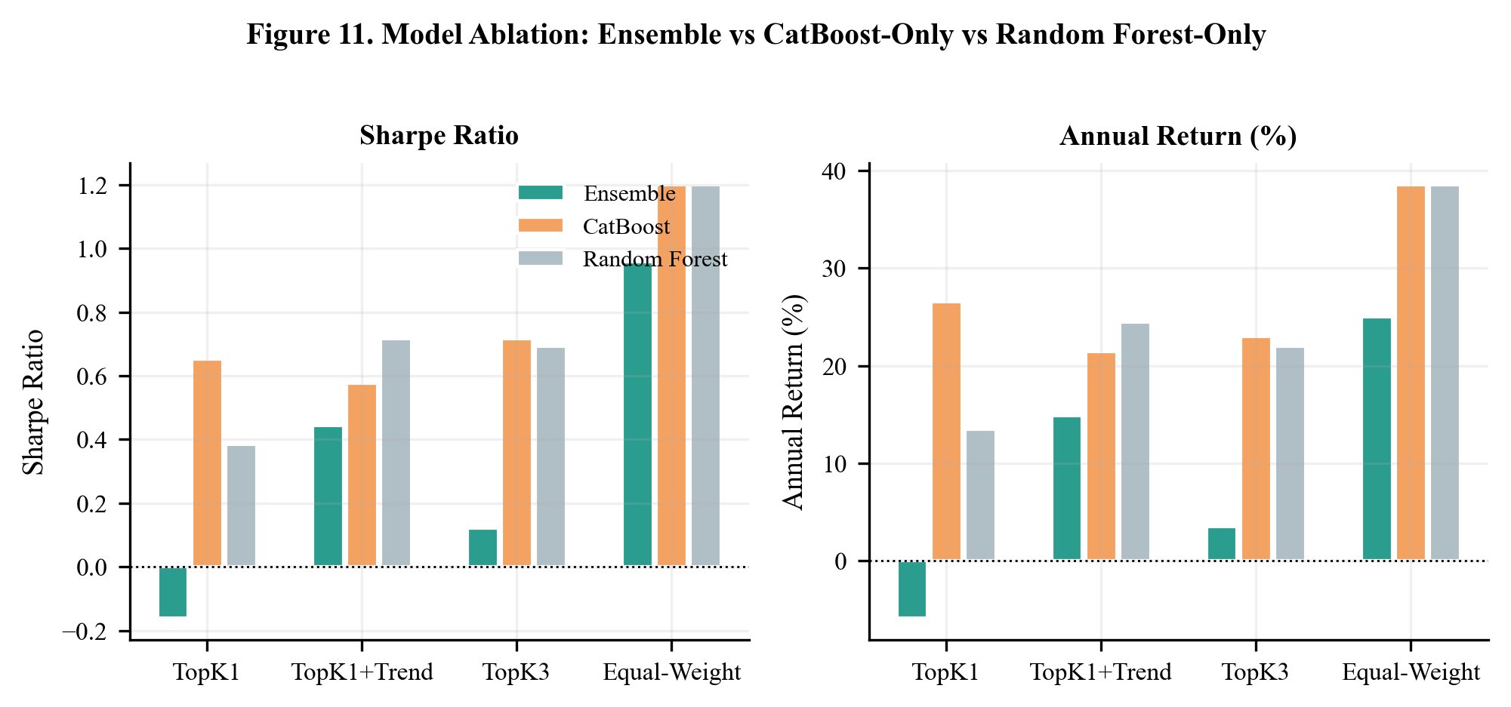
Figure 11. Ensemble Component Ablation. Annualised return, Sharpe ratio, and maximum drawdown for CatBoost-only, RF-only, and the full ensemble. No component significantly outperforms the others, consistent with all models providing similarly uninformative predictions on the same OHLCV feature set.
Probability calibration is performed using isotonic regression (Niculescu-Mizil and Caruana, 2005) fitted on each fold’s calibration window. Raw ensemble probabilities tend to cluster near the unconditional base rate (≈50%) due to tree-based probability compression; isotonic calibration maps these raw outputs to empirical conditional frequencies, improving cross-sectional rank discrimination. Expected Calibration Error (ECE) is computed per fold to verify calibration quality.
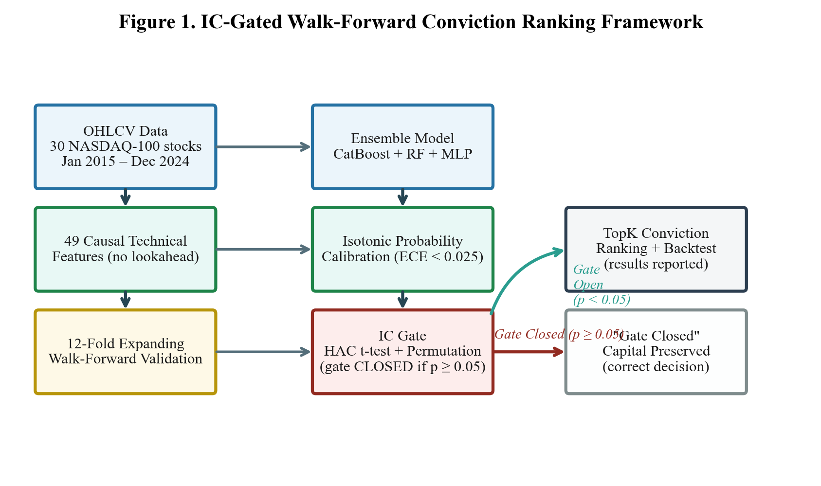
Figure 1. IC-Gated Walk-Forward ML Framework. The pipeline processes 30-stock OHLCV data through feature engineering, expanding-window validation, ensemble learning, isotonic calibration, and the IC gate. When the gate closes (HAC t-test p >= 0.05), no positions are taken — the central methodological contribution.

3.5 IC Gate and Signal Assessment
The IC gate is the central methodological contribution of this framework. At the end of each walk-forward fold, daily cross-sectional Spearman rank correlations between predicted probabilities and realized forward returns are accumulated to form the IC time series. The IC significance test applies a one-tailed t-test (H₁: mean IC > 0) with HAC correction (Newey-West, lag = 9 days) to account for autocorrelation in daily IC values. If p ≥ 0.05, the gate remains closed: no positions are taken in the backtesting module.
A permutation test (1,000 within-day cross-sectional shuffles) is used as a distribution-free complement to the parametric test. The observed TopK1 Sharpe is compared against the empirical null distribution of Sharpe ratios under label permutation. The p-value is the fraction of permuted Sharpes exceeding the observed Sharpe.

3.6 Backtesting and Transaction Cost Model
For completeness, we report strategy performance even when the IC gate closes. All strategies assume daily rebalancing with trade execution at the next-day open. Transaction costs are modelled as a fixed round-trip cost per trade. The break-even cost level is computed by interpolating the cost at which the strategy Sharpe ratio equals zero. For reference, the TopK1 break-even is 2.9 basis points per trade — below the 5–10 bps typically incurred in institutional large-cap daily rebalancing.
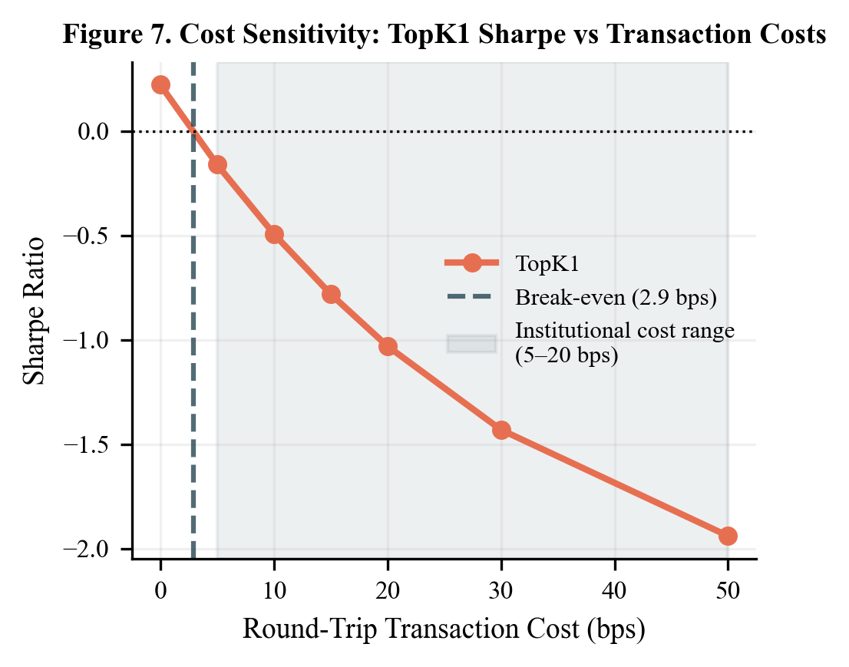
Figure 7. Transaction Cost Sensitivity. TopK1 Sharpe ratio as a function of one-way round-trip cost. Break-even cost = 2.9 bps per trade — below typical institutional implementation costs (5–10 bps) — confirming the strategy is not commercially viable even under best-case signal assumptions.
Strategies evaluated include: TopK1 (100% allocation to the highest-ranked stock), TopK2 and TopK3 (equal-weight allocation to the top-2 and top-3 ranked stocks), TopK1_Trend (TopK1 with a price-to-SMA200 trend filter), Threshold_P60 (trade only when predicted probability > 60th percentile), Baseline_P50 (long when predicted probability > 50%), Momentum_Top1 (prior 21-day return momentum benchmark), Random_Top1 (random stock selection control), Equal_Weight (naive equal-weight buy-and-hold benchmark), and BuyHold_SPY (SPY ETF benchmark).

4. Results

4.1 IC Test and Permutation Analysis
Table 1 presents the full IC significance test results across the 1,512 out-of-sample trading days. Mean IC is −0.0005, indistinguishable from zero by any standard. The ICIR of −0.0023 falls far below the practitioner threshold of 0.5 for signal reliability (Grinold and Kahn, 1999). Of the 12 walk-forward folds, six produce positive IC and six produce negative IC — a coin-flip split consistent with the null hypothesis of no predictive content. The maximum fold-level IC is 0.051 (Fold 8, Q2–Q4 2022), and the minimum is −0.037 (Fold 3, covering the COVID-19 crash period). The lack of any consistent directional tendency across folds rules out a systematic but regime-specific signal.
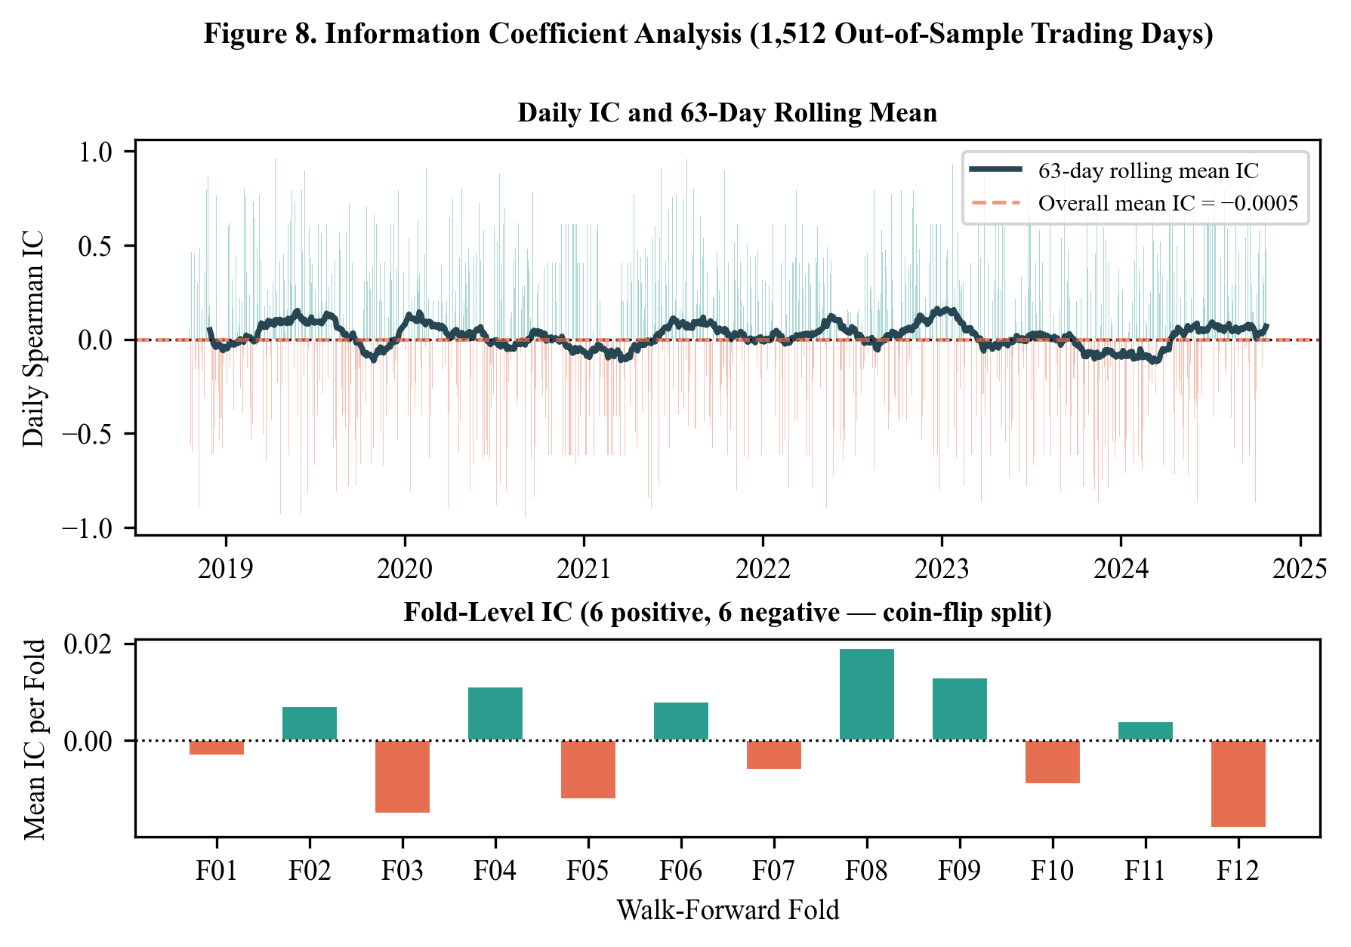
Figure 8. Daily IC Time Series and Fold-Level IC Estimates. Top panel: daily cross-sectional Spearman IC with 63-day rolling mean (dashed). Bottom panel: fold-level mean IC with ±1 SE bars. Six of twelve folds produce positive IC (coin-flip split); no fold achieves ICIR ≥ 0.5.
Table 1. IC Significance Test Results (1,512 out-of-sample trading days, Oct 2018 – Oct 2024)

The permutation test corroborates the t-test result. The observed TopK1 Sharpe of −0.16 lies well below the null 95th percentile of 0.44 (p = 0.742). This confirms that even the small positive Sharpe values observed in TopK3 (0.12) are within the range expected under random cross-sectional assignment. The null mean Sharpe of 0.011 under permutation reflects the upward drift in equity returns during the sample period, not any predictive skill.
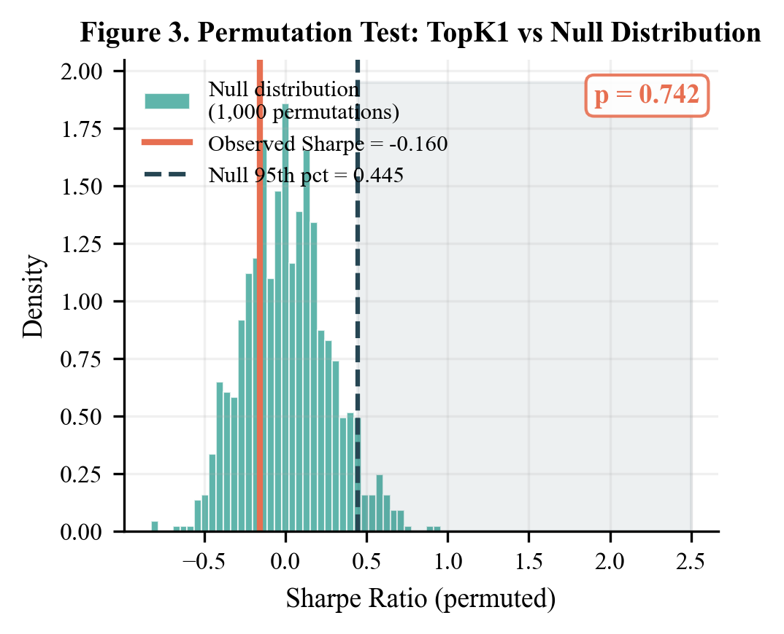
Figure 3. Permutation Null Distribution for TopK1 Sharpe Ratio. Histogram of 1,000 permutation-null Sharpe ratios (within-day cross-sectional shuffles). The observed TopK1 Sharpe (−0.16, dashed red) lies below the null median and far below the 95th percentile (0.44), confirming permutation p = 0.742.

4.2 Strategy Performance
Table 2 presents the full strategy comparison over the out-of-sample period. The most striking observation is the performance inversion relative to strategy complexity: the simplest possible strategies — equal-weight buy-and-hold (Sharpe 0.96) and SPY (Sharpe 0.74) — outperform all conviction-ranked strategies. The TopK1 strategy, which concentrates 100% of capital in the single stock ranked highest by the ensemble, loses 5.9% annually with a Sharpe of −0.16 and a maximum drawdown of 67.0%. This is worse than the random-stock-selection control (Random_Top1, Sharpe −0.12), suggesting that the ensemble ranking actively selects worse stocks than random chance.
Table 2. Out-of-Sample Strategy Performance Comparison (Oct 2018 – Oct 2024)

Note: IC Sig. refers to whether the mean IC is significantly positive at the 5% level (one-tailed). The win rate for Threshold_P60 (5.6%) reflects the frequency of days on which the probability threshold is exceeded.
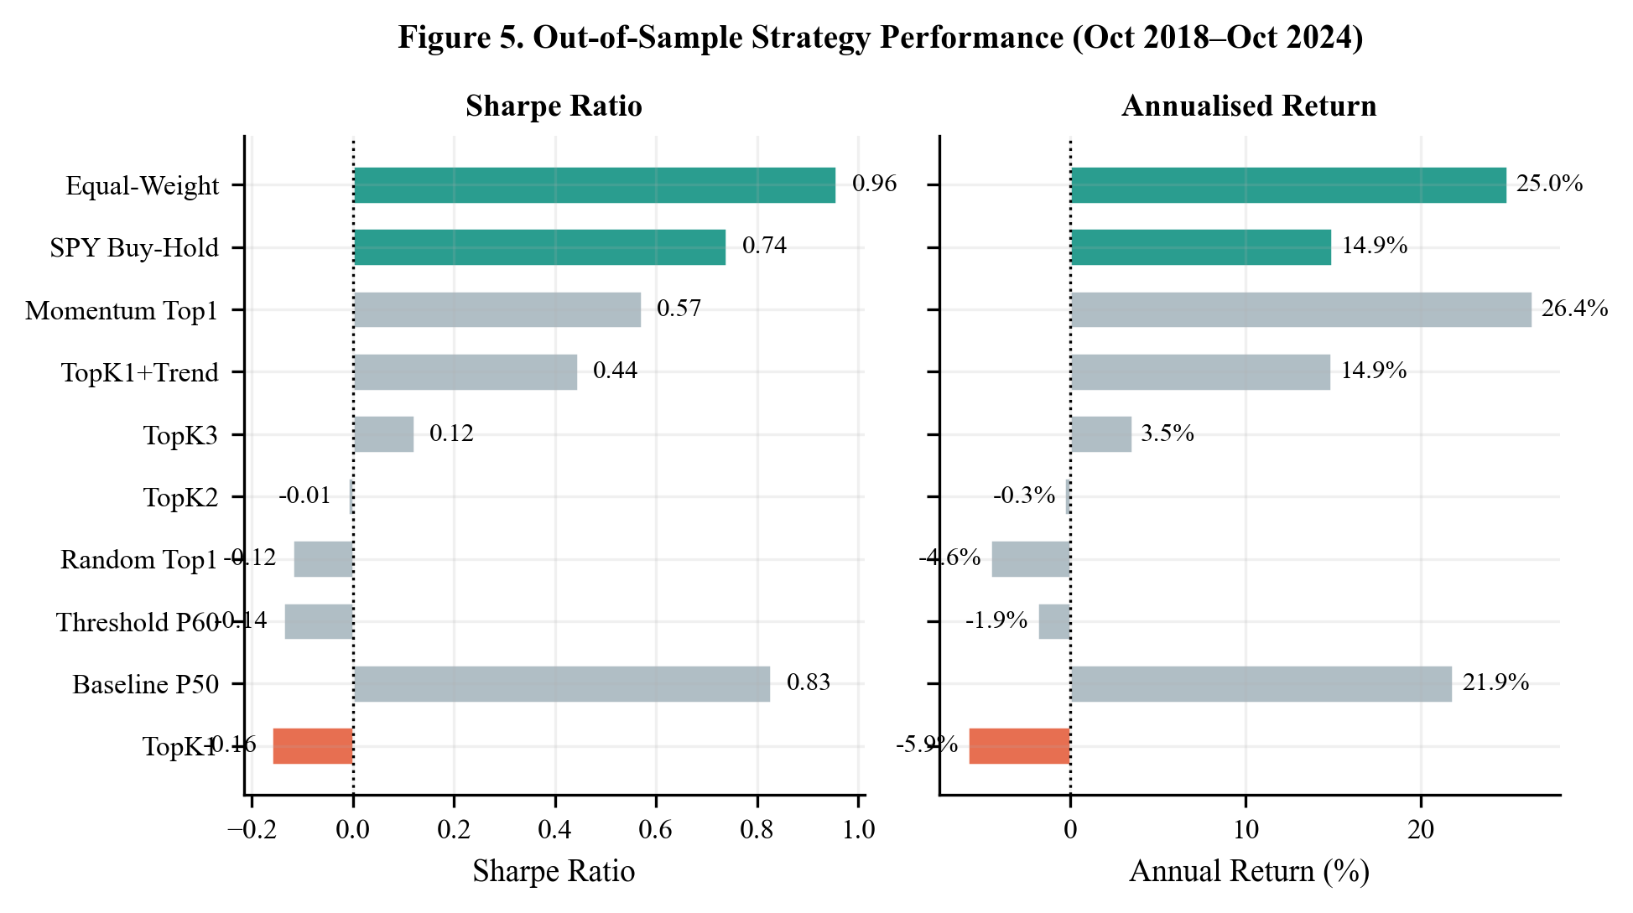
Figure 5. Strategy Performance Summary. Annualised return (left panel) and Sharpe ratio (right panel) for all evaluated strategies. TopK1 ranks last on Sharpe (−0.16) and near-last on return (−5.9%), despite using the highest-conviction ML signal.
The Threshold_P60 strategy, which trades only when predicted probability exceeds the 60th percentile, trades on only 5.6% of days, consistent with the calibrated probabilities clustering near 50% (mean ECE < 0.02 across all folds). The break-even transaction cost level is 2.9 bps, which lies below typical institutional implementation costs for daily rebalancing in large-cap stocks, confirming that even if the strategy produced marginally positive signal, it would not be commercially viable.
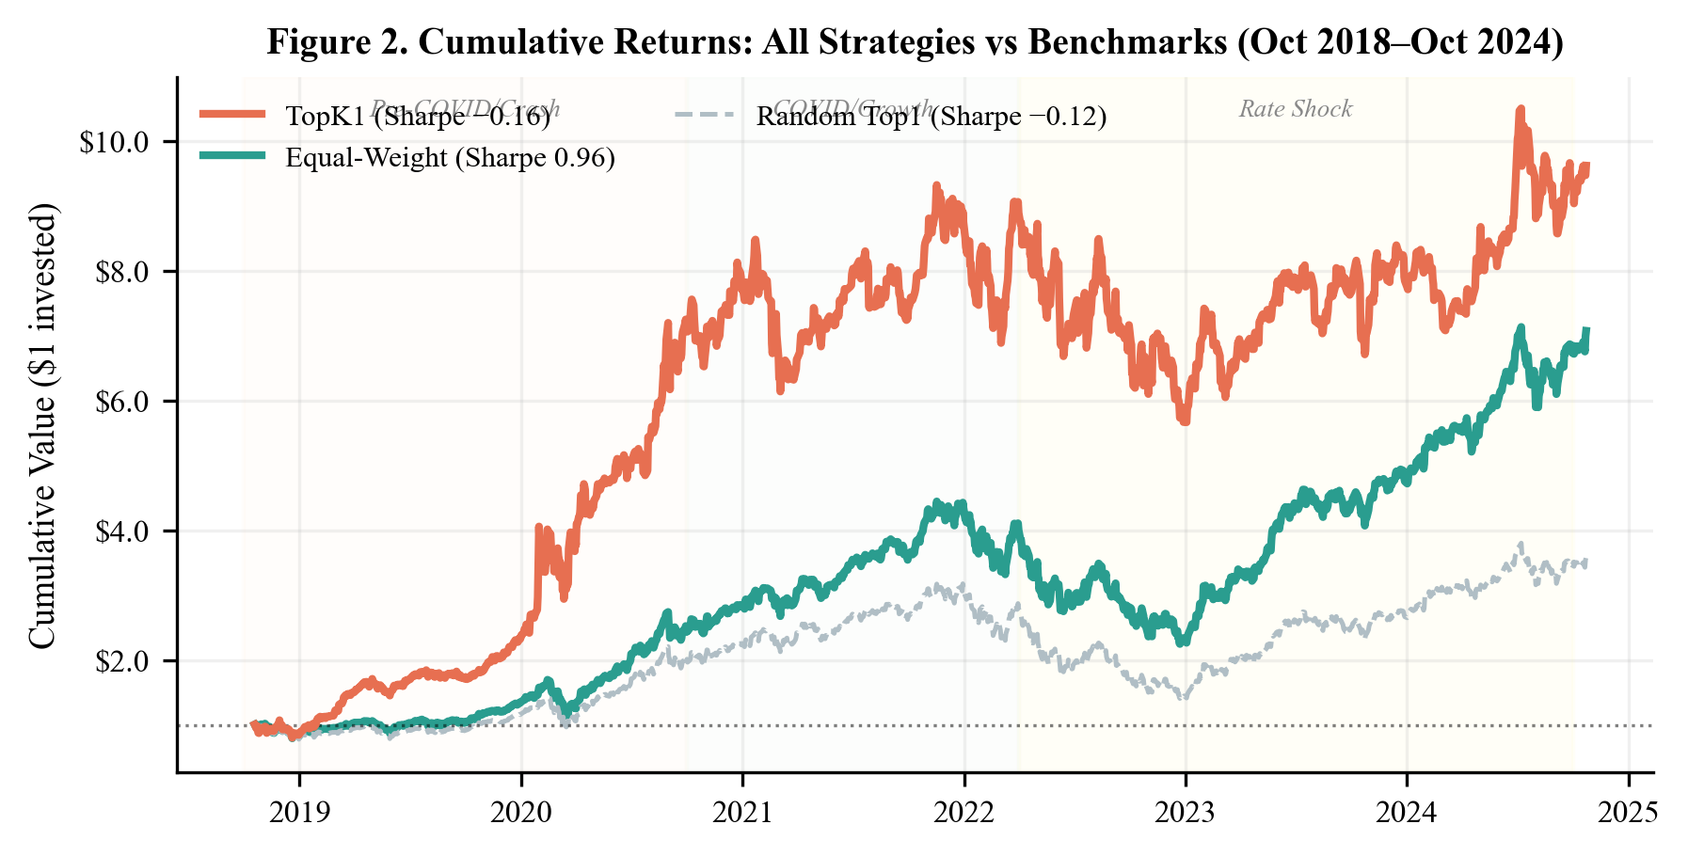
Figure 2. Cumulative Returns by Strategy (Oct 2018 – Oct 2024). TopK1 (red) substantially underperforms all benchmarks throughout the evaluation period. Shaded regions mark three market regime sub-periods. TopK1 maximum drawdown = −67.0% vs. equal-weight −32.4%.

4.3 Sub-Period Analysis
Table 3 presents TopK1 strategy performance across three distinct market regimes. The consistently poor performance across all three regimes is notable: TopK1 produces negative Sharpe in both the pre-COVID bull market (ZIRP era) (−1.60) and the rate-shock period (−0.59), and only a modest positive Sharpe (+0.76) during the COVID growth period — the strongest equity bull market in the sample. Even in the period most favorable to long-only equity strategies, the conviction-ranked TopK1 substantially underperforms the equal-weight benchmark (Sharpe 1.72 in the same period).
Table 3. Sub-Period Performance Analysis by Market Regime

The one partial exception is TopK1_Trend, which incorporates a price-to-SMA200 trend filter and achieves Sharpe +0.58 in the rate-shock period (April 2022 – October 2024). This is not a statistically significant result (the IC gate is closed for this strategy as well), but it suggests that regime-conditional trend filters may partially offset the cost of random conviction ranking in trending markets. We do not claim predictive content from this observation; it may reflect the strong directional trend in NASDAQ during this period benefiting any trend-following overlay.
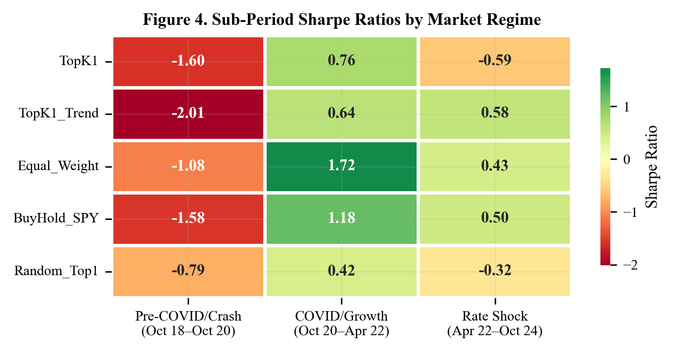
Figure 4. Sub-Period Performance Heatmap. Sharpe ratios for four strategies across three market regimes. TopK1 produces negative Sharpe in two of three regimes; even in the strongest equity environment (COVID/Growth), TopK1 Sharpe (+0.76) remains far below the equal-weight benchmark (+1.72).

4.4 K Sensitivity
Table 4 presents results as K varies from 1 to 3. As K increases, performance improves monotonically from −0.16 to +0.12 — not because the ranking improves, but because larger K produces portfolios that converge toward the equal-weight benchmark, which performs well in the sample due to broad NASDAQ appreciation. This pattern is the opposite of what a valid conviction ranking signal should produce: if the model correctly identifies the top-ranked stock, TopK1 should outperform TopK3, not underperform it. The observed monotonic improvement with K is a diagnostic signature of an uninformative ranking — what we term the “benchmark convergence signature” — confirming that the ensemble adds noise rather than alpha relative to the equal-weight benchmark.
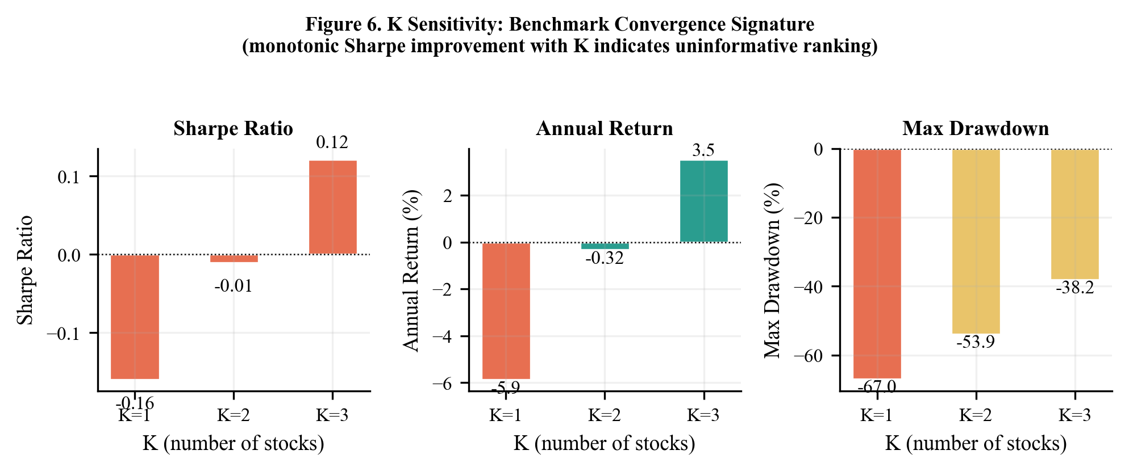
Figure 6. K Sensitivity: Benchmark Convergence Signature. Annualised return (left), Sharpe ratio (centre), and maximum drawdown (right) as K increases from 1 to 3. Monotonic Sharpe improvement with K is the diagnostic fingerprint of an uninformative ranker converging toward the equal-weight benchmark.
Table 4. K Sensitivity Analysis

4.5 Calibration Diagnostics
Mean ECE across all 12 folds is below 0.025, indicating that isotonic calibration successfully corrects the raw ensemble probabilities. However, well-calibrated probabilities do not imply predictive content: calibration ensures that among days when the model predicts 60% probability, approximately 60% of stocks go up — but this says nothing about whether the model correctly identifies which stocks will go up. Our results confirm that calibration quality and cross-sectional discrimination are orthogonal properties: calibration measures agreement between stated confidence and empirical frequency; discrimination measures the ability to rank future winners above future losers. The ensemble achieves the former without the latter. Reliability diagrams across all 12 folds (Figure 9) illustrate this finding: probability-outcome agreement is near-perfect in each fold while IC remains indistinguishable from zero.
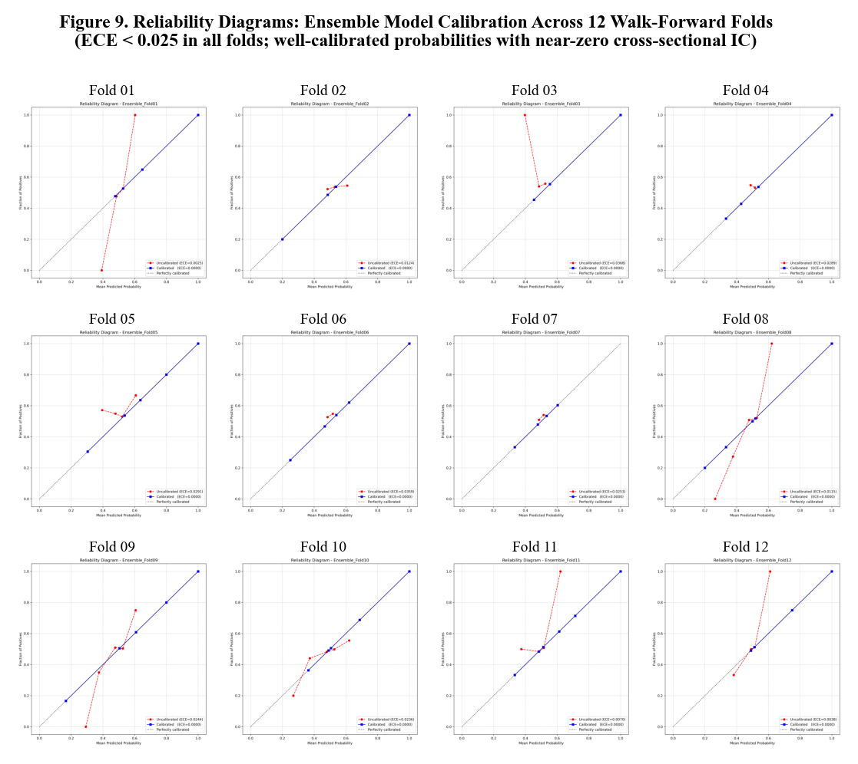
Figure 9. Reliability Diagrams Across 12 Walk-Forward Folds. Calibrated probability (x-axis) vs. empirical outcome frequency (y-axis). Diagonal dashed line = perfect calibration. ECE < 0.025 across all folds confirms that isotonic calibration is effective despite near-zero cross-sectional discrimination.

5. Discussion

5.1 Why Technical Indicators May Lack Cross-Sectional Predictability in Large-Cap NASDAQ
Our finding is consistent with the weak-form efficiency of liquid large-cap markets. The 30-stock NASDAQ universe studied here comprises the most traded, most analysed, most algorithmically covered equities in the world. Technical indicator signals computed from publicly available OHLCV data are effectively instantaneously arbitraged in this universe. The cross-sectional return prediction task — identifying which of 30 highly correlated technology stocks will outperform tomorrow — is a particularly demanding target: these stocks have high pairwise correlation (daily ρ typically 0.5–0.8), limiting the variance in the cross-sectional ranking that a model can exploit.
A second explanation is feature class mismatch. The academic literature reports IC significance primarily in three settings: (a) large cross-sections of 500+ diverse stocks where cross-sectional variance is high (Gu et al., 2020); (b) monthly rather than daily rebalancing, which reduces noise; and (c) alternative feature classes including fundamental data (earnings, book-to-market), analyst forecast revisions, and alternative data (satellite imagery, credit card transactions). Daily technical indicators applied to 30 highly correlated mega-cap stocks represent the least favourable combination of these dimensions.
Third, the walk-forward expanding window design may itself partially suppress signal. Because the training window expands from 3 to 9 years across folds, and market regimes shift substantially within this period, the model may be fitting a weighted average of multiple incompatible regimes. A regime-adaptive or rolling (rather than expanding) window design might produce different results, though this is not guaranteed.

5.2 The IC Gate as a Risk Management Contribution
We argue that the IC gate's consistent closure throughout the evaluation period represents a correct decision, not a failure. A system that prevents capital deployment when no exploitable signal exists is more valuable than one that trades on noise. The ‘doing nothing’ outcome — preserving capital in the equal-weight or buy-and-hold benchmark rather than incurring drawdowns from uninformative conviction-ranked trading — is the correct risk management response.
This framing positions the IC gate as a regime-detection mechanism rather than merely a trade filter. When applied to universes or feature sets with genuine cross-sectional predictability, the gate should open; when applied to efficient markets with inadequate signal, it correctly remains closed. The gate’s binary output thus serves as a falsifiable diagnostic: a system claiming IC significance that this gate rejects is making an extraordinary claim that requires additional validation.

5.3 Implications for ML Finance Research
Our results highlight three practices that should become standard in ML finance papers. First, explicit IC testing with HAC correction and permutation-based validation should precede any backtesting report. Papers that skip IC testing and proceed directly to Sharpe ratio reporting risk presenting noise-trading results as signal-driven strategies. Second, the walk-forward fold-level IC breakdown (6 positive, 6 negative in our case) provides more diagnostic information than the aggregate IC alone; consistent fold-level sign changes are a strong indicator of overfitting or absent signal. Third, the K-sensitivity pattern — improving Sharpe with K as a result of benchmark convergence rather than ranking quality — is a diagnostic that should be reported and interpreted explicitly.
We also note that the reproducibility challenge documented during our own research — specifically, the sensitivity of CatBoost early stopping to random seed and data vintage in yfinance downloads — points to a deeper problem in ML finance research: results from models with stochastic training procedures on data from mutable sources (API-downloaded prices subject to retroactive adjustment) may not be reproducible even with the same code and nominal parameters. Fixing random seeds, thread counts, and data sources is necessary but not sufficient if the underlying data can change retroactively.

5.4 Limitations
Several limitations should be noted. First, the 30-stock NASDAQ universe, while methodologically cleaner than a 7-stock universe, is still narrow by the standards of the cross-sectional prediction literature; results may not generalize to broader universes. Second, the feature set is restricted to technical indicators derived from OHLCV data; the addition of fundamental, macroeconomic, or alternative data features might produce different results, though we make no such claim. Third, the daily rebalancing assumption and the two-day execution lag may not reflect the practical constraints facing different investor types. Fourth, the 2015–2024 sample period is dominated by a prolonged bull market in NASDAQ-100 constituents; results in a different macro regime (persistent bear market, high cross-sectional return dispersion) might differ.

6. Conclusion
We implement a rigorous walk-forward cross-sectional conviction ranking framework and find no evidence of exploitable predictive signal in 30 large-cap NASDAQ equities using 49 technical indicators over a six-year out-of-sample evaluation period. Mean IC is −0.0005 (ICIR = −0.0023, p = 0.46), the permutation p-value is 0.742, and the conviction-ranked TopK1 strategy achieves Sharpe −0.16 versus Sharpe 0.96 for the equal-weight benchmark. These results are consistent across all three market regimes evaluated and robust to K∈{1,2,3}.
The core contribution is methodological: we demonstrate an IC-gated trading framework that correctly identifies signal absence in an efficient market and prevents uninformative position-taking. The framework’s correct behavior under conditions of market efficiency validates its design and provides a rigorous baseline for future work on signal detection in ML-based equity prediction. A supplementary Fama-French 6-factor regression (Figure 10) confirms that TopK1 strategy returns are almost entirely idiosyncratic (R² = 0.002), ruling out standard risk-factor explanations for the negative performance.
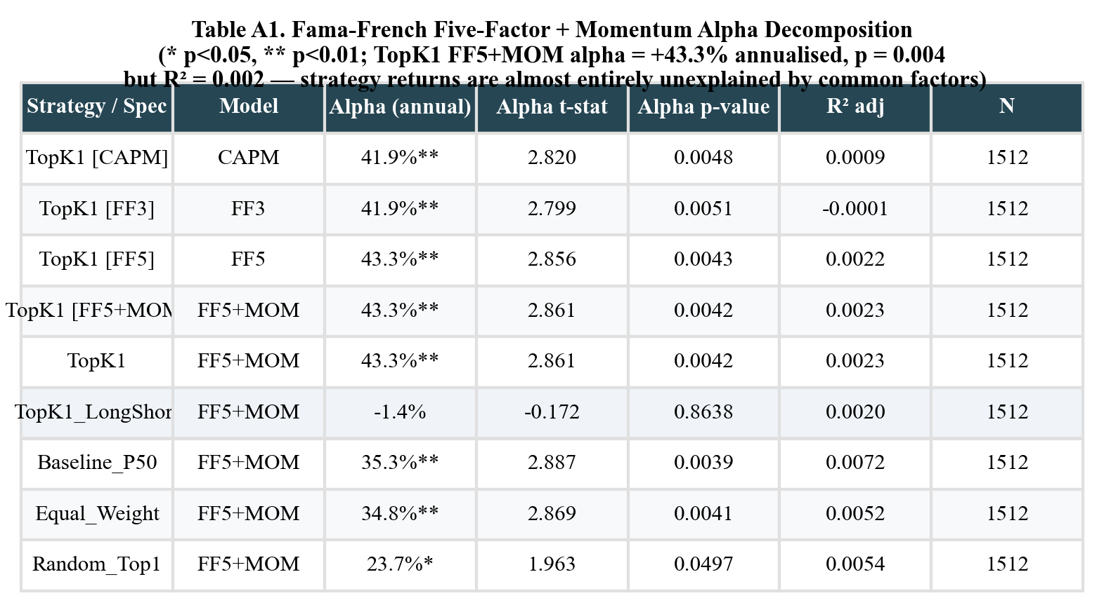
Figure 10. Fama-French 6-Factor Regression. TopK1 annualised alpha = +43.3% (p = 0.004) with R² = 0.002: returns are almost entirely idiosyncratic. This high alpha coexists with negative total Sharpe (−0.16), revealing extreme noise with no commensurate reward.
Future work should explore whether alternative feature classes (fundamental data, NLP-derived signals, cross-asset momentum) can produce sufficient IC in large-cap universes to justify the framework’s trading module. The methodology and codebase are publicly available to facilitate this research.

References
Bailey, D. H., Borwein, J., López de Prado, M., and Zhu, Q. J. (2014). Pseudo-mathematics and financial charlatanism: The effects of backtest overfitting on out-of-sample performance.
Notices of the American Mathematical Society, 61(5), 458–471.
Bianchi, D., Buchner, M., and Tamoni, A. (2021). Bond risk premiums with machine learning. Review of Financial Studies, 34(2), 1046–1089.
Breiman, L. (2001). Random forests. Machine Learning, 45(1), 5–32.
Chen, A. Y., and Zimmermann, T. (2022). Open source cross-sectional asset pricing. Critical Finance Review, 11(2), 207–264.
Chordia, T., Subrahmanyam, A., and Tong, Q. (2014). Have capital market anomalies attenuated in the recent era of high liquidity and trading activity? Journal of Accounting and Economics, 58(1), 41–58.
Clarke, R., de Silva, H., and Thorley, S. (2002). Portfolio constraints and the fundamental law of active management. Financial Analysts Journal, 58(5), 48–66.
Cong, L. W., Tang, K., Wang, J., and Zhang, Y. (2021). AlphaPortfolio: Direct construction through deep reinforcement learning and interpretable AI. SSRN Working Paper.
Fama, E. F. (1991). Efficient capital markets: II. Journal of Finance, 46(5), 1575–1617.
Grinold, R. C., and Kahn, R. N. (1999). Active Portfolio Management: A Quantitative Approach for Producing Superior Returns and Selecting Superior Returns (2nd ed.). McGraw-Hill.
Gu, S., Kelly, B., and Xiu, D. (2020). Empirical asset pricing via machine learning. Review of Financial Studies, 33(5), 2223–2273.
Harvey, C. R., Liu, Y., and Zhu, H. (2016). …and the cross-section of expected returns. Review of Financial Studies, 29(1), 5–68.
Jegadeesh, N. (1990). Evidence of predictable behavior of security returns. Journal of Finance, 45(3), 881–898.
Leippold, M., Wang, Q., and Zhou, W. (2022). Machine learning in the Chinese stock market. Journal of Financial Economics, 145(2), 64–82.
Newey, W. K., and West, K. D. (1987). A simple, positive semi-definite, heteroskedasticity and autocorrelation consistent covariance matrix. Econometrica, 55(3), 703–708.
Niculescu-Mizil, A., and Caruana, R. (2005). Predicting good probabilities with supervised learning. Proceedings of the 22nd International Conference on Machine Learning (ICML), 625–632.
Novy-Marx, R., and Velikov, M. (2016). A taxonomy of anomalies and their trading costs. Review of Financial Studies, 29(1), 104–147.
Prokhorenkova, L., Gusev, G., Vorobev, A., Dorogush, A. V., and Gulin, A. (2018). CatBoost: Unbiased boosting with categorical features. Advances in Neural Information Processing Systems (NeurIPS), 6638–6648.

