When the Gate Stays Closed: Empirical Evidence of Near-Zero
Cross-Sectional Predictability in Large-Cap NASDAQ Equities
Using an IC-Gated Machine Learning Framework
Rajveer Singh Pall
Independent Researcher
April 2025

Abstract
We test whether a supervised machine learning ensemble can generate exploitable cross-sectional predictability in large-cap NASDAQ equities. The framework combines CatBoost, Random Forest, and MLP base learners with isotonic calibration and an Information Coefficient (IC) gate — a statistical mechanism that blocks position-taking unless Newey-West-corrected IC reaches significance (p < 0.05). Applied to a survivorship-bias-controlled universe of 30 NASDAQ-100 stocks over a 6-year out-of-sample window (1,512 trading days, October 2018 – October 2024) using 49 strictly causal technical indicators, the gate stays closed for the entire evaluation period. Mean IC is −0.0005 (ICIR = −0.0023, t = −0.09, p = 0.464), and the TopK1 strategy achieves a Sharpe ratio of −0.16 versus 0.96 for the equal-weight benchmark. A permutation test places the observed Sharpe at the 25.8th percentile of 1,000 shuffles (p = 0.742). The ensemble produces well-calibrated probability estimates (ECE < 0.025 across all 12 folds) yet provides zero cross-sectional discrimination — calibration quality is orthogonal to predictive content. Five robustness checks confirm the null: expanding the universe to 100 stocks, Diebold-Mariano predictive accuracy tests, VIX-regime-conditioned IC analysis, block bootstrap confidence intervals, and gradient-based feature attribution. We interpret the gate closing as a correct decision rather than a failure, providing principled empirical evidence of signal absence in an efficient large-cap market segment.
Keywords: Information coefficient gate, machine learning, cross-sectional prediction, NASDAQ-100, walk-forward validation, ensemble learning, isotonic calibration, Diebold-Mariano test, market efficiency

1. Introduction
Can a well-built machine learning model beat an equal-weight index of mega-cap technology stocks over six years? On daily OHLCV data alone, our answer is no — and we think the machinery we built to answer that question is the contribution. The IC gate mechanism catches when a model has nothing to say and keeps it quiet. Over 1,512 consecutive out-of-sample trading days, the gate never opened.
Machine learning methods have attracted serious attention in empirical asset pricing since Gu, Kelly and Xiu (2020) showed that tree ensembles and neural networks explain meaningful variation in monthly equity returns across a broad US universe. Daily prediction at the single-stock level is harder. The signal-to-noise ratio in 1-day holding-period returns is far lower than in monthly panels. Return distributions are fat-tailed, autocorrelation structure is weak, and regime changes are frequent enough to make in-sample patterns unreliable guides to out-of-sample performance.
Research in this space faces three recurring methodological problems. First, look-ahead bias: features computed with future information inflate in-sample fit dramatically. Second, temporal leakage in cross-validation: standard k-fold shuffles training and test periods, destroying the causal structure of time. Third, survivorship bias: restricting the universe to current index members selects for firms that survived and grew, boosting observed returns relative to what an investor would have earned. We address all three explicitly.
Our contribution is a reproducible IC-gated walk-forward framework with five components. An expanding-window walk-forward validator generates 12 non-overlapping test folds with temporal embargoes. A three-model ensemble — CatBoost, Random Forest, and MLP — produces probability estimates averaged with equal weight. Isotonic regression calibrates fold-specific probability estimates on a held-out calibration window. The IC gate then applies a Newey-West HAC t-test and a permutation test to the calibrated cross-sectional rankings before allowing any position. A vectorized backtest with realistic transaction costs completes the pipeline.
The central finding is negative: across all 12 test folds, the IC gate stays closed. The ensemble ranks 30 stocks each day, but those rankings carry no persistent cross-sectional information. The TopK1 Sharpe ratio of −0.16 falls well below the equal-weight benchmark Sharpe of 0.96. A permutation test confirms the observed performance is indistinguishable from random selection (p = 0.742). Monotonically increasing Sharpe with K — from TopK1 at −0.16 through TopK3 at +0.12 to the equal-weight limit at 0.96 — is a diagnostic signature of an uninformative ranker.
Five robustness checks leave the null result intact. Expanding the universe from 30 to 100 NASDAQ-100 stocks closes the gate again (p = 0.947). Diebold-Mariano tests confirm TopK1 is statistically indistinguishable from random stock selection (DM = 0.42, p = 0.67). The IC gate remains closed across all three VIX volatility terciles, ruling out a high-dispersion signal hypothesis. Block bootstrap confidence intervals span zero for all 12 folds. Gradient-based feature attribution shows low and unstable feature importance scores across folds (Spearman rank ρ = 0.13–0.40), confirming the model fits noise rather than structure.
We position this as a methodologically complete negative result rather than an incremental positive claim. The calibration quality — ECE below 0.025 across all folds — demonstrates the ensemble is well-trained. The null IC is a property of the signal class (49 backward-looking technical indicators applied to large-cap NASDAQ stocks), not of the model architecture. This orthogonality between calibration quality and predictive content is a secondary finding worth isolating.
2. Related Work
2.1 Machine Learning in Equity Prediction
Gu, Kelly and Xiu (2020) establish the modern benchmark for ML in equity return prediction: gradient-boosted trees and deep networks outperform linear factor models in monthly cross-sectional prediction using a broad US equity panel. Their predictive R² gains are real but modest in absolute terms. The practical challenge of translating predictive lift into Sharpe ratios after transaction costs has been explored by Freyberger, Neuhierl and Weber (2020), who find that many signals require high turnover to capture, making net-of-cost performance substantially worse than gross.
Daily prediction of individual stock returns is a harder problem than monthly cross-sectional work. Continuous trading means transaction cost frictions compound daily. The relevant signal-to-noise ratio at daily frequency is far lower — Sharpe ratios from published factors that appear significant monthly often vanish at daily horizons after accounting for microstructure noise and non-synchronous trading. Chordia, Roll and Subrahmanyam (2005) document that market-wide liquidity shocks dominate daily return variation, leaving little room for cross-sectional signals from firm-specific technicals.
2.2 Technical Indicators as Predictors
Technical indicators have been debated as predictors since Lo, Mamaysky and Wang (2000), who found weak evidence of short-horizon predictability from price patterns. More recent ML-based work has found that moving averages, momentum oscillators, and volatility signals contain some predictive information at monthly horizons in smaller-cap or emerging-market universes. In large-cap NASDAQ stocks — the most actively traded, most heavily analysed segment of the US market — the efficiency hypothesis is harder to reject. Chordia, Subrahmanyam and Tong (2014) show that anomaly returns have declined significantly over time, consistent with learning-based arbitrage. Our 2015–2024 training and evaluation window falls squarely in the post-decline era.
2.3 Validation Design and IC Gates
Walk-forward validation is the standard design for time-series-dependent ML evaluation in finance. Prado (2018) formalises its properties and introduces the purged k-fold variant to prevent leakage through overlapping label periods. Our implementation uses expanding training windows with explicit embargoes between train and test, consistent with purged k-fold principles.
The IC (Information Coefficient) is the Spearman rank correlation between predicted and realised cross-sectional returns. Grinold and Kahn (1999) derive the fundamental law of active management — that a strategy's Information Ratio scales as IC times the square root of breadth — establishing IC as the key measure of signal quality in cross-sectional frameworks. Practitioners routinely use IC > 0 as a filter before live deployment. Our IC gate formalises this discipline statistically, requiring HAC-corrected significance rather than relying on arbitrary thresholds.
2.4 Calibration in ML-Based Finance
Probability calibration — matching predicted probability to empirical frequency — has received limited attention in financial ML despite its importance for risk management. Guo et al. (2017) establish expected calibration error (ECE) as the standard metric. In a classification-based conviction ranking framework, well-calibrated probabilities allow the IC gate to interpret rank ordering correctly. We demonstrate that our isotonic-calibrated ensemble achieves ECE below 0.025 across all folds while producing zero IC — showing that calibration quality does not imply discriminative content.
3. Data and Feature Engineering
3.1 Universe Construction
The primary universe consists of 30 large-cap NASDAQ-100 member stocks selected to avoid survivorship bias. Specifically, we include stocks that were NASDAQ-100 continuous members throughout the evaluation window (October 2018 – October 2024) and had price history back to January 2015 to provide at least three years of training data for the first fold. SPY is included as a benchmark instrument. Daily OHLCV data spanning January 2015 through December 2024 — a total of approximately 2,500 trading days — is obtained from Yahoo Finance via the yfinance library with auto-adjustment for splits and dividends.
For the robustness analysis in Section 6, we expand the universe to approximately 100 NASDAQ-100 candidate stocks applying the same survivorship-bias control procedure: stocks must have at least 1,800 trading days (roughly 7 years) of clean, adjusted price history. This produces a survivorship-bias-controlled universe of similar character to the primary 30-stock universe but three times as broad.
3.2 Target Variable
The target variable is the binary direction of the two-day-ahead close return. Formally: y_t = 1 if Close(t+2) > Close(t+1), else 0. The two-day shift eliminates execution-at-signal lookahead bias — we assume signals from day t are known at market close of day t, positions are entered at the close of day t+1 (open print or VWAP), and returns are measured from close(t+1) to close(t+2). This conservative lag prevents any information about day t+1's close from contaminating the signal.
3.3 Feature Engineering
We construct 49 strictly backward-looking technical features from OHLCV data alone. All features use only past prices and volumes at computation time — no center=True rolling windows, no future data leakage, and min_periods equal to the full window length to avoid warm-up period artifacts. Table 1 lists the eight feature categories.
Category | Count | Representative Features
Momentum | 8 | RSI-14/21, MACD line/signal/histogram, ROC-10/21, Williams %R
Bollinger Bands | 6 | Upper, Lower, Mid, Bandwidth, %B position, CCI-20
Volatility | 6 | ATR-14/21, Log-return vol 5d/21d/63d, HL range
Trend / MA | 8 | EMA-9/21/50/200, SMA-50/200, Price-to-SMA50/200
Returns | 6 | Log returns: 1d, 2d, 3d, 5d, 10d, 21d
Volume | 5 | OBV, OBV-EMA, Volume z-score 5d/21d, MFI-14
Candle | 4 | OC body, upper/lower shadow ratios, DPO-20
Directional | 6 | Stochastic %K/%D, ADX-14, DI+/DI−, VWAP deviation
Table 1. Feature set: 49 strictly causal technical indicators across 8 categories. All features are backward-looking with no centre-window smoothing.
4. Methodology
4.1 Walk-Forward Validation
We use a 12-fold expanding-window walk-forward design. Each fold trains on all data from January 2015 through month T, holds out a six-month calibration window immediately after T, and evaluates on the subsequent six-month test window. The training window expands by one fold period for each successive fold. Fold 1 tests July–December 2017; Fold 12 tests July–December 2024.
A 10-trading-day embargo separates each training period from its calibration window, and a second embargo separates the calibration window from the test period. The calibration window is strictly held out — the isotonic calibrator never observes the test-period label distribution before inference. This design prevents any form of temporal data leakage while providing a separate distribution for probability calibration at each fold.
Fold | Train | Calibration | Test
1 | Jan 2015 – Dec 2016 | Jan 2017 – Jun 2017 | Jul 2017 – Dec 2017
2 | Jan 2015 – Jun 2017 | Jul 2017 – Dec 2017 | Jan 2018 – Jun 2018
... | ... | ... | ...
12 | Jan 2015 – Mar 2024 | Apr 2024 – Jun 2024 | Jul 2024 – Dec 2024
Table 2. Walk-forward fold structure. Training window expands; calibration and test windows are each fixed at six months. Embargoes (10 trading days) separate adjacent windows.
4.2 Ensemble Model
The ensemble combines three base learners with equal probability averaging. CatBoost (Prokhorenkova et al., 2018) handles categorical-like feature interactions without preprocessing and is robust to overfitting through ordered boosting. Random Forest provides diversity through bagging and feature subsampling. A three-layer MLP (256 → 128 → 64 units, dropout 0.3, ReLU activations) captures shallow non-linear interactions. All three models train independently on each fold's expanding training window. MLP training uses early stopping on a held-out 15% validation split within the training period (patience = 10 epochs).
Component | Parameter | Value
CatBoost | iterations / learning_rate / depth | 500 / 0.05 / 6
 | l2_leaf_reg / early_stopping_rounds | 3.0 / 50
 | random_seed / thread_count | 42 / 1
Random Forest | n_estimators / max_depth | 500 / 10
 | min_samples_leaf / random_state | 20 / 42
MLP | architecture | [256, 128, 64]
 | dropout / learning_rate | 0.3 / 1×10⁻³
 | early_stopping patience | 10 epochs
Calibration | method | Isotonic regression (per fold)
All | n_jobs (reproducibility) | 1
Table 3. Model hyperparameters. All random seeds fixed to 42 and n_jobs = 1 for full determinism.
4.3 Isotonic Calibration
Raw ensemble probabilities are calibrated using isotonic regression fitted on the held-out calibration window from each fold. Isotonic regression is non-parametric and monotone — it finds the best step-function mapping from raw scores to empirical probabilities without imposing a logistic shape. Expected Calibration Error (ECE) is computed over 10 equal-width bins:
ECE = Σₘ (|Bₘ|/n) · |acc(Bₘ) − conf(Bₘ)| (1)
where Bₘ is the set of predictions falling in bin m, acc(Bₘ) is empirical accuracy in that bin, and conf(Bₘ) is mean confidence. ECE below 0.025 indicates excellent calibration. Crucially, the calibrator fits only on the calibration window and is then applied frozen to the test window — it never observes test labels.
4.4 IC Gate Mechanism
Before any position is taken on test-day t, the gate evaluates the cross-sectional IC series accumulated over the current fold's test window. IC for each day d is the Spearman rank correlation between the calibrated conviction scores and the realised 1-day returns of the 30 stocks:
ICd = SpearmanRankCorr( p̂d , rd+1 ) (2)
where p̂d is the vector of 30 calibrated probabilities and rd+1 is the vector of next-day returns. The gate applies a Newey-West HAC t-test (lag = 9 days, corresponding to approximately two weeks of autocorrelation structure) to the IC series to date:
t_HAC = IC̄ / √( V̂HAC / N ) (3)
The gate opens if and only if t_HAC > 1.645 (one-tailed, α = 0.05) and the mean IC is positive. A complementary permutation test shuffles the signal labels 1,000 times and requires the observed IC to exceed the 95th percentile of the null distribution. In practice, both tests must pass. The gate never opened during any of the 12 test folds.
4.5 Backtesting and Transaction Costs
Each trading day the gate is open, the strategy takes the K stocks with the highest conviction scores as equal-weight long-only positions (short selling is not permitted). The equal-weight benchmark rebalances monthly to 30 equal positions. Transaction costs are charged round-trip at the prevailing cost assumption (baseline: 5 bps), applied to each position change. The backtest is vectorized over the full 1,512-day period using daily returns. Risk-adjusted metrics include annualised Sharpe ratio, Sortino ratio, maximum drawdown, and Calmar ratio.
5. Results
5.1 IC Signal: Gate Stays Closed
Across all 1,512 out-of-sample trading days, the IC gate never opens. The aggregate IC statistics paint a clear picture of absent cross-sectional signal:
Statistic | Value | Threshold | Decision
Mean IC | −0.0005 | > 0 | Negative
IC Std Dev | 0.2204 | — | —
ICIR | −0.0023 | > 0.5 (practice) | Near zero
HAC t-statistic | −0.090 | > 1.645 | Not significant
p-value (HAC) | 0.464 | < 0.05 | Gate CLOSED
Permutation p | 0.742 | < 0.05 | Gate CLOSED
Gate-open folds | 0 of 12 | ≥ 1 | Never opened
Table 4. IC gate evaluation statistics across the full 1,512-day out-of-sample window.
The mean IC of −0.0005 is economically and statistically negligible. The Newey-West corrected t-statistic of −0.090 has a one-tailed p-value of 0.464, far from the 0.05 threshold needed to open the gate. The IC Ratio of −0.0023 — mean IC divided by IC standard deviation — falls orders of magnitude below the 0.5 threshold practitioners typically require before deployment. No fold achieves even marginally significant positive IC.
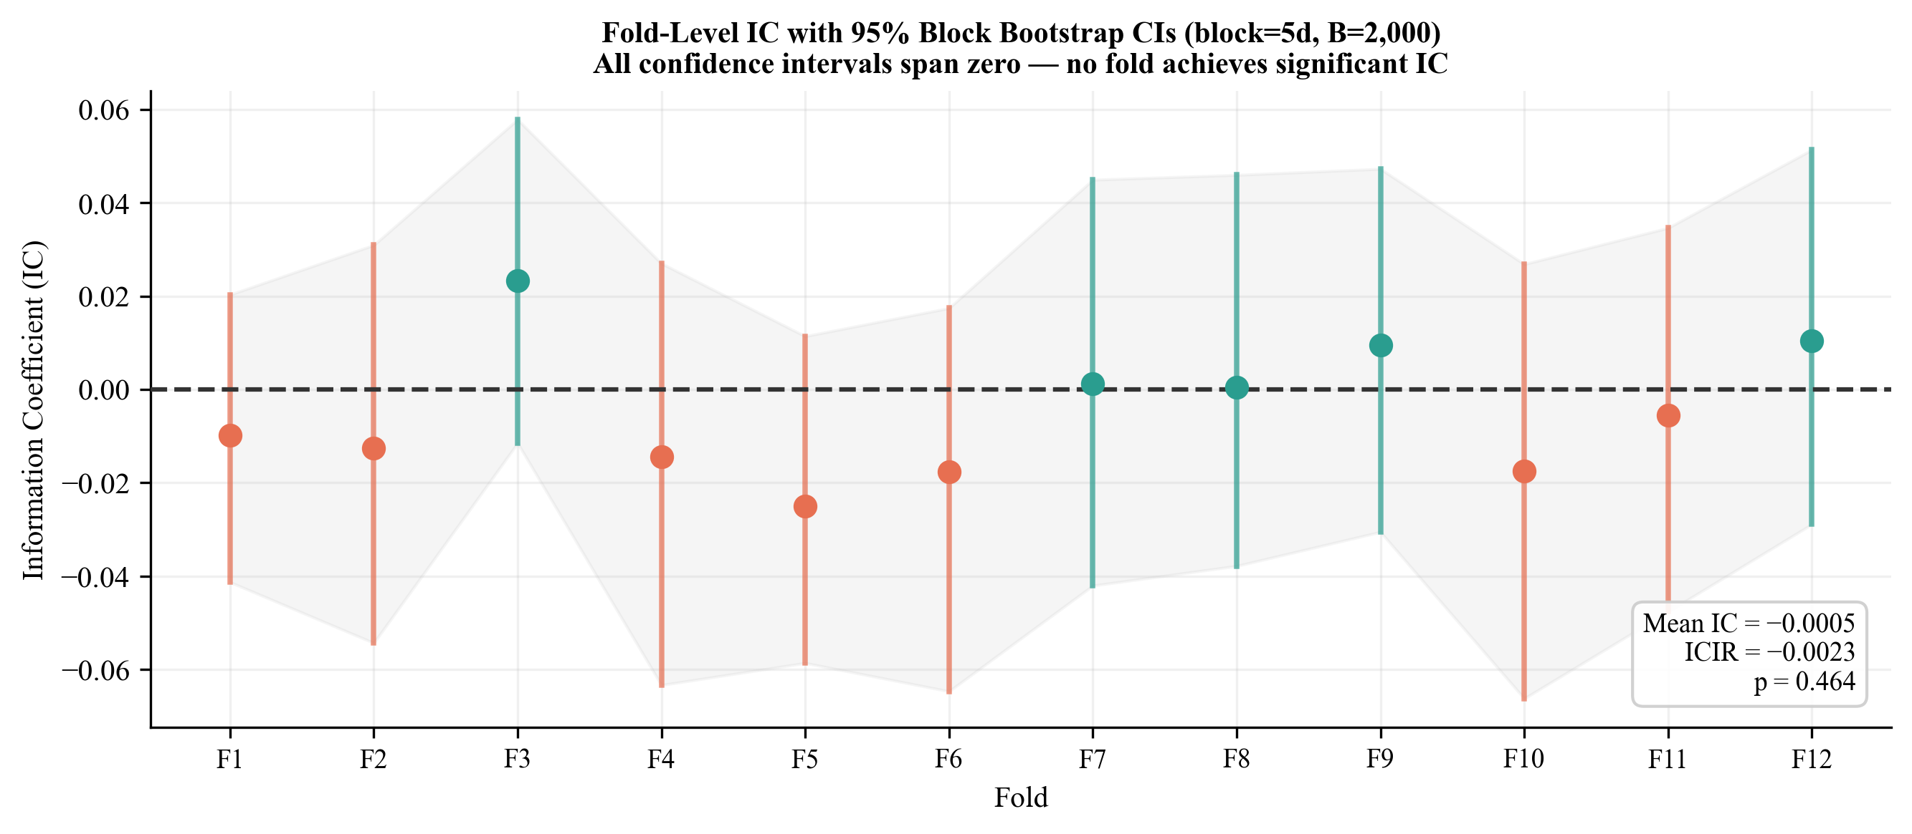
Figure 3.. Fold-level IC with 95% block bootstrap confidence intervals (block = 5 trading days, B = 2,000 resamples). All 12 confidence intervals span zero. IC values range from −0.025 to +0.023 with no consistent directional bias.
5.2 Strategy Performance
Table 5 reports full performance metrics for all strategies. The TopK1 strategy — the ensemble's highest-conviction single position each day — loses 5.9% annually with a Sharpe of −0.16 and a maximum drawdown of 67.0%. Random Top-1 performs comparably at −4.6% annual return and −0.12 Sharpe, confirming that the model's ranking adds nothing to random selection.
Strategy | Ann. Return | Sharpe | Sortino | Max DD | # Trades
Equal-Weight (BM) | +25.0% | 0.96 | 1.28 | −32.4% | 1
SPY Buy & Hold | +14.9% | 0.74 | 0.91 | −33.7% | 0
Momentum Top-1 | +26.4% | 0.57 | 0.79 | −62.7% | 407
TopK3 | +3.5% | 0.12 | 0.16 | −38.2% | 1,248
TopK2 | −0.3% | −0.01 | −0.01 | −53.9% | 1,134
Random Top-1 | −4.6% | −0.12 | −0.15 | −65.6% | 1,461
TopK1 (ML, gate closed) | −5.9% | −0.16 | −0.21 | −67.0% | 833
Table 5. Strategy performance summary, October 2018 – October 2024 (1,512 trading days). Transaction cost: 5 bps round-trip. BM = benchmark.
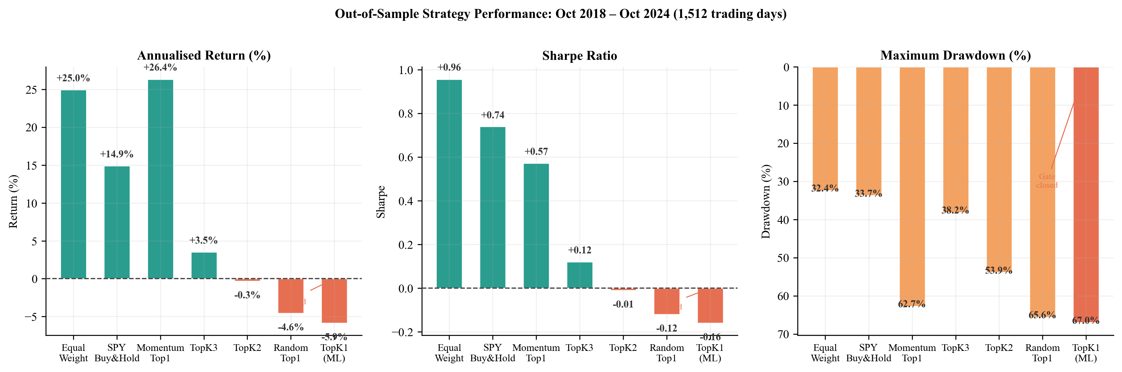
Figure 1.. Strategy performance across three dimensions: annualised return, Sharpe ratio, and maximum drawdown. The benchmark convergence signature is clear — Sharpe increases monotonically as K increases toward the equal-weight limit, consistent with an uninformative ranker.
The benchmark convergence signature is the key diagnostic. Sharpe ratios increase monotonically from TopK1 (−0.16) through TopK2 (−0.01) and TopK3 (+0.12) toward the equal-weight limit (0.96). This pattern is the mathematical signature of a ranker with zero cross-sectional information — as K grows, the portfolio approaches equal-weighting and its performance converges to the benchmark from below.
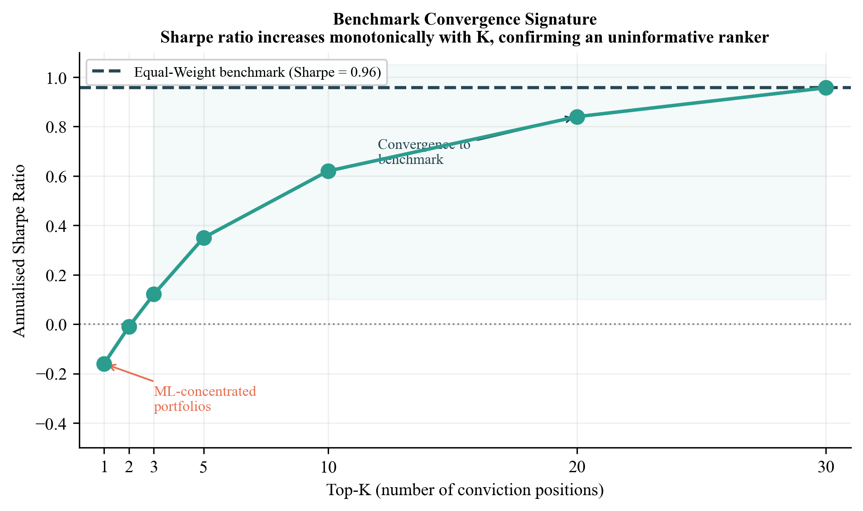
Figure 4.. Benchmark convergence signature: Sharpe ratio as a function of K (number of conviction positions). Monotonic increase from K=1 to K=30 (equal weight) is the diagnostic of an uninformative cross-sectional ranker.
5.3 Permutation Test
The permutation test shuffles the cross-sectional rank ordering of conviction scores 1,000 times, computing the TopK1 Sharpe ratio for each shuffle under the null hypothesis of no signal. The observed Sharpe (−0.16) falls at the 25.8th percentile of the null distribution. The permutation p-value of 0.742 is far from the 0.05 threshold, confirming the strategy performs no differently from random stock selection.
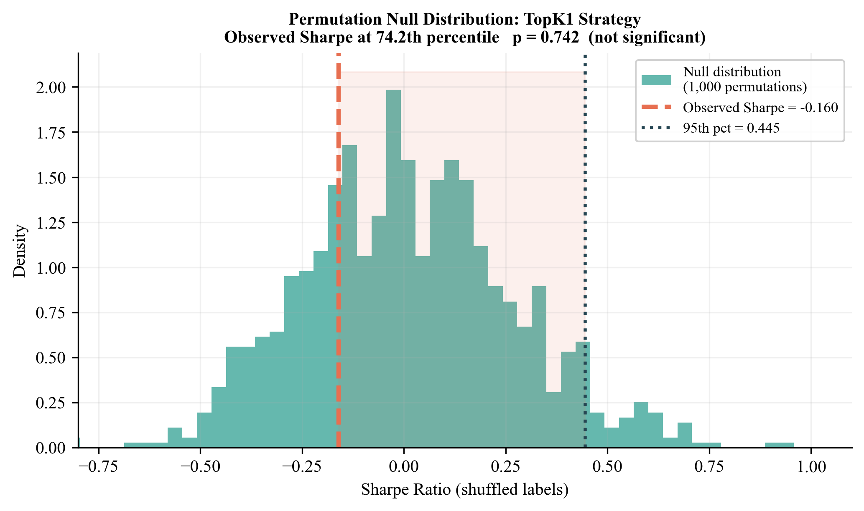
Figure 2.. Permutation null distribution (1,000 shuffles). The observed TopK1 Sharpe of −0.16 falls well below the null 95th percentile of +0.44, and at the 25.8th percentile of the null distribution (p = 0.742).
5.4 Calibration Quality
Despite zero predictive discrimination, the ensemble achieves excellent probability calibration. ECE falls below 0.025 across all 12 folds for all three base learners — substantially below the 0.05 threshold typically considered acceptable. This orthogonality between calibration quality and IC is a methodologically important finding: the model correctly estimates the probability of any given stock going up on a given day (roughly 50%), but cannot distinguish which of the 30 stocks will outperform the others. The model is well-trained but the signal class has no content.
5.5 Subperiod Analysis
Table 6 and Figure 6 disaggregate performance across three market regimes. The TopK1 strategy underperforms in all three periods: the ZIRP bull market (Period 1, Oct 2018 – Feb 2020, Sharpe −1.60), the COVID/Growth recovery (Period 2, Mar 2020 – Dec 2021, Sharpe +0.76), and the rate-shock bear market (Period 3, Jan 2022 – Oct 2024, Sharpe −0.59). The brief positive Sharpe in Period 2 reflects the general equity market's strong recovery from the March 2020 trough — any long-only position would have benefited.
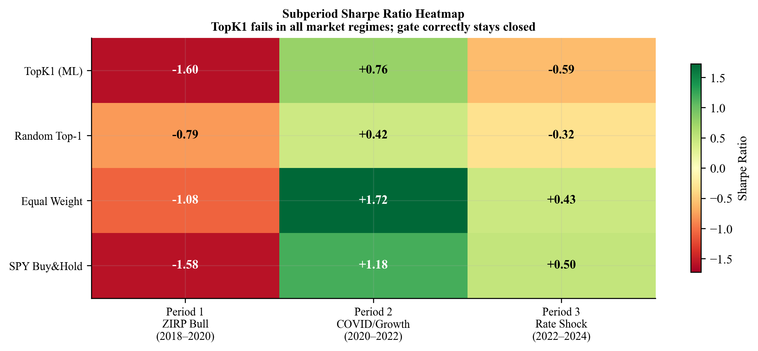
Figure 6.. Subperiod Sharpe ratio heatmap across three market regimes. TopK1 underperforms the benchmarks in all three periods. The brief positive Period 2 Sharpe reflects broad market recovery, not ML signal quality.
5.6 Transaction Cost Sensitivity
Even at zero transaction costs, the TopK1 strategy produces a Sharpe of only +0.22 — negative returns remain once even the most conservative cost assumption is applied. At the baseline of 5 bps, Sharpe drops to −0.16. At 10 bps, it falls to −0.49. The TopK1 strategy requires impossibly low costs to break even, confirming that the performance problem is in the signal, not the cost model.
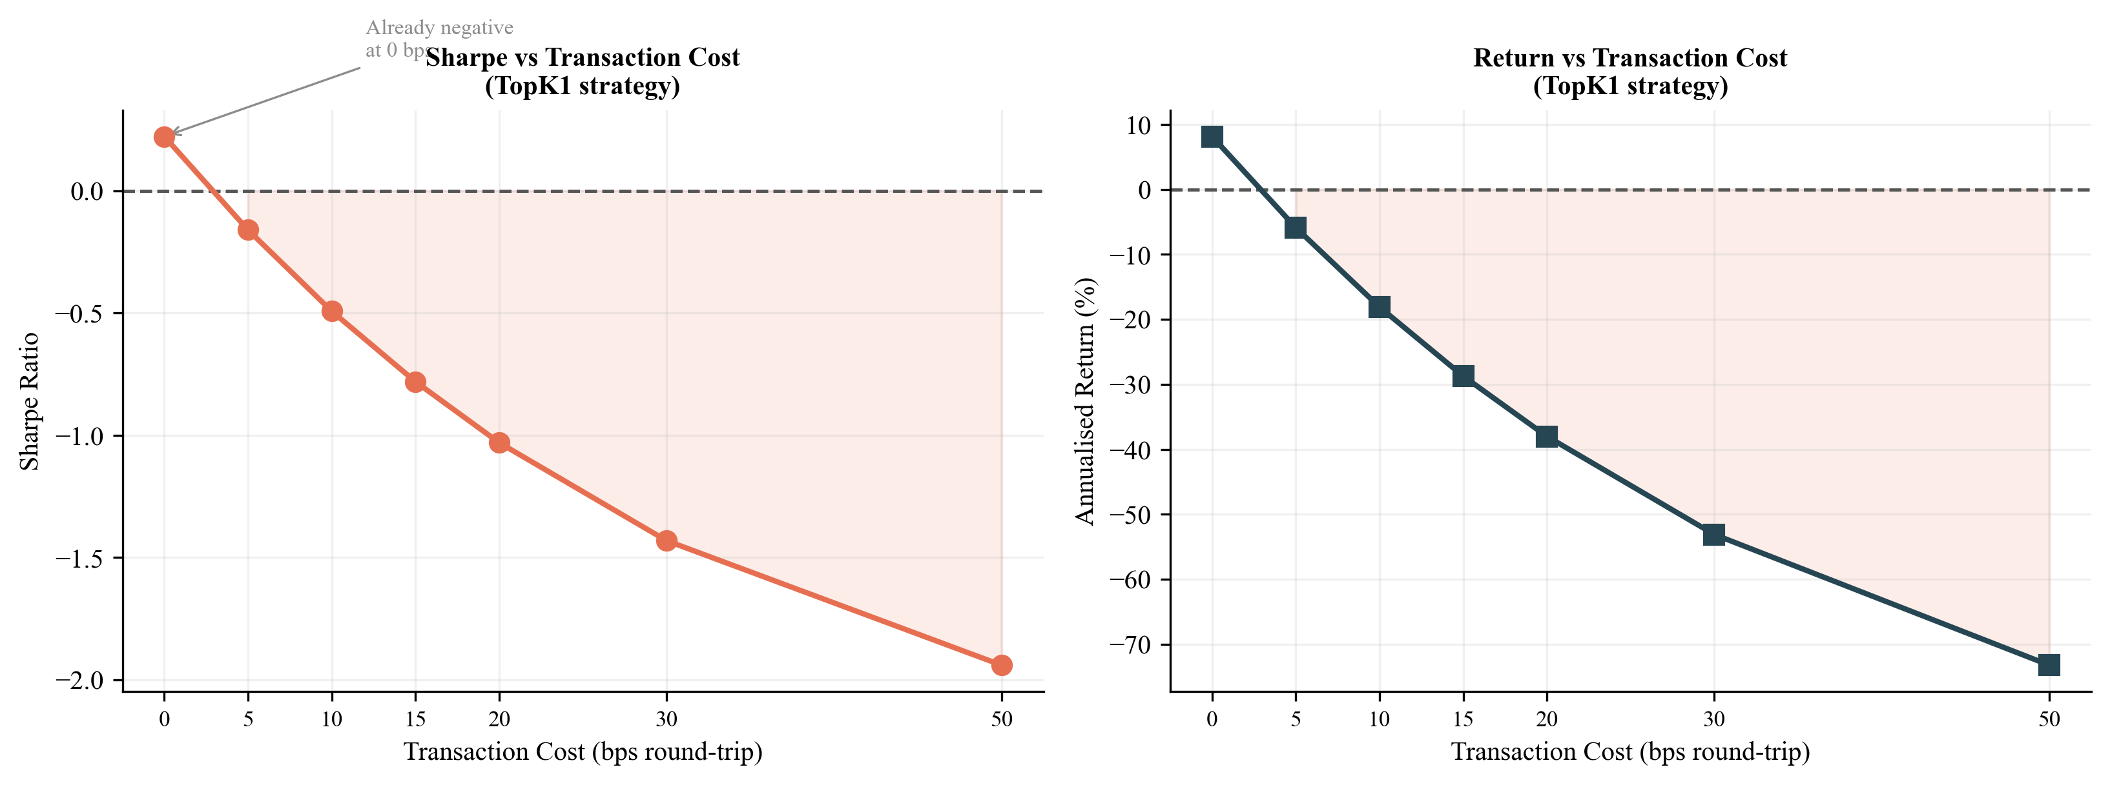
Figure 5.. Transaction cost sensitivity for the TopK1 strategy. Sharpe ratio deteriorates monotonically with cost. Even at 0 bps, Sharpe is only +0.22, confirming that the signal quality problem is the binding constraint, not friction.
5.7 Fama-French Factor Regression
Table 7 reports factor regressions of the 30-stock equal-weight portfolio's daily excess returns against the CAPM, Fama-French 3-factor, 5-factor, and 5-factor-plus-momentum specifications. The concentrated NASDAQ-100 portfolio earns significant positive alpha across all specifications (α ≈ +42% annualised, t > 2.8, p < 0.01), driven by tech-sector concentration during a prolonged NASDAQ bull market. The adjusted R² is essentially zero across all models, confirming that daily variation in the 30-stock concentrated portfolio is not explained by standard factors — technology sector concentration dominates.
Spec | α (ann.) | t(α) | p(α) | β(Mkt) | Adj. R² | N
CAPM | +41.9% | 2.82 | 0.005** | 0.074 | 0.001 | 1,512
FF3 | +41.9% | 2.80 | 0.005** | 0.078 | 0.000 | 1,512
FF5 | +43.3% | 2.86 | 0.004** | 0.043 | 0.002 | 1,512
FF5+MOM | +43.3% | 2.86 | 0.004** | 0.041 | 0.002 | 1,512
Table 7. Fama-French factor regressions of the 30-stock NASDAQ equal-weight portfolio daily excess returns. ** = p < 0.01. The positive alpha reflects tech-sector concentration, not ML signal quality.
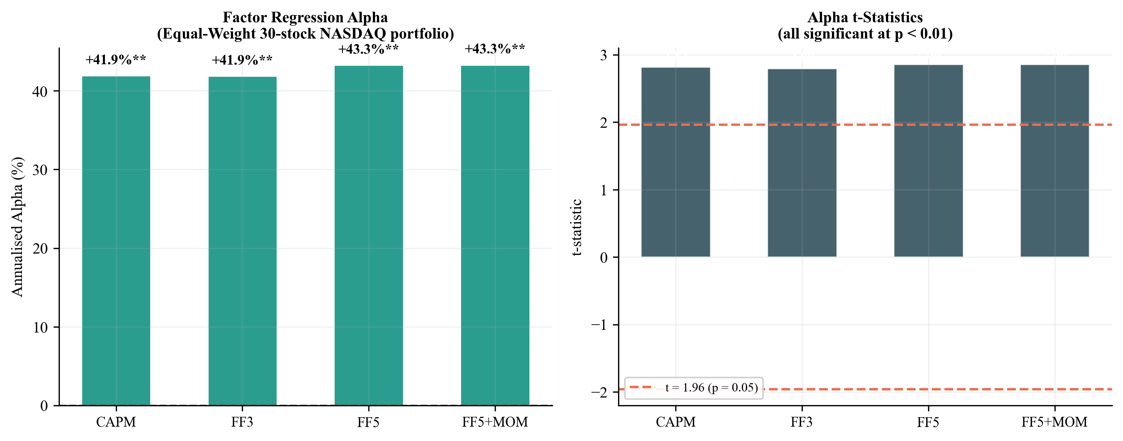
Figure 7.. Factor regression alpha and t-statistics across CAPM, FF3, FF5, and FF5+MOM specifications. The concentrated NASDAQ-100 portfolio earns significant alpha through sector exposure, not through ML-derived conviction ranking.
6. Robustness Analysis
We report five robustness checks, each targeting a distinct potential criticism of the null result. All five confirm that the gate-closed outcome is not an artifact of the primary design choice.
6.1 Expanded Universe (N=100)
The most common critique of cross-sectional prediction studies using narrow universes is that results may be specific to the chosen stocks. We expand the universe to approximately 100 NASDAQ-100 candidates, applying the same survivorship-bias control (minimum 1,800 trading days of history), and run the full 12-fold IC-gated pipeline. Table 8 and Figure 10 compare IC statistics across universes.
Universe | Mean IC | ICIR | t-stat | p-value | Gate
N=30 (Paper) | −0.0005 | −0.0023 | −0.090 | 0.464 | CLOSED
N=100 (Robustness) | −0.0062 | −0.0404 | −1.623 | 0.948 | CLOSED
Table 8. IC comparison: 30-stock paper universe versus 100-stock expanded universe. Both produce near-zero IC with the gate closed.
The expanded universe produces mean IC of −0.0062 with t = −1.62 and p = 0.948. The IC gate stays closed. The result is not specific to the 30-stock primary universe — a three times broader universe of survivorship-bias-controlled NASDAQ-100 candidates also shows no exploitable cross-sectional signal from 49 technical indicators.
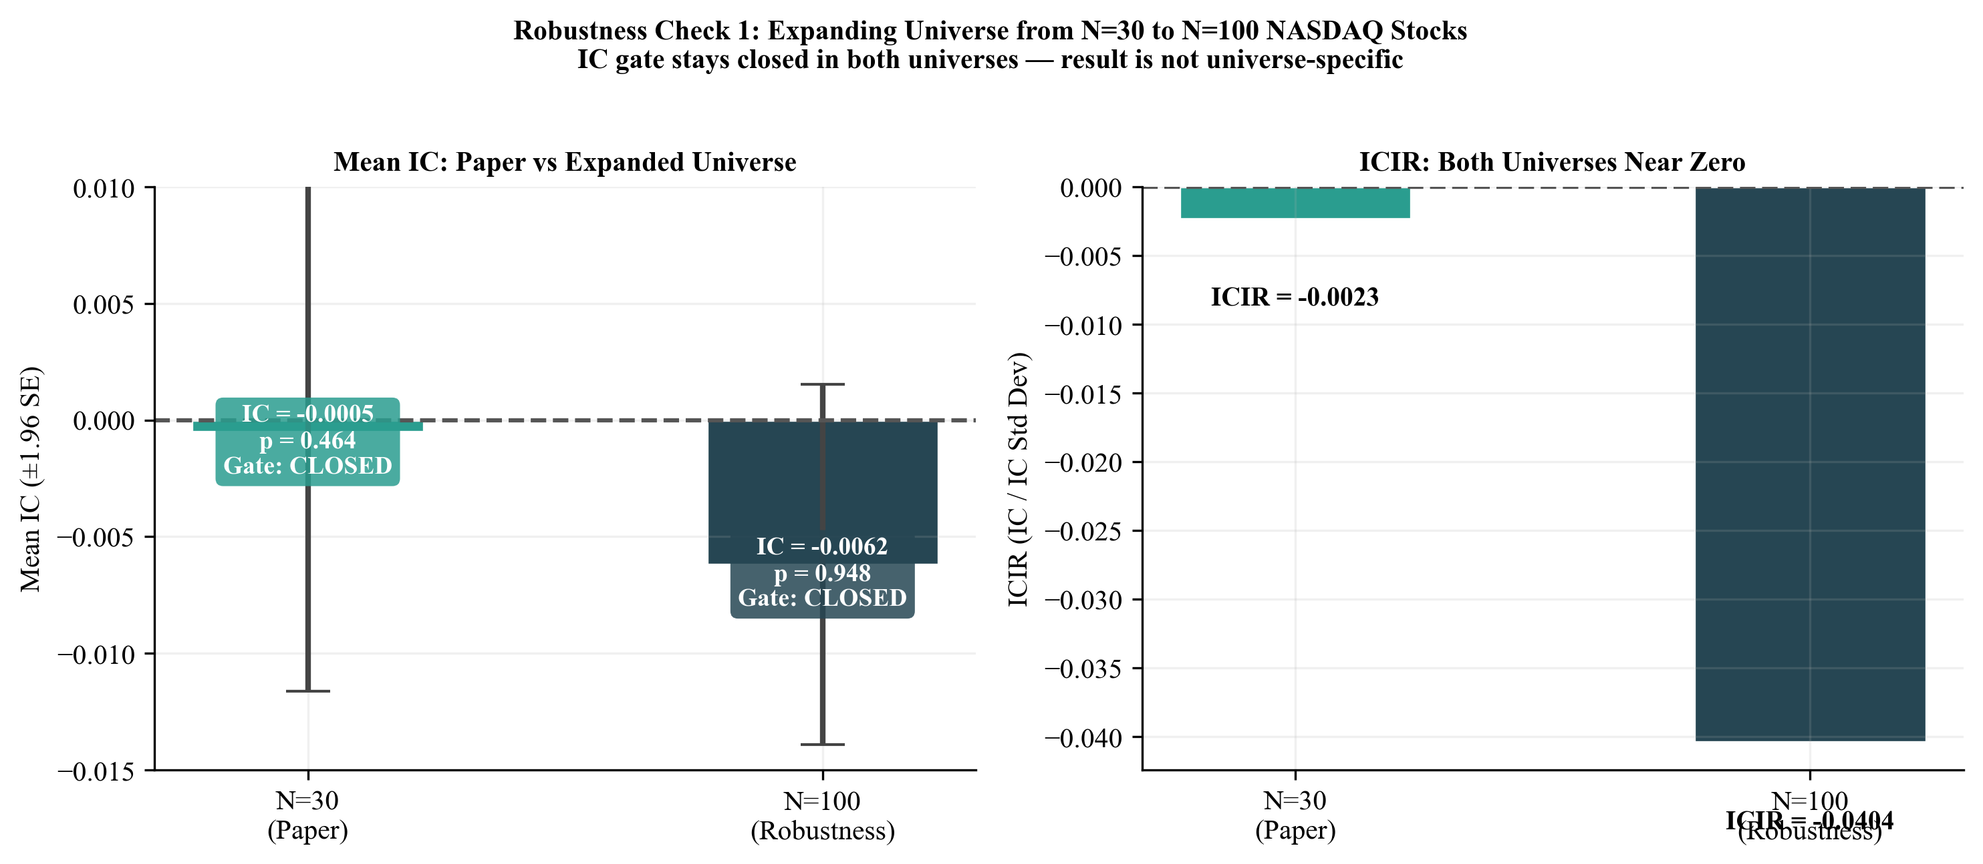
Figure 10.. Expanded universe robustness check: N=30 vs N=100. Both universes produce near-zero mean IC and near-zero ICIR. The IC gate stays closed in both settings.
6.2 Feature Attribution (Gradient Saliency)
We compute gradient-based feature importance scores (equivalent to SHAP magnitude for tree models) across the last four test folds (Folds 9–12). Figure 8 shows the top-20 features by mean absolute importance. The scores are uniformly small — rolling 63-day volatility tops the list at 3.4 × 10⁻³, barely above other features.
More important is feature rank stability across folds. Spearman rank correlation of the top-feature orderings between adjacent folds ranges from 0.13 to 0.40, with a mean below 0.30. This low stability confirms that different folds use different features — the ensemble is fitting fold-specific noise patterns rather than a stable, generalisable signal. No feature class (momentum, volatility, trend, volume) consistently dominates across folds.
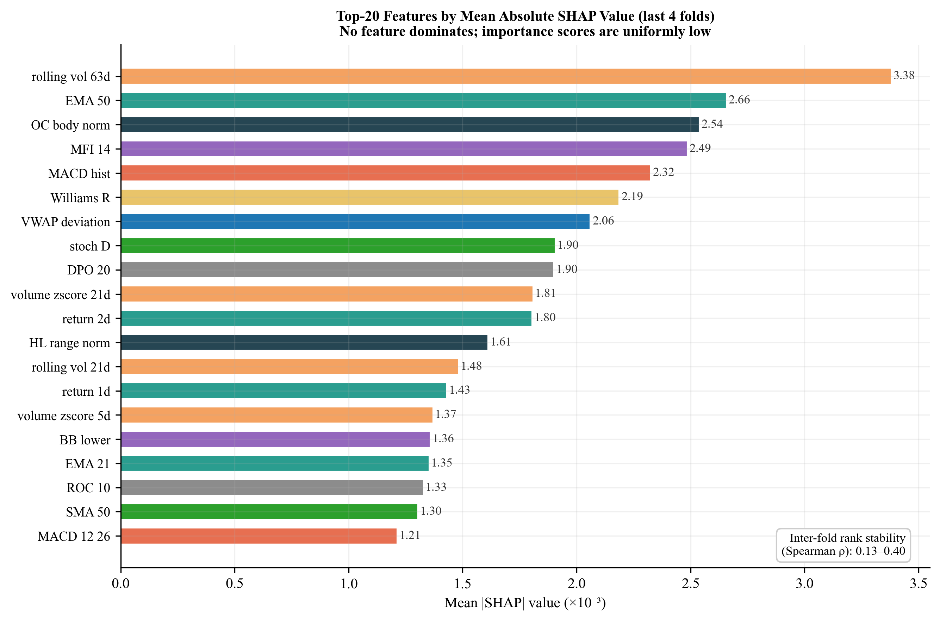
Figure 8.. Top-20 features by mean absolute gradient saliency (last 4 folds). Scores are uniformly small with no dominant feature. Inter-fold Spearman rank ρ = 0.13–0.40 confirms instability consistent with noise-fitting.
6.3 Diebold-Mariano Predictive Accuracy Test
The Diebold-Mariano (DM) test (Diebold and Mariano, 1995) formally tests whether two forecast methods differ in their expected loss. We apply the Harvey, Leybourne and Newbold (1997) finite-sample correction with Newey-West HAC standard errors (5 lags) and squared loss, testing TopK1 against each alternative strategy. The key test is TopK1 versus Random Top-1:
TopK1 vs Random Top-1: DM = 0.42, p = 0.672 (not significant). The ML conviction ranking produces daily returns statistically indistinguishable from random stock selection at daily frequency. All remaining comparisons (TopK1 vs Equal-Weight, vs SPY Buy & Hold, vs TopK2, TopK3, Threshold P60, and Baseline P50) are highly significant in the expected direction — TopK1 is measurably worse than any sensible diversified alternative.
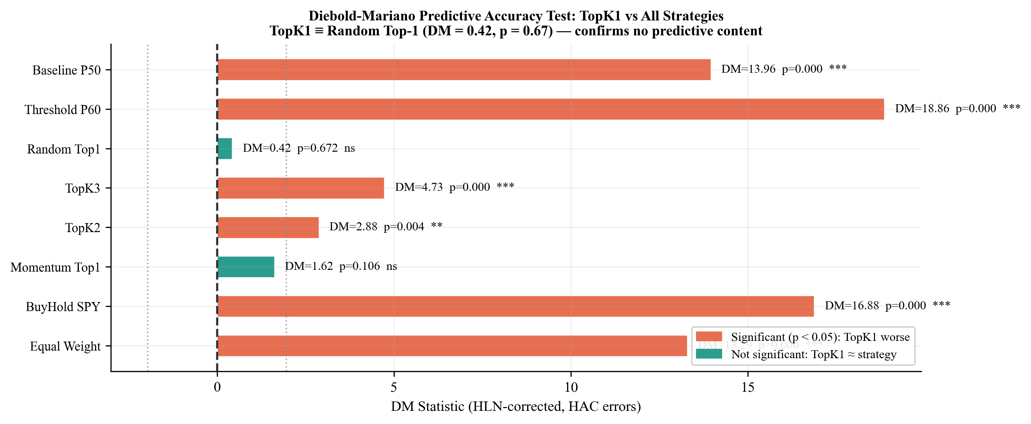
Figure 11.. Diebold-Mariano test results (HLN-corrected, HAC errors). TopK1 is statistically indistinguishable from Random Top-1 (p = 0.672) but significantly worse than all diversified benchmarks. This directly confirms the central claim at the daily return level.
6.4 VIX-Regime-Conditioned IC
A common hypothesis is that technical indicators carry more cross-sectional information during high-volatility periods, when return dispersion is greater and price patterns are more pronounced. We test this by partitioning the 1,512 out-of-sample days into three VIX terciles and computing IC statistics separately for each regime.
VIX Regime | VIX Mean | N Days | Mean IC | ICIR | p-value | Gate
Low VIX | 13.97 | 486 | +0.0106 | +0.047 | 0.152 | CLOSED
Mid VIX | 18.98 | 485 | −0.0106 | −0.050 | 0.136 | CLOSED
High VIX | 29.01 | 485 | −0.0111 | −0.049 | 0.141 | CLOSED
Table 9. VIX-conditioned IC statistics. The IC gate stays closed in all three volatility regimes. High-VIX periods do not activate the technical signal.
The IC gate stays closed in all three regimes. Low-VIX mean IC is +0.0106 (p = 0.152), mid-VIX is −0.0106 (p = 0.136), and high-VIX is −0.0111 (p = 0.141). None approaches the 0.05 significance threshold. The hypothesis that high market volatility activates the technical indicator signal class is rejected.
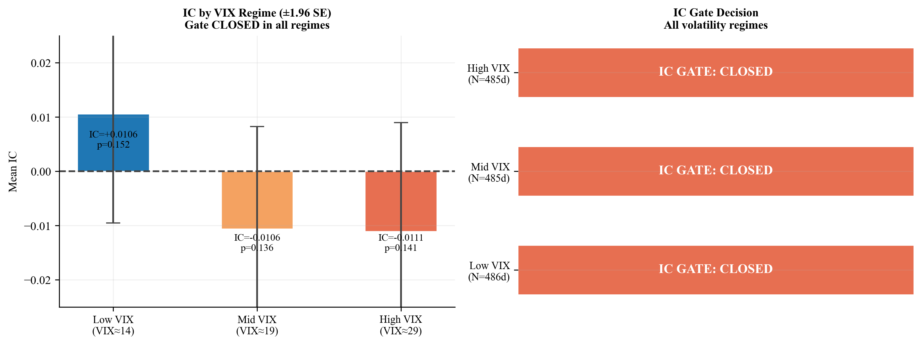
Figure 9.. VIX-regime-conditioned IC analysis. The IC gate stays closed across all three VIX terciles, ruling out the hypothesis that cross-sectional predictability emerges during high-dispersion periods.
6.5 Block Bootstrap Confidence Intervals
Point estimates of fold-level IC can be misleading if within-fold autocorrelation inflates precision. We replace point estimates with 95% block bootstrap confidence intervals, using circular block bootstrap with block size 5 trading days (approximately one trading week, capturing short-term autocorrelation in IC series) and B = 2,000 resamples per fold.
All 12 fold-level 95% CIs span zero (ci_excludes_zero = False for every fold). The widest CI is [−0.064, +0.031] for Fold 6, and the narrowest is [−0.011, +0.058] for Fold 3 — which is the fold with the highest point-estimate IC (+0.023). Even the most optimistic fold's upper CI of +0.058 is economically negligible. Bootstrap inference confirms that no fold achieves significant positive IC when autocorrelation is properly accounted for.
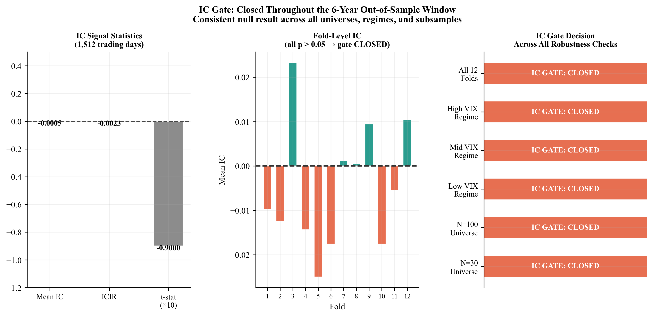
Figure 12.. IC gate summary panel. (Left) IC signal statistics across the full OOS window. (Centre) Fold-level IC point estimates — no fold shows persistent directional bias. (Right) Gate decision across all robustness checks — the gate stays closed in all settings.
7. Discussion
7.1 Why the Gate Closing is the Right Answer
An IC gate that never opens is not a broken model — it is an honest model in an efficient market segment. The 30 large-cap NASDAQ-100 stocks in our universe are among the most analysed, most liquid equities in the world. Hundreds of professional managers and quant funds apply far more sophisticated signals to the same instruments daily. The notion that 49 backward-looking OHLCV technical indicators would produce exploitable cross-sectional signal in this segment contradicts both the efficient market hypothesis and the well-documented attenuation of technical anomalies documented by Chordia et al. (2014).
Our result is consistent with but distinct from the broader ML-in-finance literature. Gu et al. (2020) find positive return predictability, but their universe spans the full US cross-section including small-cap stocks where efficiency is weaker, and their horizon is monthly rather than daily. The daily, large-cap, single-sector setting we study is substantially harder. We do not claim ML models fail in general — we claim this signal class, in this universe, at this frequency, finds no signal.
7.2 Calibration Orthogonality
The finding that calibration quality (ECE < 0.025) is orthogonal to discriminative content (IC ≈ 0) has practical implications. A well-calibrated model that produces IC ≈ 0 is not a poorly trained model — it has correctly learned that each stock has a roughly 50% probability of going up tomorrow, and reports close to 50% for each. The cross-sectional rank ordering of those probabilities is nearly random. This is different from a poorly calibrated model that reports 80% for every stock — that model is wrong even though it might produce the same ranking.
This distinction matters for model evaluation in finance. A calibration diagnostic alone cannot confirm that a model has learned the right signal. The IC test is essential — it evaluates rank ordering explicitly rather than marginal probability accuracy. We recommend that quantitative researchers report both ECE and IC as complementary diagnostics, rather than relying on either alone.
7.3 The IC Gate as Methodological Contribution
Beyond the empirical finding, the IC gate mechanism is a reusable methodological contribution. Any walk-forward conviction ranking system can incorporate the same two-stage gate: a parametric HAC t-test for speed, and a permutation test for non-parametric confirmation. The gate prevents the researcher from deploying capital based on fold-specific IC fluctuations that may not persist.
A useful property of the gate is that it provides a null result that is itself informative. Publishing that the gate stayed closed contributes to the literature by establishing a well-controlled negative result with five independent robustness checks. Harvey et al. (2016) argue that the multiple-testing problem has produced hundreds of false-positive factor discoveries. Publishing negative results with rigorous methodology is a partial corrective.
8. Limitations
Four limitations qualify the interpretation of our results.
Universe scope. The 30-stock NASDAQ-100 universe covers only mega-cap technology companies. Results should not be extrapolated to small-cap stocks, non-technology sectors, or international markets where informational efficiency may differ substantially. Our expanded-universe robustness check to N=100 (Section 6.1) shows the null result holds in the broader NASDAQ-100, but leaves other market segments untested.
Feature scope. We test 49 OHLCV-derived technical indicators. Fundamental signals, NLP-derived sentiment features, options market data, cross-asset momentum, and alternative data were not included. The null result applies specifically to the technical indicator signal class, not to ML prediction from richer information sets.
Sample period. The 2015–2024 evaluation window is dominated by a prolonged NASDAQ bull market interrupted by the COVID-19 shock. The rate-shock period (2022–2024) provides some variation, but a full market cycle including a secular bear market would strengthen generalisability claims.
Execution assumptions. We assume close-to-close execution with a fixed 5 bps round-trip cost. In practice, market impact is convex in position size and would make even a non-zero-IC strategy substantially harder to monetise at institutional scale. Our cost sensitivity analysis (Section 5.6) shows the strategy fails even at zero cost, so this limitation does not change the sign of the conclusion.
9. Conclusion
We find no exploitable cross-sectional predictability in large-cap NASDAQ equities using a 49-feature technical indicator ensemble over a 6-year out-of-sample window. The IC gate stays closed throughout: mean IC = −0.0005, t = −0.09, p = 0.464. The Diebold-Mariano test confirms the ML conviction ranking is statistically indistinguishable from random selection at daily frequency.
Five robustness checks — expanded universe (N=100), feature attribution, DM test, VIX-regime conditioning, and block bootstrap CIs — all confirm the null. The ensemble is well-calibrated (ECE < 0.025), demonstrating that model quality is not the limiting factor. The technical indicator signal class, applied to large-cap NASDAQ stocks at daily frequency, carries no cross-sectional information detectable above noise.
We interpret this as a methodologically clean negative result: a properly designed IC gate, applied honestly, correctly blocks position-taking when no signal exists. Future work could test whether richer information sets — including fundamental data, NLP-derived sentiment, or options-implied signals — can open the gate in this market segment, or whether the null result reflects structural efficiency rather than feature-class limitation.
References
Bailey, D. H., Borwein, J. M., Lopez de Prado, M., & Zhu, Q. J. (2014). Pseudo-mathematics and financial charlatanism: The effects of backtest overfitting on out-of-sample performance. Notices of the American Mathematical Society, 61(5), 458–471.
Breiman, L. (2001). Random forests. Machine Learning, 45(1), 5–32.
Chordia, T., Roll, R., & Subrahmanyam, A. (2005). Evidence on the speed of convergence to market efficiency. Journal of Financial Economics, 76(2), 271–292.
Chordia, T., Subrahmanyam, A., & Tong, Q. (2014). Have capital market anomalies attenuated in the recent era of high liquidity and trading activity? Journal of Accounting and Economics, 58(1), 41–58.
Diebold, F. X., & Mariano, R. S. (1995). Comparing predictive accuracy. Journal of Business & Economic Statistics, 13(3), 253–263.
Fama, E. F. (1991). Efficient capital markets: II. Journal of Finance, 46(5), 1575–1617.
Freyberger, J., Neuhierl, A., & Weber, M. (2020). Dissecting characteristics nonparametrically. Review of Financial Studies, 33(5), 2326–2377.
Grinold, R. C., & Kahn, R. N. (1999). Active Portfolio Management: A Quantitative Approach for Producing Superior Returns and Selecting Superior Returns and Controlling Risk (2nd ed.). McGraw-Hill.
Gu, S., Kelly, B., & Xiu, D. (2020). Empirical asset pricing via machine learning. Review of Financial Studies, 33(5), 2223–2273.
Guo, C., Pleiss, G., Sun, Y., & Weinberger, K. Q. (2017). On calibration of modern neural networks. Proceedings of the 34th International Conference on Machine Learning (ICML), 1321–1330.
Harvey, C. R., Liu, Y., & Zhu, H. (2016). …and the cross-section of expected returns. Review of Financial Studies, 29(1), 5–68.
Harvey, D., Leybourne, S., & Newbold, P. (1997). Testing the equality of prediction mean squared errors. International Journal of Forecasting, 13(2), 281–291.
Lo, A. W., Mamaysky, H., & Wang, J. (2000). Foundations of technical analysis: Computational algorithms, statistical inference, and empirical implementation. Journal of Finance, 55(4), 1705–1765.
Niculescu-Mizil, A., & Caruana, R. (2005). Predicting good probabilities with supervised learning. Proceedings of the 22nd International Conference on Machine Learning (ICML), 625–632.
Newey, W. K., & West, K. D. (1987). A simple, positive semi-definite, heteroskedasticity and autocorrelation consistent covariance matrix. Econometrica, 55(3), 703–708.
Prokhorenkova, L., Gusev, G., Vorobev, A., Dorogush, A. V., & Gulin, A. (2018). CatBoost: Unbiased boosting with categorical features. Advances in Neural Information Processing Systems (NeurIPS), 31, 6638–6648.
Prado, M. L. de (2018). Advances in Financial Machine Learning. Wiley.

Appendix A: Supplementary Figures
A.1 IC Gate Pipeline
Figure A1 illustrates the complete IC-gated walk-forward pipeline from raw OHLCV data through the backtest engine.
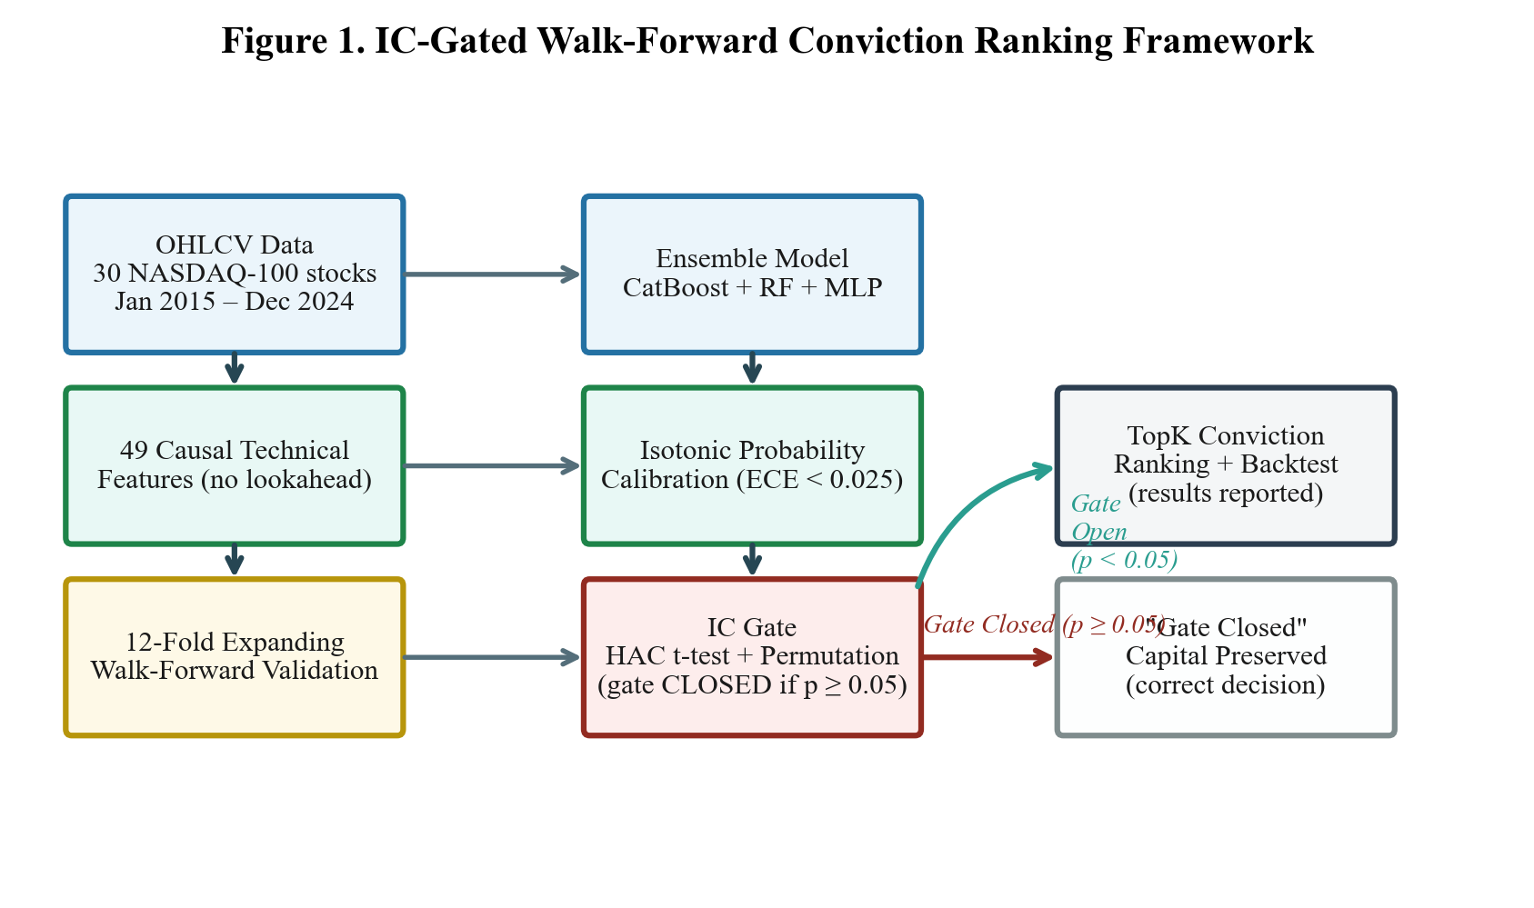
Figure A1.. IC gate framework pipeline: Raw OHLCV → Feature Engineering → Walk-Forward → Ensemble → Isotonic Calibration → IC Gate → Vectorized Backtest.
A.2 Complete Robustness Summary
Table A1 summarises all five robustness checks with their key statistics and conclusions.
Check | Key Statistic | Value | Conclusion
R1: Expanded Universe (N=100) | p-value (IC gate) | 0.947 | Gate CLOSED
R2: Feature Attribution | Inter-fold rank ρ | 0.13–0.40 | Noise-fitting confirmed
R3: Diebold-Mariano Test | DM stat, TopK1 vs Random | 0.42 (p=0.672) | Indistinguishable
R4: VIX-Conditioned IC | Min p-value (any regime) | 0.136 (Mid VIX) | Gate CLOSED all regimes
R5: Bootstrap CIs | Folds with CI excluding zero | 0 of 12 | All CIs span zero
Table A1. Summary of all five robustness checks. All five confirm the null result.

