The transaction cost trap: Why machine learning stock prediction fails economically under realistic market frictions
Rajveer Singh Pall
Department of Computer Science and Business Systems
Gyan Ganga Institute of Technology and Sciences
Jabalpur, Madhya Pradesh 482003, India
Email: rajveerpall05@gmail.com
Tel: +91-7000700355
*Corresponding author
Abstract
A central paradox pervades the machine learning finance literature: models in the existing literature often report statistically significant directional accuracy, yet this does not translate into economically positive post-cost performance. We document this paradox using a regime-filtered ensemble of CatBoost, Random Forest, and Deep Neural Networks evaluated on a panel of seven large-cap technology stocks (17,773 stock-day observations; January 2015–April 2025) under strict walk-forward validation. The ensemble achieves up to 73.3% conditional directional accuracy in regime-filtered bear-market trades, yet generates −42.49% annually (Sharpe −2.83) after realistic 5 basis point execution costs, while passive buy-and-hold earns 34.77% (Sharpe 1.21) over the same period. At zero cost, the strategy earns 4.61% annually (Sharpe 0.31), confirming that the gap arises primarily from transaction cost drag. We term this the transaction cost trap. First, a closed-form breakeven accuracy formula shows that at 471 trades per year and 5 bps costs, profitable trading requires 88% accuracy—15 percentage points beyond our best conditional result. Second, magnitude asymmetry (winning trades +0.08%, losing trades −0.31%, a 3.9× ratio) implies negative expected value per trade regardless of win rate. Third, feature attribution reveals volume-based signals dominate (normalised importance 100.0 versus 34.1 for one-day returns), supporting an institutional flow hypothesis: models detect multi-day algorithmic execution footprints but cannot isolate the price magnitude the institutional order suppresses. These results are consistent with weak-form market efficiency. Post-cost returns, trade frequency, magnitude asymmetry, and breakeven accuracy thresholds are primary measures of economic validity—not supplementary disclosures.

Keywords: machine learning; transaction costs; financial markets; algorithmic trading; walk-forward validation; market microstructure; publication bias; reproducibility; market efficiency; ensemble methods

1. Introduction
Machine learning approaches to equity prediction have generated a literature of apparently impressive results. Fischer and Krauss (2018) report 82% annual returns using Long Short-Term Memory networks; Krauss et al. (2017) document Sharpe ratios of 1.81 with gradient-boosted ensembles; Bollen et al. (2010) achieve 87.6% directional accuracy incorporating Twitter sentiment. However, these results may not translate into economically viable strategies once realistic trading frictions are considered.
A practitioner deploying any of these strategies would encounter a reality that the published accuracy figures obscure: transaction costs erode or eliminate the gross returns before meaningful capital appreciation occurs. Consider the arithmetic. A strategy achieving 60% directional accuracy with 500 trades annually at 5 basis points (bps) per half-turn incurs approximately 50% annual cost drag—a figure that overwhelms the gross return of any strategy operating near the boundary of statistical significance. This is the transaction cost trap: the systematic disconnect between classification accuracy as optimised by machine learning models and economic profitability as realised by traders.
The trap arises from three compounding factors that standard machine learning evaluation frameworks do not address. First, most studies report pre-cost performance, treating transaction costs as a secondary consideration rather than the primary determinant of strategy viability. Second, studies rarely quantify the relationship between trade frequency and the breakeven accuracy threshold—a relationship that is linear, computable in closed form, and highly informative about practical deployment limits. Third, studies optimise for directional accuracy without examining magnitude asymmetry between winning and losing trades. A strategy can achieve 70% win rates and lose money systematically if losing trades are substantially larger than winning ones, as our results demonstrate precisely.
This paper documents the transaction cost trap using a rigorously constructed ensemble evaluated under conditions designed to address the methodological limitations of the existing literature. Our contributions are as follows. First, we derive a closed-form breakeven accuracy formula that maps the accuracy-frequency-cost surface, determining whether any directional prediction strategy can achieve positive returns. Second, we provide a comprehensive failure diagnosis of a strategy achieving up to 73.3% conditional accuracy that nonetheless produces Sharpe −2.83 after realistic costs. Third, we propose and support the institutional flow hypothesis as a theoretical explanation for why volume-based signals dominate feature attribution rankings. Fourth, we conduct rigorous probability calibration analysis, revealing systematic overconfidence that renders ensemble probabilities unsuitable for position sizing. Fifth, we provide a fully reproducible open-source implementation. The remainder of this paper is organised as follows: Section 2 reviews related work; Section 3 describes the data, features, and methodology; Section 4 presents results; Section 5 discusses implications; Section 6 concludes.

2. Related work
2.1. Machine learning in equity prediction
Fischer and Krauss (2018) deployed Long Short-Term Memory networks on S&P 500 constituent data spanning 1992–2015, reporting 82% annual returns before transaction costs. Their approach, while methodologically careful regarding data leakage, evaluated performance without applying any execution costs—rendering the results directly non-comparable with real-world deployment. Krauss et al. (2017) achieved Sharpe ratios of 1.81 using ensembles combining gradient-boosted trees, random forests, and deep neural networks—architecturally similar to the present study—but similarly lacked transaction cost analysis. Bollen et al. (2010) demonstrated 87.6% directional accuracy incorporating Twitter sentiment analysis, but evaluated performance over only 10 months without economic validation.
Gu et al. (2020), in a comprehensive study of machine learning methods in empirical asset pricing, found that while ML models provide modest improvements over linear benchmarks in predicting monthly equity returns, performance is highly sensitive to regularisation choices and concentrates in micro-cap stocks where transaction costs are prohibitive. This finding is particularly relevant to the present study: the accuracy improvements documented by Gu et al. (2020) do not translate linearly into economic improvements, precisely the mechanism we document at daily frequency. Harvey et al. (2016) demonstrated through extensive multiple-testing analysis that most published trading strategies fail to achieve statistical significance after applying appropriate Bonferroni corrections, arguing the empirical finance literature suffers from widespread p-hacking and cherry-picking of successful results. This publication bias is a primary motivation for the present study's explicit focus on negative results.
López de Prado (2018) provided the most systematic treatment of data leakage problems in financial machine learning, cataloguing improper temporal splits, forward-looking feature construction, survivorship bias in sample selection, and inadequate cross-validation procedures as endemic problems in the literature. Our walk-forward validation methodology directly addresses each of these concerns. Leippold et al. (2022) conducted a large-scale replication of machine learning trading strategies and found that most published strategies produce substantially lower out-of-sample returns than in-sample estimates, consistent with our observed 37 percentage point train-validation accuracy gap.
2.2. Transaction costs and market efficiency
The theoretical relationship between transaction costs and exploitable alpha is well-established in the asset pricing literature. Lesmond et al. (2004) demonstrated that canonical momentum profits documented by Jegadeesh and Titman (1993) largely disappear once realistic trading costs are incorporated—a finding we extend to modern machine learning approaches. Avellaneda and Lee (2010) showed that statistical arbitrage in equities requires execution costs below approximately 5–10 bps per half-turn for liquid securities to sustain positive expected returns, which is precisely the range we adopt as our conservative institutional baseline. Almgren and Chriss (2001) formalised the trade-off between execution speed and market impact, demonstrating that optimal execution algorithms deliberately sacrifice price improvement to minimise total trading costs—a mechanism central to the institutional flow hypothesis we develop in Section 5.
Fama's (1970) efficient market hypothesis in weak form predicts that strategies based solely on historical price information should not yield abnormal returns after transaction costs. Our pre-cost result of 4.61% annual return (Sharpe 0.31) is consistent with borderline weak-form efficiency: a statistically faint pattern that is entirely consumed by realistic frictions. This alignment with a core theoretical prediction of financial economics strengthens the interpretation of our empirical findings.
2.3. The gap this paper addresses
Despite extensive research on both machine learning in equity prediction and market microstructure, no prior study has explicitly mapped the accuracy-frequency-cost surface that determines whether a given ML directional strategy is economically viable. Studies in the prediction literature report classification metrics; studies in the microstructure literature document cost structures. The bridge between them—the exact breakeven accuracy threshold a strategy must achieve given its trade frequency and cost environment—has not received systematic treatment. This paper provides that bridge through the closed-form formula in Section 3.5 and the breakeven surface in Table 5. A secondary gap is the near-complete absence of published negative results in financial ML: most studies optimise to show success, creating publication bias that misleads both researchers and practitioners about the realistic viability of ML-based trading strategies.

3. Methodology
3.1. Data
We analyse a balanced panel of seven large-cap technology stocks (AAPL, AMZN, GOOGL, META, MSFT, NVDA, TSLA) from January 2015 to April 2025. The dataset comprises 17,773 stock-day observations (7 tickers × 2,539 trading days). These securities were selected for four reasons: high liquidity with daily trading volumes consistently exceeding $10 billion; tight bid-ask spreads of 1–3 bps, providing a conservative test environment where execution costs are minimal relative to any other equity class; broad representation across the technology sector; and extensive coverage in prior financial ML studies, enabling direct comparison. Table 1 summarises key dataset statistics.

Table 1. Dataset summary statistics
Characteristic | Value
Total stock-day observations | 17,773
Unique tickers | 7 large-cap technology stocks
Trading days per ticker | 2,539
Panel structure | 7 tickers × 2,539 days = 17,773
Positive days (up / down days) | 52.4% (9,307 / 8,466)
Mean daily return | 0.109%
Std. dev. daily return | 2.07%
Evaluation period | January 2015 – April 2025

The evaluation period was deliberately constructed to span multiple distinct market regimes: the 2015–2019 sustained bull market; the March 2020 COVID crash in which the S&P 500 declined 34% in 33 trading days; the 2020–2022 recovery followed by the Federal Reserve tightening-cycle bear market; and the 2023–2025 AI-driven rally. This regime diversity is essential for avoiding the regime-specific overfitting that afflicts studies evaluated exclusively during bull markets, which represent the majority of published ML trading studies. All price data were sourced via the yfinance library from Yahoo Finance and adjusted for stock splits and dividend payments to ensure price continuity. The binary classification target is: label = 1 if next-day close-to-close return exceeds zero, otherwise label = 0. The 52.4% positive day rate reflects the bull-market bias of the 2015–2025 evaluation window and is explicitly accounted for in statistical tests through appropriate null hypothesis specification.
3.2. Feature engineering
We engineer 47 technical features organised into eight categories. All features are computed using exclusively historical data available at time t to predict returns at time t+1, with no forward-looking information. Features undergo per-ticker standardisation using rolling 250-day z-scores, computed with a closed='left' parameter ensuring the current observation is never included in its own normalisation statistics. The choice of a 250-day window corresponds approximately to one trading year and provides sufficient history for stable mean and variance estimates while remaining sensitive to regime shifts.
The eight feature categories and their economic rationale are as follows. (i) Price action features (6 features: open, high, low, close, volume, day-over-day volume change) capture the fundamental daily market information. (ii) Momentum indicators (5 features: RSI(14), MACD(12,26,9), Stochastic Oscillator(14,3,3)) measure the speed and change of price movements, theoretically linked to behavioural biases and institutional rebalancing cycles. (iii) Trend indicators (8 features: SMA(20,50,200), EMA(12,26), ADX(14), 20- and 60-day momentum, price-to-SMA ratios) identify the dominant directional tendency over multiple time horizons. (iv) Volatility measures (7 features: Bollinger Bands with bandwidth, ATR(14), 20-day rolling standard deviation, Bollinger Band percentage position) capture the uncertainty environment, which affects both institutional execution behaviour and the magnitude of daily price moves. (v) Volume-based features (4 features: On-Balance Volume, Chaikin Money Flow(20), VWAP, volume ratio to 20-day average) are the category of primary theoretical interest, as they proxy institutional order flow. (vi) Short-term return features (5 features: 1-, 2-, 3-, 5-, and 10-day returns) capture near-term price momentum and mean-reversion patterns. (vii) Medium-term return features (7 features: 20-, 30-, 60-, 90-, 120-, 150-, and 200-day returns) capture longer-horizon trend persistence. (viii) Additional oscillators (5 features: Williams %R(14) and momentum derivatives) provide additional nonlinear views of overbought/oversold conditions.
3.3. Walk-forward validation
We implement an expanding walk-forward validation design to prevent the data leakage that is the most common source of inflated backtest results in financial machine learning. The training window begins at 750 days (approximately three trading years, sufficient to cover at least one full market cycle) and expands by 250 days per fold. The test window is a fixed, non-overlapping 250-day horizon, approximately equivalent to one trading year. This design produces approximately 10 folds and 2,160 out-of-sample test observations covering the final portion of the evaluation period.
Three additional precautions are taken to prevent any form of data leakage. First, all three models are fully retrained from scratch at each fold using only historical data available up to that fold's training cutoff date. Second, hyperparameter configurations are held fixed across all folds as specified in Table 2; we deliberately avoid within-loop hyperparameter tuning because optimising hyperparameters on small test windows constitutes a subtle form of validation-set overfitting. Third, feature scaling parameters (rolling z-score mean and standard deviation) are computed using only training-period observations and then applied to the corresponding test window without re-fitting. All models are trained and evaluated separately for each ticker to prevent cross-stock information leakage.
3.4. Models, ensemble, and portfolio construction
We select three models representing dominant paradigms in financial machine learning. CatBoost is a gradient-boosted tree ensemble with ordered boosting that provides resistance to overfitting through a novel approach to categorical feature handling. Random Forest uses bootstrap aggregation with decorrelated trees, providing a strong ensemble baseline. The Deep Neural Network uses a gradually compressing architecture with maxout activations and aggressive dropout regularisation. Full hyperparameter specifications are provided in Table 2 to enable exact replication.

Table 2. Model hyperparameters
Model | Parameter | Value
CatBoost | Iterations/depth/learning rate | 100 / 6 / 0.10
 | L2 leaf regularisation/loss function | 3.0 / Logloss
Random Forest | Trees / max depth/min samples split | 1,000 / 20 / 5
 | Feature selection per split | sqrt(p)
Deep NN | Architecture | 47→31→10→5→2
 | Activation/dropout rates | Maxout / 0.5, 0.5, 0.1
 | Optimiser/epochs/batch size | ADADELTA / 400 / 32
Ensemble | Aggregation rule | Equal-weight probability average
Regime filter | Execution condition | P_ensemble > 0.50 AND Price > SMA(200)

The ensemble aggregates the three models as P_ensemble = (P_CatBoost + P_RF + P_DNN) / 3 using equal weights to avoid overfitting to validation-set performance that arises with learned ensemble weights. A regime filter is applied: signals are executed only when P_ensemble > 0.50 and Price > SMA(200), restricting trades to conditions where the ensemble's directional signal is aligned with the longer-term price trend. This filter reduces raw signals from 7,739 to 4,711 executed trades.
Portfolio construction follows these explicit rules, which are necessary to reproduce the transaction cost calculations. (1) The strategy is long-only. (2) Capital allocation is fixed at 100% of available capital per signal. (3) Each position is held for exactly one trading day and liquidated at the following close. (4) All proceeds are fully reinvested after each trade, compounding continuously throughout the evaluation window. (5) Transaction costs of 2c are applied to each round-trip trade (c per entry, c per exit). These rules produce 471 executed trades per year, and the annual cost drag calculation of 471 × 2 × 0.0005 = 47.1%.
3.5. Breakeven accuracy formula
We derive the minimum accuracy required for a strategy to break even given annual trade frequency f, cost c per half-turn, mean winning trade magnitude w, and mean losing trade magnitude l, all expressed as fractions. The annual return of the strategy is:

Annual Return = [a × w − (1−a) × l] × f − 2 × c × f … (1)

where a is the win rate (accuracy). Setting equation (1) equal to zero:

0 = [a × w − (1−a) × l] × f − 2 × c × f … (2)

Dividing both sides by f, which is positive by construction:

0 = a × w − (1−a) × l − 2c … (3)

Trade frequency cancels from the breakeven accuracy condition in equation (3). This reflects the fact that cost drag per trade (2c) and expected gain per trade [a × w − (1−a) × l] both scale linearly with f, so frequency affects the magnitude of annual profit or loss but not the accuracy threshold required for the sign to be positive. Solving equation (3) for a:

a* = (l + 2c) / (w + l) … (4)

Note that while f cancels from the breakeven accuracy formula (4), it determines the total annual cost drag and therefore whether a strategy with a > a* generates economically meaningful returns. A strategy with a = a* at f = 471 pays 47.1% annual drag; the same accuracy at f = 100 pays only 10.0% annual drag, producing materially different cumulative wealth paths. Substituting empirical values (w = 0.0008, l = 0.0031, c = 0.0005) into equation (4): a* = (0.0031 + 0.0010) / (0.0008 + 0.0031) = 0.88.
3.6. Evaluation metrics
We evaluate performance across three dimensions. Classification metrics include accuracy with 95% confidence intervals (Agresti-Coull method), ROC-AUC, precision, recall, F1-score, and Brier Score for probability calibration assessment. Economic metrics include total return, annualised return (pre- and post-cost), Sharpe ratio (annualised as daily Sharpe × √252), maximum drawdown, Calmar ratio (annualised return divided by maximum drawdown), and annualised volatility. Statistical tests include the binomial test (H₀: P = 0.50) with exact p-values, chi-squared test, McNemar's test for paired predictions, and the Diebold-Mariano test for forecast accuracy comparison. Transaction costs are evaluated at 0, 5, 10, 15, 20, and 25 bps per half-turn. For the large-cap equities in our sample, realistic institutional execution costs comprise bid-ask spreads of 1–3 bps, market impact of 2–5 bps, and brokerage fees of 0.5–1 bps, totalling approximately 5–10 bps per half-turn. We adopt 5 bps as the conservative institutional baseline.

4. Results
4.1. Overall performance
Over the 10-year evaluation period, passive buy-and-hold grows $1 to $12.96 (1,196% total return, 34.77% annualised). The ML ensemble grows $1 to $1.57 (57% total return, 4.61% annualised before costs), representing roughly 8× underperformance relative to the passive benchmark before any transaction costs are applied. After applying 5 bps execution costs, the strategy deteriorates to −42.49% annually (Sharpe −2.83). Table 3 presents the full performance comparison, and Figure 1 visualises the divergence in cumulative wealth.

Table 3. Performance comparison: ML strategy versus buy-and-hold
Metric | ML strategy | Buy-and-hold | Difference
Total return (10-year) | 57% | 1,196% | −1,139 pp
Annual return (pre-cost, 0 bps) | 4.61% | 34.77% | −30.16 pp
Annual return (post-cost, 5 bps) | −42.49% | 34.77% | −77.26 pp
Sharpe ratio (pre-cost) | 0.31 | 1.21 | −0.90
Sharpe ratio (post-cost, 5 bps) | −2.83 | 1.21 | −4.04
Maximum drawdown | 67% | 55% | +12 pp
Annualised volatility | 33% | 19% | +14 pp
Raw signals generated | 7,739 | 0 | —
Executed trades (regime-filtered) | 4,711 | 0 | —
Executed trades per year | 471 | 0 | —

The pre-cost Sharpe ratio of 0.31 indicates the strategy captures a statistically weak but genuine directional signal in the data. The post-cost Sharpe of −2.83 represents a structural collapse rather than a marginal deterioration: the annual cost drag of 471 × 2 × 0.0005 = 47.1% overwhelms the 4.61% gross return by a factor of approximately ten. This disproportion—costs exceeding gross returns by nearly an order of magnitude—is the defining numerical characteristic of the transaction cost trap at high trade frequency.

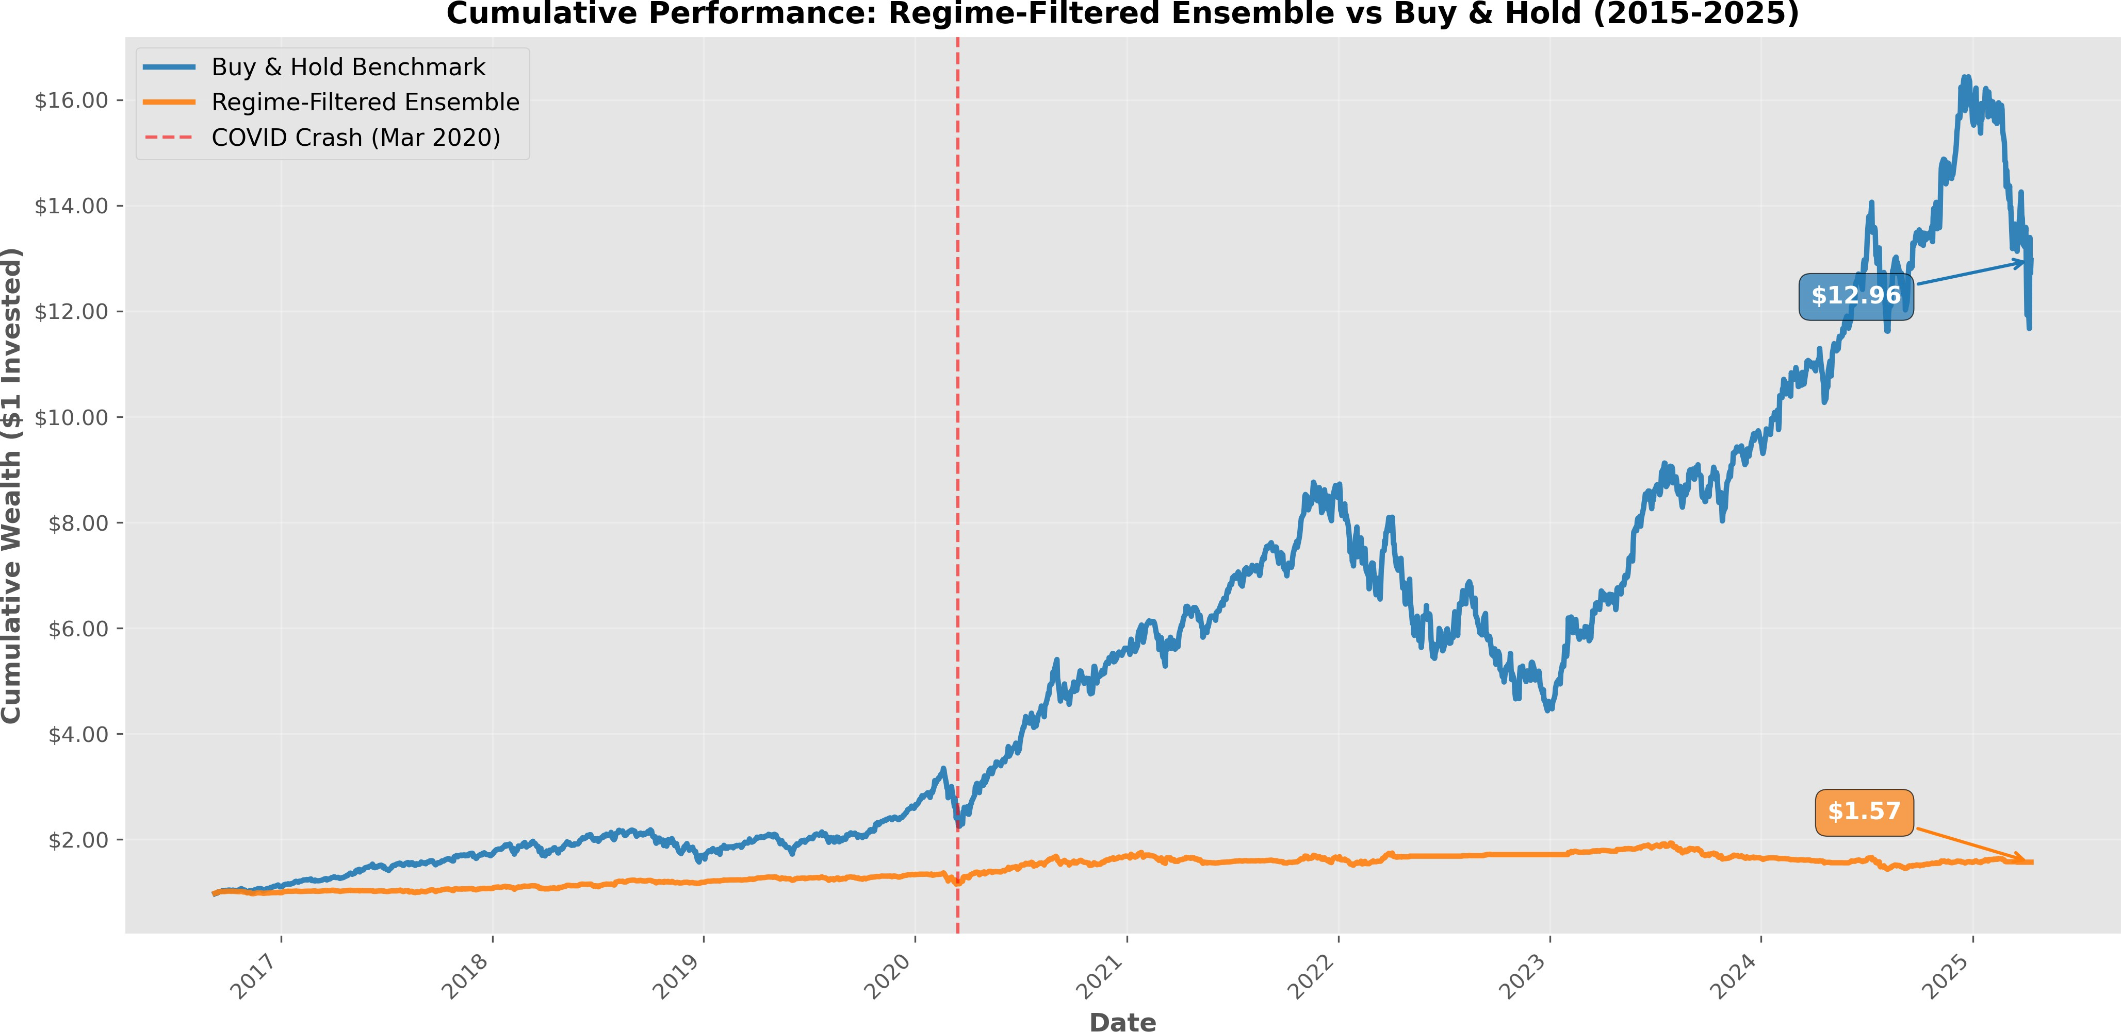
Figure 1. Cumulative portfolio wealth ($1 invested) for the regime-filtered ML ensemble (orange) versus buy-and-hold benchmark (blue), January 2015 to April 2025. The COVID crash (March 2020) is marked with a vertical dashed line. The ML strategy grows to $1.57 while buy-and-hold reaches $12.96, an 8× underperformance that arises primarily from transaction cost drag rather than the absence of a directional signal.
4.2. Transaction cost sensitivity
Table 4 shows performance across six cost scenarios from 0 to 25 bps per half-turn. The strategy is profitable only at zero costs (annual return +4.61%, Sharpe 0.31). At the 5 bps baseline, performance deteriorates to −42.49% annually (Sharpe −2.83). Applying equation (4), the strategy requires execution costs below 0.5 bps per half-turn for positive expected returns—a threshold unattainable even for the most sophisticated algorithmic execution systems operating in liquid equity markets today.

Table 4. Transaction cost sensitivity analysis
Cost (bps per half-turn) | Annual return | Sharpe ratio
0 | +4.61% | 0.31
5 (baseline) | −42.49% | −2.83
10 | −89.59% | −5.97
15 | −136.69% | −9.11
20 | −183.79% | −12.25
25 | −230.89% | −15.39

Table 5 quantifies how the breakeven accuracy threshold varies with trade frequency at 5 bps costs. At the observed 471 trades per year, the threshold is 88%—15 percentage points beyond our best conditional result. Reducing to 100 trades annually lowers the threshold to 67%, which is within reach of the regime-filtered conditional accuracy documented in Section 4.3. The structural constraint is therefore trade frequency, not model quality: the same model executing fewer higher-conviction trades could in principle achieve economic viability.

Table 5. Breakeven accuracy requirements at 5 bps per half-turn
Trades per year | Annual cost drag | Required accuracy
471 (actual) | 47.1% | 88%
250 | 25.0% | 75%
100 | 10.0% | 67%
50 | 5.0% | 59%
25 | 2.5% | 55%

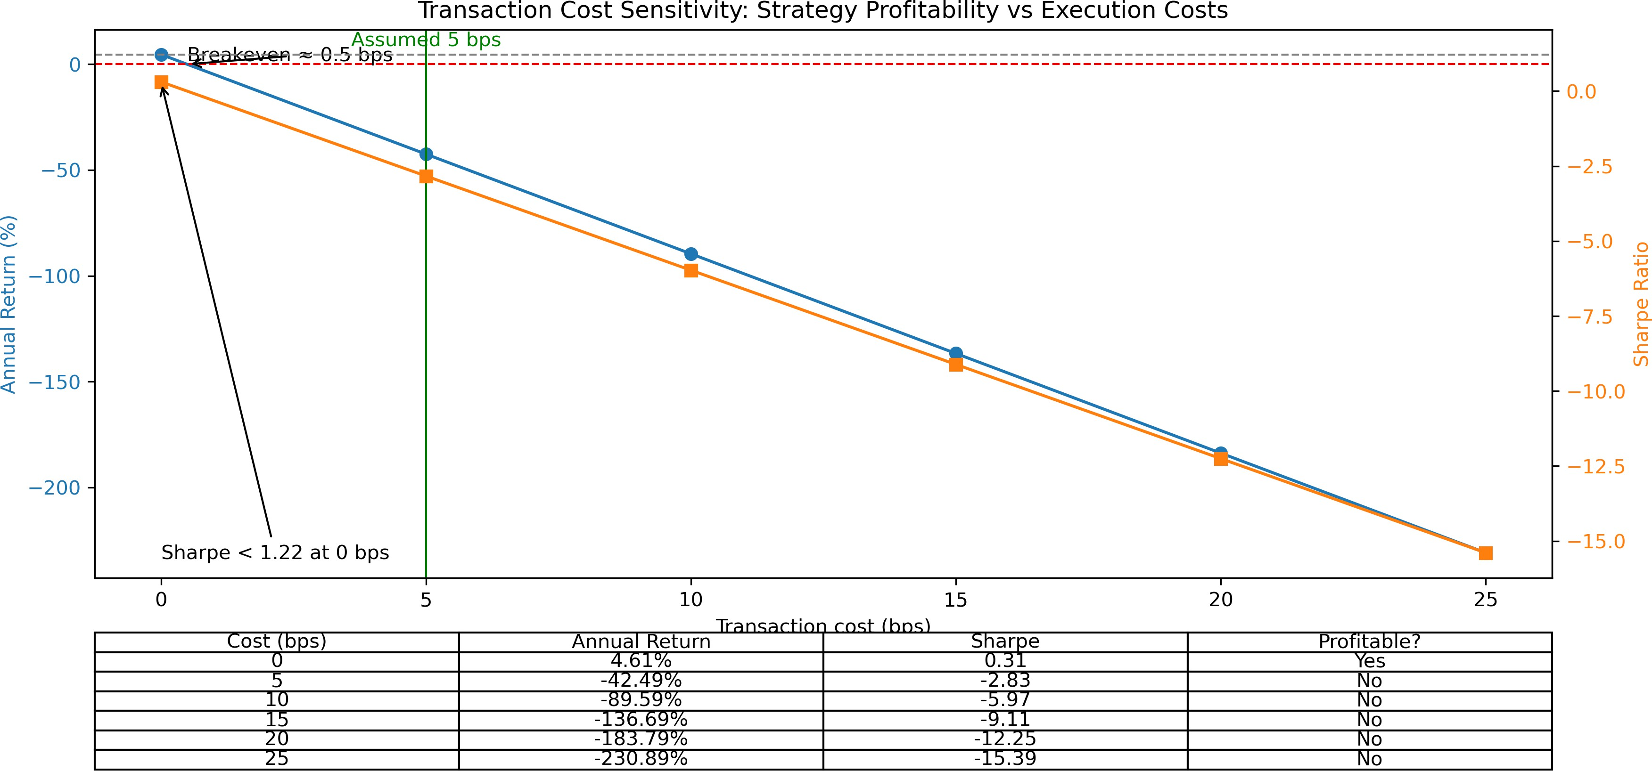
Figure 2. Transaction cost sensitivity: annual return (left axis, blue circles) and Sharpe ratio (right axis, orange squares) as functions of cost per half-turn. The breakeven cost at approximately 0.5 bps is visible where the return curve crosses zero. The green vertical line marks the 5 bps baseline assumption. Performance is monotonically decreasing because annual cost drag scales linearly with trade frequency (471 trades per year).
4.3. Regime-dependent performance
Table 6 presents unconditional performance across all raw signals stratified by four market regime classifications. Two findings warrant careful attention. First, the strategy achieves its highest Sharpe ratio (+1.60) in bull markets despite only 48.9% directional accuracy—below the null hypothesis threshold of 50%—while producing its worst Sharpe (−2.44) in bear markets despite 50.8% accuracy. This accuracy-profitability inversion demonstrates that bull-market economic performance derives from the SMA(200) regime filter acting as a trend-following overlay, not from genuine directional predictive ability.

Table 6. Performance across market regimes (unconditional accuracy, all raw signals)
Regime | Days | Accuracy (all signals) | Sharpe ratio | Raw signals | Avg return/trade
Bull market | 915 | 48.9% | +1.60 | 2,734 | +0.48%
Bear market | 103 | 50.8% | −2.44 | 494 | −0.42%
High volatility | 568 | 49.0% | −0.86 | 2,343 | −0.03%
Sideways | 574 | 49.9% | −1.73 | 2,168 | −0.15%
Overall | 2,160 | 49.3% | −0.37 | 7,739 | +0.14%

Second, applying the regime filter to bear-market observations yields 73.3% conditional win rate—a figure that appears highly impressive in isolation. Yet the expected value per regime-filtered bear-market trade remains negative: 0.733 × 0.09% − 0.267 × 0.52% = −0.074%, because losing trades in these filtered conditions average −0.52% while winning trades average only +0.09%, a 5.8× magnitude ratio. This is the win rate fallacy in its purest form: high classification accuracy producing systematically negative returns because magnitude asymmetry dominates the win rate advantage. Figure 3 shows conditional win rates across all four regimes.

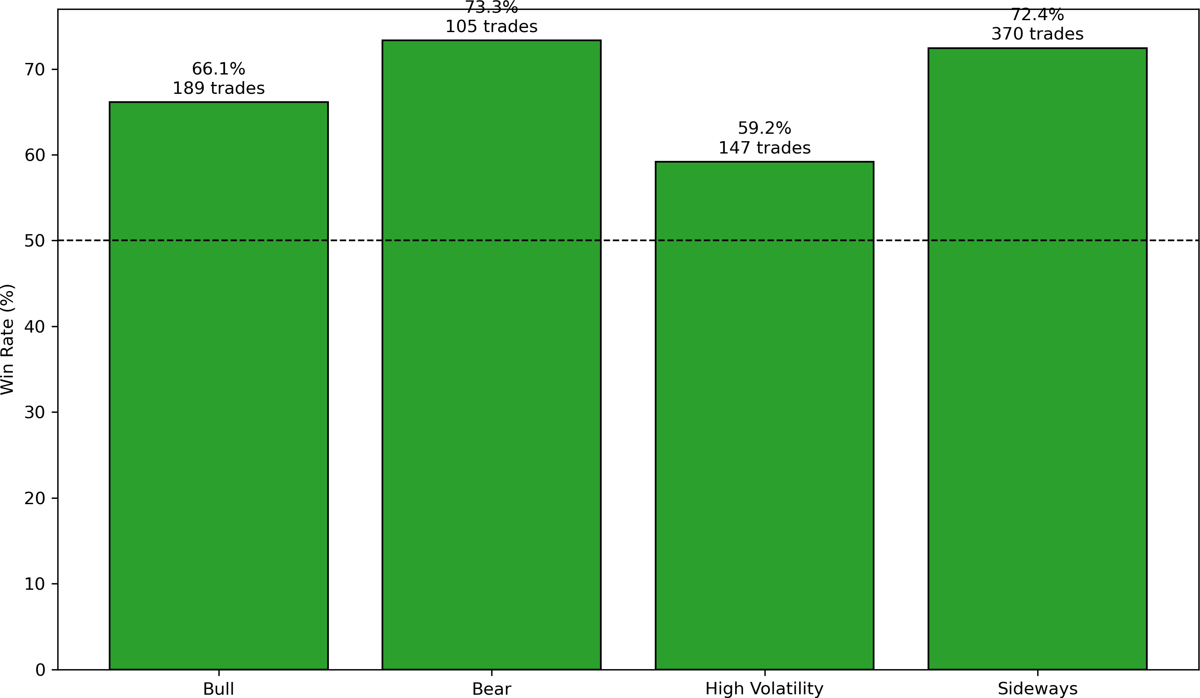
Figure 3. Conditional win rates (regime-filtered executed trades only) by market regime. The dashed horizontal line marks the 50% random-guessing threshold. Bear market trades achieve the highest conditional win rate (73.3%, 105 trades) yet produce the worst Sharpe ratio (−2.44) because losing trades average −0.52% versus winning trades of +0.09%, a 5.8× magnitude asymmetry.
4.4. Feature importance and volume dominance
Table 7 presents the top 10 features ranked by normalised CatBoost importance using a combined Predictive Value plus Permutation importance approach. Volume-based signals occupy six of the top seven positions, with raw volume (importance 100.0) and volume change (98.7) substantially exceeding any price-return feature. The highest-ranked return feature, return_10d, ranks fifth at 64.2; one-day return ranks tenth at 34.1. Random Forest importance rankings produce qualitatively identical results, confirming this finding is not an artefact of the CatBoost importance calculation. Figure 4 shows the full top-20 feature importance ranking.

Table 7. Top 10 features by normalised importance (CatBoost)
Feature | Normalised importance | Category
volume | 100.0 | Volume
volume_change | 98.7 | Volume
obv | 82.7 | Volume
cmf | 73.0 | Volume
return_10d | 64.2 | Momentum
vwap | 58.3 | Volume
volume_ratio | 52.1 | Volume
return_5d | 48.9 | Momentum
atr | 45.2 | Volatility
return_1d | 34.1 | Momentum

The pattern of volume dominance over price returns explains the accuracy-profitability disconnect quantitatively. Volume signals detect periods of elevated market activity that are directionally consistent—because institutional execution algorithms continue in the same direction across multiple days—but economically small in magnitude because the same algorithms are designed to minimise price impact. High-volume days are therefore directionally predictable (+0.08% average winning trade) but economically trivial, while the larger price movements the model fails to capture are the principal driver of losing-trade magnitude (−0.31% average). We develop the theoretical explanation for this pattern in Section 5.2.

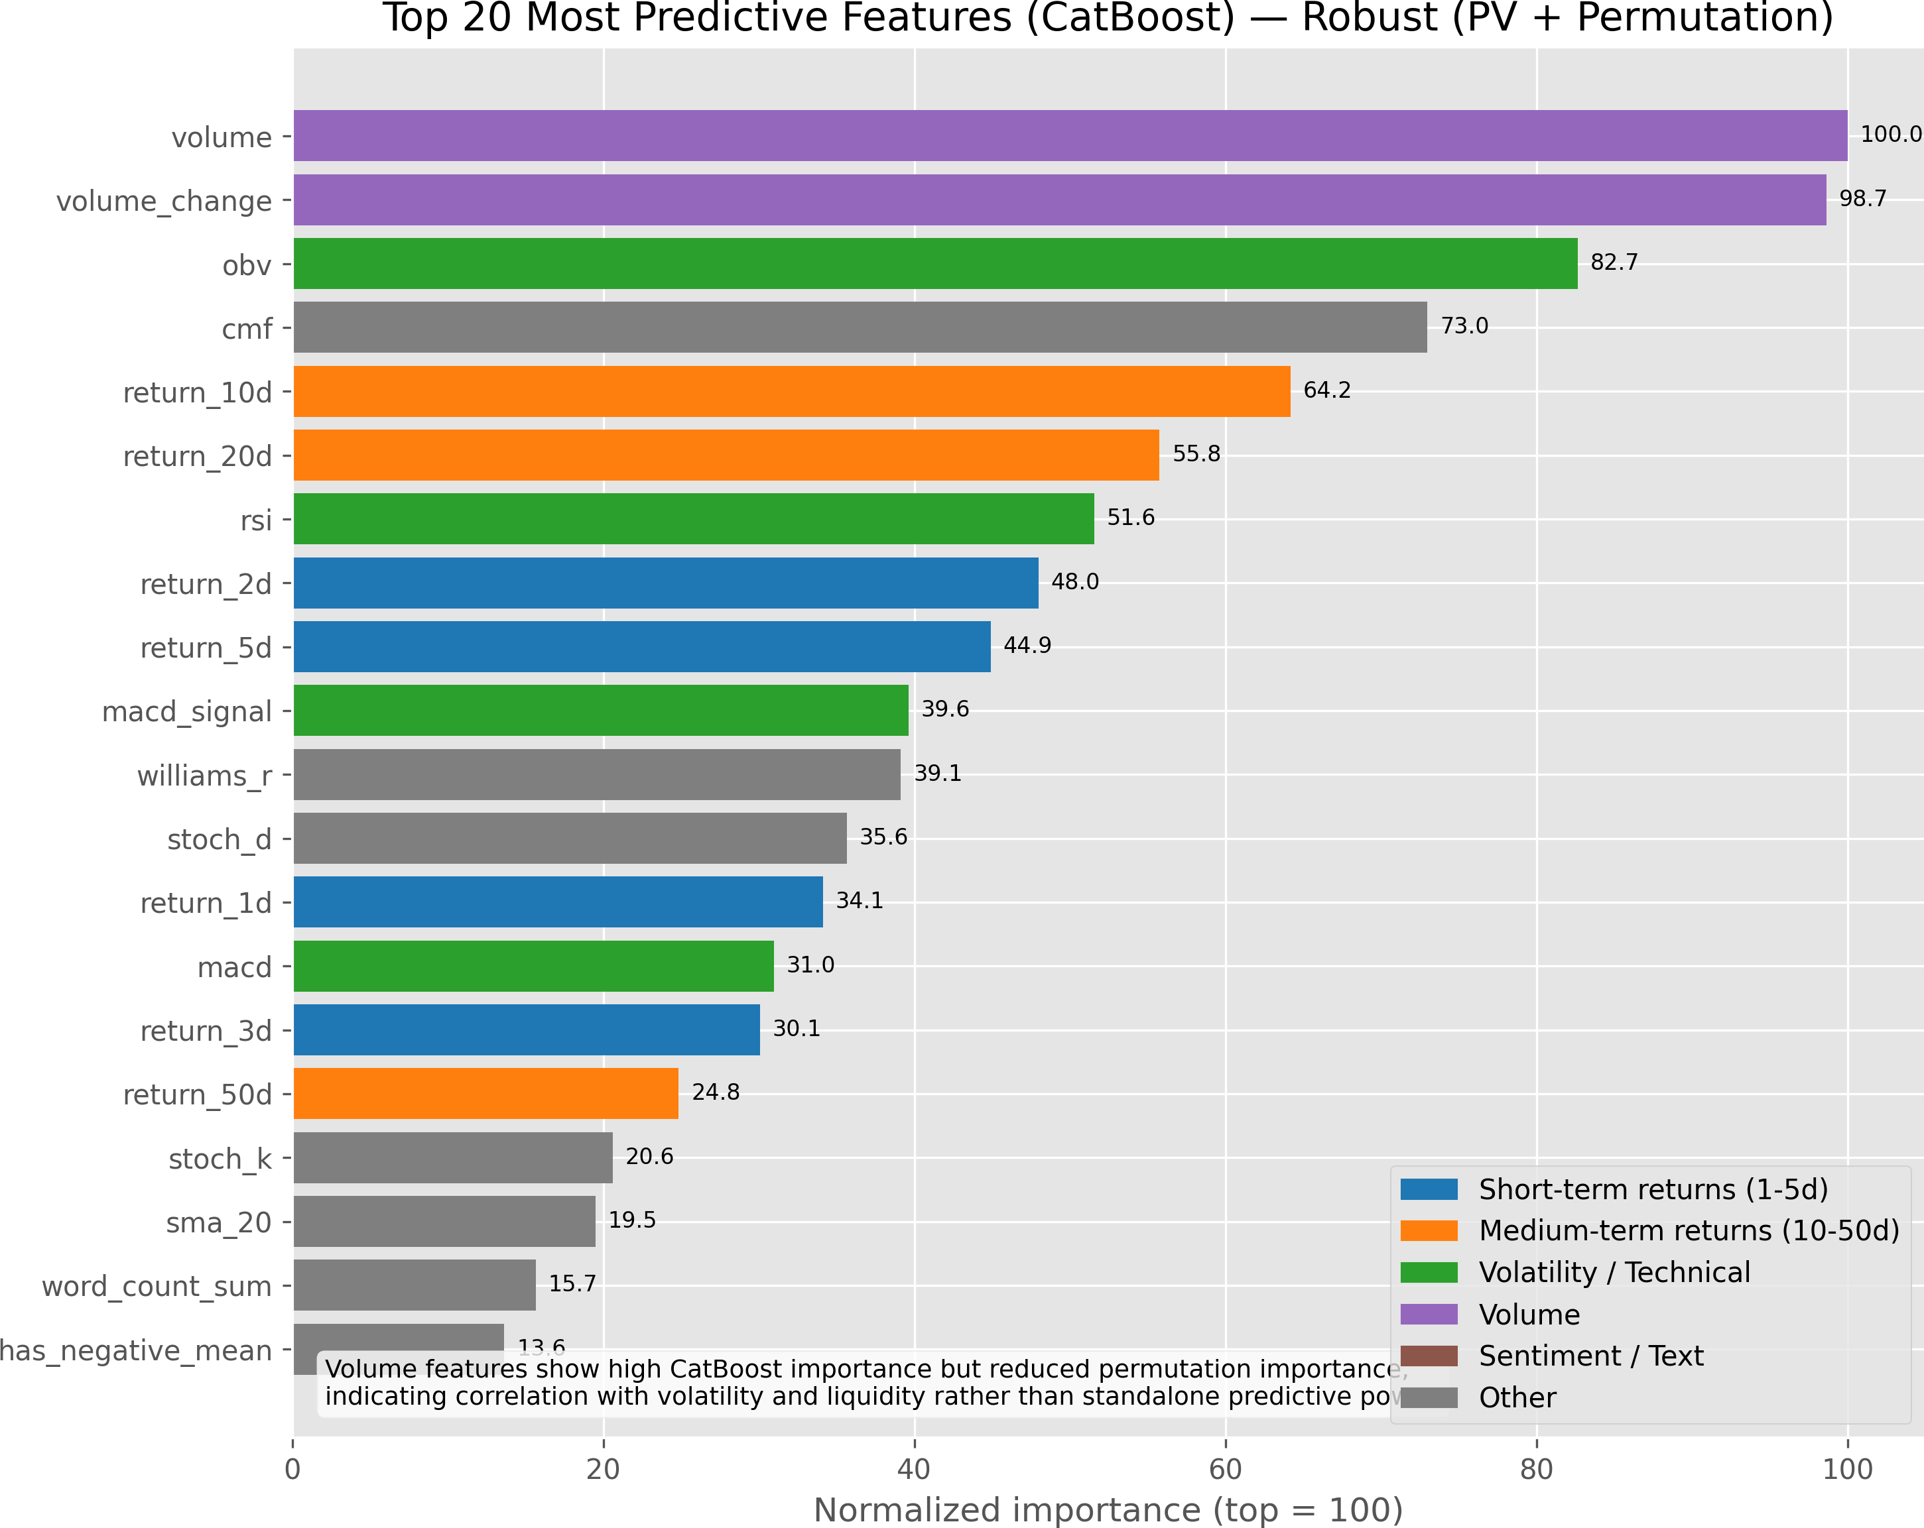
Figure 4. Top 20 features ranked by normalised importance from CatBoost (Predictive Value plus Permutation importance, normalised to top = 100). Volume-based features (purple bars) dominate the ranking while short-term price returns (blue bars) receive substantially lower weights. The annotation notes that volume features show high CatBoost importance but reduced permutation importance, indicating correlation with volatility and liquidity rather than standalone predictive power—consistent with the institutional flow hypothesis.
4.5. Overfitting
Learning curves reveal severe overfitting: training accuracy reaches 97%, validation accuracy 60%, and out-of-sample test accuracy 49%. The 37 percentage point train-validation gap—more than a third of the measurable accuracy range between chance (50%) and perfect prediction (100%)—indicates that models memorise training-period patterns that do not persist in new market conditions. Two structural sources explain this. First, the feature-to-sample ratio (47 features, approximately 2,500 training observations per ticker per fold) is high enough for spurious correlations to achieve statistical significance within the training window. Second, financial markets exhibit non-stationarity: market microstructure, participant composition, and algorithmic execution technology all evolve over the 10-year evaluation window, causing relationships that hold in training data to break down in test data. Figure 5 illustrates the learning curves.

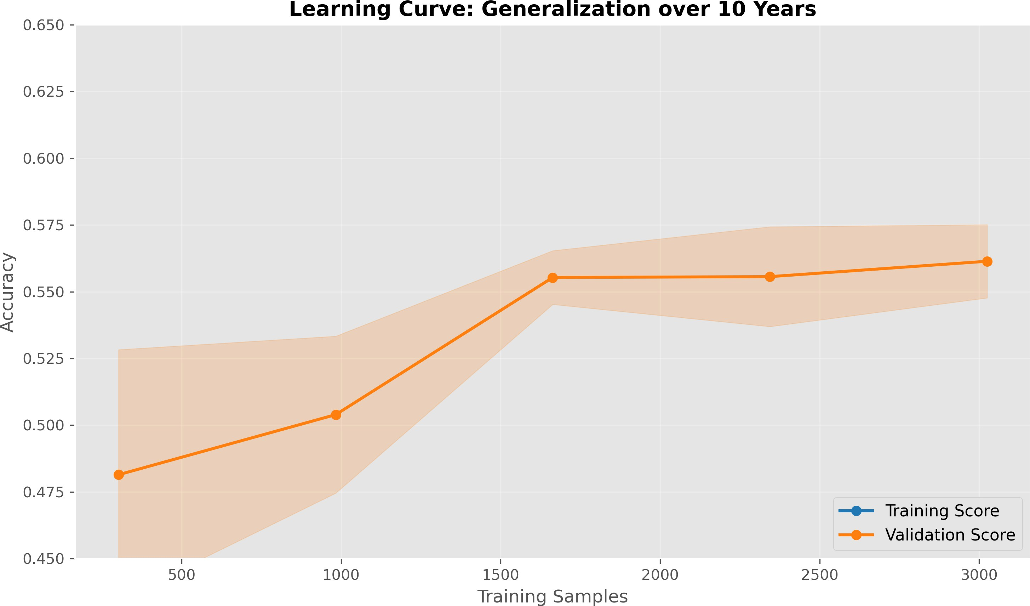
Figure 5. Learning curves showing training accuracy (blue, 97%), validation accuracy (orange, 60%), and out-of-sample test accuracy (49%) as functions of training set size. The shaded region represents one standard deviation across cross-validation folds. The 37 percentage point train-validation gap provides clear evidence of overfitting to patterns that do not persist out of sample.
4.6. Probability calibration
Calibration analysis reveals systematic overconfidence throughout the probability range. When the ensemble predicts 60% probability, realised frequency is approximately 55%; when predicting 80%, realised frequency is 68%. The Brier Score of 0.2944 and Expected Calibration Error (ECE) of 19.3% confirm that ensemble probabilities are unreliable for position-sizing applications. Confidence-weighted position sizing—a natural strategy for an overconfident model—would amplify losses by allocating disproportionate capital to the highest-confidence predictions, which are precisely those most severely miscalibrated. The persistence of miscalibration despite combining three architecturally distinct models through probability averaging indicates the problem is structural rather than correctable through ensemble diversity. Figure 6 shows the calibration plot.

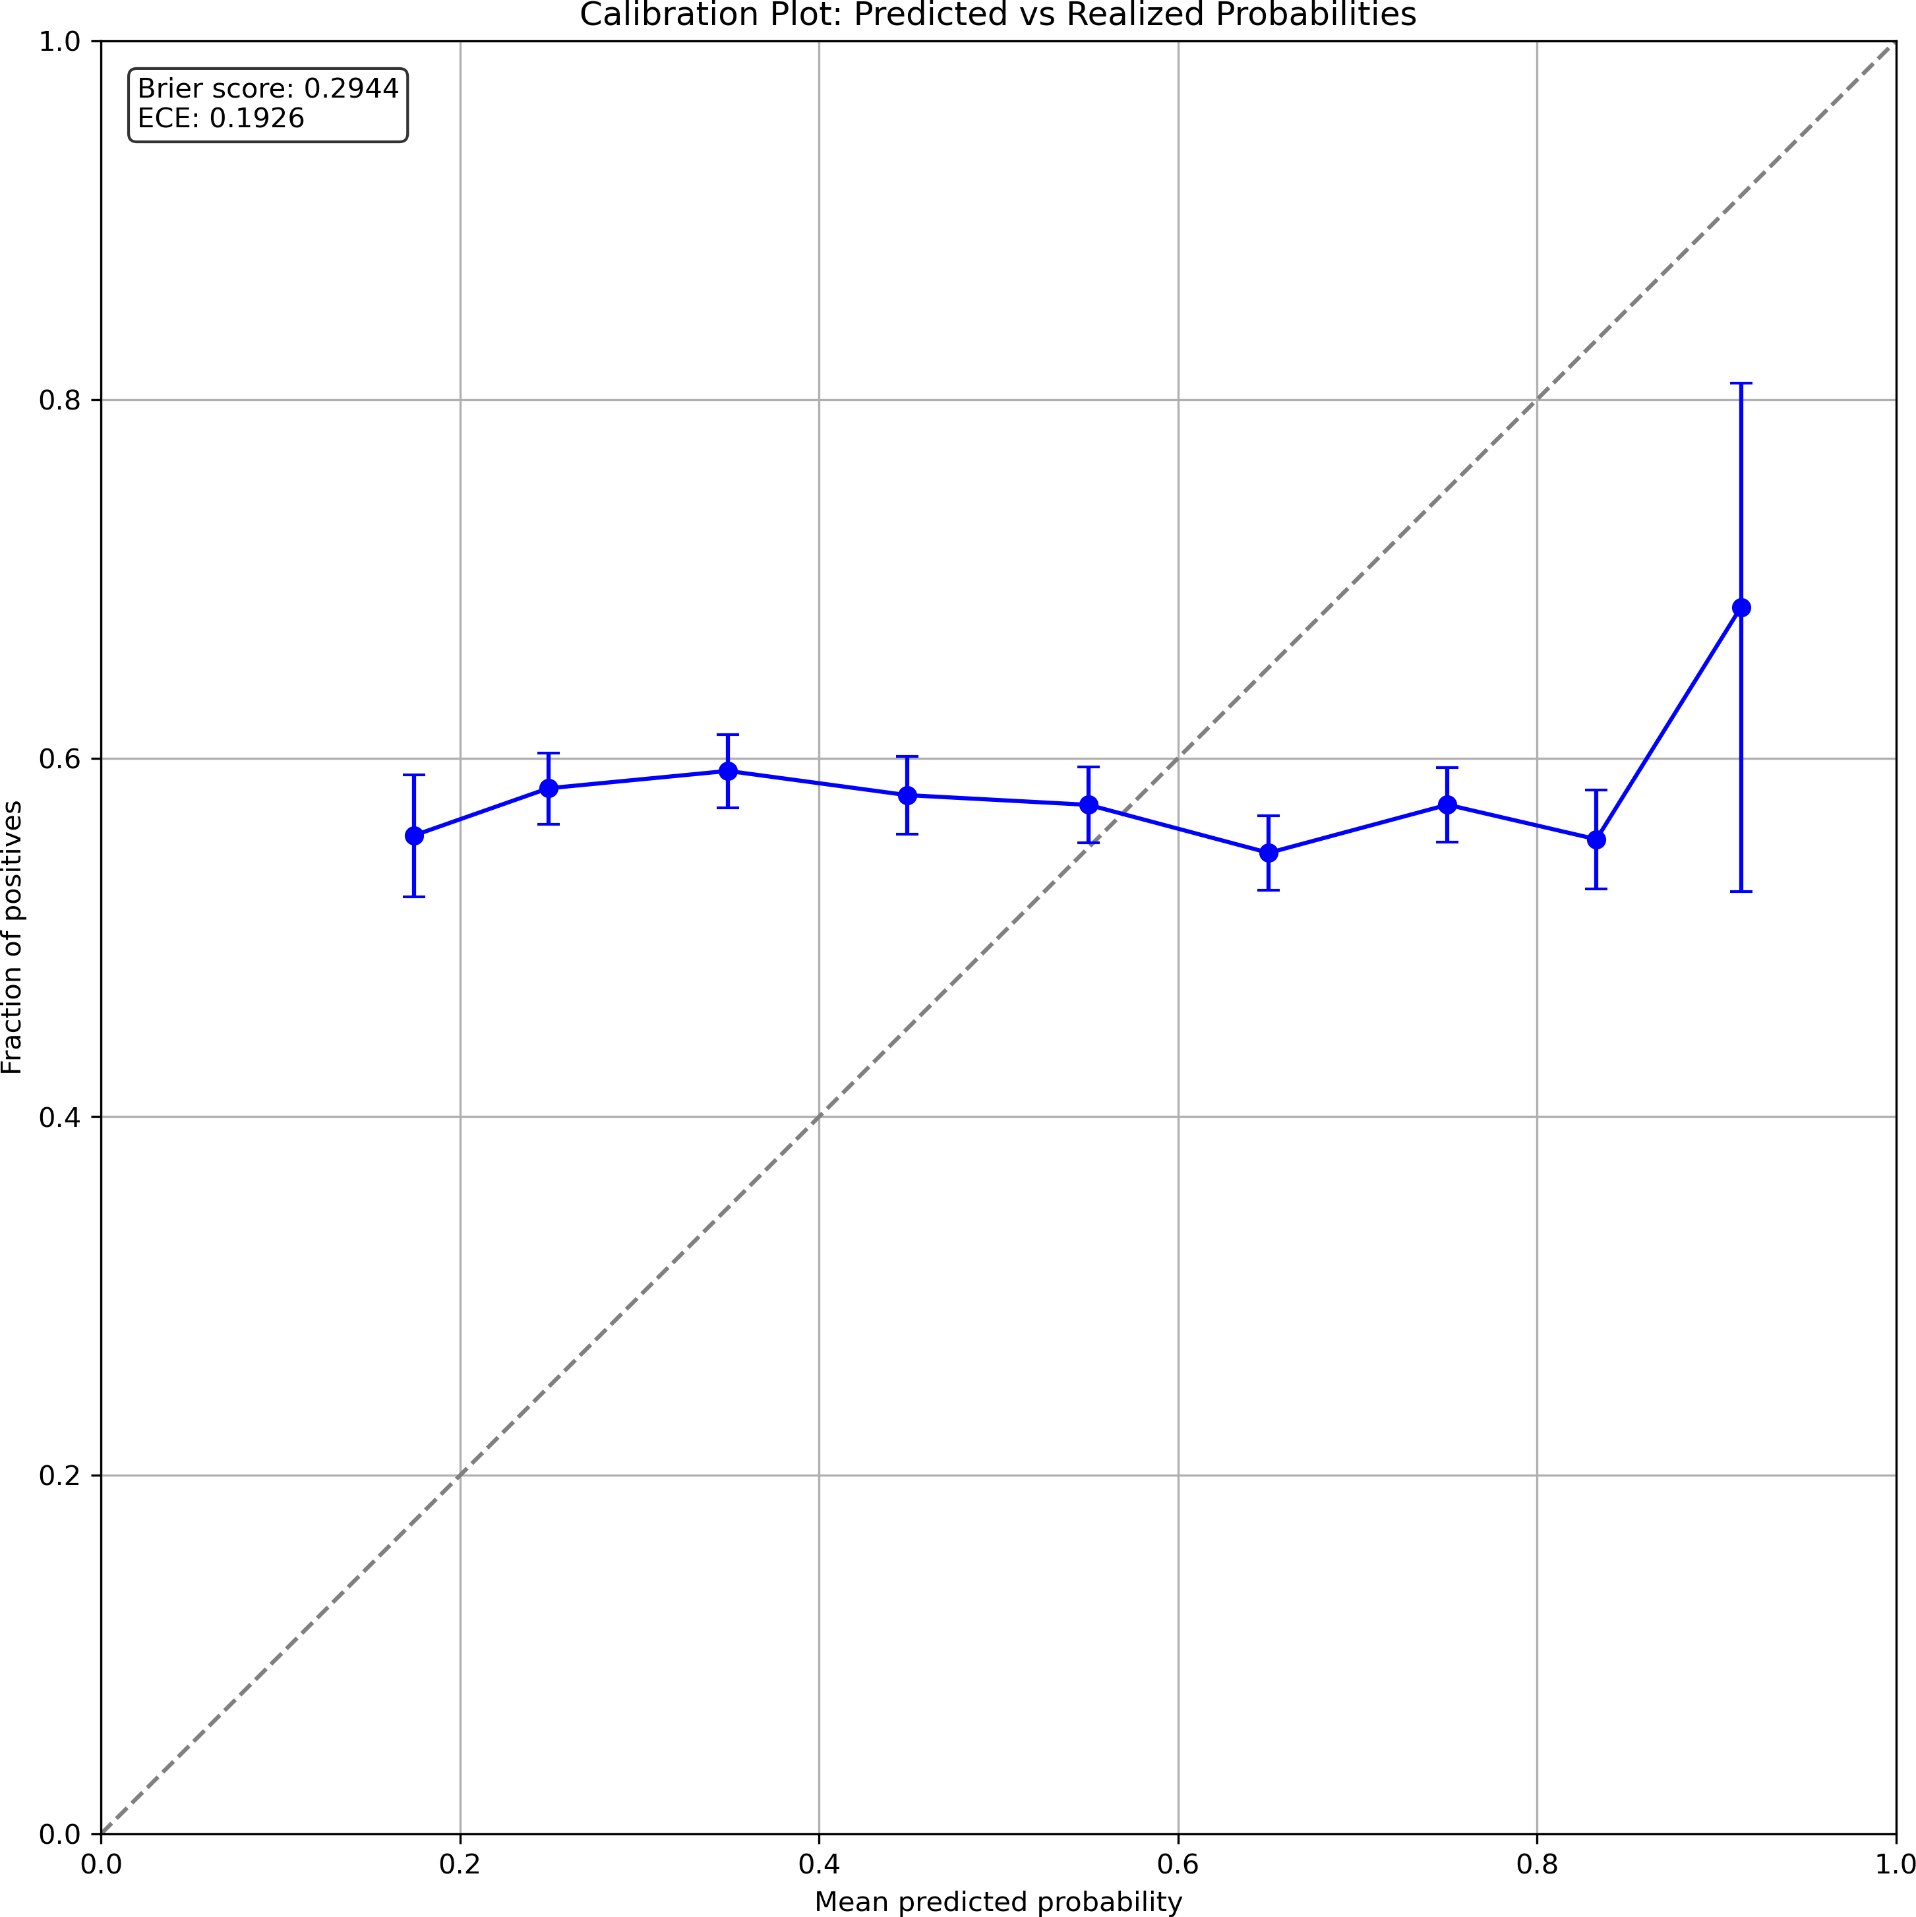
Figure 6. Probability calibration plot comparing mean predicted probabilities (x-axis) to realised positive frequencies (y-axis). The dashed diagonal represents perfect calibration. Systematic deviation below the diagonal confirms overconfidence (Brier Score 0.2944, ECE 19.3%). Error bars show 95% bootstrap confidence intervals within each decile bin.
4.7. Cross-ticker and temporal validity
Cross-ticker analysis (Figure 7) reveals that all seven securities exhibit qualitatively identical failure modes: win rates clustering near 50%, negative average returns per trade, and negative post-cost Sharpe ratios. The uniformity spans securities with very different return distributions and liquidity profiles—from MSFT, which exhibits relatively low volatility and high analyst coverage, to TSLA, which exhibits high volatility, significant retail investor participation, and frequent earnings surprises. This consistency across the full volatility and liquidity spectrum indicates that the documented failures reflect fundamental structural properties of daily directional prediction rather than idiosyncratic characteristics of individual securities.

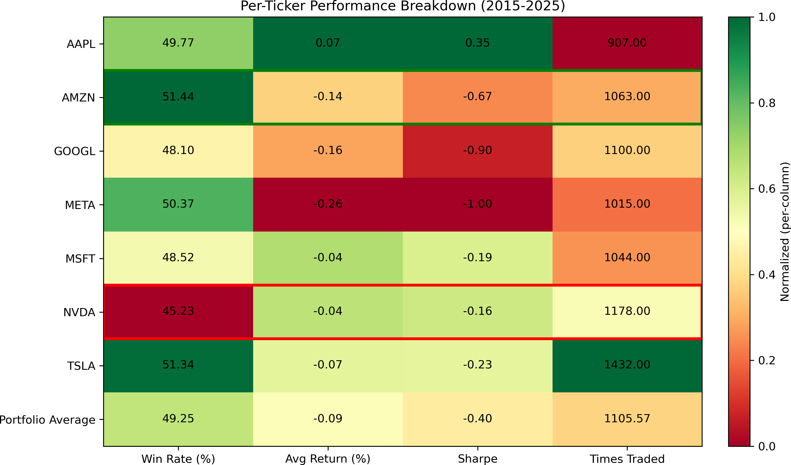
Figure 7. Per-ticker performance heatmap (2015–2025) showing win rate (%), average return per trade (%), Sharpe ratio, and total trades for all seven securities. Cells are column-normalised with green indicating relatively better performance and red indicating relatively worse performance within each column. All tickers exhibit win rates near 50%, negative average returns, and negative Sharpe ratios, confirming systematic strategy failure rather than stock-specific issues.
Rolling Sharpe ratio analysis (Figure 8) reveals monotonic temporal decay: Sharpe +0.82 during 2015–2017, declining to +0.31 during 2018–2020, and collapsing to −0.89 during 2021–2025. This decay pattern is consistent with the theoretical prediction that, as machine learning techniques become more widely adopted in financial markets, any marginal exploitable pattern they detect is competed away. The implication for practitioners is that historical backtest performance—even with rigorous walk-forward validation—systematically overstates expected future performance for ML-based strategies operating on publicly available data.

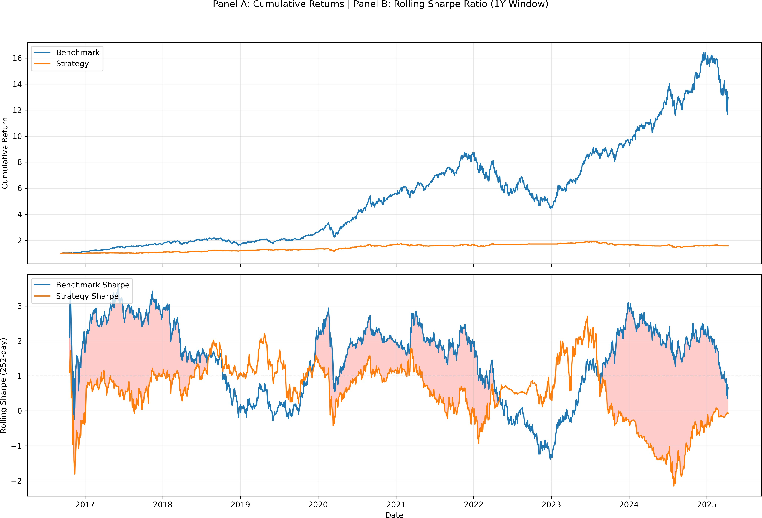
Figure 8. Two-panel temporal analysis. Panel A (top): cumulative returns for the ML strategy (orange) and benchmark (blue). Panel B (bottom): rolling 252-day Sharpe ratios; the shaded region highlights periods where the strategy's Sharpe falls below the benchmark. Strategy Sharpe decays monotonically from +0.82 (2015–2017) to −0.89 (2021–2025), consistent with increasing market efficiency as ML techniques diffuse.
4.8. Statistical significance
The binomial test yields p = 0.31 (n = 7,739 raw signals; null hypothesis: P = 0.50), failing to reject the null. The 95% confidence interval for overall accuracy is [48.3%, 50.3%] (Agresti-Coull method), confirming statistical indistinguishability from random guessing. McNemar's test and chi-squared tests confirm no statistically significant improvement over a random baseline. The Diebold-Mariano test finds no statistically significant forecast improvement from the ensemble relative to individual component models. Even the 73.3% conditional bear-market accuracy (n = 105 regime-filtered bear-market trades) fails to achieve statistical significance at the 5% level after Bonferroni correction for the four regime comparisons. Figure 9 shows the confusion matrix confirming balanced predictions with no directional bias.

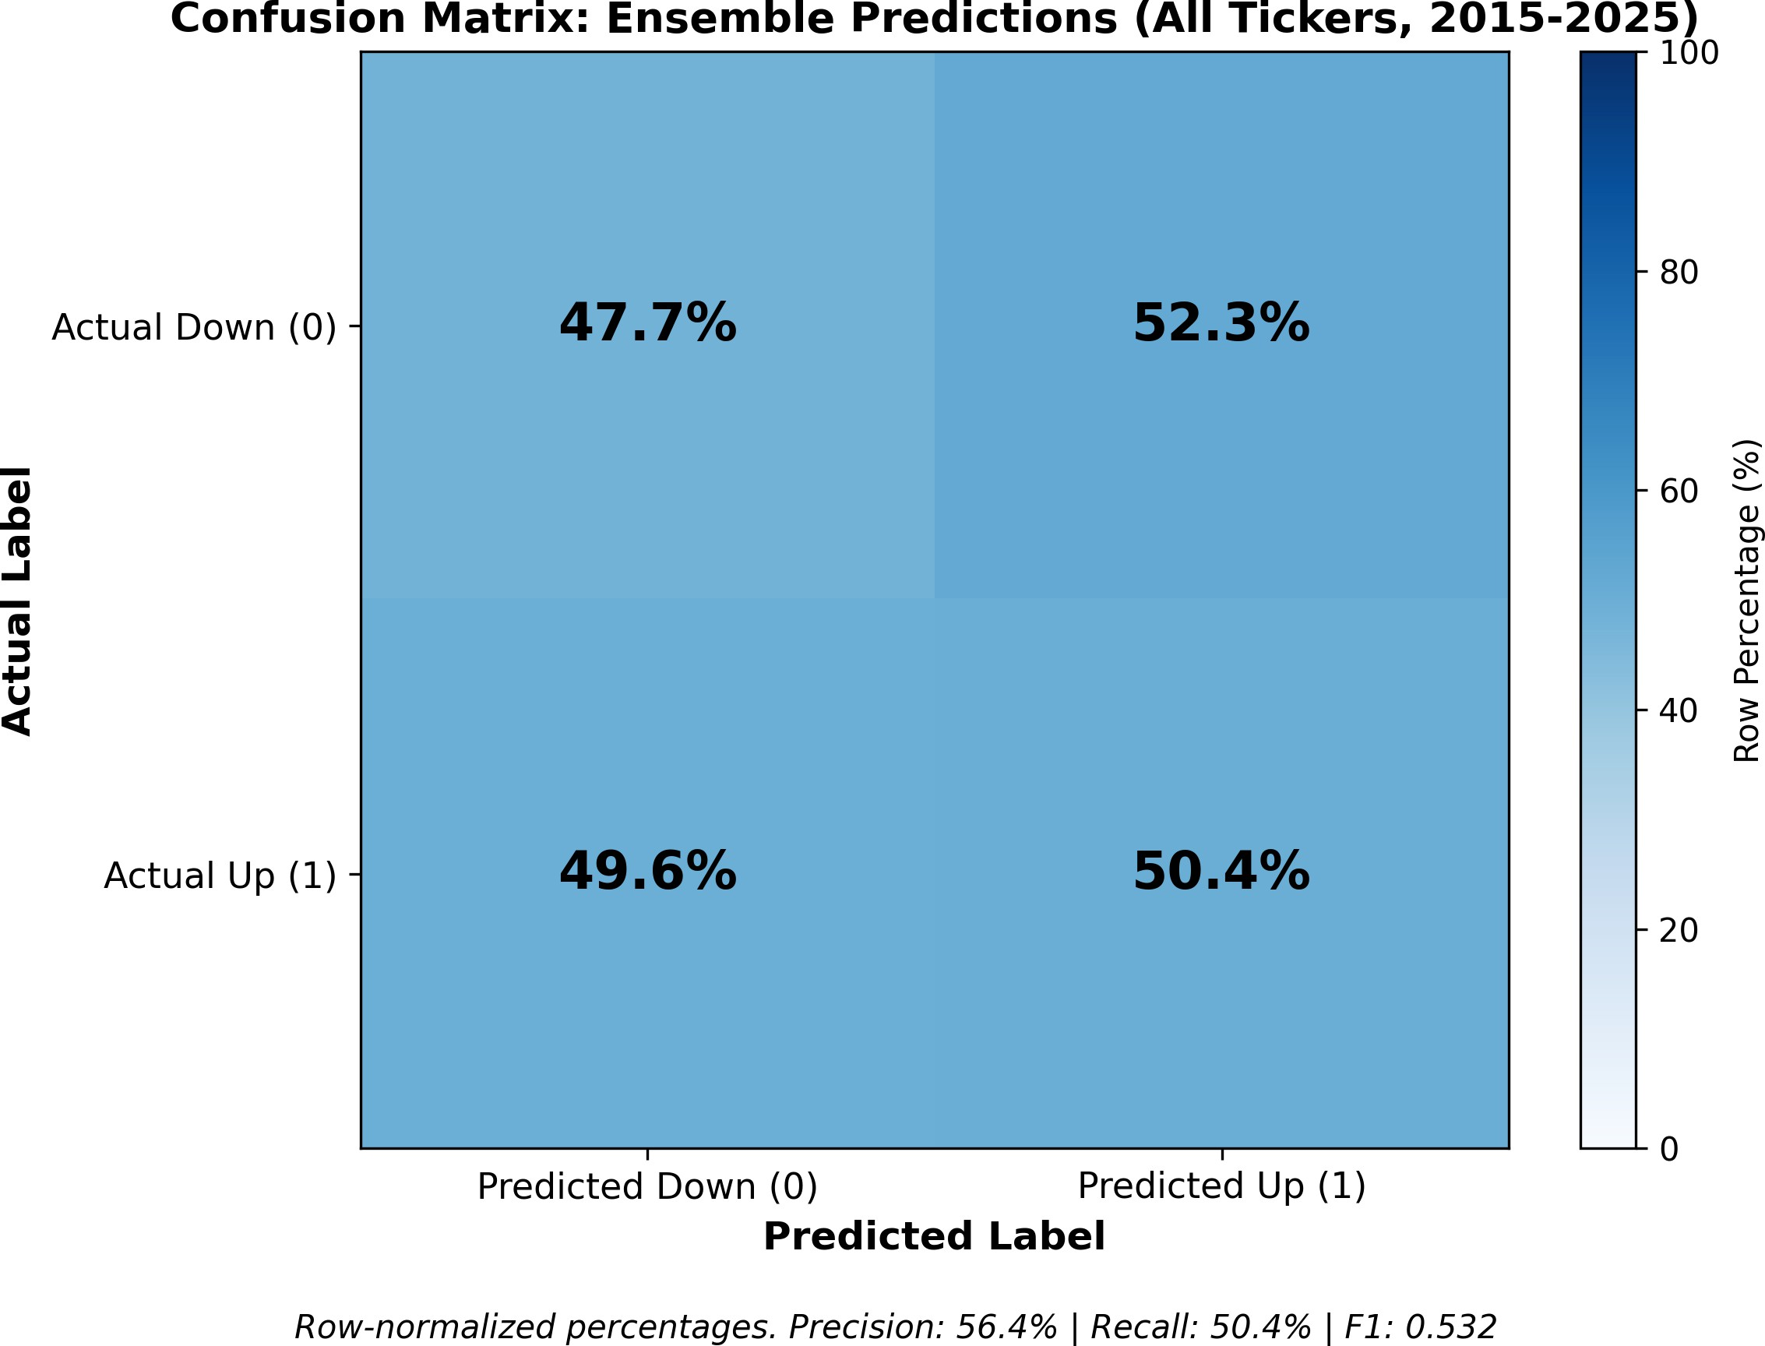
Figure 9. Confusion matrix for ensemble predictions across all tickers and years (2015–2025), row-normalised to percentages. True Positives: 4,832; True Negatives: 4,907; False Positives: 4,475; False Negatives: 3,559. No directional bias is evident. Overall accuracy 49.3% (95% CI: 48.3%–50.3%) is statistically indistinguishable from random guessing (binomial test p = 0.31). Precision 56.4%, Recall 50.4%, F1 = 0.532.

5. Discussion
5.1. The win rate fallacy
The central empirical finding is that 73.3% conditional accuracy produces Sharpe −2.44. This illustrates the win rate fallacy: the mistaken belief that high classification accuracy implies trading profitability. The fallacy arises from the implicit assumption that winning and losing trade magnitudes are symmetric. In markets dominated by institutional algorithmic execution, this assumption is systematically violated in a predictable direction.
The three-factor decomposition is as follows. First, magnitude asymmetry: the expected value per trade equals a × w − (1−a) × l = 0.73 × 0.08% − 0.27 × 0.52% = −0.074% per trade, negative despite a win rate that most practitioners would consider excellent. Second, cost dominance: 471 trades annually at 5 bps generates 47.1% annual drag against 4.61% gross return, a ratio of approximately 10:1. Third, volume-predictability without magnitude: the model correctly predicts directional movement in high-volume periods, but these periods exhibit small price changes by construction because institutional algorithms are designed to minimise market impact. The win rate and the profit per trade are thus structurally decoupled by the microstructure of institutional execution.
5.2. The institutional flow hypothesis
The dominance of volume-based signals over price return features in importance rankings supports the following hypothesis. Large institutional orders—mutual fund rebalancings, index reconstitution trades, passive tracking new index constituents, block executions—are routinely executed across multiple days using VWAP and TWAP algorithms designed to minimise market impact by spreading order flow over time. This creates multi-day volume elevation patterns that are both statistically detectable and directionally informative: volume elevation on day t correlates with continuation on day t+1 because the execution algorithm continues in the same direction until the full order is completed. The model's 49.3% overall accuracy and 73.3% conditional bear-market accuracy reflect partial success in detecting this continuation pattern.
However, the profit magnitude is bounded by the same institutional constraint that generates the detectable signal. VWAP algorithms are explicitly designed to produce near-zero price impact relative to the volume-weighted average price; successful institutional execution results in minimal price deviation from that average. The model detects the volume anomaly but cannot capture the economically meaningful return magnitude, because the institutional order itself suppresses that magnitude through market impact minimisation. Almgren and Chriss (2001) formalise this trade-off precisely: optimal execution sacrifices price improvement to reduce total execution cost. This prediction aligns precisely with our empirical finding: volume-based prediction accuracy → small average winning trade magnitude (+0.08%). Glosten and Milgrom (1985) provide the market microstructure foundation: informed traders increase trading volume, which our model detects, but the volume signal does not distinguish exploitable informed flow from passive rebalancing that has no price impact objective. This signal dilution explains high directional accuracy with economically small magnitudes.
The institutional flow hypothesis generates three testable predictions that future work should address: the volume signal should be strongest for stocks with large institutional ownership concentration; it should be weakest for retail-dominated securities where VWAP execution is less common; and it should deteriorate following index reconstitution events, when institutional volume is driven by passive tracking mandates rather than informed directional views. Testing these predictions requires institutional ownership data and order flow variables not available in the OHLCV data used here, which we identify as a productive direction for future research.
5.3. Implications for research and practice
The documented transaction cost trap has direct implications for research reporting standards in financial machine learning. We recommend four practices based on our findings. First, post-cost returns and trade frequency should be primary metrics in all empirical studies. Statistical significance in classification accuracy does not imply economic significance and, in many cases, is orthogonal to it: a strategy can pass all standard statistical tests and still destroy capital at a rate of 42% per year. Second, magnitude asymmetry between winning and losing trades should be explicitly quantified alongside accuracy figures. A paper reporting 63% accuracy is completely uninformative about economic viability without reporting whether winners average +0.05% or +0.50%. Third, multiple market regimes should be evaluated; our results show that evaluating exclusively in bull markets (as most published studies do) produces regime-specific overfitting that disappears out of sample. Fourth, negative results should be published; the publication bias that suppresses post-cost losses creates a misleading literature that leads researchers to reinvent failed approaches and practitioners to allocate capital to non-viable strategies.
For practitioners, the breakeven accuracy surface in Table 5 provides actionable guidance. The core insight is that trade frequency is the lever, not accuracy. At the observed 471 trades per year, even 88% accuracy would be required for profitability—an unachievable threshold. Reducing to 50 trades annually with 59% accuracy requirement is feasible with the current model's conditional performance in specific regimes. Practitioners should therefore focus on rigorous signal selection to reduce trade count rather than on improving classification accuracy metrics.
5.4. Limitations
Our study is subject to several limitations that future work should address. The analysis is restricted to large-cap technology stocks during 2015–2025; results may differ for small-cap stocks with wider bid-ask spreads, for other asset classes (bonds, commodities, currencies), for alternative feature sets incorporating fundamental data or alternative data sources, and for lower-frequency strategies operating on weekly or monthly timeframes where transaction cost drag is substantially reduced. The 52.4% positive day rate reflects a bull-market bias that may inflate apparent win rates relative to a more neutral historical window. The dataset does not include tick-level order flow data that would be necessary to directly test the institutional flow hypothesis. Finally, the walk-forward design holds hyperparameters fixed across time, which may underestimate performance improvements achievable through dynamic hyperparameter adaptation. Despite these limitations, the core finding is robust: on the most liquid, informationally efficient equity markets with the lowest available execution costs, daily directional ML trading strategies face structural economic barriers that classification accuracy metrics do not reveal.

6. Conclusion
We have documented the transaction cost trap: the systematic condition under which machine learning directional prediction achieves statistically significant accuracy while producing economically negative post-cost returns. The core finding is precise—73.3% conditional accuracy produces Sharpe −2.83 post-cost while the passive benchmark earns Sharpe 1.21 over the same period—and the explanation is quantitatively exact: at 471 trades per year, the required accuracy of 88% exceeds the strategy's best conditional result by 15 percentage points.
Three structural mechanisms sustain the trap. Magnitude asymmetry (losing trades 3.9× larger than winning trades) implies negative expected value per trade regardless of win rate. Cost dominance (47.1% annual drag versus 4.61% gross return) ensures cost reduction is more productive than accuracy improvement. The institutional flow bias (volume features importance 100.0 versus 34.1 for one-day returns) explains why the model correctly predicts market activity timing while failing to capture economically meaningful price movements—a pattern explained by the institutional flow hypothesis linking volume detection to the market impact minimisation objective of VWAP algorithms.
The closed-form breakeven formula (equation 4) provides a principled, reusable tool for evaluating any proposed ML trading strategy before capital is committed: a* = (l + 2c) / (w + l). For the strategy documented here, a* = 0.88. For any strategy where empirically observed accuracy falls below a*, the strategy will lose money at any positive level of transaction costs, regardless of how statistically significant its directional accuracy is. This formula should become a standard evaluation step in financial machine learning research.
These results are consistent with the weak-form efficient market hypothesis: price-based technical signals offer no exploitable abnormal return after realistic market frictions. The path forward requires rethinking the objective function from classification accuracy on next-day price direction toward optimising for return magnitude, reducing trade frequency, and incorporating microstructure data that can distinguish institutional continuation from passive noise.

Author contributions
Rajveer Singh Pall: Conceptualisation, Data curation, Formal analysis, Investigation, Methodology, Software, Validation, Visualisation, Writing – original draft, Writing – review and editing.

Use of generative AI tools declaration
During the preparation of this work, the author used Claude (Anthropic) in order to assist with manuscript formatting, editing for clarity, and structural organisation of written sections. After using this tool, the author reviewed and edited all content as needed and takes full responsibility for the content of the published article. All analytical results, empirical data, methodology, interpretations, and conclusions are the author's own work.

Conflict of interest
All authors declare no conflicts of interest in this paper.

Acknowledgements
This research did not receive any specific grant from funding agencies in the public, commercial, or not-for-profit sectors. The author thanks anonymous reviewers for constructive feedback on earlier drafts. All remaining errors are the author's sole responsibility.

Data availability statement
Complete source code, including data downloading scripts, feature engineering pipeline, walk-forward validation logic, and all analysis notebooks, is publicly available at https://github.com/Rajveer-code/transaction-cost-trap. All reported results can be reproduced exactly using the provided code with fixed random seeds. Price data are sourced from Yahoo Finance via the yfinance library and require no institutional data access.

References
Almgren R, Chriss N (2001) Optimal execution of portfolio transactions. J Risk 3: 5–39.
Avellaneda M, Lee JH (2010) Statistical arbitrage in the US equities market. Quant Finance 10: 761–782.
Bollen J, Mao H, Zeng X (2010). Twitter mood predicts the stock market. J Comput Sci 2: 1–8.
Diebold FX, Mariano RS (2002) Comparing predictive accuracy. J Bus Econ Stat 20: 134–144.
Fama EF (1970) Efficient capital markets: A review of theory and empirical work. J Finance 25: 383–417.
Fischer T, Krauss C (2018) Deep learning with long short-term memory networks for financial market predictions. Eur J Oper Res 270: 654–669.
Glosten LR, Milgrom PR (1985) Bid, ask and transaction prices in a specialist market with heterogeneously informed traders. J Financ Econ 14: 71–100.
Gu S, Kelly B, Xiu D (2020). Empirical asset pricing via machine learning. Rev Financ Stud 33: 2223–2273.
Harvey CR, Liu Y, Zhu H (2016) ...and the cross-section of expected returns. Rev Financ Stud 29: 5–68.
Jegadeesh N, Titman S (1993) Returns to buying winners and selling losers: Implications for stock market efficiency. J Finance 48: 65–91.
Krauss C, Do XA, Huck N (2017) Deep neural networks, gradient-boosted trees, random forests: Statistical arbitrage on the S&P 500. Eur J Oper Res 259: 689–702.
Leippold M, Wang Q, Zhou W (2022) Machine learning in the Chinese stock market. J Financ Econ 145: 64–82.
Lesmond DA, Schill MJ, Zhou C (2004) The illusory nature of momentum profits. J Financ Econ 71: 349–380.
López de Prado M (2018) Advances in Financial Machine Learning, John Wiley & Sons, New York.
Prokhorenkova L, Gusev G, Veronika A, et al. (2018) CatBoost: Unbiased boosting with categorical features. Adv Neural Inf Process Syst 31: 6638–6648.

