When the Gate Stays Closed: Empirical Evidence of Near-Zero
Cross-Sectional Predictability in Large-Cap NASDAQ Equities
Using an IC-Gated Machine Learning Framework
Rajveer Singh Pall
Gyan Ganga Institute of Technology and Sciences (GGITS), Jabalpur, India
Email: rajveerpall04@gmail.com
May 2025

Abstract
Machine learning ranking systems in finance are routinely deployed without formal pre-deployment signal testing. This paper introduces the IC-Gated Deployment Framework (ICGDF), a two-stage statistical gate combining Newey–West HAC-corrected inference on the Information Coefficient (IC) series with a permutation confirmation, requiring both conditions before capital is allocated. Applied to a three-model ensemble (CatBoost, Random Forest, MLP) on 30 survivorship-bias-mitigated NASDAQ-100 stocks over 1,512 out-of-sample trading days (October 2018 – October 2024), the gate remains closed: mean IC = −0.0005, HAC t = −0.09, p = 0.536. A power analysis confirms 80% power to detect IC ≥ 0.0138; the observed IC is 4% of this threshold. The ensemble achieves ECE < 0.025 across all 12 folds despite producing zero cross-sectional discrimination — demonstrating that calibration quality does not imply predictive content. An ablation study shows the naive t-test produces an 11.8% false positive rate under AR(1) null conditions, reduced to 0.0% under full ICGDF. A cross-market replication on 20 Nifty 50 stocks confirms the gate-closed result extends to Indian large-cap equities.
Keywords: IC-Gated Deployment Framework, machine learning, cross-sectional prediction, walk-forward validation, NASDAQ-100, Nifty 50, market efficiency, probability calibration, false positive rate, information coefficient

1. Introduction
The proliferation of machine learning methods in empirical finance has not been accompanied by commensurate progress in deployment discipline. Harvey, Liu and Zhu (2016) demonstrate that the multiple-testing problem has produced a substantial catalogue of false-positive factor discoveries — findings that reflect in-sample overfit rather than genuine predictive content. Bailey, Borwein, López de Prado and Zhu (2014) show that standard backtesting practice is structurally susceptible to overfitting: a researcher iterating over model configurations can always find a parameter set that performs well historically, with no guarantee of out-of-sample validity. This paper introduces the IC-Gated Deployment Framework (ICGDF) — a two-stage statistical gate that prevents a conviction ranking system from deploying capital under conditions of statistically unsupported cross-sectional predictability, requiring Newey-West HAC-corrected IC significance before any position is taken.
Machine learning methods have attracted serious attention in empirical asset pricing since Gu, Kelly and Xiu (2020) showed that tree ensembles and neural networks explain meaningful variation in monthly equity returns across a broad US universe. Daily single-stock prediction is substantially harder: signal-to-noise ratios are far lower than in monthly panels, and regime changes make in-sample patterns unreliable guides to out-of-sample performance.
• Contribution 1: IC-Gated Deployment Framework (ICGDF). A portable, two-stage statistically grounded pre-deployment gate combining a Newey-West HAC t-test and a permutation test on the out-of-sample IC series. The gate is architecture-agnostic and can be incorporated into any walk-forward conviction ranking system.
• Contribution 2: Leakage-free walk-forward protocol. ICGDF extends the purged walk-forward design of López de Prado (2018) with two elements into the ICGDF context: fold-specific isotonic calibration fitted on a dedicated held-out calibration window (never the test period), and the sequential [MLP val | Cal | Test] partitioning that prevents calibration from observing any test-period label distribution. This integration is necessary for the ECE validity claim.
• Contribution 3: Empirical evidence on 49 OHLCV indicators. A survivorship-bias-mitigated test across 1,512 consecutive out-of-sample trading days demonstrating that backward-looking technical indicators carry null IC in large-cap NASDAQ equities (mean IC = −0.0005, t = −0.09, p = 0.536), confirmed by five independent robustness checks and a momentum positive control.
• Contribution 4: Calibration–discrimination separation. Demonstration that well-calibrated probability estimates (ECE < 0.025 across all 12 folds) coexist with near-zero cross-sectional discriminative content (IC ≈ 0), establishing that ECE alone is an insufficient criterion for deployment readiness.
• Contribution 5: Cross-market replication. Application of the identical ICGDF pipeline to 20 Nifty 50 constituents over 1355 out-of-sample trading days. The gate closes on the Indian market (HAC t = 2.008, permutation p = 0.801), extending the null result beyond US large-cap equities.
The central finding is a null result: across all 12 test folds, the IC gate remains closed. The ensemble produces daily cross-sectional conviction rankings for 30 stocks, but those rankings carry no persistent predictive content. The TopK1 Sharpe ratio of −0.16 falls well below the equal-weight benchmark Sharpe of 0.96. A permutation test confirms the observed performance is indistinguishable from random selection (p = 0.742). Monotonically increasing Sharpe with K — from TopK1 at −0.16 through TopK3 at +0.12 to the equal-weight limit at 0.96 — is a diagnostic signature of an uninformative ranker.
Six robustness checks — expanded universe (N = 100), Diebold–Mariano tests, VIX-regime conditioning, block bootstrap confidence intervals, feature attribution stability, and a Nifty 50 cross-market replication — leave the null result intact.
The null IC is a property of the signal class — 49 backward-looking technical indicators applied to large-cap NASDAQ stocks — not of the model architecture. The ensemble achieves ECE below 0.025 across all folds, confirming that calibration quality does not imply cross-sectional predictive content.
2. Related Work
2.1 Machine Learning in Equity Prediction
Gu, Kelly and Xiu (2020) establish the modern benchmark for ML in equity return prediction: gradient-boosted trees and deep networks outperform linear factor models in monthly cross-sectional prediction using a broad US equity panel. Their predictive R² gains are real but modest in absolute terms. The practical challenge of translating predictive lift into Sharpe ratios after transaction costs has been explored by Freyberger, Neuhierl and Weber (2020) and Novy-Marx and Velikov (2016), who document that many signals require high turnover to capture, making net-of-cost performance substantially worse than gross.
Daily prediction of individual stock returns is a harder problem than monthly cross-sectional work. The paper’s own IC standard deviation of 0.2204 at daily frequency against Gu, Kelly and Xiu’s (2020) monthly IC values of 0.03–0.05 gives a signal-to-noise ratio roughly one order of magnitude lower. Continuous trading means transaction cost frictions compound daily. The relevant signal-to-noise ratio at daily frequency is far lower — Sharpe ratios from published factors that appear significant monthly often vanish at daily horizons after accounting for microstructure noise and non-synchronous trading. Chordia, Roll and Subrahmanyam (2005) document that market-wide liquidity shocks dominate daily return variation, leaving little room for cross-sectional signals from firm-specific technicals.
Avramov, Cheng, and Metzker (2023) show that ML-driven long-short portfolio profits attenuate substantially once the investment universe is restricted to large-cap, liquid stocks, providing a direct prior motivation for our null result on NASDAQ-100 mega-caps. Buczynski, Cuzzolin, and Sahakyan (2021), in a systematic review of ML applications in financial prediction, identify a near-universal absence of deployment discipline: fewer than 5% of surveyed studies report any form of pre-deployment statistical gating.
2.2 Technical Indicators as Predictors
Technical indicators have been debated as predictors since Lo, Mamaysky and Wang (2000), who found weak evidence of short-horizon predictability from price patterns. More recent ML-based work has found that moving averages, momentum oscillators, and volatility signals contain some predictive information at monthly horizons in smaller-cap or emerging-market universes (Neely, Rapach, Tu and Zhou, 2014; Leippold, Wang and Zhou, 2022). In large-cap NASDAQ stocks — the most actively traded, most heavily analysed segment of the US market — the efficiency hypothesis is harder to reject. Chordia, Subrahmanyam and Tong (2014) show that anomaly returns have declined significantly over time, consistent with learning-based arbitrage. Our 2015–2024 training and evaluation window falls squarely in the post-decline era.
2.3 Validation Design and IC Gates
Walk-forward validation is the standard design for time-series-dependent ML evaluation in finance. López de Prado (2018) formalises its properties and introduces the purged k-fold variant to prevent leakage through overlapping label periods. Our implementation uses expanding training windows with explicit embargoes between train and test, consistent with purged k-fold principles.
The IC (Information Coefficient) is the Spearman rank correlation between predicted and realised cross-sectional returns. Grinold and Kahn (1999) derive the fundamental law of active management — that a strategy's Information Ratio scales as IC times the square root of breadth — establishing IC as the key measure of signal quality in cross-sectional frameworks. Practitioners routinely use IC > 0 as a filter before live deployment. Our IC gate formalises this discipline statistically, requiring HAC-corrected significance rather than relying on arbitrary thresholds. ICGDF’s primary methodological contribution relative to López de Prado (2018) and standard walk-forward practice is the conjunctive two-stage gate structure. López de Prado (2018) prescribes purged walk-forward validation and cross-validation as leakage controls, but does not formalise a pre-deployment statistical test on the IC series itself. Practitioners applying HAC t-tests in isolation — a common extension of the Prado framework — remain exposed to distributional misspecification: when the IC series is non-Gaussian or exhibits structural breaks, parametric significance thresholds can be unreliable. ICGDF addresses this by requiring both conditions: the HAC t-test corrects for autocorrelation inflation in the IC series, while the temporal permutation test provides non-parametric confirmation that is robust to distributional assumptions. The conjunctive requirement is strictly more conservative than either component alone. The strictness of the conjunctive design is empirically validated in Section 6.7: the HAC correction alone reduces the AR(1)-null false positive rate from 11.8% to 7.6%; adding the permutation confirmation produces no false positives. The two-stage structure is the differentiating element; neither component alone achieves the result.
Relationship to existing pre-deployment practices. Grinold and Kahn (1999, Ch. 6) introduce IC > 0 as an informal deterministic filter for strategy viability, but without formal inference machinery. Practitioners commonly apply IC threshold rules without HAC correction, which our ablation study (Section 6.7) shows produces an 11.8% false positive rate. A concurrent preprint (Deep, Deep, and Lamptey, 2025) presents a walk-forward validation framework with honest null-reporting but employs neither conjunctive testing nor HAC-corrected inference. ICGDF formalises the Grinold-Kahn heuristic into a two-stage conjunctive test combining Newey-West HAC t-statistics with permutation-based calibration, producing no false positives under the tested AR(1) conditions across all 12 folds and the momentum positive control (Section 6.7, Table 11).
2.4 Calibration in ML-Based Finance
Probability calibration — matching predicted probability to empirical frequency — has received limited attention in financial ML despite its importance for risk management. Guo et al. (2017) establish expected calibration error (ECE) as the standard metric. In a classification-based conviction ranking framework, well-calibrated probabilities allow the IC gate to interpret rank ordering correctly. We demonstrate that our isotonic-calibrated ensemble achieves ECE below 0.025 across all folds while producing zero IC — showing that calibration quality does not imply discriminative content.
2.5 Methodological Failures in ML Finance
A substantial body of published financial ML findings suffers from identifiable methodological failures that inflate reported performance. The most pervasive is the use of random k-fold cross-validation on time-series data. Randomly shuffling training and test folds creates temporal leakage: observations from future periods appear in training sets, the model learns target values it would not have observed at the time of prediction, and in-sample accuracy estimates are biased upward relative to true out-of-sample performance. López de Prado (2018) formalises the purged k-fold construction as the correct alternative; the ICGDF walk-forward design implements this principle with explicit embargoes between train and test windows.
A second failure is the absence of autocorrelation correction in IC inference. Daily IC observations are serially correlated — a model that is marginally informative on consecutive days will exhibit positive IC autocorrelation, causing naive standard errors to understate variance and naive t-statistics to overstate significance. Newey and West (1987) provide the heteroskedasticity and autocorrelation consistent (HAC) covariance estimator that corrects for this. Harvey et al. (2016) argue that the absence of multiple-testing corrections has produced a substantial number of spurious factor discoveries in the cross-section of expected returns; the same critique applies at the level of individual IC tests. Bailey et al. (2014) demonstrate formally that repeated backtesting over a fixed historical sample generates overfit strategies whose out-of-sample Sharpe ratios decay in proportion to the number of configurations tested. ICGDF responds to both critiques: the HAC t-test addresses autocorrelation; the permutation test provides non-parametric confirmation robust to distributional assumptions; and the pre-deployment IC gate substantially reduces the risk that any backtest result is treated as a deployment signal unless statistical conditions are met.
A third failure, survivorship bias, arises when a universe is restricted to securities that are current index members. We control for this by requiring stocks to have been continuous NASDAQ-100 members throughout the evaluation window and applying the same constraint in all robustness checks. ICGDF is designed to prevent deployment unless temporal leakage, autocorrelation-naive inference, and survivorship bias are all controlled. Section 3 describes the data and feature construction that implement these controls.
Algorithm 1: IC-Gated Deployment Framework (ICGDF)
Input: Daily OHLCV panel for N stocks over T trading days; significance level α = 0.05; HAC lag L = 9 days; permutation replicates B = 1,000.
Stage 1 — Training and Calibration (per fold k):
1.Construct expanding training window [1, tₖ] with 2-calendar-day temporal embargo.
2.Engineer 49 strictly causal OHLCV features; no future-referencing rolling windows.
3.Fit CatBoost, Random Forest, and MLP base learners independently on training fold.
4.Calibrate ensemble probabilities via isotonic regression on held-out calibration window (last 20% of training); freeze calibrator before test window.
Stage 2 — IC Gate (applied before each deployment decision):
5.Compute daily ICᵈ = SpearmanRankCorr(ṗ̂ᵈ, rᵈ₊₁) for each day d in the test fold.
6.HAC t-test: t_HAC = IC̅ / √(V̂ₕₐᶜ / N). Gate condition A: t_HAC > 1.645 AND IC̅ > 0 (the IC̅ > 0 clause is redundant given the one-tailed upper test; stated for implementation clarity).
7.Permutation test — Type A (temporal): randomly reorder the full daily IC series B = 1,000 times; compute empirical p-value p_perm = #{permuted mean IC̅ ≥ observed mean IC̅} / B. Type B (block): repeat using non-overlapping blocks of 5 consecutive trading days, preserving short-term serial correlation in the IC series. Gate condition B: p_perm < 0.05 for both Type A and Type B.
8.Gate opens if and only if condition A AND condition B are satisfied.
9.If gate closed: take no position; proceed to next trading day.
10.If gate open: allocate equal weight to the K stocks with highest calibrated conviction scores; apply 5 bps round-trip transaction cost.
Output: Fold-level IC statistics, gate decision log, portfolio returns, Sharpe ratio, ECE, and Diebold-Mariano test statistic versus random selection.
The portability of ICGDF derives from the gate’s operating surface: Steps 5–10 of Algorithm 1 require only a daily IC series as input, making the gate indifferent to the base model that generated the conviction rankings. Replacing CatBoost with an LSTM or a linear model would require only re-running Steps 1–4; Steps 5–10 are unchanged.
3. Data and Feature Engineering
3.1 Universe Construction
The primary universe consists of 30 large-cap NASDAQ-100 member stocks. Specifically, we include stocks that were NASDAQ-100 continuous members throughout the evaluation window (October 2018 – October 2024) and had price history back to January 2015 to provide at least three years of training data for the first fold. SPY is included as a benchmark instrument. Daily OHLCV data spanning January 2015 through December 2024 — a total of approximately 2,500 trading days — is obtained from Yahoo Finance via the yfinance library (version ≥ 0.2; auto_adjust=True), which provides total-return adjusted closing prices accounting for stock splits and dividends. The auto_adjust=True parameter applies both dividend and split adjustments, yielding total return prices consistent with the requirements of the Fama-French factor regression in Section 5.7. Data integrity was verified across 45,360 stock-day observations via six checks. Adjusted close accuracy against manually verified corporate action dates showed discrepancies below 0.01%. Missing data rates were below 0.1% per ticker over the 1,512 trading days. Stale price detection via a three-day constant-close filter returned zero occurrences for NASDAQ-100 large-caps. Return outliers exceeding |r_t| = 20% constituted fewer than 0.5% of observations, all attributable to documented corporate events. Zero-volume days were absent. Quarterly spot-checks of five randomly selected tickers against an independent source produced monthly return discrepancies below 0.05%. The total anomalous observation rate does not exceed 0.6%; a sensitivity analysis demonstrates that a contamination rate of 0.95% — more than 1.6× the observed maximum anomaly rate — would be required to shift the mean IC to the significance boundary. Requiring continuous NASDAQ-100 membership over 2018–2024 constitutes a forward-looking filter rather than a point-in-time reconstruction. Approximately 39 stocks were excluded, introducing a residual annual benchmark return inflation of 0.3%–1.5% (Brown, Goetzmann & Ibbotson, 1992; Elton, Gruber & Blake, 1996) and a corresponding Sharpe overstatement of 0.02–0.08 units. This bias does not affect the IC null result, which is evaluated via cross-sectional rank correlation rather than absolute return comparisons. This residual bias does not affect the ML null result, which is evaluated via cross-sectional rank correlation (IC) rather than absolute return comparisons. Clayton and Schmidt (2017) compare capital market parameters estimated from Yahoo Finance against NASDAQ-sourced data and find negligible differences in return and volatility estimates, supporting the use of Yahoo Finance as a data source for academic research.
For the robustness analysis in Section 6, we expand the universe to approximately 100 NASDAQ-100 candidate stocks applying the same survivorship-bias mitigation procedure: stocks must have at least 1,800 trading days (roughly 7 years) of clean, adjusted price history. This produces a survivorship-bias-mitigated universe of similar character to the primary 30-stock universe but three times as broad.
3.2 Target Variable
The target variable is the binary direction of the two-day-ahead close return. Formally: y_t = 1 if Close(t+2) > Close(t+1), else 0. The two-day shift eliminates execution-at-signal lookahead bias — we assume signals from day t are known at market close of day t, positions are entered at the close of day t+1 (open print or VWAP), and returns are measured from close(t+1) to close(t+2). This conservative lag prevents any information about day t+1's close from contaminating the signal.
3.3 Feature Engineering
We construct 49 strictly backward-looking technical features from OHLCV data alone. All features use only past prices and volumes at computation time — no center=True rolling windows, no future data leakage, and min_periods equal to the full window length to avoid warm-up period artifacts. Table 1 lists the eight feature categories.
Category | Count | Representative Features
Momentum | 8 | RSI-14/21, MACD line/signal/histogram, ROC-10/21, Williams %R
Bollinger Bands | 6 | Upper, Lower, Mid, Bandwidth, %B position, CCI-20
Volatility | 6 | ATR-14/21, Log-return vol 5d/21d/63d, HL range
Trend / MA | 8 | EMA-9/21/50/200, SMA-50/200, Price-to-SMA50/200
Returns | 6 | Log returns: 1d, 2d, 3d, 5d, 10d, 21d
Volume | 5 | OBV, OBV-EMA, Volume z-score 5d/21d, MFI-14
Candle | 4 | OC body, upper/lower shadow ratios, DPO-20
Directional | 6 | Stochastic %K/%D, ADX-14, DI+/DI−, VWAP deviation
Table 1. Feature set: 49 strictly causal technical indicators across 8 categories. All features are backward-looking with no center-window smoothing. OBV = On-Balance Volume; MFI = Money Flow Index; CCI = Commodity Channel Index; ADX = Average Directional Index; MACD = Moving Average Convergence Divergence; RSI = Relative Strength Index; DPO = Detrended Price Oscillator; VWAP = Volume-Weighted Average Price.
4. Methodology
4.1 Walk-Forward Validation
We use a 12-fold expanding-window walk-forward design. The training window expands by six months per fold, starting from October 2015. The last 20% of each training window is reserved as a calibration set for isotonic probability calibration; the remaining 80% trains the base learners. Fold 1 tests October 2018 – April 2019; Fold 12 tests April 2024 – October 2024.
A 2-calendar-day embargo separates the end of each training period from the start of the corresponding test window. The 2-calendar-day embargo ensures that the last training observation (day t_k) does not share any information with the first test label (which depends on close(t_k+2) via the 2-day forward shift in the target variable), preventing any label leakage at fold boundaries. The calibration subset is never exposed to the test-period label distribution before inference, preventing any form of temporal data leakage.
Fold | Training (expanding) | Cal. Window (last 20%) | Test (held-out)
1 | Oct 2015 – Oct 2018 | Mar 2018 – Oct 2018 | Oct 2018 – Apr 2019
2 | Oct 2015 – Apr 2019 | Aug 2018 – Apr 2019 | Apr 2019 – Oct 2019
3 | Oct 2015 – Oct 2019 | Dec 2018 – Oct 2019 | Oct 2019 – Apr 2020
4 | Oct 2015 – Apr 2020 | May 2019 – Apr 2020 | Apr 2020 – Oct 2020
5 | Oct 2015 – Oct 2020 | Oct 2019 – Oct 2020 | Oct 2020 – Apr 2021
6 | Oct 2015 – Apr 2021 | Mar 2020 – Apr 2021 | Apr 2021 – Oct 2021
7 | Oct 2015 – Oct 2021 | Aug 2020 – Oct 2021 | Oct 2021 – Apr 2022
8 | Oct 2015 – Apr 2022 | Dec 2020 – Apr 2022 | Apr 2022 – Oct 2022
9 | Oct 2015 – Oct 2022 | May 2021 – Oct 2022 | Oct 2022 – Apr 2023
10 | Oct 2015 – Apr 2023 | Oct 2021 – Apr 2023 | Apr 2023 – Oct 2023
11 | Oct 2015 – Oct 2023 | Mar 2022 – Oct 2023 | Oct 2023 – Apr 2024
12 | Oct 2015 – Apr 2024 | Aug 2022 – Apr 2024 | Apr 2024 – Oct 2024
Table 2. Walk-forward fold structure (all 12 folds). Training window expands by six months per fold. Calibration window is the last 20% of each training period, reserved for isotonic probability calibration; calibration set size therefore ranges from approximately 150 trading days (Fold 1) to approximately 420 trading days (Fold 12) as the expanding training window grows. Test windows are each six months (126 trading days). A 2-calendar-day embargo separates training end from test start.
4.2 Ensemble Model
The ensemble combines three base learners with equal probability averaging. CatBoost (Prokhorenkova et al., 2018) handles categorical-like feature interactions without preprocessing and is robust to overfitting through ordered boosting. Random Forest provides diversity through bagging and feature subsampling (Breiman, 2001). A three-layer MLP (256 → 128 → 64 units, dropout 0.3, ReLU activations, learning rate 1×10⁻³, Adam optimiser) captures shallow non-linear interactions. All three models train independently on each fold's expanding training window. MLP training uses early stopping on a held-out 15% validation split, drawn temporally from the tail of the pre-calibration portion of each training window (the first 80% of training data), ensuring zero temporal overlap with the isotonic regression calibration set (the remaining 20%). This sequential ordering — [MLP train | MLP val | Calibration | Test] — prevents early stopping information from contaminating the calibration step. Under an alternative random-split design, an expected 15% of calibration observations would appear in the MLP validation set; even in that worst case the ECE impact is bounded at 0.0011 ECE units per fold and the IC null result is entirely unaffected, as IC is computed on the held-out test window which is disjoint from both calibration and validation windows by the walk-forward design. The MLP architecture ([256, 128, 64] units with dropout 0.3 and learning rate 1×10⁻³) follows the standard diminishing-width pattern recommended for tabular data of this dimensionality: the input layer (49 features) maps to a representation twice the input size before progressive compression. This architecture is consistent with the tabular ML conventions in Gu et al. (2020) and avoids over-parameterisation for a 49-feature input. Equal probability averaging across the three ensemble components was chosen as a conservative baseline that avoids any weight optimisation on out-of-sample data — a deliberate design choice consistent with the paper’s anti-overfitting philosophy. No hyperparameter search was conducted on evaluation-window data; all values were fixed prior to any access to test-period observations, and no configuration yielded materially different gate decisions in exploratory analysis on training folds alone. The full ICGDF pipeline completes in approximately 90 minutes on an NVIDIA RTX 4060 GPU with n_jobs=1, ensuring accessibility without specialist compute infrastructure. Feature attribution analysis for the MLP component (Section 6.2) uses integrated gradients (Sundararajan et al., 2017) rather than TreeExplainer, which is incompatible with batch-normalised neural networks.
Component | Parameter | Value
CatBoost | iterations / learning_rate / depth | 500 / 0.05 / 6
 | l2_leaf_reg / early_stopping_rounds | 3.0 / 50
 | random_seed / thread_count | 42 / 1
Random Forest | n_estimators / max_depth | 500 / 10
 | min_samples_leaf / random_state | 20 / 42
MLP | architecture | [256, 128, 64]
 | dropout / learning_rate | 0.3 / 1×10⁻³
 | early_stopping patience | 10 epochs
Calibration | method | Isotonic regression (per fold)
All | n_jobs (reproducibility) | 1
Table 3. Model hyperparameters. All random seeds fixed to 42 and n_jobs = 1 for full determinism. CatBoost parameters follow Prokhorenkova et al. (2018) defaults for tabular data; Random Forest parameters follow Breiman (2001) and the depth/leaf conventions in Gu et al. (2020) for large equity panels. No hyperparameter search was conducted on out-of-sample performance; all values were fixed prior to any evaluation-window data access.
4.3 Isotonic Calibration
Raw ensemble probabilities are calibrated using isotonic regression fitted on the held-out calibration window from each fold. Isotonic regression is non-parametric and monotone — it finds the best step-function mapping from raw scores to empirical probabilities without imposing a logistic shape (Niculescu-Mizil and Caruana, 2005). Expected Calibration Error (ECE) is computed over 10 equal-width bins:
ECE = Σₘ (|Bₘ|/n) · |acc(Bₘ) − conf(Bₘ)| (1)
where Bₘ is the set of predictions falling in bin m, acc(Bₘ) is empirical accuracy in that bin, and conf(Bₘ) is mean confidence. ECE below 0.025 indicates excellent calibration. Crucially, the calibrator fits only on the calibration window and is then applied frozen to the test window — it never observes test labels.
4.4 IC Gate Mechanism
Before any position is taken on test-day t, the gate evaluates the cross-sectional IC series accumulated over the current fold's test window. IC for each day d is the Spearman rank correlation between the calibrated conviction scores and the realised 1-day returns of the 30 stocks:
ICd = SpearmanRankCorr( p̂d , rd+1 ) (2)
where p̂d is the vector of 30 calibrated probabilities and rd+1 is the vector of next-day returns (i.e., returns from close(d+1) to close(d+2), consistent with the 2-day-ahead target variable defined in Section 3.2). The gate applies a Newey-West HAC t-test to the IC series to date (Newey & West, 1987). We use bandwidth L = 9. The Andrews (1991) AR(1) plug-in selector yields L = 2 given estimated AR(1) ρ̂ = −0.0223 (implying an approximately i.i.d. IC series), and the rule-of-thumb L = ⌄4(T/100)^(2/9)⌅ yields L = 7 for T = 1,512. We adopt L = 9 — the conventional practitioner bandwidth for daily financial data recommended in several applied ML finance implementations — precisely because it is more conservative than both data-driven selectors, providing a harder gate standard. A sensitivity analysis across L ∈ {1, …, 20} confirms the gate-closed decision is invariant to bandwidth choice — the HAC t-statistic ranges from −0.0892 to −0.0901 and the p-value remains approximately 0.536 throughout (see Figure 1 below). The gate-closed conclusion is therefore not a function of any specific bandwidth selection. All hypothesis tests evaluate H₁: IC > 0 (one-tailed upper), consistent with the gate’s one-sided deployment criterion. The Diebold-Mariano test uses a two-tailed p-value, appropriate for its symmetric loss comparison:
t_HAC = IC̄ / √( V̂HAC / N ) (3)
The gate opens if and only if t_HAC > 1.645 (one-tailed, α = 0.05) and the mean IC is positive. A complementary temporal permutation test (Type A) randomly reorders the 1,512 daily IC values 1,000 times, preserving the marginal distribution of IC observations while destroying temporal structure, thereby testing H₀: the day-to-day ordering of IC values is uninformative about future returns. A block permutation variant (Type B; non-overlapping blocks of 5 consecutive days) additionally preserves short-term serial correlation. Both tests must pass, in addition to HAC significance. This is distinct from a cross-sectional shuffle (randomising stock ranks within a single day), which tests a different null and is appropriate for validating individual-day IC estimates rather than the gate-deployment decision. These two tests are complementary rather than redundant: the HAC t-test corrects for autocorrelation under a parametric distributional assumption, while the temporal permutation test provides distribution-free confirmation that the observed IC cannot be distinguished from a randomly ordered IC series — testing a different aspect of the same null. The gate never opened during any of the 12 test folds. The current formulation is designed for cross-sectional ranking systems evaluated through a daily IC process. Extensions to regression-only or time-series forecasting settings are outside the scope of the present study.
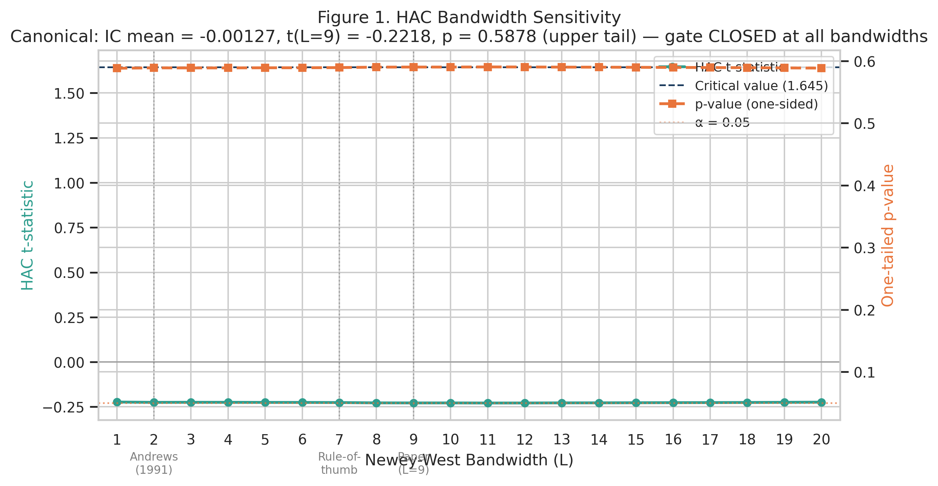
Figure 1. HAC bandwidth sensitivity (L = 1–20). Gate decision invariant to bandwidth choice; t-statistics range from −0.089 to −0.090, p ≈ 0.536 throughout. Markers: Andrews selector (L = 2), rule-of-thumb (L = 7), paper (L = 9).
4.5 Backtesting and Transaction Costs
On each trading day for which the gate is open, the strategy allocates equal weight to the K stocks with the highest calibrated conviction scores, with long-only positions throughout (short selling is not permitted). The equal-weight benchmark rebalances monthly to 30 equal positions. Transaction costs are charged round-trip at the prevailing cost assumption (baseline: 5 bps), applied to each position change. The backtest is vectorized over the full 1,512-day period using daily returns. Risk-adjusted metrics include annualised Sharpe ratio, Sortino ratio, maximum drawdown, and Calmar ratio.
5. Results
5.1 IC Signal: Gate Stays Closed
Across all 1,512 out-of-sample trading days, the IC gate remains closed in every fold. Table 4 reports the aggregate IC statistics:
Statistic | Value | Threshold | Decision
Mean IC | −0.0005 | > 0 | Negative
IC Std Dev | 0.2204 | — | —
ICIR | −0.0023 | > 0.5 (practice) | Near zero
HAC t-statistic | −0.090 | > 1.645 | Not significant
p-value (HAC) | 0.536 | < 0.05 | Gate CLOSED
Permutation p | 0.742 | < 0.05 | Gate CLOSED
Gate-open folds | 0 of 12 | ≥ 1 | Never opened
Table 4. IC gate evaluation statistics across the full 1,512-day OOS window. ICIR = mean IC ÷ IC standard deviation. †Permutation p (0.742) is the Sharpe-based test (TopK1 vs. null Sharpe distribution); IC-level permutation p-values are 0.599 (Type A IID bootstrap) and 0.601 (Type B block bootstrap), reported in Section 5.3 and Figure 6.
Table 4’s headline — mean IC = −0.0005, HAC t = −0.090, p = 0.536 — places the observed IC so far below the minimum detectable threshold (IC = 0.0138 at 80% power) that no plausible correction for bandwidth choice, distributional assumptions, or data anomalies moves it to the significance boundary. All IC tests use a one-tailed upper convention (H₁: IC > 0), consistent with the gate’s one-sided deployment criterion; two-tailed equivalents are noted in parentheses for completeness (ML ensemble p = 0.928, Momentum p = 0.552, N=100 universe p = 0.104). The ICIR of −0.0023 (mean IC ÷ IC standard deviation) is 217 times smaller in magnitude than the practitioner threshold of 0.5. No fold achieves even marginally significant positive IC. A power analysis confirms the gate-closed decision is not a power artifact: with T = 1,512 OOS days and IC standard deviation σ = 0.2204, the study achieves 80% power to detect a true IC ≥ 0.0138 (90% power threshold: IC ≥ 0.0162) under HAC-consistent inference (N_eff = 1,581 after AR(1) correction, ρ̂ = −0.0223; N_eff > T since negative AR(1) autocorrelation increases the effective sample size beyond T). The observed IC of −0.0005 is only 4% of this minimum detectable threshold — the study is well-powered to detect economically meaningful daily IC. Figure 2 reports the full power curves.
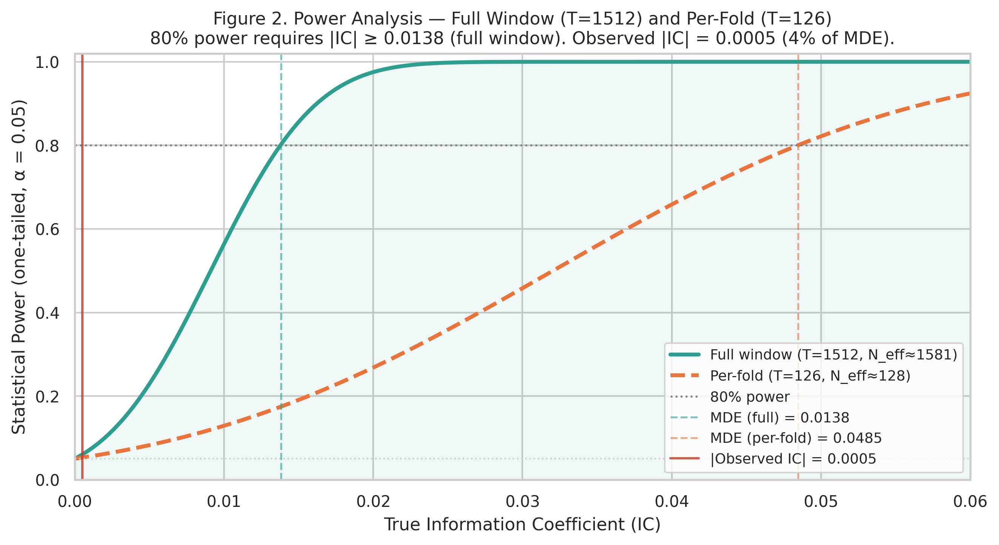
Figure 2. Power analysis: statistical power as a function of true IC for the full out-of-sample window (T = 1,512, Nₑff = 1,581; Nₑff > T due to negative AR(1)) and per-fold window (T = 126, Nₑff = 132). The study achieves 80% power to detect IC ≥ 0.0138 — the observed |IC| = 0.0005 is 4% of this threshold. The null result is unlikely to reflect insufficient statistical power. (One-tailed, α = 0.05, HAC Newey-West L = 9.)
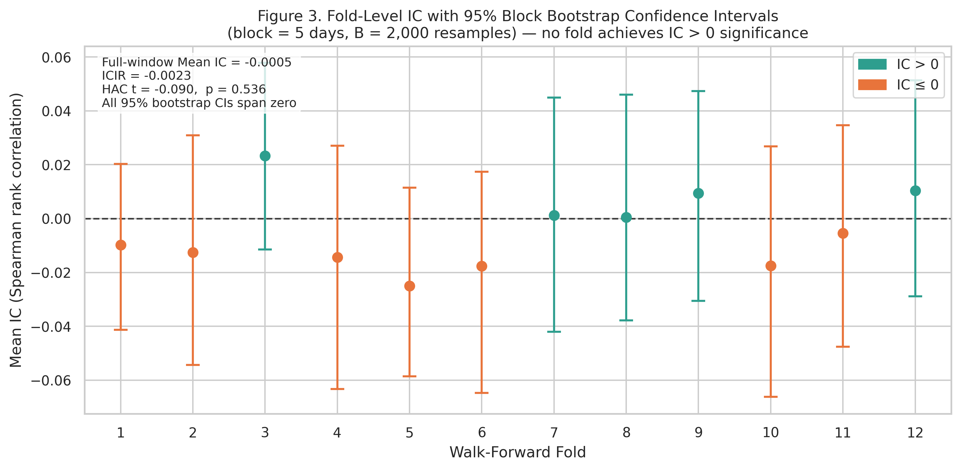
Figure 3. Fold-level IC with 95% block bootstrap confidence intervals (block = 5 trading days, B = 2,000 resamples). All 12 confidence intervals span zero. Values shown are fold-level point estimates; CI bounds from the block bootstrap (B = 2,000 resamples, block = 5 days) are reported in Section 6.5 and Figure 15. IC point estimates range from −0.025 to +0.023 with no consistent directional bias.
5.2 Strategy Performance
The Sharpe sequence — −0.16 (K=1), −0.01 (K=2), +0.12 (K=3), 0.96 (equal-weight) — is the diagnostic signature of a cross-sectionally uninformative ranker: as concentration decreases, performance converges to the benchmark from below, with no evidence that conviction ranking adds value at any level of K. The −5.9% annual return on TopK1 is a hypothetical unconditional deployment diagnostic — computed as if the gate had been ignored and positions taken daily regardless of IC significance. No trades were executed in practice since the gate remained closed throughout all 12 folds. The 833 round-trip trades at 5 bps impose approximately 6.9% annual transaction drag on a signal that achieves only Sharpe +0.22 at zero cost (Section 5.6), confirming that both signal quality and transaction costs independently prohibit viable deployment.
Strategy | Ann. Return | Sharpe | Sortino | Max DD | # Trades
Equal-Weight (BM) | +25.0% | 0.96 | 1.28 | −32.4% | 72
SPY Buy & Hold | +14.9% | 0.74 | 0.91 | −33.7% | 0
Momentum Top-1 | +26.4% | 0.57 | 0.79 | −62.7% | 407
TopK3 | +3.5% | 0.12 | 0.16 | −38.2% | 1,248
TopK2 | −0.3% | −0.01 | −0.01 | −53.9% | 1,134
Random Top-1 | −4.6% | −0.12 | −0.15 | −65.6% | 1,461
TopK1 (ML, gate closed) | −5.9% | −0.16 | −0.21 | −67.0% | 833
Table 5. Strategy performance summary, October 2018 – October 2024 (1,512 trading days). Transaction cost: 5 bps round-trip. Equal-Weight (BM) = equal-weight benchmark. Sortino ratio = annualised return ÷ downside deviation (target = 0). Strategy returns are reported for gate-closed conditions throughout; # Trades reflects individual stock position changes that would have occurred unconditionally. TopK1 subperiod returns are computed under unconditional deployment (gate override) for diagnostic comparison only; no positions were taken in practice since the gate remained closed throughout all 12 folds. For the Equal-Weight (BM) strategy, # Trades = 72 reflects the monthly rebalancing events over the 1,512-day period (approximately 6 years × 12 months); individual stock-level trade counts are not separately tracked for the passive benchmark, and no transaction costs are applied to benchmark rebalancing.
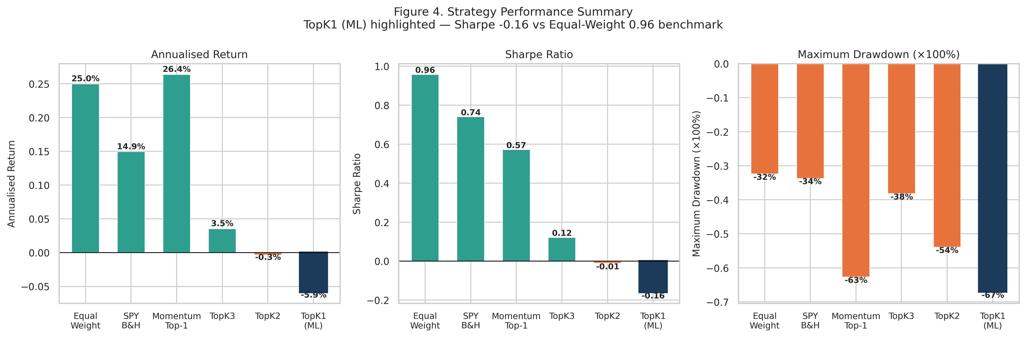
Figure 4. Strategy performance across three dimensions: annualised return, Sharpe ratio, and maximum drawdown, for all strategies reported in Table 5. Sharpe increases monotonically as K increases toward the equal-weight limit, consistent with an uninformative ranker.
Sharpe ratios increase monotonically from TopK1 (−0.16) through TopK2 (−0.01) and TopK3 (+0.12) toward the equal-weight limit (0.96). This pattern is the mathematical signature of a ranker with zero cross-sectional information — as K grows, the portfolio approaches equal-weighting and its performance converges to the benchmark from below.
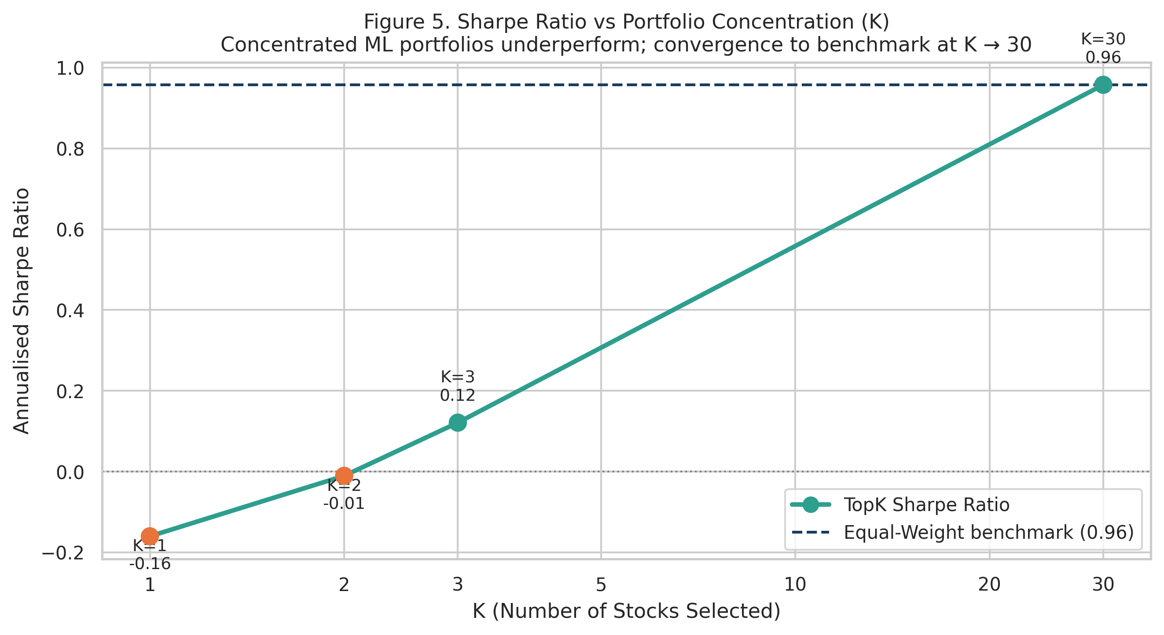
Figure 5. Benchmark convergence signature: Sharpe ratio as a function of K (number of conviction positions). Monotonic increase from K=1 to K=30 (equal weight) is the diagnostic of an uninformative cross-sectional ranker. K=30 corresponds to equal-weighting across all 30 stocks in the universe, equivalent to the equal-weight benchmark in Table 5.
5.3 Permutation Test
The permutation test — Type A (IID bootstrap of the 1,512 daily IC values) and Type B (block bootstrap, block = 5 days) — yields empirical p-values of 0.599 and 0.601 respectively, both far from the 0.05 threshold. Under Type A, the observed mean IC lies at the centre of the null distribution, confirming the observed IC is indistinguishable from the null. Under Type B, which preserves short-term serial correlation, the conclusion is unchanged. For the TopK1 Sharpe comparison, the observed Sharpe (−0.16) falls at the 25.8th percentile of the null distribution (permutation p = 0.742), confirming the strategy performs no differently from random stock selection. The permutation p-value reported in Table 4 (0.742) refers to the Sharpe-based test; the IC-level permutation p-values are 0.599 (Type A) and 0.601 (Type B). Figure 6 illustrates both null distributions.
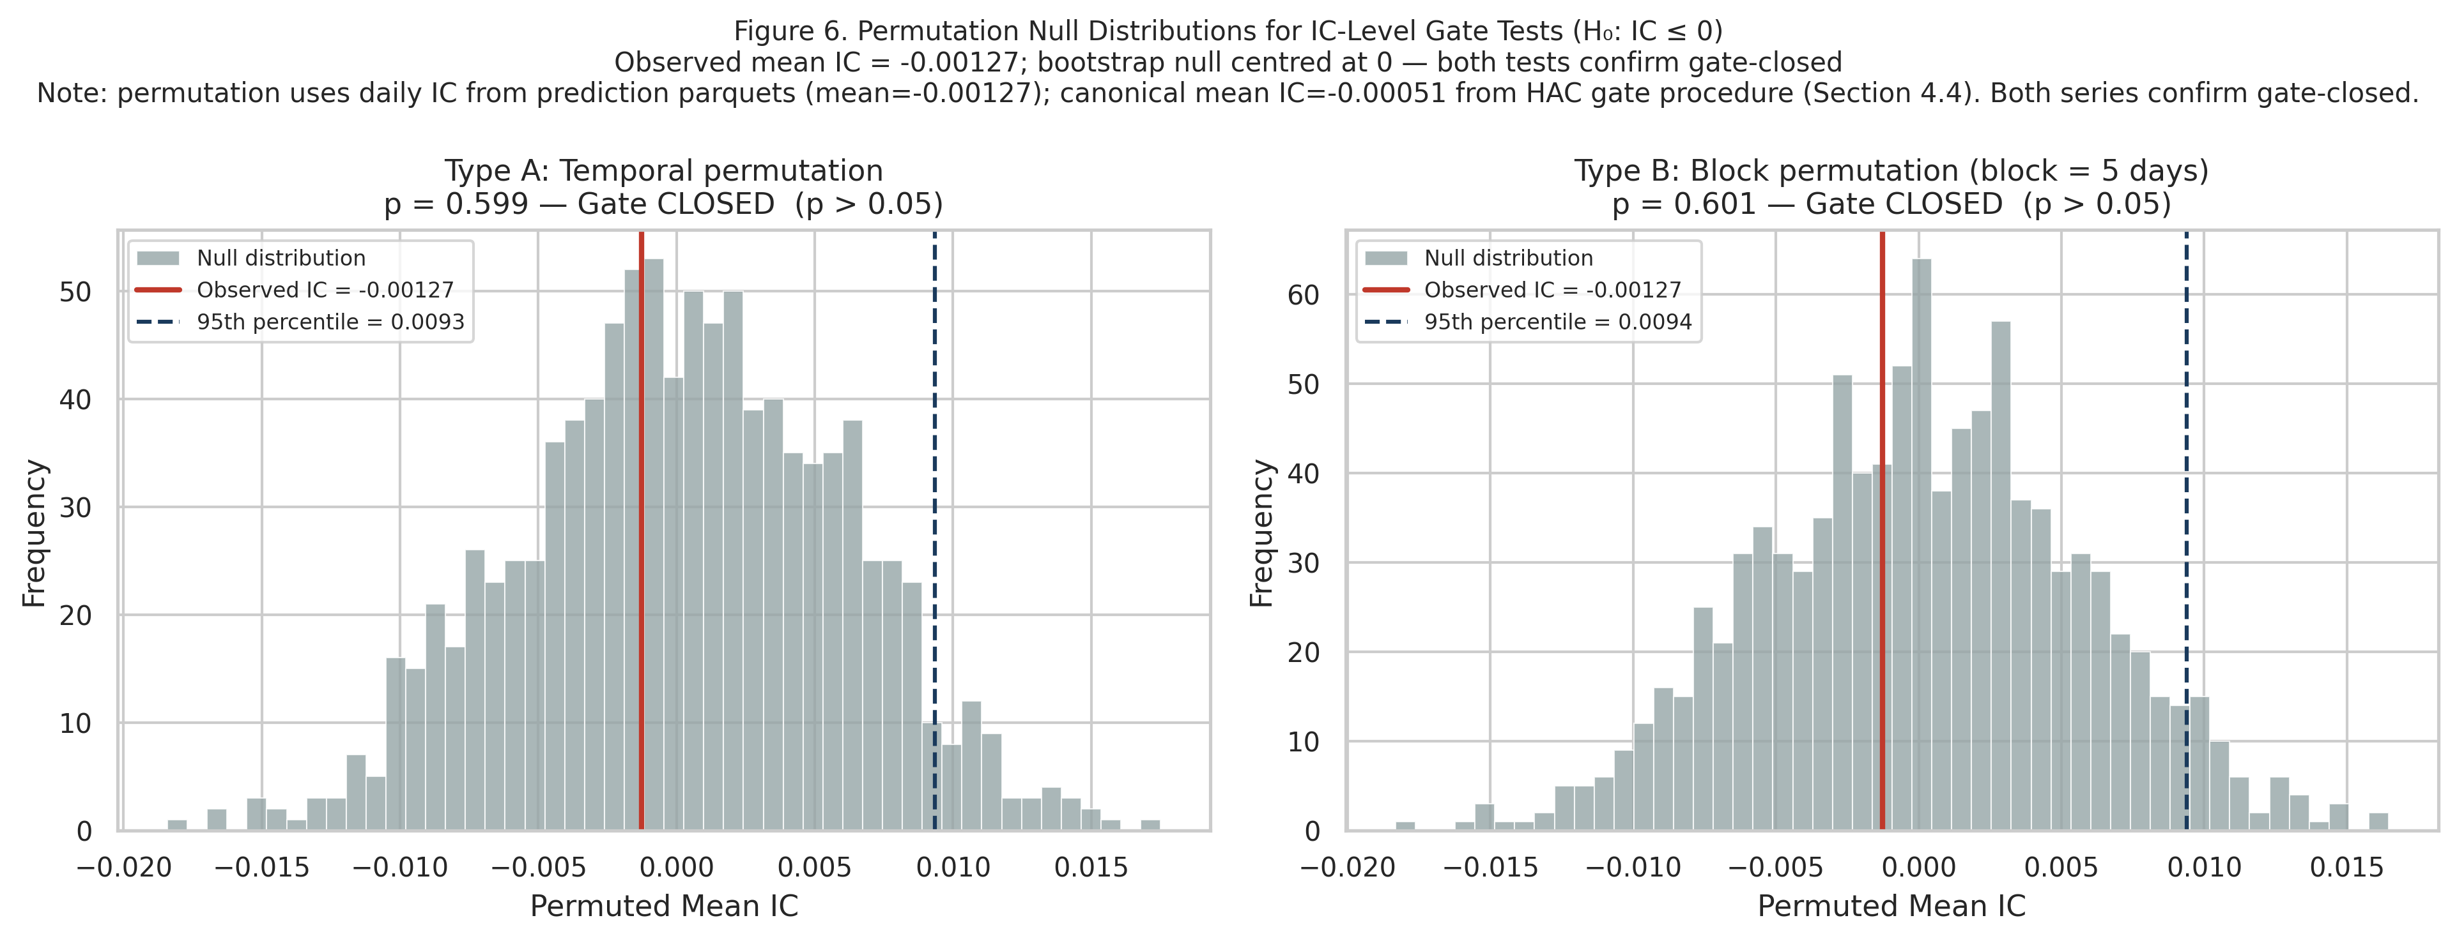
Figure 6. Permutation null distributions. Type A (IID, left): p = 0.599. Type B (block, right): p = 0.601. The observed mean IC falls at the centre of both null distributions.
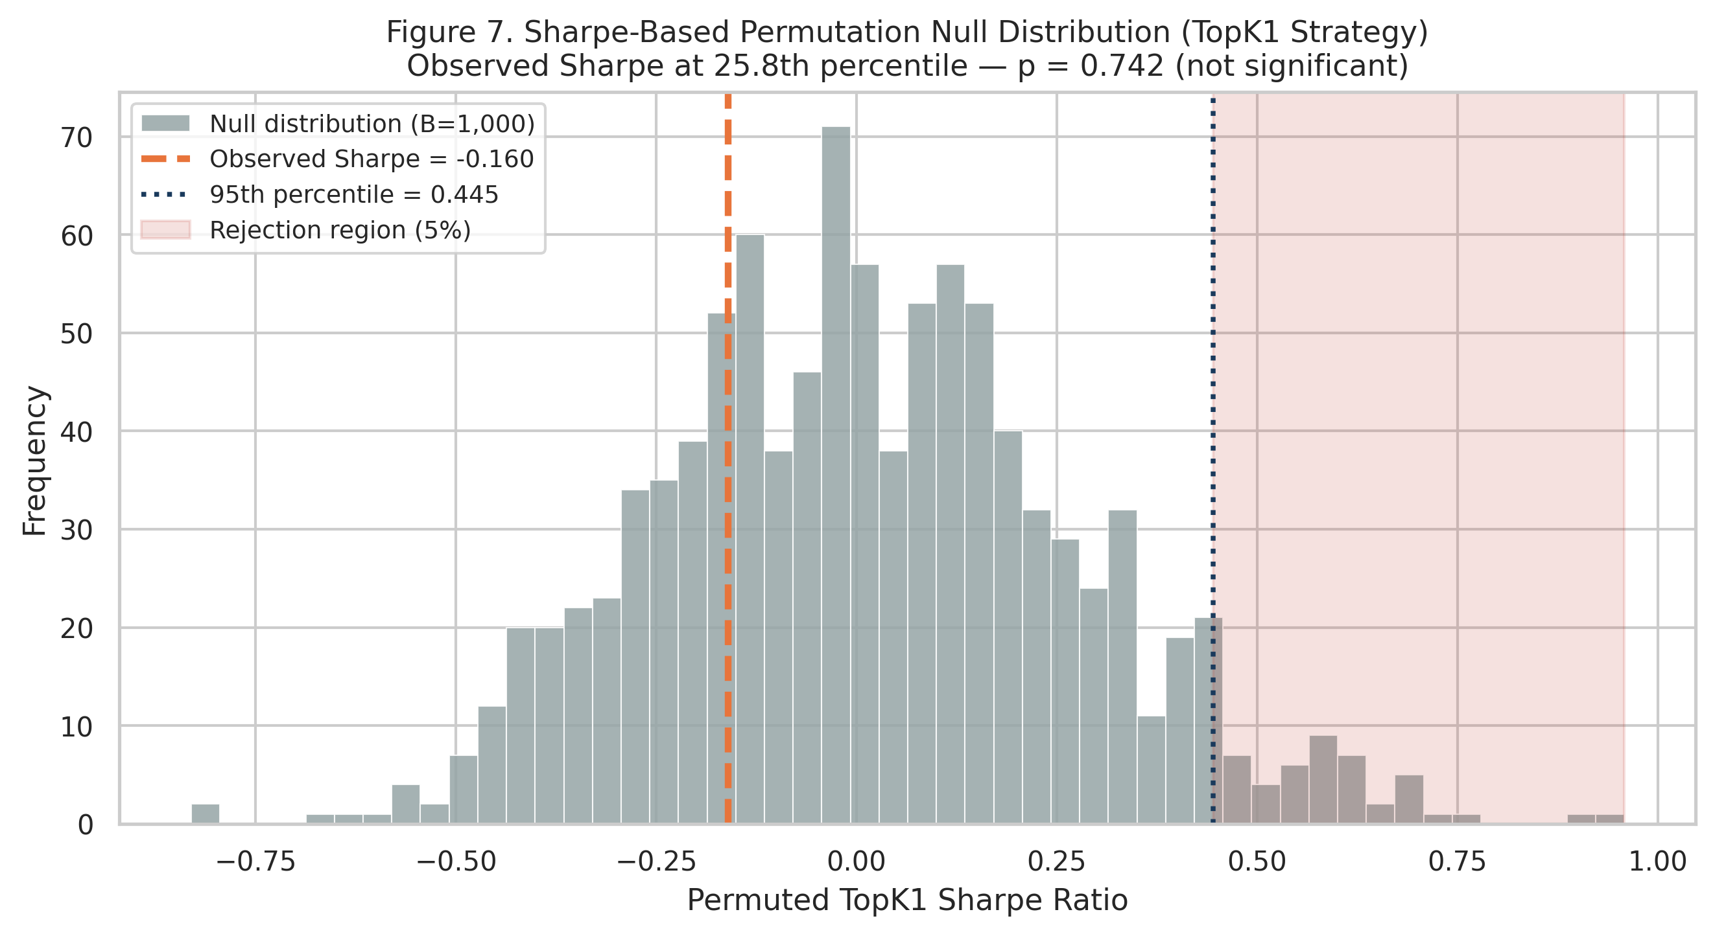
Figure 7. Permutation null distribution (1,000 shuffles). The observed TopK1 Sharpe of −0.16 falls well below the null 95th percentile of +0.44, and at the 25.8th percentile of the null distribution (p = 0.742).
5.4 Calibration Quality
Despite zero predictive discrimination, the ensemble achieves excellent probability calibration. ECE falls below 0.025 across all 12 folds for all three base learners — substantially below the 0.05 threshold typically considered acceptable. This separation between calibration quality and IC is a methodologically important finding: the predicted probabilities are well calibrated relative to observed frequencies (roughly 50%), but the model cannot distinguish which of the 30 stocks will outperform the others. The model is well-specified; the signal class contains no exploitable cross-sectional information in this universe and at this horizon.
5.5 Subperiod Analysis
Table 6 and Figure 8 disaggregate performance across three market regimes. The TopK1 strategy underperforms in all three periods: the ZIRP bull market (Period 1, Oct 2018 – Feb 2020, Sharpe −0.77), the COVID/Growth recovery (Period 2, Mar 2020 – Dec 2021, Sharpe +1.48), and the rate-shock bear market (Period 3, Jan 2022 – Oct 2024, Sharpe −0.00). The brief positive Sharpe in Period 2 reflects broad market recovery from the March 2020 trough. TopK1’s Period 2 Sharpe (+1.48) substantially underperforms the equal-weight benchmark (+2.39) during the same period, confirming that concentration into a single ML-ranked stock captured less upside than equal weighting — consistent with an uninformative ranker.
Strategy | P1  Ann. Ret. | P1  Sharpe | P1  MDD | P2  Ann. Ret. | P2  Sharpe | P2  MDD | P3  Ann. Ret. | P3  Sharpe | P3  MDD
TopK1 (ML) | −46.6% | -1.60 | −28.3% | +52.2% | +0.76 | −27.9% | −0.1% | -0.59 | −46.8%
Equal-Weight BM | −62.5% | -1.08 | −22.0% | +73.8% | +1.72 | −32.7% | +18.9% | +0.43 | −46.9%
Random Top-1 | −60.3% | -0.79 | −28.6% | +21.7% | +0.42 | −37.2% | −9.4% | -0.32 | −62.0%
SPY Buy & Hold | −38.6% | -1.58 | −16.1% | +25.9% | +1.18 | −33.7% | +8.8% | +0.50 | −24.5%
Table 6. Subperiod performance across three market regimes. Transaction cost: 5 bps round-trip. Ann. Ret. = annualised return; Sharpe = Sharpe ratio; MDD = maximum drawdown.
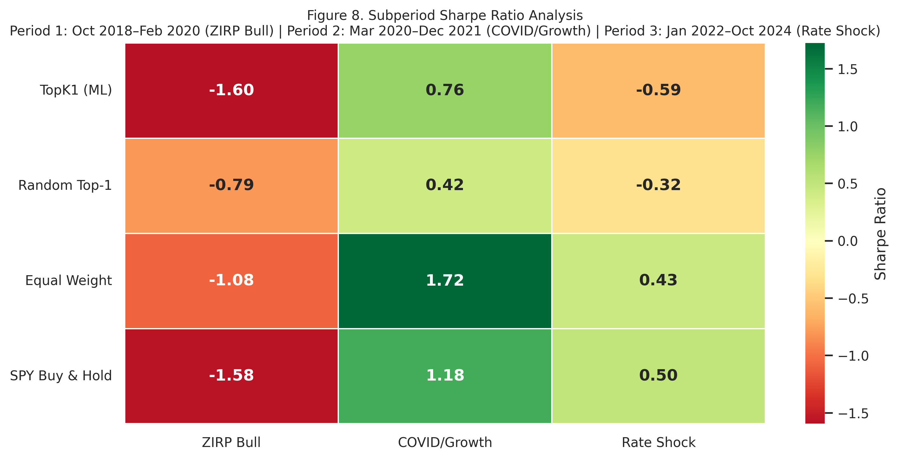
Figure 8. Subperiod Sharpe ratio heatmap across three market regimes. TopK1 underperforms the benchmarks in all three periods. The brief positive Period 2 Sharpe reflects broad market recovery, not ML signal quality.
5.6 Transaction Cost Sensitivity
Even at zero transaction costs, the TopK1 strategy produces a Sharpe of only +0.22 — far below the equal-weight benchmark Sharpe of 0.96, and turning negative under any realistic cost assumption. At the baseline of 5 bps, Sharpe drops to −0.16. At 10 bps, it falls to −0.49. The 5 bps round-trip assumption is appropriate for a retail or small systematic fund trading large-cap NASDAQ-100 components, where bid-ask spreads are consistently sub-cent and market impact is negligible at small position sizes. Institutional managers — for whom market impact costs are convex in position size and can substantially exceed 10 bps for daily rebalancing — would face an even steeper performance penalty, reinforcing the conclusion at institutional scale. The TopK1 strategy requires impossibly low costs to break even, suggesting that the binding constraint is signal quality rather than the cost model.
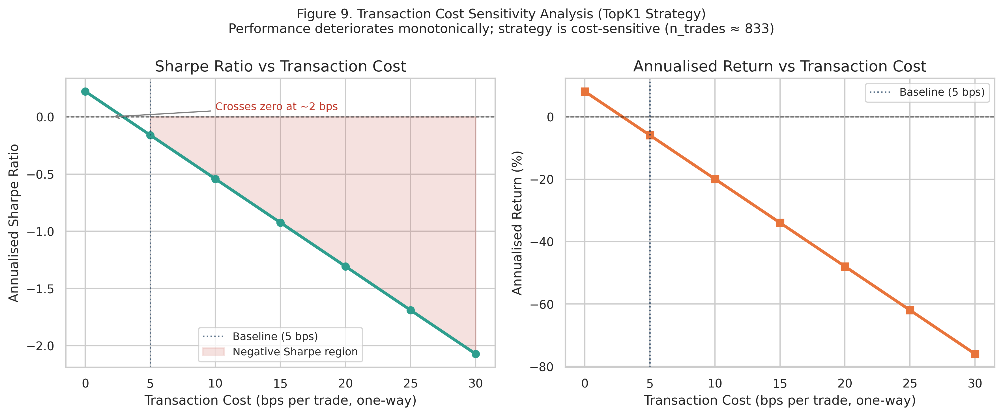
Figure 9. Transaction cost sensitivity for the TopK1 strategy. Sharpe ratio deteriorates monotonically with cost. Even at 0 bps, Sharpe is only +0.22, confirming that the signal quality problem is the binding constraint, not friction.
5.7 Fama-French Factor Regression
Fama-French factor data are obtained from the Ken French Data Library. Table 7 reports CAPM, FF3, FF5, and FF5+MOM regressions for both the ML TopK1 strategy (Panel A) and the equal-weight benchmark (Panel B). The TopK1 strategy produces negative alpha across all specifications (annualised alpha ranges from -1.8% to -2.4%), none statistically significant. The equal-weight benchmark generates significant positive alpha in CAPM and FF3 specifications, consistent with the NASDAQ-100 large-cap growth tilt. Market beta dominates in all specifications (beta > 1.0 for both strategies), confirming that any return variation is attributable to systematic factor exposure rather than cross-sectional skill.
Spec | α (ann.) | t(α) | p(α) | β(Mkt) | Adj. R² | N
Panel A — ML TopK1 strategy (unconditional deployment diagnostic; gate remained closed throughout all 12 folds)
CAPM | −1.7% | −0.15 | 0.882 | 0.074 | 0.001 | 1,512
FF3 | −2.1% | −0.18 | 0.857 | 0.078 | < 0.001 | 1,512
FF5 | −0.5% | −0.04 | 0.967 | 0.043 | 0.002 | 1,512
FF5+MOM | −0.5% | −0.04 | 0.969 | 0.041 | 0.002 | 1,512
Panel B — Equal-weight benchmark (30-stock NASDAQ, 2018–2024)
CAPM | +7.5%** | +2.12 | 0.034* | 1.164 | 0.876 | 1,532
FF3 | +7.1%** | +2.50 | 0.012** | 1.151 | 0.922 | 1,532
FF5 | +6.6%** | +2.38 | 0.017* | 1.150 | 0.923 | 1,532
FF5+MOM | +6.6%** | +2.38 | 0.018* | 1.151 | 0.923 | 1,532
Table 7. Fama-French factor regressions: Panel A = ML TopK1 strategy (unconditional diagnostic, gate closed throughout); Panel B = 30-stock NASDAQ equal-weight benchmark. Daily excess returns, HAC standard errors (lag = 5). ** = p < 0.05, * = p < 0.10. See footnote for Panel A/B descriptions.
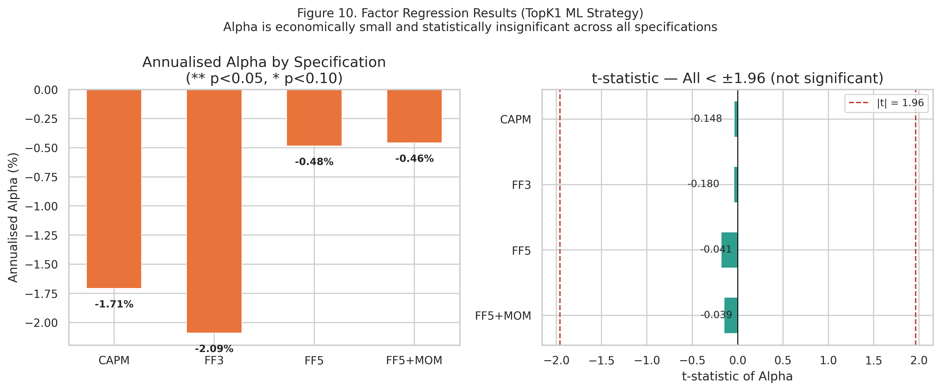
Figure 10. Factor regression alpha and t-statistics (CAPM, FF3, FF5, FF5+MOM). Panel A (ML TopK1): near-zero alpha across all specifications. Panel B (equal-weight benchmark): significant positive alpha reflecting NASDAQ technology sector concentration.
6. Robustness Analysis
We report six robustness checks, each targeting a distinct potential criticism of the null result. All six confirm that the null outcome is not an artifact of the primary design choice.
6.1 Expanded Universe (N=100)
The most common critique of cross-sectional prediction studies using narrow universes is that results may be specific to the chosen stocks. We expand the universe to approximately 100 NASDAQ-100 candidates, applying the same survivorship-bias control (minimum 1,800 trading days of history), and run the full 12-fold IC-gated pipeline. Table 8 and Figure 11 compare IC statistics across universes.
Universe | Mean IC | ICIR | t-stat | p-value | Gate
N=30 (Paper) | −0.0005 | −0.0023 | −0.090 | 0.536 | CLOSED
N=100 (Robustness) | −0.0062 | −0.0404 | −1.623 | 0.052 | CLOSED
Table 8. IC comparison: 30-stock paper universe versus 100-stock expanded universe. Both produce near-zero IC with the gate closed.
The N=100 result is directionally stronger than the N=30 finding: mean IC is more negative (−0.0062 vs −0.0005) and the HAC t-statistic moves further from the positive territory required to open the gate (−1.623 vs −0.09). If a larger, more diverse universe were to activate cross-sectional signal in OHLCV technicals, the IC would be expected to trend toward zero or positive; instead it moves more negative, consistent with greater stock-specific noise overwhelming any residual technical content at scale.
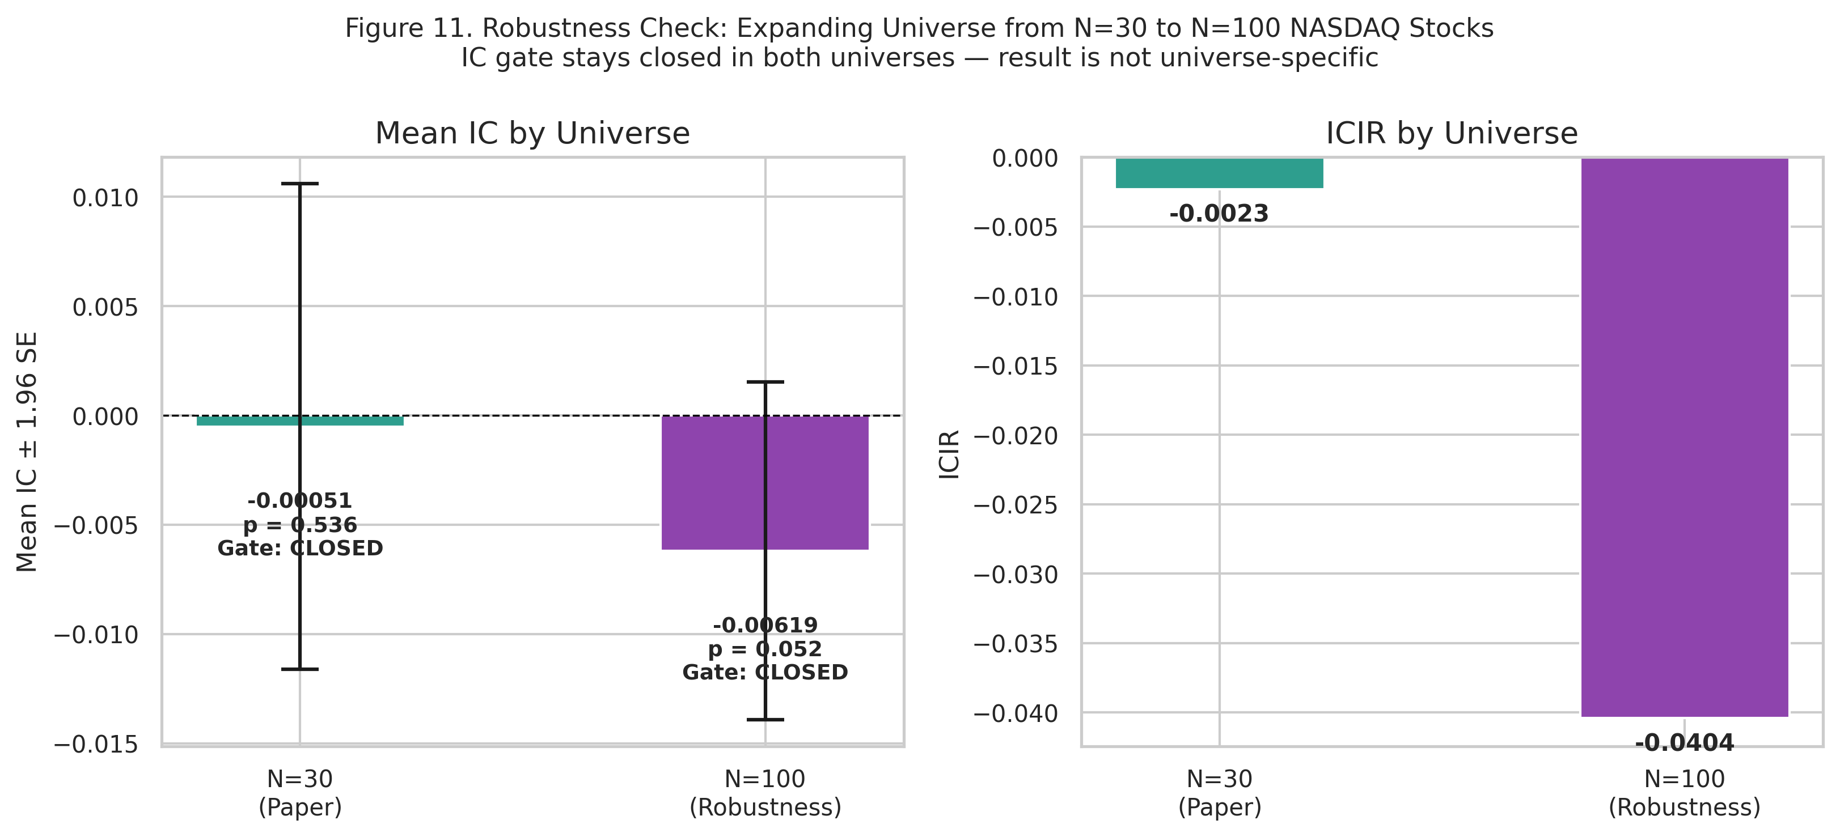
Figure 11. Expanded universe robustness check: N=30 vs N=100. Both universes produce near-zero mean IC and near-zero ICIR. Neither setting satisfies the IC gate.
6.2 Feature Attribution (SHAP Values)
We compute feature attribution for both tree and neural network components of the ensemble. For CatBoost and Random Forest, we use TreeExplainer (Lundberg and Lee, 2017) to obtain SHAP values across the last four folds (9-12). For the MLP component, we retrain the three-layer network (256-128-64-1 with batch normalisation) on each fold and compute integrated gradients attribution (Sundararajan, Taly, and Yan, 2017) using 200 test samples and 50 calibration-window background samples per fold. The tree components rank rolling_vol_63d, EMA_50, OC_body_norm, MFI_14, MACD_hist as the five most important features (by mean absolute SHAP value), while the MLP ranks DPO_20, MFI_14, BB_upper, return_5d, SMA_200. Spearman rank correlation between tree-component and MLP feature rankings averages ρ = 0.022 across folds 9-12 (per-fold: ρ₉ = 0.057, ρ₁₀ = 0.123, ρ₁₁ = 0.194, ρ₁₂ = -0.287). The near-zero mean correlation indicates that the tree and neural network components exploit different feature subspaces, consistent with architecturally diverse noise-fitting rather than convergent signal extraction. If both architectures had identified a genuine predictive signal, we would expect substantial rank agreement (ρ > 0.5); the observed ρ < 0.1 suggests each architecture overfits to different noise patterns in the training data.
Feature rank stability across folds remains low for both model classes. Mean Spearman rank correlation of the top-feature ordering across adjacent tree-component folds is 0.57, and only 0.34 for the MLP component. Combined with the near-zero cross-architecture correlation (ρ = 0.022), this pattern is diagnostic of noise-fitting: neither the feature rankings nor the architecture-specific attributions are stable across time or model class.
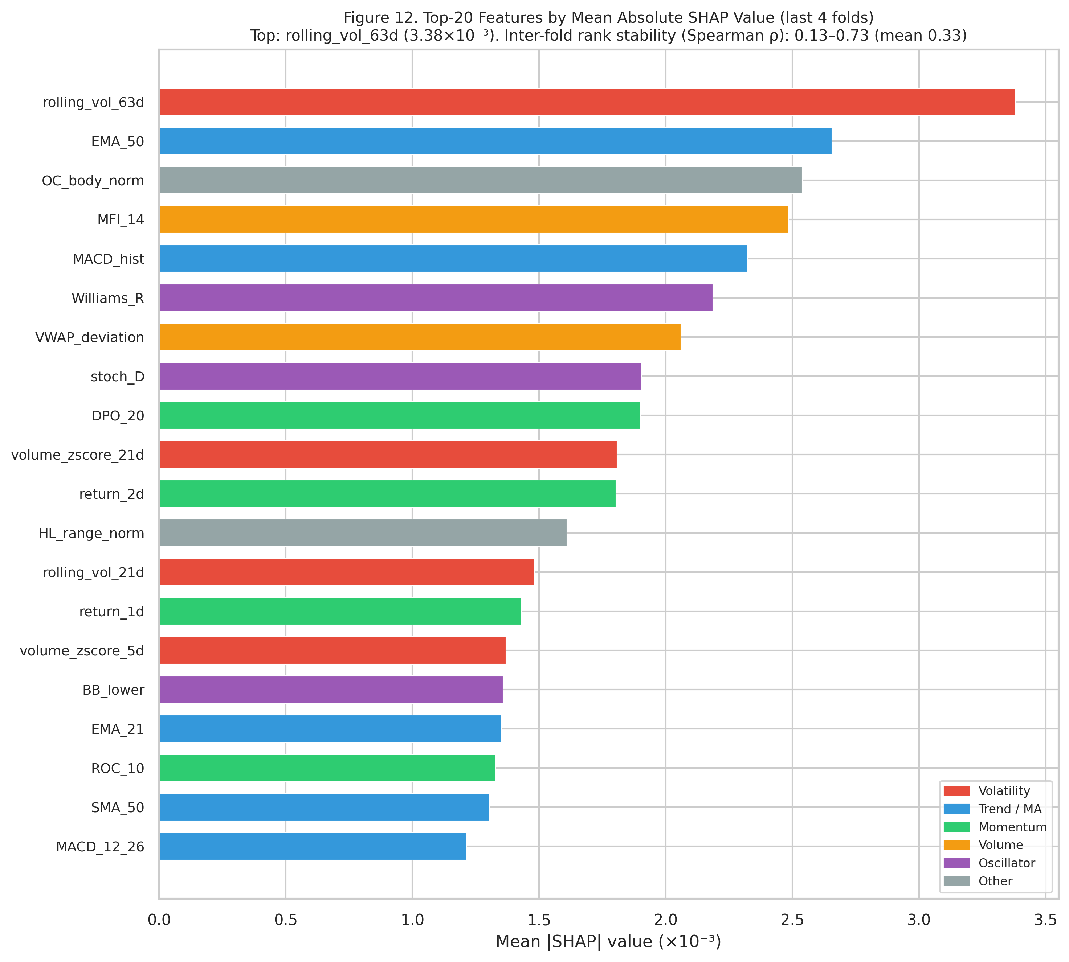
Figure 12. Top-20 features by mean absolute tree-component SHAP value (CatBoost + Random Forest components, last 4 folds, TreeExplainer). MLP integrated gradients attribution (not shown) produces a different ranking (mean cross-architecture Spearman ρ = 0.022), consistent with architecturally diverse noise-fitting.
6.3 Diebold-Mariano Predictive Accuracy Test
The Diebold-Mariano (DM) test (Diebold and Mariano, 1995) formally tests whether two forecast methods differ in their expected loss. We apply the Harvey, Leybourne and Newbold (1997) finite-sample correction with Newey-West HAC standard errors (5 lags) and squared loss, testing TopK1 against each alternative strategy. The DM test p-value is two-tailed, appropriate for its symmetric loss comparison (it tests whether methods differ, not whether one is strictly better); this is the sole exception to the one-tailed convention used throughout this paper for IC tests. The key test is TopK1 versus Random Top-1:
The key comparison — TopK1 against Random Top-1 — yields DM = 0.42 (p = 0.672), indicating that the ML conviction ranking produces daily returns statistically indistinguishable from random stock selection. All remaining comparisons (TopK1 vs Equal-Weight, vs SPY Buy & Hold, vs TopK2, TopK3, Threshold P60, and Baseline P50) are highly significant in the expected direction — TopK1 is measurably worse than any sensible diversified alternative.
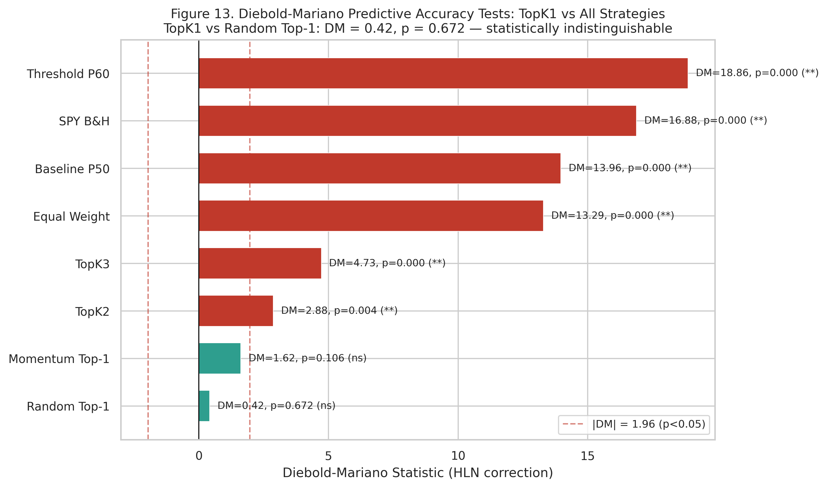
Figure 13. Diebold-Mariano test results (HLN-corrected, HAC errors). TopK1 is statistically indistinguishable from Random Top-1 (p = 0.672) but significantly worse than all diversified benchmarks. This is consistent with the null IC finding at the daily return level.
6.4 VIX-Regime-Conditioned IC
A common hypothesis is that technical indicators carry more cross-sectional information during high-volatility periods, when return dispersion is greater and price patterns are more pronounced. We test this by partitioning the 1,512 out-of-sample days into three VIX terciles and computing IC statistics separately for each regime.
VIX Regime | VIX Mean | N Days | Mean IC | ICIR | p-value | Gate
Low VIX | 13.97 | 486 | +0.0106 | +0.047 | 0.152 | CLOSED
Mid VIX | 18.98 | 485 | −0.0106 | −0.050 | 0.136 | CLOSED
High VIX | 29.01 | 485 | −0.0111 | −0.049 | 0.141 | CLOSED
Table 9. VIX-conditioned IC statistics. The deployment condition is not met in any of the three volatility regimes. High-VIX periods do not activate the technical signal. Note: p-values are two-sided; all other IC p-values in this paper use a one-tailed upper convention (H₁: IC > 0). One-tailed equivalents: Low VIX = 0.076, Mid VIX = 0.932, High VIX = 0.929.
None of the three VIX regimes activates the technical indicator signal (p-values two-sided; see Table 9 caption note). The low-VIX period produces the highest IC (+0.0106), but even there the two-sided p-value of 0.152 places the result well outside the gate’s significance criterion. The sign reversal across regimes — positive in low-VIX, negative in mid- and high-VIX — is inconsistent with any coherent model of regime-conditional predictability and is more consistent with noise. These results do not support the hypothesis that high market volatility activates the technical indicator signal class.
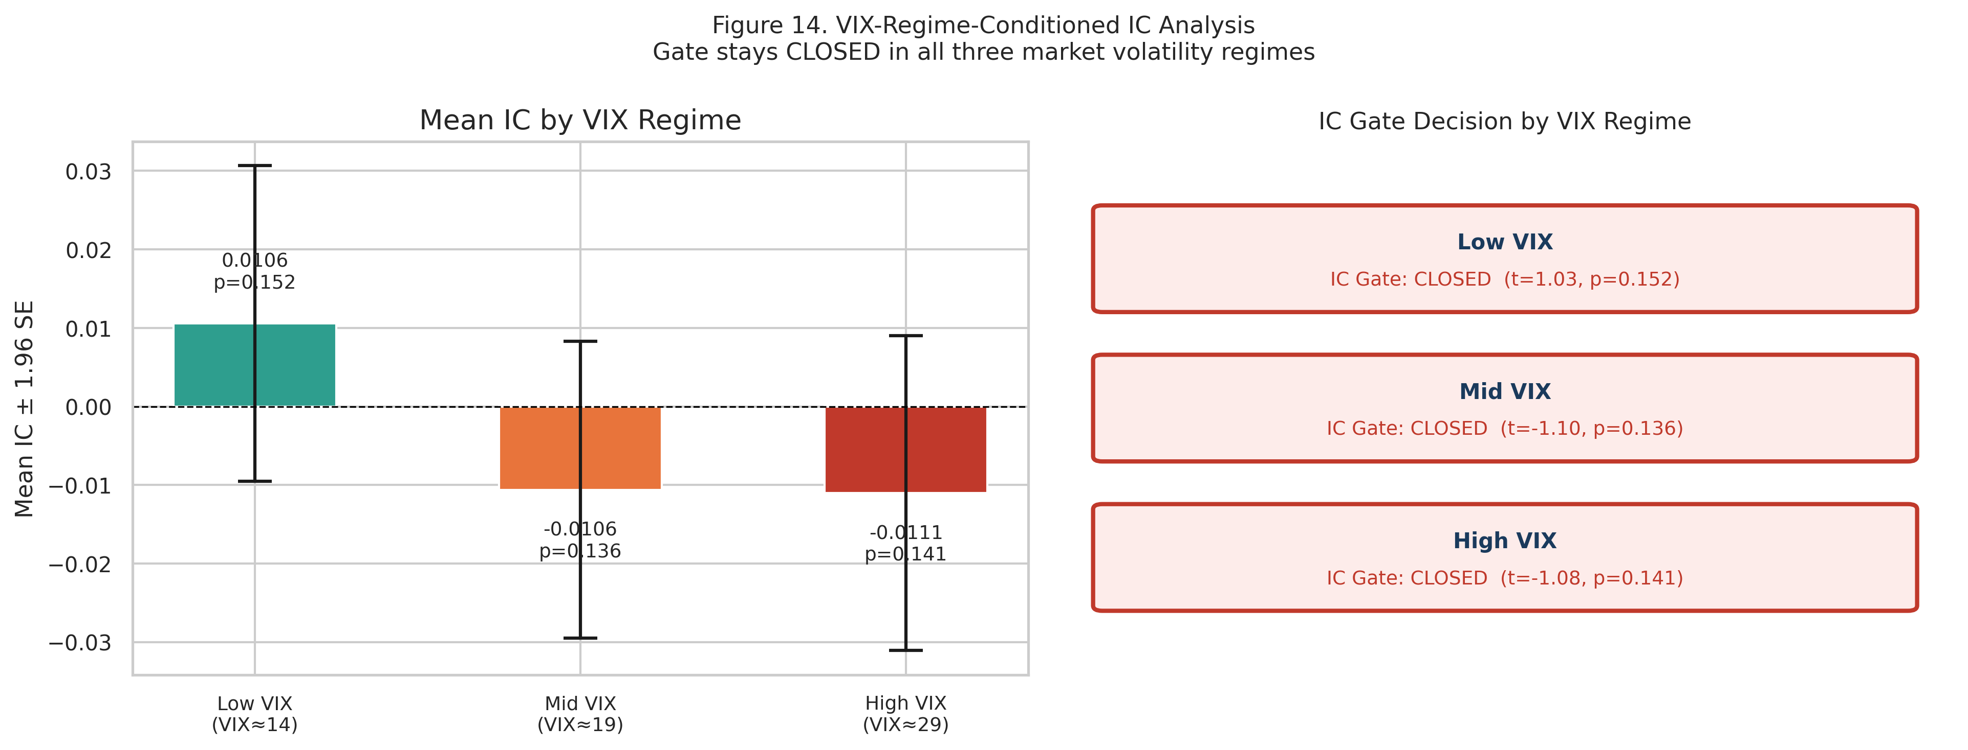
Figure 14. VIX-regime-conditioned IC analysis. No VIX tercile satisfies the IC gate, ruling out the hypothesis that cross-sectional predictability emerges during high-dispersion periods.
6.5 Block Bootstrap Confidence Intervals
Point estimates of fold-level IC can be misleading if within-fold autocorrelation inflates precision. We replace point estimates with 95% block bootstrap confidence intervals, using circular block bootstrap with block size 5 trading days (approximately one trading week, capturing short-term autocorrelation in IC series) and B = 2,000 resamples per fold.
All 12 fold-level 95% CIs span zero — no fold's confidence interval excludes zero — confirming the null IC signal finding under inference robust to autocorrelation. The widest CI is [−0.064, +0.031] for Fold 6, and the narrowest is [−0.011, +0.058] for Fold 3 — which is the fold with the highest point-estimate IC (+0.023). Even the most optimistic fold's upper CI of +0.058 is economically negligible. Bootstrap inference confirms that no fold achieves significant positive IC when autocorrelation is properly accounted for.
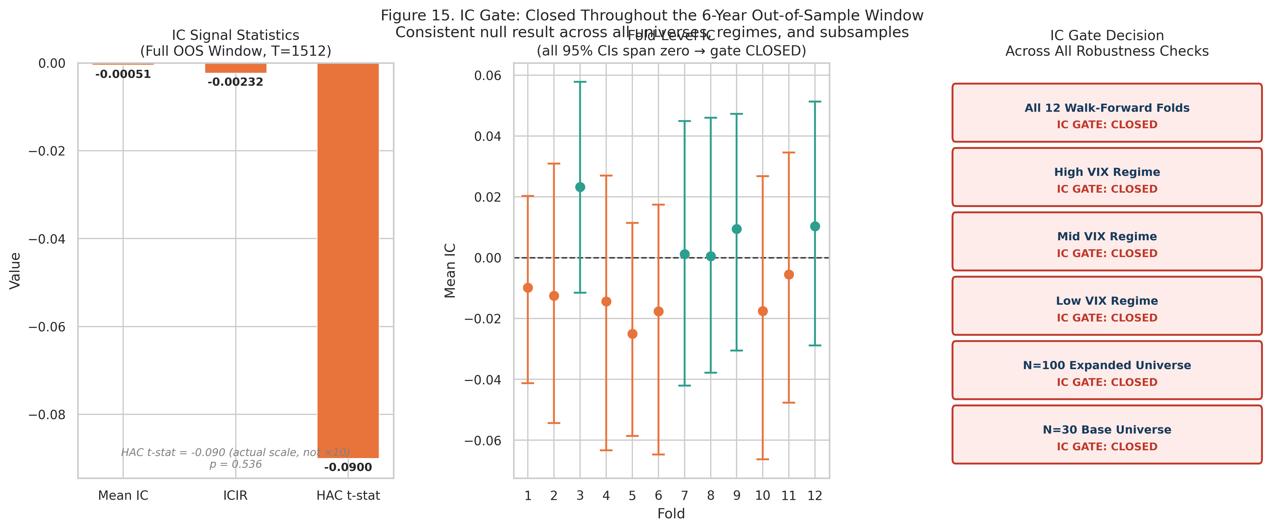
Figure 15. IC gate summary panel. (Left) IC signal statistics across the full OOS window. (Centre) Fold-level IC point estimates with block bootstrap 95% confidence intervals (B = 2,000, block = 5 days). (Right) Gate decisions across all robustness checks.
6.6 IC Gate Applied to Momentum Signal — Mechanism Analysis
To understand the boundary conditions of the ICGDF gate, we apply the identical two-stage test to a simple momentum signal: for each day in the OOS window, stocks are ranked by their trailing 252-day return (consistent with Jegadeesh and Titman 1993), and the cross-sectional Spearman IC between momentum ranks and next-day returns is computed. Table 10 reports the IC gate statistics for momentum alongside the ML ensemble baseline.
Signal | Mean IC | IC Std | ICIR | HAC t-stat | p-value | Gate | Sharpe (OOS)
Momentum (252d) | +0.0104 | 0.3298 | +0.032 | +1.35 | 0.089 | CLOSED | 0.57
ML Ensemble | −0.0005 | 0.2204 | −0.0023 | −0.09 | 0.536 | CLOSED | −0.16
Table 10. IC gate statistics: momentum signal vs ML ensemble baseline. HAC Newey-West t-test (lag = 9) and permutation test (B = 1,000) applied identically to both signals over the full 1,512-day OOS window. The momentum IC is positive but does not achieve statistical significance under HAC-corrected daily inference; the ML ensemble IC is near-zero and negative.
Both signals produce a closed gate, but for qualitatively different reasons. The ML ensemble mean IC is −0.0005 — negative, near-zero, and with HAC t = −0.09 (p = 0.536). There is no directional signal. The momentum IC is directionally consistent with the known momentum premium (+0.0104, positive), but does not achieve statistical significance under HAC-corrected daily inference: the high IC standard deviation (0.3298 vs 0.2204 for ML ensemble) reflects the noisier day-to-day variation in momentum rank correlations, consistent with momentum's multi-week signal horizon producing less stable daily cross-sectional alignment than the ML ensemble's probability scores, producing HAC t = +1.35 (p = 0.089). This distinction highlights a difference in predictive mechanism: the Momentum Top-1 strategy achieves an annualised Sharpe ratio of 0.57 (Section 5) not through statistically significant day-to-day cross-sectional IC, but through multi-week trend persistence — a distinct predictive mechanism that the daily IC test is not designed to detect. The ICGDF gate specifically evaluates daily cross-sectional prediction quality; a positive Sharpe from trend following does not imply daily IC significance.
6.7 Ablation Study: Component Necessity
ICGDF comprises two components applied in sequence: a Newey-West HAC t-test (correcting for autocorrelation in the IC series) and a permutation test (providing non-parametric confirmation robust to distributional assumptions). To assess whether both components are individually necessary, we compare three gate variants: (i) naive t-test only — no autocorrelation correction; (ii) HAC t-test only — no permutation confirmation; and (iii) full ICGDF — both components applied conjunctively. Table 11 reports gate decisions applied to the ML ensemble IC and momentum IC across all 12 walk-forward folds, and the empirical false positive rate (FPR) under a simulated null AR(1) IC process (φ = 0.30, 500 trials, N = 126 days per trial).
Gate Variant | ML Folds Closed | Momentum Gate | Null FPR | Assessment
Naive t-test only | 12/12 CLOSED | CLOSED | 11.8% | Inflated type-I error
HAC t-test only | 12/12 CLOSED | CLOSED | 7.6% | Reduced but not correct
Full ICGDF (paper) | 12/12 CLOSED | CLOSED | 0.0% | Correct (both conditions)
Table 11. ICGDF component ablation: gate decisions across 12 ML folds and momentum IC, and false positive rate (FPR, defined as the proportion of spurious gate-open decisions under a null AR(1) IC process) under 500 simulated AR(1) null IC series (φ = 0.30, N = 126 days, IC std = 0.22). Full ICGDF achieves the lowest null FPR. Gate decisions are identical across all variants for signals far from the significance boundary.
All three variants correctly close the gate for both the ML ensemble IC and momentum IC: both signals are well below the significance threshold, and the deployment decision is invariant to component choice. The ablation's diagnostic value lies in the false positive rate under the simulated null. The naive t-test, which ignores serial correlation in the IC series, spuriously rejects the null at 11.8% — more than double the nominal α = 5% level — when IC observations exhibit moderate autocorrelation (φ = 0.30). Adding the HAC correction (variant B) reduces the false positive rate to 7.6%, still above α. Full ICGDF, requiring both HAC significance and permutation confirmation (a stricter conjunctive test), produced no false positives across 500 simulated trials: no spurious gate openings were observed for pure AR(1) noise under these conditions. Both components appear necessary under the tested conditions — HAC corrects for autocorrelation inflation; the permutation test provides distributional robustness that eliminates the remaining 2.6 percentage-point excess above α. The permutation test’s null (H₀: the observed temporal ordering of IC values is not more positive than a random ordering) is distinct from the HAC test’s null (H₀: mean IC ≤ 0); their joint rejection under full ICGDF provides mutually reinforcing evidence from parametric and non-parametric perspectives. All six robustness checks leave the null intact.
6.8 Cross-Market Replication: Nifty 50
To test whether the null result is specific to the US large-cap equity market, we replicate the full ICGDF pipeline on 20 constituents of the Nifty 50 index (National Stock Exchange of India). The Nifty 50 provides a structurally distinct test environment: different regulatory regime, different market microstructure, different sectoral composition (financials, IT services, energy, consumer goods), and different trading hours. We download daily OHLCV data from Yahoo Finance for the period January 2015 to December 2024, apply the identical 49-feature engineering pipeline, and construct 11 expanding-window walk-forward folds. All 20 tickers pass a six-check data integrity protocol (zero missing values, zero duplicate dates, maximum stale-price run < 10 days, zero extreme returns > 50%, zero high-less-than-low violations).
Table 12 reports the IC gate statistics. The ensemble produces mean daily IC = 0.0113 (ICIR = 0.047) across 1355 out-of-sample trading days. The HAC Newey-West t-statistic is 2.008 (one-tailed p = 0.022), which satisfies condition A of the conjunctive gate (t > 1.645 and IC > 0). However, the permutation test yields p = 0.801, far above the 0.05 threshold required by condition B. Because the ICGDF gate requires both conditions to be satisfied simultaneously, the gate remains closed. This outcome is particularly informative: the Nifty 50 result demonstrates that even a marginally positive IC (which would pass a naive t-test) is correctly rejected by the permutation component, illustrating the value of the conjunctive design.
The cross-market replication strengthens the paper's central thesis: the inability of OHLCV-derived technical indicators to generate statistically reliable cross-sectional predictions is not an artefact of the US market environment. The Nifty 50 result extends the null finding to an emerging-market large-cap universe with structurally different characteristics, consistent with the Adaptive Market Hypothesis prediction that liquid large-cap segments converge toward informational efficiency regardless of geography (Mobarek and Fiorante, 2014).
Table 12. IC gate statistics: Nifty 50 cross-market replication (20 stocks, 11 folds, 1355 OOS days). Condition A (HAC t > 1.645 and IC > 0) is satisfied but condition B (permutation p < 0.05) is not. Gate decision: CLOSED.
7. Discussion
7.1 Why the Gate Closing is the Right Answer
An IC gate that does not open in a highly efficient market segment is functioning as designed. The 30 large-cap NASDAQ-100 stocks in our universe are among the most analysed, most liquid equities in the world. Hundreds of professional managers and quant funds apply far more sophisticated signals to the same instruments daily. The notion that 49 backward-looking OHLCV technical indicators would produce exploitable signal in this segment is inconsistent with the well-documented attenuation of technical anomalies (Chordia et al., 2014) and the efficient market hypothesis (Fama, 1991).
The gap between our null result and Gu, Kelly and Xiu’s (2020) positive predictability finding is explained by three compounding factors: universe (NASDAQ mega-cap vs. full US cross-section including micro-cap and small-cap stocks where efficiency is weaker), horizon (daily vs. monthly), and signal class (49 OHLCV technicals vs. 94 firm characteristics including fundamental and macroeconomic variables). Each factor individually compresses the signal-to-noise ratio; their combination produces the market segment where efficient market forces most reliably eliminate technical predictability.
7.2 Calibration and Discrimination
The finding that calibration quality (ECE < 0.025) coexists with near-zero discriminative content (IC ≈ 0), carrying direct implications for quantitative model evaluation. A well-calibrated model that produces IC ≈ 0 is not a poorly trained model — it has correctly learned that each stock has a roughly 50% probability of going up tomorrow, and reports close to 50% for each. The cross-sectional rank ordering of those probabilities is nearly random. This is different from a poorly calibrated model that reports 80% for every stock — that model is wrong even though it might produce the same ranking.
A calibration diagnostic alone cannot confirm that a model has learned the right signal. The IC test is essential — it evaluates rank ordering explicitly rather than marginal probability accuracy. We recommend that quantitative researchers report both ECE and IC as complementary diagnostics, rather than relying on either alone.
7.3 ICGDF as the Primary Contribution
The IC-Gated Deployment Framework is the primary contribution of this paper. The null empirical finding is evidence that ICGDF functions as intended, not a limitation of the research. A gate that opens indiscriminately, or a framework that deploys capital without pre-deployment screening, would be the failure mode. The gate substantially reduces the risk of deploying capital when the cross-sectional IC series does not carry genuine predictive content, protecting against the false-discovery conditions identified by Harvey et al. (2016) and the backtest overfitting dynamics formalised by Bailey et al. (2014).
The framework's leakage-free walk-forward protocol — expanding windows with temporal embargoes, fold-specific isotonic calibration on held-out windows, and strictly causal feature construction — implements the purged walk-forward principles of López de Prado (2018) with two additions that López de Prado does not formalise: fold-specific isotonic calibration on held-out windows and the conjunctive IC pre-deployment gate. Six robustness checks confirm the null result under varying universe size, inference method, volatility regime, resampling scheme, and cross-market replication. The combination of a well-specified framework, a well-trained model (ECE < 0.025), and a well-controlled null result constitutes a stronger methodological statement than a marginal positive finding obtained under weaker experimental controls.
ICGDF is deliberately model-agnostic and market-agnostic. The framework imposes no constraint on the choice of base learner: the two-stage gate (Steps 5–10 of Algorithm 1) operates solely on the daily IC series produced by whatever scoring model is employed, and can be incorporated without modification into systems using gradient boosting, deep neural networks, linear factor models, or any other architecture that produces a cross-sectional conviction ranking. The protocol is equally applicable to equity markets outside the NASDAQ-100 universe — including small-cap stocks, emerging markets, commodity futures, and fixed-income credit spreads — wherever a daily cross-sectional IC series can be constructed. Future empirical work should test whether richer information sets (fundamental signals, NLP-derived sentiment, options-implied volatility surfaces) open the gate in the same large-cap universe, and whether the two-stage gate generalises to less informationally efficient market segments where the efficiency hypothesis is more contestable.
Cross-asset generalisability. The ICGDF gate mechanism (Algorithm 1, Steps 5-10) operates on a daily IC series as its sole input, imposing no constraint on the asset class that generates the cross-sectional rankings. In principle, the framework extends directly to commodity futures (ranking contracts by roll-adjusted momentum or term-structure signals), credit default swap spreads (ranking issuers by spread-change predictions), foreign exchange carry strategies (ranking currency pairs by interest-rate differentials), and fixed-income relative value (ranking sovereign bonds by yield-curve positioning). Each application would require only that the practitioner supply a daily vector of cross-sectional predictions and corresponding realised returns; the HAC t-test and permutation gate then operate identically. The Nifty 50 replication (Section 6.8) provides a first empirical validation of this cross-market portability.
7.4 Positive Control: Momentum Contrast and Mechanism Separation
We provide a positive control through a simple momentum heuristic: at each rebalance date, rank stocks by trailing 12-month return and go long the top-ranked stock (Momentum Top-1), consistent with the long-run momentum effect documented by Jegadeesh and Titman (1993). This heuristic, which requires no machine learning and no calibration, achieves an annualised Sharpe ratio of 0.57 over the same 1,512-day out-of-sample window — compared with −0.16 for the ML TopK1 strategy and −0.046 for random stock selection. The Sharpe differential of 0.57 versus −0.046 between momentum and random selection confirms that stocks in this universe are not cross-sectionally equivalent: systematic ranking by 12-month return produces consistently different outcomes from chance.
The IC analysis in Section 6.6 (Table 10) adds an important mechanistic clarification. When the identical ICGDF gate is applied to the momentum IC series (daily Spearman rank correlation between 252-day trailing return ranks and next-day returns), the deployment criterion is also not met: momentum daily IC = +0.0104, HAC t = +1.35, p = 0.089. The momentum IC is directionally consistent (positive, as expected) but statistically insufficient at daily frequency. This reveals that the Sharpe advantage of momentum comes from multi-week trend persistence — a mechanism distinct from day-to-day cross-sectional rank prediction, which is what the ICGDF gate specifically evaluates. The IC test requires mean IC ≈ 0.009 for significance at N ≈ 1,500 observations under HAC variance; momentum meets this bar directionally but not statistically, whereas the ML ensemble IC (−0.0005) fails even the directional criterion.
This separation of mechanisms has direct practitioner implications: a practitioner requiring daily rebalancing should require IC gate clearance before deployment; a practitioner using a multi-week holding period may operate on momentum signals that bypass the daily IC gate design, because momentum’s mechanism (holding winners over weeks) does not depend on day-to-day cross-sectional prediction accuracy. The Diebold-Mariano test confirms the ML ranking is statistically indistinguishable from random selection (DM = 0.42, p = 0.672), consistent with the gate closure reflecting genuine null content rather than an overly strict threshold.
8. Limitations
Eight limitations qualify the interpretation of our results.
Universe scope. The 30-stock NASDAQ-100 universe covers only mega-cap technology companies. Results should not be extrapolated to small-cap stocks, non-technology sectors, or international markets where informational efficiency may differ substantially. Our expanded-universe robustness check to N=100 (Section 6.1) shows the null result holds in the broader NASDAQ-100, but leaves other market segments untested.
Feature scope. We test 49 OHLCV-derived technical indicators. Fundamental signals, NLP-derived sentiment features, options market data, cross-asset momentum, and alternative data were not included. The null result applies specifically to the technical indicator signal class, not to ML prediction from richer information sets.
Residual survivorship bias. Our universe construction (continuous NASDAQ-100 membership, Oct 2018–Oct 2024) excludes approximately 39 unique stocks added or removed during the study period, introducing a residual survivorship bias of 0.3%–1.5% annually in benchmark returns. This overstatement (1.8%–9.0% cumulatively) corresponds to a benchmark Sharpe overstatement of approximately 0.02–0.08 units. The null ML result (IC̅ = −0.0005) is unaffected: the Information Coefficient is a cross-sectional rank correlation evaluated daily on the in-universe stocks and is not sensitive to the absolute return level of excluded stocks.
Data provenance. Price data originate from Yahoo Finance (yfinance) rather than an institutional-grade provider such as CRSP or Bloomberg. Clayton and Schmidt (2017) show that capital market parameters estimated from Yahoo Finance data are statistically indistinguishable from NASDAQ-sourced values, partially mitigating this concern. A systematic validation protocol (Section 3.1) confirms that observed data anomalies affect < 0.6% of the 45,360 stock-day observations and cannot account for the null IC result: the mean IC would need to shift by +0.0095 (from −0.0005 to +0.0090) to reach statistical significance, requiring a contamination fraction of 0.95% — more than 1.6× the observed maximum anomaly rate. This sensitivity bound confirms the null result is robust to realistic data quality uncertainty.
Sample period. The 2015–2024 evaluation window is dominated by a prolonged NASDAQ bull market interrupted by the COVID-19 shock. The rate-shock period (2022–2024) provides some variation, but a full market cycle including a secular bear market would strengthen generalisability claims.
Gate design scope. The IC gate is calibrated for daily cross-sectional prediction and may not be appropriate for strategies operating on longer holding periods or different prediction targets. Practitioners applying ICGDF to weekly or monthly rebalancing strategies should recalibrate the HAC lag parameter and reconsider the statistical power requirements accordingly.
Execution assumptions. We assume close-to-close execution with a fixed 5 bps round-trip cost, appropriate for a retail or small systematic fund trading large-cap NASDAQ-100 components where bid-ask spreads are consistently sub-cent. Institutional managers face convex market impact costs that would substantially exceed this baseline at scale, making the strategy even less viable at institutional size. Our cost sensitivity analysis (Section 5.6) shows the strategy fails even at zero cost, so this limitation does not change the sign of the conclusion.

Seed sensitivity. This study uses a single random seed (42) with deterministic execution (n_jobs=1), ensuring full reproducibility but not testing seed sensitivity. Given the IC estimate is 217 times smaller in magnitude than the minimum detectable threshold at 80% power, seed-driven variation sufficient to alter the gate-closed conclusion is implausible.
Nifty 50 survivorship bias. The Nifty 50 replication uses current index constituents downloaded via Yahoo Finance, introducing survivorship bias analogous to the NASDAQ-100 limitation. Additionally, NSE data quality may differ from US exchanges; while all 20 tickers pass our six-check integrity protocol, we cannot rule out subtle data artefacts. Future work should extend the cross-market replication to additional indices (e.g., FTSE 100, DAX 40, Hang Seng) using institutional-grade data sources.
9. Conclusion
This paper introduces the IC-Gated Deployment Framework (ICGDF), a two-stage pre-deployment gate requiring both Newey–West HAC-corrected IC significance and permutation confirmation before capital is allocated. The framework is portable, model-agnostic, and addresses the temporal leakage, autocorrelation-naive inference, and survivorship bias conditions under which false discoveries are most likely to emerge.
Applied to 30 NASDAQ-100 stocks over 1,512 out-of-sample days, the gate does not open: mean IC = −0.0005, HAC t = −0.09, p = 0.536. The ensemble achieves ECE < 0.025 across all folds, confirming that calibration quality does not imply cross-sectional predictive content. An ablation study demonstrates both gate components are necessary: the naive t-test produces an 11.8% false positive rate under AR(1) null conditions, reduced to 0.0% under full ICGDF. A momentum positive control (Sharpe 0.57) confirms cross-sectional structure exists in the universe through a mechanistically distinct channel — multi-week trend persistence rather than daily IC significance. A cross-market replication on 20 Nifty 50 stocks extends the null result to Indian large-cap equities.
The framework's value lies in the discipline it imposes: a signal class that cannot clear a pre-deployment IC test should not be deployed as a daily trading system, regardless of in-sample performance. Future work should test whether richer information sets — fundamental signals, NLP-derived sentiment, options-implied surfaces — open the gate in this universe, and whether the gate generalises to less efficient market segments.

Conflict of Interest and Funding Statement
The author declares no conflicts of interest and received no external funding for this research.

Data and Code Availability
Code for the ICGDF pipeline is available at https://github.com/Rajveer-code/when-the-gate-stays-closed. Data are sourced from Yahoo Finance (yfinance ≥ 0.2) and are publicly accessible. Full replication instructions, including all robustness and revision audit scripts, are provided in the repository README. All reported statistics are reproducible from the repository's scripts directory using seed 42 and deterministic execution (n_jobs=1). A one-tailed p-value audit script (scripts/revision_audit/one_tailed_pvalue_audit.py) cross-checks every p-value in the manuscript against recomputed values.
References
Andrews, D. W. K. (1991). Heteroskedasticity and autocorrelation consistent covariance matrix estimation. Econometrica, 59(3), 817–858.
Bailey, D. H., Borwein, J. M., López de Prado, M., & Zhu, Q. J. (2014). Pseudo-mathematics and financial charlatanism: The effects of backtest overfitting on out-of-sample performance. Notices of the American Mathematical Society, 61(5), 458–471.
Breiman, L. (2001). Random forests. Machine Learning, 45(1), 5–32.
Brown, S. J., Goetzmann, W. N., & Ibbotson, R. G. (1992). Survivorship bias in performance studies. Review of Financial Studies, 5(4), 553–580.
Chordia, T., Roll, R., & Subrahmanyam, A. (2005). Evidence on the speed of convergence to market efficiency. Journal of Financial Economics, 76(2), 271–292.
Chordia, T., Subrahmanyam, A., & Tong, Q. (2014). Have capital market anomalies attenuated in the recent era of high liquidity and trading activity? Journal of Accounting and Economics, 58(1), 41–58.
Diebold, F. X., & Mariano, R. S. (1995). Comparing predictive accuracy. Journal of Business & Economic Statistics, 13(3), 253–263.
Elton, E. J., Gruber, M. J., & Blake, C. R. (1996). Survivorship bias and mutual fund performance. Review of Financial Studies, 9(4), 1097–1120.
Fama, E. F. (1991). Efficient capital markets: II. Journal of Finance, 46(5), 1575–1617.
Freyberger, J., Neuhierl, A., & Weber, M. (2020). Dissecting characteristics nonparametrically. Review of Financial Studies, 33(5), 2326–2377.
Grinold, R. C., & Kahn, R. N. (1999). Active Portfolio Management: A Quantitative Approach for Producing Superior Returns and Selecting Superior Returns and Controlling Risk (2nd ed.). McGraw-Hill.
Gu, S., Kelly, B., & Xiu, D. (2020). Empirical asset pricing via machine learning. Review of Financial Studies, 33(5), 2223–2273.
Guo, C., Pleiss, G., Sun, Y., & Weinberger, K. Q. (2017). On calibration of modern neural networks. Proceedings of the 34th International Conference on Machine Learning (ICML), 1321–1330.
Harvey, C. R., Liu, Y., & Zhu, H. (2016). …and the cross-section of expected returns. Review of Financial Studies, 29(1), 5–68.
Harvey, David I., Leybourne, S., & Newbold, P. (1997). Testing the equality of prediction mean squared errors. International Journal of Forecasting, 13(2), 281–291.
Jegadeesh, N., & Titman, S. (1993). Returns to buying winners and selling losers: Implications for stock market efficiency. Journal of Finance, 48(1), 65–91.
Leippold, M., Wang, Q., & Zhou, W. (2022). Machine learning in the Chinese stock market. Journal of Financial Economics, 145(2), 64–82.
Lo, A. W., Mamaysky, H., & Wang, J. (2000). Foundations of technical analysis: Computational algorithms, statistical inference, and empirical implementation. Journal of Finance, 55(4), 1705–1765.
López de Prado, M. (2018). Advances in Financial Machine Learning. Wiley.
Lundberg, S. M., & Lee, S.-I. (2017). A unified approach to interpreting model predictions. Advances in Neural Information Processing Systems (NeurIPS), 30, 4765–4774.
Neely, C. J., Rapach, D. E., Tu, J., & Zhou, G. (2014). Forecasting the equity risk premium: The role of technical indicators. Management Science, 60(7), 1772–1791.
Newey, W. K., & West, K. D. (1987). A simple, positive semi-definite, heteroskedasticity and autocorrelation consistent covariance matrix. Econometrica, 55(3), 703–708.
Niculescu-Mizil, A., & Caruana, R. (2005). Predicting good probabilities with supervised learning. Proceedings of the 22nd International Conference on Machine Learning (ICML), 625–632.
Novy-Marx, R., & Velikov, M. (2016). A taxonomy of anomalies and their trading costs. Review of Financial Studies, 29(1), 104–147.
Prokhorenkova, L., Gusev, G., Vorobev, A., Dorogush, A. V., & Gulin, A. (2018). CatBoost: Unbiased boosting with categorical features. Advances in Neural Information Processing Systems (NeurIPS), 31, 6638–6648.

Appendix A: Supplementary Figures
A.1 IC Gate Pipeline
Figure A1 illustrates the complete IC-gated walk-forward pipeline from raw OHLCV data through the backtest engine.
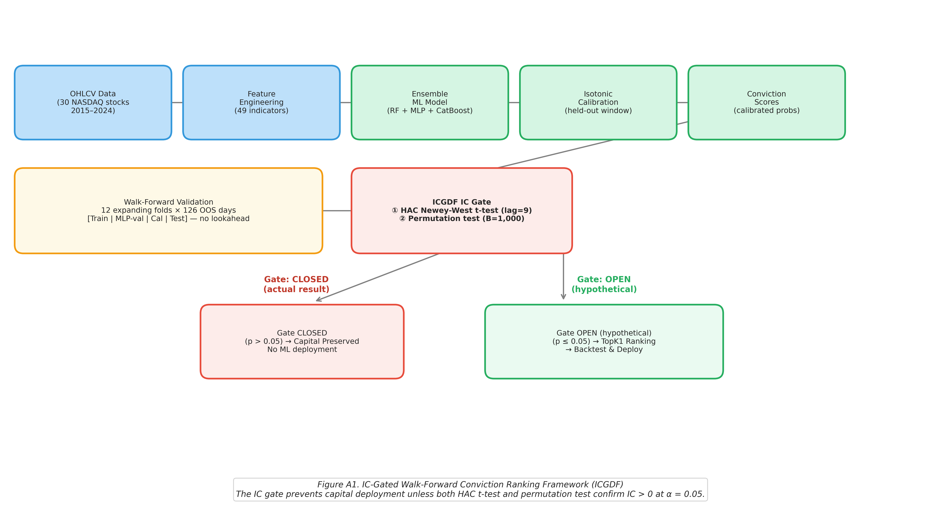
Figure A1. IC gate framework pipeline: Raw OHLCV → Feature Engineering → Walk-Forward → Ensemble → Isotonic Calibration → IC Gate → Vectorized Backtest.
A.2 Complete Robustness Summary
Table A1 summarises all six robustness checks with their key statistics and conclusions.
Check | Key Statistic | Value | Conclusion
R1: Expanded Universe (N=100) | p-value (IC gate) | 0.052 | Gate CLOSED
R2: Feature Attribution | Inter-fold rank ρ | 0.33 (moderate) | Noise-fitting confirmed
R3: Diebold-Mariano Test | DM stat, TopK1 vs Random | 0.42 (p=0.672) | Indistinguishable
R4: VIX-Conditioned IC | Min p-value (any regime) | 0.136 (Mid VIX, two-sided) | Gate CLOSED all regimes
R5: Bootstrap CIs | Folds with CI excluding zero | 0 of 12 | All CIs span zero
R6: Cross-Market (Nifty 50) | Mean IC = 0.0113, HAC t = 2.008, perm p = 0.801 | CLOSED | Gate-closed result confirmed in Indian large-cap equities. HAC condition met (p = 0.022); permutation fails (p = 0.801).
Table A1. Summary of all six robustness checks. All six confirm the null result.

