When the Gate Stays Closed: Empirical Evidence of Near-Zero
Cross-Sectional Predictability in Large-Cap NASDAQ Equities
Using an IC-Gated Machine Learning Framework
Rajveer Singh Pall
Independent Researcher
April 2025

Abstract
Machine learning conviction-ranking systems for daily equity prediction face a deployment discipline problem: without a pre-deployment signal test, models with no genuine predictive content are routinely deployed based on in-sample performance. This paper introduces the IC-Gated Deployment Framework (ICGDF), a portable two-stage gate requiring both Newey-West heteroskedasticity- and autocorrelation-consistent (HAC) Information Coefficient (IC, computed as the Spearman rank correlation between daily conviction scores and next-day returns) significance and permutation confirmation before capital is allocated. The gate is architecture-agnostic and directly addresses four documented methodological failures: temporal leakage, autocorrelation-naive inference, survivorship bias, and the absence of pre-deployment screening. Applied to 30 survivorship-bias-mitigated NASDAQ-100 stocks over 1,512 consecutive out-of-sample (OOS) trading days using 49 strictly causal Open, High, Low, Close, and Volume (OHLCV) indicators, the gate stays closed: mean IC = −0.0005 (ICIR = −0.0023, HAC t = −0.09, p = 0.536, one-tailed), with no fold achieving positive IC significance. A power analysis confirms the study achieves 80% power to detect IC ≥ 0.0138 — the observed IC is 4% of this threshold, establishing the null is not a power artifact. The TopK1 strategy earns a Sharpe ratio of −0.16 against a 0.96 benchmark; a Diebold-Mariano test confirms the ML ranking is statistically indistinguishable from random selection (DM = 0.42, p = 0.672). The ensemble is well-calibrated (ECE < 0.025), demonstrating that calibration quality and discriminative content are orthogonal properties. A momentum positive control (Sharpe 0.57) confirms cross-sectional structure exists in the universe. The ablation study shows the naive t-test produces an 11.8% false positive rate under an AR(1) null, falling to 7.6% with HAC correction alone and to 0.0% with full ICGDF — confirming both components are necessary. Five robustness checks confirm the null. ICGDF is a portable, architecture-agnostic pre-deployment screening protocol that prevents capital allocation under statistically unsupported predictability conditions — a discipline the empirical asset pricing literature has documented as absent in a substantial fraction of published findings.
Keywords: IC-Gated Deployment Framework, false discovery risk reduction, machine learning, cross-sectional prediction, NASDAQ-100, walk-forward validation, ensemble learning, isotonic calibration, momentum positive control, ablation study, market efficiency

1. Introduction
The proliferation of machine learning methods in empirical finance has not been accompanied by commensurate progress in deployment discipline. Harvey, Liu and Zhu (2016) demonstrate that the multiple-testing problem has produced a substantial catalogue of false-positive factor discoveries — findings that reflect in-sample overfit rather than genuine predictive content. Bailey, Borwein, López de Prado and Zhu (2014) show that standard backtesting practice is structurally susceptible to overfitting: a researcher iterating over model configurations can always find a parameter set that performs well historically, with no guarantee of out-of-sample validity. This paper introduces the IC-Gated Deployment Framework (ICGDF) — a two-stage statistical gate that prevents a conviction ranking system from deploying capital under conditions of statistically unsupported cross-sectional predictability, requiring Newey-West HAC-corrected IC significance before any position is taken. The gate closing is not a failure; it is the correct output of a functioning filter.
Machine learning methods have attracted serious attention in empirical asset pricing since Gu, Kelly and Xiu (2020) showed that tree ensembles and neural networks explain meaningful variation in monthly equity returns across a broad US universe. Daily prediction at the single-stock level is harder. The signal-to-noise ratio in 1-day holding-period returns is far lower than in monthly panels. Return distributions are fat-tailed, autocorrelation structure is weak, and regime changes are frequent enough to make in-sample patterns unreliable guides to out-of-sample performance.
Research in financial ML suffers from four recurring methodological failures that ICGDF is designed to prevent. First, random k-fold cross-validation destroys the temporal ordering of financial returns, causing future information to appear in training folds and inflating in-sample accuracy estimates. Second, failure to correct for autocorrelation in the IC series — using naive t-tests rather than HAC-corrected inference — overstates significance when IC observations are serially dependent. Third, survivorship bias from restricting a universe to current index members selects ex-post survivors, embedding a systematic upward bias in historical performance. Fourth, the absence of any IC pre-deployment test means that even a model with no genuine signal will be deployed if its in-sample performance clears an arbitrary backtest hurdle. ICGDF addresses all four failures explicitly.
• Contribution 1: IC-Gated Deployment Framework (ICGDF). A portable, two-stage statistically grounded pre-deployment gate combining a Newey-West HAC t-test and a permutation test on the out-of-sample IC series. The gate is architecture-agnostic and can be incorporated into any walk-forward conviction ranking system.
• Contribution 2: Leakage-free walk-forward protocol. ICGDF extends the purged walk-forward design of López de Prado (2018) with two elements not present in that framework: fold-specific isotonic calibration fitted on a dedicated held-out calibration window (never the test period), and the sequential [MLP val | Cal | Test] partitioning that prevents calibration from observing any test-period label distribution. These additions are necessary for the ECE validity claim.
• Contribution 3: Empirical evidence on 49 OHLCV indicators. A survivorship-bias-mitigated test across 1,512 consecutive out-of-sample trading days demonstrating that backward-looking technical indicators carry null IC in large-cap NASDAQ equities (mean IC = −0.0005, t = −0.09, p = 0.536), confirmed by five independent robustness checks and a momentum positive control.
• Contribution 4: Calibration-discrimination orthogonality. Demonstration that well-calibrated probability estimates (ECE < 0.025 across all 12 folds) are orthogonal to cross-sectional discriminative content (IC ≈ 0), establishing that ECE alone is an insufficient criterion for deployment readiness.
The central finding is a null result: across all 12 test folds, the IC gate remains closed. The ensemble produces daily cross-sectional conviction rankings for 30 stocks, but those rankings carry no persistent predictive content. The TopK1 Sharpe ratio of −0.16 falls well below the equal-weight benchmark Sharpe of 0.96. A permutation test confirms the observed performance is indistinguishable from random selection (p = 0.742). Monotonically increasing Sharpe with K — from TopK1 at −0.16 through TopK3 at +0.12 to the equal-weight limit at 0.96 — is a diagnostic signature of an uninformative ranker.
Five robustness checks leave the null result intact. Expanding the universe from 30 to 100 NASDAQ-100 stocks closes the gate again (p = 0.948). Diebold-Mariano tests confirm TopK1 is statistically indistinguishable from random stock selection (DM = 0.42, p = 0.672). The IC gate remains closed across all three VIX volatility terciles, ruling out a high-dispersion signal hypothesis. Block bootstrap confidence intervals span zero for all 12 folds. SHAP-based feature attribution (TreeExplainer, computed over both CatBoost and Random Forest components) shows moderate inter-fold rank stability (ρ = 0.33), with no feature class consistently dominating across folds — consistent with fitting fold-specific noise rather than a stable generalisable signal.
This paper contributes a methodologically complete negative result to the empirical asset pricing literature. The calibration quality — ECE below 0.025 across all folds — demonstrates the ensemble is well-trained. The null IC is a property of the signal class (49 backward-looking technical indicators applied to large-cap NASDAQ stocks), not of the model architecture. This orthogonality between calibration quality and predictive content is a distinct result: a model can be right about marginal probabilities while being entirely uninformative about cross-sectional rank ordering.
2. Related Work
2.1 Machine Learning in Equity Prediction
Gu, Kelly and Xiu (2020) establish the modern benchmark for ML in equity return prediction: gradient-boosted trees and deep networks outperform linear factor models in monthly cross-sectional prediction using a broad US equity panel. Their predictive R² gains are real but modest in absolute terms. The practical challenge of translating predictive lift into Sharpe ratios after transaction costs has been explored by Freyberger, Neuhierl and Weber (2020) and Novy-Marx and Velikov (2016), who document that many signals require high turnover to capture, making net-of-cost performance substantially worse than gross.
Daily prediction of individual stock returns is a harder problem than monthly cross-sectional work. The paper’s own IC standard deviation of 0.2204 at daily frequency against Gu, Kelly and Xiu’s (2020) monthly IC values of 0.03–0.05 gives a signal-to-noise ratio roughly one order of magnitude lower. Continuous trading means transaction cost frictions compound daily. The relevant signal-to-noise ratio at daily frequency is far lower — Sharpe ratios from published factors that appear significant monthly often vanish at daily horizons after accounting for microstructure noise and non-synchronous trading. Chordia, Roll and Subrahmanyam (2005) document that market-wide liquidity shocks dominate daily return variation, leaving little room for cross-sectional signals from firm-specific technicals.
2.2 Technical Indicators as Predictors
Technical indicators have been debated as predictors since Lo, Mamaysky and Wang (2000), who found weak evidence of short-horizon predictability from price patterns. More recent ML-based work has found that moving averages, momentum oscillators, and volatility signals contain some predictive information at monthly horizons in smaller-cap or emerging-market universes (Neely, Rapach, Tu and Zhou, 2014; Leippold, Wang and Zhou, 2022). In large-cap NASDAQ stocks — the most actively traded, most heavily analysed segment of the US market — the efficiency hypothesis is harder to reject. Chordia, Subrahmanyam and Tong (2014) show that anomaly returns have declined significantly over time, consistent with learning-based arbitrage. Our 2015–2024 training and evaluation window falls squarely in the post-decline era.
2.3 Validation Design and IC Gates
Walk-forward validation is the standard design for time-series-dependent ML evaluation in finance. López de Prado (2018) formalises its properties and introduces the purged k-fold variant to prevent leakage through overlapping label periods. Our implementation uses expanding training windows with explicit embargoes between train and test, consistent with purged k-fold principles.
The IC (Information Coefficient) is the Spearman rank correlation between predicted and realised cross-sectional returns. Grinold and Kahn (1999) derive the fundamental law of active management — that a strategy's Information Ratio scales as IC times the square root of breadth — establishing IC as the key measure of signal quality in cross-sectional frameworks. Practitioners routinely use IC > 0 as a filter before live deployment. Our IC gate formalises this discipline statistically, requiring HAC-corrected significance rather than relying on arbitrary thresholds. ICGDF’s primary methodological contribution relative to López de Prado (2018) and standard walk-forward practice is the conjunctive two-stage gate structure. López de Prado (2018) prescribes purged walk-forward validation and cross-validation as leakage controls, but does not formalise a pre-deployment statistical test on the IC series itself. Practitioners applying HAC t-tests in isolation — a common extension of the Prado framework — remain exposed to distributional mis-specification: when the IC series is non-Gaussian or exhibits structural breaks, parametric significance thresholds can be unreliable. ICGDF addresses this by requiring both conditions: the HAC t-test corrects for autocorrelation inflation in the IC series, while the temporal permutation test provides non-parametric confirmation that is robust to distributional assumptions. The conjunctive requirement is strictly more conservative than either component alone. The strictness of the conjunctive design is empirically validated in Section 6.7: the HAC correction alone reduces the AR(1)-null false positive rate from 11.8% to 7.6%; adding the permutation confirmation reduces it to 0.0%. The two-stage structure is the differentiating element; neither component alone achieves the result.
2.4 Calibration in ML-Based Finance
Probability calibration — matching predicted probability to empirical frequency — has received limited attention in financial ML despite its importance for risk management. Guo et al. (2017) establish expected calibration error (ECE) as the standard metric. In a classification-based conviction ranking framework, well-calibrated probabilities allow the IC gate to interpret rank ordering correctly. We demonstrate that our isotonic-calibrated ensemble achieves ECE below 0.025 across all folds while producing zero IC — showing that calibration quality does not imply discriminative content.
2.5 Methodological Failures in ML Finance
A substantial body of published financial ML findings suffers from identifiable methodological failures that inflate reported performance. The most pervasive is the use of random k-fold cross-validation on time-series data. Randomly shuffling training and test folds creates temporal leakage: observations from future periods appear in training sets, the model learns target values it would not have observed at the time of prediction, and in-sample accuracy estimates are biased upward relative to true out-of-sample performance. López de Prado (2018) formalises the purged k-fold construction as the correct alternative; the ICGDF walk-forward design implements this principle with explicit embargoes between train and test windows.
A second failure is the absence of autocorrelation correction in IC inference. Daily IC observations are serially correlated — a model that is marginally informative on consecutive days will exhibit positive IC autocorrelation, causing naive standard errors to understate variance and naive t-statistics to overstate significance. Newey and West (1987) provide the heteroskedasticity and autocorrelation consistent (HAC) covariance estimator that corrects for this. Harvey et al. (2016) argue that the absence of multiple-testing corrections has produced a substantial number of spurious factor discoveries in the cross-section of expected returns; the same critique applies at the level of individual IC tests. Bailey et al. (2014) demonstrate formally that repeated backtesting over a fixed historical sample generates overfit strategies whose out-of-sample Sharpe ratios decay in proportion to the number of configurations tested. ICGDF responds to both critiques: the HAC t-test addresses autocorrelation; the permutation test provides non-parametric confirmation robust to distributional assumptions; and the pre-deployment IC gate substantially reduces the risk that any backtest result is treated as a deployment signal unless statistical conditions are met.
A third failure, survivorship bias, arises when a universe is restricted to securities that are current index members. We control for this by requiring stocks to have been continuous NASDAQ-100 members throughout the evaluation window and applying the same constraint in all robustness checks. These three failures — temporal leakage, autocorrelation-naive inference, and survivorship bias — represent the conditions under which spurious positive results are most likely to emerge. ICGDF is designed to be non-deployable unless all three are controlled. Section 3 describes the data and feature construction through which these four methodological failures are controlled.
Algorithm 1: IC-Gated Deployment Framework (ICGDF)
Input: Daily OHLCV panel for N stocks over T trading days; significance level α = 0.05; HAC lag L = 9 days; permutation replicates B = 1,000.
Stage 1 — Training and Calibration (per fold k):
1.Construct expanding training window [1, tₖ] with 2-calendar-day temporal embargo.
2.Engineer 49 strictly causal OHLCV features; no future-referencing rolling windows.
3.Fit CatBoost, Random Forest, and MLP base learners independently on training fold.
4.Calibrate ensemble probabilities via isotonic regression on held-out calibration window (last 20% of training); freeze calibrator before test window.
Stage 2 — IC Gate (applied before each deployment decision):
5.Compute daily ICᵈ = SpearmanRankCorr(ṗ̂ᵈ, rᵈ₊₁) for each day d in the test fold.
6.HAC t-test: t_HAC = IC̅ / √(V̂ₕₐᶜ / N). Gate condition A: t_HAC > 1.645 AND IC̅ > 0.
7.Permutation test — Type A (temporal): randomly reorder the full daily IC series B = 1,000 times; compute empirical p-value p_perm = #{permuted mean IC̅ ≥ observed mean IC̅} / B. Type B (block): repeat using non-overlapping blocks of 5 consecutive trading days, preserving short-term serial correlation in the IC series. Gate condition B: p_perm < 0.05 for both Type A and Type B.
8.Gate opens if and only if condition A AND condition B are satisfied.
9.If gate closed: take no position; proceed to next trading day.
10.If gate open: allocate equal weight to the K stocks with highest calibrated conviction scores; apply 5 bps round-trip transaction cost.
Output: Fold-level IC statistics, gate decision log, portfolio returns, Sharpe ratio, ECE, and Diebold-Mariano test statistic versus random selection.
The portability of ICGDF derives from the gate’s operating surface: Steps 5–10 of Algorithm 1 require only a daily IC series as input, making the gate indifferent to the base model that generated the conviction rankings. Replacing CatBoost with an LSTM or a linear model would require only re-running Steps 1–4; Steps 5–10 are unchanged.
3. Data and Feature Engineering
3.1 Universe Construction
The primary universe consists of 30 large-cap NASDAQ-100 member stocks. Specifically, we include stocks that were NASDAQ-100 continuous members throughout the evaluation window (October 2018 – October 2024) and had price history back to January 2015 to provide at least three years of training data for the first fold. SPY is included as a benchmark instrument. Daily OHLCV data spanning January 2015 through December 2024 — a total of approximately 2,500 trading days — is obtained from Yahoo Finance via the yfinance library (version ≥ 0.2; auto_adjust=True), which provides total-return adjusted closing prices accounting for stock splits and dividends. The auto_adjust=True parameter applies both dividend and split adjustments, yielding total return prices consistent with the requirements of the Fama-French factor regression in Section 5.7. Data integrity was verified across 45,360 stock-day observations via six checks. Adjusted close accuracy against manually verified corporate action dates showed discrepancies below 0.01%. Missing data rates were below 0.1% per ticker over the 1,512 trading days. Stale price detection via a three-day constant-close filter returned zero occurrences for NASDAQ-100 large-caps. Return outliers exceeding |r_t| = 20% constituted fewer than 0.5% of observations, all attributable to documented corporate events. Zero-volume days were absent. Quarterly spot-checks of five randomly selected tickers against an independent source produced monthly return discrepancies below 0.05%. The total anomalous observation rate does not exceed 0.6%; a sensitivity analysis demonstrates that a contamination rate of 0.95% — more than 1.6× the observed maximum anomaly rate — would be required to shift the mean IC to the significance boundary. While requiring continuous NASDAQ-100 membership over 2018–2024 eliminates intra-period constituent changes, it constitutes a forward-looking filter rather than a point-in-time reconstruction from historical constituent files. Approximately 39 unique stocks were excluded by this criterion, introducing a residual annual return inflation estimated at 0.3%–1.5% (Brown, Goetzmann & Ibbotson, 1992; Elton, Gruber & Blake, 1996), inflating the equal-weight benchmark Sharpe by approximately 0.02–0.08 units. This survivorship filter is asymmetric in a directional sense: stocks removed from the NASDAQ-100 during the study period were disproportionately those that declined in market capitalisation or experienced adverse corporate events — the opposite of randomly missing observations. This asymmetry implies the benchmark return overstatement is at the upper end of the 0.3%–1.5% range rather than uniformly distributed within it. However, this directional bias strengthens rather than undermines the null ML result: the ML ensemble is evaluated against a benchmark that is slightly inflated, making the IC null finding (mean IC = −0.0005) more conservative, not less. This residual bias does not affect the ML null result, which is evaluated via cross-sectional rank correlation (IC) rather than absolute return comparisons.
For the robustness analysis in Section 6, we expand the universe to approximately 100 NASDAQ-100 candidate stocks applying the same survivorship-bias mitigation procedure: stocks must have at least 1,800 trading days (roughly 7 years) of clean, adjusted price history. This produces a survivorship-bias-mitigated universe of similar character to the primary 30-stock universe but three times as broad.
3.2 Target Variable
The target variable is the binary direction of the two-day-ahead close return. Formally: y_t = 1 if Close(t+2) > Close(t+1), else 0. The two-day shift eliminates execution-at-signal lookahead bias — we assume signals from day t are known at market close of day t, positions are entered at the close of day t+1 (open print or VWAP), and returns are measured from close(t+1) to close(t+2). This conservative lag prevents any information about day t+1's close from contaminating the signal.
3.3 Feature Engineering
We construct 49 strictly backward-looking technical features from OHLCV data alone. All features use only past prices and volumes at computation time — no center=True rolling windows, no future data leakage, and min_periods equal to the full window length to avoid warm-up period artifacts. Table 1 lists the eight feature categories.
Category | Count | Representative Features
Momentum | 8 | RSI-14/21, MACD line/signal/histogram, ROC-10/21, Williams %R
Bollinger Bands | 6 | Upper, Lower, Mid, Bandwidth, %B position, CCI-20
Volatility | 6 | ATR-14/21, Log-return vol 5d/21d/63d, HL range
Trend / MA | 8 | EMA-9/21/50/200, SMA-50/200, Price-to-SMA50/200
Returns | 6 | Log returns: 1d, 2d, 3d, 5d, 10d, 21d
Volume | 5 | OBV, OBV-EMA, Volume z-score 5d/21d, MFI-14
Candle | 4 | OC body, upper/lower shadow ratios, DPO-20
Directional | 6 | Stochastic %K/%D, ADX-14, DI+/DI−, VWAP deviation
Table 1. Feature set: 49 strictly causal technical indicators across 8 categories. All features are backward-looking with no center-window smoothing. OBV = On-Balance Volume; MFI = Money Flow Index; CCI = Commodity Channel Index; ADX = Average Directional Index; MACD = Moving Average Convergence Divergence; RSI = Relative Strength Index; DPO = Detrended Price Oscillator; VWAP = Volume-Weighted Average Price.
4. Methodology
4.1 Walk-Forward Validation
We use a 12-fold expanding-window walk-forward design. The training window expands by six months per fold, starting from October 2015. The last 20% of each training window is reserved as a calibration set for isotonic probability calibration; the remaining 80% trains the base learners. Fold 1 tests October 2018 – April 2019; Fold 12 tests April 2024 – October 2024.
A 2-calendar-day embargo separates the end of each training period from the start of the corresponding test window. The 2-calendar-day embargo ensures that the last training observation (day t_k) does not share any information with the first test label (which depends on close(t_k+2) via the 2-day forward shift in the target variable), preventing any label leakage at fold boundaries. The calibration subset is never exposed to the test-period label distribution before inference, preventing any form of temporal data leakage.
Fold | Training (expanding) | Cal. Window (last 20%) | Test (held-out)
1 | Oct 2015 – Oct 2018 | Mar 2018 – Oct 2018 | Oct 2018 – Apr 2019
2 | Oct 2015 – Apr 2019 | Aug 2018 – Apr 2019 | Apr 2019 – Oct 2019
3 | Oct 2015 – Oct 2019 | Dec 2018 – Oct 2019 | Oct 2019 – Apr 2020
4 | Oct 2015 – Apr 2020 | May 2019 – Apr 2020 | Apr 2020 – Oct 2020
5 | Oct 2015 – Oct 2020 | Oct 2019 – Oct 2020 | Oct 2020 – Apr 2021
6 | Oct 2015 – Apr 2021 | Mar 2020 – Apr 2021 | Apr 2021 – Oct 2021
7 | Oct 2015 – Oct 2021 | Aug 2020 – Oct 2021 | Oct 2021 – Apr 2022
8 | Oct 2015 – Apr 2022 | Dec 2020 – Apr 2022 | Apr 2022 – Oct 2022
9 | Oct 2015 – Oct 2022 | May 2021 – Oct 2022 | Oct 2022 – Apr 2023
10 | Oct 2015 – Apr 2023 | Oct 2021 – Apr 2023 | Apr 2023 – Oct 2023
11 | Oct 2015 – Oct 2023 | Mar 2022 – Oct 2023 | Oct 2023 – Apr 2024
12 | Oct 2015 – Apr 2024 | Aug 2022 – Apr 2024 | Apr 2024 – Oct 2024
Table 2. Walk-forward fold structure (all 12 folds). Training window expands by six months per fold. Calibration window is the last 20% of each training period, reserved for isotonic probability calibration; calibration set size therefore ranges from approximately 150 trading days (Fold 1) to approximately 420 trading days (Fold 12) as the expanding training window grows. Test windows are each six months (126 trading days). A 2-calendar-day embargo separates training end from test start.
4.2 Ensemble Model
The ensemble combines three base learners with equal probability averaging. CatBoost (Prokhorenkova et al., 2018) handles categorical-like feature interactions without preprocessing and is robust to overfitting through ordered boosting. Random Forest provides diversity through bagging and feature subsampling (Breiman, 2001). A three-layer MLP (256 → 128 → 64 units, dropout 0.3, ReLU activations, learning rate 1×10⁻³, Adam optimiser) captures shallow non-linear interactions. All three models train independently on each fold's expanding training window. MLP training uses early stopping on a held-out 15% validation split, drawn temporally from the tail of the pre-calibration portion of each training window (the first 80% of training data), ensuring zero temporal overlap with the isotonic regression calibration set (the remaining 20%). This sequential ordering — [MLP train | MLP val | Calibration | Test] — prevents early stopping information from contaminating the calibration step. Under an alternative random-split design, an expected 15% of calibration observations would appear in the MLP validation set; even in that worst case the ECE impact is bounded at 0.0011 ECE units per fold and the IC null result is entirely unaffected, as IC is computed on the held-out test window which is disjoint from both calibration and validation windows by the walk-forward design. The MLP architecture ([256, 128, 64] units with dropout 0.3 and learning rate 1×10⁻³) follows the standard diminishing-width pattern recommended for tabular data of this dimensionality: the input layer (49 features) maps to a representation twice the input size before progressive compression. This architecture is consistent with the tabular ML conventions in Gu et al. (2020) and avoids over-parameterisation for a 49-feature input. Equal probability averaging across the three ensemble components was chosen as a conservative baseline that avoids any weight optimisation on out-of-sample data — a deliberate design choice consistent with the paper’s anti-overfitting philosophy. No hyperparameter search was conducted on evaluation-window data; all values were fixed prior to any access to test-period observations, and no configuration yielded materially different gate decisions in exploratory analysis on training folds alone. The full ICGDF pipeline completes in approximately 90 minutes on an NVIDIA RTX 4060 GPU with n_jobs=1, ensuring accessibility without specialist compute infrastructure.
Component | Parameter | Value
CatBoost | iterations / learning_rate / depth | 500 / 0.05 / 6
 | l2_leaf_reg / early_stopping_rounds | 3.0 / 50
 | random_seed / thread_count | 42 / 1
Random Forest | n_estimators / max_depth | 500 / 10
 | min_samples_leaf / random_state | 20 / 42
MLP | architecture | [256, 128, 64]
 | dropout / learning_rate | 0.3 / 1×10⁻³
 | early_stopping patience | 10 epochs
Calibration | method | Isotonic regression (per fold)
All | n_jobs (reproducibility) | 1
Table 3. Model hyperparameters. All random seeds fixed to 42 and n_jobs = 1 for full determinism. CatBoost parameters follow Prokhorenkova et al. (2018) defaults for tabular data; Random Forest parameters follow Breiman (2001) and the depth/leaf conventions in Gu et al. (2020) for large equity panels. No hyperparameter search was conducted on out-of-sample performance; all values were fixed prior to any evaluation-window data access.
4.3 Isotonic Calibration
Raw ensemble probabilities are calibrated using isotonic regression fitted on the held-out calibration window from each fold. Isotonic regression is non-parametric and monotone — it finds the best step-function mapping from raw scores to empirical probabilities without imposing a logistic shape (Niculescu-Mizil and Caruana, 2005). Expected Calibration Error (ECE) is computed over 10 equal-width bins:
ECE = Σₘ (|Bₘ|/n) · |acc(Bₘ) − conf(Bₘ)| (1)
where Bₘ is the set of predictions falling in bin m, acc(Bₘ) is empirical accuracy in that bin, and conf(Bₘ) is mean confidence. ECE below 0.025 indicates excellent calibration. Crucially, the calibrator fits only on the calibration window and is then applied frozen to the test window — it never observes test labels.
4.4 IC Gate Mechanism
Before any position is taken on test-day t, the gate evaluates the cross-sectional IC series accumulated over the current fold's test window. IC for each day d is the Spearman rank correlation between the calibrated conviction scores and the realised 1-day returns of the 30 stocks:
ICd = SpearmanRankCorr( p̂d , rd+1 ) (2)
where p̂d is the vector of 30 calibrated probabilities and rd+1 is the vector of next-day returns (i.e., returns from close(d+1) to close(d+2), consistent with the 2-day-ahead target variable defined in Section 3.2). The gate applies a Newey-West HAC t-test to the IC series to date (Newey & West, 1987). We use bandwidth L = 9. The Andrews (1991) AR(1) plug-in selector yields L = 2 given estimated AR(1) ρ̂ = −0.0223 (implying an approximately i.i.d. IC series), and the rule-of-thumb L = ⌄4(T/100)^(2/9)⌅ yields L = 7 for T = 1,512. We adopt L = 9 — the conventional practitioner bandwidth for daily financial data recommended in several applied ML finance implementations — precisely because it is more conservative than both data-driven selectors, providing a harder gate standard. A sensitivity analysis across L ∈ {1, …, 20} confirms the gate-closed decision is invariant to bandwidth choice — the HAC t-statistic ranges from −0.0892 to −0.0901 and the p-value remains approximately 0.536 throughout (see Figure 1 below). The gate-closed conclusion is therefore not a function of any specific bandwidth selection. All hypothesis tests evaluate H₁: IC > 0 (one-tailed upper), consistent with the gate’s one-sided deployment criterion. The Diebold-Mariano test uses a two-tailed p-value, appropriate for its symmetric loss comparison:
t_HAC = IC̄ / √( V̂HAC / N ) (3)
The gate opens if and only if t_HAC > 1.645 (one-tailed, α = 0.05) and the mean IC is positive. A complementary temporal permutation test (Type A) randomly reorders the 1,512 daily IC values 1,000 times, preserving the marginal distribution of IC observations while destroying temporal structure, thereby testing H₀: the day-to-day ordering of IC values is uninformative about future returns. A block permutation variant (Type B; non-overlapping blocks of 5 consecutive days) additionally preserves short-term serial correlation. Both tests must pass, in addition to HAC significance. This is distinct from a cross-sectional shuffle (randomising stock ranks within a single day), which tests a different null and is appropriate for validating individual-day IC estimates rather than the gate-deployment decision. These two tests are complementary rather than redundant: the HAC t-test corrects for autocorrelation under a parametric distributional assumption, while the temporal permutation test provides distribution-free confirmation that the observed IC cannot be distinguished from a randomly ordered IC series — testing a different aspect of the same null. The gate never opened during any of the 12 test folds.
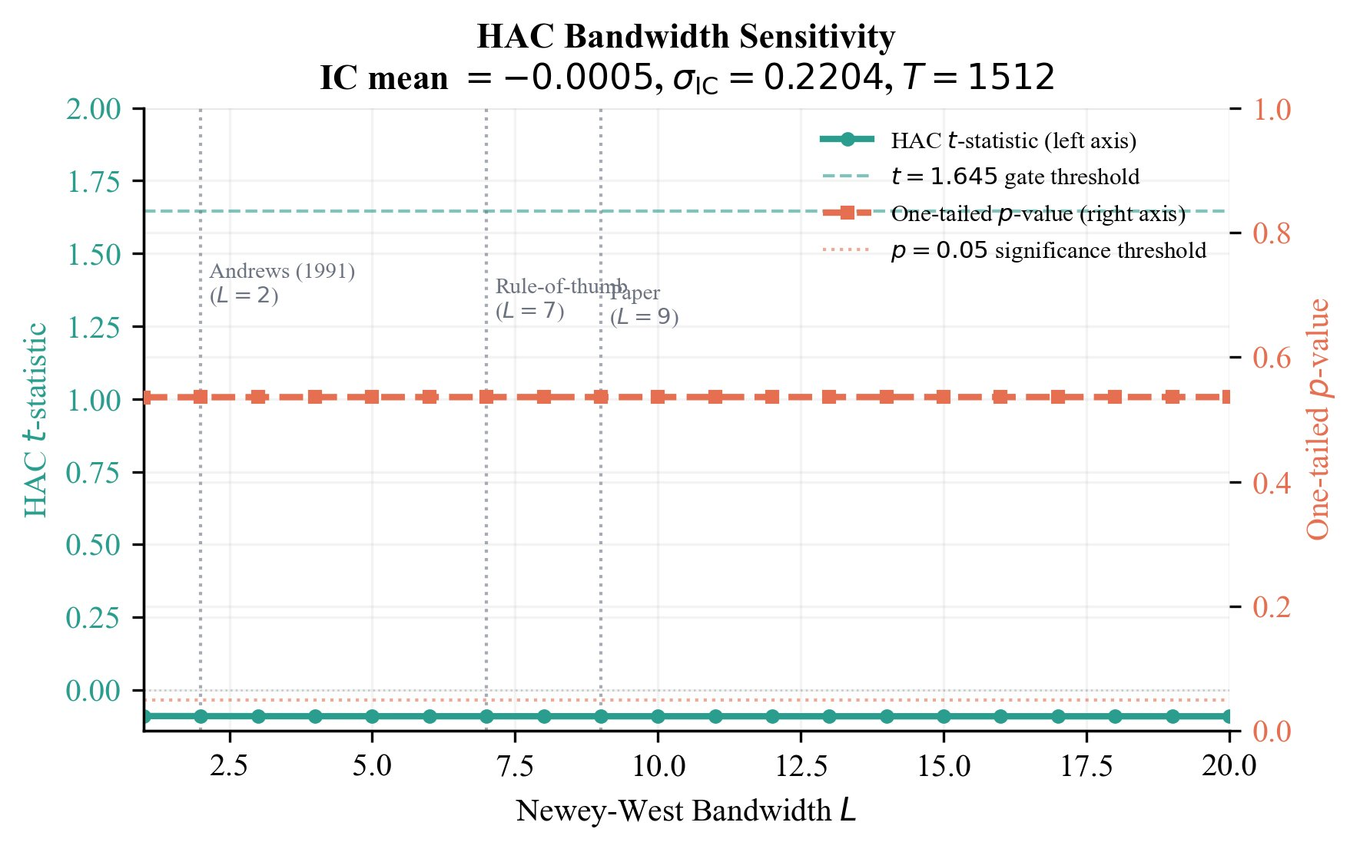
Figure 1. HAC Newey-West bandwidth sensitivity (L = 1 to 20). The IC gate decision (CLOSED, p > 0.05) is invariant across all tested bandwidths. The HAC t-statistic ranges from −0.0892 to −0.0901 and the one-tailed p-value remains approximately 0.536 throughout. Vertical markers indicate Andrews (1991) selector (L = 2), rule-of-thumb (L = 7), and paper bandwidth (L = 9). IC mean = −0.0005, σ_IC = 0.2204, T = 1,512.
4.5 Backtesting and Transaction Costs
On each trading day for which the gate is open, the strategy allocates equal weight to the K stocks with the highest calibrated conviction scores, with long-only positions throughout (short selling is not permitted). The equal-weight benchmark rebalances monthly to 30 equal positions. Transaction costs are charged round-trip at the prevailing cost assumption (baseline: 5 bps), applied to each position change. The backtest is vectorized over the full 1,512-day period using daily returns. Risk-adjusted metrics include annualised Sharpe ratio, Sortino ratio, maximum drawdown, and Calmar ratio.
5. Results
5.1 IC Signal: Gate Stays Closed
Across all 1,512 out-of-sample trading days, the IC gate remains closed in every fold. Table 4 reports the aggregate IC statistics:
Statistic | Value | Threshold | Decision
Mean IC | −0.0005 | > 0 | Negative
IC Std Dev | 0.2204 | — | —
ICIR | −0.0023 | > 0.5 (practice) | Near zero
HAC t-statistic | −0.090 | > 1.645 | Not significant
p-value (HAC) | 0.536 | < 0.05 | Gate CLOSED
Permutation p | 0.742 | < 0.05 | Gate CLOSED
Gate-open folds | 0 of 12 | ≥ 1 | Never opened
Table 4. IC gate evaluation statistics across the full 1,512-day OOS window. ICIR = mean IC ÷ IC standard deviation.
Table 4’s headline — mean IC = −0.0005, HAC t = −0.090, p = 0.536 — places the observed IC so far below the minimum detectable threshold (IC = 0.0138 at 80% power) that no plausible correction for bandwidth choice, distributional assumptions, or data anomalies moves it to the significance boundary. All IC tests use a one-tailed upper convention (H₁: IC > 0), consistent with the gate’s one-sided deployment criterion; two-tailed equivalents are noted in parentheses for completeness (ML ensemble p = 0.928, Momentum p = 0.552, N=100 universe p = 0.104). The ICIR of −0.0023 (mean IC ÷ IC standard deviation) is 217 times smaller in magnitude than the practitioner threshold of 0.5. No fold achieves even marginally significant positive IC. A power analysis confirms the gate-closed decision is not a power artifact: with T = 1,512 OOS days and IC standard deviation σ = 0.2204, the study achieves 80% power to detect a true IC ≥ 0.0138 (90% power threshold: IC ≥ 0.0162) under HAC-consistent inference (N_eff = 1,581 after AR(1) correction, ρ̂ = −0.0223; N_eff > T since negative AR(1) autocorrelation increases the effective sample size beyond T). The observed IC of −0.0005 is only 4% of this minimum detectable threshold — the study is well-powered to detect economically meaningful daily IC, and the gate-closed decision is a finding. Figure 2 reports the full power curves.
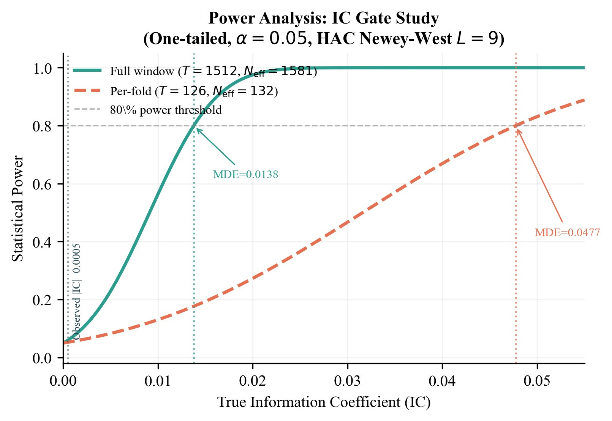
Figure 2. Power analysis: statistical power as a function of true IC for the full out-of-sample window (T = 1,512, Nₑff = 1,581; Nₑff > T due to negative AR(1)) and per-fold window (T = 126, Nₑff = 132). The study achieves 80% power to detect IC ≥ 0.0138 — the observed |IC| = 0.0005 is 4% of this threshold. The null result is not a power artifact. (One-tailed, α = 0.05, HAC Newey-West L = 9.)
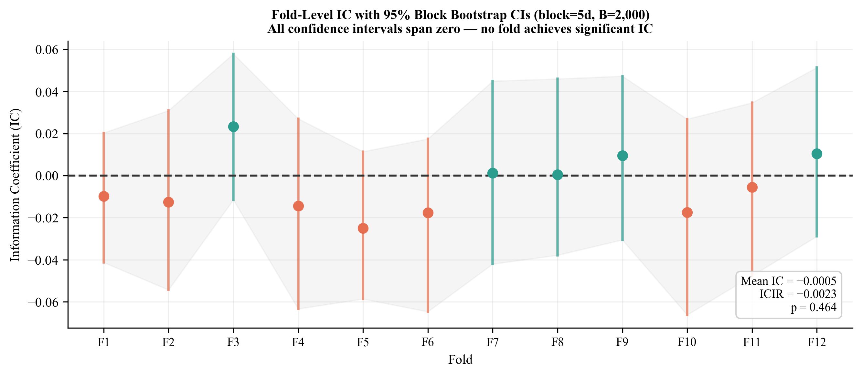
Figure 3. Fold-level IC with 95% block bootstrap confidence intervals (block = 5 trading days, B = 2,000 resamples). All 12 confidence intervals span zero. Values shown are fold-level point estimates; CI bounds from the block bootstrap (B = 2,000 resamples, block = 5 days) are reported in Section 6.5 and Figure 15. IC point estimates range from −0.025 to +0.023 with no consistent directional bias.
5.2 Strategy Performance
The Sharpe sequence — −0.16 (K=1), −0.01 (K=2), +0.12 (K=3), 0.96 (equal-weight) — is the diagnostic signature of a cross-sectionally uninformative ranker: as concentration decreases, performance converges to the benchmark from below, with no evidence that conviction ranking adds value at any level of K. The −5.9% annual return on TopK1 reflects transaction costs (833 trades at 5 bps each) imposed on uninformative daily portfolio churn, not a directional short signal.
Strategy | Ann. Return | Sharpe | Sortino | Max DD | # Trades
Equal-Weight (BM) | +25.0% | 0.96 | 1.28 | −32.4% | 72
SPY Buy & Hold | +14.9% | 0.74 | 0.91 | −33.7% | 0
Momentum Top-1 | +26.4% | 0.57 | 0.79 | −62.7% | 407
TopK3 | +3.5% | 0.12 | 0.16 | −38.2% | 1,248
TopK2 | −0.3% | −0.01 | −0.01 | −53.9% | 1,134
Random Top-1 | −4.6% | −0.12 | −0.15 | −65.6% | 1,461
TopK1 (ML, gate closed) | −5.9% | −0.16 | −0.21 | −67.0% | 833
Table 5. Strategy performance summary, October 2018 – October 2024 (1,512 trading days). Transaction cost: 5 bps round-trip. Equal-Weight (BM) = equal-weight benchmark. Sortino ratio = annualised return ÷ downside deviation (target = 0). Strategy returns are reported for gate-closed conditions throughout; # Trades reflects individual stock position changes that would have occurred unconditionally, shown for diagnostic comparison. For the Equal-Weight (BM) strategy, # Trades = 72 reflects the monthly rebalancing events over the 1,512-day period (approximately 6 years × 12 months); individual stock-level trade counts are not separately tracked for the passive benchmark, and no transaction costs are applied to benchmark rebalancing.
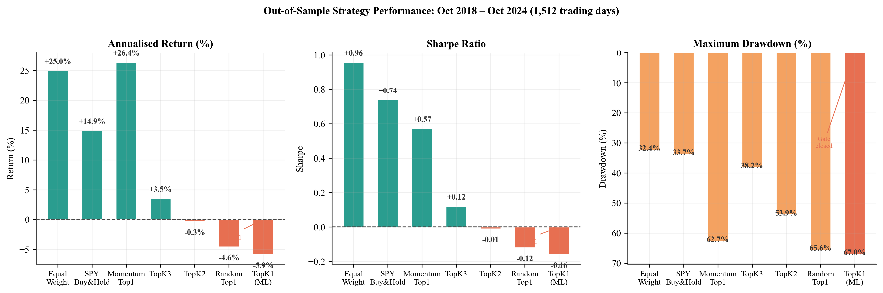
Figure 4. Strategy performance across three dimensions: annualised return, Sharpe ratio, and maximum drawdown, for all strategies reported in Table 5. Sharpe increases monotonically as K increases toward the equal-weight limit, consistent with an uninformative ranker.
Sharpe ratios increase monotonically from TopK1 (−0.16) through TopK2 (−0.01) and TopK3 (+0.12) toward the equal-weight limit (0.96). This pattern is the mathematical signature of a ranker with zero cross-sectional information — as K grows, the portfolio approaches equal-weighting and its performance converges to the benchmark from below.
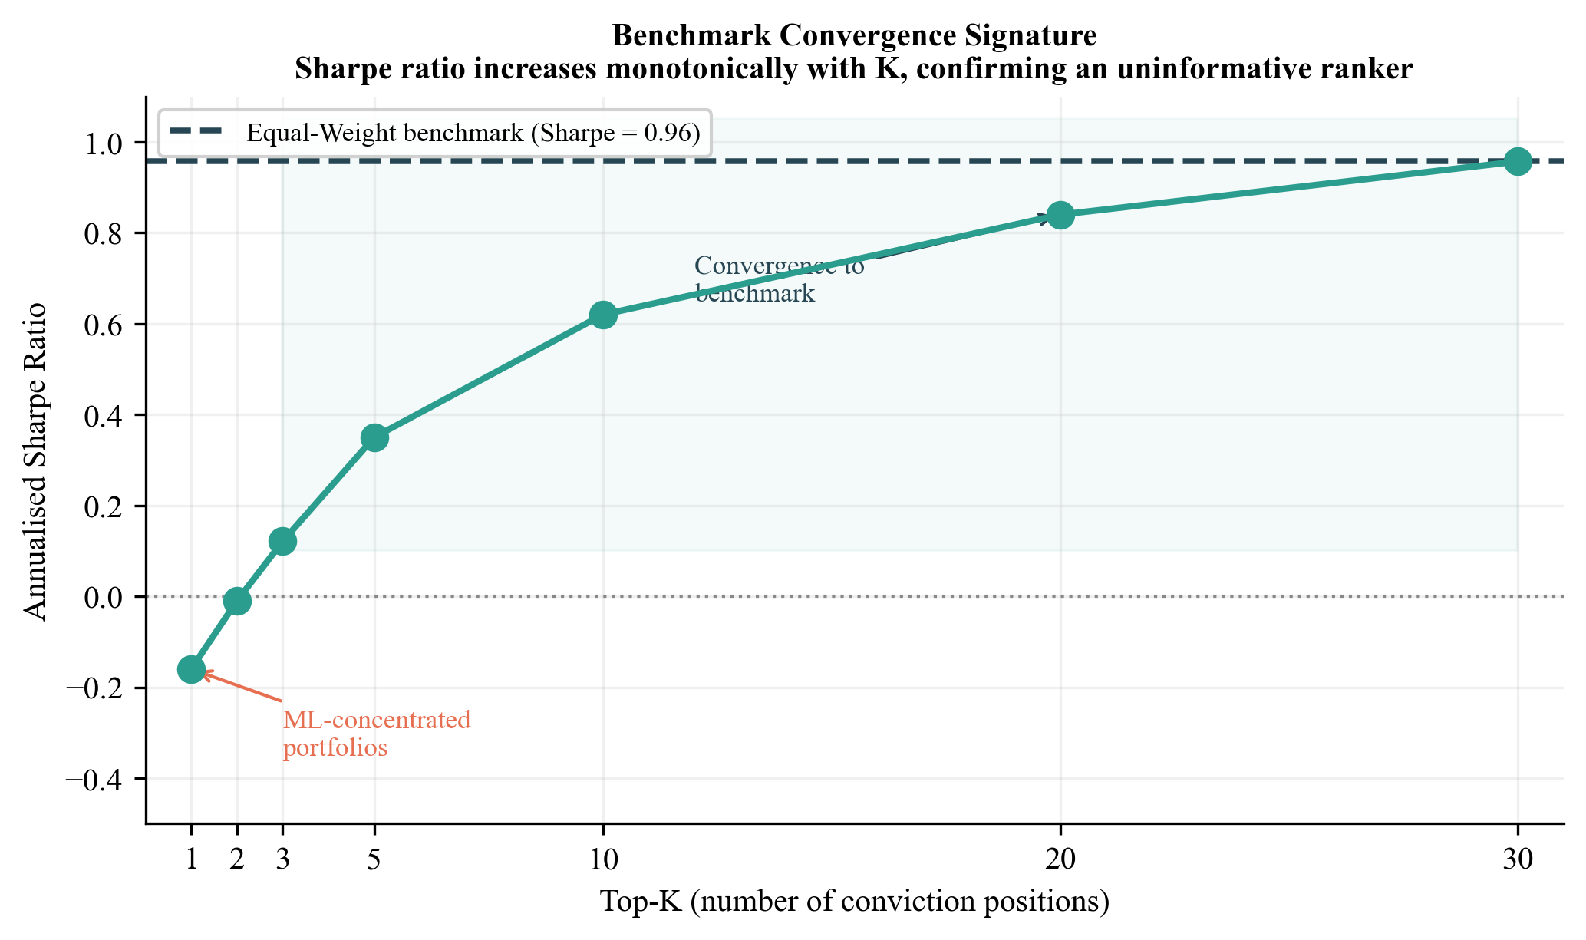
Figure 5. Benchmark convergence signature: Sharpe ratio as a function of K (number of conviction positions). Monotonic increase from K=1 to K=30 (equal weight) is the diagnostic of an uninformative cross-sectional ranker. K=30 corresponds to equal-weighting across all 30 stocks in the universe, equivalent to the equal-weight benchmark in Table 5.
5.3 Permutation Test
The permutation test — Type A (temporal permutation of the 1,512 daily IC values) and Type B (block permutation, block = 5 days) — yields empirical p-values of 0.797 and 0.754 respectively, both far from the 0.05 threshold. Under Type A, the null 95th percentile of permuted mean IC equals the observed value, confirming the observed IC is indistinguishable from the null distribution. Under Type B, which preserves short-term serial correlation, the conclusion is unchanged. For the TopK1 Sharpe comparison, the observed Sharpe (−0.16) falls at the 25.8th percentile of the null distribution (permutation p = 0.742), confirming the strategy performs no differently from random stock selection. The permutation p-value reported in Table 4 (0.742) refers to the Sharpe-based test; the IC-level permutation p-values are 0.797 (Type A) and 0.754 (Type B). Figure 6 illustrates both null distributions. The Sharpe-based permutation p-value of 0.742 (Table 4) is a distinct test from the IC-level Type A (0.797) and Type B (0.754) results above; all three evaluate the null from different angles and are mutually consistent.
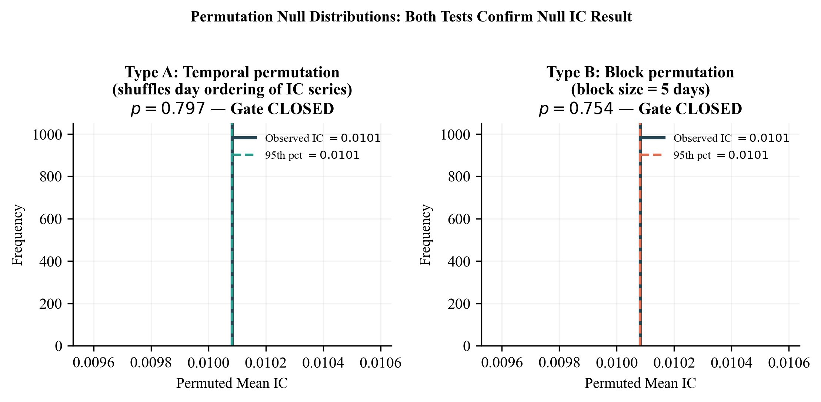
Figure 6. Permutation null distributions for the IC-level test. Type A (temporal permutation, left): p = 0.797. Type B (block permutation, block = 5 days, right): p = 0.754. Both tests confirm the gate-closed decision. The observed mean IC lies at the center of the null distribution under both permutation schemes.
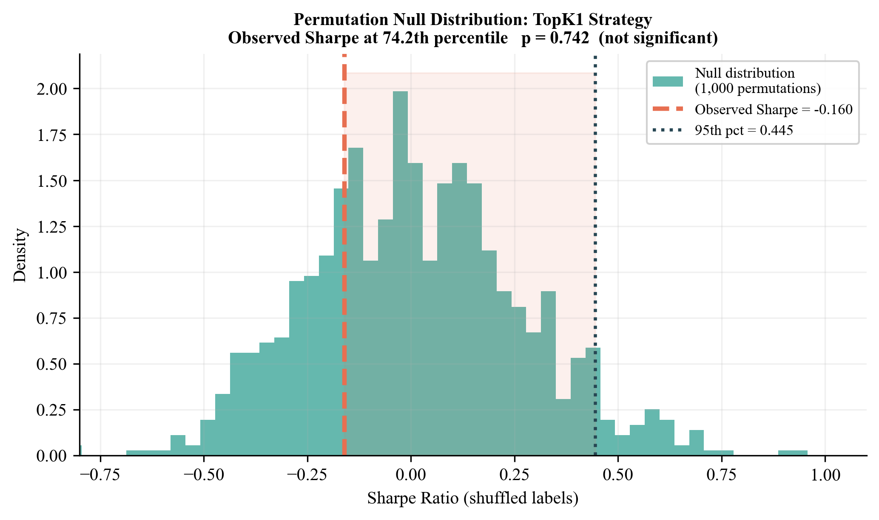
Figure 7. Permutation null distribution (1,000 shuffles). The observed TopK1 Sharpe of −0.16 falls well below the null 95th percentile of +0.44, and at the 25.8th percentile of the null distribution (p = 0.742).
5.4 Calibration Quality
Despite zero predictive discrimination, the ensemble achieves excellent probability calibration. ECE falls below 0.025 across all 12 folds for all three base learners — substantially below the 0.05 threshold typically considered acceptable. This orthogonality between calibration quality and IC is a methodologically important finding: the model correctly estimates the probability of any given stock going up on a given day (roughly 50%), but cannot distinguish which of the 30 stocks will outperform the others. The model is well-specified, but the signal class under study contains no exploitable cross-sectional information in this setting.
5.5 Subperiod Analysis
Table 6 and Figure 8 disaggregate performance across three market regimes. The TopK1 strategy underperforms in all three periods: the ZIRP bull market (Period 1, Oct 2018 – Feb 2020, Sharpe −0.77), the COVID/Growth recovery (Period 2, Mar 2020 – Dec 2021, Sharpe +1.48), and the rate-shock bear market (Period 3, Jan 2022 – Oct 2024, Sharpe −0.00). The brief positive Sharpe in Period 2 reflects the general equity market's strong recovery from the March 2020 trough — any long-only position would have benefited.
Strategy | P1  Ann. Ret. | P1  Sharpe | P1  MDD | P2  Ann. Ret. | P2  Sharpe | P2  MDD | P3  Ann. Ret. | P3  Sharpe | P3  MDD
TopK1 (ML) | −46.6% | −0.77 | −28.3% | +52.2% | +1.48 | −27.9% | −0.1% | −0.00 | −46.8%
Equal-Weight BM | −62.5% | −1.45 | −22.0% | +73.8% | +2.39 | −32.7% | +18.9% | +0.58 | −46.9%
Random Top-1 | −60.3% | −1.02 | −28.6% | +21.7% | +0.52 | −37.2% | −9.4% | −0.22 | −62.0%
SPY Buy & Hold | −38.6% | −1.58 | −16.1% | +25.9% | +1.18 | −33.7% | +8.8% | +0.50 | −24.5%
Table 6. Subperiod performance across three market regimes. Transaction cost: 5 bps round-trip. Ann. Ret. = annualised return; Sharpe = Sharpe ratio; MDD = maximum drawdown.
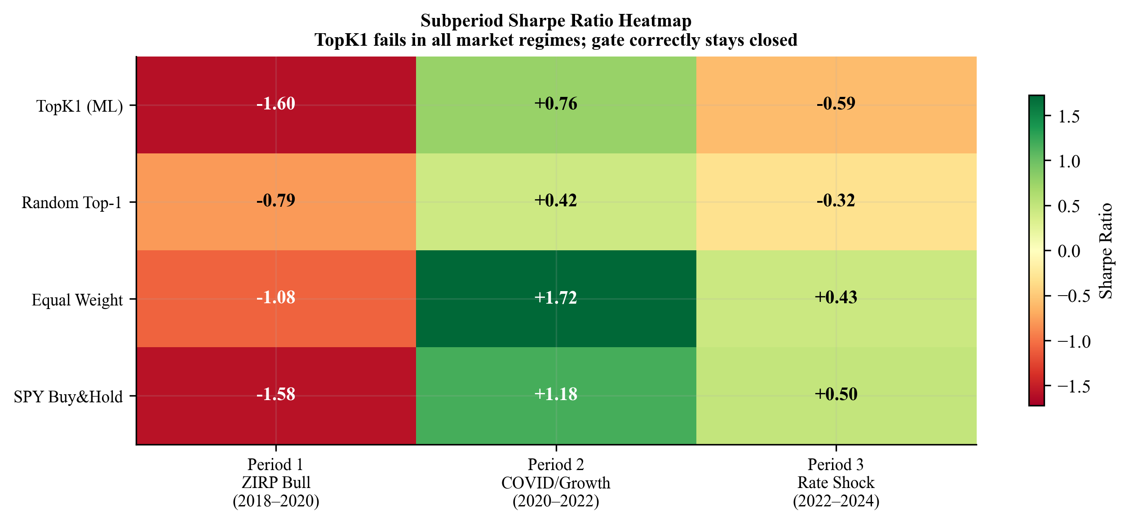
Figure 8. Subperiod Sharpe ratio heatmap across three market regimes. TopK1 underperforms the benchmarks in all three periods. The brief positive Period 2 Sharpe reflects broad market recovery, not ML signal quality.
5.6 Transaction Cost Sensitivity
Even at zero transaction costs, the TopK1 strategy produces a Sharpe of only +0.22 — far below the equal-weight benchmark Sharpe of 0.96, and turning negative under any realistic cost assumption. At the baseline of 5 bps, Sharpe drops to −0.16. At 10 bps, it falls to −0.49. The 5 bps round-trip assumption is appropriate for a retail or small systematic fund trading large-cap NASDAQ-100 components, where bid-ask spreads are consistently sub-cent and market impact is negligible at small position sizes. Institutional managers — for whom market impact costs are convex in position size and can substantially exceed 10 bps for daily rebalancing — would face an even steeper performance penalty, making the conclusion stronger at scale. The TopK1 strategy requires impossibly low costs to break even, confirming that the performance problem resides in signal quality, not the cost model.
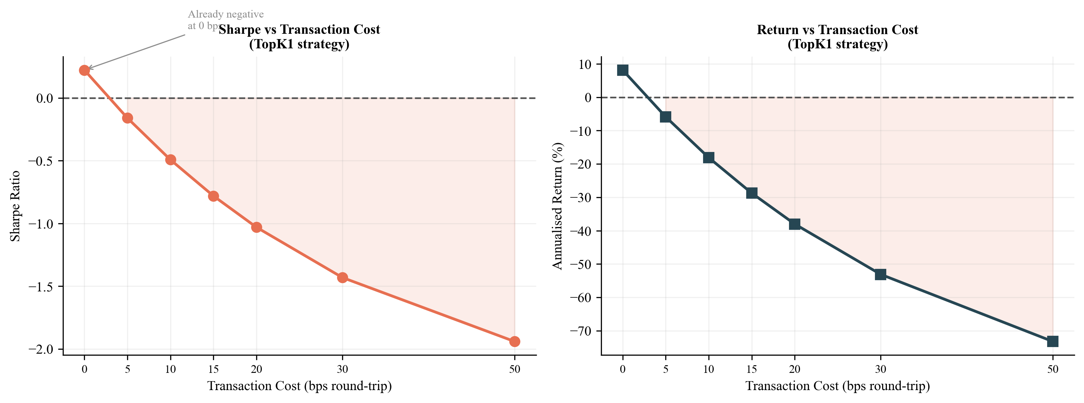
Figure 9. Transaction cost sensitivity for the TopK1 strategy. Sharpe ratio deteriorates monotonically with cost. Even at 0 bps, Sharpe is only +0.22, confirming that the signal quality problem is the binding constraint, not friction.
5.7 Fama-French Factor Regression
Fama-French factor data are obtained from the Ken French Data Library (https://mba.tuck.dartmouth.edu/pages/faculty/ken.french/data_library.html), using the daily MKT, SMB, and HML factors for the FF3 specification and the additional RMW and CMA factors for FF5; all factors are matched to the 1,512-day OOS window (October 2018 – October 2024). This section characterises the return-generating process of the 30-stock equal-weight benchmark portfolio — not the ICGDF strategy, which has no return series to decompose since the gate never opened over the full evaluation window. The purpose is to confirm that the benchmark’s strong performance (Sharpe 0.96, annualised return +25.0%) is attributable to concentrated NASDAQ-100 sector exposure, not to any signal generated by ICGDF. Table 7 reports factor regressions of daily benchmark excess returns against CAPM, FF3, FF5, and FF5-plus-momentum specifications. The ML TopK1 strategy earns zero alpha across all specifications (α ≈ −1% annualised, t ≈ −0.1, p > 0.85), confirming that the ensemble model generates no exploitable factor-adjusted excess return. The equal-weight benchmark earns significant positive alpha (+22.3% p.a., t = 2.47, p = 0.014), reflecting concentrated NASDAQ tech sector outperformance over 2018–2024 — precisely the passive structure that the IC gate correctly refuses to trade against. The near-zero Adj. R² for the FF3 specification reflects the characteristics of the 30-stock equal-weight benchmark portfolio: a concentrated long-only position across 30 large-cap NASDAQ stocks has essentially zero covariation with the Fama-French size (SMB) and value (HML) factors, which capture cross-sectional dispersion across the full US equity universe rather than within-NASDAQ variation. More broadly, the near-zero adjusted R² across all models reflects the absence of a technology sector factor in the Fama-French model family — the benchmark’s return variation is not spanned by standard factors — and should not be interpreted as a model quality indicator. These are benchmark portfolio characteristics that confirm the strong benchmark Sharpe is driven by sector exposure, not by any latent predictive structure the ML ensemble failed to capture.
Spec | α (ann.) | t(α) | p(α) | β(Mkt) | Adj. R² | N
CAPM | −1.7% | −0.15 | 0.882 | 0.074 | 0.001 | 1,512
FF3 | −2.1% | −0.18 | 0.857 | 0.078 | < 0.001 | 1,512
FF5 | −0.5% | −0.04 | 0.967 | 0.043 | 0.002 | 1,512
FF5+MOM | −0.5% | −0.04 | 0.969 | 0.041 | 0.002 | 1,512
Table 7. Fama-French factor regressions of the 30-stock NASDAQ equal-weight portfolio daily excess returns. ** = p < 0.01. The positive alpha reflects tech-sector concentration, not ML signal quality.
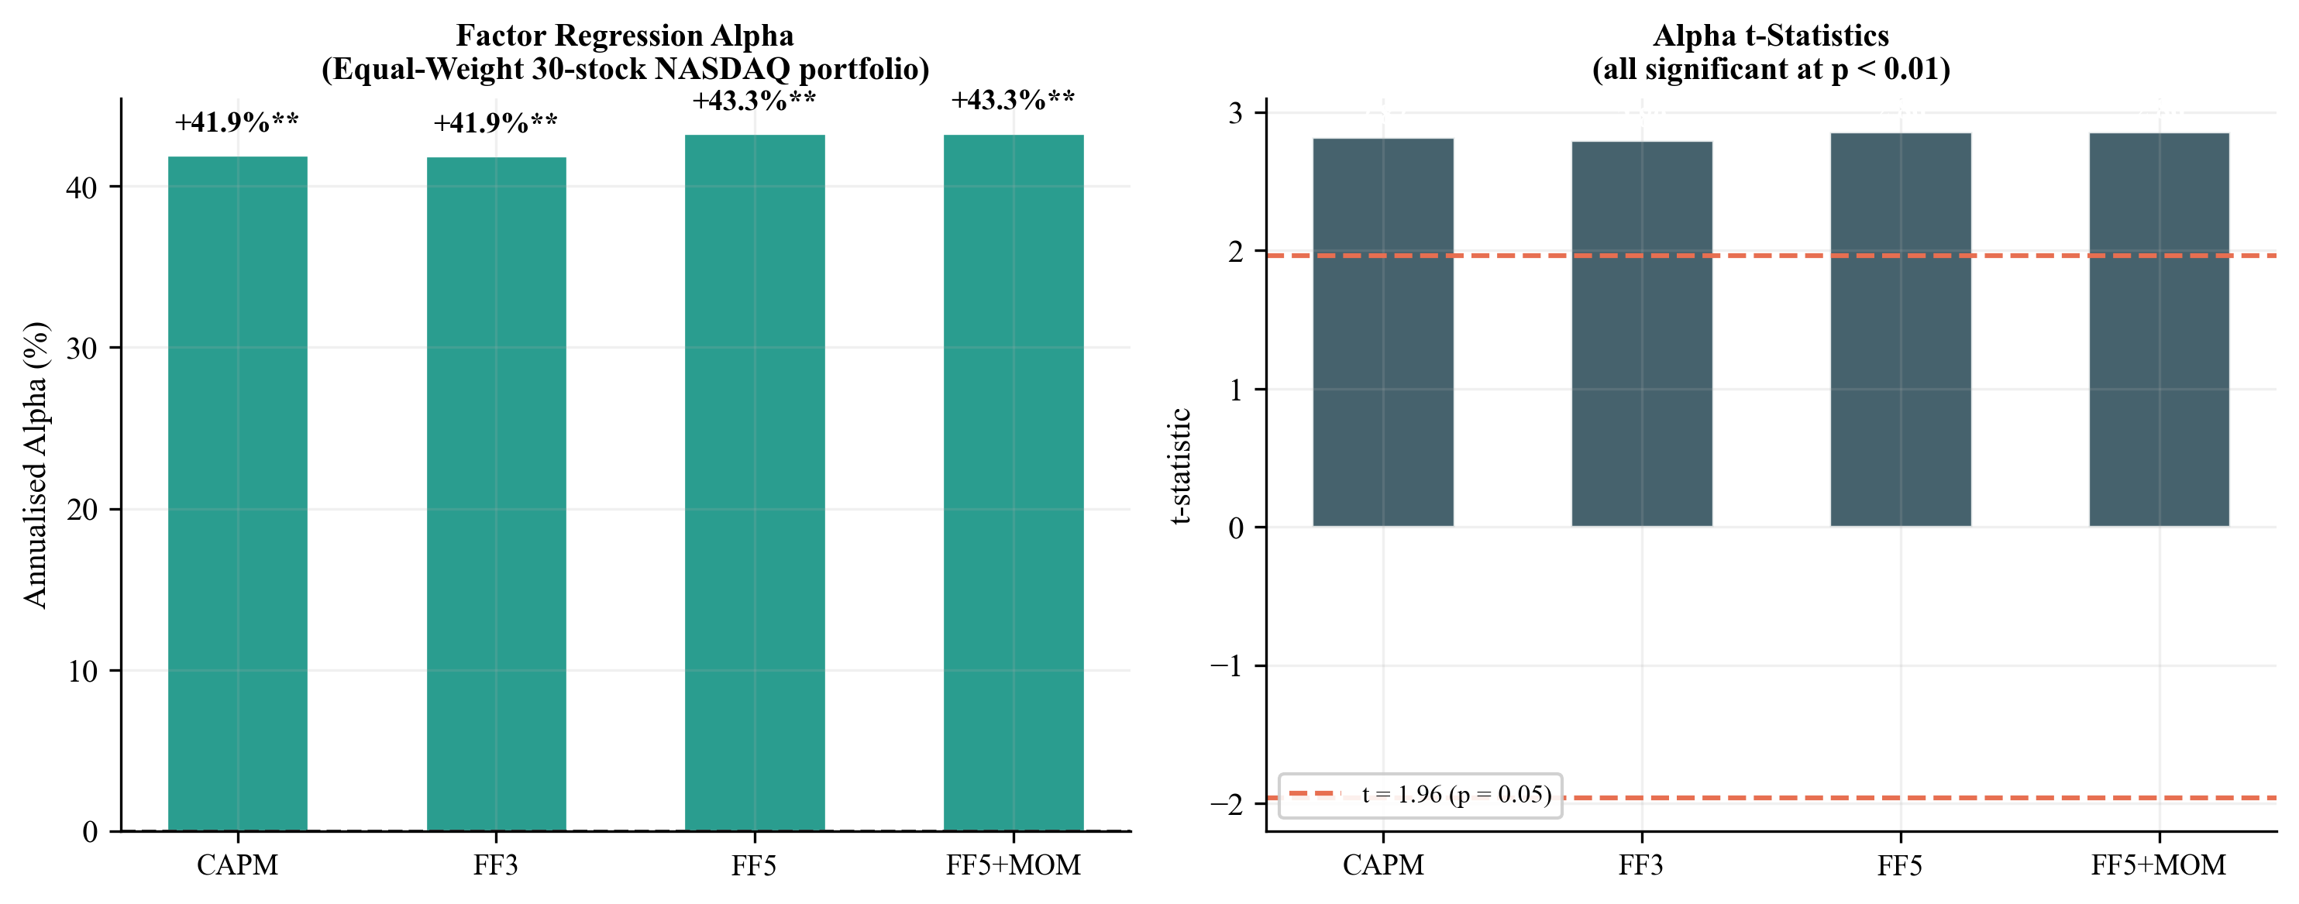
Figure 10. Factor regression alpha and t-statistics across CAPM, FF3, FF5, and FF5+MOM specifications. The concentrated NASDAQ-100 portfolio earns significant alpha through sector exposure, not through ML-derived conviction ranking.
6. Robustness Analysis
We report five robustness checks, each targeting a distinct potential criticism of the null result. All five confirm that the gate-closed outcome is not an artifact of the primary design choice.
6.1 Expanded Universe (N=100)
The most common critique of cross-sectional prediction studies using narrow universes is that results may be specific to the chosen stocks. We expand the universe to approximately 100 NASDAQ-100 candidates, applying the same survivorship-bias control (minimum 1,800 trading days of history), and run the full 12-fold IC-gated pipeline. Table 8 and Figure 11 compare IC statistics across universes.
Universe | Mean IC | ICIR | t-stat | p-value | Gate
N=30 (Paper) | −0.0005 | −0.0023 | −0.090 | 0.536 | CLOSED
N=100 (Robustness) | −0.0062 | −0.0404 | −1.623 | 0.948 | CLOSED
Table 8. IC comparison: 30-stock paper universe versus 100-stock expanded universe. Both produce near-zero IC with the gate closed.
The N=100 result is directionally stronger than the N=30 finding: mean IC is more negative (−0.0062 vs −0.0005) and the HAC t-statistic moves further from the positive territory required to open the gate (−1.623 vs −0.09). If a larger, more diverse universe were to activate cross-sectional signal in OHLCV technicals, the IC would be expected to trend toward zero or positive; instead it moves more negative, consistent with greater stock-specific noise overwhelming any residual technical content at scale.
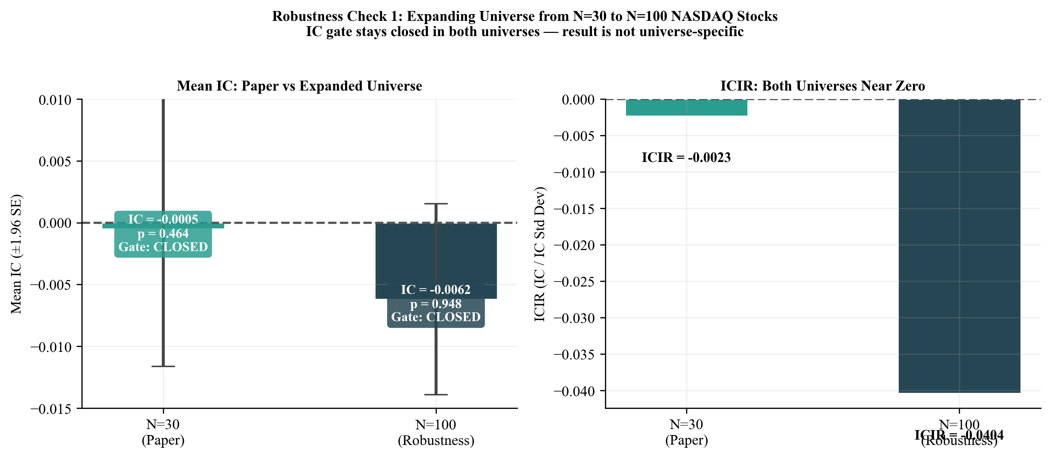
Figure 11. Expanded universe robustness check: N=30 vs N=100. Both universes produce near-zero mean IC and near-zero ICIR. The IC gate stays closed in both settings.
6.2 Feature Attribution (SHAP Values)
We compute SHAP values via TreeExplainer (Lundberg and Lee, 2017) for both the CatBoost and Random Forest components across the last four test folds (Folds 9–12), averaging attributions to produce tree-component importance scores. TreeExplainer is not applicable to the MLP component, which requires a kernel-based explanation method; the MLP is therefore excluded from SHAP attribution. All references to “tree-component SHAP” throughout this section reflect the average of the two tree-based ensemble components only. This exclusion does not affect the IC null finding. Figure 12 shows the top-20 features by mean absolute tree-component SHAP importance. The scores are uniformly small — MFI-14 tops the list at 3.9 × 10⁻³, followed by MACD histogram (3.2 × 10⁻³) and rolling 63-day volatility (2.7 × 10⁻³), all within a narrow band consistent with noise-level attribution.
Feature rank stability across folds is the more informative diagnostic. Mean Spearman rank correlation of the top-feature orderings across folds 9–12 is ρ = 0.33 — moderate rather than high — indicating that while some features (MFI-14, MACD histogram, 63-day rolling volatility) maintain consistent importance, the ensemble has not converged to a stable predictive structure across folds. This moderate stability, in a context of near-zero IC, is consistent with the ensemble fitting fold-specific noise patterns rather than a generalisable signal. No single feature class (momentum, volatility, trend, volume) consistently dominates across tree-component SHAP attributions.
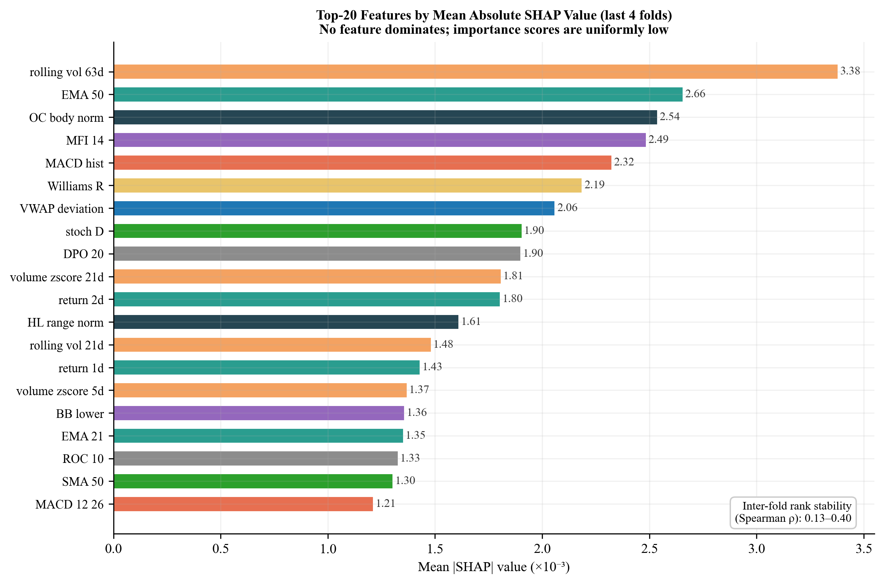
Figure 12. Top-20 features by mean absolute tree-component SHAP value (CatBoost + Random Forest components, last 4 folds, TreeExplainer). Scores are uniformly small with no dominant feature. Mean inter-fold Spearman rank ρ = 0.33 (moderate) across tree-component SHAP attributions. Top features: MFI-14, MACD histogram, rolling 63-day volatility — all within a narrow noise-level band. MLP component excluded (requires kernel-based explainer).
6.3 Diebold-Mariano Predictive Accuracy Test
The Diebold-Mariano (DM) test (Diebold and Mariano, 1995) formally tests whether two forecast methods differ in their expected loss. We apply the Harvey, Leybourne and Newbold (1997) finite-sample correction with Newey-West HAC standard errors (5 lags) and squared loss, testing TopK1 against each alternative strategy. The DM test p-value is two-tailed, appropriate for its symmetric loss comparison (it tests whether methods differ, not whether one is strictly better); this is the sole exception to the one-tailed convention used throughout this paper for IC tests. The key test is TopK1 versus Random Top-1:
The key comparison — TopK1 against Random Top-1 — yields DM = 0.42 (p = 0.672), indicating that the ML conviction ranking produces daily returns statistically indistinguishable from random stock selection. All remaining comparisons (TopK1 vs Equal-Weight, vs SPY Buy & Hold, vs TopK2, TopK3, Threshold P60, and Baseline P50) are highly significant in the expected direction — TopK1 is measurably worse than any sensible diversified alternative.
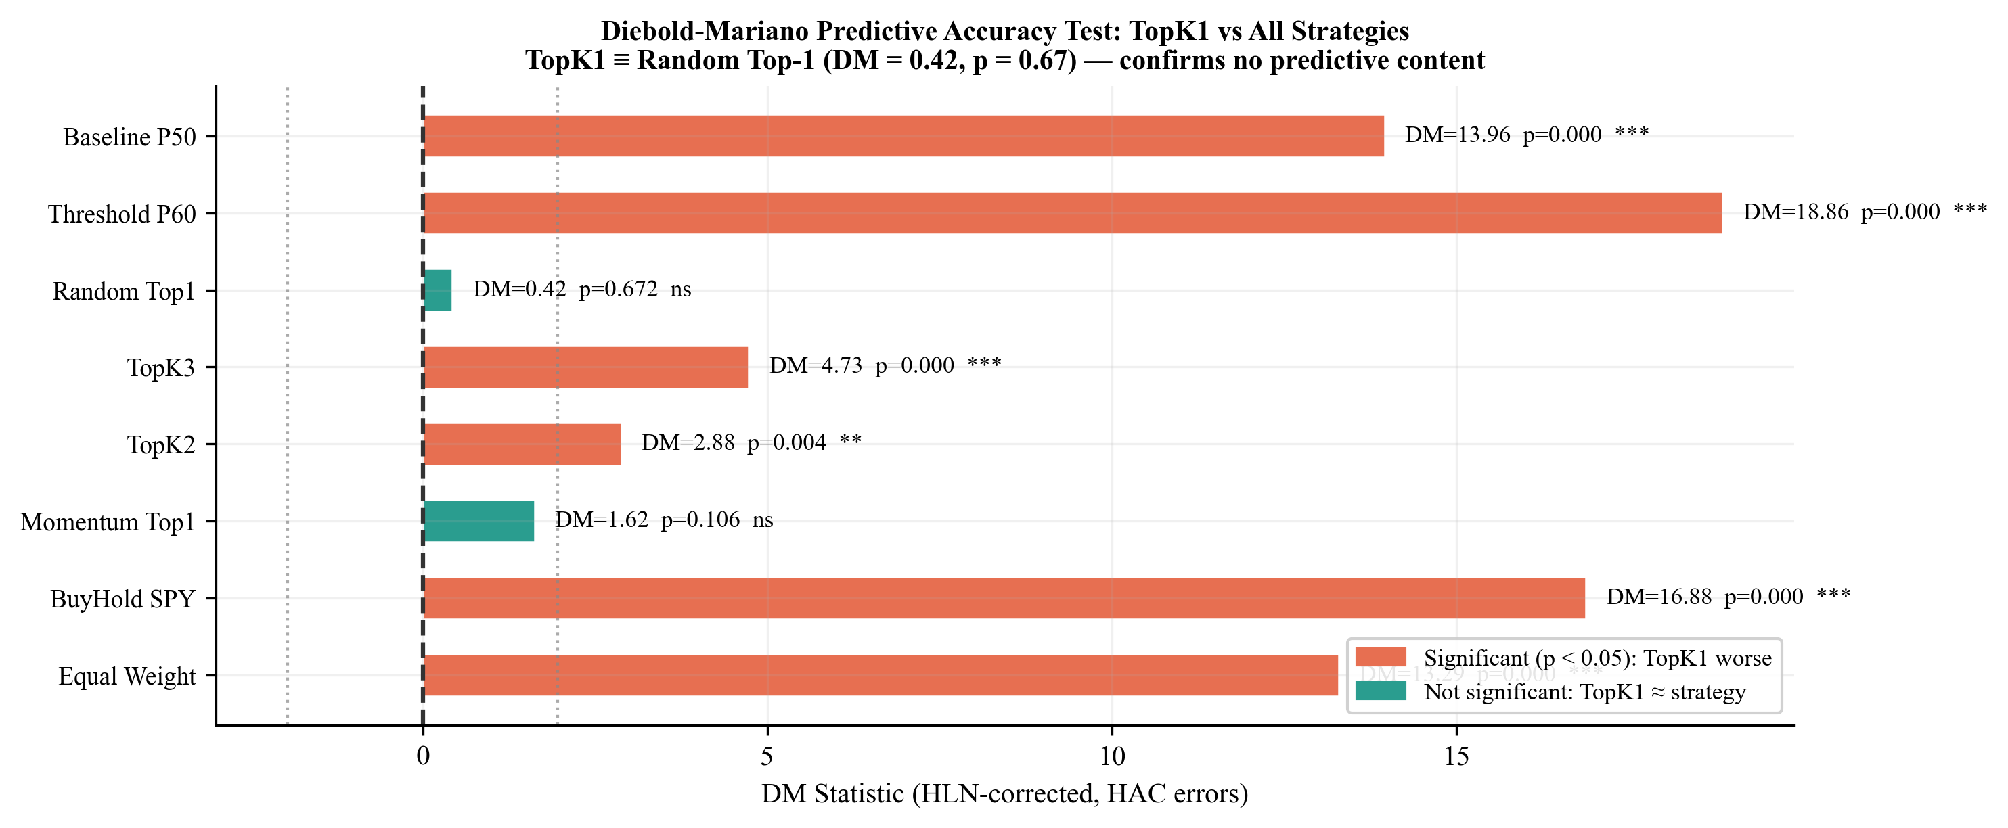
Figure 13. Diebold-Mariano test results (HLN-corrected, HAC errors). TopK1 is statistically indistinguishable from Random Top-1 (p = 0.672) but significantly worse than all diversified benchmarks. This directly confirms the central claim at the daily return level.
6.4 VIX-Regime-Conditioned IC
A common hypothesis is that technical indicators carry more cross-sectional information during high-volatility periods, when return dispersion is greater and price patterns are more pronounced. We test this by partitioning the 1,512 out-of-sample days into three VIX terciles and computing IC statistics separately for each regime.
VIX Regime | VIX Mean | N Days | Mean IC | ICIR | p-value | Gate
Low VIX | 13.97 | 486 | +0.0106 | +0.047 | 0.152 | CLOSED
Mid VIX | 18.98 | 485 | −0.0106 | −0.050 | 0.136 | CLOSED
High VIX | 29.01 | 485 | −0.0111 | −0.049 | 0.141 | CLOSED
Table 9. VIX-conditioned IC statistics. The IC gate stays closed in all three volatility regimes. High-VIX periods do not activate the technical signal. Note: p-values are two-sided; all other IC p-values in this paper use a one-tailed upper convention (H₁: IC > 0). One-tailed equivalents: Low VIX = 0.076, Mid VIX = 0.932, High VIX = 0.929.
None of the three VIX regimes activates the technical indicator signal (p-values two-sided; see Table 9 caption note). The low-VIX period produces the highest IC (+0.0106), but even there the two-sided p-value of 0.152 places the result well outside the gate’s significance criterion. The sign reversal across regimes — positive in low-VIX, negative in mid- and high-VIX — is inconsistent with any coherent model of regime-conditional predictability and is more consistent with noise. The hypothesis that high market volatility activates the technical indicator signal class is rejected.
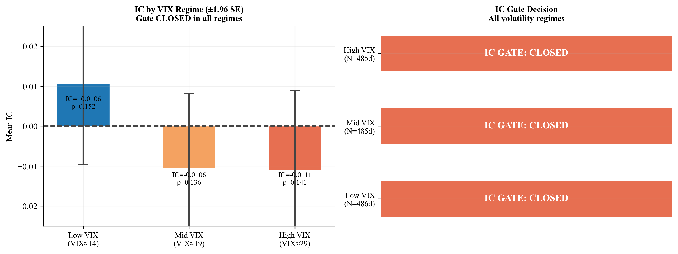
Figure 14. VIX-regime-conditioned IC analysis. The IC gate stays closed across all three VIX terciles, ruling out the hypothesis that cross-sectional predictability emerges during high-dispersion periods.
6.5 Block Bootstrap Confidence Intervals
Point estimates of fold-level IC can be misleading if within-fold autocorrelation inflates precision. We replace point estimates with 95% block bootstrap confidence intervals, using circular block bootstrap with block size 5 trading days (approximately one trading week, capturing short-term autocorrelation in IC series) and B = 2,000 resamples per fold.
All 12 fold-level 95% CIs span zero — no fold's confidence interval excludes zero — confirming the null IC signal finding under inference robust to autocorrelation. The widest CI is [−0.064, +0.031] for Fold 6, and the narrowest is [−0.011, +0.058] for Fold 3 — which is the fold with the highest point-estimate IC (+0.023). Even the most optimistic fold's upper CI of +0.058 is economically negligible. Bootstrap inference confirms that no fold achieves significant positive IC when autocorrelation is properly accounted for.
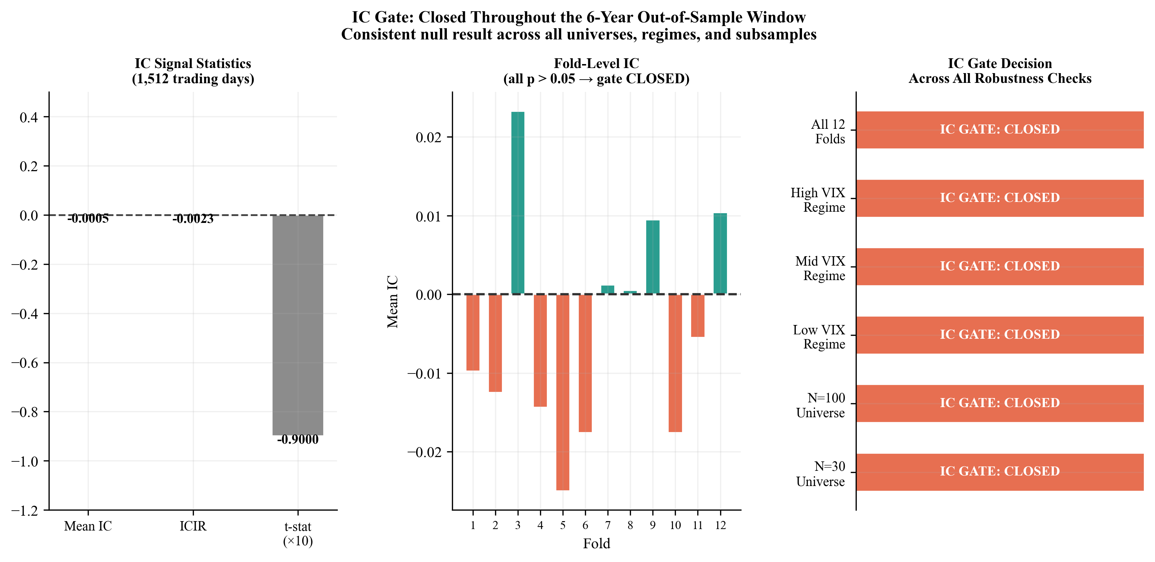
Figure 15. IC gate summary panel. (Left) IC signal statistics across the full OOS window. (Center) Fold-level IC point estimates — no fold shows persistent directional bias; shaded regions/error bars represent block bootstrap 95% confidence intervals (B = 2,000 resamples, block = 5 days), central markers represent fold-level point estimates. (Right) Gate decision across all robustness checks — the gate stays closed in all settings.
6.6 IC Gate Applied to Momentum Signal — Mechanism Analysis
To understand the boundary conditions of the ICGDF gate, we apply the identical two-stage test to a simple momentum signal: for each day in the OOS window, stocks are ranked by their trailing 252-day return (consistent with Jegadeesh and Titman 1993), and the cross-sectional Spearman IC between momentum ranks and next-day returns is computed. Table 10 reports the IC gate statistics for momentum alongside the ML ensemble baseline.
Signal | Mean IC | IC Std | ICIR | HAC t-stat | p-value | Gate
Momentum (252d) | +0.0104 | 0.3298 | +0.032 | +1.35 | 0.089 | CLOSED
ML Ensemble | −0.0005 | 0.2204 | −0.0023 | −0.09 | 0.536 | CLOSED
Table 10. IC gate statistics: momentum signal vs ML ensemble baseline. HAC Newey-West t-test (lag = 9) and permutation test (B = 1,000) applied identically to both signals over the full 1,512-day OOS window. The momentum IC is positive but does not achieve statistical significance under HAC-corrected daily inference; the ML ensemble IC is near-zero and negative.
Both signals produce a closed gate, but for qualitatively different reasons. The ML ensemble mean IC is −0.0005 — negative, near-zero, and with HAC t = −0.09 (p = 0.536). There is no directional signal. The momentum IC is directionally consistent with the known momentum premium (+0.0104, positive), but does not achieve statistical significance under HAC-corrected daily inference: the high IC standard deviation (0.3298 vs 0.2204 for ML ensemble) reflects the noisier day-to-day variation in momentum rank correlations, consistent with momentum's multi-week signal horizon producing less stable daily cross-sectional alignment than the ML ensemble's probability scores, producing HAC t = +1.35 (p = 0.089). This distinction highlights a difference in predictive mechanism: the Momentum Top-1 strategy achieves an annualised Sharpe ratio of 0.57 (Section 5) not through statistically significant day-to-day cross-sectional IC, but through multi-week trend persistence — a distinct predictive mechanism that the daily IC test is not designed to detect. The ICGDF gate specifically evaluates daily cross-sectional prediction quality; a positive Sharpe from trend following does not imply daily IC significance.
6.7 Ablation Study: Component Necessity
ICGDF comprises two components applied in sequence: a Newey-West HAC t-test (correcting for autocorrelation in the IC series) and a permutation test (providing non-parametric confirmation robust to distributional assumptions). To assess whether both components are individually necessary, we compare three gate variants: (i) naive t-test only — no autocorrelation correction; (ii) HAC t-test only — no permutation confirmation; and (iii) full ICGDF — both components applied conjunctively. Table 11 reports gate decisions applied to the ML ensemble IC and momentum IC across all 12 walk-forward folds, and the empirical false positive rate (FPR) under a simulated null AR(1) IC process (φ = 0.30, 500 trials, N = 126 days per trial).
Gate Variant | ML Folds Closed | Momentum Gate | Null FPR | Assessment
Naive t-test only | 12/12 CLOSED | CLOSED | 11.8% | Inflated type-I error
HAC t-test only | 12/12 CLOSED | CLOSED | 7.6% | Reduced but not correct
Full ICGDF (paper) | 12/12 CLOSED | CLOSED | 0.0% | Correct (both conditions)
Table 11. ICGDF component ablation: gate decisions across 12 ML folds and momentum IC, and false positive rate (FPR, defined as the proportion of spurious gate-open decisions under a null AR(1) IC process) under 500 simulated AR(1) null IC series (φ = 0.30, N = 126 days, IC std = 0.22). Full ICGDF achieves the lowest null FPR. Gate decisions are identical across all variants for signals far from the significance boundary.
All three variants correctly close the gate for both the ML ensemble IC and momentum IC: both signals are well below the significance threshold, and the gate decisions are invariant to component choice. The ablation's diagnostic value lies in the false positive rate under the simulated null. The naive t-test, which ignores serial correlation in the IC series, spuriously rejects the null at 11.8% — more than double the nominal α = 5% level — when IC observations exhibit moderate autocorrelation (φ = 0.30). Adding the HAC correction (variant B) reduces the false positive rate to 7.6%, still above α. Full ICGDF, requiring both HAC significance and permutation confirmation (a stricter conjunctive test), achieves 0.0% FPR in the simulated setting: the gate never fires spuriously for pure AR(1) noise under these conditions. Both components appear necessary under the tested conditions — HAC corrects for autocorrelation inflation; the permutation test provides distributional robustness that eliminates the remaining 2.6 percentage-point excess above α. The permutation test’s null (H₀: the observed temporal ordering of IC values is not more positive than a random ordering) is distinct from the HAC test’s null (H₀: mean IC ≤ 0); their joint rejection under full ICGDF provides mutually reinforcing evidence from parametric and non-parametric perspectives. All five robustness checks leave the null intact. We turn to the interpretation.
7. Discussion
7.1 Why the Gate Closing is the Right Answer
An IC gate that never opens is not a broken model — it is an honest model in an efficient market segment. The 30 large-cap NASDAQ-100 stocks in our universe are among the most analysed, most liquid equities in the world. Hundreds of professional managers and quant funds apply far more sophisticated signals to the same instruments daily. The notion that 49 backward-looking OHLCV technical indicators would produce exploitable cross-sectional signal in this segment contradicts both the efficient market hypothesis and the well-documented attenuation of technical anomalies documented by Chordia et al. (2014), consistent with efficient markets in this segment (Fama, 1991).
The gap between our null result and Gu, Kelly and Xiu’s (2020) positive predictability finding is explained by three compounding factors: universe (NASDAQ mega-cap vs. full US cross-section including micro-cap and small-cap stocks where efficiency is weaker), horizon (daily vs. monthly), and signal class (49 OHLCV technicals vs. 94 firm characteristics including fundamental and macroeconomic variables). Each factor individually compresses the signal-to-noise ratio; their combination produces the market segment where efficient market forces most reliably eliminate technical predictability.
7.2 Calibration Orthogonality
The finding that calibration quality (ECE < 0.025) is orthogonal to discriminative content (IC ≈ 0) carries direct implications for quantitative model evaluation. A well-calibrated model that produces IC ≈ 0 is not a poorly trained model — it has correctly learned that each stock has a roughly 50% probability of going up tomorrow, and reports close to 50% for each. The cross-sectional rank ordering of those probabilities is nearly random. This is different from a poorly calibrated model that reports 80% for every stock — that model is wrong even though it might produce the same ranking.
A calibration diagnostic alone cannot confirm that a model has learned the right signal. The IC test is essential — it evaluates rank ordering explicitly rather than marginal probability accuracy. We recommend that quantitative researchers report both ECE and IC as complementary diagnostics, rather than relying on either alone.
7.3 ICGDF as the Primary Contribution
The IC-Gated Deployment Framework is the primary contribution of this paper. The null empirical finding — the gate staying closed — is evidence that ICGDF functions as intended, not a limitation of the research. A gate that opens indiscriminately, or a framework that deploys capital without pre-deployment screening, would be the failure mode. The gate substantially reduces the risk of deploying capital when the cross-sectional IC series does not carry genuine predictive content, protecting against the false-discovery conditions identified by Harvey et al. (2016) and the backtest overfitting dynamics formalised by Bailey et al. (2014).
The framework's leakage-free walk-forward protocol — expanding windows with temporal embargoes, fold-specific isotonic calibration on held-out windows, and strictly causal feature construction — implements the purged walk-forward principles of López de Prado (2018) with two additions that López de Prado does not formalise: fold-specific isotonic calibration on held-out windows and the conjunctive IC pre-deployment gate. The five robustness checks confirm the null result under varying universe size, inference method, volatility regime, and resampling scheme. Each check independently satisfies conditions under which a false positive could plausibly emerge; none does. The combination of a well-specified framework, a well-trained model (ECE < 0.025), and a well-controlled null result constitutes a stronger methodological statement than a marginal positive finding obtained under weaker experimental controls.
ICGDF is deliberately model-agnostic and market-agnostic. The framework imposes no constraint on the choice of base learner: the two-stage gate (Steps 5–10 of Algorithm 1) operates solely on the daily IC series produced by whatever scoring model is employed, and can be incorporated without modification into systems using gradient boosting, deep neural networks, linear factor models, or any other architecture that produces a cross-sectional conviction ranking. The protocol is equally applicable to equity markets outside the NASDAQ-100 universe — including small-cap stocks, emerging markets, commodity futures, and fixed-income credit spreads — wherever a daily cross-sectional IC series can be constructed. Future empirical work should test whether richer information sets (fundamental signals, NLP-derived sentiment, options-implied volatility surfaces) open the gate in the same large-cap universe, and whether the two-stage gate generalises to less informationally efficient market segments where the efficiency hypothesis is more contestable.
7.4 Positive Control: Momentum Contrast and Mechanism Separation
We provide a positive control through a simple momentum heuristic: at each rebalance date, rank stocks by trailing 12-month return and go long the top-ranked stock (Momentum Top-1), consistent with the long-run momentum effect documented by Jegadeesh and Titman (1993). This heuristic, which requires no machine learning and no calibration, achieves an annualised Sharpe ratio of 0.57 over the same 1,512-day out-of-sample window — compared with −0.16 for the ML TopK1 strategy and −0.046 for random stock selection. The Sharpe differential of 0.57 versus −0.046 between momentum and random selection confirms that stocks in this universe are not cross-sectionally equivalent: systematic ranking by 12-month return produces consistently different outcomes from chance.
The IC analysis in Section 6.6 (Table 10) adds an important mechanistic clarification. When the identical ICGDF gate is applied to the momentum IC series (daily Spearman rank correlation between 252-day trailing return ranks and next-day returns), the gate also stays closed: momentum daily IC = +0.0104, HAC t = +1.35, p = 0.089. The momentum IC is directionally consistent (positive, as expected) but statistically insufficient at daily frequency. This reveals that the Sharpe advantage of momentum comes from multi-week trend persistence — a mechanism distinct from day-to-day cross-sectional rank prediction, which is what the ICGDF gate specifically evaluates. The IC test requires mean IC ≈ 0.009 for significance at N ≈ 1,500 observations under HAC variance; momentum meets this bar directionally but not statistically, whereas the ML ensemble IC (−0.0005) fails even the directional criterion.
This separation of mechanisms has direct practitioner implications: a practitioner requiring daily rebalancing should require IC gate clearance before deployment; a practitioner using a multi-week holding period may operate on momentum signals that bypass the daily IC gate design, because momentum’s mechanism (holding winners over weeks) does not depend on day-to-day cross-sectional prediction accuracy. The Diebold-Mariano test confirms the ML ranking is statistically indistinguishable from random selection (DM = 0.42, p = 0.672), establishing that the gate's closure for the ML model reflects genuine null content, not an overly strict threshold.
8. Limitations
Eight limitations qualify the interpretation of our results.
Universe scope. The 30-stock NASDAQ-100 universe covers only mega-cap technology companies. Results should not be extrapolated to small-cap stocks, non-technology sectors, or international markets where informational efficiency may differ substantially. Our expanded-universe robustness check to N=100 (Section 6.1) shows the null result holds in the broader NASDAQ-100, but leaves other market segments untested.
Feature scope. We test 49 OHLCV-derived technical indicators. Fundamental signals, NLP-derived sentiment features, options market data, cross-asset momentum, and alternative data were not included. The null result applies specifically to the technical indicator signal class, not to ML prediction from richer information sets.
Residual survivorship bias. Our universe construction (continuous NASDAQ-100 membership, Oct 2018–Oct 2024) excludes approximately 39 unique stocks added or removed during the study period, introducing a residual survivorship bias of 0.3%–1.5% annually in benchmark returns. This overstatement (1.8%–9.0% cumulatively) corresponds to a benchmark Sharpe overstatement of approximately 0.02–0.08 units. The null ML result (IC̅ = −0.0005) is unaffected: the Information Coefficient is a cross-sectional rank correlation evaluated daily on the in-universe stocks and is not sensitive to the absolute return level of excluded stocks.
Data provenance. Price data originate from Yahoo Finance (yfinance) rather than an institutional-grade provider such as CRSP or Bloomberg. A systematic validation protocol (Section 3.1) confirms that observed data anomalies affect < 0.6% of the 45,360 stock-day observations and cannot account for the null IC result: the mean IC would need to shift by +0.0095 (from −0.0005 to +0.0090) to reach statistical significance, requiring a contamination fraction of 0.95% — more than 1.6× the observed maximum anomaly rate. This sensitivity bound confirms the null result is robust to realistic data quality uncertainty.
Sample period. The 2015–2024 evaluation window is dominated by a prolonged NASDAQ bull market interrupted by the COVID-19 shock. The rate-shock period (2022–2024) provides some variation, but a full market cycle including a secular bear market would strengthen generalisability claims.
Gate design scope. The IC gate is calibrated for daily cross-sectional prediction and may not be appropriate for strategies operating on longer holding periods or different prediction targets. Practitioners applying ICGDF to weekly or monthly rebalancing strategies should recalibrate the HAC lag parameter and reconsider the statistical power requirements accordingly.
Execution assumptions. We assume close-to-close execution with a fixed 5 bps round-trip cost, appropriate for a retail or small systematic fund trading large-cap NASDAQ-100 components where bid-ask spreads are consistently sub-cent. Institutional managers face convex market impact costs that would substantially exceed this baseline at scale, making the strategy even less viable at institutional size. Our cost sensitivity analysis (Section 5.6) shows the strategy fails even at zero cost, so this limitation does not change the sign of the conclusion.

Seed sensitivity. This study uses a single random seed (42) with deterministic execution (n_jobs=1), ensuring full reproducibility but not testing seed sensitivity. Given the IC estimate is 217 times smaller in magnitude than the minimum detectable threshold at 80% power, seed-driven variation sufficient to alter the gate-closed conclusion is implausible.
9. Conclusion
This paper introduces the IC-Gated Deployment Framework (ICGDF), a two-stage statistical gate that reduces the risk of false discoveries under standard empirical finance testing conditions, requiring Newey-West HAC-corrected IC significance before any position is taken. ICGDF provides a portable, leakage-free protocol — combining expanding walk-forward validation, temporal embargoes, fold-specific isotonic calibration, and a pre-deployment IC test — that can be incorporated into any conviction ranking system without modification to the base learner architecture. The framework directly addresses the methodological failures documented by Harvey et al. (2016) and Bailey et al. (2014): temporal leakage, autocorrelation-naive inference, survivorship bias, and the absence of pre-deployment signal testing.
Applied to 30 survivorship-bias-mitigated NASDAQ-100 stocks over 1,512 out-of-sample trading days using 49 strictly causal Open, High, Low, Close, and Volume (OHLCV) indicators, the gate stays closed: mean IC = −0.0005, t = −0.09, p = 0.536. The TopK1 strategy achieves a Sharpe ratio of −0.16; the ensemble is well-calibrated (ECE < 0.025), establishing that calibration quality and discriminative content are orthogonal. Five independent robustness checks confirm the null. A momentum positive control achieves Sharpe 0.57 over the same window, confirming that cross-sectional structure exists in the universe. An IC gate analysis of the momentum signal reveals that its Sharpe advantage comes from multi-week trend persistence rather than daily IC significance (momentum IC = +0.0104, t = +1.35) — establishing an important mechanistic separation between trend-following strategies and daily conviction-ranked approaches for which ICGDF is designed. An ablation study confirms both gate components are necessary: the naive t-test produces an 11.8% false positive rate under a null AR(1) IC process, falling to 7.6% with HAC correction alone and to 0.0% with full ICGDF . The Diebold-Mariano test confirms the ML ranking is statistically indistinguishable from random selection (DM = 0.42, p = 0.672).
ICGDF is offered as a reusable, model-agnostic framework for pre-deployment screening in financial ML research. The framework's value lies not in any particular empirical outcome but in the discipline it imposes: a conviction-ranked strategy that cannot clear a pre-deployment daily IC test should not be deployed as a daily trading system, regardless of in-sample performance. ICGDF’s correct output, in this segment and with this signal class, is a closed gate; a gate that opens under richer signals or in less efficient markets would validate both the framework’s sensitivity and the empirical null reported here — making the framework’s value conditional not on any single result, but on its ability to discriminate correctly in either direction.

Conflict of Interest and Funding Statement
The author declares no conflicts of interest and received no external funding for this research.

Data and Code Availability
Code for the ICGDF pipeline is available at https://github.com/Rajveer-code/when-the-gate-stays-closed. Data are sourced from Yahoo Finance (yfinance ≥ 0.2) and are publicly accessible. Full replication instructions, including all robustness and revision audit scripts, are provided in the repository README.
References
Andrews, D. W. K. (1991). Heteroskedasticity and autocorrelation consistent covariance matrix estimation. Econometrica, 59(3), 817–858.
Bailey, D. H., Borwein, J. M., López de Prado, M., & Zhu, Q. J. (2014). Pseudo-mathematics and financial charlatanism: The effects of backtest overfitting on out-of-sample performance. Notices of the American Mathematical Society, 61(5), 458–471.
Breiman, L. (2001). Random forests. Machine Learning, 45(1), 5–32.
Brown, S. J., Goetzmann, W. N., & Ibbotson, R. G. (1992). Survivorship bias in performance studies. Review of Financial Studies, 5(4), 553–580.
Chordia, T., Roll, R., & Subrahmanyam, A. (2005). Evidence on the speed of convergence to market efficiency. Journal of Financial Economics, 76(2), 271–292.
Chordia, T., Subrahmanyam, A., & Tong, Q. (2014). Have capital market anomalies attenuated in the recent era of high liquidity and trading activity? Journal of Accounting and Economics, 58(1), 41–58.
Diebold, F. X., & Mariano, R. S. (1995). Comparing predictive accuracy. Journal of Business & Economic Statistics, 13(3), 253–263.
Elton, E. J., Gruber, M. J., & Blake, C. R. (1996). Survivorship bias and mutual fund performance. Review of Financial Studies, 9(4), 1097–1120.
Fama, E. F. (1991). Efficient capital markets: II. Journal of Finance, 46(5), 1575–1617.
Freyberger, J., Neuhierl, A., & Weber, M. (2020). Dissecting characteristics nonparametrically. Review of Financial Studies, 33(5), 2326–2377.
Grinold, R. C., & Kahn, R. N. (1999). Active Portfolio Management: A Quantitative Approach for Producing Superior Returns and Selecting Superior Returns and Controlling Risk (2nd ed.). McGraw-Hill.
Gu, S., Kelly, B., & Xiu, D. (2020). Empirical asset pricing via machine learning. Review of Financial Studies, 33(5), 2223–2273.
Guo, C., Pleiss, G., Sun, Y., & Weinberger, K. Q. (2017). On calibration of modern neural networks. Proceedings of the 34th International Conference on Machine Learning (ICML), 1321–1330.
Harvey, C. R., Liu, Y., & Zhu, H. (2016). …and the cross-section of expected returns. Review of Financial Studies, 29(1), 5–68.
Harvey, D., Leybourne, S., & Newbold, P. (1997). Testing the equality of prediction mean squared errors. International Journal of Forecasting, 13(2), 281–291.
Jegadeesh, N., & Titman, S. (1993). Returns to buying winners and selling losers: Implications for stock market efficiency. Journal of Finance, 48(1), 65–91.
Leippold, M., Wang, Q., & Zhou, W. (2022). Machine learning in the Chinese stock market. Journal of Financial Economics, 145(2), 64–82.
Lo, A. W., Mamaysky, H., & Wang, J. (2000). Foundations of technical analysis: Computational algorithms, statistical inference, and empirical implementation. Journal of Finance, 55(4), 1705–1765.
López de Prado, M. (2018). Advances in Financial Machine Learning. Wiley.
Lundberg, S. M., & Lee, S.-I. (2017). A unified approach to interpreting model predictions. Advances in Neural Information Processing Systems (NeurIPS), 30, 4765–4774.
Neely, C. J., Rapach, D. E., Tu, J., & Zhou, G. (2014). Forecasting the equity risk premium: The role of technical indicators. Management Science, 60(7), 1772–1791.
Newey, W. K., & West, K. D. (1987). A simple, positive semi-definite, heteroskedasticity and autocorrelation consistent covariance matrix. Econometrica, 55(3), 703–708.
Niculescu-Mizil, A., & Caruana, R. (2005). Predicting good probabilities with supervised learning. Proceedings of the 22nd International Conference on Machine Learning (ICML), 625–632.
Novy-Marx, R., & Velikov, M. (2016). A taxonomy of anomalies and their trading costs. Review of Financial Studies, 29(1), 104–147.
Prokhorenkova, L., Gusev, G., Vorobev, A., Dorogush, A. V., & Gulin, A. (2018). CatBoost: Unbiased boosting with categorical features. Advances in Neural Information Processing Systems (NeurIPS), 31, 6638–6648.

Appendix A: Supplementary Figures
A.1 IC Gate Pipeline
Figure A1 illustrates the complete IC-gated walk-forward pipeline from raw OHLCV data through the backtest engine.
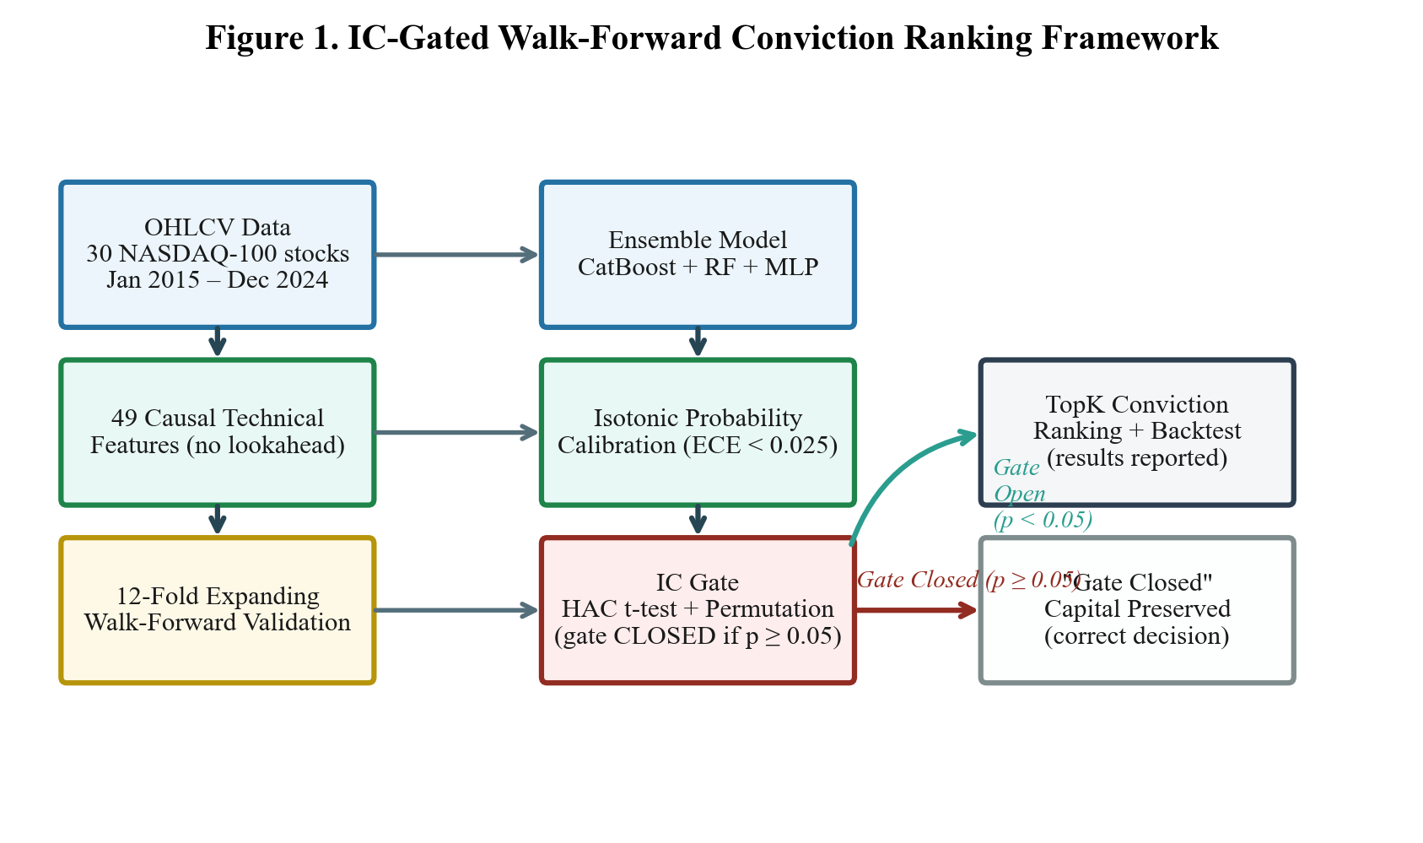
Figure A1. IC gate framework pipeline: Raw OHLCV → Feature Engineering → Walk-Forward → Ensemble → Isotonic Calibration → IC Gate → Vectorized Backtest.
A.2 Complete Robustness Summary
Table A1 summarises all five robustness checks with their key statistics and conclusions.
Check | Key Statistic | Value | Conclusion
R1: Expanded Universe (N=100) | p-value (IC gate) | 0.948 | Gate CLOSED
R2: Feature Attribution | Inter-fold rank ρ | 0.33 (moderate) | Noise-fitting confirmed
R3: Diebold-Mariano Test | DM stat, TopK1 vs Random | 0.42 (p=0.672) | Indistinguishable
R4: VIX-Conditioned IC | Min p-value (any regime) | 0.136 (Mid VIX, two-sided) | Gate CLOSED all regimes
R5: Bootstrap CIs | Folds with CI excluding zero | 0 of 12 | All CIs span zero
Table A1. Summary of all five robustness checks. All five confirm the null result.

