Rajveer Dhillon 500777569

**Entities:**

Publisher: The head company that funds, regulates and handles the legal rights of the IP.

Director: The lead in development of the video game and creative lead.

Video Game: The product produced by the Director, Publisher and Developers.

Engine: The Gaming engine the video game runs on (can be internally created or uses a third-party engine).

Developers: The subsidiary or out-sourced development studio employed by the publisher to create the game.

**Relationships:**

Contract: The connection between the publisher and the director and developers; employed and given a budget by the publisher.

Produce: The Director(s) and their team produce the game.

Distribute: The publisher owns the rights and distributes the game with having a release date and has on record the amount of copies sold.

Program: The developers using the Engine with a programming language used to create the game.

Encode: The Engine encodes the game into a usable state (like an exe) and can be used in specified media platforms.

**Attributes:**

Director:

* Name: The Director’s name.
* Company (O): The Director’s company in which they work for.
* Date of Birth: The date of birth of the Director.

Publisher:

* Name: The Name of the Publisher.
* Headquarters: The location of the main Headquarters of the Publisher.
* President: The Head President of the Publisher.

Developers:

* Parent Company: The Company that owns the Development Team.
* Date of Formation: The date in which the Development team was formed.

Engine:

* Company Developer: The Company that created the Engine.
* Royalties (O): The company can employ royalties when using the Engine.

Video Game:

* Rating: The review scores that were given by game review companies.
* Genre: The multiple genres the video game uses.
* DLC (O): The down-loadable-content for the Video game.
* Platform: The platform(s) the game was made available on.

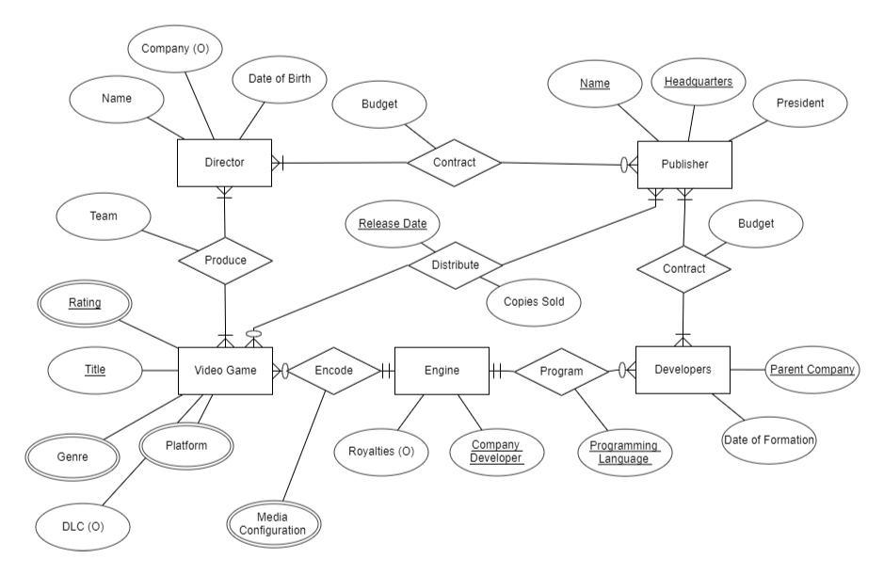All other attributes on relationships are explained in the relationship section.

**Figure 1: ERD of the Square Enix Library for Video Games.**

**Cardinality:**

Director to Publisher:

The Publisher can contract a Director or multiple directors for a project and a Director can work for no Publisher or many.

Publisher to Developers:

The Publisher can contract at least one or more Development Teams to work in conjunction on one project and Development team can work on one or multiple projects.

Publisher to Video Game:

The Publisher can have no games, or many games published (distributed) and a video game must have one or more publishers.

Developers to Engine:

Developers need an Engine to program a game but can use multiple engines to create games while the

Engine to Video Game:

The Video game can only be encoded by one engine, but the engine can have no games or multiple games created on its engine.

Director to Video Game:

The Director can direct multiple games but must at least direct one game to be considered a director and the video game can have at least one or more directors.