**Design of the Project:**

The objective of this data base is to document the multiple Video Games the Company Square Enix has created throughout its history as well as document the games’ success. Using the ERD created in lab 2 (minor adjustments since lab 2), the basic structures of the tables were created. Using SQliteStudio application, the database was constructed.

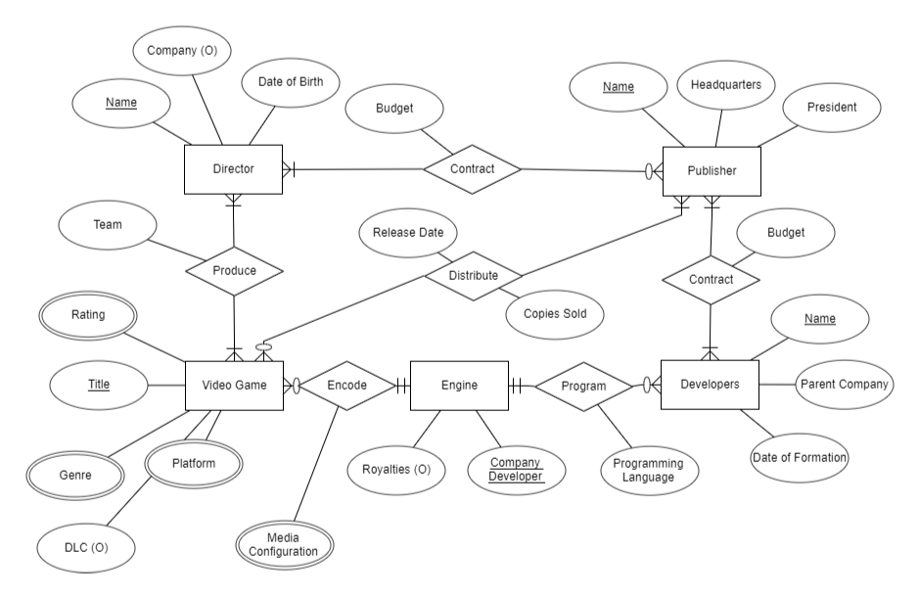

**Figure 1: ERD of the Square Enix Library of Games.**

Using Figure 1, the database schema can be created in which primary keys will be underlined and foreign keys will be **bolded**. The relationships with the entities are also discussed.

**Entity Data Schemas:**

1. Director (Name, Date of Birth, Company)

The Director has a Name which is unique and a primary key since the Director cannot be categorized by a integer id since they at times are not part of the company or were at a point but then was not.

The Director has a *Contract* with the Publisher in which the publisher requires the Director to direct the Video Game while providing a Budget.

1. Publisher (Name, Headquarter, President)

The Name of the Company is important as it is the leading benefactor for the Video Game for which it is the primary key.

The Publisher has a *Contract* with the Director as well as the Developer in which they provide a budget in order for the respective to continue their work.

1. Developers (Name, Parent Company, Date of Formation)

The Name of the developer is unique and a primary key. The Parent Company is also unique as it doesn’t necessarily belong to the publisher or even other publishers.

The Developers *Program* the Video Game with an Engine in which a Programming Language is used.

1. Engine (Company Developer, Royalties)

The Company Developer indicates the company in which the engine was created by as it doesn’t have to be created by the Publisher and as such is the primary key. Royalties indicates the percentage of royalties the Publisher owes to the Company Developer based on units sold

The Engine *Encodes* the Video game into different media configurations such as digital or physical.

1. Video Game (Title, DLC)

The Title of a Video Game is the primary key as it is distinct

The Video Game is *Produced* by the director as the director has a team in order to create the video game. The Video Game is also *Distributed* by the Publisher and the Publisher dictates the Release Date as well as the Copies to be produced and sold.

The Multi-Attribute data schemas for Video Game:

1. Rating (**Title**, Metacritic, Famistu, IGN, …)
2. Genre (**Title**, Hack and Slash, RPG, MMORPG, …)
3. Platform(**Title**, PS4, XboxOne, PS3, Xbox 360, Wii u, Steam, …)
4. Media Configuration (**Title,** Physical, Digital)

From these multi-attribute data schemas, the primary and foreign key are the Title as it is indicative to know what the ratings, genre and platform are for which game. The media configuration can be either physical or digital (can be both). The parameters for the multi-attribute data schemas are too numerous to account for and as such examples are used.

**Relationship Data Schemas:**

1. Contract (Publisher to Director) (**Director Name, Publisher,** Budget)

The contract between the Director and Publisher has it’s own table and as such the budget is determined with the Director’s Name and Publisher’s Name as they are foreign keys.

1. Contract (Publisher to Developers) (**Developers, Publisher,** Budget)

The contract between the Developers and the Publisher with Developer’s Name and Publisher’s name being a foreign key.

1. Produce (**Director** **Name, Title,** Team)

The Director and the Video Game Title are foreign keys as they are needed for the production as well as a team.

1. Distribute (**Title, Publisher,** Release Date, Copies Sold)

The Distribution needs the Title of the Video Game as well as the Publisher in order to have a release date and the production of the units and how many they sold.

**SQL Tables:**

**Entities:**

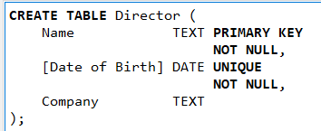**Director**

**Figure 2: Director Table.**

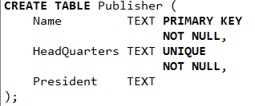**Publisher**

**Figure 3: Publisher Table.**

**Developers**

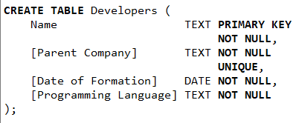**Figure 4: Developers Table.**

**Engine**

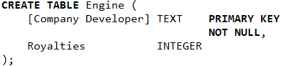

**Figure 5: Engine Table.**

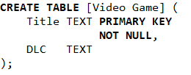**Video Game**

**Figure 6: Video Game Table.**

**Multi-Attribute Tables:**

**Media Configuration**

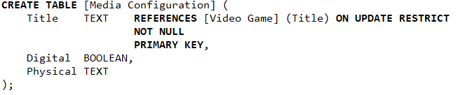

**Figure 7: Media Configuration Table**

**Rating**

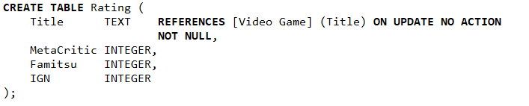

**Figure 8: Rating Table**

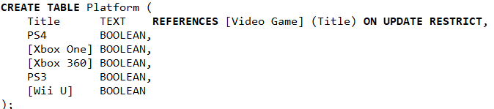**Platform**

**Figure 9: Platform Table**

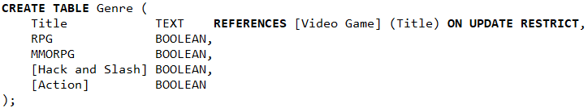**Genre**

**Figure 10: Genre Table**

**Relationship Tables:**

**Contract (Publisher to Developer)**

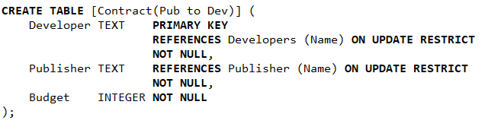

**Figure 11: Contract Developer to Publisher Table.**

**Distribute Table**

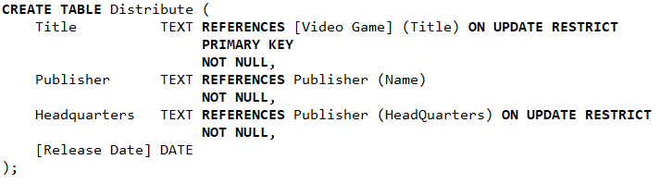

**Figure 12: Distribute Table**

**Produce**

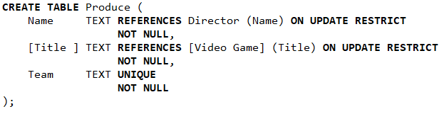

**Figure 13: Produce Table**

**Contract (Publisher to Director)**

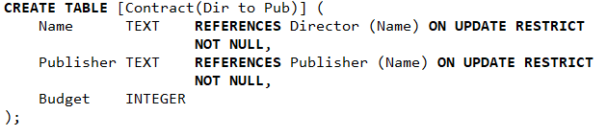

**Figure 14: Contract (Pub to Dir) Table**