**Online Mobile Shopping Portal-SRS**

**ABSTRACT**

Online mobile shopping   is a form of  electronic commerce which allows consumers to directly buy goods from a seller over the internet  using website. This project deals with developing an e-commerce   website for online different types of products. It provides the user with a catalog of different types   of products available for purchase in the store. The Online mobile shopping project has been developed to allow business grows larger and faster. This site will let consumer to view and order products online from any part of the world. The site sells different types of products. Under this website many products and services can be ordered.

The Online mobile shopping Web is designed from a user point of view. The user friendly design helps the users in accomplishing their task with ease. Attempts have been made to keep the design simple and understandable. The screens were designed in React and the business logic was written in Java. The total lines of code written in this Website are HTML5 + CSS3 + React JS.

**SYSTEM ANALYSIS**

**EXISTING SYSTEM**

* In the existing system details are maintained manually. Due to this the data retrieved is time consuming. Due to human calculation errors occur. Even when the data is maintained on spreadsheet inconsistency occurs as an order might be missed or wrongly entered or twice.
* Data are stride an excel sheet which takes lot of time and data may be corrupted.
* As storage and exchange of data is achieved only by use of excel sheets which lack validation capabilities, there is always risk of invalid, inaccurate or incomplete data being fed in computer.
* Difficulty in managing multiple forms.
* Lack of security.

**DISADVANTAGES:**

* Time Consuming: In our current system, all the process are carried out by human so naturally it require more time and in that sense, it will require more time to complete transaction.
* Difficult in Accounting: It is difficult to calculate that every month how much product is selling and how much payment is given by customer.
* Difficult in Stock Management: It is difficult to find out that which product is sold more at the end of the month and on the basis of that the next time the shopkeeper can maintain the stock of that item.

**PROPOSED SYSTEM**

* The proposed system is computerized and has been developed using advance language therefore it gives more facilities than present system. It provides quick access to any data. In this system user have to enter the data only once and then it get linked with all files. This reduces the workload of user and it is also a time saving process. The information about any Subscriber can be easily retrieved. The system maintains all records easy.
* The new system will convert manual work to the computerized work.
* By converting manual work to the computerized work in that case it will remove all paper work.
* By maintaining all the work on computer will increase our accuracy as well as speed of our work.
* It will easily used and the time consuming is decreased.

**ADVANTAGES:**

* Computerized Mobile Shop System is better than the Manual Shop System.
* Accuracy and Security can be maintained easily by the Admin.
* It can handle all the Information about the Customer, Clients, Items and Admin.
* All the information about sale, purchase will be maintain properly in this system.
* All manual calculation of sale or all the money management will be performed by the computer automatically.
* This system will provide timely report information.
* It will produce report for sale, bill information.
* The computer can hold amount of data in its storage device.
* The operation and speed of the computer is very high.
* We can calculate result and print any report within seconds.
* Any difficulties we can solve easily.
* A database application can be stored in computer effectively.
* It is very user friendly and easy to handle.
* So the computerized system is more suitable than the manual system.

**SCOPE:**

* This System has large scope for the Mobile Shop Management System& Mobile Information.
* The System stores all information of the Mobiles.
* System can able to accept user request and manages information like Mobile’s as well as the Customers and Clients
* System provides the facility of Mobile Information with their Prices.
* System Provide facility of payment and purchase Products

**Functional Requirements :**

**Admin Module :**

**1. Admin Login :**

Admin can login using verified username and password.

**2. User Management :**

Admin can manage all the details of user, will manage all the user request.

**3. Product Details:** Admin can see the details of registered Brands or add/view/delete a products as per requirements.

**User Module :**

**1. User Registration & Login :**

New users can register themselves and sign up. Existing users can login and

start using this app. Users can view/purchase products.

**2. Choose Brands type:**

User can choose of which brands and which mobiles they want.

**3. Products Availability display:**

User can Search the available product by title or keyword,

And will be able to view details and purchase for the same.

**Functionalities Performed By Admin, Users :**

These are the core functionalities performed by Admin and users

**MODULES:**

1. Admin
2. Users

**1) Admin**

* Login
* Home
* User Registration
* View User Details
* View Products details
* Add/Delete products.
* Logout

**3) Users**

* Home
* Search for products
  + Give Request
  + Download Request
* View Status (Availability of product) and status of your order.
* Product Details
* Give Feedback.
* Logout

**Use-Case Diagrams**

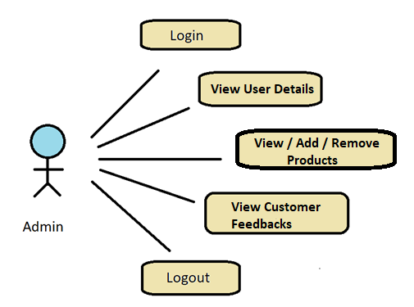

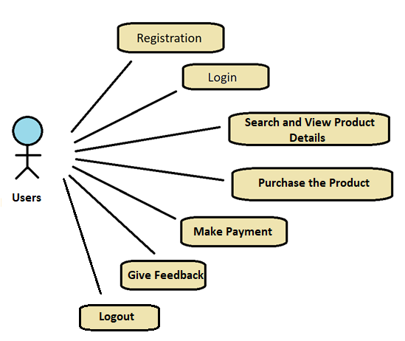

**MODULE SPECIFICATION**

**User**

**•: View Products**

Here User can search for various products by their names or brands .

User can also view The “Best deals of the day” along with “Trending Products” and all.

**Purchase product:**

If the user wishes to purchase the product then he can add the product to cart and can proceed further by making payment for the same.

**•Give Feedback:**

The customer can give the feedback he experienced using our app.

**•Help:**

The user can contact us for any product / purchase related issues at the given customer care number .

Also he can write us an email about his issues.

**Admin**

**Dashboard:**

In this section admin can view all the product Details ,Brands detail.

The Admin can add New products if he wishes. Also he can Remove the product.

Admin can view the users details and the feedback given by them.

**Manage Contact us query:**

Admin can manage Contact us query.

**View Feedback:**

The admin easily view the feedbacks and solve the query.

**Registered users:**

Admin can view the registered users.

**Manage pages:**

Admin can update the pages data information.

**Contact info:**

Admin can update the contact info.

**Manage Subscribers:**

Admin can manage subscribers.

**Non-Functional Requirements**:

Following Non-Functional Requirements will be there in the

insurance to the internet:

(i) Secure access to consumer’s confidential data.

(ii) 24X7 availability.

(iii) Better component design to get better performance at peak

time.

(iv) Flexible service based architecture will be highly desirable for

future extension. Non-Functional Requirements define system

properties and constraints.

Various other Non-Functional Requirements are:

Security

Reliability

Maintainability

Portability

Compatibility

Resource Utilization

**Performance Requirements**:

In order to maintain an acceptable speed at maximum number of purchasing and Transactions allowed from a particular customer as any number of users can access to the system at any time. Also the connections to the servers will be based on the attributes of the user like his location and server will be working 24X7 times.

**Technical Issues**:

This system will work on client-server architecture. It will require an internet server and which will be able to run application. The system should support some commonly used browser such as mozzila firefox, chrome etc.

**HARDWARE REQUIREMENT**

Hardware requirements for insurance on internet

will be same for both parties which are as follows:

|  |  |
| --- | --- |
| **RAM** | 2 GB |
| **Hard disk** | 320 GB |
| **Processor** | Dual Core |

**Software Requirements**

**Client side:**

|  |  |
| --- | --- |
| **Web Browser** | Google Chrome or any  compatible browser |
| **Operating System** | Windows or any equivalent OS |

**Server side:**

|  |  |
| --- | --- |
| **Web Server** | TOMCAT |
| **Server side Language** | REACT JS |
| **Database Server** | MYSQL |
| **Web Browser** | Google Chrome or any  compatible browser |
| **Operating System** | Windows or any equivalent OS |

**Communication Interfaces**:

The two parties should be connected by LAN or WAN for the communication purpose.

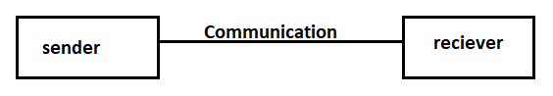

**ER DIAGRAM**

The Entity-Relationship (ER) model was originally proposed by Peter in 1976 [Chen76] as a way to unify the network and relational database views. Simply stated the ER model is a conceptual data model that views the real world as entities and relationships. A basic component of the model is the Entity-Relationship diagram which is used to visually represent data objects. Since Chen wrote his paper the model has been extended and today it is commonly used for database design for the database designer, the utility of the ER model is:

* It maps well to the relational model. The constructs used in the ER model can easily be transformed into relational tables.
* It is simple and easy to understand with a minimum of training. Therefore, the model can be used by the database designer to communicate the design to the end user.
* In addition, the model can be used as a design plan by the database developer to implement a data model in specific database management

software.

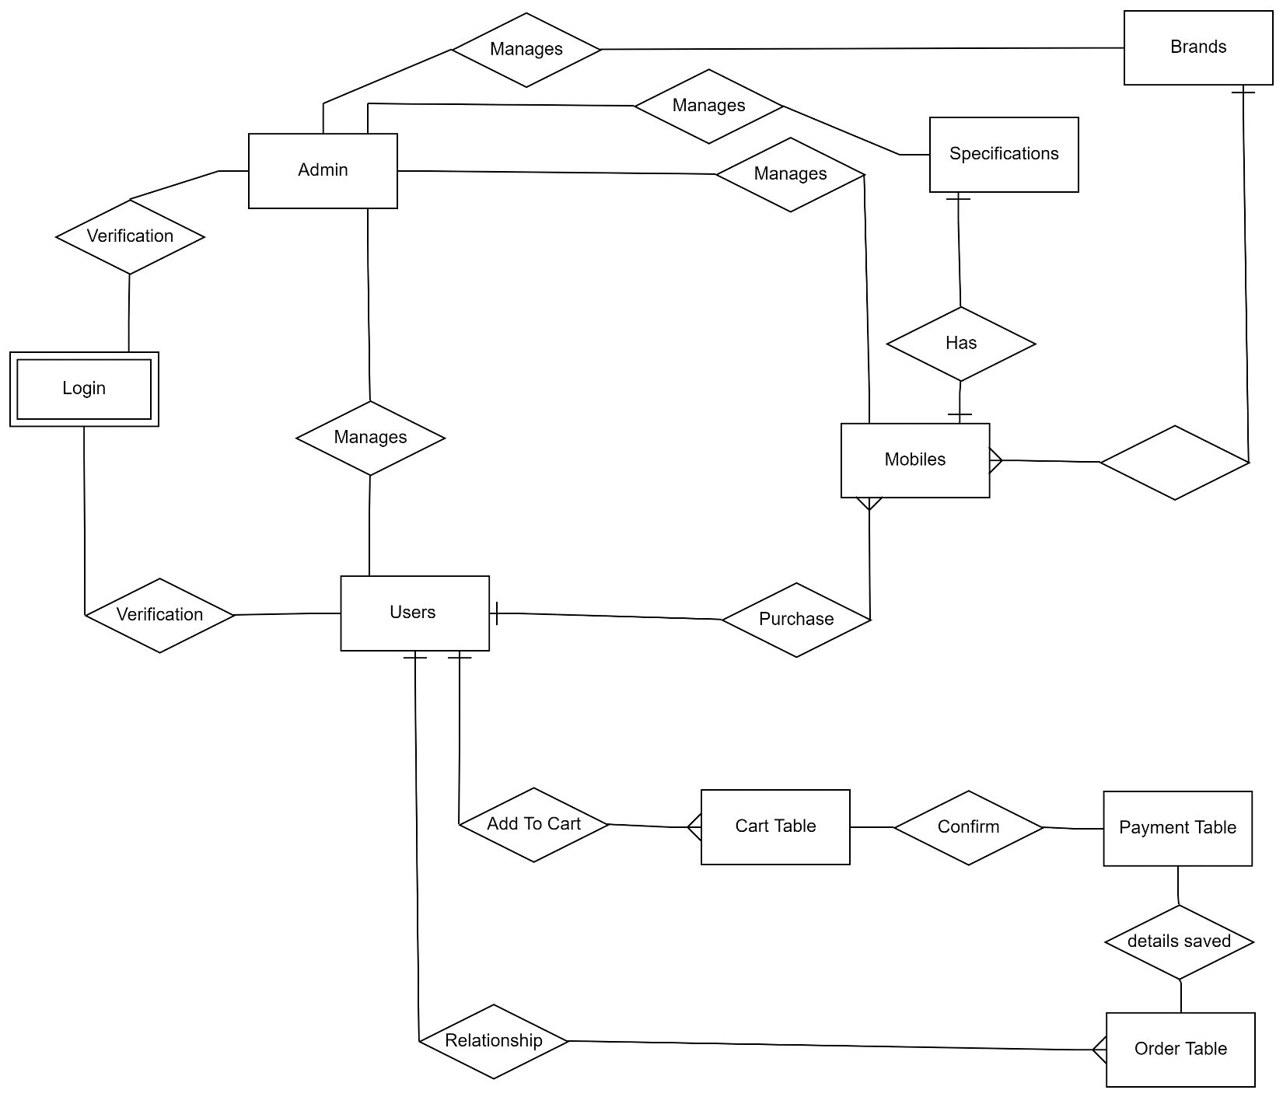

1. **DATABASE DESIGN DOCUMENT**

**4.1. Database Description**

Database description describes all the databases used in the software to store all the records. The database in turn is further described in detail giving all the fields used with their data type, constraints available to them and description. Constraints include primary key, foreign key, etc. Which allow the entities to be uniquely identified.

**4.2. Purpose**

In this database description we describe all the databases which are used to store the all the records of the products, the customers and billing calculation of store.The term database design can be used to  describe many different parts of the design of an overall database system.It also be used to apply to the overall processs of designing,not just the data structure but also  the forms  and queries used as part of the overall database application.

**4.3 System Overview**

We are creating the application  for smartcode company.

* **System Title:** Online Mobile shopping store
* **System Category:** RDBMS(Relational Database Management System) Short for Relational Database Management System, RDBMS refers to a relational database plus supporting software for managing users and processing SQL queries, performing backups/restores and associated tasks.
* **Operational Status:** Under development status
* **Undergoing Major Modification:** Data will be stored in the database after the development.

**4.5 Acronyms and Abbreviations**

* secqustn: Security Question
* mobno: Mobile number
* Qty:Quantity
* amt:Amount

**4.6 Points of Contact**

**4.6.1 Information**

Aventior

2rdfloor ,city Light building

Ring Road ,surat-01

Contact no-1 : 9773466956

Contact no-2 : 9865785240

**4.6.2 Coordination**

Database should be secure ,Security is the degree of protection against danger ,damage ,loss and criminal activity. Security as a form of protection are structure and processes that provide or improve security as a condition.

**4.6.3 Data Owners**

Admin

**4.7 DATABASE  IDENTIFICATION AND DESCRIPTION**

**4.7.1 Naming Conventions**

* All names used throughout the database should be lowercase only. This will eliminate errors related to case-sensitivity.
* Separate name parts by underlines, never by spaces
* Do not use numbers in the name
* Clear and unambiguous naming.
* Primary Key field should be underlined.

**4.7.2 DATABASE IDENTIFICATION**

The database used in our application namely

* Login Table
* Category(Brands) Table
* User(Customer) Table
* Products Table
* Cart Table
* Bill Table
* Payment Table

* The Login Table stores the details of the user who are logged in.

**Fields**: Usertype (New/Existing),Username, Password.

* The User Table stores the details of the new user.

**Fields**: UserId, EmailId, username, password, gender, address, country, mobileNo.

* The  Category Table  used to add Category details.

**Fields**: BrandID, BrandName.

* The Products Table used to store  new mobile  details.

**Fields:** Id, mobileName, Modelno, Description, Color, Image, Quantity, Amount

* The Cart Table is used to store the details of the items purchased by the customers.

**Fields:** user_id, category, model, amount, quantity.

* The Bill Table used to store the bill details.

**Fields:** user_id **,**bill_no , UserName, address, mob_no, category, model, quantity, amount, tax, total_price

The Payment Table is used to store the payment details of the user.

**Fields:** card_type, card_number, name_on_card, security_number(cvv), billing_address, city, postal_code, country, expiry_date

**4.7.3 System using the database**

Processor: Pentium  Dual-core CPU T4400 @ 2.20GHZ 2.20GHz

Installed Memory: 4.00 GB

System Type: 64 bit operating system

**Table Structure**

**Users Table**

|  |  |  |
| --- | --- | --- |
| **Name** | **Type** | **Extra** |
| id | int | Primary, auto_increment |
| email | varchar(30) | Unique |
| First_name | varchar(30) |  |
| Last_name | varchar(30) |  |
| Mobile_no | varchar(30) |  |
| Password | varchar(30) |  |
| Role | varchar(30) |  |
| User_adr | int | FK |

Mobiles Table

|  |  |  |
| --- | --- | --- |
| **Name** | **Type** | **Extra** |
| id | Int | PK,Auto-increment |
| tag | varchar |  |
| Imei | varchar | unique |
| Manuf_date | Date |  |
| Mob_color | varchar |  |
| Mob_image | varchar |  |
| Mob_model | varchar | unique |
| Mob_name | varchar |  |
| Price | Double |  |
| Quantity | int |  |
| Brand_id | int | FK |
|  |  |  |

Brands Table

|  |  |  |
| --- | --- | --- |
| **Name** | **Type** | **Extra** |
| Id | int | PK,Auto-increment |
| Brand_image | varchar |  |
| Brand_name | varchar | unique |

**Specifications Table**

|  |  |  |
| --- | --- | --- |
| **Name** | **Type** | **Extra** |
| Id | Int | PK,Auto-increment |
| battery | varchar |  |
| Dimensions | Varchar |  |
| Front_cam | Varchar |  |
| Network | Varchar |  |
| Os | Varchar |  |
| Ram | Varchar |  |
| Rear_cam | Varchar |  |
| Rom | varchar |  |
| Screen_size | Varchar |  |
| Sim | Varchar |  |
| Mobile_id | int | FK |

**Address Table**

|  |  |  |
| --- | --- | --- |
| **Name** | **Type** | **Extra** |
| Id | Int | PK,Auto-increment |
| City | Varchar |  |
| Pincode | Int |  |
| State | Varchar |  |
| Locality | Varchar |  |

**Cart Table**

|  |  |  |
| --- | --- | --- |
| **Name** | **Type** | **Extra** |
| Id | Int | PK,Auto-increment |
| Quantity | Int |  |
| Ram | varchar |  |
| Storage | varchar |  |
| Total_amount | Double |  |
| Brand_id | Int | FK |
| Mobile_id | Int | FK |
| User_id | Int | FK |

**Order-Details Table**

|  |  |  |
| --- | --- | --- |
| **Name** | **Type** | **Extra** |
| Id | Int | PK,Auto-increment |
| Delivery_date | Date |  |
| Mobile_id | Int |  |
| Order_date | Date |  |
| Total_price | Double |  |
| User_id | Int | FK |

**Payment Table**

|  |  |  |
| --- | --- | --- |
| **Name** | **Type** | **Extra** |
| Id | Int | PK,Auto-increment |
| Account_holder_name | varchar |  |
| Card_number | Int |  |
| Total_amount | Double |  |
| Order_id | Int | FK |
| User_id | Int | FK |

**ER diagram**

An entity-relationship (ER) diagram is a specialized graphic that illustrates the interrelationships between entities in a database. ER diagrams often use symbols to represent three different types of information. Boxes are commonly used to represent entities. Diamonds are normally used to represent relationships and ovals are used to represent attributes

An **entity-relationship model** (ERM) in [software engineering](http://engineering) is an abstract and conceptual representation of [data](http://data). Entity-relationship modeling is a relational schema [database modeling](http://model) method, used to produce a type of [conceptual schema](http://schema) or [semantic data model](http://model) of a system, often a [relational database](http://database), and its requirements in a [top-down](http://top-down) fashion.

**Entity:**

Entity is the thing which we want to store information. It is an elementary basic building block of storing information about business process. An entity represents an object  defined within the information system about which you want to store information. Entities are distinct things in the enterprise.

**Relationships**

A relationship is a named collection or association between entities or used to relate two or more entities with  some common attributes or meaningful interaction between the objects.

**Attributes**

Attributes are the properties of the entities and relationship, Descriptor of the entity. Attributes are elementary pieces of information attached to an entity.

Data Dictionary

Table Name: Login

Description: This table stores the username and password.

Table Name: User Table

Description: This table stores the details of the new user.

**Table Name: Brands Table**

Description: This table  used to add Category details.

**Table Name: Products Table**

Description: The Products Table used to store new mobile details.

**Table Name: Cart Table**

Description:  The Cart Table is used to store the details of the items purchased by the customers.

**Table Name: Bill Table**

Description:  The Bill Table used to store the bill details.

**Table Name: Payment Table**

card_type, card_number, name_on_card, security_number, billing_address, city, postal_code, country, expiry_date

Description: The Payment Table is used to store the payment details of the user.

1. **DATABASE ADMINISTRATIVE INFORMATION**

**3.1 Responsible**

Essentially the main role of a database administrative has to do with overseeing the installation and ongoing function of software on a system designed for use by the number of users. There are several specific responsibilities that the typical database administrator will perform in the just about any corporate environment.

A Basic responsibility for just about every  database administrator involves the installation of new databases. As part of the database installation, the database administrator will set up login credential to authorized person, define the privileges associated with each authorized  user,and ensure that every work station attached to the network is set up to access the new database. This process usually involves a period of troubleshooting, in which the database administrator will address and resolve any problems that users experience with the new project.

* There are four different types of database administrator jobs:

Installation, maintenance, data modeling, and user management. A database administrator is responsible for managing the database(s) that are used to hold the data for large database-driven software.

* Computer often play an integral role wit sales team activities and documentation tracking. Sales administrator jobs may therefore manage information information technology to minimize electronic data problem.

**3.2 System Information**

**3.2Database management System (DBMs) Configuration.1**

**SQL server**

|  |  |
| --- | --- |
| Microsoft SQL Server Management Studio | 10.0.1600.22 ((SQL_PreRelease).080709-1414 ) |
| Microsoft Analysis Services Client Tools | 2007.0100.1600.022 ((SQL_PreRelease).080709-1414 ) |
| Microsoft Data Access Components (MDAC) | 6.1.7601.17514 (win7sp1_rtm.101119-1850) |
| Microsoft MSXML | 3.0 4.0 5.0 6.0 |
| Microsoft Internet Explorer | 9.0.8112.16421 |
| Microsoft .NET Framework | 2.0.50727.5448 |
| Operating System | 6.1.7601 |

**3.2.2 Hardware Configuration**

|  |  |
| --- | --- |
| processor | processor 133-Mhz intel Pentium-class |
| Hard disk | 120GB recommended |
| memory | 128MB of RAM,256MB |
| Display | Standard output display |
| keyboard | Standard qwerty keyboard for interface |
| mouse | Standard mouse with two buttons |

**3.2.3 Database Software utilities**

Utilities software (also known as program, service routine, tool, or utility routine is a type of computer software. It is specially designed to help manage and tune the computer hardware, operating system or application software and perform a single task  or a small range of task; as opposed to application software which tend to be software suites.

3.2.4 Support Software Available for Maintaining Database

Operating System:

Microsoft has worked under the code name window 7 on the successor of windows vista since approximately august 2007. The new operating system is based on windows vista and comes with new program me functions and improvements in detail. Steve Ballmer talked with a Keynote onto the Gartner symposium IT 2008 on October 16th 2008 that window 7 one windows vista is but with numerous improvements. It shall be release after 2.5 years development time as a new window major release. the version number is not wants to prevent problem with programs which checks the version number. Microsoft introduced the first window 7 test release with the build 6801 on the professional developer conference in Los Angeles on October 28th, 2008.

Minimum hardware requirements for window 7

**Architecture**                32-bit                                  64-bit

**Processor**        1 GHz x86 processor      1 GHz x86 processor

**Memory** (RAM)             1GB                                             2GB

**Graphics** **card**               Direct X9graphics processor with WDDM driver

                   Model                                                1.0

**HDD free space**             16GB of free disk space 20 GB of free disk space

**Optical drive**                    DVD drive (only to install from DVD/CD media)

**3.2.5 Security**

To maintain non replication of data Most of the tables are designed with primary key.

 Data Integration between the tables maintains using foreign key.

User Authentication for the system stored in the login tables.

Backup provision is given in order to prevent loss of data.

**3.3 Storage Requirements**

our application can store in C Drive

Capacity: 83,780,169,728 bytes 78.0 GB

Tools: Error Checking

Defragmentation

Back up

Hardware

All Devices:

|  |  |
| --- | --- |
| Name | Type |
| Generic Flash Disk USB Drive | Disk Drive |
| Hitachi S545016139A3000 | Disk Drive |
| MATSHITA DVD RAM UJ89ASATA | DVD/CD |

**3.4 Recovery**

Database recovery is the process of restoring the database to a correct state following a failure.

The failure may be the result of a system crash due to hardware or software errors, a media failure, such as a head crash, or a software error in the application, such as logical errors in the program that is access the database.   It may also be result of unintentional or intentional correction or destruction of data. Whatever the underlying cause of the failure, the DBMS must be able to recover from the failure and restore the database to a consistent state. It is the responsibility of DBMS to ensure that the database is reliable and remains in a consistent state in the presence of failures. In general, backup and recovery refers to the various strategies and procedures involved in the protecting the database against data loss and reconstructing the data such that no data is loss after failure.