1. **Data Summary**

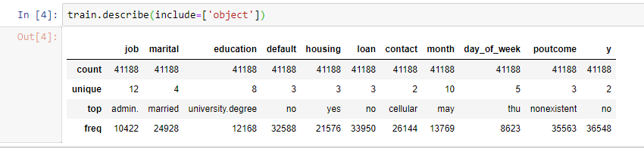

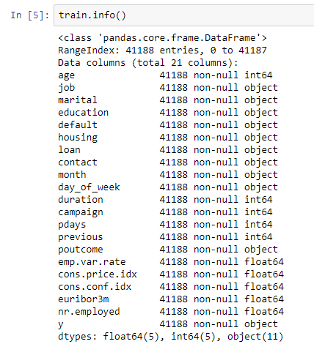

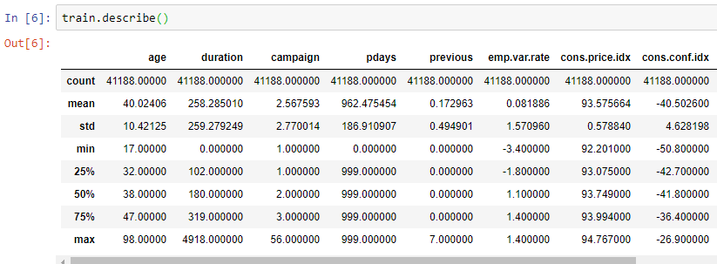

1. **Feature Engineering** 
   1. **Label encoding:**

I encoded all categorical features into numbers using Label encoder (sklearn library).

1. **Feature selection**
   1. **Backward Elimination**
   2. **Statistics method**
   3. **Recursive Feature Elimination**

|  |  |  |  |
| --- | --- | --- | --- |
| **Backward Elimination** | **Statistics Method** | **Recursive Feature Elimination** | **Final Selected Features** |
| Marital  Default  Contact  Previous  Poutcome  emp.var.rate  cons.conf.idx  euribor3m  day_of_week | Age  Marital  Education  Default  Contact  Month  day_of_week  duration  campaign  pdays  poutcome  emp.var.rate  cons.price.idx  cons.conf.idx  euribor3m  nr.employed | Age  Education  Default  Duration  Campaign  Pdays  Previous  euribor3m  nr.employed | Age  Education  Default  Duration  Campaign  Pdays  Previous  euribor3m  nr.employed  cons.conf.idx  emp.var.rate |

1. **Model Selection**

I Built 2 machine learning model:

1. Random forest
2. Support Vector Machine

|  |  |  |
| --- | --- | --- |
|  | **Random Forest** | **SVM** |
| **Accuracy** | 80.5% | 89.6% |

1. 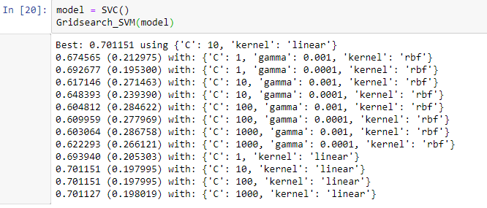**Parameter Tuning in SVM**
2. **Model Evaluation**

|  |  |  |
| --- | --- | --- |
| **N = 4119** | **Predicted: No** | **Predicted: Yes** |
| **Actual: No** | 3663 | 119 |
| **Actual: Yes** | 5 | 332 |

1. **Conclusion**

This Model can classify the Clients which will subscribe a term deposit or not.

So by using this model, Your team will reduce the marketing cost and random calling.