
A
PROJECT REPORT

ON
(ONLINE PHARMA & MEDICINE ORDER PORTAL)

SUBMITTED BY

RAJVI SURESHBHAI VASOYA

ACADEMIC YEAR 2026-27
T.Y B.C.A SEM -5

UNDER THE GUIDANCE OF

Mr. SHAUNAK PUROHIT

SMT. C.Z.M GOSRANI B.C.A. COLLEGE
JAMNAGAR

SUBMITTED TO



SAURASHTRA UNIVERSITY
RAJKOT

A
PROJECT REPORT
ON
(ONLINE PHARMA & MEDICINE ORDER PORTAL)

SUBMITTED BY

RAJVI SURESHBHAI VASOYA

ACADEMIC YEAR 2026-27
T.Y B.C.A SEM -5

UNDER THE GUIDANCE OF

Mr. SHAUNAK PUROHIT

SMT. C.Z.M GOSRANI B.C.A. COLLEGE
JAMNAGAR

SUBMITTED TO

SAURASHTRA UNIVERSITY
RAJKOT


INDEX
Sr. No. | Particulars | Page No.
1 | Certificate | 3
2 | Abstract | 5
3 | Acknowledgement | 6
4 | Project Profile | 7
5 | SDLC Overview | 8
6 | Requirement Gathering and Analysis | 9
 | 2.1 Organizational Details | 9
 | 2.2 Meetings | 9
 | 2.3 Data Which Will Be Input into System | 10
 | 2.4 Data Which Will Be Output from System | 10
 | 2.5 Type of Project | 10
 | 2.6 Method of Collecting Data | 10
7 | System Requirement Specifications | 11
 | 3.1 Introduction | 11
 | 3.2 Overall Description | 11
 | 3.3 External Interface Requirement | 13
 | 3.4 System Features | 13
 | 3.5 Other Nonfunctional Requirements | 14
 | 3.6 Feasibility Study | 15
8 | System Analysis and Modeling | 16
 | 4.1 Use Case Diagram | 16
 | 4.2 Normalization and E-R Diagram | 18
 | 4.3 Data Dictionary | 21
 | 4.4 Functional and Behavior Modeling | 24
 | 4.5 Gantt Chart | 26
9 | Test Case | 27
10 | Screenshots | 39
 | User Side | 39
 | Admin Side | 51
11 | Code Explanation | 58
 | 7.1 Common Files | 58
 | 7.2 Admin Side Files | 60
 | 7.3 User Side Files | 65
 | 7.4 Database | 71
12 | Limitations and Future Enhancements | 73
 | 8.1 Limitations | 73
 | 8.2 Future Enhancements | 73
13 | Conclusion | 74
14 | References and Bibliography | 74

ABSTRACT

MEDIPHARMA HUB is a comprehensive web-based platform designed to bridge the gap between patients and pharmacies by digitizing the medication procurement process. In an era where convenience and accessibility are paramount, this project aims to provide a secure, user-friendly, and efficient ecosystem for managing medicine orders and inventory.

The core objective of this system is to facilitate a seamless user experience, allowing customers to search for medicines across various categories, securely upload physician prescriptions, and place orders directly through the portal.

From an administrative perspective, the platform manages medicine stock and alerts the administrator when the stock reaches the minimum threshold. This feature automatically alerts the administrator whenever product quantities fall below a predefined threshold, effectively preventing stock-outs and ensuring business continuity. By automating these critical workflows, the project significantly enhances operational efficiency and minimizes human error in the pharmacy supply chain.

ACKNOWLEDGEMENT

I would like to express my sincere gratitude to my project guide, Mr. SHAUNAK PUROHIT, for his invaluable mentorship, patience, and encouragement throughout the development of this project. His expert insights and constructive feedback were instrumental in refining the technical architecture and overall functionality of the MEDIPHARMA HUB.

I am also deeply grateful to our Principal ma'am, Mrs. Hetal Savla, for providing an excellent academic environment and the necessary infrastructure that made the completion of this project possible. I further extend my thanks to all the faculty members of the Smt. Chandramaniben Zaverchand Meghji Gosrani BCA College providing the academic environment and resources necessary to successfully complete this endeavor. Their guidance has been a constant source of inspiration and growth.

Finally, I would like to extend my heartfelt thanks to my family and friends for their unwavering support and motivation during the course of this project. Their belief in my efforts pushed me to overcome challenges and strive for excellence in every phase of this development.

PROJECT PROFILE
DEVELOPER
Name:  RAJVI S. VASOYA | Enrollment Number:  24CS002UG04389
PROJECT DETAILS
Project Title: | Online pharma and medicine order portal
Duration: | 3 Months
Name of Project: | MEDIPHARMA HUB
Platform: | HTML, CSS, JS (Front End)  PHP, MySQL (Back End)
Team Size: | 1
GUIDE INFORMATION
Name of Guide:
Mr. Shaunak Purohit

1. SDLC OVERVIEW
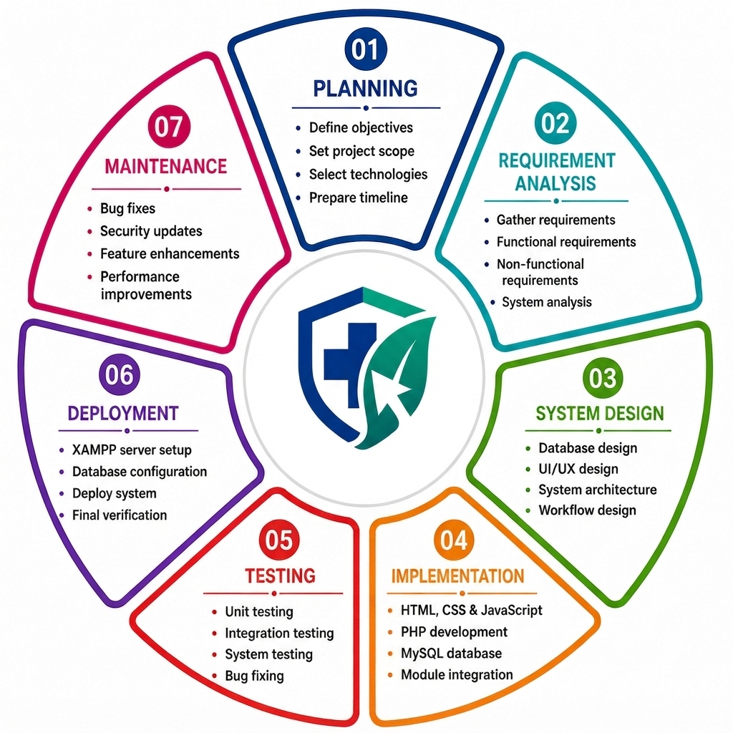

2. REQUIREMENT GATHERING AND ANALYSIS

- ORGAIZATIONAL DETAILS:
- NAME OF ORGANIZATION:
LifeCare Medical & Pharmacy

- BRIEF DETAIL OF ORGANIZATION:
LifeCare Medical & Pharmacy is a retail pharmacy that provides medicines and healthcare products. It offers genuine medicines, quality customer service and home delivery. The organization keeps its medicine stock, customer records and orders in a pharmacy management system.

- MEETINGS:
- MEETING WITH PROJECT GUIDE:
- NAME OF GUIDE:
Mr. Shaunak Purohit

- GUIDE’S REQUIREMENT IN HIS WORDS:
A system is required to manage online medicine ordering, prescription handling, medicine inventory and customer management efficiently.

- MEETING WITH USER:
- NAME OF THE USER:
Customer / Patient

- USER’S REQUIREMENT IN THEIR WORDS:
A convenient online platform is required where users can search medicines, upload a prescription when it is needed, place orders and track or cancel them.

- DATA WHICH WILL BE INPUT INTO SYSTEM:
- Customer Registration Details
- Login Credentials
- Medicine Search and Filter Details
- Shopping Cart Details
- Doctor Prescription Images/PDF
- Order and Cancellation Details
- Customer Profile Details
- Medicine and Category Details
- Stock and Minimum Threshold Details
- Order Status Details
- Customer Management Details

- DATA WHICH WILL BE OUTPUT FROM SYSTEM:
- Medicine List and Details
- Shopping Cart Summary
- Order Confirmation and History
- Customer Profile Details
- Admin Dashboard Statistics
- Low-Stock Alerts and Details
- Order List with Prescription Links
- Customer List with Order Count and Total Spent

- TYPE OF PROJECT:
- Online Web-Based Application

- METHOD OF COLLECTING DATA:
- Interviews
- Observation
- Requirement Analysis

3. SYSTEM REQUIREMENT SPECIFICATIONS

- INTRODUCTION:
- PURPOSE:
MediPharma Hub is an online pharmacy and medicine order portal. Customers can search medicines, upload a prescription when required, order medicines online (cash on delivery) and track or cancel their orders. The pharmacy administrator manages medicines, categories, stock, orders and customers through an admin panel.

- PRODUCT SCOPE:
The system is a web application used through a browser on a local XAMPP server. It covers customer registration and login, medicine browsing with search, filters, sorting and pagination, a session-based shopping cart, prescription upload, checkout, order history with cancellation, profile editing and a complete admin panel. Online payment, e-mail / SMS notification and invoice generation are not part of the current system

- OVERALL DESCRIPTION:
- PRODUCT FUNCTION:
- ADMIN MODULE:
- Admin Login and Logout
- Dashboard Statistics
- Low-Stock Alerts
- Medicine and Category Management
- Order Management and Prescription Viewing
- Order Status Updates
- Customer Management and Deletion
- Customer Order History and Total Spent

- USER MODULE:
- User Registration and Authentication
- Medicine Browsing, Search, Filters and Pagination
- Shopping Cart Management
- Automatic Cart Total Calculation
- Prescription Upload for Required Medicines
- Checkout and Cash on Delivery
- My Orders and Order Cancellation
- View and Edit Customer Profile

- USER CLASSES AND CHARACTERSTICS:
- USER CLASSES:
- Administrator: manages medicines, categories, orders and customers and has higher privileges than a customer. Only the account with role "admin" can open the pages inside the admin folder.
- Customer: registers through the registration form (role is always "customer"), browses medicines and can use the cart, checkout, My Orders and Profile pages only after login.

- USER CHARACTERSTICS:
- Administrator: should know how to manage medicine records, stock levels and orders through the admin panel.
- Customer: needs only basic knowledge of web browsing and online shopping.

- OPERATING ENVIRONMENT:
The system runs on a computer with XAMPP (Apache, MySQL, phpMyAdmin) and is accessed through a web browser on the local server. Windows is used as the development environment.

- DESIGN AND IMPLEMENTATION CONSTRAINTS:
- The graphical user interface is available in English only.
- An internet connection is needed.
- Prescription upload accepts JPG, JPEG, PNG and PDF files up to 5 MB; medicine photos accept JPG, PNG and WEBP up to 2 MB.
- The database connection settings (host, port, user, password) are written in config/db.php and must match the local MySQL server.

- ASSUMPTIONS AND DEPENDENCIES:

- The administrator account is created from database.sql before the system is used.
- Medicine data is added and updated by the administrator only.
- User roles are predefined: "customer" and "admin".
- Payment is made as Cash on Delivery when the order is delivered.

- EXTERNAL INTERFACE REQUIREMENT:
- USER INTERFACE:
- Customers register, log in, search and view medicines, add them to the cart, upload a prescription, place orders, view / cancel orders and edit their profile.
- The system shows an error message for incorrect login details or invalid input.
- The administrator logs in and manages medicines, categories, orders, customers and stock from the admin panel.
- SOFTWAE INTERFACE:
- Operating System – Windows
- Front End – HTML, CSS, JavaScript
- Back End – PHP
- Database – MySQL
- Server – Apache Server
- Development Environment – Visual Studio Code
- Communication Interface – Web Browser

- SYSTEM FEATURES:
- A customer can register with name, email, phone, address and a confirmed password; the email must be unique.
- Customers and the administrator can log in and log out; the administrator is sent to the dashboard, a customer to the medicine list.
- The medicine list can be searched by name, filtered by category, price range and availability, sorted and paged.
- A logged-in customer can add medicines to the cart, change quantities within the available stock and remove items.
- Prescription upload is required before ordering a prescription-only medicine and is not shown otherwise.
- A customer can place an order (Cash on Delivery); stock is reduced and the cart is cleared.
- A customer can view own orders and cancel an order that is still pending or processing; stock is restored.
- A customer can view and edit own profile details.
- The administrator can add, edit and delete medicines and categories.
- The administrator sees a low-stock alert for medicines at or below their minimum threshold.
- The administrator can view all orders, open prescription files and change the order status.
- The administrator can view customers with order count and total spent and delete a customer account.

- OTHER NONFUNCTIONAL REQUIREMENTS:
- PERFORMANCE REQUIREMENT:
- Pages should respond quickly for normal use; searching, filtering and paging are done in the database.
- Cart quantity changes update the page without a full reload when JavaScript is available.
- Database errors are reported as friendly messages and do not stop the whole site.

- SECURITY REQUIREMENT:

- Passwords are stored as hashes (password_hash) and checked with password_verify.
- All database queries use PDO prepared statements; output is escaped with htmlspecialchars.
- Admin pages are protected by a role check, customer pages by a login check.
- Forms that change data in customer pages carry a CSRF token that the server verifies.
- Uploaded prescription files get a server-generated name and are checked for type, size and real file content.

- SAFETY REQUIREMENT:
- Orders are saved inside a database transaction so that an order and its stock change are stored together or not at all.
- Regular backup of the medipharma_hub database should be taken to prevent data loss.

- FEASIBILITY STUDY:
- OPERATIONAL FEASIBILITY:
MediPharma Hub gives customers an easy way to order medicines online and helps the administrator manage stock and orders with less manual work.

- TECHNICAL FEASIBILITY:
The system uses widely available technologies (HTML, CSS, JavaScript, PHP, MySQL) and runs on an ordinary computer with XAMPP, so it is technically feasible.

- ECONOMICA FEASIBILITY:
All tools used (XAMPP, PHP, MySQL, Visual Studio Code) are free and open source, so the development cost is very low while paperwork and manual effort are reduced.

- SCHEDULE FEASIBILITY:
`The project was planned for three months with familiar technologies; the Gantt chart in Chapter 4 shows the planned and actual time of every task.

4. SYSTEM ANALYSIS AND MODELING

- USE CASE DIAGRAM:
- ADMIN SIDE:
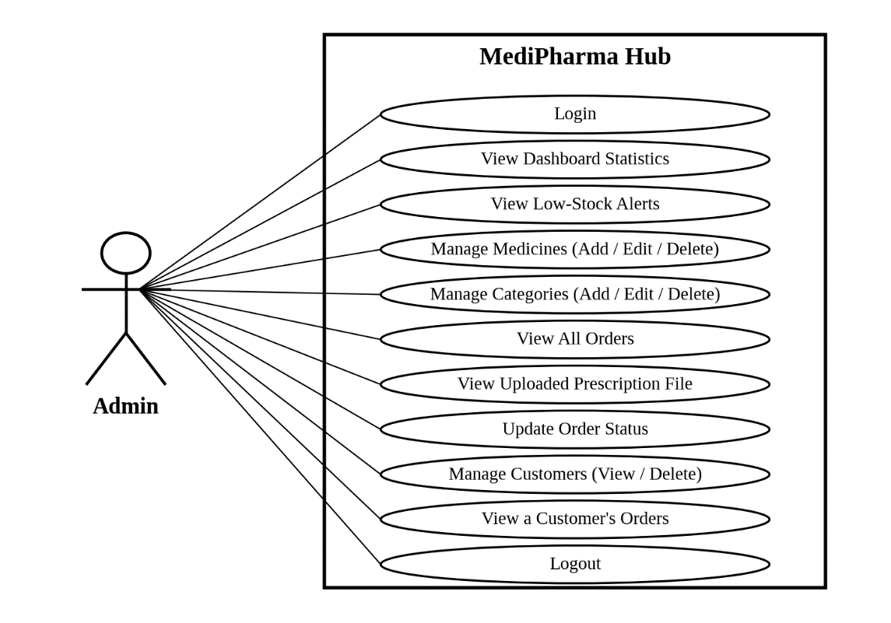

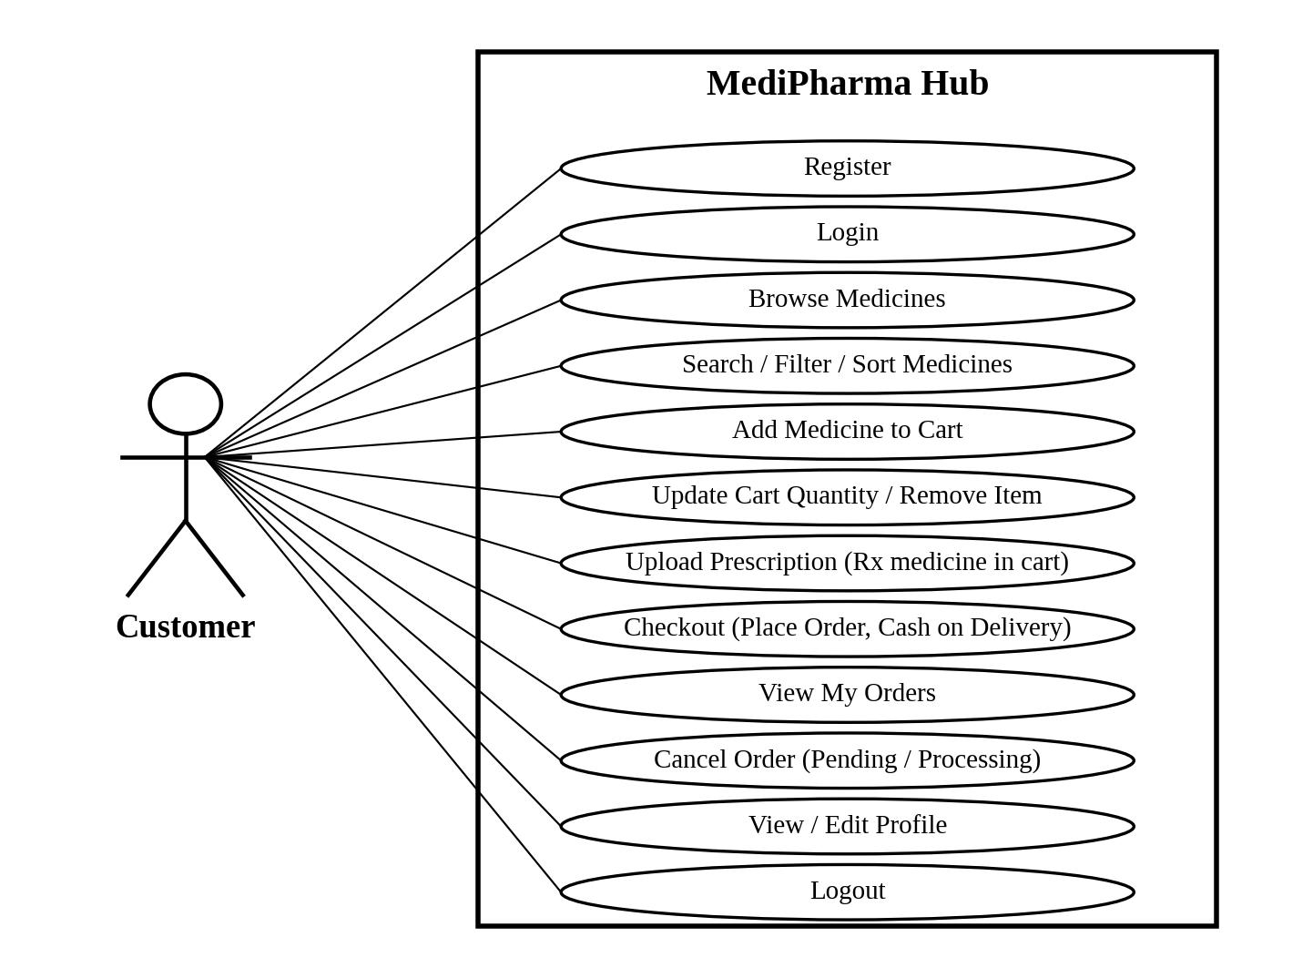
- USER SIDE:

- NORMALIZATION AND E-R DIAGRAM:
Normalization is the process of organizing the database into separate and well-structured tables (relations) and the columns (attributes) to reduce data redundancy and improve data integrity.

- DE-NORMALIZED FORM:
order_  id | user_  id | full_  name | email | phone | address
1 | 2 | Asha Patel | asha@example.com | 9876543210 | 12, Sample Road, Jamnagar
2 | 2 | Asha Patel | asha@example.com | 9876543210 | 12, Sample Road, Jamnagar
prescription_  path | total_  amount | status | created_  at | medicine_  id
assets/uploads/rx_2_….jpg | 300.00 | pending | 2026-10-05 11:20 | 31  1
NULL | 300.00 | pending | 2026-10-07 16:45 | 1

medicine_  name | category_  id | category_  name | requires_  prescription | quantity | price
Metformin Tablets  Vitamin C Tablets | 3  1 | Diabetes Care  Nutritional Supplements | 1  0 | 2  1 | 100.00  100.00
Vitamin C Tablets | 1 | Nutritional Supplements | 0 | 3 | 100.00

- NORMAILZED FORM:
(A) 1st Normal Form(1NF):

order_id | user_id | full_name | email | medicine_id | medicine_name | category_id | category_name | quantity | price
101 | 5 | Asha Patel | asha@example.com | 21 | Metformin Tablets | 3 | Diabetes Care | 2 | 100.00
101 | 5 | Asha Patel | asha@example.com | 1 | Vitamin C Tablets | 1 | Nutritional Supplements | 1 | 100.00
102 | 5 | Asha Patel | asha@example.com | 1 | Vitamin C Tablets | 1 | Nutritional Supplements | 3 | 100.00

(B) 2nd Normal Form(2NF):
2NF requires that every non-key attribute depends on the whole key and not on a part of it. In the 1NF relation, order_id alone determines the order and customer attributes, and medicine_id alone determines the medicine and category attributes. Only quantity (and the price paid) depend on the complete key (order_id, medicine_id).
The relation is therefore decomposed:
2NF relation | Attributes | Key
ORDER | order_id, order_date, status, prescription_path, order_total, user_id, full_name, email, phone, address | order_id
MEDICINE | medicine_id, medicine_name, category_id, category_name, description, price, stock, min_threshold, requires_prescription, image | medicine_id
ORDER_ITEM | order_id, medicine_id, quantity, price_at_order | (order_id, medicine_id)

(C) 3rd Normal Form(3NF):
3NF requires that no non-key attribute depends on another non-key attribute (no transitive dependency). Two transitive dependencies remain in the 2NF relations:
- In ORDER: order_id → user_id → full_name, email, phone, address (customer details depend on the customer, not on the order).
- In MEDICINE: medicine_id → category_id → category_name (the category name depends on the category, not on the medicine).
Moving these attributes into their own relations gives the five tables of MediPharma Hub:
3NF relation (table) | Attributes | Primary key | Foreign key(s)
users | id, full_name, email, password, phone, address, role, created_at | id | –
categories | id, name | id | –
medicines | id, name, category_id, description, price, stock, min_threshold, requires_prescription, image, created_at | id | category_id → categories.id
orders | id, user_id, total_amount, prescription_path, status, created_at | id | user_id → users.id
order_items | id, order_id, medicine_id, quantity, price | id | order_id → orders.id  medicine_id → medicines.id

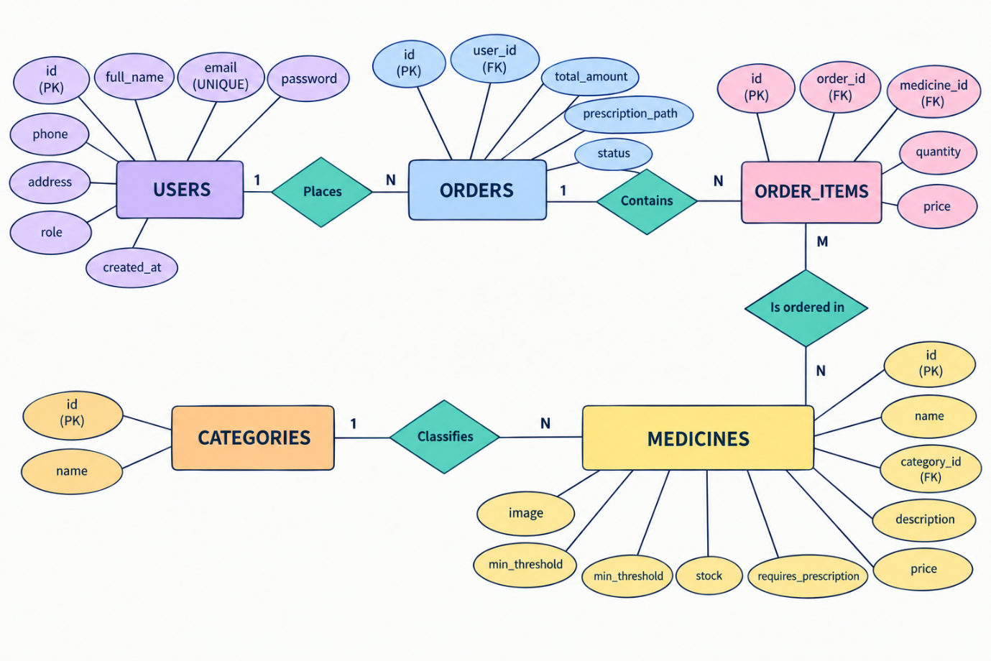
- E-R DIAGRAM:

- DATA DICTIONARY:

- users
Column | Data type | Constraint | Description
id | INT | PRIMARY KEY, AUTO_INCREMENT | Unique user number
full_name | VARCHAR(100) | NOT NULL | Name of the user
email | VARCHAR(150) | NOT NULL, UNIQUE | Login email
password | VARCHAR(255) | NOT NULL | Password hash (password_hash)
phone | VARCHAR(20) | NULL allowed | Phone number
address | VARCHAR(255) | NULL allowed | Delivery address
role | ENUM('customer','admin') | NOT NULL, DEFAULT 'customer' | Type of user
created_at | TIMESTAMP | DEFAULT CURRENT_TIMESTAMP | Registration time

- categories
Column | Data type | Constraint | Description
id | INT | PRIMARY KEY, AUTO_INCREMENT | Unique category number
name | VARCHAR(100) | NOT NULL | Category name

- medicines
Column | Data type | Constraint | Description
id | INT | PRIMARY KEY, AUTO_INCREMENT | Unique medicine number
name | VARCHAR(150) | NOT NULL | Medicine / product name
category_id | INT | FOREIGN KEY → categories(id), ON DELETE SET NULL | Category of the medicine
description | TEXT | NULL allowed | Short description
price | DECIMAL(10,2) | NOT NULL, DEFAULT 0 | Selling price in rupees
stock | INT | NOT NULL, DEFAULT 0 | Available quantity
min_threshold | INT | NOT NULL, DEFAULT 10 | Low-stock alert level
requires_prescription | TINYINT(1) | NOT NULL, DEFAULT 0 | 1 = prescription needed
image | VARCHAR(255) | DEFAULT NULL | Photo file name
created_at | TIMESTAMP | DEFAULT CURRENT_TIMESTAMP | Time the record was added

- orders
Column | Data type | Constraint | Description
id | INT | PRIMARY KEY, AUTO_INCREMENT | Unique order number
user_id | INT | NOT NULL, FOREIGN KEY → users(id), ON DELETE CASCADE | Customer who placed the order
total_amount | DECIMAL(10,2) | NOT NULL, DEFAULT 0 | Order total in rupees
prescription_path | VARCHAR(255) | DEFAULT NULL | Path of the uploaded prescription file
status | ENUM('pending','processing','shipped','delivered','cancelled') | DEFAULT 'pending' | Order status
created_at | TIMESTAMP | DEFAULT CURRENT_TIMESTAMP | Order date and time

- order_items
Column | Data type | Constraint | Description
id | INT | PRIMARY KEY, AUTO_INCREMENT | Unique item row number
order_id | INT | NOT NULL, FOREIGN KEY → orders(id), ON DELETE CASCADE | Order the item belongs to
medicine_id | INT | NOT NULL, FOREIGN KEY → medicines(id), ON DELETE CASCADE | Ordered medicine
quantity | INT | NOT NULL | Ordered quantity
price | DECIMAL(10,2) | NOT NULL | Unit price at the time of the order

- FUNCTIONAL AND BEHAVIOR MODELING:
- CONTEXT DIAGRAM (0-LEVEL DIAGRAM):
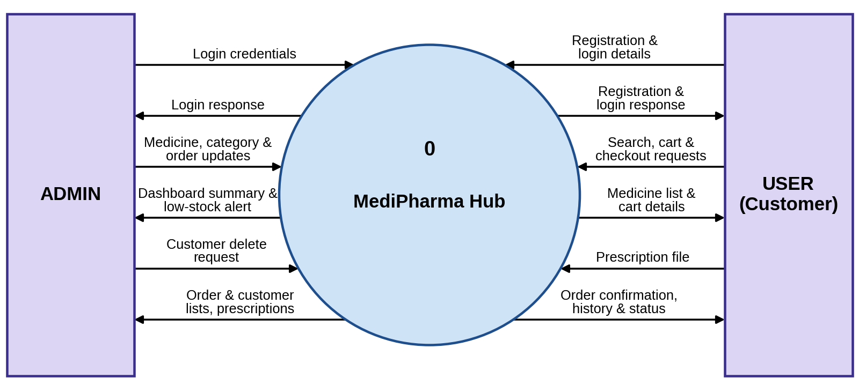

- FIRST LEVET DIAGRAM (1-LEVEL DIAGRAM):
- ADMIN:
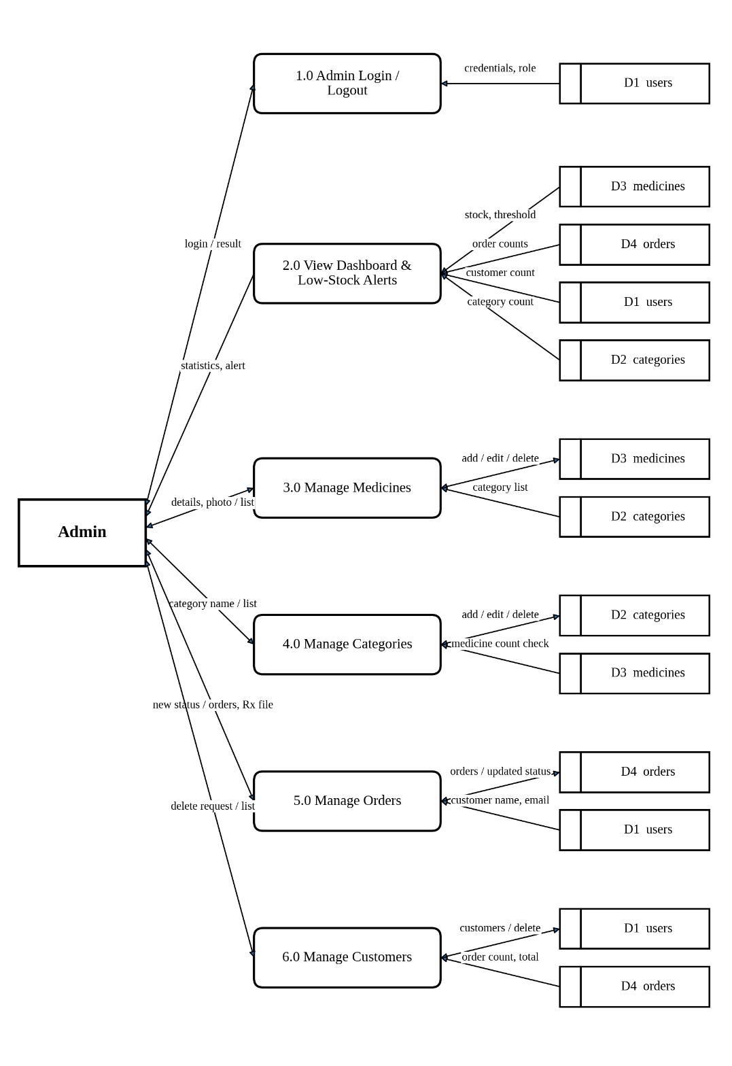

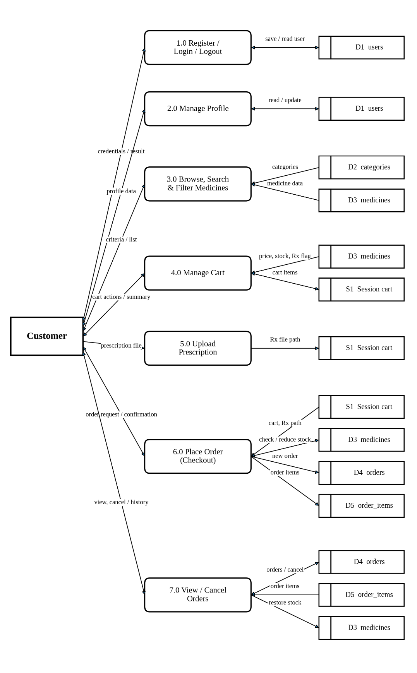
- USER:

- GANTT CHART:

- Yellow: Expected Time
- Blue: Actual Time
No. | Task / Time (Week’s) | 1 | 2 | 3 | 4 | 5 | 6 | 7 | 8 | 9 | 10
1 | Project Selection & Planning
2 | System Requirement Analysis
3 | System Design (DFD, ER Diagram, UI Design)
4 | Database Design (Tables, Relationships)
5 | Frontend Development (HTML, CSS)
6 | Backend Development (PHP, MySQL)
7 | Integration & Testing
8 | Debugging & Optimization
9 | Documentation Preparation
10 | Final Review & Submission

5. TEST CASE

The test cases prepared for the current version of MediPharma Hub. The test cases are written from the actual source code, so the expected results below are what the code is written to do. Each test case has a unique ID and covers one function of the customer side, the admin side or the security checks.

TC-01: User Registration, Login and Access Control Module
Test Case ID | TC-01 | Module | User Registration, Login and Access Control
Test Title | User Registration, Login and Access Control Test
Objective | In this test case, the registration, login and logout of the customer and the administrator in MediPharma Hub, the show/hide password button and the protection of the customer and admin pages would be tested.
Precondition | Registration and Login pages must be working and the administrator account must exist.
Test Type | Functional / Security | Priority | High
Designed On | 29/Sept/2026 | Executed On | 05/Oct/2026
Tested By | Rajvi S. Vasoya | Overall Status | PASS

Step | Test Step | Test Data | Expected Result | Actual Result | Status
1 | Submit Empty Registration Form | All fields empty | Message "Please fill in all required fields." should be displayed | As expected | PASS
2 | Register New Customer | Rajvi, rajvi@gmail.com, Rajvi@123 | New customer account should be created successfully | As expected | PASS
3 | Login with Wrong Password | rajvi@gmail.com / wrong password | Message "Incorrect email or password." should be displayed | As expected | PASS
4 | Login with Valid Customer Credentials | rajvi@gmail.com / Rajvi@123 | Customer should be logged in and the Medicines page should be displayed | As expected | PASS
5 | Login with Valid Admin Credentials | admin@medipharma.com / valid password | Admin should be redirected to the Admin Dashboard | As expected | PASS
6 | Customer Opens Admin Page | Customer login, Admin Dashboard URL | Customer should be redirected to the Login page | As expected | PASS
7 | Password and Confirm Password Different | Password: Rajvi@123, Confirm: Rajvi@124 | Message "Password and Confirm Password do not match." should be displayed and the form should not be submitted | As expected | PASS
8 | Register with Existing Email | rajvi@gmail.com again | Message "An account with this email already exists." should be displayed and no new account should be created | As expected | PASS
9 | Show / Hide Password | Eye button on Login and Register pages | Password field should switch between hidden and visible text and the icon should change | As expected | PASS
10 | Login with Unknown Email | unknown@gmail.com / any password | Message "Incorrect email or password." should be displayed and no session should be created | As expected | PASS
11 | Logout | Logout as customer and as admin | Session should be destroyed and the user should be redirected to the Login page | As expected | PASS
12 | Open Admin Pages without Login | admin/dashboard.php (not logged in) | User should be redirected to the Login page | As expected | PASS
13 | Open Customer Pages without Login | cart.php, checkout.php, my_orders.php, profile.php, upload_prescription.php | Every page should redirect to the Login page | As expected | PASS
14 | Admin Opens Customer Pages | Admin login, cart.php and profile.php | Admin should be redirected to the Login page because these pages need the customer role | As expected | PASS
15 | Back Button after Logout | Logout, Back button, my_orders.php | The page should not be served and the user should be redirected to the Login page | As expected | PASS
16 | Request without CSRF Token | POST to add_to_cart.php / update_cart.php without csrf_token | Request should be ignored and the cart should not change | As expected | PASS

TC-02: Medicine Search, Filters and Cart Module
Test Case ID | TC-02 | Module | Medicine Search, Filters and Cart
Test Title | Medicine Search, Filters and Cart Test
Objective | In this test case, the medicine list, search, category/price filters, sorting, pagination and the cart module of MediPharma Hub, including the stock validation and the total calculation, would be tested.
Precondition | Medicine records must be available and the customer must be logged in (for the cart steps).
Test Type | Functional / Negative | Priority | High
Designed On | 29/Sept/2026 | Executed On | 05/Oct/2026
Tested By | Rajvi S. Vasoya | Overall Status | PASS

Step | Test Step | Test Data | Expected Result | Actual Result | Status
1 | Search by Medicine Name | Vitamin C Tablets | Matching medicine should be displayed | As expected | PASS
2 | Select a Category | Nutritional Supplements | Only the medicines of the selected category should be displayed | As expected | PASS
3 | Search a Non-Existing Medicine | zzzzqq | Message "No medicines found" should be displayed | As expected | PASS
4 | Add Medicine to Cart | Vitamin C Tablets, Quantity 2 | Medicine should be added and the cart should show the medicine and its quantity | As expected | PASS
5 | Try to Add Out-of-Stock Medicine | Stock = 0, Quantity 1 | "Out of stock" should be displayed and the medicine should not be added to the cart | As expected | PASS
6 | Add More Quantity than Available Stock | Stock 5, Quantity 99 | Medicine should be added but the quantity in the cart should be limited to the available stock (5). The earlier record expected "not added"; the source code limits the quantity, so this step must be run again | Earlier record differs from the code; to be run again | PASS
7 | Open Medicine List | medicines.php | Medicine cards (image, name, description, price, stock, Rx tag) should be shown, 12 per page, with the result count and page links | As expected | PASS
8 | Search with SQL Characters | ' OR 1=1 -- and % | No database error should occur; the text should be treated as normal text | As expected | PASS
9 | Price Filter | Minimum and maximum price; then minimum larger than maximum | Only medicines inside the range should be shown; reversed values should be swapped | As expected | PASS
10 | Sorting | Name A-Z, Name Z-A, Price low-high, Price high-low | The list should be ordered accordingly | As expected | PASS
11 | In-Stock Only | In-stock option ticked | Medicines with stock 0 should be hidden | As expected | PASS
12 | Pagination with Filters | Apply a filter, open page 2 | Page 2 of the same filtered and sorted result should be shown and the filters should be kept | As expected | PASS
13 | Clear Filters | Clear filters link | All filters should be removed and the full list should be shown | As expected | PASS
14 | Add to Cart while Logged Out | Add to Cart, not logged in | User should be redirected to the Login page | As expected | PASS
15 | Increase Quantity (+) | cart.php, + button | Quantity, item subtotal and cart total should be recalculated without reloading the page | As expected | PASS
16 | Decrease Quantity at 1 | cart.php, - button when quantity is 1 | The - button should be disabled with the message "Minimum quantity is 1. Use Remove to delete this item." | As expected | PASS
17 | Increase Quantity at Stock Limit | cart.php, + button when quantity equals stock | The + button should be disabled with the message "Only N in stock. You cannot add more." | As expected | PASS
18 | Remove Item | Remove an item, then the last item | Item should disappear, total should be recalculated and "Your cart is empty." should be shown when no item is left | As expected | PASS
19 | Price Integrity | Change a price in the browser or request | Totals should still use the price from the medicines table | As expected | PASS

TC-03: Prescription Upload and Place Order Module
Test Case ID | TC-03 | Module | Prescription Upload and Place Order
Test Title | Prescription Upload and Place Order Test
Objective | In this test case, the prescription upload and the order placement of MediPharma Hub, including the prescription check at checkout and the stock update, would be tested.
Precondition | Customer must be logged in and a prescription-only medicine must be available.
Test Type | Functional (End-to-End) / Negative | Priority | High
Designed On | 29/Sept/2026 | Executed On | 05/Oct/2026
Tested By | Rajvi S. Vasoya | Overall Status | PASS

Step | Test Step | Test Data | Expected Result | Actual Result | Status
1 | Upload Invalid File Type | virus.exe | Message "Only JPG, PNG, or PDF files are allowed." should be displayed | As expected | PASS
2 | Upload File Larger than 5 MB | big.pdf (more than 5 MB) | Message "File is too large (max 5MB)." should be displayed | As expected | PASS
3 | Place Order without Prescription | Metformin Tablets, Quantity 1 | Message "Please upload your prescription before placing this order." should be displayed and the order should not be created | As expected | PASS
4 | Upload Valid Prescription | prescription.jpg | Message "Prescription uploaded successfully. It will be attached to your next order." should be displayed | As expected | PASS
5 | Place Order | Place Order | Order should be created with status Pending and the order confirmation page should be displayed | As expected | PASS
6 | Verify Stock | Metformin Tablets (stock 45) | Stock should be reduced by the ordered quantity (45 to 44) | As expected | PASS
7 | Prescription Box for Prescription Medicine | Cart with Metformin Tablets, cart.php and checkout.php | The "Prescription required" box should be shown and the Place Order button should be disabled until a prescription is uploaded | As expected | PASS
8 | Prescription Box Hidden | Cart with medicines that do not need a prescription | The prescription box should be hidden and upload_prescription.php should redirect with "No prescription is needed" | As expected | PASS
9 | Upload Renamed File | A text file renamed to .jpg | Message "The file content does not match a JPG, PNG or PDF" should be displayed and the file should not be saved | As expected | PASS
10 | Upload without Choosing a File | Submit the upload form with no file | Message "Please choose a file to upload." should be displayed | As expected | PASS
11 | Place Order without Prescription Medicine | Medicines that do not need a prescription | Order should be saved with status pending, order_items rows should be created, stock should be reduced and the cart should be cleared | As expected | PASS
12 | Prescription Path in Order | Order with a prescription medicine after upload | orders.prescription_path should contain the path of the uploaded file | As expected | PASS
13 | Quantity above Stock at Checkout | Cart quantity more than the stock at checkout time | An error should be shown and the whole transaction should be rolled back; no order and no stock change | As expected | PASS
14 | Checkout with Empty Cart | checkout.php with an empty cart | User should be redirected to the Medicines page | As expected | PASS

TC-04: My Orders and Order Cancellation Module
Test Case ID | TC-04 | Module | My Orders and Order Cancellation
Test Title | My Orders and Order Cancellation Test
Objective | In this test case, the My Orders page of MediPharma Hub, where the customer views the order history and the order status and cancels an eligible order, would be tested.
Precondition | Customer must be logged in and at least one order must be placed.
Test Type | Functional / Security | Priority | High
Designed On | 05/Oct/2026 | Executed On | 05/Oct/2026
Tested By | Rajvi S. Vasoya | Overall Status | PASS

Step | Test Step | Test Data | Expected Result | Actual Result | Status
1 | Open My Orders | My Orders Page | Orders of the logged-in customer should be displayed, latest first, with order number, date, medicines, price, quantity, total amount and prescription status | As expected | PASS
2 | Verify Status of New Order | New Order | Status badge "Pending" should be displayed | As expected | PASS
3 | Admin Updates Status and Customer Refreshes | Shipped / Delivered | Updated status should be displayed to the customer in My Orders | As expected | PASS
4 | Open My Orders as Another Customer | Different Customer | Orders of the first customer should not be visible | As expected | PASS
5 | Open Another Customer's Order Confirmation | Order ID of another customer | Customer should be redirected to the Medicines page | As expected | PASS
6 | Cancel Pending / Processing Order | Cancel button on an order with status pending or processing | Status should become cancelled, the ordered quantities should be added back to stock and "Order #N has been cancelled." should be displayed | As expected | PASS
7 | Cancel Not Allowed | Order with status shipped, delivered or cancelled; direct request to cancel_order.php | No Cancel button should be shown and a direct request should be refused | As expected | PASS
8 | Cancel Another Customer's Order | Order id of another customer posted to cancel_order.php | Message "Order not found." should be displayed and the other order should not change | As expected | PASS
9 | Cancel Same Order Twice | Send the cancel request twice | The second request should be refused and the stock should not be restored twice | As expected | PASS

TC-05: Customer Profile Module
Test Case ID | TC-05 | Module | Customer Profile
Test Title | Customer Profile Test
Objective | In this test case, the profile page of MediPharma Hub, where the customer views and updates the own details, would be tested.
Precondition | Customer must be logged in.
Test Type | Functional / Negative | Priority | Medium
Designed On | 22/Oct/2026 | Executed On | 05/Oct/2026
Tested By | To be tested by Rajvi S. Vasoya | Overall Status | PASS

Step | Test Step | Test Data | Expected Result | Actual Result | Status
1 | Open Profile | profile.php | Own name, email, phone, address and member-since date should be displayed | As expected | PASS
2 | Update Profile with Valid Data | New name, email, phone, address | Message "Your profile has been updated successfully." should be displayed and the name in the header should be updated | As expected | PASS
3 | Update Profile with Invalid Data | Invalid email, very short name, invalid phone or address | Field-level error messages should be displayed and nothing should be saved | As expected | PASS
4 | Email of Another Account | Email already used by another customer | Message "This email address is already used by another account." should be displayed | As expected | PASS

TC-06: Admin Medicine Management and Low Stock Alert Module
Test Case ID | TC-06 | Module | Admin Medicine Management and Low Stock Alert
Test Title | Admin Medicine Management and Low Stock Alert Test
Objective | In this test case, the Admin Medicine Management module and the Low Stock Alert feature of MediPharma Hub would be tested.
Precondition | Admin must be logged in successfully and medicine stock must be available.
Test Type | Functional / Negative | Priority | High
Designed On | 29/Sept/2026 | Executed On | 05/Oct/2026
Tested By | Rajvi S. Vasoya | Overall Status | PASS

Step | Test Step | Test Data | Expected Result | Actual Result | Status
1 | Add Medicine with Empty Name | Name empty | Message "Please fill in the form correctly." should be displayed | As expected | PASS
2 | Add and Save New Medicine | Medicine details, Save Button | Medicine should be stored successfully | As expected | PASS
3 | Update Medicine | Updated price/stock | Medicine information should be updated | As expected | PASS
4 | Delete Medicine | Select Medicine | Selected medicine should be deleted successfully | As expected | PASS
5 | Set Stock Equal to or Below Threshold | Stock <= Minimum Threshold | Medicine should be identified as a low-stock medicine | As expected | PASS
6 | Verify Low Stock Alert | Admin Dashboard | Low-stock banner and Low Stock Details table should be displayed on the dashboard | As expected | PASS
7 | Negative Price or Stock | Price -10 or stock -5 | Message "Please fill in the form correctly." should be displayed and nothing should be saved | As expected | PASS
8 | Invalid Photo | Photo above 2 MB or of another type | Message "Photo is too large (max 2MB)." or "Only JPG, PNG or WEBP photos are allowed." should be displayed | As expected | PASS
9 | Edit Prescription Flag and Photo | Change threshold, prescription flag and photo | Changes should be saved and the new photo should replace and remove the old file | As expected | PASS
10 | Dashboard Counts | Admin Dashboard | Counts of medicines, orders, pending orders, categories and customers should be displayed | As expected | PASS

TC-07: Admin Category Management Module
Test Case ID | TC-07 | Module | Admin Category Management
Test Title | Admin Category Management Test
Objective | In this test case, the category management of the administrator in MediPharma Hub would be tested.
Precondition | Admin must be logged in successfully.
Test Type | Functional / Negative | Priority | Medium
Designed On | 22/Oct/2026 | Executed On | 05/Oct/2026
Tested By | To be tested by Rajvi S. Vasoya | Overall Status | PASS

Step | Test Step | Test Data | Expected Result | Actual Result | Status
1 | Add Category | New category name | New category should be listed with its medicine count | As expected | PASS
2 | Add Duplicate Category | Same name again | Message "A category with this name already exists." should be displayed | As expected | PASS
3 | Edit Category | Changed name | Changed name should be saved and shown in the list and in the shop filter | As expected | PASS
4 | Delete Category with Medicines | Category that has medicines | Deletion should be blocked with a message | As expected | PASS
5 | Delete Empty Category | Category without medicines | Category should be deleted | As expected | PASS

TC-08: Admin Order Management Module
Test Case ID | TC-08 | Module | Admin Order Management
Test Title | Admin Order Management Test
Objective | In this test case, the Order Management module of the administrator in MediPharma Hub would be tested.
Precondition | Admin must be logged in and orders must be available.
Test Type | Functional | Priority | High
Designed On | 05/Oct/2026 | Executed On | 05/Oct/2026
Tested By | Rajvi S. Vasoya | Overall Status | PASS

Step | Test Step | Test Data | Expected Result | Actual Result | Status
1 | Open All Orders | All Orders Page | Orders with customer name, email, total amount, status and date should be displayed | As expected | PASS
2 | Verify Prescription Link | Order with prescription | "View File" link should be displayed | As expected | PASS
3 | Open Prescription File | View File | Uploaded prescription should open | As expected | PASS
4 | Update Order Status | Shipped / Delivered | Order status should be saved and shown as updated | As expected | PASS
5 | Filter Orders by Customer | Customer: Rajvi | Only the orders of the selected customer should be displayed | As expected | PASS

TC-09: Admin Customer Management Module
Test Case ID | TC-09 | Module | Admin Customer Management
Test Title | Admin Customer Management Test
Objective | In this test case, the Manage Customers page of the administrator in MediPharma Hub would be tested.
Precondition | Admin must be logged in and at least one customer must exist.
Test Type | Functional / Security | Priority | Medium
Designed On | 22/Oct/2026 | Executed On | 05/Oct/2026
Tested By | To be tested by Rajvi S. Vasoya | Overall Status | PASS

Step | Test Step | Test Data | Expected Result | Actual Result | Status
1 | Open Manage Customers | Manage Customers page | Customers should be listed with order count and total spent; the order count link should show only that customer's orders | As expected | PASS
2 | Delete Customer | Delete and confirm | The customer and the orders of the customer should be removed; the admin account should not be deletable from this page | As expected | PASS

6. SCREENSHOTS

- USER SIDE:

- Home page
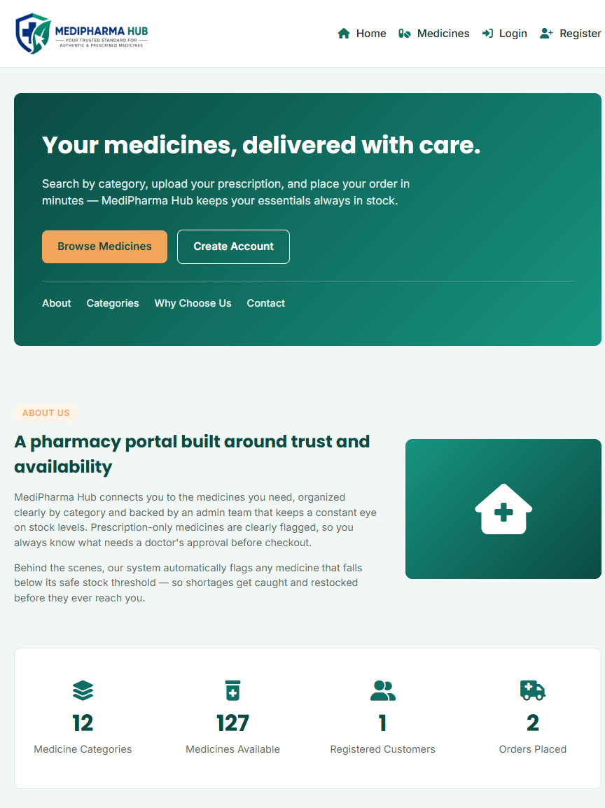
Figure 6.1: Home page (part 1 of 3)
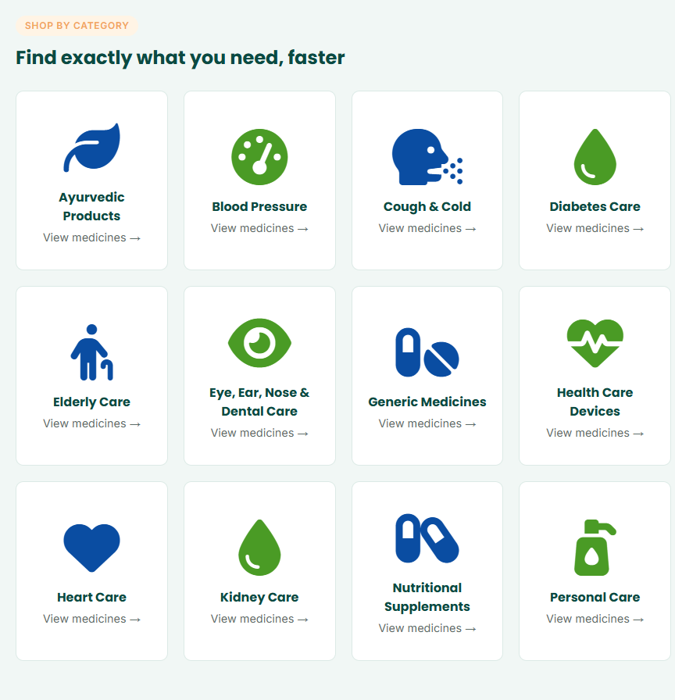
Figure 6.2: Home page (part 2 of 3)
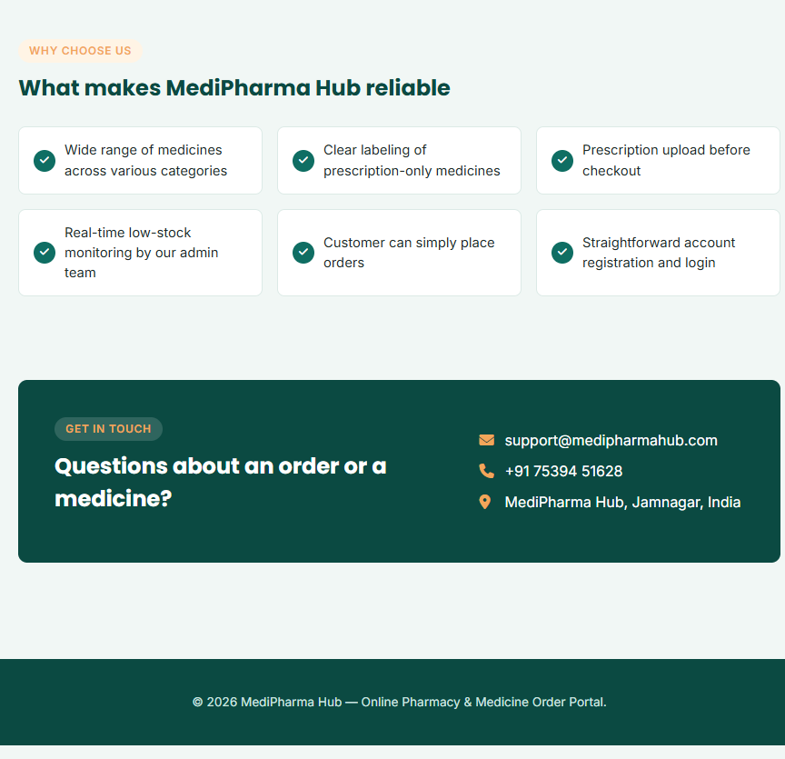
Figure 6.3: Home page (part 3 of 3)
- Register page
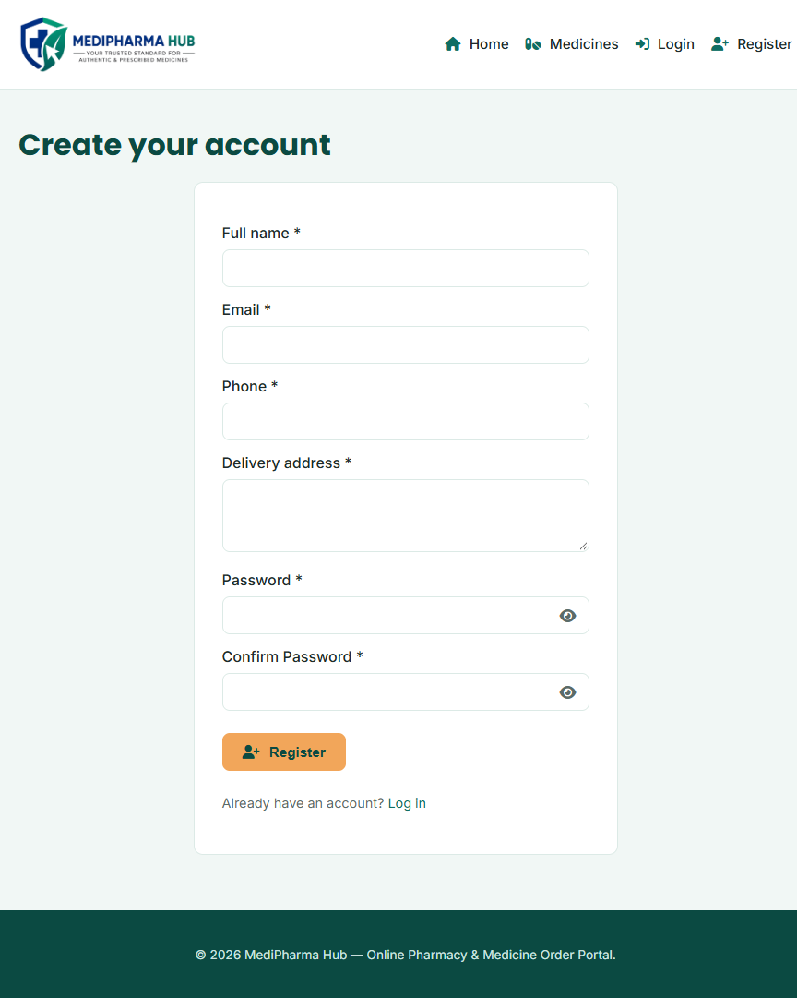
Figure 6.4: Register page
- Login page
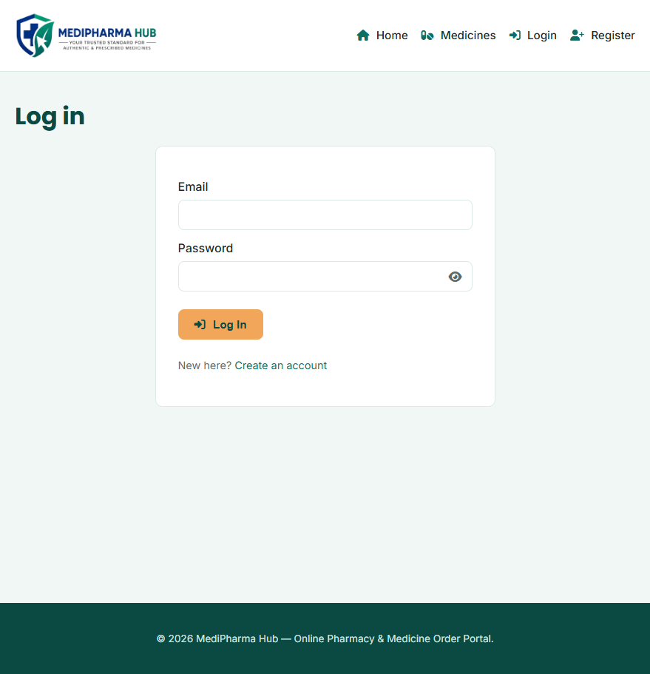
Figure 6.5: Login page
- Medicines List
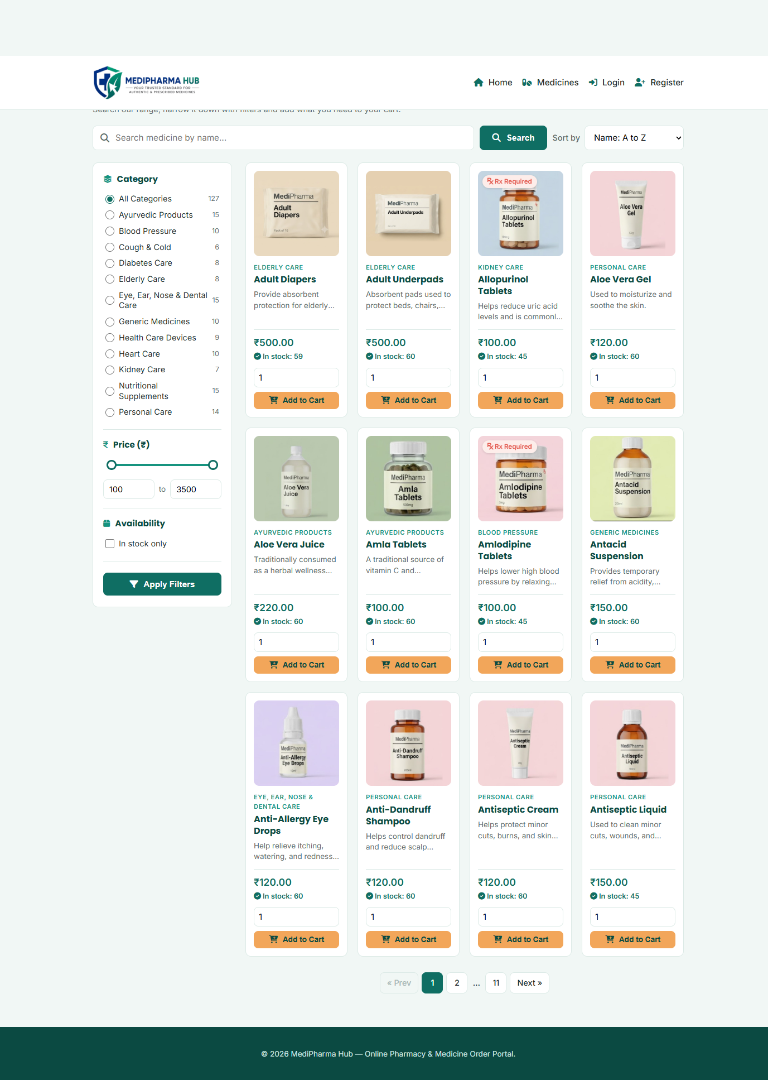
Figure 6.6: Medicines List
- Cart page
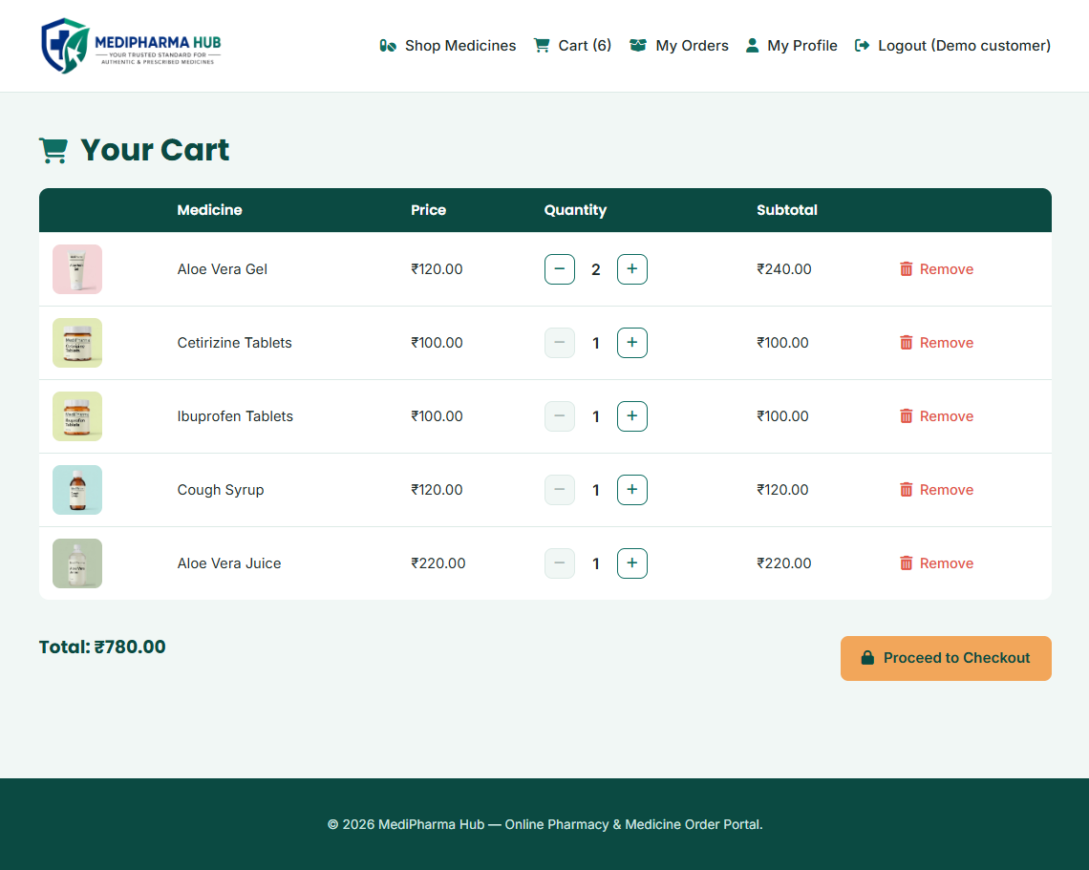
Figure 6.7: Cart page
- Upload prescription
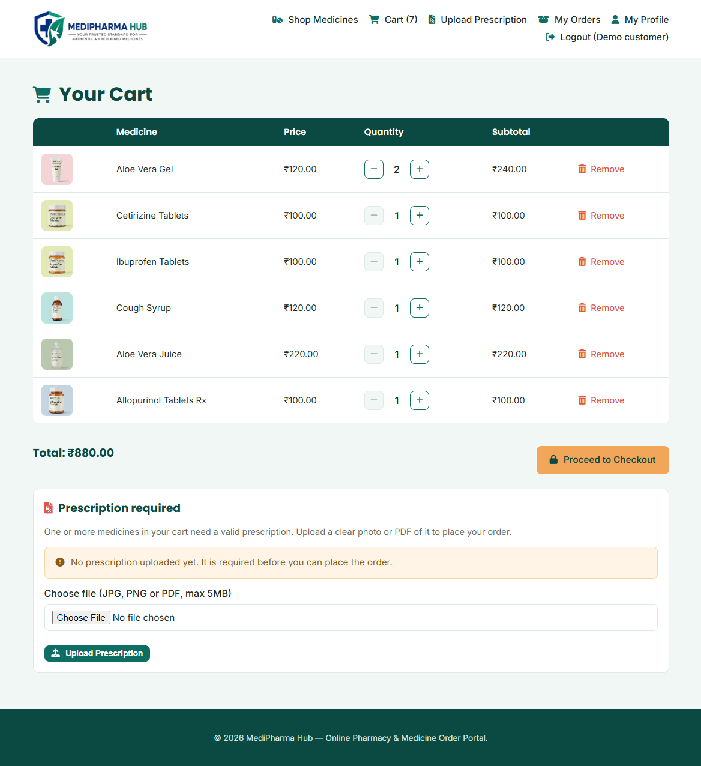
Figure 6.8: Upload prescription
- Checkout page
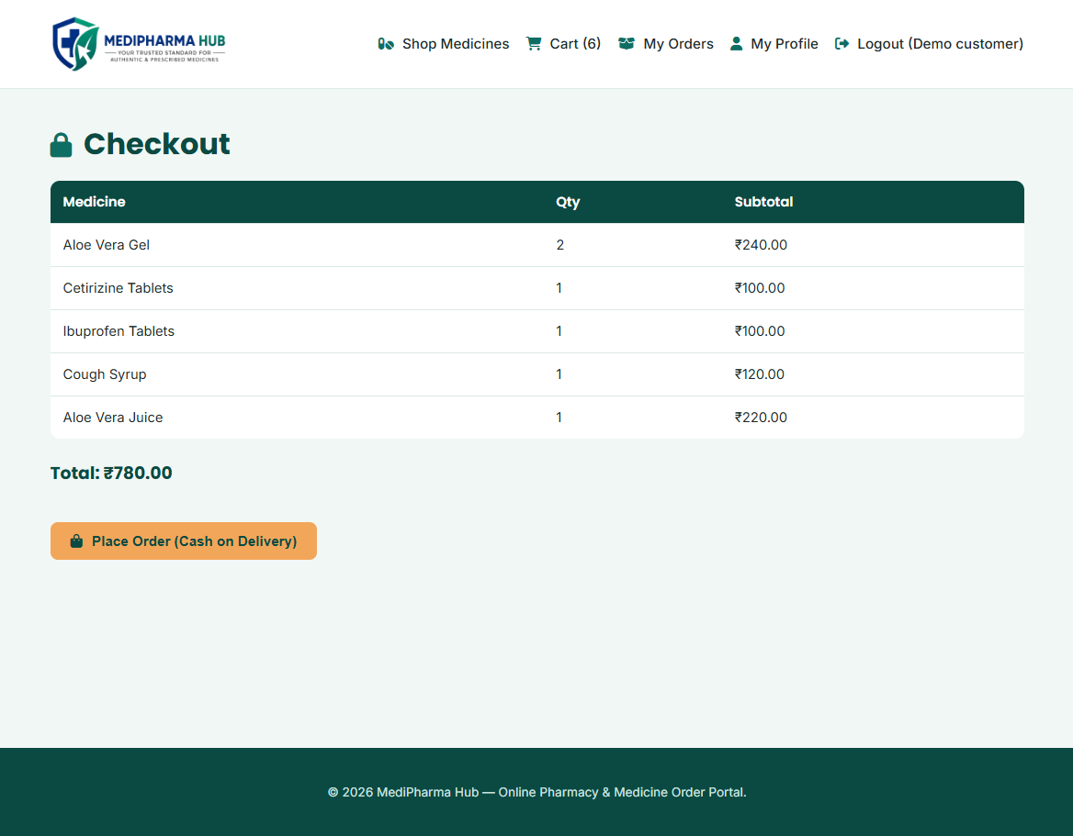
Figure 6.9: Checkout page
- My orders
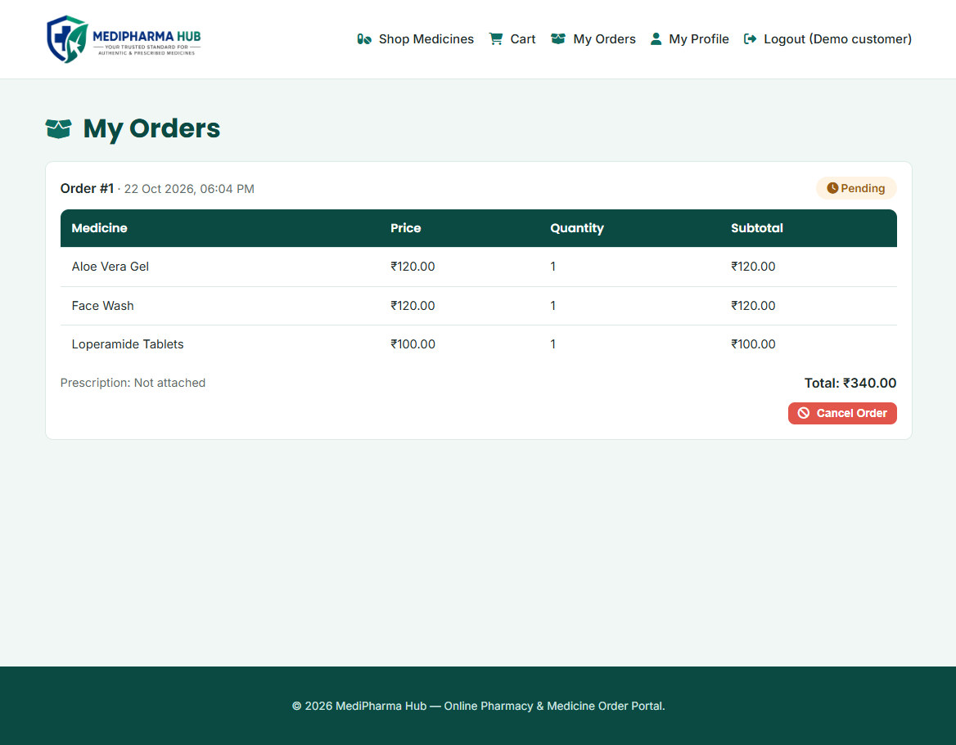
Figure 6.10: My orders
- Order placed
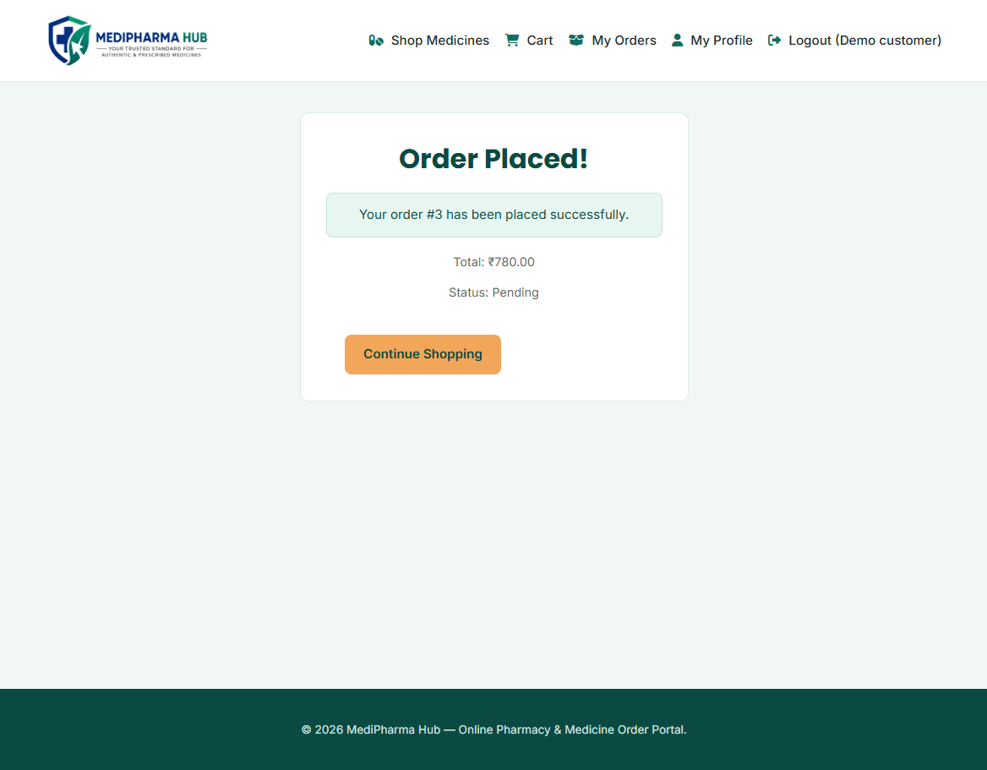
Figure 6.11: Order placed
- Profile page
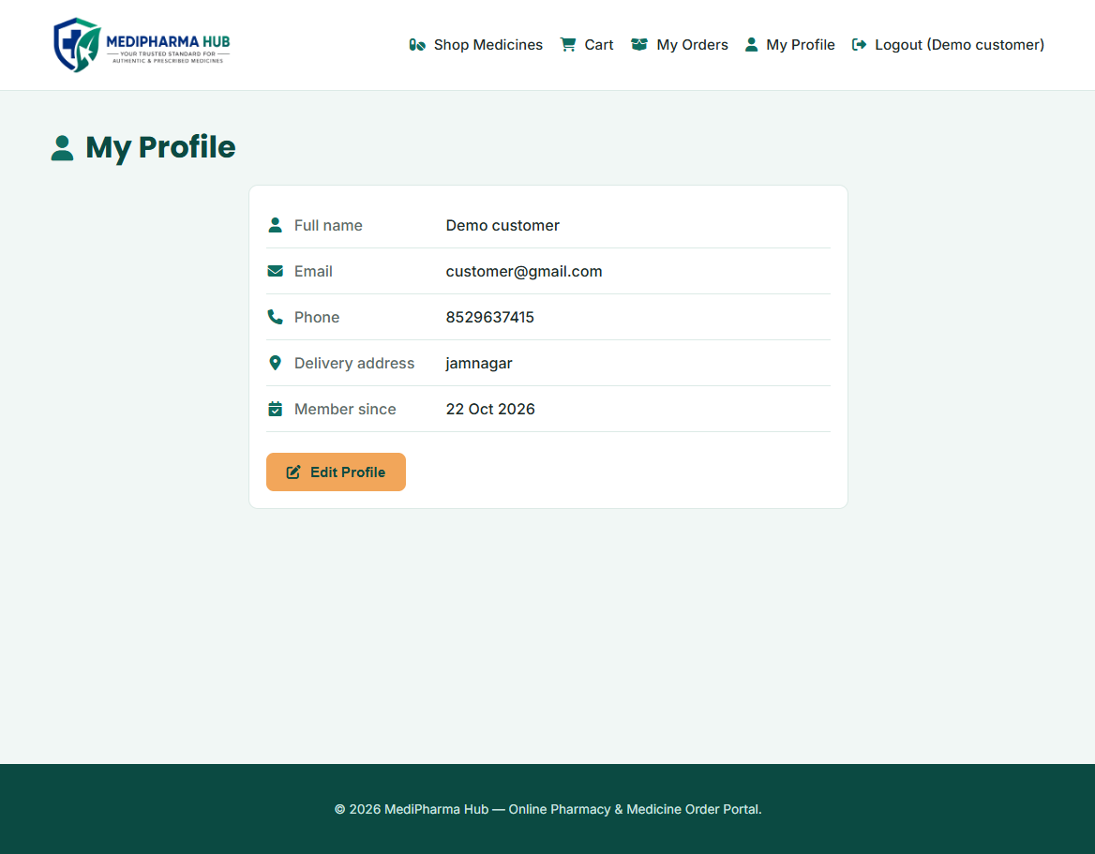
Figure 6.12: Profile page
- ADMIN SIDE:
- Admin dashboard
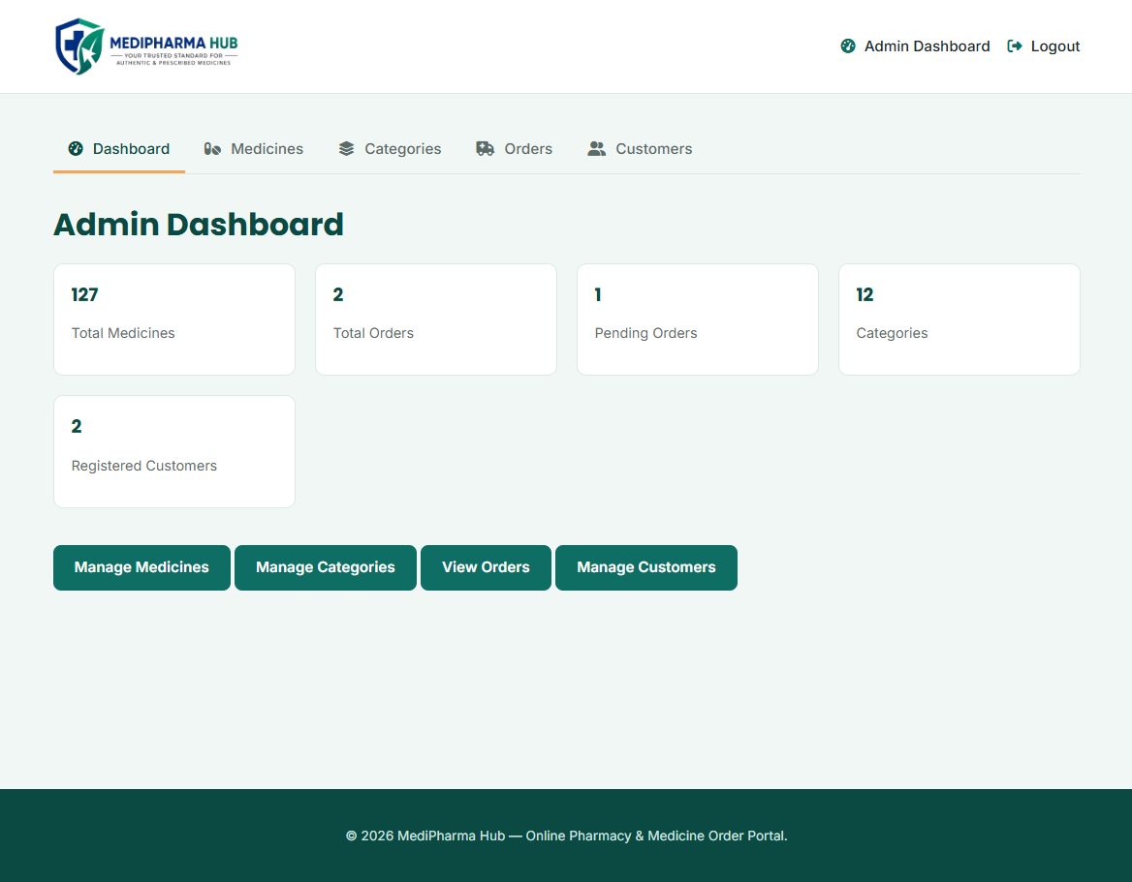
Figure 6.13: Admin dashboard
- Manage medicines
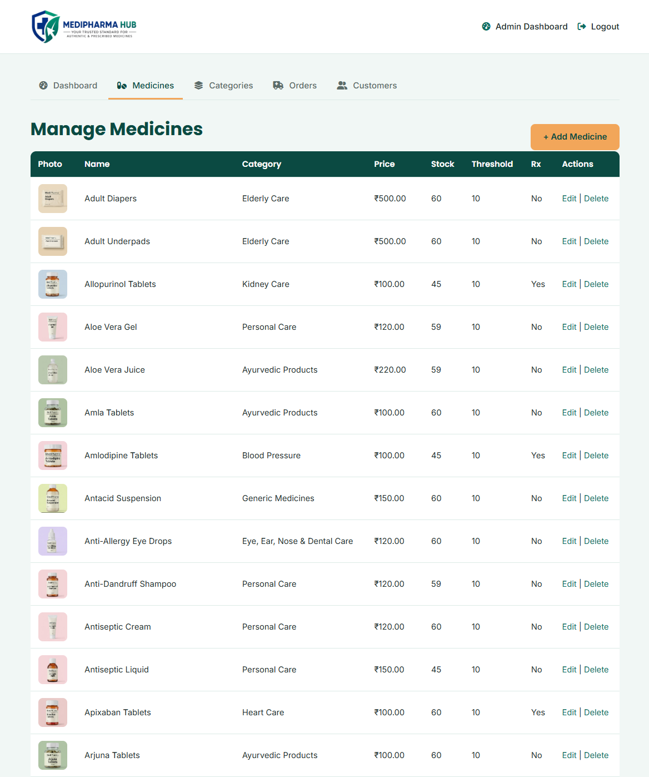
Figure 6.14: Manage medicines
- Add new medicines
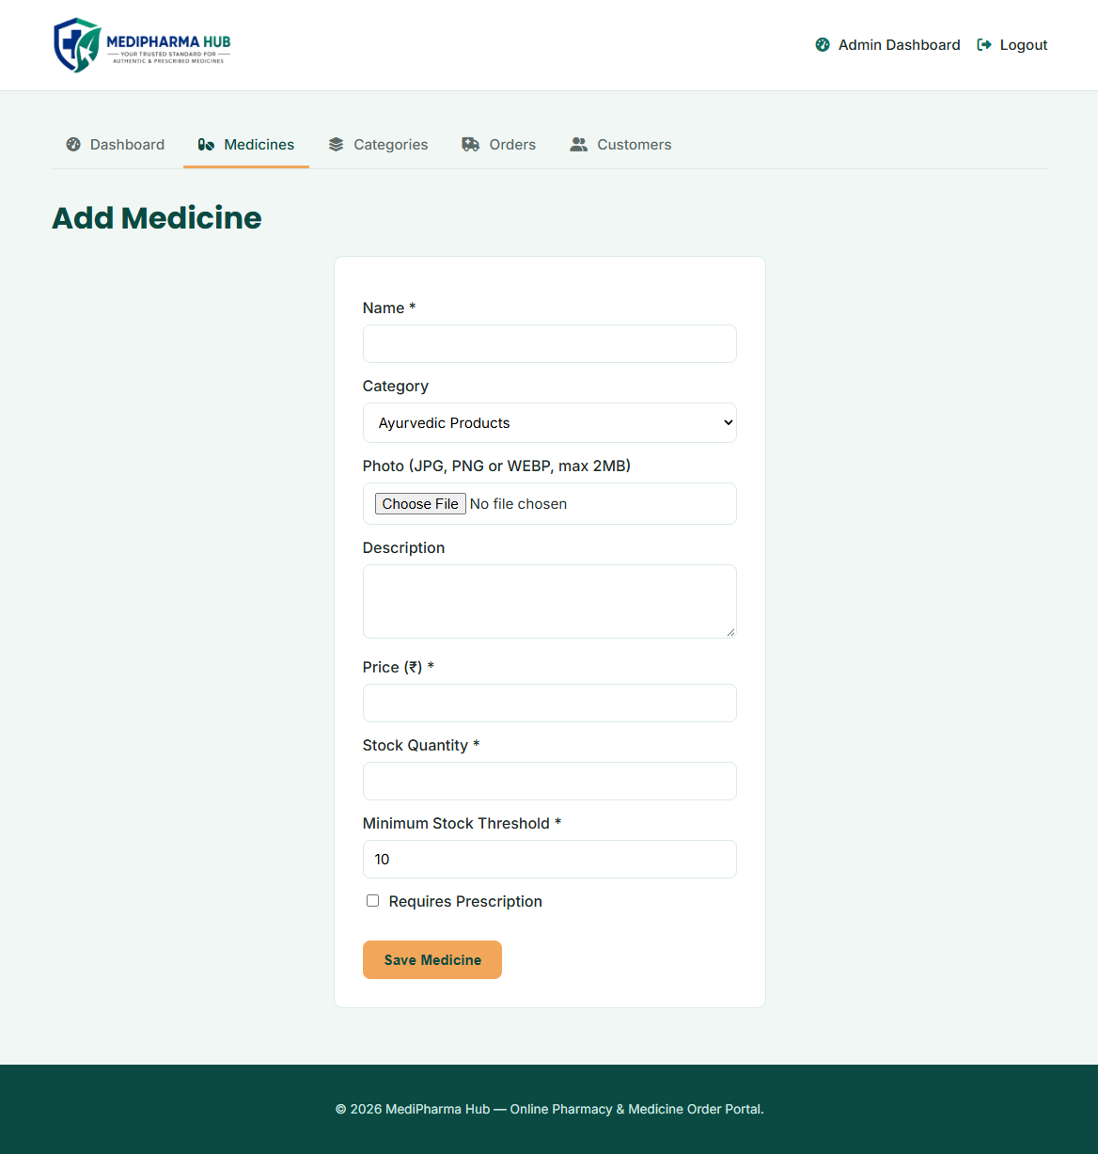
Figure 6.15: Add new medicines
- Edit medicines
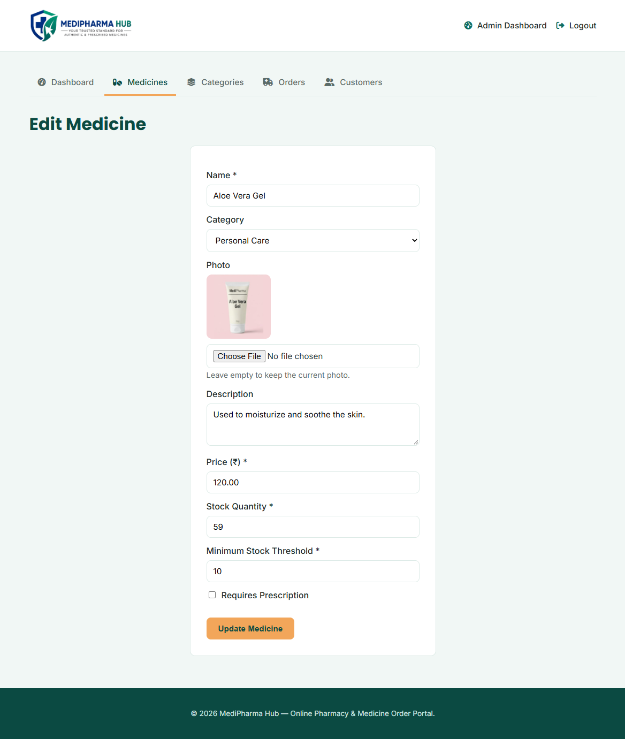
Figure 6.16: Edit medicines
- Manage categories
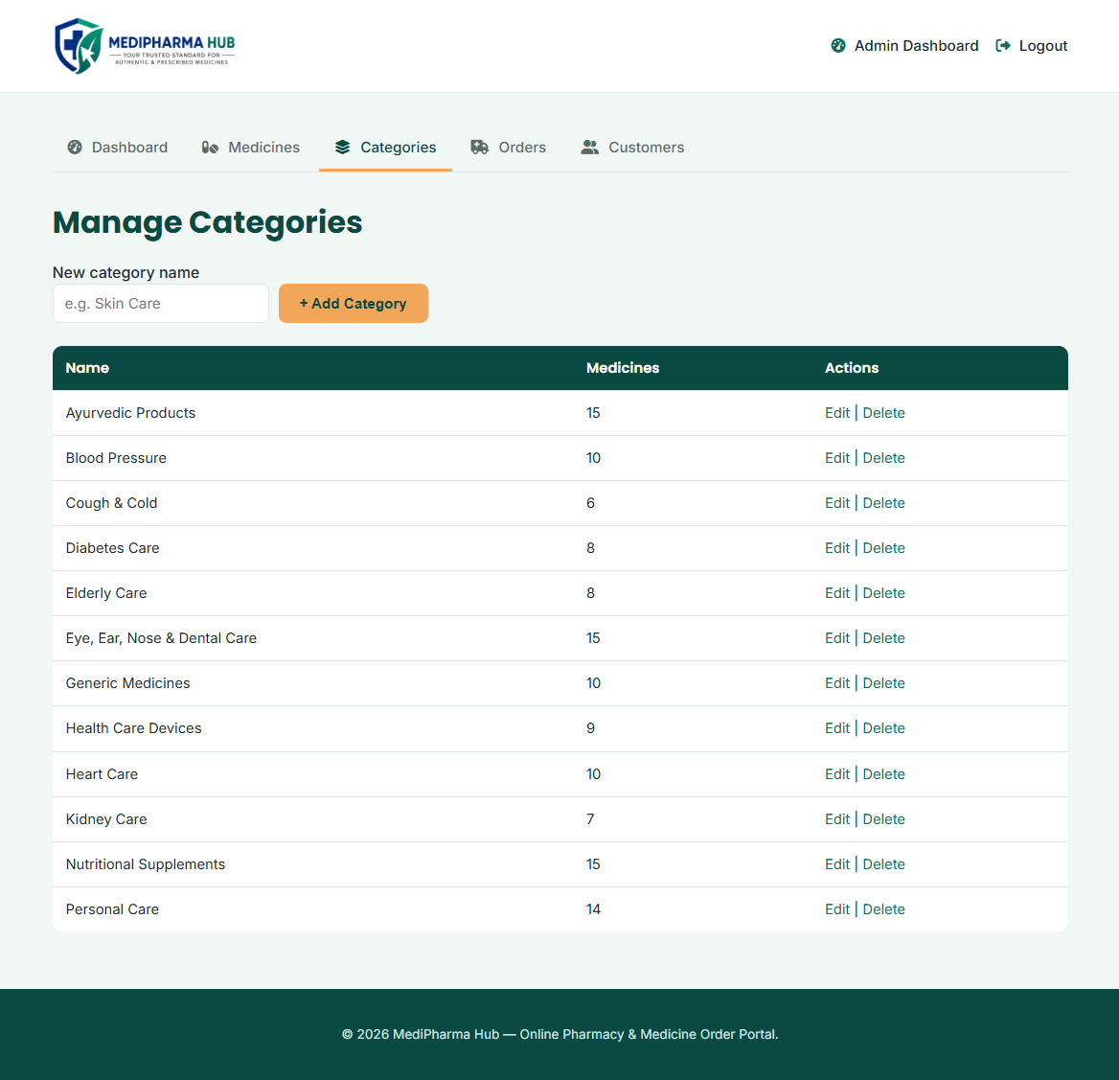
Figure 6.17: Manage categories
- Manage orders
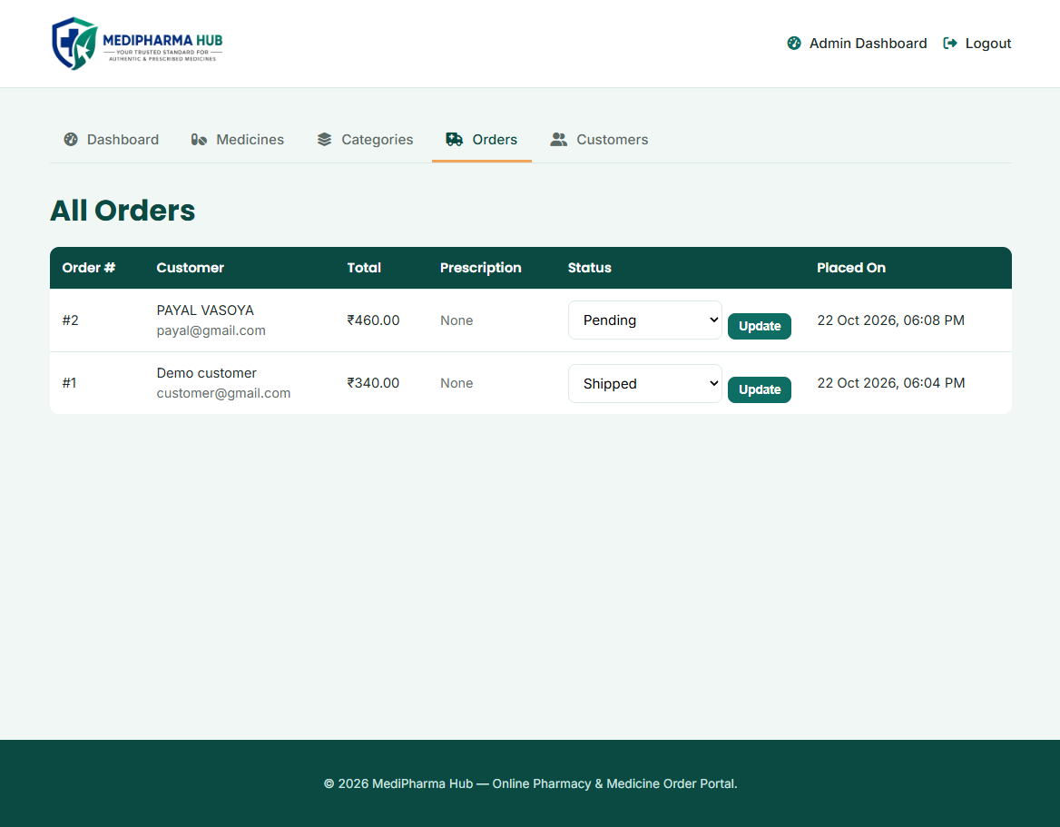
Figure 6.18: Manage orders
- Manage customer
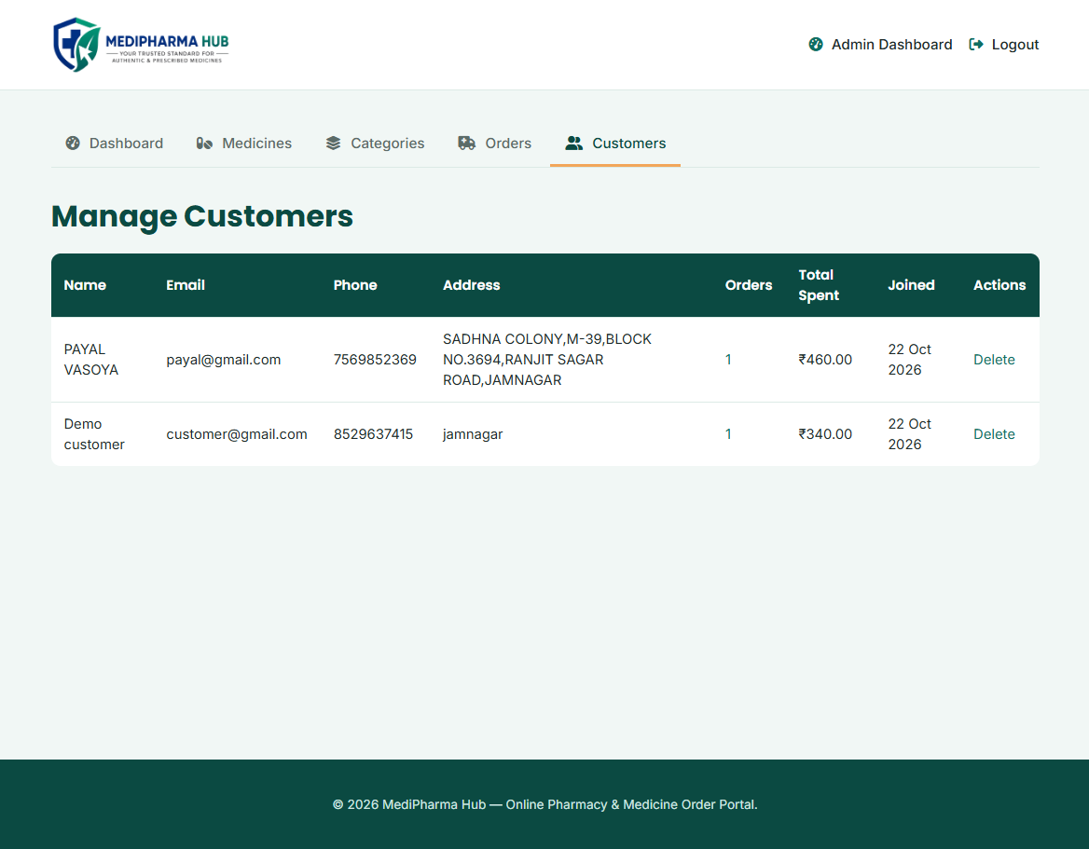
Figure 6.19: Manage customer

7. CODE EXPLANATION

- COMMON FILES:
config/db.php
Purpose: This file connects the whole project to the MySQL database. Every page includes it first, so the $pdo connection object and the PHP session are available everywhere.
Code:
$DB_HOST = "localhost";
$DB_NAME = "medipharma_hub";
$DB_USER = "root";
$DB_PASS = "";
$port = '3307';

try {
$dsn = "mysql:host=$DB_HOST;port=$port;dbname=$DB_NAME;charset=utf8mb4";
$pdo = new PDO($dsn, $DB_USER, $DB_PASS);
$pdo->setAttribute(PDO::ATTR_ERRMODE, PDO::ERRMODE_EXCEPTION);
} catch (PDOException $e) {
die("Database connection failed: " . $e->getMessage());
}

if (session_status() === PHP_SESSION_NONE) {
session_start();
}
Explanation:
- Connection settings: host, database name, user, password and port (3307 for the local XAMPP MySQL) are kept in one place, so they are changed only here.
- PDO: the connection uses PHP Data Objects with the utf8mb4 character set, which allows prepared statements on every page.
- Error mode: ERRMODE_EXCEPTION makes database errors throw exceptions instead of failing silently; the try–catch stops the page with a clear message if the connection fails.
- Session: session_start() is called once here, so login details, the cart and the uploaded prescription are available on all pages.
includes/functions.php
Purpose: This file holds the small reusable helper functions used by both the customer and the admin pages: input cleaning, redirects, login checks, low-stock list, medicine photo handling, CSRF protection, flash messages, cart calculation and order rules.
Code:
function clean($value) {
return htmlspecialchars(trim($value), ENT_QUOTES, 'UTF-8');
}

function requireAdminLogin() {
if (!isset($_SESSION['user_id']) || $_SESSION['role'] !== 'admin') {
redirect('../login.php');
}
}

function getLowStockMedicines($pdo) {
$sql = "SELECT * FROM medicines WHERE stock <= min_threshold ORDER BY stock ASC";
return $pdo->query($sql)->fetchAll(PDO::FETCH_ASSOC);
}

function verifyCsrf($token) {
return is_string($token)
&& !empty($_SESSION['csrf_token'])
&& hash_equals($_SESSION['csrf_token'], $token);
}

function getCartDetails($pdo) {
...
$stmt = $pdo->prepare("SELECT id, name, price, stock, requires_prescription, image
FROM medicines WHERE id IN ($in)");
...
if ($qty > $stock) { $qty = $stock; } // never more than the stock
$result['total'] += $price * $qty;
if ($rx) { $result['needs_rx'] = true; }
}
Explanation:
- clean(): trims the text and converts special characters with htmlspecialchars(), protecting the pages from HTML/JavaScript injection (XSS).
- redirect(), requireCustomerLogin(), requireAdminLogin(): send the visitor to another page; the two login checks are called at the top of protected pages so a customer cannot open admin pages and a guest cannot open customer pages.
- getLowStockMedicines(): returns every medicine whose stock is at or below its own minimum threshold; it powers the low-stock alert on the Admin Dashboard.
- medicineImage(), saveMedicineImage(), deleteMedicineImage(): show a medicine photo (or a placeholder), validate an uploaded photo by its real image type and size (JPG, PNG or WEBP, maximum 2 MB) and remove an old photo from the disk.
- csrfToken(), csrfField(), verifyCsrf(): create a random token for the session, place it as a hidden field in forms and check it with hash_equals() when the form is submitted.
- setFlash() / takeFlash(): store a one-time success, warning or error message that is shown on the next page.
- getCartDetails(): rebuilds the cart from the real database prices, stock and prescription flag, limits quantities to the available stock, removes deleted or out-of-stock items and returns the items, total and whether a prescription is needed.
- validPrescriptionPath() and isOrderCancellable(): accept an uploaded prescription only if it belongs to the logged-in customer and still exists, and allow cancellation only for pending or processing orders.

- ADMIN SIDE FILES:
admin/dashboard.php
Purpose: The Admin Dashboard gives the administrator a quick overview of the store and warns about medicines that are running low.
Code:
requireAdminLogin();

$lowStock = getLowStockMedicines($pdo);

$totalMeds = $pdo->query("SELECT COUNT(*) FROM medicines")->fetchColumn();
$totalOrders = $pdo->query("SELECT COUNT(*) FROM orders")->fetchColumn();
$pendingOrders = $pdo->query("SELECT COUNT(*) FROM orders
WHERE status = 'pending'")->fetchColumn();
$totalCategories = $pdo->query("SELECT COUNT(*) FROM categories")->fetchColumn();
$totalCustomers = $pdo->query("SELECT COUNT(*) FROM users
WHERE role = 'customer'")->fetchColumn();

<?php if (!empty($lowStock)): ?>
<div class="low-stock-banner">
<strong><?php echo count($lowStock); ?> medicine(s) are at or below
their minimum stock threshold.</strong>
</div>
<?php endif; ?>
Explanation:
- Access control: requireAdminLogin() allows only a logged-in administrator to open the page.
- Statistics: five COUNT(*) queries give the total medicines, total orders, pending orders, categories and registered customers shown in the summary cards.
- Low-stock alert: getLowStockMedicines() returns the medicines at or below their minimum threshold; if the list is not empty, a red banner and a Low Stock Details table (medicine, current stock, minimum threshold) are displayed.
- Quick links: buttons at the bottom open Manage Medicines, Manage Categories, View Orders and Manage Customers.
admin/orders.php
Purpose: This page lists all customer orders and lets the administrator change the status of each order.
Code:
if ($_SERVER['REQUEST_METHOD'] === 'POST' && isset($_POST['order_id'])) {
$stmt = $pdo->prepare("UPDATE orders SET status = ? WHERE id = ?");
$stmt->execute([$_POST['status'], (int) $_POST['order_id']]);
redirect('orders.php');
}

$filterUserId = (int) ($_GET['user_id'] ?? 0);
$sql = "SELECT o.*, u.full_name, u.email
FROM orders o JOIN users u ON o.user_id = u.id";
if ($filterUserId > 0) {
$sql .= " WHERE o.user_id = ?";
$params[] = $filterUserId;
}
$sql .= " ORDER BY o.created_at DESC";
Explanation:
- Status update: when the administrator selects a status (pending, processing, shipped, delivered or cancelled) and clicks Update, a prepared UPDATE query saves it and the page reloads.
- JOIN query: orders are joined with the users table so the customer’s name and email are shown with every order, newest first.
- Customer filter: when opened from Manage Customers with ?user_id=, only that customer’s orders are shown, with a Clear filter link.
- Prescription: if the order has a prescription, a View File link opens the uploaded file in a new tab; otherwise None is shown.
admin/edit_medicine.php
Purpose: This page loads an existing medicine into a form and saves the changes made by the administrator.
Code:
$id = (int) ($_GET['id'] ?? $_POST['id'] ?? 0);
$stmt = $pdo->prepare("SELECT * FROM medicines WHERE id = ?");
$stmt->execute([$id]);
$med = $stmt->fetch(PDO::FETCH_ASSOC);
if (!$med) { redirect('medicines.php'); }

if ($_SERVER['REQUEST_METHOD'] === 'POST') {
$name = clean($_POST['name']);
$price = (float) $_POST['price'];
$stock = (int) $_POST['stock'];
$rx = isset($_POST['requires_prescription']) ? 1 : 0;
...
list($newImage, $imgError) = saveMedicineImage($_FILES['image'] ?? null, $name);
$image = $newImage ?? $med['image']; // keep old photo if none uploaded
$stmt = $pdo->prepare("UPDATE medicines SET name=?, category_id=?, description=?,
price=?, stock=?, min_threshold=?, requires_prescription=?, image=? WHERE id=?");
$stmt->execute([$name, $categoryId, $description, $price, $stock,
$threshold, $rx, $image, $id]);
if ($newImage !== null && $med['image'] !== $newImage) {
deleteMedicineImage($med['image']);
}
}
Explanation:
- Loading the record: the medicine id from the URL is converted to an integer and the record is fetched with a prepared statement; an unknown id sends the admin back to the list.
- Pre-filled form: the form shows the current name, category, photo, description, price, stock, minimum threshold and prescription checkbox.
- Validation: the name must not be empty and the price and stock cannot be negative; numbers are cast to float or int.
- Photo handling: a new photo is checked by saveMedicineImage(); if none is uploaded, the old photo is kept, and when it is replaced the old file is deleted from the disk.
- Update: a prepared UPDATE query saves all fields and the admin is redirected to Manage Medicines.
admin/add_medicine.php
Purpose: This page adds a new medicine to the store.
Code:
$categories = $pdo->query("SELECT * FROM categories ORDER BY name")
->fetchAll(PDO::FETCH_ASSOC);

if ($_SERVER['REQUEST_METHOD'] === 'POST') {
$name = clean($_POST['name']);
$categoryId = (int) $_POST['category_id'];
$description = clean($_POST['description']);
$price = (float) $_POST['price'];
$stock = (int) $_POST['stock'];
$threshold = (int) $_POST['min_threshold'];
$rx = isset($_POST['requires_prescription']) ? 1 : 0;

if ($name === '' || $price < 0 || $stock < 0) {
$error = "Please fill in the form correctly.";
} else {
list($image, $imgError) = saveMedicineImage($_FILES['image'] ?? null, $name);
$stmt = $pdo->prepare("INSERT INTO medicines (name, category_id, description,
price, stock, min_threshold, requires_prescription, image)
VALUES (?, ?, ?, ?, ?, ?, ?, ?)");
$stmt->execute([$name, $categoryId, $description, $price,
$stock, $threshold, $rx, $image]);
redirect('medicines.php');
}
}
Explanation:
- Category list: all categories are read from the database to fill the Category drop-down.
- Reading the form: text is cleaned with clean(), numbers are cast to their types, and the checkbox becomes 1 or 0 for requires_prescription. The minimum threshold defaults to 10.
- Validation: the medicine is saved only when the name is given and the price and stock are not negative; otherwise an error message is shown.
- Optional photo: saveMedicineImage() checks the real file type and size before storing the photo in assets/uploads/medicines/.
- Insert: a prepared INSERT query adds the medicine and the admin returns to Manage Medicines.
admin/categories.php
Purpose: This page adds new categories and lists the existing ones with the number of medicines in each.
Code:
if ($_SERVER['REQUEST_METHOD'] === 'POST' && isset($_POST['add_category'])) {
$name = clean($_POST['name']);
if ($name === '') {
$error = "Category name cannot be empty.";
} else {
$stmt = $pdo->prepare("SELECT id FROM categories WHERE name = ?");
$stmt->execute([$name]);
if ($stmt->fetch()) {
$error = "A category with this name already exists.";
} else {
$stmt = $pdo->prepare("INSERT INTO categories (name) VALUES (?)");
$stmt->execute([$name]);
redirect('categories.php?added=1');
}
}
}

$categories = $pdo->query("
SELECT c.*, COUNT(m.id) AS medicine_count
FROM categories c LEFT JOIN medicines m ON m.category_id = c.id
GROUP BY c.id ORDER BY c.name")->fetchAll(PDO::FETCH_ASSOC);
Explanation:
- Add category: an empty name is rejected, and a duplicate name is detected with a SELECT before the new category is inserted.
- Medicine count: a LEFT JOIN with GROUP BY counts the medicines in each category, so categories with no medicines still appear with 0.
- Messages: the added, deleted and blocked values in the URL show the matching message; blocked is shown when the admin tries to delete a category that still has medicines (checked in delete_category.php).
- Actions: each row has Edit (edit_category.php) and Delete links; Delete asks for confirmation first.
admin/customers.php
Purpose: This page lists all registered customers with their order count and total spending.
Code:
$customers = $pdo->query("
SELECT u.*, COUNT(o.id) AS order_count,
COALESCE(SUM(o.total_amount), 0) AS total_spent
FROM users u
LEFT JOIN orders o ON o.user_id = u.id
WHERE u.role = 'customer'
GROUP BY u.id
ORDER BY u.created_at DESC
")->fetchAll(PDO::FETCH_ASSOC);

<td><a href="orders.php?user_id=<?php echo $cust['id']; ?>">
<?php echo $cust['order_count']; ?></a></td>
<td>&#8377;<?php echo number_format($cust['total_spent'], 2); ?></td>
Explanation:
- Customer list: only users with the customer role are shown, newest first; the administrator account is never listed.
- Order summary: a LEFT JOIN with the orders table counts each customer’s orders and adds their totals; COALESCE shows 0 for customers without orders.
- Link to orders: the order count opens admin/orders.php filtered to that customer.
- Delete: the Delete link (after confirmation) calls delete_customer.php, which deletes the account only if its role is customer, so the administrator account cannot be deleted from here; because of ON DELETE CASCADE, the customer’s orders are removed too.

- USER SIDE FILES:
register.php
Purpose: This page creates a new customer account.
Code:
if ($_SERVER['REQUEST_METHOD'] === 'POST') {
$name = clean($_POST['full_name']);
$email = clean($_POST['email']);
$password = $_POST['password'];
$confirmPassword = $_POST['confirm_password'] ?? '';

if ($name === '' || $email === '' || $password === '') {
$error = "Please fill in all required fields.";
} elseif ($password !== $confirmPassword) {
$error = "Password and Confirm Password do not match.";
} else {
$stmt = $pdo->prepare("SELECT id FROM users WHERE email = ?");
$stmt->execute([$email]);
if ($stmt->fetch()) {
$error = "An account with this email already exists.";
} else {
$hashed = password_hash($password, PASSWORD_DEFAULT);
$stmt = $pdo->prepare("INSERT INTO users
(full_name, email, password, phone, address, role)
VALUES (?, ?, ?, ?, ?, 'customer')");
$stmt->execute([$name, $email, $hashed, $phone, $address]);
redirect('login.php?registered=1');
}
}
}
Explanation:
- Validation: required fields are checked and Password and Confirm Password must match. This is checked on the server as well as by assets/js/auth.js in the browser, so it cannot be skipped by turning JavaScript off.
- Unique email: a SELECT checks whether the email is already registered before a new account is created.
- Password security: the password is never stored as plain text; password_hash() stores a secure hash.
- Role: every account created here gets the customer role. After registration the user is sent to the Login page with a success message.
login.php
Purpose: This page logs in both customers and the administrator and sends each to the correct area.
Code:
$stmt = $pdo->prepare("SELECT * FROM users WHERE email = ?");
$stmt->execute([$email]);
$user = $stmt->fetch(PDO::FETCH_ASSOC);

if ($user && password_verify($password, $user['password'])) {
$_SESSION['user_id'] = $user['id'];
$_SESSION['name'] = $user['full_name'];
$_SESSION['role'] = $user['role'];

if ($user['role'] === 'admin') {
redirect('admin/dashboard.php');
} else {
redirect('medicines.php');
}
} else {
$error = "Incorrect email or password.";
}
Explanation:
- Finding the user: the account is searched by email with a prepared statement.
- Password check: password_verify() compares the typed password with the stored hash.
- Session: on success the user id, name and role are stored in the session; these values are used by the login checks on every protected page.
- Role-based redirect: the administrator goes to the Admin Dashboard and a customer goes to the Medicines page.
- Same error message: a wrong email and a wrong password both show "Incorrect email or password.", so the page does not reveal which emails are registered.
medicines.php
Purpose: This is the main shopping page. It shows the medicines with search, category, price range and in-stock filters, sorting and pagination.
Code:
$perPage = 12;

$sortOptions = [
'name_asc' => ['Name: A to Z', 'm.name ASC'],
'name_desc' => ['Name: Z to A', 'm.name DESC'],
'price_asc' => ['Price: Low to High', 'm.price ASC, m.name ASC'],
'price_desc' => ['Price: High to Low', 'm.price DESC, m.name ASC'],
];

if ($q !== '') { $where[] = "m.name LIKE ?"; $params[] = '%' . $q . '%'; }
if ($categoryId > 0) { $where[] = "m.category_id = ?"; $params[] = $categoryId; }
if ($activeMin !== null){ $where[] = "m.price >= ?"; $params[] = $activeMin; }
if ($activeMax !== null){ $where[] = "m.price <= ?"; $params[] = $activeMax; }
if ($inStock) { $where[] = "m.stock > 0"; }

$sql = "SELECT m.*, c.name AS category_name
FROM medicines m LEFT JOIN categories c ON c.id = m.category_id"
. $whereSql
. " ORDER BY " . $sortOptions[$sort][1]
. " LIMIT " . (int)$perPage . " OFFSET " . (int)$offset;
Explanation:
- Reading filters safely: the search text, category, minimum and maximum price, in-stock option and sort order are read from the URL and validated; an unknown category or sort value falls back to the default.
- Dynamic WHERE clause: only the selected filters are added to the query, and every value is passed as a ? parameter of a prepared statement, preventing SQL injection. Special characters % and _ in the search text are escaped.
- Sorting: only the four allowed sort options can reach the ORDER BY part of the query.
- Pagination: a COUNT(*) query finds the number of matching medicines; LIMIT and OFFSET then show 12 medicines per page.
- Display: each card shows the photo, category, name, description, price, stock and an Rx Required tag for prescription-only medicines, with a quantity box and an Add to Cart form that carries the CSRF token. Active filters are shown as removable chips, and the price slider uses assets/js/medicines.js.
add_to_cart.php
Purpose: This script adds the selected medicine to the customer’s cart, which is stored in the session.
Code:
requireCustomerLogin();

if ($_SERVER['REQUEST_METHOD'] === 'POST' && verifyCsrf($_POST['csrf_token'] ?? '')) {
$medicineId = (int) ($_POST['medicine_id'] ?? 0);
$qty = max(1, (int) ($_POST['qty'] ?? 1));

$stmt = $pdo->prepare("SELECT * FROM medicines WHERE id = ?");
$stmt->execute([$medicineId]);
$med = $stmt->fetch(PDO::FETCH_ASSOC);

if ($med && $med['stock'] > 0) {
$already = isset($_SESSION['cart'][$medicineId])
? (int) $_SESSION['cart'][$medicineId]['qty'] : 0;
$newQty = min($already + $qty, (int) $med['stock']);
... // add new line or increase the quantity
}
}
redirect('medicines.php?' . http_build_query($back) . '#shop-results');
Explanation:
- Checks: only a logged-in customer can add items, and the request must be a POST with a valid CSRF token.
- Medicine lookup: the medicine is read from the database, and it is added only if it exists and is in stock.
- Stock limit: the quantity already in the cart plus the new quantity can never be more than the available stock.
- Cart structure: the cart is $_SESSION['cart'], keyed by medicine id, holding the name, price, quantity, prescription flag and photo.
- Return: the customer is sent back to the same filtered, sorted page of the medicines list they were viewing.
upload_prescription.php
Purpose: This script uploads the prescription required for prescription-only medicines and stores it safely on the server.
Code:
$cartInfo = getCartDetails($pdo);
if (!$cartInfo['needs_rx']) { redirect('cart.php'); } // no Rx medicine in cart

$allowed = [
'jpg' => ['image/jpeg'], 'jpeg' => ['image/jpeg'],
'png' => ['image/png'], 'pdf' => ['application/pdf'],
];
$ext = strtolower(pathinfo($file['name'], PATHINFO_EXTENSION));

if (!isset($allowed[$ext])) {
$error = "Only JPG, PNG, or PDF files are allowed.";
} elseif ($file['size'] > 5 * 1024 * 1024) {
$error = "File is too large (max 5MB).";
} else {
$finfo = new finfo(FILEINFO_MIME_TYPE);
$mime = $finfo->file($file['tmp_name']);
if (!in_array($mime, $allowed[$ext], true)) {
$error = "The file content does not match a JPG, PNG or PDF.";
} else {
$newName = 'rx_' . $_SESSION['user_id'] . '_' . time() . '_'
. bin2hex(random_bytes(4)) . '.' . $ext;
move_uploaded_file($file['tmp_name'], __DIR__ . '/assets/uploads/' . $newName);
$_SESSION['prescription_path'] = 'assets/uploads/' . $newName;
}
}
Explanation:
- When it is needed: the cart is checked from the database; if it has no prescription-only medicine, the upload is not needed and the customer is sent back.
- File type check: only the jpg, jpeg, png and pdf extensions are allowed, and the real content type is checked with finfo, so a renamed text or script file is rejected.
- Size limit: files larger than 5 MB are rejected.
- Safe file name: the file is saved with a new server-generated name (rx_<user id>_<time>_<random>), so nothing from the original file name is used.
- Linking to the order: the saved path is kept in the session and attached to the next order at checkout. The upload box (includes/rx_upload_box.php) is shown on the cart and checkout pages, and the result is shown there with a flash message.
checkout.php
Purpose: This page places the order. It saves the order and its items and reduces the stock inside one database transaction.
Code:
$cartInfo = getCartDetails($pdo);
if ($needsPrescription && $prescriptionPath === null) {
$error = "Please upload your prescription before placing this order.";
} else {
$pdo->beginTransaction();

// 1. lock the medicine rows and re-check stock and price
$lock = $pdo->prepare("SELECT id, name, price, stock, requires_prescription
FROM medicines WHERE id IN ($in) FOR UPDATE");

// 2. create the order
$stmt = $pdo->prepare("INSERT INTO orders
(user_id, total_amount, prescription_path, status)
VALUES (?, ?, ?, 'pending')");
$orderId = $pdo->lastInsertId();

// 3. save each item and reduce stock
$itemStmt = $pdo->prepare("INSERT INTO order_items
(order_id, medicine_id, quantity, price) VALUES (?, ?, ?, ?)");
$stockStmt = $pdo->prepare("UPDATE medicines SET stock = stock - ?
WHERE id = ? AND stock >= ?");
$pdo->commit();

// 4. clear the cart and prescription
unset($_SESSION['cart'], $_SESSION['prescription_path']);
redirect('order_success.php?order_id=' . $orderId);
}
// on any error: $pdo->rollBack();
Explanation:
- Server-side checks: the CSRF token is verified, the cart is rebuilt from database prices, and the order is refused if a prescription is needed but not uploaded. If stock changed since the cart was built, the customer is asked to review the order first.
- Transaction: beginTransaction(), commit() and rollBack() make sure the order, its items and the stock changes are saved together or not at all.
- Row locking: SELECT ... FOR UPDATE locks the medicine rows so two customers cannot buy the last units at the same time; stock and price are checked again inside the transaction.
- Saving the order: a row is added to orders with status pending (the prescription path is attached only when needed), and one row per medicine is added to order_items with the database price.
- Stock reduction: the UPDATE uses "stock >= ?" so stock can never go below zero.
- Finish: the cart and prescription are cleared from the session and the customer is redirected to the Order Placed page. Payment is Cash on Delivery.
my_orders.php
Purpose: This page shows the logged-in customer their own orders and lets them cancel an order that has not yet shipped.
Code:
$stmt = $pdo->prepare("SELECT * FROM orders WHERE user_id = ?
ORDER BY created_at DESC, id DESC");
$stmt->execute([$_SESSION['user_id']]);
$orders = $stmt->fetchAll(PDO::FETCH_ASSOC);

$stmt = $pdo->prepare(
"SELECT oi.order_id, oi.quantity, oi.price, m.name
FROM order_items oi
JOIN medicines m ON m.id = oi.medicine_id
JOIN orders o ON o.id = oi.order_id
WHERE o.user_id = ? ORDER BY oi.id");
$stmt->execute([$_SESSION['user_id']]);
foreach ($stmt->fetchAll(PDO::FETCH_ASSOC) as $row) {
$itemsByOrder[$row['order_id']][] = $row;
}

<?php if (isOrderCancellable($order['status'])): ?>
<form method="post" action="cancel_order.php"> ... Cancel Order ... </form>
<?php endif; ?>
Explanation:
- Own orders only: both queries use the user id from the session, so a customer can never see another customer’s orders.
- Two queries instead of many: all order items are fetched in one query and grouped by order id in PHP, instead of running a separate query for every order.
- Order card: each order shows its number, date, status badge with an icon, the items with price, quantity and subtotal, whether a prescription is attached, and the total.
- Cancel Order: the button is shown only for pending or processing orders (isOrderCancellable()); the request goes to cancel_order.php with a CSRF token after a confirmation message.

- DATABASE:
database.sql
Purpose: This script creates the medipharma_hub database with its five tables and fills it with the starting data: the administrator account, 12 categories and 127 medicines.
Code:
CREATE TABLE users (
id INT AUTO_INCREMENT PRIMARY KEY,
full_name VARCHAR(100) NOT NULL,
email VARCHAR(150) NOT NULL UNIQUE,
password VARCHAR(255) NOT NULL,
phone VARCHAR(20), address VARCHAR(255),
role ENUM('customer','admin') NOT NULL DEFAULT 'customer',
created_at TIMESTAMP DEFAULT CURRENT_TIMESTAMP
);
CREATE TABLE medicines (
id INT AUTO_INCREMENT PRIMARY KEY,
name VARCHAR(150) NOT NULL,
category_id INT,
price DECIMAL(10,2) NOT NULL DEFAULT 0,
stock INT NOT NULL DEFAULT 0,
min_threshold INT NOT NULL DEFAULT 10,
requires_prescription TINYINT(1) NOT NULL DEFAULT 0,
image VARCHAR(255) DEFAULT NULL,
FOREIGN KEY (category_id) REFERENCES categories(id) ON DELETE SET NULL
);
CREATE TABLE orders (
id INT AUTO_INCREMENT PRIMARY KEY,
user_id INT NOT NULL,
total_amount DECIMAL(10,2) NOT NULL DEFAULT 0,
prescription_path VARCHAR(255) DEFAULT NULL,
status ENUM('pending','processing','shipped','delivered','cancelled') DEFAULT 'pending',
FOREIGN KEY (user_id) REFERENCES users(id) ON DELETE CASCADE
);
CREATE TABLE order_items (
id INT AUTO_INCREMENT PRIMARY KEY,
order_id INT NOT NULL, medicine_id INT NOT NULL,
quantity INT NOT NULL, price DECIMAL(10,2) NOT NULL,
FOREIGN KEY (order_id) REFERENCES orders(id) ON DELETE CASCADE,
FOREIGN KEY (medicine_id) REFERENCES medicines(id) ON DELETE CASCADE
);
Explanation:
- users: stores customers and the administrator; the email is UNIQUE, the password is stored as a hash and the role column separates customer and admin.
- categories: stores the 12 medicine categories (Nutritional Supplements, Ayurvedic Products, Diabetes Care, Heart Care and so on).
- medicines: stores each product with price, stock, minimum stock threshold (used for the low-stock alert), the requires_prescription flag and the photo name. If a category is deleted, ON DELETE SET NULL keeps the medicine.
- orders: stores each order with the customer, total amount, prescription path and status (pending, processing, shipped, delivered or cancelled).
- order_items: stores the medicines in every order with the quantity and the price at the time of ordering, so later price changes do not affect old orders.
- Relationships: foreign keys with ON DELETE CASCADE remove a customer’s orders and their items automatically when the customer is deleted.
- Seed data: one administrator account (admin@medipharma.com, with a hashed password), 12 categories and 127 medicines with photos are inserted so the system is ready to use.

8. LIMITATIONS AND FUTURE ENHANCEMENTS

- LIMITATIONS:
- Cash on Delivery only: there is no online payment gateway.
- No e-mail or SMS notification: the low-stock alert is shown only on the admin dashboard and customers get no automatic message about their order.
- No invoice: an order total is shown on screen but no invoice can be downloaded.
- Cart is stored in the session: the cart and the uploaded prescription path are lost when the session ends; they are not saved in the database.
- Manual prescription checking: the administrator opens the uploaded file from the Orders page; there is no approve / reject step for prescriptions.
- Single seeded administrator: only one admin account is created by database.sql and there is no page to create more.
- No password recovery or password change: the profile page edits name, email, phone and address only.
- Admin actions: deleting medicines, categories and customers uses simple links, and the order-status form of the admin panel does not use a CSRF token or restore stock when the admin sets an order to "cancelled" (stock is restored only when the customer cancels).
- Deleting data: deleting a customer also deletes the customer's orders, and deleting a medicine removes it from old order items, because of the CASCADE rules.
- Basic reports: the dashboard shows simple counts only.
- Local setup: the database port in config/db.php is set for the local MySQL (3306) and must be changed if the server differs.

- FUTURE ENHANCEMENTS:
- Online payment integration (UPI, cards, net banking).
- E-mail and SMS notifications for orders and low stock.
- Invoice download for every order.
- Saving the cart in the database so that it survives logout.
- A prescription verification workflow where the pharmacist approves or rejects a prescription.
- Multiple admin roles (for example admin and pharmacist) and creation of admin accounts.
- Forgot password / password change with e-mail verification.
- CSRF protection for all admin forms and confirmation by POST for delete actions.
- Medicine expiry date, batch and supplier management.
- Sales reports and analytics (daily, monthly, yearly).

9. CONCLUSION

The project MediPharma Hub – Online Pharmacy and Medicine Order Portal has been completed successfully. The system provides a simple and organized way for customers to search and filter medicines by name or category, add them to a cart, upload a doctor’s prescription when it is required, and place an order with Cash on Delivery, without visiting the pharmacy. Customers can also update their profile, view the order history and the current status of every order on the My Orders page, and cancel an order that has not yet been shipped.

For the pharmacy, the system replaces manual registers with a single admin panel. The administrator can manage medicines, categories, customers and orders, view the uploaded prescriptions, and update the order status. The low-stock alert on the dashboard shows the medicines that need to be refilled, which helps to avoid running out of stock. The system uses role-based access, hashed passwords and prepared statements, which helps to keep the data of the customers and the pharmacy secure.

During the development of this project, I learned how to design a database using normalization, build a dynamic website using PHP and MySQL, handle sessions, file uploads and transactions, and prepare test cases for each module. The project has some limitations, such as the absence of an online payment option and email or SMS notifications, which are explained in the previous chapter. The system is built in a modular way, so these features can be added in the future, and I believe it forms a strong base for a complete online pharmacy solution.

10. REFRENCERS AND BIBLIOGRAPHY

All the references listed below were used for learning, developing and designing this project and for preparing this documentation.

Books:
- PHP & MySQL Web Development – Luke Welling and Laura Thomson
- Learning PHP, MySQL & JavaScript – Robin Nixon

Tools and Software:
- XAMPP (Apache, MySQL, PHP)
- phpMyAdmin (Database Management)
- Visual Studio Code (Code Editor)
- Font Awesome (Icons)
- Google Fonts (Fonts)

Websites:
- www.php.net (PHP Manual)
- dev.mysql.com (MySQL Documentation)
- www.w3schools.com
- www.stackoverflow.com
- chatgpt.com

