Experiment 6
AIM: Create Product Catalog Application using ASP.NET MVC Architecture. (Controllers, Models, Views, Routing)

Source : Product_Catelog.csproj

Code :

ProductsController.cs:
using System.Collections.Generic;
using System.Linq;
using System.Web.Mvc;
using Product_Catelog.Models;

namespace Product_Catelog.Controllers
{
public class ProductsController : Controller
{
// GET: Products (Displays the product catalog listing)
public ActionResult Index()
{
List<Product> catalog = GetProductCatalog();
return View("Products", catalog);
}

// GET: Products/Details/{id} (Displays detailed specifications for a single product)
public ActionResult Details(int id)
{
List<Product> catalog = GetProductCatalog();
Product product = catalog.FirstOrDefault(p => p.ProductId == id);

if (product == null)
{
return HttpNotFound("Requested product could not be found.");
}

return View("View", product);
}

// Mock repository method providing sample catalog items
private List<Product> GetProductCatalog()
{
return new List<Product>
{
new Product
{
ProductId = 101,
ProductName = "Sony WH-1000XM5 Wireless ANC Headphones",
ProductPrice = 29990,
ProductCategory = "Audio",
ImageUrl = "https://images.unsplash.com/photo-1505740420928-5e560c06d30e?w=800&auto=format&fit=crop&q=80",
Description = "Industry-leading active noise cancellation with integrated processor V1 and dual sensors for crystal-clear acoustics.",
Rating = 4.8,
InStock = true
},
new Product
{
ProductId = 102,
ProductName = "Dell XPS 15 OLED Laptop",
ProductPrice = 174990,
ProductCategory = "Computers",
ImageUrl = "https://images.unsplash.com/photo-1593642632823-8f785ba67e45?w=800&auto=format&fit=crop&q=80",
Description = "Stunning 3.5K OLED touchscreen display packed with 13th Gen Intel Core i7 and NVIDIA RTX 4060 graphics.",
Rating = 4.7,
InStock = true
},
new Product
{
ProductId = 103,
ProductName = "Fujifilm X-T50 Mirrorless Camera",
ProductPrice = 129900,
ProductCategory = "Photography",
ImageUrl = "https://images.unsplash.com/photo-1516035069371-29a1b244cc32?w=800&auto=format&fit=crop&q=80",
Description = "40.2-megapixel X-Trans CMOS 5 HR sensor, dedicated film simulation dial, and built-in 7.0-stop IBIS.",
Rating = 4.9,
InStock = true
},
new Product
{
ProductId = 104,
ProductName = "Apple Watch Ultra 2 Smartwatch",
ProductPrice = 89900,
ProductCategory = "Wearables",
ImageUrl = "https://images.unsplash.com/photo-1523275335684-37898b6baf30?w=800&auto=format&fit=crop&q=80",
Description = "Aerospace-grade titanium case with brightest Always-On Retina display and precision dual-frequency GPS.",
Rating = 4.9,
InStock = true
},
new Product
{
ProductId = 105,
ProductName = "Logitech MX Master 3S Wireless Mouse",
ProductPrice = 9995,
ProductCategory = "Accessories",
ImageUrl = "https://images.unsplash.com/photo-1615663245857-ac93bb7c39e7?w=800&auto=format&fit=crop&q=80",
Description = "Quiet click switches with 8,000 DPI track-on-glass sensor and MagSpeed electromagnetic scroll wheel.",
Rating = 4.6,
InStock = true
}
};
}
}
}
Product.cs:
using System;

namespace Product_Catelog.Models
{
public class Product
{
public int ProductId { get; set; }

public string ProductName { get; set; }

public int ProductPrice { get; set; }

public string ProductCategory { get; set; }

public string ImageUrl { get; set; }

public string Description { get; set; }

public double Rating { get; set; }

public bool InStock { get; set; }
}
}
Products.cshtml:
@model List<Product_Catelog.Models.Product>

@{
Layout = null;
}

<!DOCTYPE html>
<html lang="en">
<head>
<meta charset="utf-8" />
<meta name="viewport" content="width=device-width, initial-scale=1" />
<title>PrimeTech Catalog - Product Showcase</title>

<link href="https://cdn.jsdelivr.net/npm/bootstrap@5.3.3/dist/css/bootstrap.min.css" rel="stylesheet" />
<link href="https://cdn.jsdelivr.net/npm/bootstrap-icons@1.11.3/font/bootstrap-icons.min.css" rel="stylesheet" />

<style>
:root {
--primary-accent: #2563eb;
--primary-hover: #1d4ed8;
--bg-canvas: #f8fafc;
--card-shadow: 0 10px 30px rgba(15, 23, 42, 0.08);
}

body {
background-color: var(--bg-canvas);
font-family: -apple-system, BlinkMacSystemFont, "Segoe UI", Roboto, "Helvetica Neue", Arial, sans-serif;
color: #1e293b;
min-height: 100vh;
display: flex;
flex-direction: column;
}

.hero-banner {
background: linear-gradient(135deg, #0f172a 0%, #1e3a8a 60%, #2563eb 100%);
color: #ffffff;
padding: 45px 20px;
text-align: center;
box-shadow: 0 6px 20px rgba(15, 23, 42, 0.2);
margin-bottom: 35px;
}

.hero-banner h1 {
font-weight: 800;
letter-spacing: -0.5px;
margin-bottom: 8px;
}

.hero-banner p {
color: #cbd5e1;
font-size: 1.05rem;
margin: 0;
}

.content-card {
background: #ffffff;
border-radius: 16px;
padding: 30px;
box-shadow: var(--card-shadow);
border: 1px solid #e2e8f0;
}

.table {
vertical-align: middle;
margin-bottom: 0;
}

.table thead th {
background-color: #0f172a;
color: #f8fafc;
font-weight: 600;
padding: 14px 18px;
border: none;
letter-spacing: 0.3px;
}

.table thead th:first-child {
border-top-left-radius: 10px;
}

.table thead th:last-child {
border-top-right-radius: 10px;
}

.table tbody td {
padding: 16px 18px;
border-bottom: 1px solid #f1f5f9;
}

.table tbody tr {
transition: all 0.2s ease-in-out;
}

.table tbody tr:hover {
background-color: #f8fafc;
transform: translateY(-1px);
}

.thumb-preview {
width: 52px;
height: 52px;
object-fit: cover;
border-radius: 10px;
border: 1px solid #e2e8f0;
margin-right: 14px;
}

.product-title {
font-weight: 600;
color: #0f172a;
margin-bottom: 2px;
}

.product-code {
font-size: 0.8rem;
color: #64748b;
}

.price-tag {
font-weight: 700;
color: #059669;
font-size: 1.05rem;
}

.btn-view-details {
background-color: var(--primary-accent);
border-color: var(--primary-accent);
color: white;
border-radius: 20px;
padding: 7px 18px;
font-size: 0.875rem;
font-weight: 600;
transition: all 0.2s ease;
}

.btn-view-details:hover {
background-color: var(--primary-hover);
border-color: var(--primary-hover);
color: white;
transform: translateY(-2px);
box-shadow: 0 4px 12px rgba(37, 99, 235, 0.3);
}

.page-footer {
margin-top: auto;
text-align: center;
padding: 25px 0;
color: #64748b;
font-size: 0.9rem;
border-top: 1px solid #e2e8f0;
background: #ffffff;
}
</style>
</head>
<body>

<header class="hero-banner">
<div class="container">
<h1><i class="bi bi-cpu me-2"></i>PrimeTech Electronics</h1>
<p>Curated catalog of premium hardware, computing, and smart devices</p>
</div>
</header>

<main class="container mb-5">
<div class="content-card">
<div class="d-flex flex-wrap justify-content-between align-items-center mb-4 pb-2 border-bottom">
<div>
<h4 class="fw-bold mb-1">Featured Inventory</h4>
<p class="text-muted small mb-0">Browse through our current available technology lineup</p>
</div>
<div class="mt-2 mt-sm-0">
<span class="badge bg-primary rounded-pill px-3 py-2 fs-6">
<i class="bi bi-box-seam me-1"></i> @Model.Count Items Available
</span>
</div>
</div>

<div class="table-responsive">
<table class="table table-hover align-middle">
<thead>
<tr>
<th>Product Details</th>
<th>Category</th>
<th>Availability</th>
<th>Price</th>
<th class="text-center">Action</th>
</tr>
</thead>
<tbody>
@foreach (var item in Model)
{
<tr>
<td>
<div class="d-flex align-items-center">
<img src="@item.ImageUrl" alt="@item.ProductName" class="thumb-preview" />
<div>
<div class="product-title">@item.ProductName</div>
<div class="product-code">SKU: PRD-@item.ProductId</div>
</div>
</div>
</td>
<td>
<span class="badge bg-light text-dark border px-3 py-2 rounded-pill">
@item.ProductCategory
</span>
</td>
<td>
@if (item.InStock)
{
<span class="badge bg-success-subtle text-success border border-success-subtle px-2 py-1 rounded-pill small">
<i class="bi bi-check-circle-fill me-1"></i>In Stock
</span>
}
else
{
<span class="badge bg-secondary-subtle text-secondary px-2 py-1 rounded-pill small">
Out of Stock
</span>
}
</td>
<td>
<span class="price-tag">₹@item.ProductPrice.ToString("N0")</span>
</td>
<td class="text-center">
@Html.ActionLink(
"View Details",
"Details",
"Products",
new { id = item.ProductId },
new { @class = "btn btn-view-details" }
)
</td>
</tr>
}
</tbody>
</table>
</div>
</div>
</main>

<footer class="page-footer">
<div class="container">
<p class="mb-0">&copy; 2026 Marwadi University &bull; Product Catalog &bull; Rajvirsinh Dodiya</p>
</div>
</footer>

</body>
</html>
View.cshtml:
@model Product_Catelog.Models.Product

@{
Layout = null;
}

<!DOCTYPE html>
<html lang="en">
<head>
<meta charset="utf-8" />
<meta name="viewport" content="width=device-width, initial-scale=1" />
<title>@Model.ProductName - PrimeTech Specifications</title>

<link href="https://cdn.jsdelivr.net/npm/bootstrap@5.3.3/dist/css/bootstrap.min.css" rel="stylesheet" />
<link href="https://cdn.jsdelivr.net/npm/bootstrap-icons@1.11.3/font/bootstrap-icons.min.css" rel="stylesheet" />

<style>
:root {
--primary-accent: #2563eb;
--bg-canvas: #f8fafc;
}

body {
background-color: var(--bg-canvas);
font-family: -apple-system, BlinkMacSystemFont, "Segoe UI", Roboto, "Helvetica Neue", Arial, sans-serif;
color: #1e293b;
min-height: 100vh;
display: flex;
flex-direction: column;
}

.hero-banner {
background: linear-gradient(135deg, #0f172a 0%, #1e3a8a 60%, #2563eb 100%);
color: #ffffff;
padding: 35px 20px;
text-align: center;
box-shadow: 0 6px 20px rgba(15, 23, 42, 0.2);
margin-bottom: 35px;
}

.hero-banner h1 {
font-weight: 700;
font-size: 1.85rem;
margin: 0;
}

.product-card {
background: #ffffff;
border-radius: 18px;
padding: 35px;
max-width: 900px;
margin: auto;
box-shadow: 0 10px 30px rgba(15, 23, 42, 0.08);
border: 1px solid #e2e8f0;
}

.product-image-container {
border-radius: 14px;
overflow: hidden;
background: #f1f5f9;
box-shadow: 0 4px 15px rgba(0, 0, 0, 0.06);
}

.product-image {
width: 100%;
height: 340px;
object-fit: cover;
transition: transform 0.3s ease;
}

.product-image:hover {
transform: scale(1.03);
}

.spec-item {
display: flex;
justify-content: space-between;
align-items: center;
padding: 12px 16px;
background-color: #f8fafc;
border-radius: 10px;
margin-bottom: 10px;
border: 1px solid #edf2f7;
}

.spec-label {
color: #64748b;
font-weight: 500;
font-size: 0.95rem;
}

.spec-value {
color: #0f172a;
font-weight: 600;
}

.price-highlight {
font-size: 1.75rem;
font-weight: 800;
color: #059669;
}

.btn-back {
background-color: #0f172a;
color: #ffffff;
border-radius: 10px;
padding: 10px 24px;
font-weight: 600;
text-decoration: none;
display: inline-block;
transition: all 0.2s ease;
}

.btn-back:hover {
background-color: #1e293b;
color: #ffffff;
transform: translateY(-2px);
box-shadow: 0 4px 12px rgba(15, 23, 42, 0.2);
}

.page-footer {
margin-top: auto;
text-align: center;
padding: 25px 0;
color: #64748b;
font-size: 0.9rem;
border-top: 1px solid #e2e8f0;
background: #ffffff;
}
</style>
</head>
<body>

<header class="hero-banner">
<div class="container">
<h1><i class="bi bi-info-circle me-2"></i>Product Specifications</h1>
</div>
</header>

<main class="container mb-5">
<div class="product-card">
<div class="row align-items-center g-4">
<div class="col-md-5">
<div class="product-image-container">
<img src="@Model.ImageUrl" alt="@Model.ProductName" class="product-image" />
</div>
</div>

<div class="col-md-7">
<div class="d-flex align-items-center gap-2 mb-2">
<span class="badge bg-primary px-3 py-1 rounded-pill">@Model.ProductCategory</span>
@if (Model.InStock)
{
<span class="badge bg-success-subtle text-success border border-success-subtle px-2 py-1 rounded-pill small">
In Stock
</span>
}
</div>

<h2 class="fw-bold mb-3">@Model.ProductName</h2>

<p class="text-secondary mb-4">
@Model.Description
</p>

<div class="spec-item">
<span class="spec-label">Product Identifier (ID)</span>
<span class="spec-value">#@Model.ProductId</span>
</div>

<div class="spec-item">
<span class="spec-label">Customer Rating</span>
<span class="spec-value text-warning">
<i class="bi bi-star-fill me-1"></i> @Model.Rating / 5.0
</span>
</div>

<div class="spec-item">
<span class="spec-label">Regular Price</span>
<span class="price-highlight">₹@Model.ProductPrice.ToString("N0")</span>
</div>

<div class="mt-4 pt-2">
@Html.ActionLink(
"← Back to Catalog",
"Index",
"Products",
null,
new { @class = "btn-back" }
)
</div>
</div>
</div>
</div>
</main>

<footer class="page-footer">
<div class="container">
<p class="mb-0">&copy; 2026 Marwadi University &bull; Product Catalog &bull; Rajvirsinh Dodiya</p>
</div>
</footer>

</body>
</html>
Output :
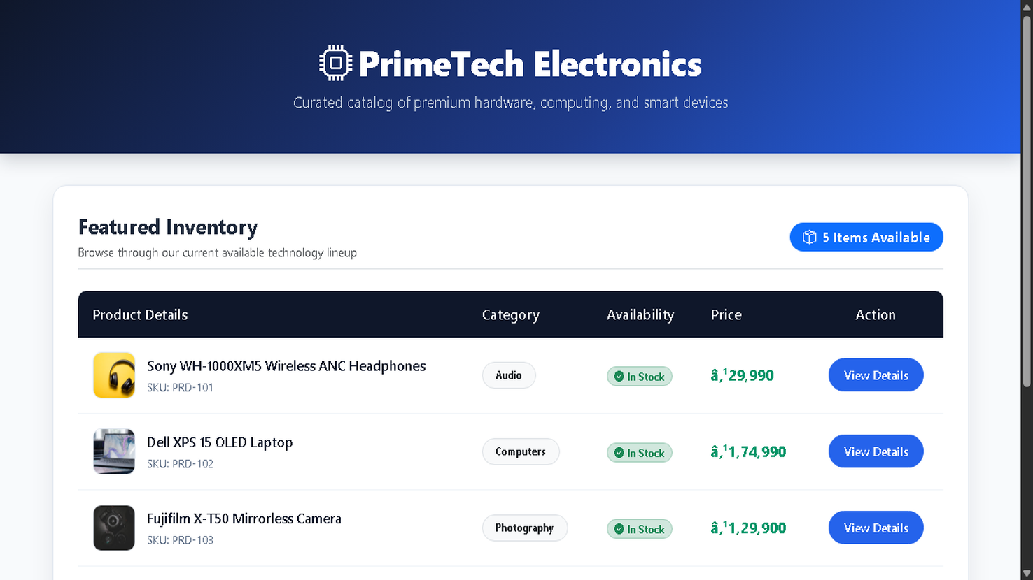

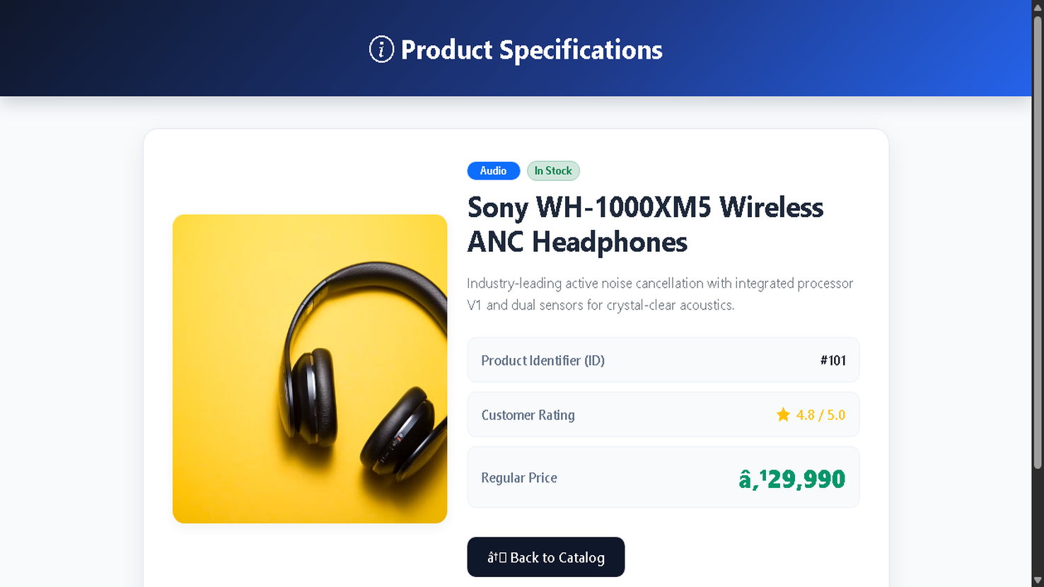

GitHub URL : https://github.com/RajvirDodiya/.NetPracticals

