Experiment 7
AIM: Develop Feedback Management Module using MVC Layout, Partial View & Validation. (HTML Helpers, Validation, Layouts)

Source : StudentFeedback.csproj

Code :

FeedBackController.cs:
using System.Collections.Generic;
using System.Linq;
using System.Web.Mvc;
using StudentFeedback.Models;

namespace StudentFeedback.Controllers
{
public class FeedbackController : Controller
{
// In-memory collection storing student feedback entries for the session
private static readonly List<Feedback> feedbackRepository = new List<Feedback>
{
new Feedback
{
EnrollmentNumber = "92400120478",
StudentName = "Rajvirsinh Dodiya",
SubjectName = ".NET Framework & C# Programming",
Rating = 5,
Comments = "Practical sessions provided great insight into ASP.NET MVC architecture, controllers, and view rendering."
},
new Feedback
{
EnrollmentNumber = "92200103018",
StudentName = "Dev Patel",
SubjectName = "Enterprise Web Development",
Rating = 4,
Comments = "Enjoyed the hands-on lab assignments on Model-View-Controller pattern and entity validation."
}
};

// GET: Feedback / Index (Portal landing page)
[HttpGet]
public ActionResult Index()
{
return View();
}

// GET: Feedback / Create (Form view to submit new feedback)
[HttpGet]
public ActionResult Create()
{
return View(new Feedback());
}

// POST: Feedback / Create (Processes and validates feedback submission)
[HttpPost]
[ValidateAntiForgeryToken]
public ActionResult Create(Feedback feedback)
{
if (ModelState.IsValid)
{
feedbackRepository.Add(feedback);
return RedirectToAction("List");
}

return View(feedback);
}

// GET: Feedback / List (Renders summary table of all submitted responses)
[HttpGet]
public ActionResult List()
{
return View(feedbackRepository.ToList());
}
}
}
Feedback.cs:
using System.ComponentModel.DataAnnotations;

namespace StudentFeedback.Models
{
public class Feedback
{
[Required(ErrorMessage = "Enrollment number is mandatory.")]
[Display(Name = "Enrollment Number")]
public string EnrollmentNumber { get; set; }

[Required(ErrorMessage = "Please enter the student's full name.")]
[Display(Name = "Student Name")]
[StringLength(80, ErrorMessage = "Name cannot exceed 80 characters.")]
public string StudentName { get; set; }

[Required(ErrorMessage = "Course/Subject title is required.")]
[Display(Name = "Course / Subject")]
public string SubjectName { get; set; }

[Required(ErrorMessage = "Please provide an evaluation rating between 1 and 5.")]
[Range(1, 5, ErrorMessage = "Evaluation score must be between 1 and 5.")]
[Display(Name = "Satisfaction Rating")]
public int Rating { get; set; }

[Required(ErrorMessage = "Feedback remarks cannot be left blank.")]
[StringLength(500, ErrorMessage = "Remarks must be 500 characters or fewer.")]
[Display(Name = "Feedback & Comments")]
public string Comments { get; set; }
}
}
Index.cshtml:
@{
ViewBag.Title = "Portal Dashboard";
Layout = "~/Views/Shared/_LayoutView.cshtml";
}

<div class="page-card">
@Html.Partial("~/Views/Shared/_StudentInfo.cshtml")

<div class="alert alert-info border-0 rounded-3 mb-4" style="background-color: #f0fdfa; color: #115e59;">
<i class="bi bi-info-circle-fill me-2"></i>
Welcome to the EduPulse Academic Evaluation System. Your honest feedback plays a critical role in refining teaching methods, syllabus pace, and lab resources.
</div>

<div class="row g-4 mt-1">
<div class="col-md-6">
<div class="p-4 rounded-3 h-100 border bg-light d-flex flex-column justify-content-between">
<div>
<div class="d-flex align-items-center mb-3">
<div class="p-2 rounded-circle bg-white text-success shadow-sm me-3">
<i class="bi bi-pencil-fill fs-4"></i>
</div>
<h4 class="mb-0 fw-bold" style="color: #0f766e;">Submit Course Feedback</h4>
</div>
<p class="text-secondary">
Provide detailed feedback on lectures, subject comprehension, faculty guidance, and practical sessions.
</p>
</div>
<div class="mt-3">
<a href="@Url.Action("Create", "Feedback")" class="btn btn-brand w-100">
<i class="bi bi-plus-circle me-1"></i> Launch Feedback Form
</a>
</div>
</div>
</div>

<div class="col-md-6">
<div class="p-4 rounded-3 h-100 border bg-light d-flex flex-column justify-content-between">
<div>
<div class="d-flex align-items-center mb-3">
<div class="p-2 rounded-circle bg-white text-primary shadow-sm me-3">
<i class="bi bi-view-list fs-4"></i>
</div>
<h4 class="mb-0 fw-bold" style="color: #0f766e;">Explore Responses</h4>
</div>
<p class="text-secondary">
Inspect recorded ratings and observational comments submitted by fellow students across different modules.
</p>
</div>
<div class="mt-3">
<a href="@Url.Action("List", "Feedback")" class="btn btn-outline-secondary w-100" style="border-radius: 10px; padding: 11px 24px; font-weight: 600;">
<i class="bi bi-card-checklist me-1"></i> View Submitted Responses
</a>
</div>
</div>
</div>
</div>
</div>
Create.cshtml:
@model StudentFeedback.Models.Feedback

@{
ViewBag.Title = "Submit Feedback";
Layout = "~/Views/Shared/_LayoutView.cshtml";
}

<div class="page-card">
@Html.Partial("~/Views/Shared/_StudentInfo.cshtml")

@using (Html.BeginForm("Create", "Feedback", FormMethod.Post, new { @class = "row g-4 mt-1" }))
{
@Html.AntiForgeryToken()

@Html.ValidationSummary(false, "", new { @class = "validation-summary-errors" })

<div class="col-md-6">
@Html.LabelFor(m => m.EnrollmentNumber, new { @class = "form-label" })
<div class="input-group">
<span class="input-group-text bg-light text-muted"><i class="bi bi-hash"></i></span>
@Html.TextBoxFor(m => m.EnrollmentNumber, new
{
@class = "form-control",
placeholder = "e.g., 92400120478"
})
</div>
@Html.ValidationMessageFor(m => m.EnrollmentNumber, "", new { @class = "field-validation-error" })
</div>

<div class="col-md-6">
@Html.LabelFor(m => m.StudentName, new { @class = "form-label" })
<div class="input-group">
<span class="input-group-text bg-light text-muted"><i class="bi bi-person"></i></span>
@Html.TextBoxFor(m => m.StudentName, new
{
@class = "form-control",
placeholder = "Enter your full name"
})
</div>
@Html.ValidationMessageFor(m => m.StudentName, "", new { @class = "field-validation-error" })
</div>

<div class="col-md-6">
@Html.LabelFor(m => m.SubjectName, new { @class = "form-label" })
<div class="input-group">
<span class="input-group-text bg-light text-muted"><i class="bi bi-journal-bookmark"></i></span>
@Html.TextBoxFor(m => m.SubjectName, new
{
@class = "form-control",
placeholder = "e.g., .NET Web Applications / Cloud Computing"
})
</div>
@Html.ValidationMessageFor(m => m.SubjectName, "", new { @class = "field-validation-error" })
</div>

<div class="col-md-6">
@Html.LabelFor(m => m.Rating, new { @class = "form-label" })
<div class="input-group">
<span class="input-group-text bg-light text-muted"><i class="bi bi-star"></i></span>
@Html.DropDownListFor(m => m.Rating,
new SelectList(new[] {
new { Value = 5, Text = "5 - ★★★★★ (Exceptional)" },
new { Value = 4, Text = "4 - ★★★★☆ (Commendable)" },
new { Value = 3, Text = "3 - ★★★☆☆ (Satisfactory)" },
new { Value = 2, Text = "2 - ★★☆☆☆ (Needs Improvement)" },
new { Value = 1, Text = "1 - ★☆☆☆☆ (Unsatisfactory)" }
}, "Value", "Text"),
"-- Choose Rating Score --",
new { @class = "form-select" })
</div>
@Html.ValidationMessageFor(m => m.Rating, "", new { @class = "field-validation-error" })
</div>

<div class="col-12">
@Html.LabelFor(m => m.Comments, new { @class = "form-label" })
@Html.TextAreaFor(m => m.Comments, new
{
@class = "form-control",
rows = 4,
placeholder = "Share specific observations regarding teaching clarity, laboratory assignments, or topics needing review..."
})
<div class="form-text text-muted">Maximum 500 characters.</div>
@Html.ValidationMessageFor(m => m.Comments, "", new { @class = "field-validation-error" })
</div>

<div class="col-12 d-flex flex-wrap gap-3 mt-4 pt-2 border-top">
<button type="submit" class="btn btn-brand">
<i class="bi bi-send-check me-1"></i> Submit Feedback
</button>

<a href="@Url.Action("Index", "Feedback")" class="btn btn-outline-secondary" style="border-radius: 10px; padding: 11px 24px; font-weight: 600;">
<i class="bi bi-arrow-left me-1"></i> Cancel
</a>
</div>
}
</div>

@section Scripts {
@Scripts.Render("~/bundles/jqueryval")
}
List.cshtml:
@model IEnumerable<StudentFeedback.Models.Feedback>

@{
ViewBag.Title = "Evaluation Responses";
Layout = "~/Views/Shared/_LayoutView.cshtml";
}

<div class="page-card">
@Html.Partial("~/Views/Shared/_StudentInfo.cshtml")

<div class="d-flex flex-wrap justify-content-between align-items-center gap-3 mb-4">
<div>
<h4 class="mb-0 fw-bold" style="color: #0f766e;">Recorded Submissions</h4>
<small class="text-muted">Overview of evaluations registered in this session</small>
</div>

<span class="badge rounded-pill px-3 py-2 fs-6" style="background-color: #0f766e; color: #ffffff;">
<i class="bi bi-people-fill me-1"></i> Responses Logged: @Model.Count()
</span>
</div>

<div class="table-responsive">
<table class="table table-bordered table-hover feedback-table mb-0">
<thead>
<tr>
<th>Enrollment No.</th>
<th>Student Name</th>
<th>Course / Subject</th>
<th>Rating</th>
<th>Observations &amp; Remarks</th>
</tr>
</thead>

<tbody>
@if (Model.Any())
{
foreach (var item in Model)
{
<tr>
<td class="fw-semibold text-secondary">
<i class="bi bi-person-badge me-1"></i>@Html.DisplayFor(m => item.EnrollmentNumber)
</td>
<td class="fw-bold text-dark">
@Html.DisplayFor(m => item.StudentName)
</td>
<td>
<span class="badge bg-light text-dark border px-2 py-1">
@Html.DisplayFor(m => item.SubjectName)
</span>
</td>
<td>
@if (item.Rating >= 5)
{
<span class="badge bg-success px-2 py-1">
★★★★★ @item.Rating/5
</span>
}
else if (item.Rating == 4)
{
<span class="badge bg-primary px-2 py-1">
★★★★☆ @item.Rating/5
</span>
}
else if (item.Rating == 3)
{
<span class="badge bg-warning text-dark px-2 py-1">
★★★☆☆ @item.Rating/5
</span>
}
else
{
<span class="badge bg-danger px-2 py-1">
★☆☆☆☆ @item.Rating/5
</span>
}
</td>
<td class="text-break text-muted">
@Html.DisplayFor(m => item.Comments)
</td>
</tr>
}
}
else
{
<tr>
<td colspan="5" class="text-center text-secondary py-5">
<i class="bi bi-inbox fs-2 d-block mb-2 text-muted"></i>
No student responses recorded yet. Be the first to provide feedback!
</td>
</tr>
}
</tbody>
</table>
</div>

<div class="d-flex flex-wrap gap-3 mt-4 pt-3 border-top">
<a href="@Url.Action("Create", "Feedback")" class="btn btn-brand">
<i class="bi bi-plus-circle me-1"></i> Submit Another Response
</a>

<a href="@Url.Action("Index", "Feedback")" class="btn btn-outline-secondary" style="border-radius: 10px; padding: 11px 24px; font-weight: 600;">
<i class="bi bi-house me-1"></i> Portal Dashboard
</a>
</div>
</div>
_LayoutView.cshtml:
<!DOCTYPE html>
<html lang="en">
<head>
<meta charset="utf-8" />
<meta name="viewport" content="width=device-width, initial-scale=1.0" />
<title>@ViewBag.Title - Marwadi University Feedback Portal</title>

<!-- Bootstrap 5 & Bootstrap Icons -->
<link href="https://cdn.jsdelivr.net/npm/bootstrap@5.3.3/dist/css/bootstrap.min.css" rel="stylesheet" />
<link href="https://cdn.jsdelivr.net/npm/bootstrap-icons@1.11.3/font/bootstrap-icons.min.css" rel="stylesheet" />

<style>
:root {
--brand-primary: #0f766e;
--brand-secondary: #0d9488;
--brand-dark: #134e4a;
--accent-glow: rgba(13, 148, 136, 0.15);
--bg-body: #f0fdf4;
--surface-card: #ffffff;
}

* {
box-sizing: border-box;
}

body {
margin: 0;
min-height: 100vh;
display: flex;
flex-direction: column;
background: linear-gradient(180deg, #f0fdfa 0%, #f8fafc 100%);
font-family: -apple-system, BlinkMacSystemFont, "Segoe UI", Roboto, "Helvetica Neue", Arial, sans-serif;
color: #1e293b;
}

/* Top Brand Header */
.portal-header {
background: linear-gradient(135deg, #134e4a 0%, #0f766e 50%, #0d9488 100%);
color: #ffffff;
padding: 26px 0;
box-shadow: 0 4px 15px rgba(15, 118, 110, 0.2);
}

.portal-header h2 {
margin: 0;
font-size: 26px;
font-weight: 700;
letter-spacing: -0.3px;
}

.portal-header .tagline {
margin: 5px 0 0;
color: #ccfbf1;
font-size: 0.95rem;
}

/* Navigation Bar */
.portal-nav {
background-color: #ffffff;
border-bottom: 1px solid #e2e8f0;
box-shadow: 0 2px 5px rgba(0, 0, 0, 0.03);
}

.portal-nav a {
display: inline-flex;
align-items: center;
padding: 14px 18px;
color: #475569;
font-weight: 600;
font-size: 0.95rem;
text-decoration: none;
transition: all 0.2s ease;
border-bottom: 3px solid transparent;
}

.portal-nav a:hover {
color: var(--brand-primary);
background-color: #f0fdfa;
border-bottom-color: var(--brand-secondary);
}

/* Main Section */
.portal-main {
flex: 1;
padding-top: 35px;
padding-bottom: 45px;
}

.page-card {
background-color: var(--surface-card);
padding: 35px;
border-radius: 16px;
box-shadow: 0 10px 30px rgba(15, 23, 42, 0.06);
border: 1px solid #e2e8f0;
}

.page-heading {
color: var(--brand-dark);
font-weight: 700;
font-size: 1.75rem;
margin-bottom: 6px;
}

.page-subheading {
color: #64748b;
font-size: 1.05rem;
margin-bottom: 25px;
}

/* Form elements */
.form-label {
color: #334155;
font-weight: 600;
font-size: 0.95rem;
margin-bottom: 6px;
}

.form-control,
.form-select {
padding: 12px 14px;
border-radius: 10px;
border: 1px solid #cbd5e1;
font-size: 0.95rem;
transition: all 0.2s;
}

.form-control:focus,
.form-select:focus {
border-color: var(--brand-secondary);
box-shadow: 0 0 0 0.25rem var(--accent-glow);
}

.btn-brand {
background-color: var(--brand-primary);
border-color: var(--brand-primary);
color: #ffffff;
padding: 11px 24px;
border-radius: 10px;
font-weight: 600;
transition: all 0.2s ease;
}

.btn-brand:hover {
background-color: var(--brand-dark);
border-color: var(--brand-dark);
color: #ffffff;
transform: translateY(-1px);
box-shadow: 0 4px 14px rgba(15, 118, 110, 0.3);
}

/* Feedback Table */
.feedback-table th {
background-color: var(--brand-dark);
color: #ffffff;
font-weight: 600;
padding: 14px;
border: none;
}

.feedback-table td {
padding: 14px;
vertical-align: middle;
}

/* Footer */
.portal-footer {
margin-top: auto;
padding: 22px 0;
background-color: #0f172a;
color: #94a3b8;
text-align: center;
font-size: 0.9rem;
}

.field-validation-error {
display: block;
margin-top: 5px;
color: #e11d48;
font-size: 0.85rem;
font-weight: 500;
}

.validation-summary-errors {
background-color: #fef2f2;
border: 1px solid #fecaca;
border-radius: 10px;
padding: 14px;
color: #b91c1c;
margin-bottom: 20px;
}

.validation-summary-errors ul {
margin-bottom: 0;
padding-left: 20px;
}
</style>
</head>
<body>

<!-- Header Section -->
<header class="portal-header">
<div class="container d-flex flex-wrap justify-content-between align-items-center">
<div>
<h2><i class="bi bi-mortarboard-fill me-2 text-warning"></i>Marwadi University</h2>
<p class="tagline">Student Course Evaluation &amp; Academic Feedback System</p>
</div>
<div class="d-none d-md-block text-end">
<span class="badge bg-light text-dark px-3 py-2 rounded-pill">
<i class="bi bi-person-circle text-success me-1"></i>Rajvirsinh Dodiya
</span>
</div>
</div>
</header>

<!-- Navigation Menu -->
<nav class="portal-nav">
<div class="container d-flex flex-wrap">
<a href="@Url.Action("Index", "Feedback")">
<i class="bi bi-house-door me-2"></i>Home
</a>
<a href="@Url.Action("Create", "Feedback")">
<i class="bi bi-pencil-square me-2"></i>Submit Feedback
</a>
<a href="@Url.Action("List", "Feedback")">
<i class="bi bi-table me-2"></i>Review All Feedbacks
</a>
</div>
</nav>

<!-- Main Dynamic Body -->
<main class="portal-main">
<div class="container">
@RenderBody()
</div>
</main>

<!-- Footer -->
<footer class="portal-footer">
<div class="container">
<p class="mb-0">Marwadi University 2026 &bull; Student Feedback System &bull; Rajvirsinh Dodiya</p>
</div>
</footer>

<!-- Bootstrap 5 JavaScript Bundle -->
<script src="https://cdn.jsdelivr.net/npm/bootstrap@5.3.3/dist/js/bootstrap.bundle.min.js"></script>
@RenderSection("Scripts", required: false)

</body>
</html>
_StudentInfo.cshtml:
<div class="mb-4 pb-2 border-bottom d-flex justify-content-between align-items-center">
<div>
<h2 class="page-heading">Student Feedback Portal</h2>
<p class="page-subheading mb-0">
Please provide your valuable course and faculty feedback below.
</p>
</div>
<div class="d-none d-lg-block">
<span class="badge border px-3 py-2 rounded-pill" style="background-color: #ccfbf1; color: #0f766e;">
<i class="bi bi-mortarboard-fill me-1"></i> Marwadi University &bull; 2026
</span>
</div>
</div>
Output :
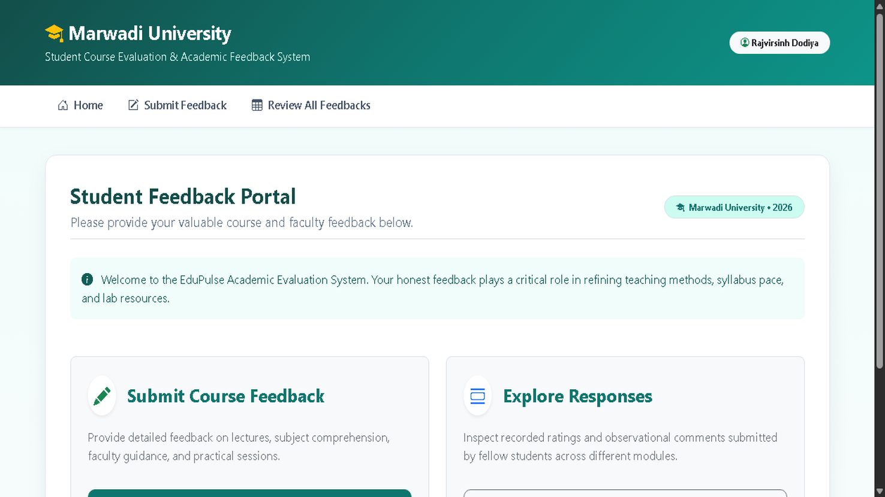

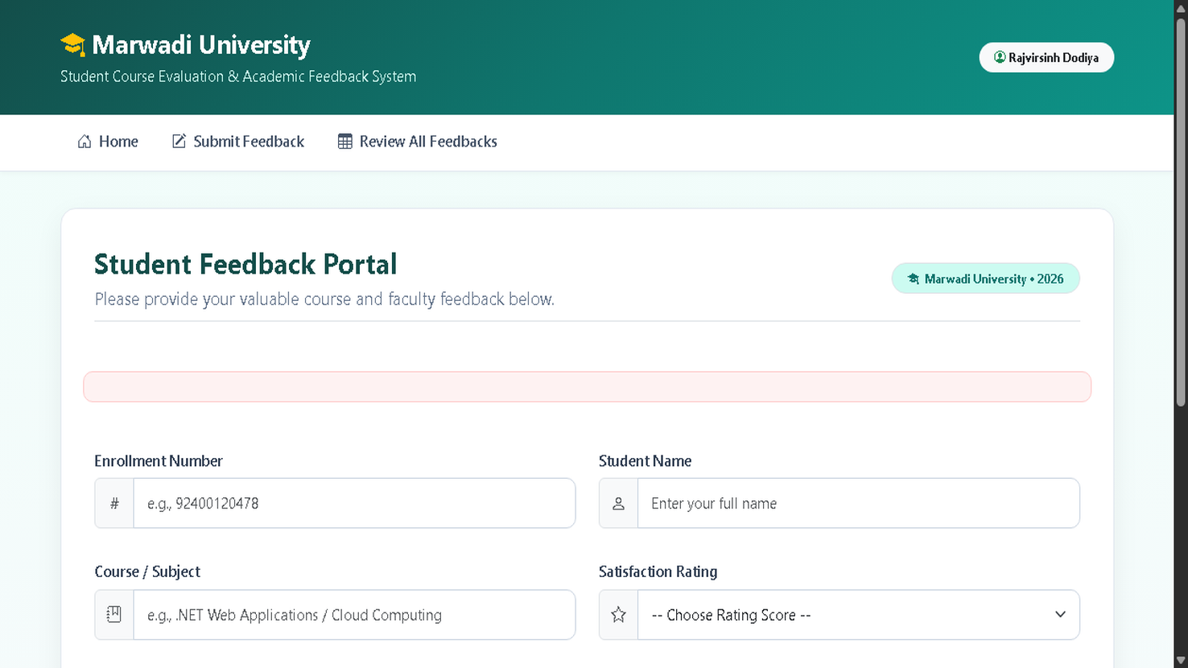

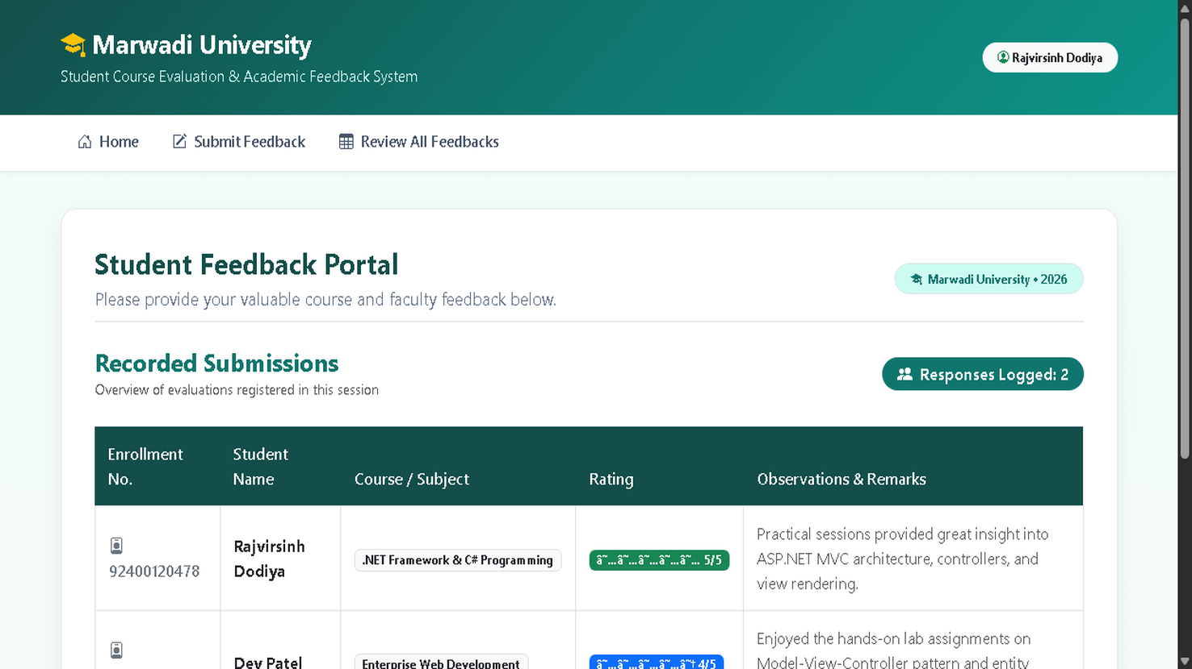

GitHub URL : https://github.com/RajvirDodiya/.NetPracticals

