2. Topic Name: Data Frames

**Target audience:** Technical learners of all skill levels.

**Exercise 1:** Data Frames

A data frame is an R object that stores relational data in a tabl structure made up of rows and columns. You can think of a data frame as a spreadsheet or as a SQL table. While data frames can be created in R, they are usually imported with data from JSON.

Data frames have rows and columns, each column has a name and stores the values of one variable, each row contains a set of values, one from each column, and the data stored in a data frame can be of many different types: numeric or character.

A data frame containing the address, age and name of students in a class could look like this:

**Art in workspace:** an image of a data frame. It has details about students.

When you have data in a CSV, you can load it into a data frame in R using readr‘s write_csv() function:

df <- read_csv('my_csv_file.csv')

* In the example above, the read_csv() function is called
* The CSV file my_csv_file.csv is passed in as an argument
* A data frame containing the data from my_csv_file.csv is returned

You can also save data from a data frame to a CSV using readr‘s write_csv() function:

write_csv('new_csv_file.csv')

In the example above, write_csv() takes two arguments:

* df, which represents a data frame object
* new_csv_file.csv, the name of the CSV file that will hold the data from the data frame

By default, this method will save the CSV file to your current directory.

1. Topic Name: **Data Frame**

**Target audience : A new commerce graduate who wants to pursue a career in the field of Data Analysis**

**Explanation**

A DataFrame is a two-dimensional, tabular data structure commonly used in data analysis and manipulation — especially in Python with the pandas library.

**✅ Features of DataFrame:**

* Can hold different data types (integer, float, string, etc.)
* Labeled axes (rows and columns)
* Built on top of NumPy

**Language Mostly Use**

1. Python Pandas
2. R language

Pandas is a powerful open-source Python library for data analysis and manipulation.

It offers two core data structures:

1. Series → 1D labeled array (like a single column)
2. DataFrame → 2D labeled table (like Excel or SQL table)

**Series :**

## A Series is a one-dimensional labeled array capable of holding any data type (integers, strings, floats, etc.). Think of it like a single column in Excel.

🧩 Structure of Series

Index Value

0 'Raj'

1 'Simran'

2 'Rahul'

import pandas as pd

s = pd.Series(['Raj', 'Simran', 'Rahul'])

print(s)

**DataFrame:**

📘 Theory:

A DataFrame is a 2-dimensional labeled data structure with columns of potentially different types.

You can think of it as a table (like Excel or SQL):

* Rows have indexes
* Columns have labels

🧩 Structure of DataFrame:

Index | Name | Age | City

-------------------------------

0 | Raj | 25 | Delhi

1 | Simran | 30 | Mumbai

2 | Rahul | 22 | Pune

Code Example:

data = {

'Name': ['Raj', 'Simran', 'Rahul'],

'Age': [25, 30, 22],

'City': ['Delhi', 'Mumbai', 'Pune']

}

df = pd.DataFrame(data)

print(df)

DIAGRAM: Series vs DataFrame

Series (1D)

------------

Index Value

0 10

1 20

2 30

DataFrame (2D)

--------------------------

Index | Name | Age | City

0 | Raj | 25 | Delhi

1 | Simran | 30 | Mumbai

2 | Rahul | 22 | Pune

**🔍 Difference Between Series and DataFrame**

| Feature | Series | DataFrame |
| --- | --- | --- |
| Dimension | 1D | 2D |
| Structure | Single column | Multiple columns |
| Axis Labels | Index only | Rows (index) + Columns |
| Real-Life Use | One column of a table | Full table (rows & columns) |
| Example | List of names | Table of names, ages, cities |

**How to Load Datasets in DataFrame**

**1. Load from CSV**

df = pd.read_csv('filename.csv')

**2. Load from Excel**

df = pd.read_excel('filename.xlsx')

**3. Load from JSON**

df = pd.read_json('filename.json')

**🔍 Useful DataFrame Functions**

| **Function** | **Purpose** |
| --- | --- |
| df.head() | First 5 rows |
| df.tail() | Last 5 rows |
| df.shape | Rows and columns count |
| df.columns | List of column names |
| df.dtypes | Data types of columns |
| df.info() | Summary of DataFrame |
| df.describe() | Stats summary for numeric columns |
| **🧠 Summary**   * **Series** = 1D (like a column) * **DataFrame** = 2D (like a table) * Pandas is used to handle structured data * You can create DataFrames from lists, dicts, NumPy arrays, or external files (CSV, Excel) |  |

. Topic Name: **End-to-End Data Pipeline**

**🚀 Building an End-to-End Data Pipeline: From Raw Data to Ready-for-Analysis**

In today’s data-driven world, raw data is abundant—but often messy, unstructured, and unsuitable for immediate analysis. A **data pipeline** serves as the backbone for transforming raw data into clean, organized, and analysis-ready datasets. In this article, we’ll walk through the process of building an **end-to-end data pipeline** using a simple raw dataset, focusing on real-world tools and practical steps.

**🧱 What Is a Data Pipeline?**

A **data pipeline** is a series of processes that move data from a source to a destination, performing necessary transformations along the way. This includes:

1. **Ingestion** – Fetching or collecting raw data.
2. **Cleaning** – Handling missing, duplicate, or incorrect data.
3. **Transformation** – Restructuring or aggregating data.
4. **Storage** – Saving the cleaned data to a storage system.
5. 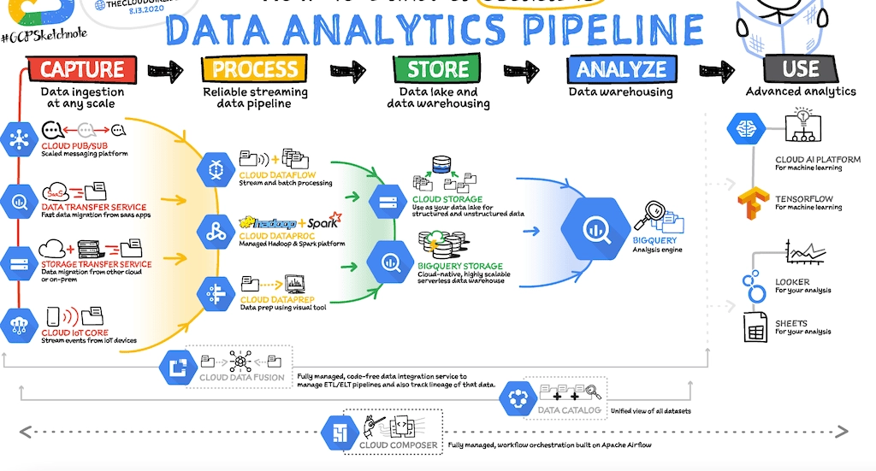**Analysis** – Making the data available for visualization, machine learning, or reporting.

Step-by-Step Guide: Creating a Basic Data Pipeline

**🧩 Step 1: Data Ingestion**

We start by importing the dataset. The source could be a CSV file, a database, an API, or even a real-time data stream.

import pandas as pd

# Load raw data

df_raw = pd.read_csv('customer_purchases_raw.csv')

**🧽 Step 2: Data Cleaning**

Raw data often contains missing values, duplicates, or inconsistent formats. We’ll clean it using pandas.

**Tasks:**

* Remove duplicates
* Handle missing values
* Standardize formats

# Remove duplicate rows

df_cleaned = df_raw.drop_duplicates()

# Fill missing values

df_cleaned['purchase_amount'].fillna(0, inplace=True)

df_cleaned['date'] = pd.to_datetime(df_cleaned['date'], errors='coerce')

**🔁 Step 3: Data Transformation**

Now we make the data more usable—like extracting time features or aggregating totals.

**Code Snippet:**

# Extract year and month for grouping

df_cleaned['year_month'] = df_cleaned['date'].dt.to_period('M')

# Total purchase per customer per month

df_transformed = df_cleaned.groupby(['customer_id', 'year_month'])['purchase_amount'].sum().reset_index()

Flow chart showing “Clean Data → Transformation → Summary Table

**💾 Step 4: Data Storage**

Once cleaned and transformed, we save the dataset to a new location for analysis.

# Save the final data

df_transformed.to_csv('processed_customer_purchases.csv', index=False)

Other storage options might include:

* Databases (e.g., PostgreSQL)
* Data lakes (e.g., AWS S3)
* Data warehouses (e.g., Snowflake, BigQuery)

**📊 Step 5: Data Analysis**

Now, the data is ready for downstream tasks like dashboards, reports, or machine learning models.

# Example: Simple analysis

top_customers = df_transformed.groupby('customer_id')['purchase_amount'].sum().sort_values(ascending=False).head(10)

print(top_customers)

**📌 Image Suggestion:** Bar chart of "Top 10 Customers by Total Purchases"

**🛠 Tools You Can Use**

Depending on your use case and scale, a modern data pipeline might include:

| **Stage** | **Tool Examples** |
| --- | --- |
| Ingestion | pandas, Apache Kafka, Airbyte |
| Cleaning | pandas, OpenRefine |
| Transformation | dbt, Apache Spark, pandas |
| Storage | PostgreSQL, AWS S3, Google BigQuery |
| Analysis | Power BI, Tableau, Python (Matplotlib, Seaborn) |

**✅ Final Thoughts**

A well-designed data pipeline reduces manual work, improves data quality, and enables faster, more accurate insights. For beginners, starting with simple pipelines using pandas in Python is a great foundation. As your needs grow, you can scale using tools like Airflow, Spark, and cloud platforms.

Part 3: Reflection

**🧠 Educator's Thought Process – Article on DataFrame & Data Pipeline**

**🔹 1. While Writing on DataFrame**

* 🏁 **Started with learner's mindset**: “If I were a beginner, what would confuse me the most?”
* 📚 **Introduced Series first** to build foundational knowledge before jumping to DataFrames.
* 📊 **Used real-world analogies** like Excel and SQL tables to simplify abstract concepts.
* 🧩 **Explained structure visually**: Rows, columns, index, and data types with diagrams.
* 🧪 **Provided hands-on examples** using simple Python and Pandas code blocks.
* ❓ **Included typical beginner questions**, e.g., difference between df['col'] and df[['col']].
* 🛠️ **Demonstrated multiple creation methods** (dict, lists, arrays, files) to show flexibility.
* 🔍 **Emphasized importance of data types**, .info(), .dtypes(), and .describe() for analysis.
* 📈 **Made sure to include practical use cases**, not just theory (e.g., CSV loading, previewing data).
* 🎯 **Focus: conceptual clarity + progressive learning** for long-term understanding.

**🔹 2. While Writing on Data Pipeline**

* 📌 **Started with the “why”** — Why do we need pipelines in real-world data work?
* 📥 **Explained ETL conceptually**: Extract → Transform → Load, in simple language.
* 🔄 **Linked it with DataFrame usage** to help students see the end-to-end connection.
* 🧰 **Chose tools they already know (Pandas)** instead of advanced orchestration tools to reduce friction.
* 🛤️ **Framed pipeline as a process, not a tool**, to build conceptual flexibility.
* 💻 **Included step-by-step flow** of raw data processing using Pandas (read, clean, save).
* 🧠 **Focused on logical flow and real use cases**, like loading survey data or financial reports.
* ⚠️ **Mentioned common challenges** (e.g., missing data, formats) to simulate realistic thinking.
* 🏗️ **Wanted students to “think like a data engineer”**, even with basic tools.
* 💬 **Left room for future upgrades**, like introducing Airflow or Prefect later on.

1. While writing about DataFrames, my primary goal was to build a strong conceptual foundation by first introducing Series as the basic unit, then gradually expanding to the two-dimensional structure of DataFrames. I used simple analogies like pandas code and SQL tables to make the content relatable for students who may not have a strong programming background.
2. When covering Data Pipelines, I aimed to demystify the concept by explaining it as a logical flow — Extract → Transform → Load — using tools students are already familiar with, like Pandas. This helped bridge the gap between academic learning and real-world data workflows.
3. Throughout the article, I emphasized practical understanding over theoretical complexity. My intention was to help learners not just "do the code" but understand the why behind each step, so they can confidently apply the concepts in real projects or interviews.