ANN Model Architecture
Stage 3 – Customer Churn Analysis | Team 7
Prepared by: Rajwant Kaur | Role: Project Manager and Predictive Modelling

1. Objective and Stage 2 context
The proposed Artificial Neural Network (ANN) will classify whether a telecommunications customer is likely to churn (1) or remain (0). Stage 2 documented 7,043 customer records and 31 preprocessed columns. These 31 columns are not automatically the ANN input count: the target, identifiers and any leakage-prone fields must be excluded before determining the final feature dimension.
Stage 2 K-Means used tenure and MonthlyCharges and identified four clusters. Cluster 2 (newer, high-charge customers) had the highest observed churn rate, 49.18%; Cluster 3 (long-term, low-charge customers) had the lowest, 4.76%. These are clustering observations, not ANN performance results.

2. Proposed ANN architecture
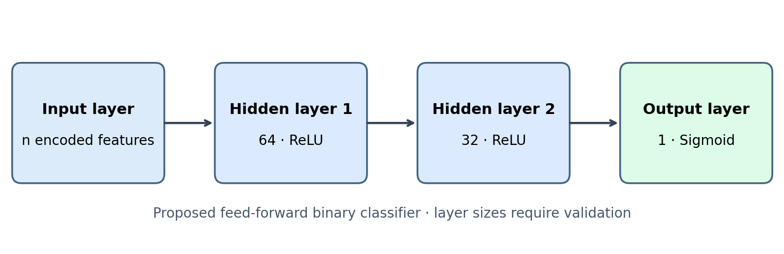
Figure 1. Proposed ANN architecture (illustrative, not a trained model).
Layer | Size | Function
Input | n features | Encoded and suitably scaled customer predictors; n determined after target/ID exclusion.
Hidden 1 | 64 neurons | Dense layer with ReLU activation.
Hidden 2 | 32 neurons | Dense layer with ReLU activation.
Output | 1 neuron | Sigmoid produces estimated probability of churn.

3. Training and optimisation specification
- Task and loss: binary classification with binary cross-entropy.
- Optimiser: Adam; initial learning rate 0.001, tuned on validation data.
- Suggested batch size: 32; maximum epochs: 100, with early stopping and restoration of best validation weights.
- Validation: use the existing Stage 2 train/test split if its provenance is confirmed; otherwise make a stratified split before fitting preprocessing. Keep the test set untouched until final evaluation.
- Regularisation: evaluate dropout (e.g., 0.2) and/or L2 regularisation if validation results suggest overfitting.
- Class imbalance: inspect churn prevalence and consider class weights or decision-threshold tuning using validation data only.

4. Inputs, leakage controls and integration
The Stage 2 report does not list all encoded feature names, the exact training/test split or every preprocessing transformation. Verify these using the actual Stage 2 scripts and dataset. Exclude the churn target (for example Churn_Yes), customer identifiers, and any post-outcome variables from predictors. Reuse fitted training-only preprocessing on validation and test records. If cluster labels are considered as extra features, ensure clustering is fitted without access to held-out evaluation records and compare against a no-cluster baseline.

5. Outputs and evaluation
For each customer, the ANN will output a churn probability between 0 and 1. A classification threshold (initially 0.50, subject to validation-based selection) converts this into churn/retention predictions. Report accuracy, precision, recall, F1-score, ROC-AUC, confusion matrix, and training/validation learning curves. Include a simple baseline model for comparison and permutation-based feature importance on held-out data, with correlated-feature caveats.

6. Status and evidence required
Architecture status: PROPOSED. No ANN has been trained or tested as part of this architecture document. Model weights, final feature count, hyperparameters, measured performance and ANN-based feature importance must be populated only after running the model on the actual prepared dataset.
Repository deliverables: ANN_Architecture_Team7.docx; ANN_Architecture_Team7.png; training and evaluation scripts; trained model; preprocessing pipeline; metrics and prediction files; evaluation charts.

7. Reference to team work
Team 7, “Stage 2 – Data Preparation and K-Means Clustering Analysis Report,” sections 1.1–1.5 and 2.2–2.10 (provided project report).

