**WELCOME TO STUDENT RECORD MANAGEMENT**

STEPS TO RUN:

Extract the zip file > Open command prompt > Change directory to location of python files > then type “**python HomePage.py**”

**LOGIN CREDENTIALS**

1. **As Administrator:**

[('Admin', 'user1', 'user1'),

('Admin', 'user2', 'user2'),

('Admin', 'user3', 'user3'),

('Admin', 'user4', 'user4'),

1. **As Professor:**

('Professor', 'user5', 'user5'),

1. **As Student:**

('Student', 'user6', 'user6')]

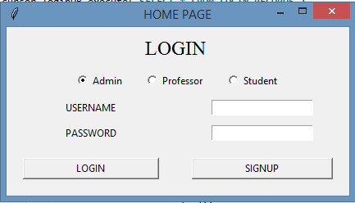

(LOGIN WINDOW)

New username and password can be created if you don’t have database file.

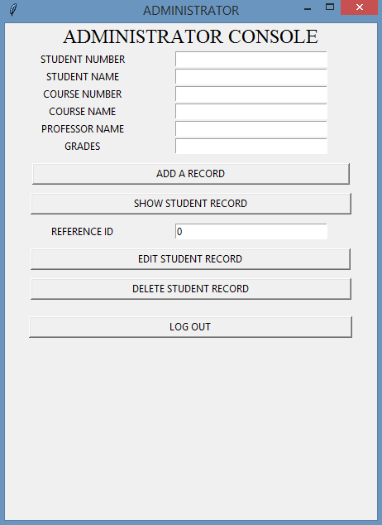

(Admin Console)

Reference ID will be **AVAILABLE/VISIBLE** only after clicking **SHOW STUDENT RECORD** Button

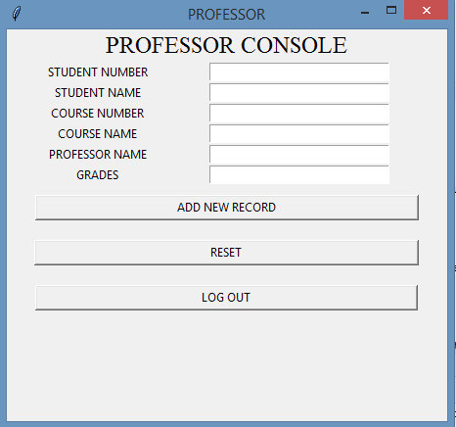

(PROFESSOR CONSOLE)

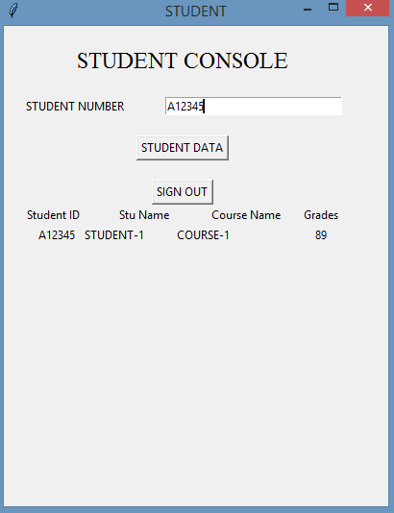

(STUDENT CONSOLE)