: 2.6, 2.8, 2.20, 2.30, 2.38, 2.44

2.6 Dice rolls. If you roll a pair of fair dice, what is the probability of

(a) getting a sum of 1?

1/6 * 1/6 = 2/6

(b) getting a sum of 5?

1 4

2 3

3 2

4 1

4/36

(c) getting a sum of 12?

Probability of getting first 6 is 1/6 and , also getting another 6 in second roll is 1/6, so 6 and 6 can be rolled with probability of (1/6) * (1/6) = 1 /36 = 0.03

2.8 Poverty and language. The American Community Survey is an ongoing survey that

provides data every year to give communities the current information they need to plan investments

and services. The 2010 American Community Survey estimates that 14.6% of Americans live below

the poverty line, 20.7% speak a language other than English (foreign language) at home, and 4.2%

fall into both categories.59

**(a) Are living below the poverty line and speaking a foreign language at home disjoint?**

Answer: No these events are not disjoint, there are people who are living below the poverty line and speak a more than once language extra apart of English

**(b) Draw a Venn diagram summarizing the variables and their associated probabilities.**

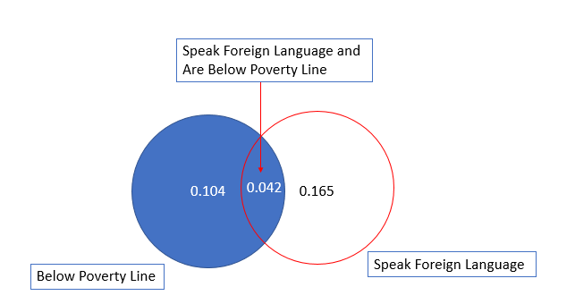

**(c) What percent of Americans live below the poverty line and only speak English at home?**

Answer: Each person living below the poverty line either speaks only English at home or some other language. From the vein diagram we know that only 4.2 % of people below poverty line doesn’t speak only English. So, the only % of Americans who speak English below pervert line are: 14.6 % – 4.2% = 10.4 % i.e. 0.104.

**(d) What percent of Americans live below the poverty line or speak a foreign language at home?**

Answer: We need to know:

p(live below Poverty line) OR p(speak Foreign Lang at home)

=> P(A) or p(B) = p(A) + p(B) – p(A intersection B)

=> = 0.146 + 0.207 − 0.042 = 0.311

**(e) What percent of Americans live above the poverty line and only speak English at home?**

**Answer: We can also solve this by**

P(! below the poverty line) AND p(!speak Foreign Lang)

P(neither below PL nor speak FL) = 1 - P(below PL or speak FL) = 1 - 0.311 = 0.689

**(f) Is the event that someone lives below the poverty line independent of the event that the person**

**speaks a foreign language at home?**

2.20 Assortative mating. Assortative mating is a nonrandom mating pattern where individuals

with similar genotypes and/or phenotypes mate with one another more frequently than what would

be expected under a random mating pattern. Researchers studying this topic collected data on

eye colors of 204 Scandinavian men and their female partners. The table below summarizes the

results. For simplicity, we only include heterosexual relationships in this exercise.65

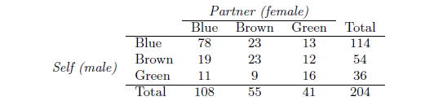

Total <- 204

FB <- 108/ Total

FBr <- 55/ Total

FG <- 41/ Total

MB <-114/ Total

MBr <-54/ Total

MG <-36/ Total

Partner (female)

Blue Brown Green Total

Blue 78 23 13 114

Self (male)

Brown 19 23 12 54

Green 11 9 16 36

Total 108 55 41 204

(a) What is the probability that a randomly chosen male respondent or his partner has blue eyes?

(b) What is the probability that a randomly chosen male respondent with blue eyes has a partner

with blue eyes?

(c) What is the probability that a randomly chosen male respondent with brown eyes has a partner

with blue eyes? What about the probability of a randomly chosen male respondent with green

eyes having a partner with blue eyes?

(d) Does it appear that the eye colors of male respondents and their partners are independent?

Explain your reasoning.

2.30 Books on a bookshelf. The table below shows the distribution of books on a bookcase

based on whether they are nonfiction or fiction and hardcover or paperback.

Format

Hardcover Paperback Total

Type

Fiction 13 59 72

Nonfiction 15 8 23

Total 28 67 95

(a) Find the probability of drawing a hardcover book first then a paperback fiction book second

when drawing without replacement.

(b) Determine the probability of drawing a fiction book first and then a hardcover book second,

when drawing without replacement.

(c) Calculate the probability of the scenario in part (b), except this time complete the calculations

under the scenario where the first book is placed back on the bookcase before randomly drawing

the second book.

(d) The final answers to parts (b) and (c) are very similar. Explain why this is the case.

2.38 Baggage fees. An airline charges the following baggage fees: $25 for the first bag and

$35 for the second. Suppose 54% of passengers have no checked luggage, 34% have one piece of

checked luggage and 12% have two pieces. We suppose a negligible portion of people check more

than two bags.

(a) Build a probability model, compute the average revenue per passenger, and compute the

corresponding standard deviation.

(b) About how much revenue should the airline expect for a flight of 120 passengers? With what

standard deviation? Note any assumptions you make and if you think they are justified.

2.44 Income and gender. The relative frequency table below displays the distribution of

annual total personal income (in 2009 inflation-adjusted dollars) for a representative sample of

96,420,486 Americans. These data come from the American Community Survey for 2005-2009.

This sample is comprised of 59% males and 41% females.69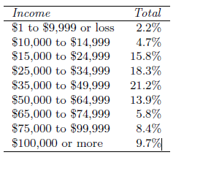

(a) Describe the distribution of total personal income.

(b) What is the probability that a randomly chosen US

resident makes less than $50,000 per year?

(c) What is the probability that a randomly chosen US

resident makes less than $50,000 per year and is female?

Note any assumptions you make.

(d) The same data source indicates that 71.8% of females

make less than $50,000 per year. Use this value to

determine whether or not the assumption you made in

part (c) is valid.

Income Total

$1 to $9,999 or loss 2.2%

$10,000 to $14,999 4.7%

$15,000 to $24,999 15.8%

$25,000 to $34,999 18.3%

$35,000 to $49,999 21.2%

$50,000 to $64,999 13.9%

$65,000 to $74,999 5.8%

$75,000 to $99,999 8.4%

$100,000 or more 9.7%