BDA400 / Data Science Tools and Techniques
Assignment 5
Technical Analysis using R - Development Phase
Assignment Value: 15%
Student Name: Rajwinder Kaur
Repository Link: https://github.com/Rajwinder222470/Technicalanalysis

1. Purpose and Approach
This development phase implements the required technical-analysis indicators using standard/core R operations rather than existing technical-analysis libraries. Each indicator is stored in its own R script so the required function names can be sourced and tested independently. The implementation follows the assignment templates and pseudocode and includes basic input validation to make failures clear during testing.

2. How to Run the Code
- Download or clone the repository and keep all .R files in one folder.
- Open the folder as an RStudio project or set the working directory to that folder.
- Run source("test_all.R") in the Console.
- Check the Console output for SMA, EMA, MACD, stdev, linreg, RSI, StochRSI, crossover, and crossunder.
- For evaluation, each individual function can also be loaded with source("filename.R") and called using the examples in this document.

3. Simple Moving Average (SMA)
Required function: sma(data, period)
The function checks that the requested period is valid and that enough observations are available. It then moves a fixed-size window across the vector, adds the values in that window, and divides by the period. The returned vector therefore contains one SMA value for every complete window.
Example test:
data <- c(10,12,15,20,18,22,25,24,21)
sma(data, 3)

4. Exponential Moving Average (EMA)
Required function: ema(data, period)
The smoothing multiplier is calculated as 2/(period+1). The first observation initializes the EMA. Each later EMA is calculated from the current value and the preceding EMA, which gives more influence to recent observations.
Example test:
ema(data, 3)

5. Moving Average Convergence Divergence (MACD)
Required function: macd(data, short_period, long_period, signal_period)
The function calls the custom EMA implementation for the short and long periods. The MACD line is short EMA minus long EMA. A further EMA of the MACD line creates the signal line, and the histogram is MACD minus signal.
Example test:
macd(c(100,105,110,115,120,125,130), 3, 5, 2)

6. Standard Deviation (stdev)
Required function: stdev(data)
The implementation calculates the arithmetic mean, each deviation from that mean, squared deviations, and the population variance by dividing by n. The square root of that variance is returned. This deliberately follows the assignment formula rather than R's built-in sd(), which uses a sample denominator by default.
Example test:
stdev(data)

7. Linear Regression (linreg)
Required function: linreg(regressionSource, regressionLength, regressionOffset)
The requested subset is selected using regression length and offset. Sequential index values act as x. The slope is computed from the sum of cross-deviations divided by the sum of squared x-deviations; the intercept is then calculated from the two means. Predicted values are returned with the slope and intercept.
Example test:
linreg(c(2,4,6,8,10,12), 5, 0)

8. Relative Strength Index (RSI)
Required function: rsi(data, period)
Consecutive price changes are separated into gains and losses. Initial average gain and loss values are calculated over the selected period. Later averages use Wilder smoothing. RSI is then calculated as 100 - 100/(1 + RS). The function also handles zero-loss cases without dividing by zero.
Example test:
rsi(c(45,50,48,55,52,49,58,60,65,62,66,68,64,70,72,69,74,76,73,78), 14)

9. Stochastic RSI (StochRSI)
Required function: stoch_rsi(data, period, k_period, d_period)
The function first calls the custom RSI function. Valid RSI values are normalized using the minimum and maximum RSI values, following the supplied pseudocode. The custom SMA function is then used to create the %K line and the %D line.
Example test:
stoch_rsi(c(45,50,48,55,52,49,58,60,65,62,66,68,64,70,72,69,74,76,73,78,80,77,82,84,81), 14, 3, 3)

10. Crossover
Required function: crossover(arr1, arr2)
The two arrays must have equal length. From the second observation onward, the function compares the current and previous relationship of the two arrays. It records 'Up' when arr1 moves from at/below arr2 to above it, 'Down' for the opposite crossing, and 'None' otherwise, matching the assignment pseudocode.
Example test:
crossover(c(10,12,15,20,18,22,25,24,21), c(18,20,22,18,15,12,10,11,13))

11. Crossunder
Required function: crossunder(arr1, arr2)
The function checks equal-length numeric arrays. A 'True' signal occurs when arr1 is currently below arr2 while the previous arr1 value was greater than or equal to arr2. The first position is 'None' because no previous value exists; later positions without a crossunder are 'False'.
Example test:
crossunder(c(10,12,15,20,18,22,25,24,21), c(18,20,22,18,15,12,10,11,13))

12. Testing and Verification
I ran test_all.R in RStudio with the nine indicator scripts in one folder. The console reported that all demonstrations and reference checks completed. The screenshots below show that run and a separate SMA example.
Figure 1. The test script loads each indicator and completes its reference checks.
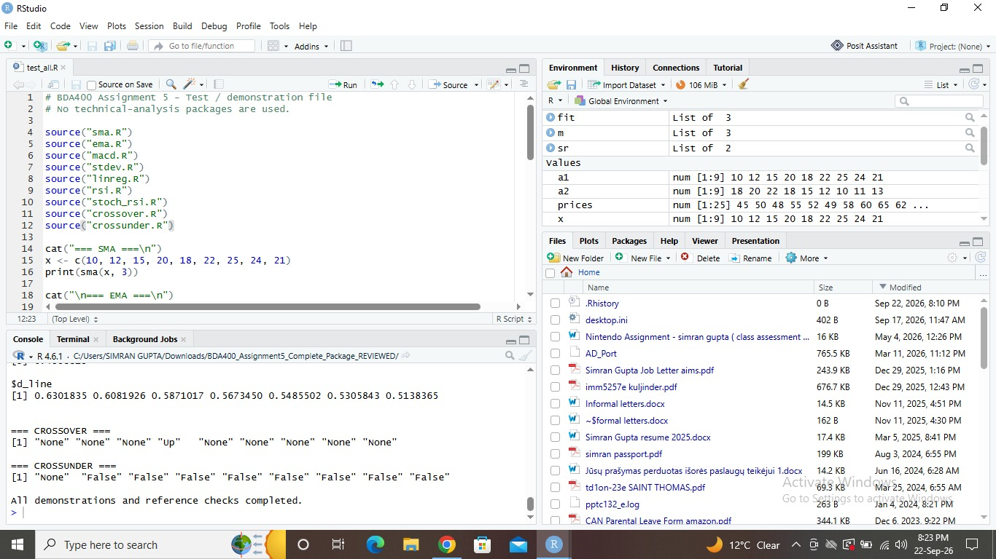
Figure 2. The SMA implementation and its calculated result in RStudio.
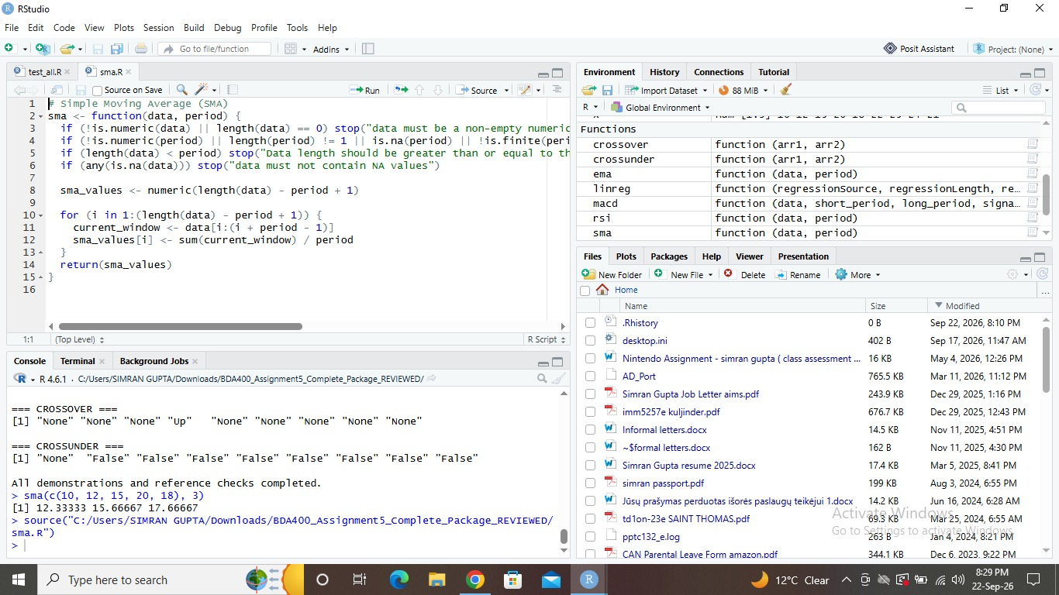

13. Rubric Alignment Checklist
Rubric criterion | Evidence in package | Weight
SMA | sma.R + explanation + test | 5
EMA | ema.R + explanation + test | 10
MACD | macd.R uses custom EMA + explanation + test | 15
Standard Deviation | stdev.R follows population formula + test | 15
Linear Regression | linreg.R returns slope, intercept, predictions + test | 15
RSI | rsi.R with Wilder smoothing + test | 10
Stochastic RSI | stoch_rsi.R using custom RSI/SMA + test | 10
Crossover | crossover.R + test | 5
Crossunder | crossunder.R + test | 5
Code Accuracy and Functionality | input checks + test_all.R + actual RStudio screenshots in Section 12 | 10

14. Final Submission Checklist
- The repository link is listed on the cover page.
- Run test_all.R in RStudio and confirm there are no errors.
- Check that the real RStudio screenshots are visible in Section 12.
- Upload every separate .R script, README.md, test_all.R, and the documentation to the repository.
- Use the College naming convention NAME_COURSE_ASSIGNMENT for the submitted document.
- Confirm the repository link works before LMS submission.

