### **DYNAMIC SOLAR PANEL**

### 

### **i) Problem Statement**

Clearly state the problem:

*Design a microcontroller-based system to dynamically position a solar panel for maximum energy capture from sunlight.*

### **ii) Scope of the Solution**

Briefly describe what your system will do:

* Track sun using LDRs or phototransistors
* Use Arduino to control motor position
* Maximize solar panel output by always facing the sun
* Prototype with simulation and actual circuit

### **iii) Required Components (Software + Hardware)**

**Hardware:**

* Arduino Uno/Nano
* 2 × LDRs or phototransistors
* 2 × 10kΩ resistors
* L293D or L298N motor driver
* Servo motor or DC motor
* 7805 voltage regulator
* Capacitors (0.1µF and 10µF)
* Jumper wires, breadboard or PCB
* Solar panel (optional for prototype)

**Software/IDE:**

* Arduino IDE (for programming)
* TinkerCad/Fritzing (for simulation)
* EasyEDA (for PCB design and Gerber generation)

### **iv) Simulated Circuit (TinkerCad / Fritzing)**

* Build your working circuit in **TinkerCad** or **Fritzing**
* Include:  
  + Arduino
  + LDRs connected to analog pins
  + Motor driver connected to motor and digital pins
  + Servo or DC motor
* Upload schematic screenshots or .fzz (Fritzing) / TinkerCad share link

<https://drive.google.com/file/d/1cD9TigqSnYT5Jcr76ZYTHxnOdrRc1Ssw/view?usp=drivesdk>

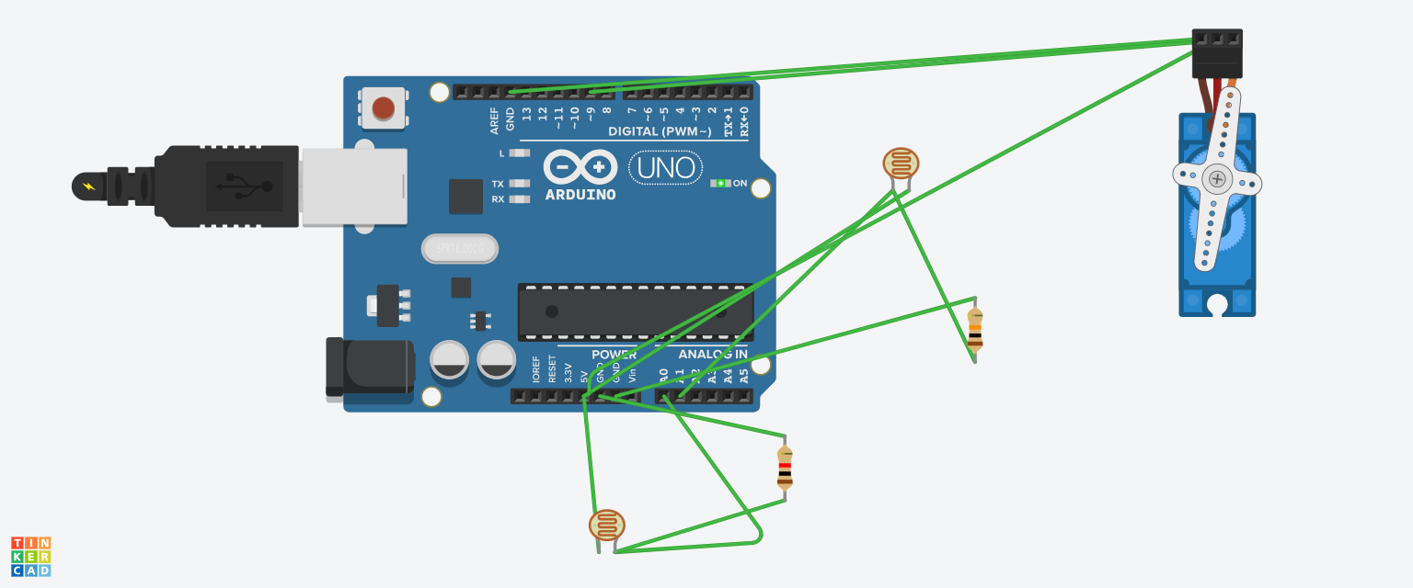

int ldrLeft = A0;

int ldrRight = A1;

int motorPin1 = 9;

int motorPin2 = 10;

void setup() {

pinMode(motorPin1, OUTPUT);

pinMode(motorPin2, OUTPUT);

Serial.begin(9600);

}

void loop() {

int left = analogRead(ldrLeft);

int right = analogRead(ldrRight);

int diff = left - right;

if (abs(diff) > 50) {

if (diff > 0) {

digitalWrite(motorPin1, HIGH);

digitalWrite(motorPin2, LOW);

} else {

digitalWrite(motorPin1, LOW);

digitalWrite(motorPin2, HIGH);

}

delay(300);

digitalWrite(motorPin1, LOW);

digitalWrite(motorPin2, LOW);

}

delay(500);

}