**Manual for Robotics User Interface**

This manual goes over how the GUI can be used to obtain various parameters, equations and joint/link quantities of a robotic manipulator. The topics covered are:

1. Homogenous Matrix Transformation
2. (A and B are clubbed together)
   1. Translation Animations
   2. Rotation Animations
      1. Euler (ZYZ) Rotations with Translation
      2. RPY Rotations with Translation
      3. Quaternions Rotations with Translation
      4. Rotation about a vector with Translation
3. Forward Kinematics
   1. Creation of a Robotic Manipulator
      1. Using Direct DH parameters
      2. Using descriptions given by a user
   2. Forward Kinematics from DH parameters
   3. Forward Kinematics for given joint positions (q)
4. Workspace
   1. Operational Workspace for given joint limits
   2. Singularities found within these joint limits
5. Inverse Kinematics
   1. Inverse kinematics for a given end effector pose using closed loop solution and Jacobian
   2. Inverse kinematics for a given end effector pose using convex optimization tools with and without given joint limits
6. Differential Kinematics
   1. Obtain the Jacobian matrix
      1. Obtain a symbolic Jacobian expression
      2. Obtain a numeric Jacobian for given joint pose
   2. Get end effector velocity using computed Jacobian
7. Inverse Differential Kinematics
   1. Obtain joint velocities given the joint positions (q) and end effector velocity (Xe_dot) components
8. Dynamics
   1. Obtain Equation of Motion (Lagrangian)
   2. Plot Joint Pose and Velocity
9. Controls
   1. Force Control
   2. Motion Control

**Functional overview**

The following table gives an overview of the inputs and outputs that are taken by each of the sub components of the application.

|  |  |  |  |  |
| --- | --- | --- | --- | --- |
|  |  |  |  | **Input** |
| **No** | **Question** | **Functionality** | **Owner** |  | **Result** |
| a | Homogenous matrix | Frame description | Aditya | Euler angles (ZYZ, XYZ), Quartenions, Angle Axis Position vector | T0H |
| Transformation mapping | Rakshith | v_i , T0H | v_base |
| Transformation operator | Rakshith | T01, T12, … , TnH | T0H |
| b | Euler Angles | Anlge -> Rotation matrix | Rakshith | alpha, beta, gamma | R |
| Rotation matrix -> Anlge | Rakshith | R | alpha, beta, gamma |
| c | FW Kinematics | Robot config -> DH | Mitul | Manipulator description | DH table |
| DH -> Serial Link | Mitul | DH table | T0H, Link obj |
| Joint parameter -> EF pose | Mitul | Link Obj, q | EF Pose (T0H) |
| d | Workspace | Robot config -> Workspace | Ravi | Link Obj |  |
| e | Inverse Kinematics (analytical) | EF Pose -> Joint Paramter | Osei | Link Obj, EF pose (T0H) | q |
| f | Differential Kinematics | Jacobian | Ravi | Link Obj, q | Jg, Ja |
| Singularities | Ravi | Jg | q_singular |
| g | Inverse Diff Kinematics | EF velocity -> Joint Velocity | Ravi |  |  |
| Inverse Kinematics (Jacobian) | EF Pose -> Joint Paramter | Osei | Link Obj, EF pose (T0H), Jacobian | q |
| h | Dynamics | Equation of Motion (Lagrangian) | Ravi | Dynamic params | B,C,G |
| Joint position and velocity -> plot | Ravi | Link Obj, q0, qd0 |  |
| i | Control (2 Planar robot) | Position Control | Ravi |  |  |
| Inverse Force control | Ravi |  |  |
|  |  |  |  |  |  |
| j | GUI |  | Rakshith |  |  |
| k | Manual |  | Rakshith, Aditya |  |  |

**Usage of the Application:**

The application has three main tabs that house different aspects of a robot. The GUI can be run using the **app1.mlapp** file.

Tab 1:

* Various rotation methods
  + Input: Translation and Rotation
  + Output: Effective Transformation Matrix and Frame Animation

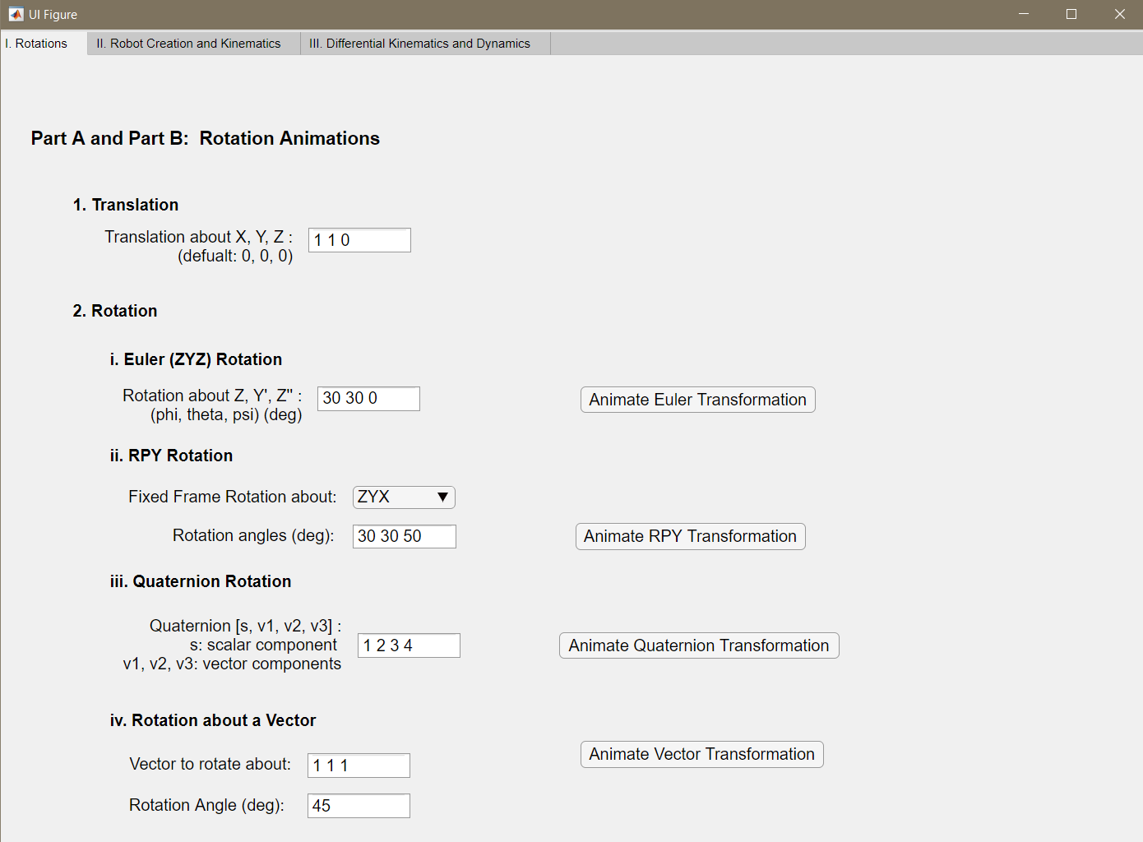

NOTE: Translation is common to all types of rotations. Pure rotation for quaternions and rotation about a vector can be obtained by keeping translation component to 0.

Tab 2:

* Creation of Robot
  + Questionnaire
    - Inputs: Type of joints, Axis of rotation, Link Orientation, Link Length
    - Output: Created Robot and DH parameters
  + Direct DH Params
    - Inputs: DH parameters
    - Output: Created Robot
* Forward Kinematics (End Effector Pose)
  + Symbolic Forward Kinematics Equations
    - Inputs: Robot object (and its DH parameters)
    - Output: Symbolic forward kinematics equations
  + Numeric forward kinematics
    - Inputs: joint angles
    - Output: Numeric transformation matrix to end effector from base of robot
* Workspace and Singularities
  + Inputs: Joint Limits, density of workspace plot
  + Outputs: Workspace plot and Singularities
* Inverse Kinematics
  + Closed Loop Inverse Kinematics
    - Inputs: Initial joint positions
    - Outputs: Final Joint positions
  + Convex Optimization based Inverse Kinematics
    - Inputs: Initial joint positions
    - Outputs: Final Joint positions

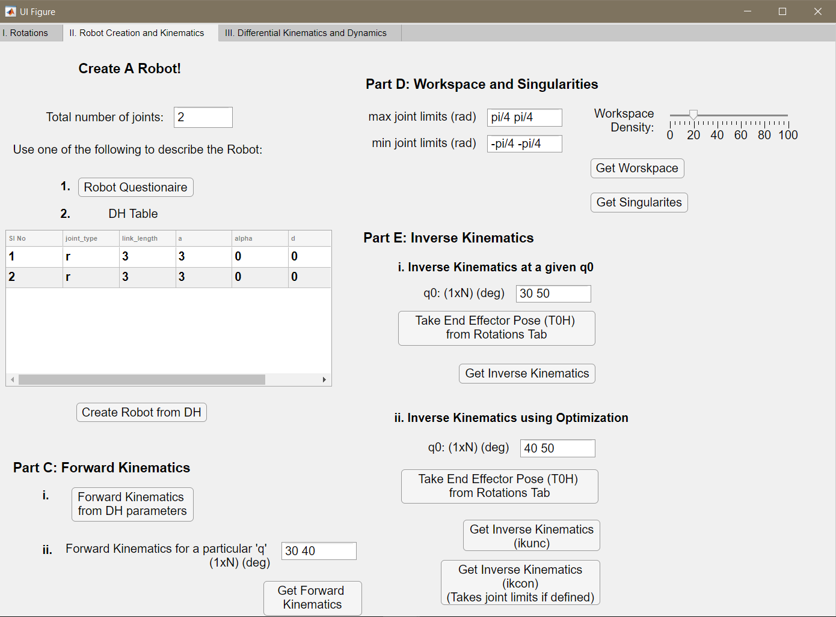

Tab 3:

* Differential Kinematics
  + Symbolic Jacobian Equations
    - Inputs: Robot object
    - Outputs: Jacobian equations
  + Numeric Jacobian
    - Inputs: Initial joint positions
    - Outputs: Numeric Jacobian
  + End Effector Velocities
    - Inputs: Initial joint velocities
    - Outputs: end effector velocity
* Inverse Differential Kinematics
  + Inputs: Initial link locations, end effector velocity
  + Outputs: Joint veloicities (q_dot)
* Dynamics:
  + Symbolic lagrangian Dynamics equations
    - Inputs: Link parameters (mass, center of gravity, etc), initial joint locations, initial joint velocities, gravity vector,
    - Outputs: Symbolic lagrangian Dynamics equations
  + End Effector Plots
    - Inputs: Constant torque at each link
    - Outputs: Plots of joint positions and joint velocities

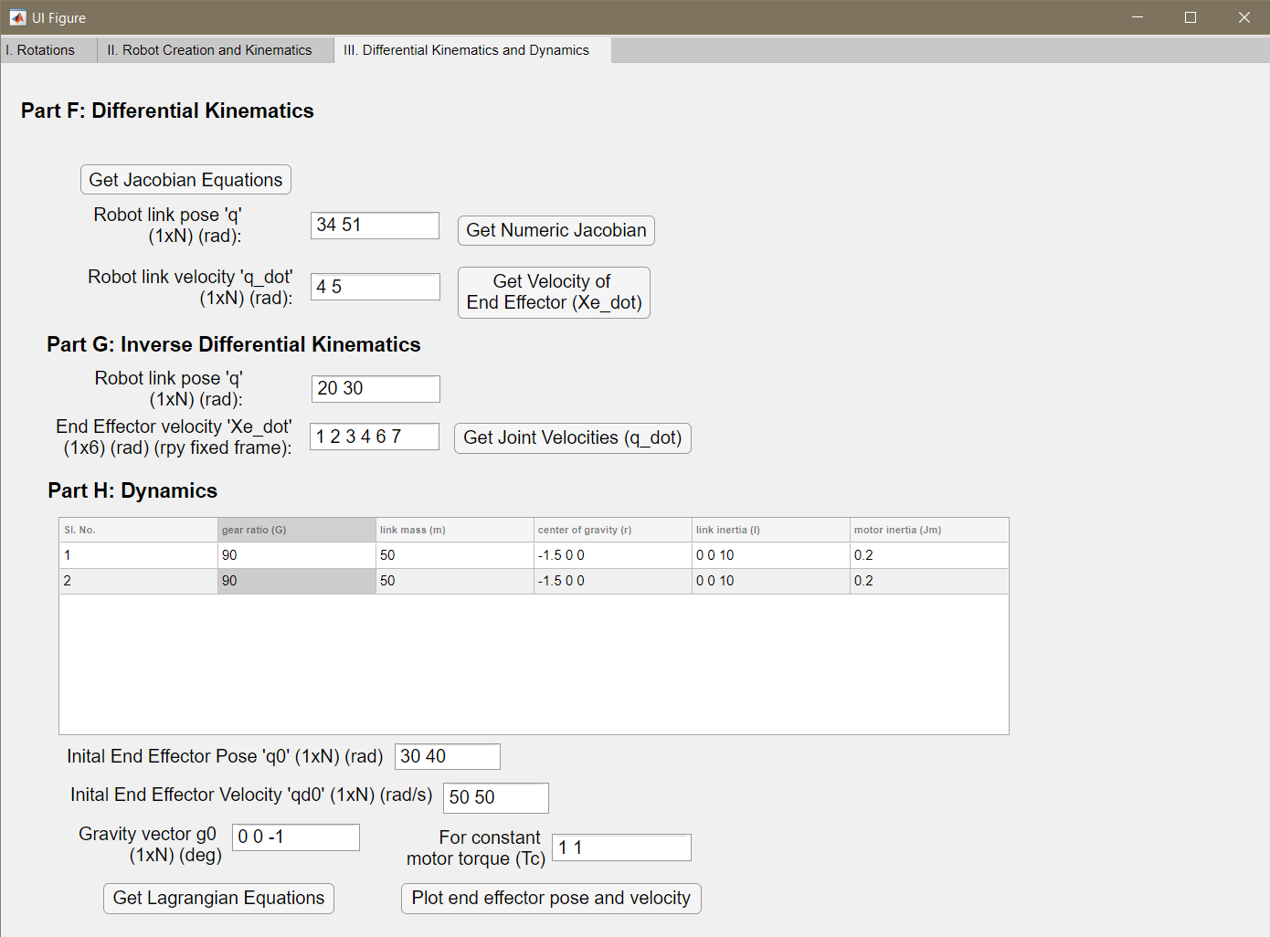

NOTE: The Toolbox has been tested on MATLAB 2019 (b). Some UI features may throw errors or warnings in 2019 (a) versions and before.

**Example1: Rotations**

Here, examples of Euler (ZYZ) rotations and rotation about the vector [1,1,1] by 45 degrees have been provided. For both cases a translation of [1, 2, 1] was used.

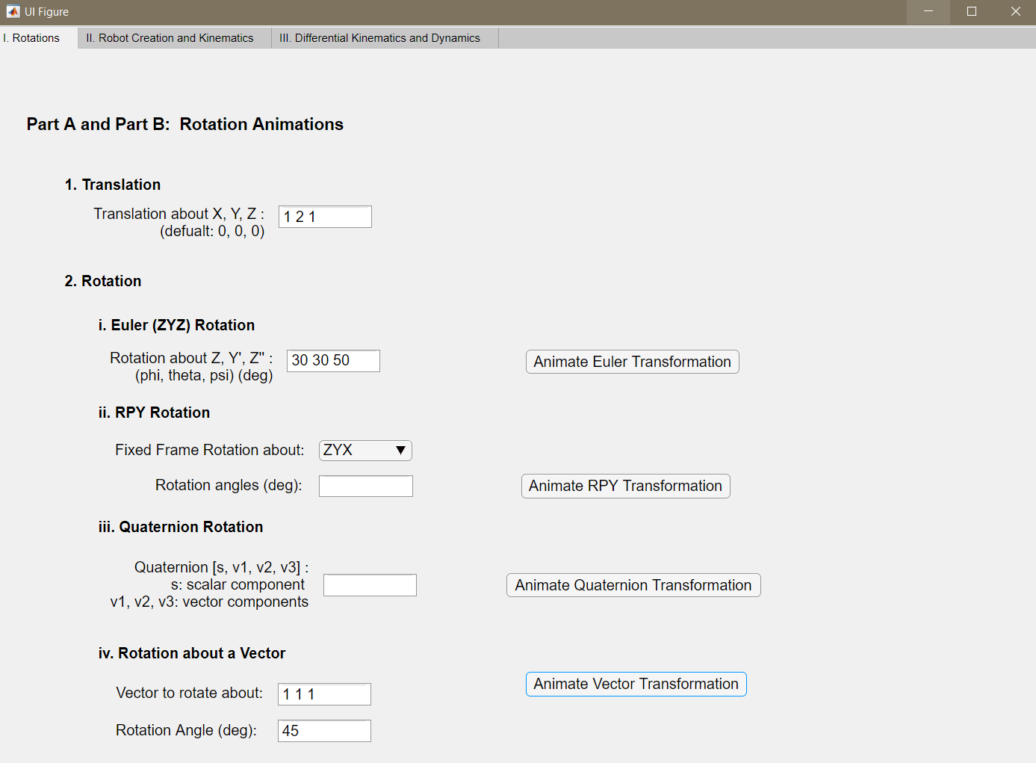

Euler Angle Rotations:

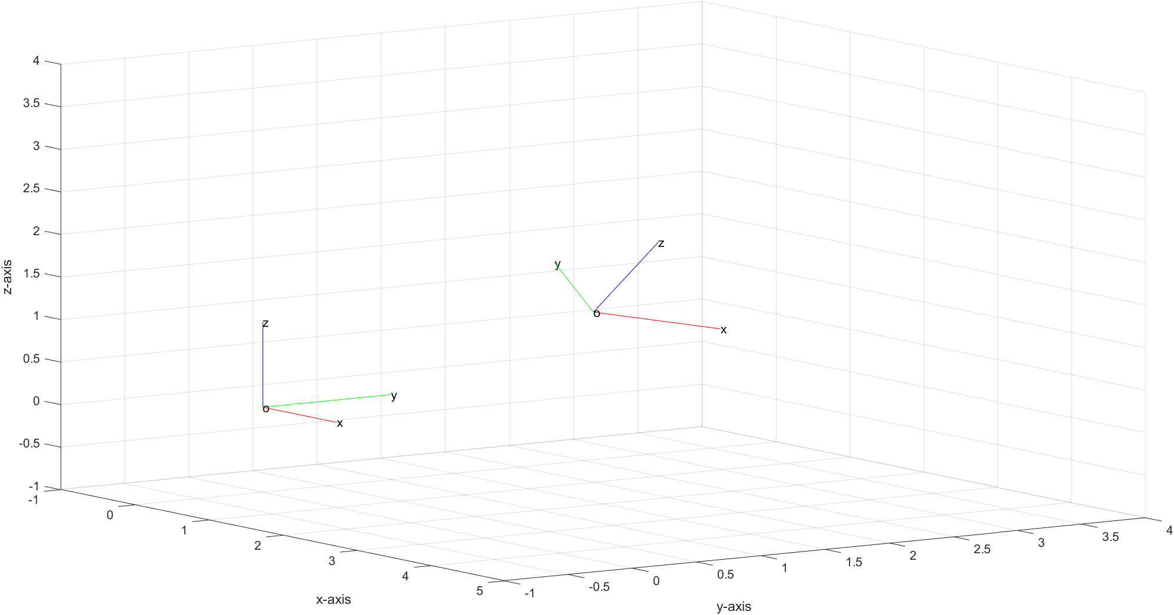

Rotation about a Vector:

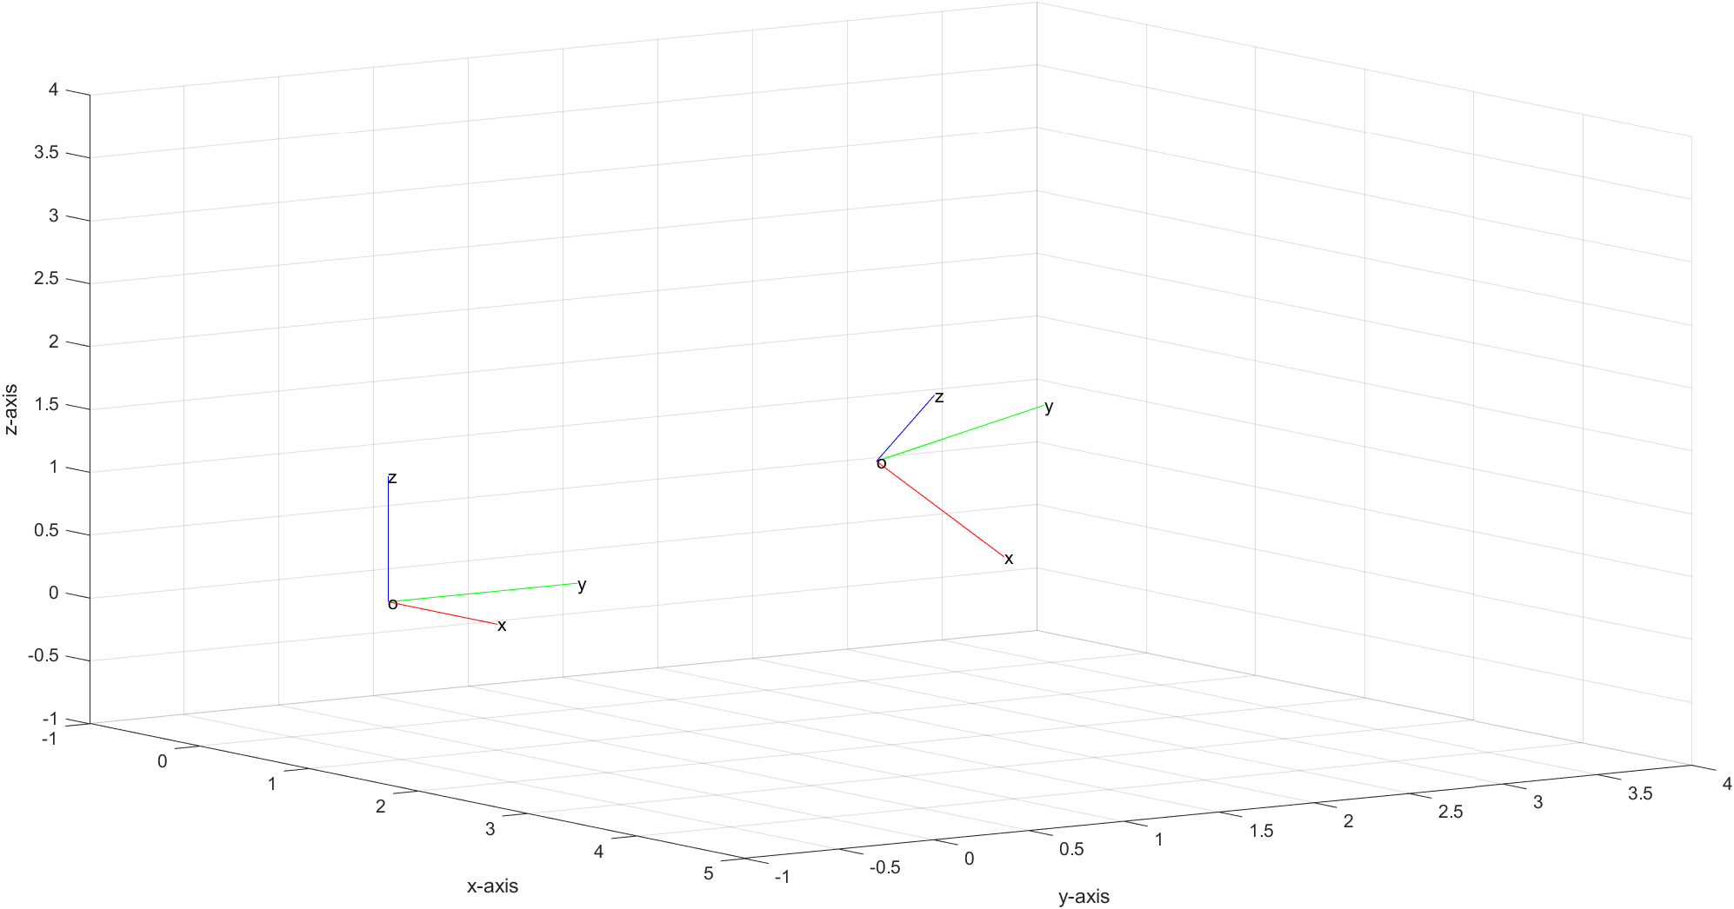

Similarly, other rotation operations can be performed.

**Example2: Creation of 2 Link Planar Robot and Related Kinematics/Dynamics**

Here the direct DH table was used to create a two link planar robot. The screenshots for the inputs provided and the corresponding outputs have been provided below:

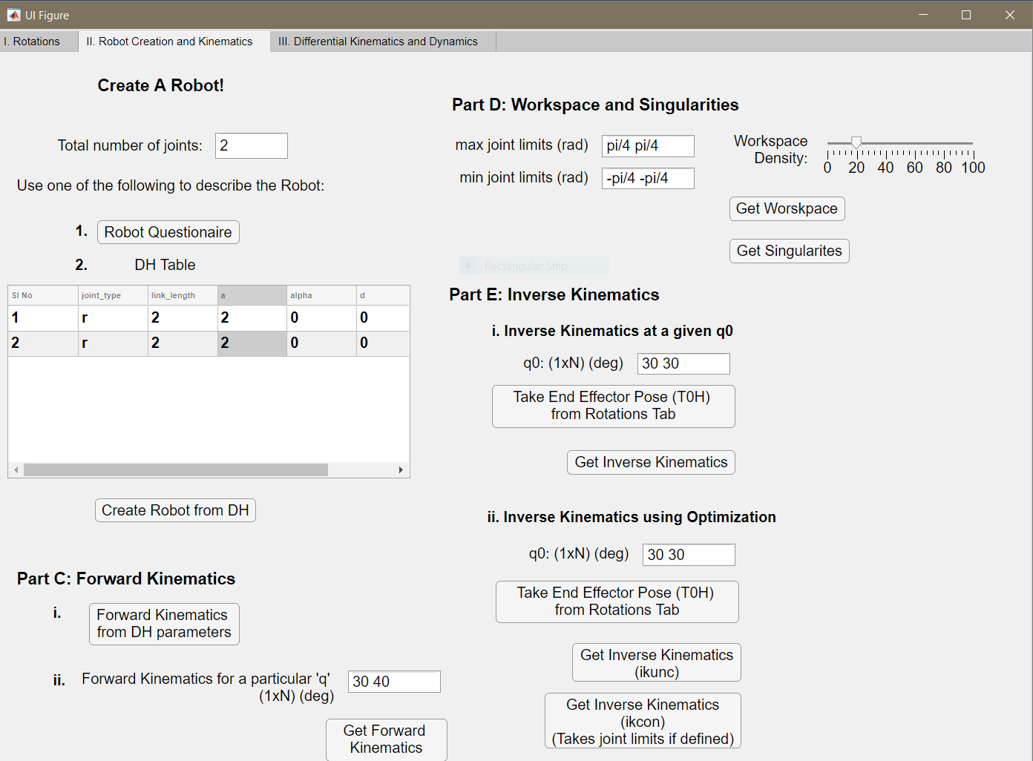

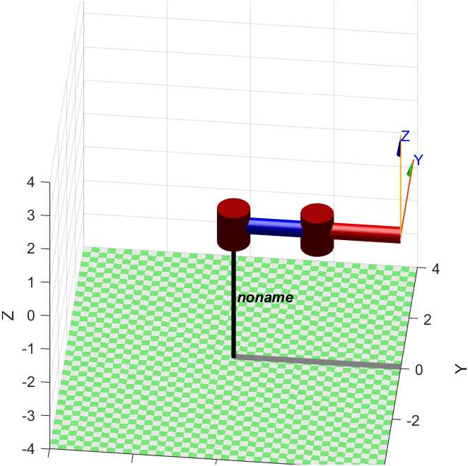

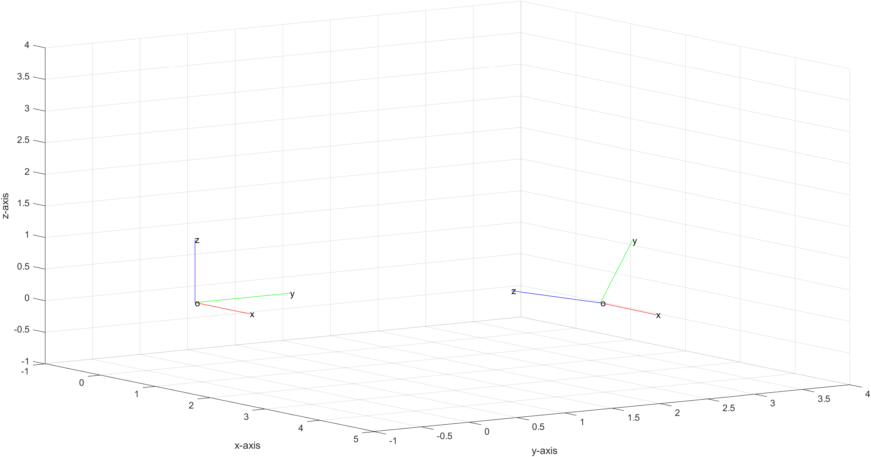

We see in this figure that the initial frame (representing the base of the robot) and the final frame (representing the end effector) are in the same plane.

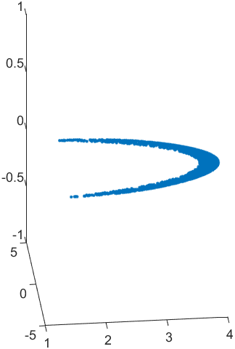

Similarly, the workspace is also plotted in 2D, with a maximum value of L1 + L2 = 2+2 = 4

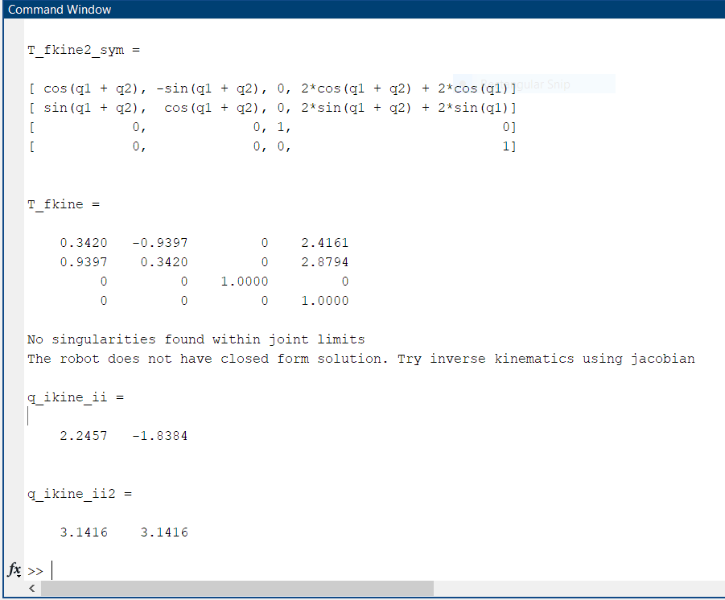

As seen in the T_fkine matrix, the z component is 0, since the robot is a planar one.



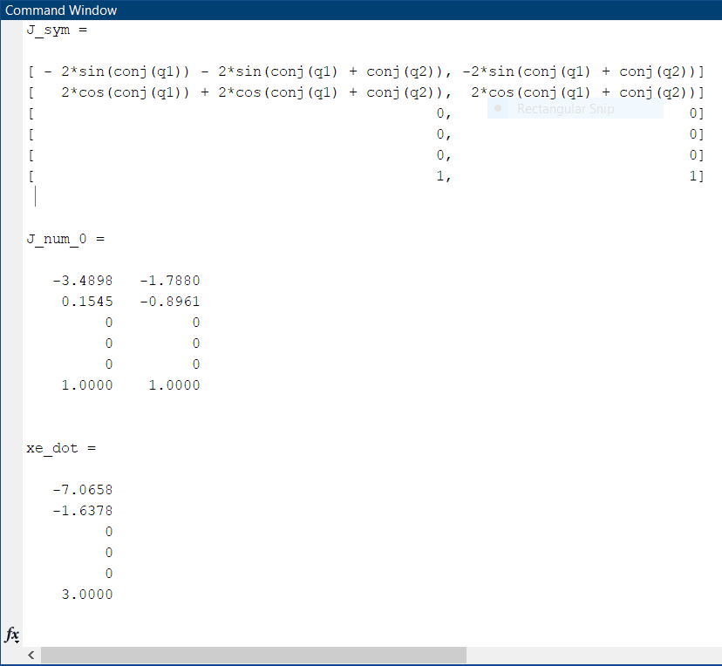

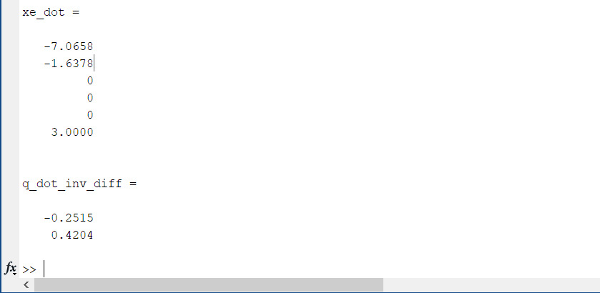

The jacobians and end effector poses also show the planarity of the robot.

**Example 3: Creation of Three Revolute 3D Robot and Statics/Dynamics**

This time the robot was made using the questionnaire option provided. The following was input to the questionnaire.

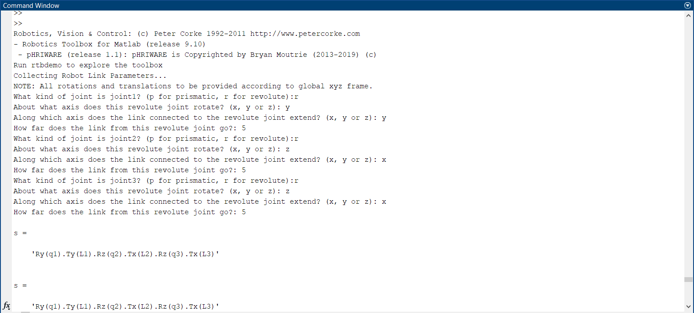

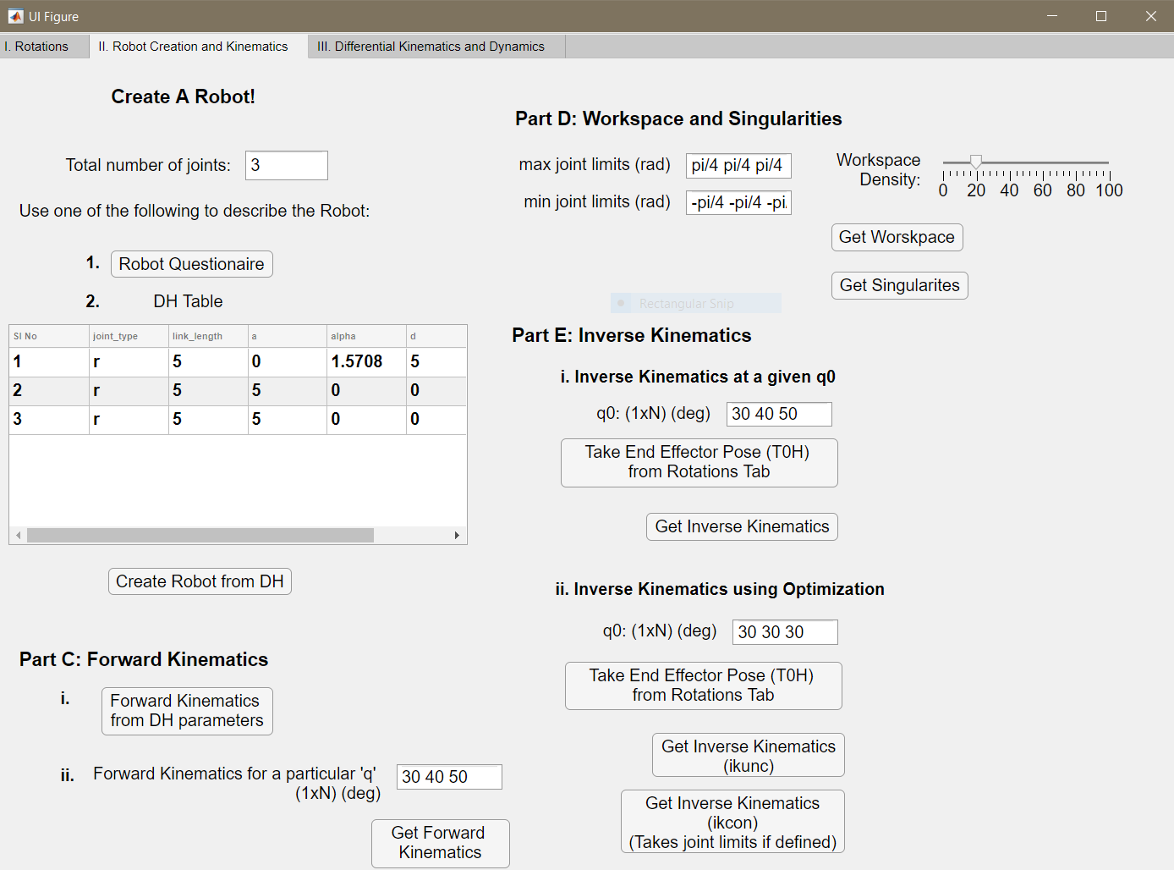

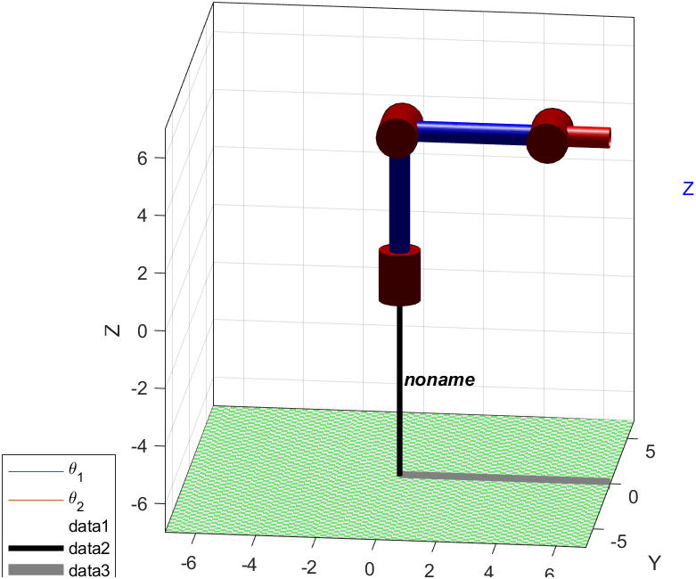

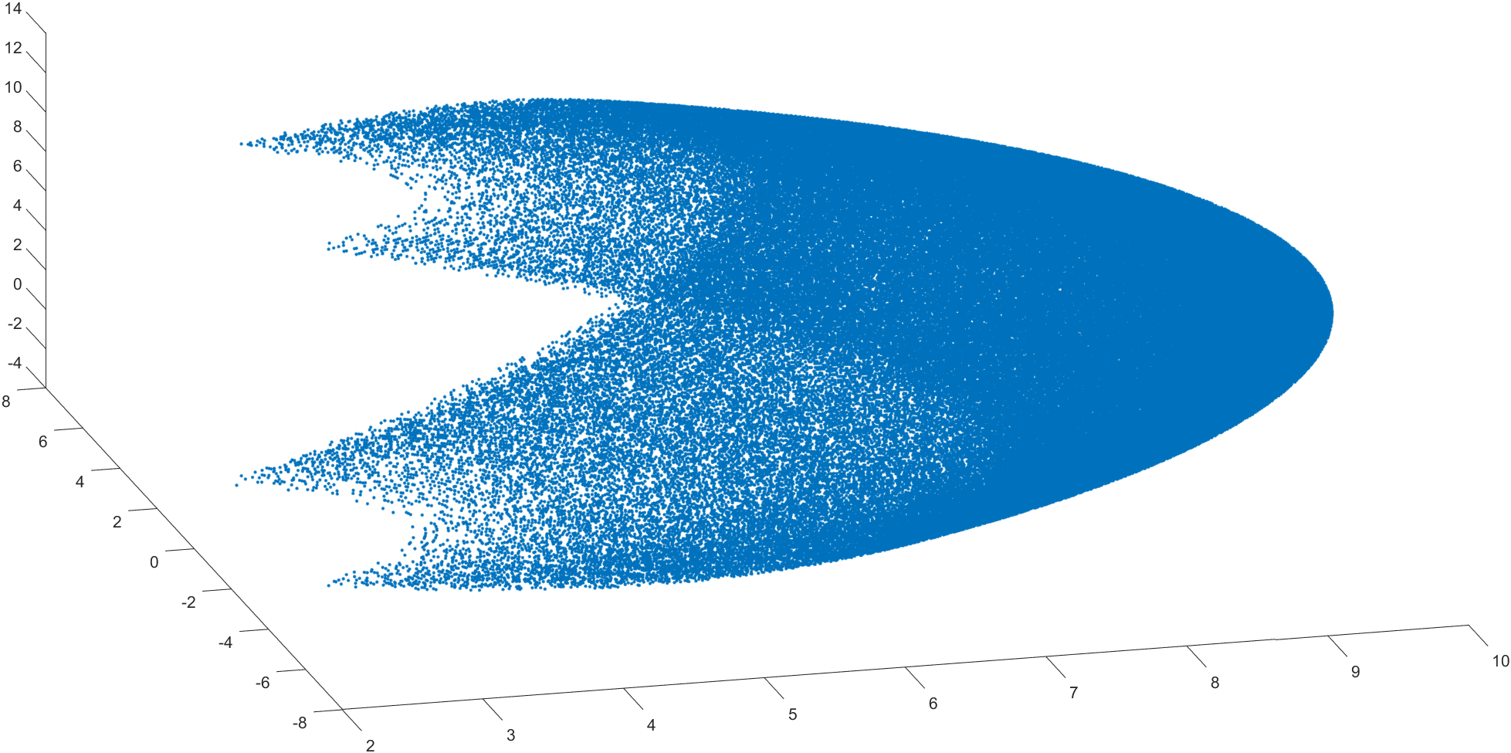

The workspace is seen to be 3 dimensional for the joint limits +/- [pi/4, pi/4, pi/4]

The following forward kinematics were obtained. Again showing three dimensional reach.

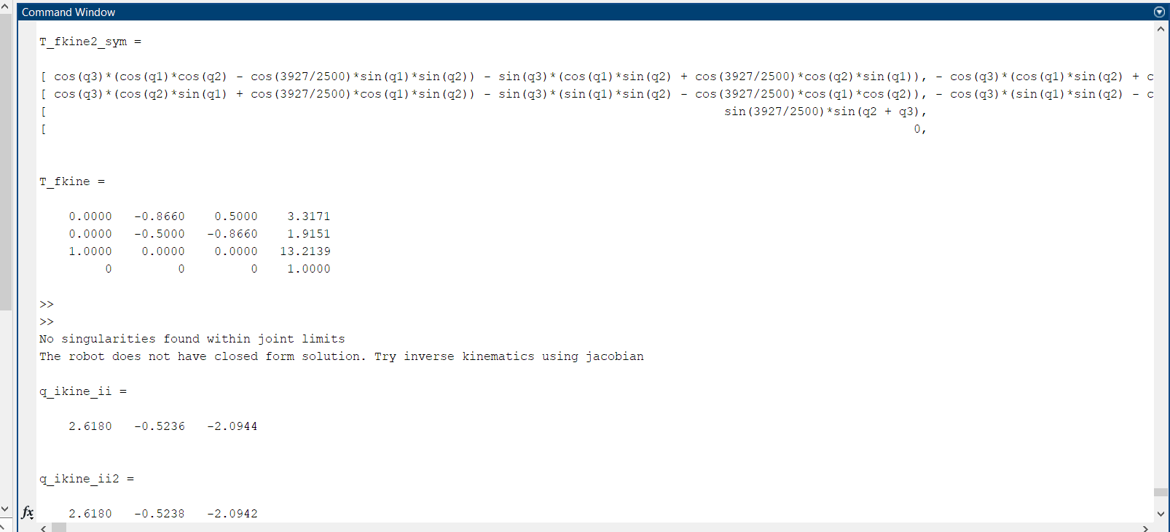

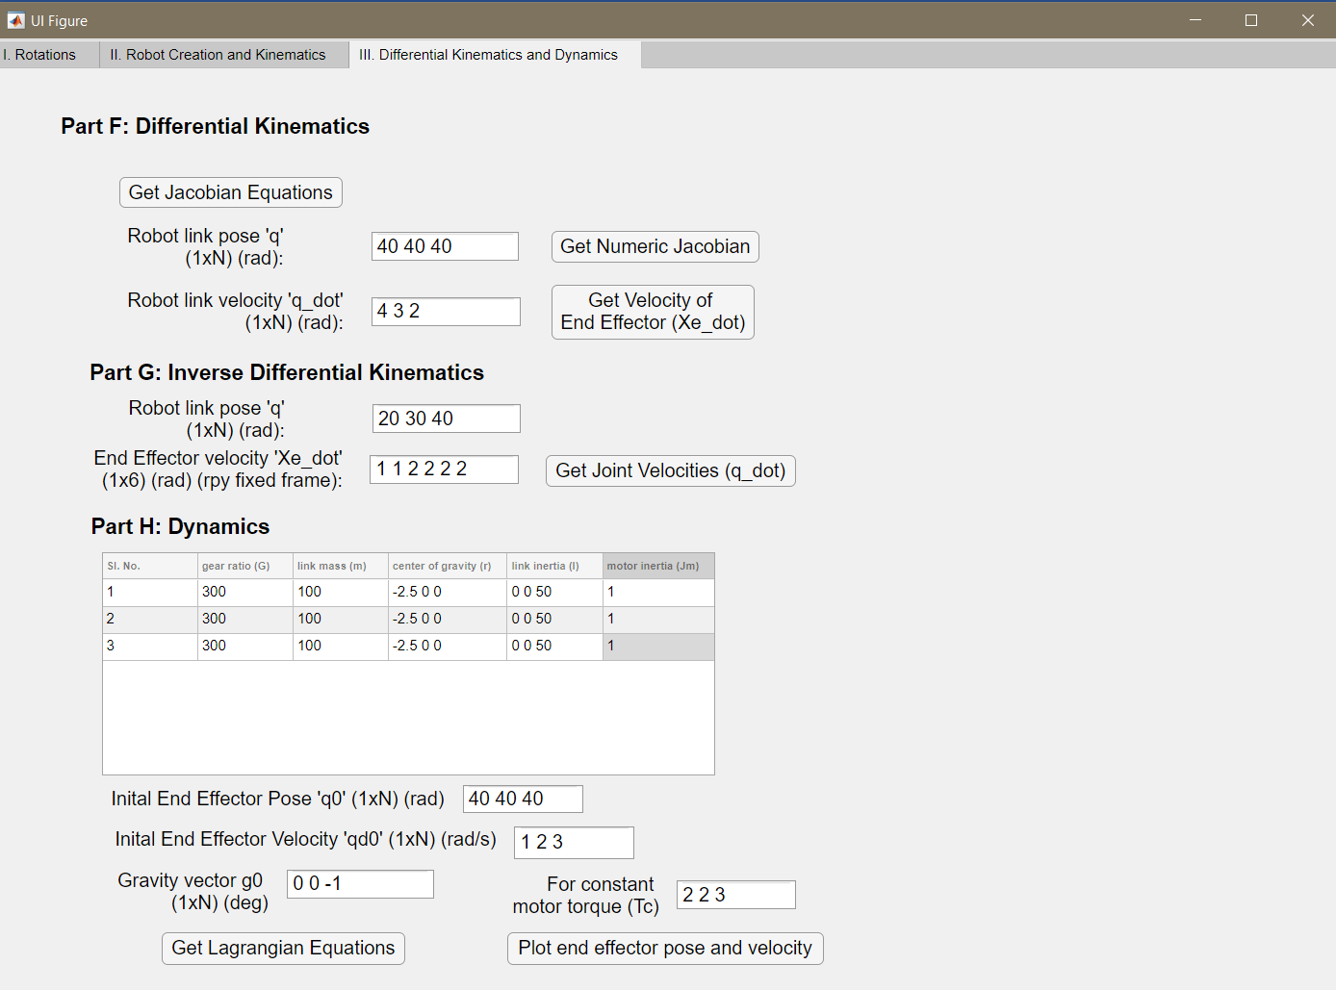

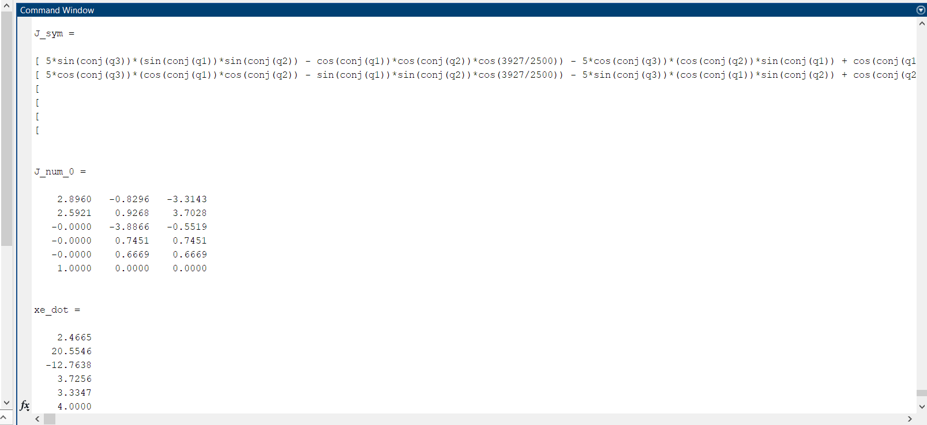

Dynamics Equations yielded the following results:

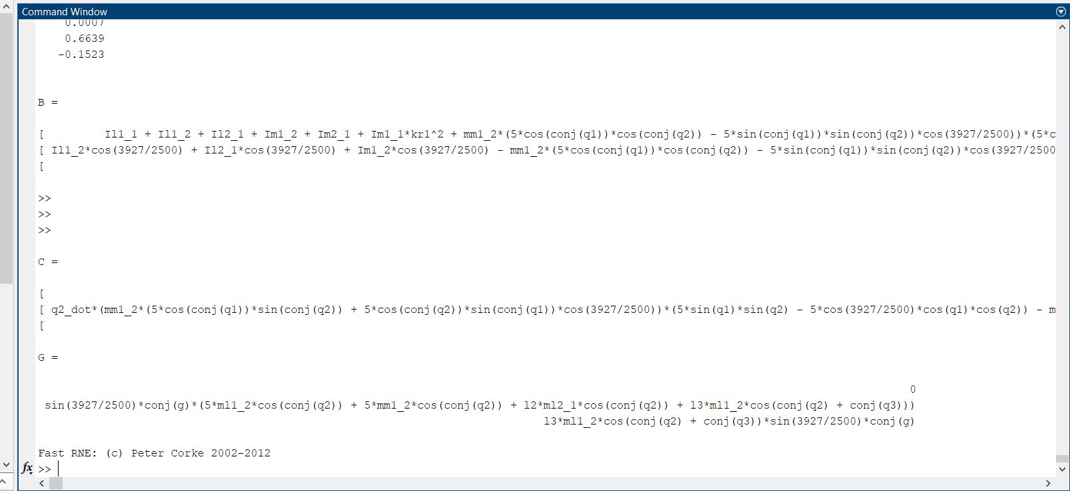

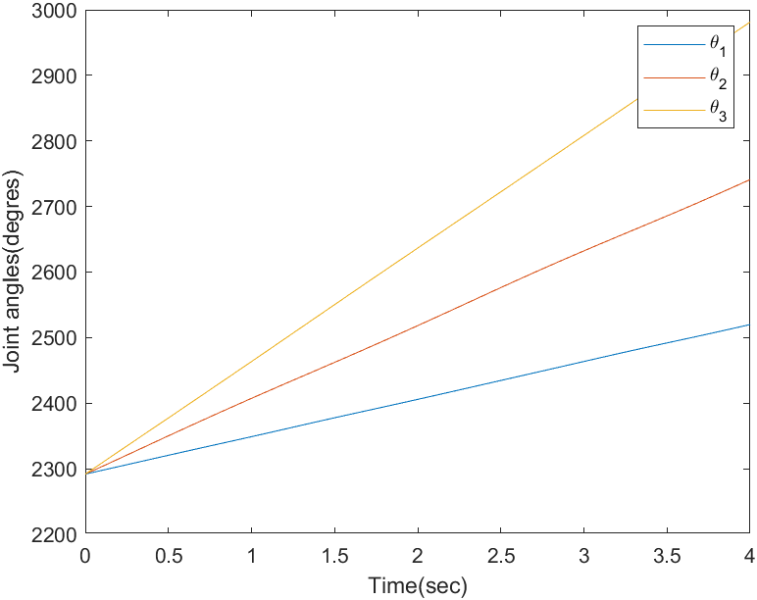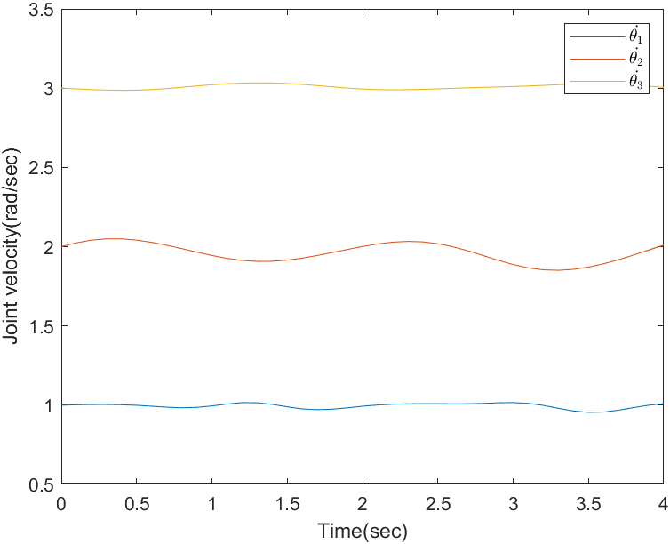

**Example 3: Controls (Force and Motion Control)**

The control portion of the project has been implemented separate from the GUI. This can be run directly using matlab/Simulink using the two folders present in the controls sub-folder.

Steps to run controls:

* Open Simulink file
* Press initialize
* Press Play button
* Press Plots

PART A: Operational space inverse dynamics control

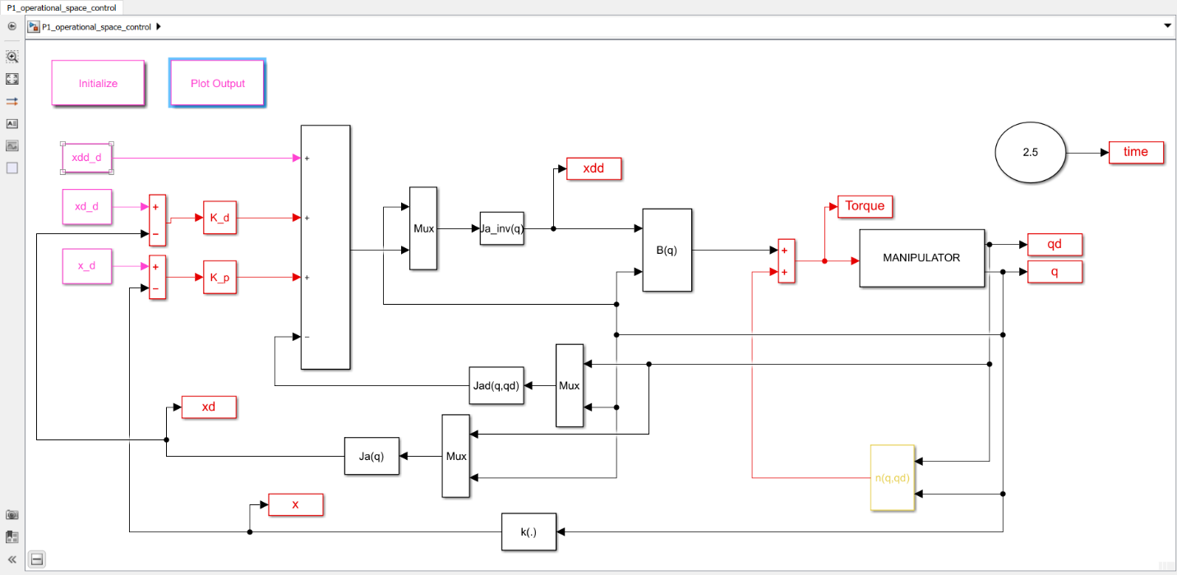

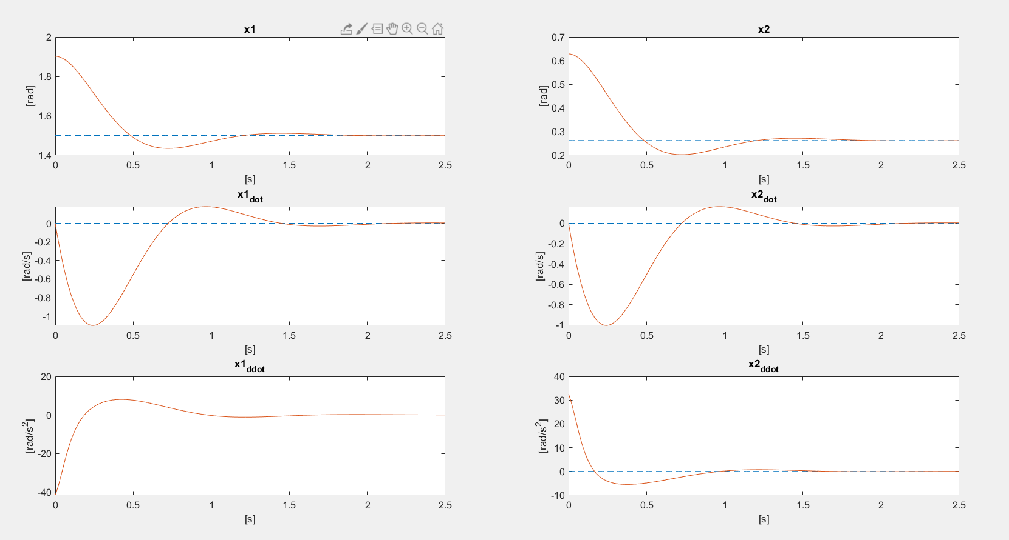

PART B: Force control via compliance control

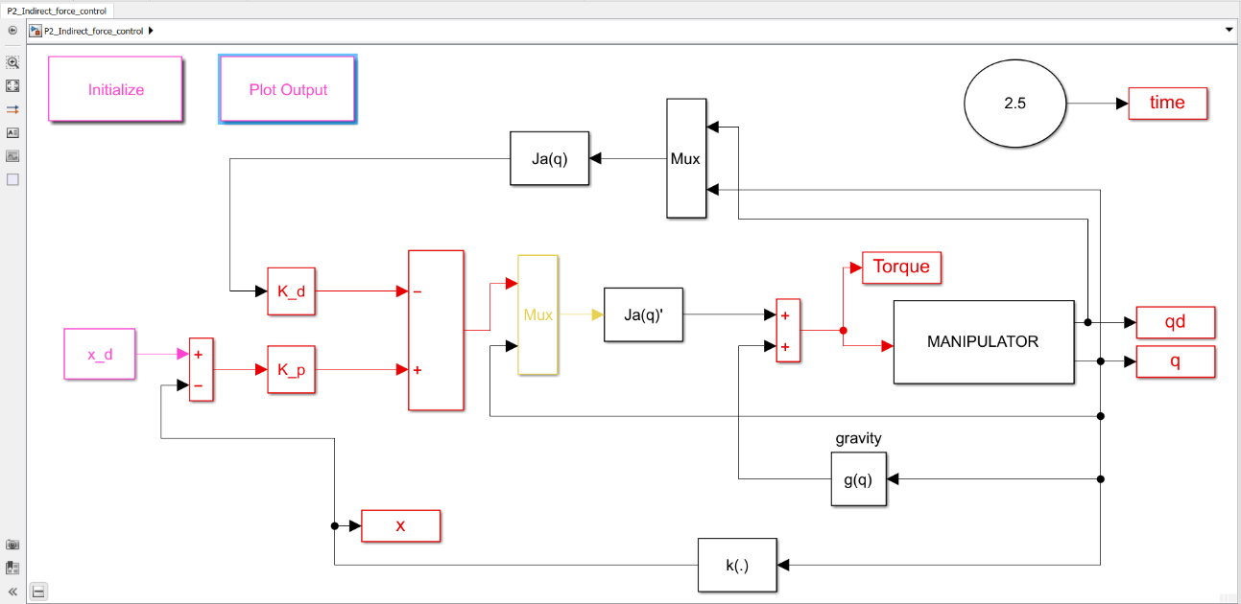

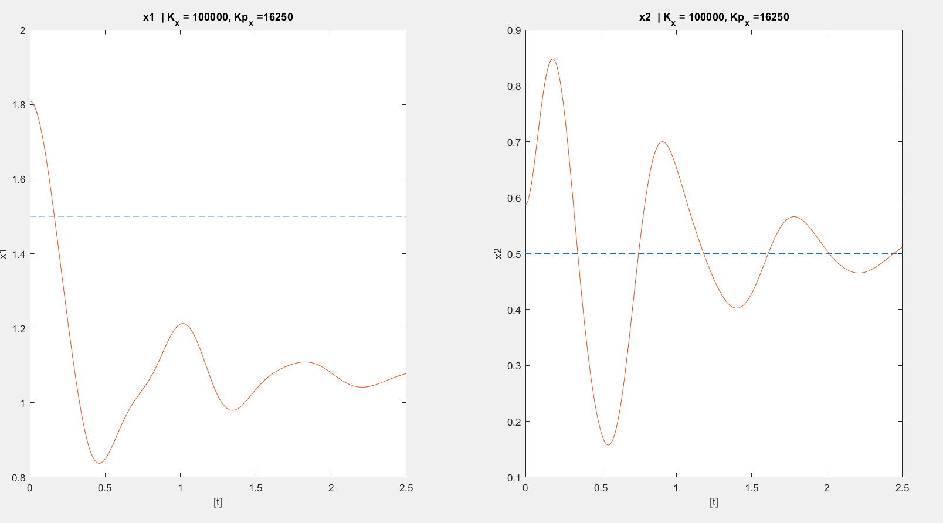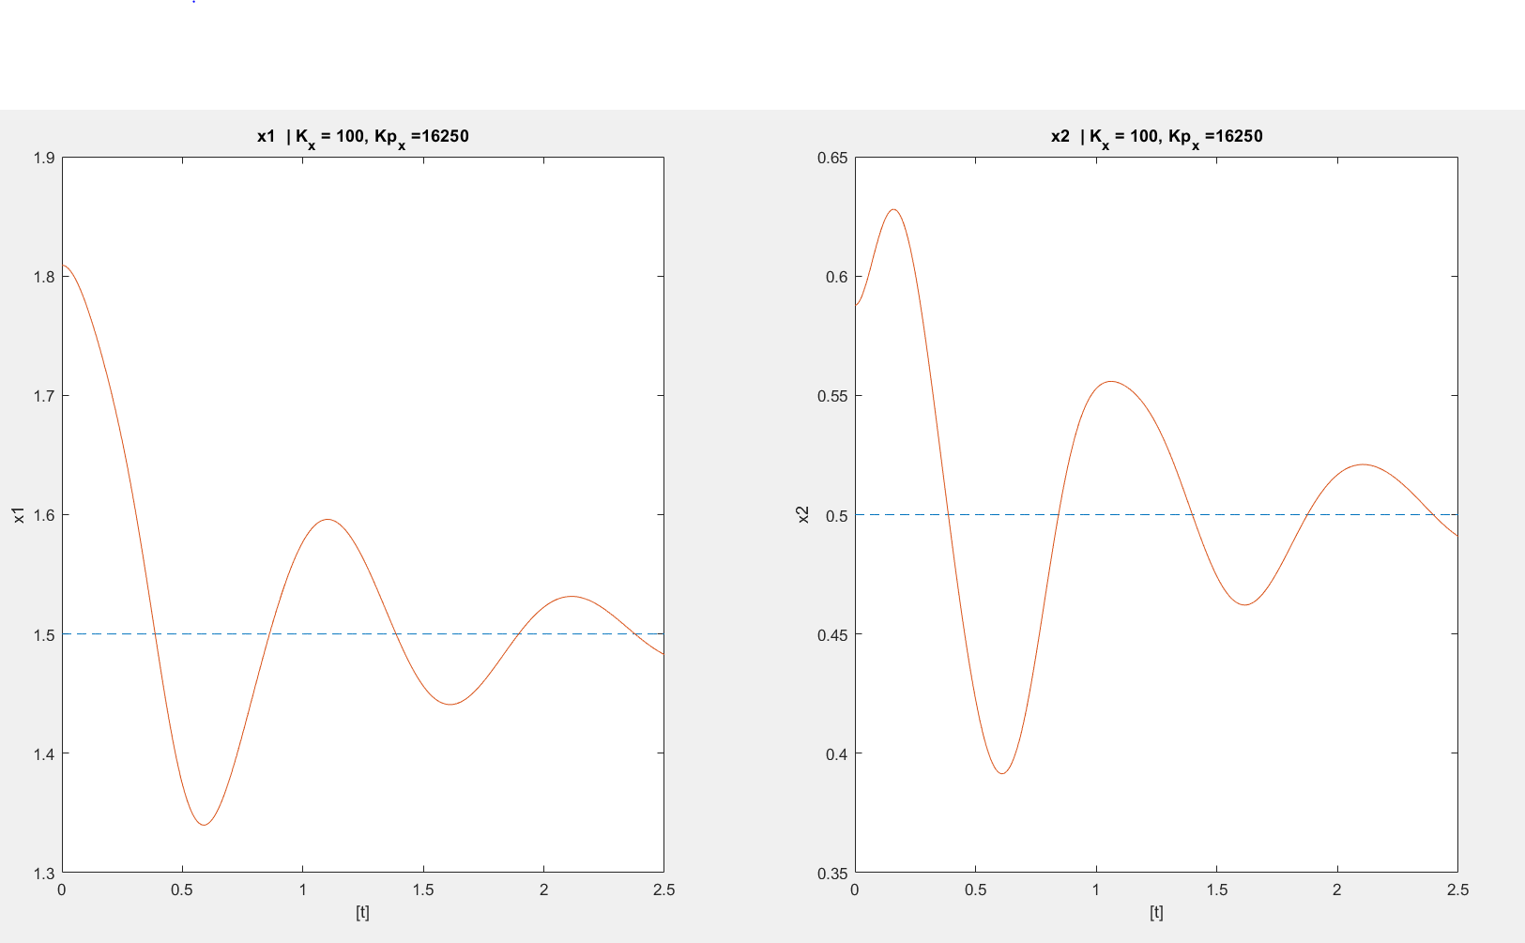

**APPENDIX:**

**Conversion of information provided by the user to DH parameters of the robot**

The program first asks for the number of links in your robot arm and then asks you which type of link the first link is. Remember, a prismatic link is a link that extends forward and a revolute link is a link that rotates about an axis. All rotations and translations are about a global frame xyz represented in the figure, which means x and y represent the plane of the paper and z axis is coming out of the paper if the robot manipulator is drawn on a sheet of paper.

Z axis

Y axis

X axis

Steps to generate the DH parameters –

1. The program asks for number of links and hence you must count the total number of links in your robotic arms and input that number.
2. It will then ask you for the type of link. Press ‘p’ for prismatic and ‘r’ for revolute. Depending on which type of link you chose, the program may ask you different questions.
3. First, it will ask you ‘'How far does this revolute/prismatic link go?’ which simply means the length of your link.
4. It will then ask 'Which axis does this prismatic/revolute link extend towards?’ and you need to define it in terms of either x, y or z axis by typing ‘x’, ‘y’ or ‘z’.
5. It will then ask 'About what axis does this revolute joint rotate?’ for the case of revolute joints and you need to define the axis about which this link is rotating, again in terms of x, y and z.
6. Repeat steps 2 – 5 until all information of the links is gathered.

**Examples of User Information to DH Parameter conversion –**

Note: All figures have been taken from Robotics Modelling, Planning and Control - Siciliano, B., Sciavicco, L., Villani, L., Oriolo, G

Example 1: Three link planar arm



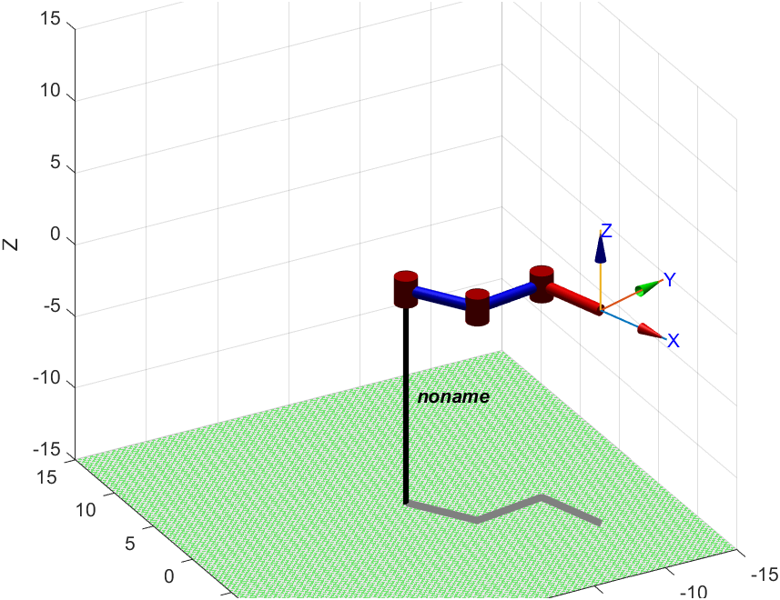

Collecting Robot Link Parameters...

NOTE: All rotations and translations to be provided according to global xyz frame.

What kind of joint is joint1? (p for prismatic, r for revolute):r

About what axis does this revolute joint rotate? (x, y or z): z

Along which axis does the link connected to the revolute joint extend? (x, y or z): x

How far does the link from this revolute joint go?: 5

What kind of joint is joint2? (p for prismatic, r for revolute):r

About what axis does this revolute joint rotate? (x, y or z): z

Along which axis does the link connected to the revolute joint extend? (x, y or z): x

How far does the link from this revolute joint go?: 5

What kind of joint is joint3? (p for prismatic, r for revolute):r

About what axis does this revolute joint rotate? (x, y or z): z

Along which axis does the link connected to the revolute joint extend? (x, y or z): x

How far does the link from this revolute joint go?: 5

s =

'Rz(q1).Tx(L1).Rz(q2).Tx(L2).Rz(q3).Tx(L3)'

>> dh = DHFactor(s);

Undefined function or variable 'DHFactor'.

Did you mean:

>> startup_rvc

Robotics, Vision & Control: (c) Peter Corke 1992-2011 http://www.petercorke.com

- Robotics Toolbox for Matlab (release 9.10)

- pHRIWARE (release 1.1): pHRIWARE is Copyrighted by Bryan Moutrie (2013-2019) (c)

Run rtbdemo to explore the toolbox

- Machine Vision Toolbox for Matlab (release 3.4)

>> dh = DHFactor(s);

In DHFactor

Rz(q1).Tx(L1).Rz(q2).Tx(L2).Rz(q3).Tx(L3)

Rz(q1).Tx(L1).Rz(q2).Tx(L2).Rz(q3).Tx(L3)

Rz(q1).Tx(L1).Rz(q2).Tx(L2).Rz(q3).Tx(L3)

initial merge + swap

Rz(q1).Tx(L1).Rz(q2).Tx(L2).Rz(q3).Tx(L3)

joint vars to Z

Rz(q1).Tx(L1).Rz(q2).Tx(L2).Rz(q3).Tx(L3)

0---------------------------------------

Rz(q1).Tx(L1).Rz(q2).Tx(L2).Rz(q3).Tx(L3)

1---------------------------------------

** deal with Ry/Ty

Rz(q1).Tx(L1).Rz(q2).Tx(L2).Rz(q3).Tx(L3)

adding: DH(null, 0, 0, 0) += Rz(q1)

adding: DH(q1, 0, 0, 0) += Tx(L1)

adding: DH(null, 0, 0, 0) += Rz(q2)

adding: DH(q2, 0, 0, 0) += Tx(L2)

adding: DH(null, 0, 0, 0) += Rz(q3)

adding: DH(q3, 0, 0, 0) += Tx(L3)

DH(q1, 0, L1, 0).DH(q2, 0, L2, 0).DH(q3, 0, L3, 0)

In DHFactor, parseString is done

>> r = eval(dh.command('myrobot'))

Error using evalin

Undefined function or variable 'L1'.

Error in opaque/eval (line 15)

[varargout{1:nargout}] = evalin('caller', tryVal);

>> syms L1 L2 L3

r = eval(dh.command('myrobot'))

r =

myrobot (3 axis, RRR, stdDH, fastRNE)

+---+-----------+-----------+-----------+-----------+-----------+

| j | theta | d | a | alpha | offset |

+---+-----------+-----------+-----------+-----------+-----------+

| 1| q1| 0| L1| 0| 0|

| 2| q2| 0| L2| 0| 0|

| 3| q3| 0| L3| 0| 0|

+---+-----------+-----------+-----------+-----------+-----------+

grav = 0 base = 1 0 0 0 tool = 1 0 0 0

0 0 1 0 0 0 1 0 0

9.81 0 0 1 0 0 0 1 0

0 0 0 1 0 0 0 1

Example 2: Anthropomorphic Arm



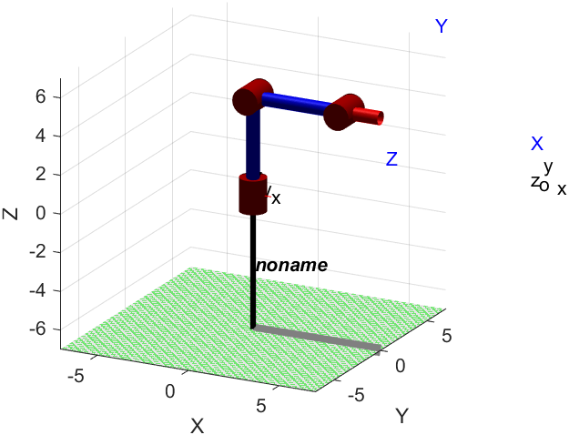

Collecting Robot Link Parameters...

NOTE: All rotations and translations to be provided according to global xyz frame.

What kind of joint is joint1? (p for prismatic, r for revolute):r

About what axis does this revolute joint rotate? (x, y or z): y

Along which axis does the link connected to the revolute joint extend? (x, y or z): y

How far does the link from this revolute joint go?: 5

What kind of joint is joint2? (p for prismatic, r for revolute):r

About what axis does this revolute joint rotate? (x, y or z): z

Along which axis does the link connected to the revolute joint extend? (x, y or z): x

How far does the link from this revolute joint go?: 5

What kind of joint is joint3? (p for prismatic, r for revolute):r

About what axis does this revolute joint rotate? (x, y or z): z

Along which axis does the link connected to the revolute joint extend? (x, y or z): x

How far does the link from this revolute joint go?: 5

s =

'Ry(q1).Ty(L1).Rz(q2).Tx(L2).Rz(q3).Tx(L3)'

In DHFactor

Ry(q1).Ty(L1).Rz(q2).Tx(L2).Rz(q3).Tx(L3)

Ry(q1).Ty(L1).Rz(q2).Tx(L2).Rz(q3).Tx(L3)

Ry(q1).Ty(L1).Rz(q2).Tx(L2).Rz(q3).Tx(L3)

initial merge + swap

Ry(q1).Ty(L1).Rz(q2).Tx(L2).Rz(q3).Tx(L3)

ReplaceToZ: Ry(q1) := Rx(-90)Rz(q1)Rx(+90)

joint vars to Z

Rx(-90).Rz(q1).Rx(+90).Ty(L1).Rz(q2).Tx(L2).Rz(q3).Tx(L3)

0---------------------------------------

ReplaceY: Rx(+90)Ty(L1) := Tz(L1)Rx(+90)

Rx(-90).Rz(q1).Tz(L1).Rx(+90).Rz(q2).Tx(L2).Rz(q3).Tx(L3)

1---------------------------------------

Rx(-90).Rz(q1).Tz(L1).Rx(+90).Rz(q2).Tx(L2).Rz(q3).Tx(L3)

1---------------------------------------

** deal with Ry/Ty

Rx(-90).Rz(q1).Tz(L1).Rx(+90).Rz(q2).Tx(L2).Rz(q3).Tx(L3)

adding: DH(null, 0, 0, 0) += Rz(q1)

adding: DH(q1, 0, 0, 0) += Tz(L1)

adding: DH(q1, L1, 0, 0) += Rx(+90)

adding: DH(null, 0, 0, 0) += Rz(q2)

adding: DH(q2, 0, 0, 0) += Tx(L2)

adding: DH(null, 0, 0, 0) += Rz(q3)

adding: DH(q3, 0, 0, 0) += Tx(L3)

Rx(-90).DH(q1, L1, 0, 90).DH(q2, 0, L2, 0).DH(q3, 0, L3, 0)

In DHFactor, parseString is done

r =

myrobot (3 axis, RRR, stdDH, fastRNE)

+---+-----------+-----------+-----------+-----------+-----------+

| j | theta | d | a | alpha | offset |

+---+-----------+-----------+-----------+-----------+-----------+

| 1| q1| L1| 0| pi/2| 0|

| 2| q2| 0| L2| 0| 0|

| 3| q3| 0| L3| 0| 0|

+---+-----------+-----------+-----------+-----------+-----------+

grav = 0 base = 1 0 0 0 tool = 1 0 0 0

0 0 0 1 0 0 1 0 0

9.81 0 -1 0 0 0 0 1 0

0 0 0 1 0 0 0 1