**Homework 3**

**Name: Raka Dalal**

I have taken step size=1000 to reduce the time of computation.

Original accuracy=precision @ 1 = 0.893

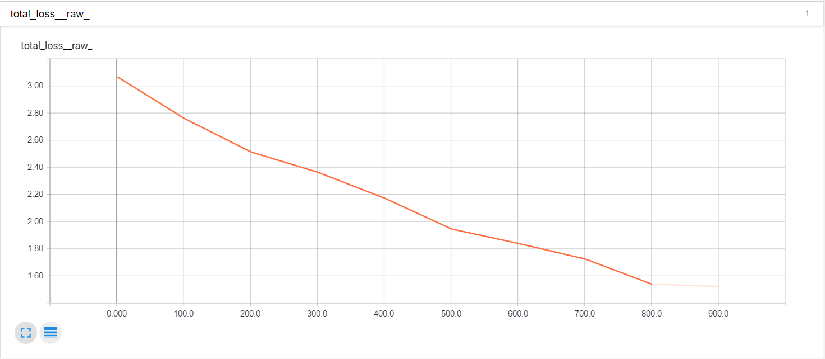

Attempts to increase or decrease accuracy:

1. I increased the number of convolutional layers from 2 to 3.

Accuracy =precision @ 1 = 0.899

When I increase the number of convolutional layers in a convolutional neural network, it can more generalize which is proportional to accuracy, i.e., higher the generalization, better the accuracy. The reverse is true for decreasing the number of convolutional layers in a convolutional neural network.

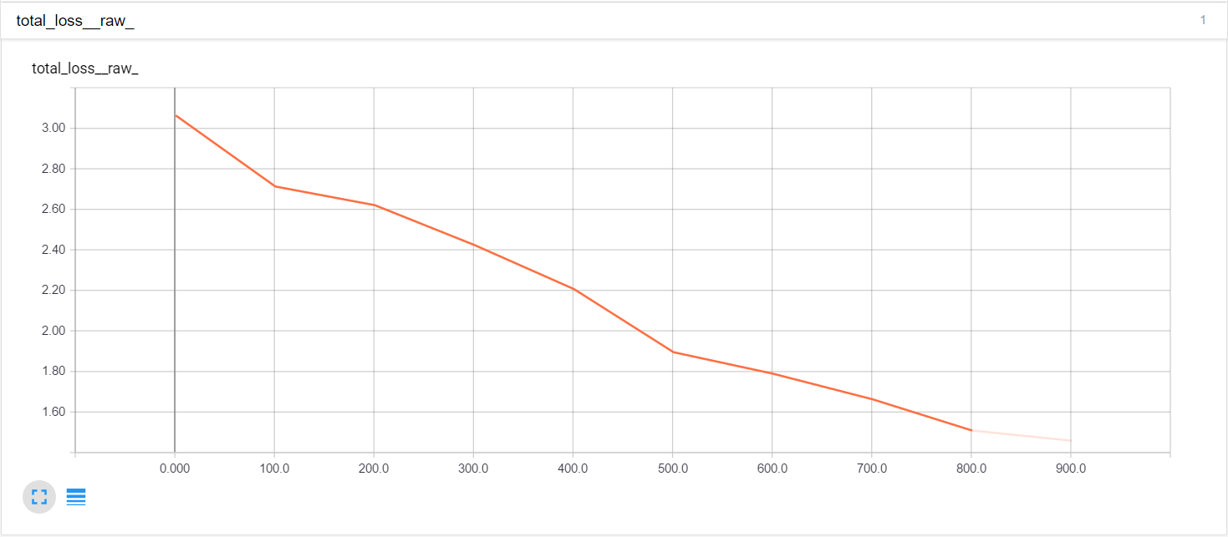

Also, I decreased the number of convolutional layers from 2 to 1.

Accuracy =precision @ 1 = 0.878

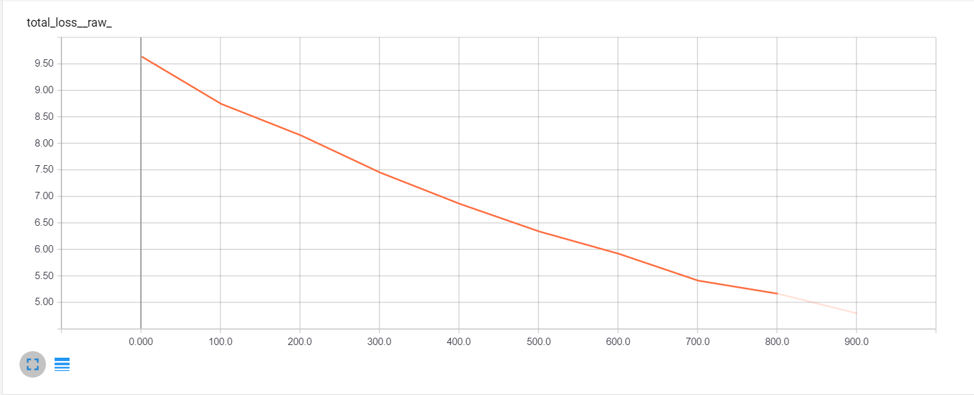

1. I removed distortion from input which decreased the accuracy.

Accuracy=precision @ 1 = 0.891

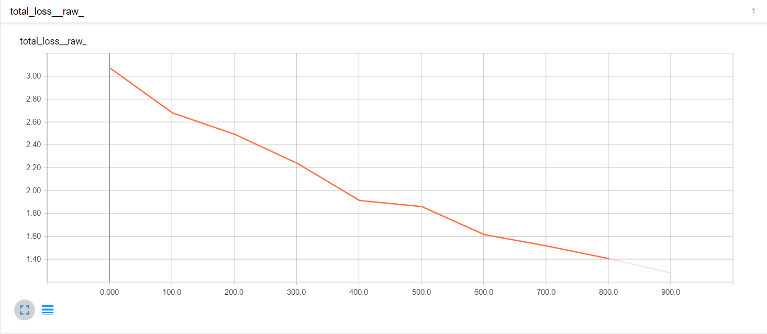

Distortion means adding noise to the input. Injecting carefully chosen noise can speed convergence in the backpropagation training of a convolutional neural network (CNN). The Noisy CNN algorithm speeds training on average because the backpropagation algorithm is a special case of the generalized expectation–maximization (EM) algorithm and such carefully chosen noise always speeds up the EM algorithm on average. The Noisy CNN (NCNN) algorithm uses the noisy-EM result to produce a hyperplane in noise space that separates helpful noise from harmful noise.

So, removing distortion from input will decrease the accuracy.