**X-Ray Image Classification to Identify Pneumonia**

**Author:** Rakat Murshed  
**Contact:** rakatmurshed13@gmail.com

**1. Introduction**

Pneumonia is a serious respiratory infection that primarily affects the lungs and can lead to severe health complications if not treated promptly. Early and accurate diagnosis is crucial for effective treatment. Chest X-ray imaging is a common tool used by healthcare professionals to detect pneumonia. This project aims to develop a Convolutional Neural Network (CNN) model to automatically classify chest X-ray images into two categories: Normal and Pneumonia. By leveraging deep learning techniques, the model can assist in the early detection of pneumonia, potentially improving patient outcomes.

**2. Methodology**

**2.1 Data Collection**

The dataset used in this project consists of chest X-ray images categorized into two classes: NORMAL and PNEUMONIA. These images were collected and organized into respective folders, allowing for straightforward labeling of the data.

**2.2 Image Processing**

To prepare the images for model training, the following preprocessing steps were applied:

* **Resizing**: All images were resized to 128x128 pixels to ensure uniformity and reduce computational load.
* **Normalization**: The pixel values of the images were normalized to a range of 0 to 1 to stabilize the training process.
* **Data Augmentation**: Data augmentation techniques such as rotation, width and height shifts, shear, zoom, and horizontal flip were used to increase the diversity of the training data and improve the model’s generalization ability.

**2.3 Model Architecture**

A custom Convolutional Neural Network (CNN) was designed for this classification task. The architecture includes:

1. **Convolutional Layers**: Three convolutional layers with increasing filter sizes (32, 64, 128) were used to extract spatial features from the images.
2. **MaxPooling Layers**: Each convolutional layer was followed by a max-pooling layer to reduce the spatial dimensions of the feature maps and control overfitting.
3. **Flatten Layer**: The 2D feature maps were flattened into a 1D feature vector.
4. **Fully Connected Layers**: Two fully connected layers were added, with the final layer using a sigmoid activation function to output a probability score for the Pneumonia class.

**2.4 Training Procedure**

The model was trained using the Adam optimizer with a binary cross-entropy loss function. A 3-fold cross-validation strategy was employed to evaluate the model’s performance across different data splits. Early stopping was implemented to halt training if the validation loss did not improve for two consecutive epochs, thereby preventing overfitting.

**2.5 Evaluation Metrics**

The performance of the model was assessed using the following metrics:

* **Mean Squared Error (MSE)**: Measures the average of the squared differences between predicted and actual values, with lower values indicating better model performance.
* **R-squared (R2) Score**: Indicates the proportion of variance in the dependent variable that is predictable from the independent variables. Higher values indicate a better fit.

**2.6 Error Analysis**

To analyze the model’s performance, bar charts were generated to visualize the MSE and R2 scores for both the training and validation sets across each fold in the cross-validation.

**3. Results**

The model was trained and evaluated over 10 epochs for each fold, and the results were recorded for both training and validation sets. The following summarizes the performance metrics:

**3.1 Performance Metrics**

* **Training MSE**: The mean squared error for the training set ranged from approximately 0.05 to 0.08 across the different folds.
* **Validation MSE**: The validation mean squared error ranged from approximately 0.06 to 0.07, indicating that the model generalized well to unseen data.
* **Training R2 Score**: The R2 score for the training data varied between 0.58 and 0.72, suggesting that the model captured a significant amount of variance in the training data.
* **Validation R2 Score**: The validation R2 score ranged from 0.59 to 0.68, indicating reasonable predictive power on the validation data.

**3.2 Error Analysis**

The following bar charts illustrate the distribution of the MSE and R2 scores across the folds for both training and validation sets:

**Training and Validation Mean Squared Error and Training and Validation R2 Score**

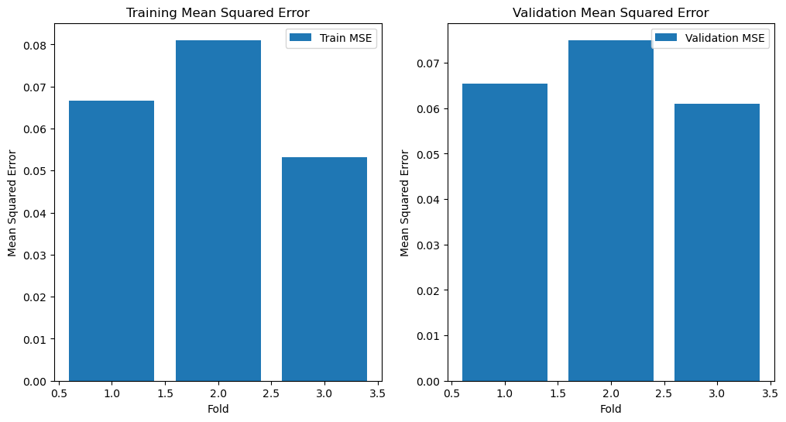

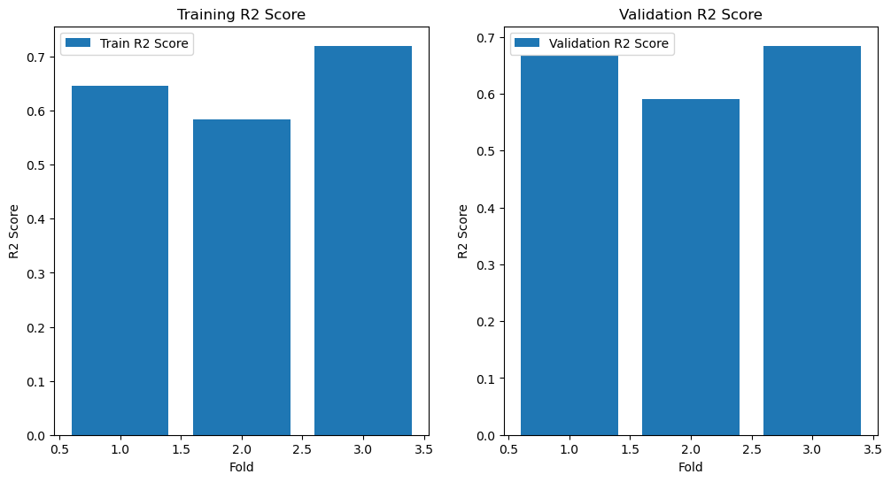

The error analysis shows a consistent performance across the different folds, with no significant overfitting or underfitting observed.

**4. Conclusion**

This project successfully developed a CNN-based model for classifying chest X-ray images into Normal and Pneumonia categories. The model was trained using a robust cross-validation strategy, and the results indicate that it can effectively distinguish between the two classes. The use of data augmentation and early stopping helped to improve the model’s generalization capabilities.

**5. Future Work**

Potential areas for improvement and future work include:

* Experimenting with deeper and more complex CNN architectures to further improve accuracy.
* Incorporating additional data preprocessing techniques to enhance image quality and feature extraction.
* Expanding the dataset to include more diverse cases, which could improve the model’s ability to generalize across different populations.

By refining these aspects, the model can become a more reliable tool in the early detection of pneumonia, potentially aiding in quicker and more accurate diagnoses.