Real-time/Field-Based Research Project Report
On
Weather Details of a City

A dissertation submitted to the Jawaharlal Nehru Technological University, Hyderabad in partial fulfillment of the requirement for the award of degree of

BACHELOR OF TECHNOLOGY IN COMPUTER SCIENCE AND ENGINEERING

Submitted by

P RAKESH (22B81A6694)
K RAVI TEJA (22B81A6696)
P SANDEEP (22B81A66B0)

Under the Guidance of
Mrs.K.Soujanya Bharathi



Department of Computer Science and Engineering
CVR COLLEGE OF ENGINEERING
(An UGC Autonomous Institution, Affiliated to JNTUH, Accredited by NBA, and NAAC)
Vastunagar, Mangalpalli (V),
Ibrahimpatnam (M),
Ranga Reddy (Dist.) - 501510, Telangana State.

2023-24



CVR COLLEGE OF ENGINEERING
(An UGC Autonomous Institution, Affiliated to JNTUH,
Accredited by NBA, and NAAC)
Vastunagar, Mangalpalli (V), Ibrahimpatnam (M), Ranga Reddy (Dist.) - 501510, Telangana State.

DEPARTMENT OF COMPUTER SCIENCE AND ENGINEERING

CERTIFICATE
This is to certify that the project work entitled “WEATHER DETAILS OF A CITY” by P RAKESH (22B81A6694) ,K RAVI TEJA(22B81A6696) ,P SANDEEP(22B81A66B0) in partial fulfillment of the requirement for the award of the degree of Bachelor of Technology in Computer Science and Engineering(Artificial Intelligence & Machine Learning), during the academic year 2023-2024.

Professor-in-charge RFP Professor and Head, CSE(AI & ML)
(Dr. Lakshmi H N)

DECLARATION

I hereby declare that this project report titled “WEATHER DETAILS OF A CITY” submitted to the Department of Computer Science and Engineering(Artificial Intlligence & Machine Learning), CVR College of Engineering, is a record of original work done by me. The information and data given in the report is authentic to the best of my knowledge. This RFP report is not submitted to any other university or institution for the award of any degree or diploma or published at any time before.

P RAKESH(22B81A05Y6)
K RAVI TEJA(22B81A6696)
P SANDEEP(22B81A66B0)

Date:
Place:

General guidelines for RFP Final report
- All the students should refer to the project course and adhere to the deadlines/ timelines of various activities. These dates are subject to minor changes, and proximity to the dates may be assumed for all the activities or events during project work. In case of any changes, it will be communicated by the RFP Section Coordinator, and it should be updated in Project work.
- Ensure that suggestions/corrections discussed during the internal evaluations are incorporated in the final report.
- Formats of the project title page and certificates given in this handout should be strictly adhered to.
- Submit the following at the time of final report submission:
Spiral bound copies of RFP (One for Dept Library and One copy per each student in the group). Soft copy of the Project final document (PDF format), Documentation and
Executable code.
The sequence in which the project document should be arranged, and bound should be as follows:
- Cover Page
- Inside cover page
- Certificate and/or Certificate from external guide (if any)
- Declaration
- Acknowledgement
- Abstract
- Table of content
- List of tables
- List of figures
- Abbreviations, symbols, and nomenclature (if any)
- Chapters
1. Introduction
2.Literature Survey
3.Requirement Analysis
4.Design
5.Implementation and Testing
6.Conclusion
- Appendices
- References
- List of papers published, based on the report (if any)

REFERENCES

Websites:
- https://www.w3schools.com/
- https://www.javatpoint.com/
- https://www.geeksforgeeks.org/
Project Report format:
Paper quality | Printed on white bond paper, weight 70 GSM
Paper Size | The standard A4
Manuscript Preparation | MS Word and LaTeX
Language | Indian English.  Check for consistent spelling of names, terms, and abbreviations, including tables and figures captions.
Size of  Project  Report | The number of pages of the Report should be preferably between 40-70 pages
Font, Size, Line spacing | Times New Roman of 12pts with1.5 line spacing.
Margins | A margin of 3.75cm (1½ inch) is to be given on the binding edge while on the other side it is to be 2.5cm(1inch).
Binding | The report submitted for examination must be hard bind and printed one side.
Cover Page Color | Cover Page-Black
Justification | - The text should be fully justified.  - The text in the tables should be left justified.
Pagination | •The page numbering, starting from acknowledgements and till the beginning of the introductory chapter, should be printed in small Roman numbers, i.e,i, ii, iii, iv...  •The page number of the first page of each chapter should not be printed (but must be accounted for).  •All page numbers from the Introduction chapter page and each chapter should be printed using Arabic numerals, i.e.1, 2, 3, 4, 5...  •All printed page numbers should be located at the bottom center of the page.
Chapters | Each chapter shall begin on a fresh page  1. Introduction  2.Literature Survey  3.Requirement Analysis  4.Design  5.Implementation and Testing  6.Conclusion
Sections and Sub sections | Each topic Title in a chapter should be properly numbered for example: 2.1, 2.2. etc.,(Bold and Upper case) where, the first digit represents the Chapter number, and second digit, the topic Title number.  Sub-topic titles, if any, may be indicated as 1.1.1, 1.1.2, etc. (Bold and title case) i.e. the first digit representing the chapter, the second representing the topic title and the third representing the sub-topic title.

TABLE OF CONTENTS

 |  |  | Page No.
 |  | List of Tables
 |  | List of Figures
 |  | Abbreviations
 |  | Symbols
1 |  | INTRODUCTION | 1
 | 1.1 | Motivation
 | 1.2 | Problem Statement
 | 1.3 | Project Objectives
 | 1.4 | Project Report Organization
2 |  | LITERATURE REVIEW
 | 2.1 | Existing Work
 | 2.2 | Limitations of Existing work
3 |  | REQUIREMENT ANALYSIS
 | 3.1 | Software requirements
 | 3.2 | Hardware requirements
 | 3.3 | User requirements
4 |  | SYSTEM DESIGN
 | 4.0 | Proposed System architecture
 | 4.1 | Proposed methods/ Algorithms
 | 4.2 | Class / Use case / Activity/ Sequence Diagrams
 | 4.3 | Datasets and Technology stack
5 |  | IMPLEMENTATION
 | 5.1 | Front page Screenshot
 | 5.2 | Results and Discussions
 | 5.3 | Testing
 | 5.4 | Validation
6 |  | CONCLUSION
 | 6.1 | Conclusion
 | 6.2 | Future scope
 |  | REFERENCES
 |  | APPENDIX: (If any like Published paper / source code)

List of Tables:

- Table 1: Software Requirements
Requirement | Description
Web Browser | Which runs websites smoothly
V S Code(IDE) | Version 1.8 LTS or above
Operating System | Windows Version 10 or above

- Table 2: Hardware Requirements
Requirement | Description
Computer System | Minimum 4GB RAM, Dual-core Processor
Internet Connection | Stable , minimum 5 Mbps

List of Figures:
- Figure 1: Use Case Diagram
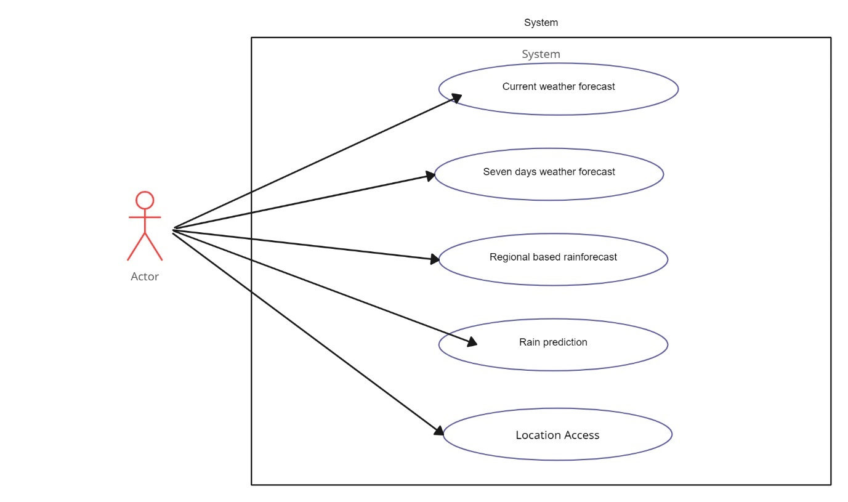

Description: Represents the various interactions between users and the system including registration, login, menu browsing, order and submission.

CHAPTER-1

INTRODUCTION

1.1 MOTIVATION
The motivation behind developing a Sports Equipment Management system can arise from various needs and objectives within athletic organizations, including:
- Inventory Control: Efficiently manage the inventory of sports equipment, ensuring availability for practices, games, and events while minimizing loss or misplacement.
- Resource Optimization: Optimize the allocation of sports equipment resources by tracking usage patterns, identifying surplus or deficient items, and reallocating resources accordingly.
- Maintenance Tracking: Monitor the condition of sports equipment, schedule maintenance tasks, and ensure timely repairs or replacements to prolong the lifespan of equipment and enhance player safety.
- Cost Management: Control costs associated with sports equipment procurement, maintenance, and replacement by implementing effective tracking and management systems.
- Compliance and Safety: Ensure compliance with safety regulations and standards by monitoring equipment safety certifications, conducting regular inspections, and addressing safety concerns promptly.
- Player Performance: Enhance player performance by providing access to well-maintained, properly fitted equipment, thereby reducing the risk of injury and optimizing player comfort and effectiveness.
- Data-Driven Decisions: Utilize data insights from equipment usage, maintenance records, and performance metrics to make informed decisions regarding equipment investments, resource allocation, and operational strategies.
- Streamlined Operations: Streamline administrative processes related to equipment management, such as check-in/check-out procedures, inventory audits, and reporting, to improve overall operational efficiency.
- Enhanced Accountability: Foster accountability among coaches, players, and staff by implementing transparent tracking systems that attribute responsibility for equipment usage, maintenance, and care.
- Long-Term Planning: Support long-term planning and strategic initiatives by maintaining comprehensive records of equipment inventory, usage history, and lifecycle management.
1.2 PROBLEM STATEMENT
Despite the significance of sports equipment management, many athletic organizations struggle with inefficient processes, outdated systems, and inadequate resources for effectively managing their equipment inventory. This often leads to issues such as equipment shortages, safety concerns, budget overruns, and operational inefficiencies. The problem lies in the absence of a comprehensive and user-friendly solution tailored to the unique needs of sports equipment management.
1.3 PROJECT OBJECTIVES
- Develop a User-Friendly Interface: Design and implement an intuitive and user-friendly interface for the Sports Equipment Management system, ensuring accessibility and ease of use for coaches, administrators, and staff members.
- Inventory Tracking and Control: Implement robust inventory tracking capabilities, including barcode scanning, RFID tagging, or similar technologies, to accurately monitor the movement and availability of sports equipment.
- Maintenance Scheduling and Tracking: Integrate features for scheduling routine maintenance tasks, tracking equipment maintenance history, and generating alerts for required repairs or replacements.
- Budget and Procurement Management: Incorporate functionalities for budget planning, purchasing requisitions, vendor management, and cost tracking to facilitate efficient procurement and expenditure management.
- Safety and Compliance Monitoring: Implement tools for monitoring equipment safety certifications, conducting safety inspections, and ensuring compliance with relevant regulations and standards.
- Player Equipment Preferences: Allow players to specify equipment preferences, such as sizes, styles, and preferences, to ensure they have access to suitable and comfortable gear.
- Reporting and Analytics: Provide comprehensive reporting and analytics capabilities to generate insights into equipment utilization, maintenance trends, budget variances, and other key performance indicators.
- Integration with External Systems: Enable integration with other relevant systems, such as team management platforms, scheduling software, and financial systems, to facilitate data exchange and streamline workflows.
- Mobile Accessibility: Develop mobile applications or responsive web interfaces to ensure access to the Sports Equipment Management system from various devices, including smartphones and tablets.
- Scalability and Customization: Design the system to be scalable and customizable, allowing for the accommodation of varying organizational sizes, sports programs, and specific requirements.
1.4 PROJECT REPORT ORGANIZATION
The project report on the development of the Sports Equipment Management system is organized into several key sections to comprehensively document the project's objectives, methodologies, implementation processes, and outcomes. Beginning with the introduction, the report provides an overview of the project's scope, objectives, and significance, while also outlining the problem statement and the motivation behind creating the Sports Equipment Management system. Following the introduction, the literature review delves into existing research, literature, and studies related to sports equipment management, inventory control, and athletic administration, providing insights into key features and best practices observed in similar solutions. The methodology section elucidates the research methodologies, tools, and techniques employed in the project's development, along with an explanation of the development process and methodologies used. Subsequently, the report moves into the requirements analysis, offering a detailed examination of the requirements gathered from stakeholders and users, including both functional and non-functional specifications. The design and architecture section provide an overview of the system architecture and user interface design, supported by descriptions of navigation flow and illustrative wireframes/mockups. Implementation details follow, outlining the coding, testing, and integration processes, along with discussions on challenges faced and mitigation strategies adopted during implementation. Integration and testing are then addressed, discussing the integration of the Sports Equipment Management system with external systems and APIs, as well as the methodologies employed for testing, including unit testing, integration testing, and user acceptance testing. Results and evaluation present findings from testing and evaluation processes, analyzing user feedback, usability metrics, performance benchmarks, and adherence to project objectives. In the discussion section, results are interpreted, strengths and weaknesses identified, and comparisons made with existing solutions, reflecting on the system's contributions to sports equipment management and athletic administration. The conclusion section summarizes key findings, achievements, and contributions of the project, reflecting on lessons learned and offering recommendations for future enhancements. The report concludes with a references section listing all sources cited, followed by appendices containing supplementary materials such as technical documentation, code snippets, and user manuals. This organization ensures a thorough documentation of the project's processes, outcomes, and insights, providing a comprehensive reference for stakeholders and future endeavors.

CHAPTER-2

LITERATURE REVIEW

2.1 EXISTING WORK
Before initiating the development of a Sports Equipment Management system, it's crucial to assess and analyze existing solutions within the realm of sports equipment management and inventory control. Several applications and tools cater to the needs of organizing, tracking, and managing sports equipment within athletic organizations. Notable among these are:
- Active Network: Active Network offers sports equipment management solutions tailored to the needs of sports leagues, clubs, and facilities. It provides features for inventory tracking, equipment checkout, and maintenance scheduling.
- EZ Facility: EZ Facility provides sports equipment management software designed to streamline equipment tracking, maintenance, and inventory control for sports facilities and organizations. It offers features for barcode scanning, maintenance alerts, and reporting.
- Playbook: Playbook is a sports management platform that includes equipment management capabilities. It allows users to track equipment usage, schedule maintenance tasks, and manage inventory levels across multiple locations or teams.
- Athletic Equipment Manager (AEM): AEM is a dedicated sports equipment management software solution that offers features such as equipment tracking, maintenance scheduling, and budget management. It caters specifically to the needs of athletic departments and sports programs.
- Equipment360: Equipment360 is a comprehensive equipment management solution designed for sports organizations and facilities. It provides tools for tracking equipment usage, scheduling maintenance, and generating reports on equipment status and availability.
- Motionsoft: Motionsoft offers sports equipment management software as part of its suite of fitness and sports management solutions. It enables users to track equipment inventory, monitor maintenance tasks, and ensure compliance with safety regulations.
- Stack Sports: Stack Sports provides sports management software that includes features for equipment management, inventory tracking, and maintenance scheduling. It is designed to meet the needs of sports leagues, clubs, and organizations of all sizes.
While these existing solutions offer various features and functionalities for sports equipment management, each has its strengths and limitations. The development of a Sports Equipment Management system will aim to address the shortcomings of existing solutions and offer unique features tailored to the specific requirements of athletic organizations.
2.2 LIMITATIONS OF EXISTING WORK
Despite their utility, existing sports equipment management solutions may have certain limitations that can impact their effectiveness and usability. Some of the key limitations include:
- Complexity: Many existing sports equipment management systems have complex interfaces and features that can be challenging for users to navigate, particularly those with limited technical expertise. This complexity may hinder adoption and utilization by coaches, staff, and volunteers.
- Limited Customization: While some solutions offer customization options, they may be limited in terms of flexibility and adaptability to the unique needs of different sports programs and organizations. Users may require more extensive customization capabilities to tailor the system to their specific requirements.
- Integration Challenges: Integrating existing sports equipment management systems with other software tools and platforms may be difficult or require additional development effort. This can lead to data silos and inefficiencies in managing equipment-related tasks and processes.
- Scalability Issues: Some sports equipment management solutions may lack scalability, making them unsuitable for organizations with expanding equipment inventories or growing user bases. Scalability concerns can arise in terms of performance, data storage, and user access.
- Mobile Accessibility: Not all existing sports equipment management systems offer mobile accessibility or dedicated mobile applications. Limited mobile access can restrict users' ability to manage equipment-related tasks and access important information while on the go.
- Reporting and Analytics: While many solutions provide reporting capabilities, they may lack advanced analytics features for generating insights into equipment usage patterns, maintenance trends, and resource allocation. This can hinder organizations' ability to make data-driven decisions and optimize equipment management processes.
- Data Security Concerns: Users may have concerns about the security and privacy of their data when using third-party sports equipment management systems, particularly if sensitive information such as equipment inventories and usage records is involved. Ensuring robust data security measures is essential to address these concerns and build trust with users.
- Training and Support: Adequate training and ongoing support are essential for maximizing the effectiveness of sports equipment management systems. However, some solutions may lack comprehensive training resources and responsive support services, leading to user frustration and dissatisfaction.
By addressing these limitations and incorporating innovative features and functionalities, a customized Sports Equipment Management system can offer a tailored solution that meets the specific needs and preferences of athletic organizations, coaches, and staff members.

CHAPTER-3

REQUIREMENT ANALYSIS

3.1 SOFTWARE REQUIREMENTS
Software Requirements for Sports Equipment Management:
- User Interface:
  - The application should feature an intuitive and user-friendly interface accessible via web browsers and mobile devices.
  - It should support multiple languages and provide accessibility features for users with disabilities.
- Inventory Management:
  - Users should be able to easily track and manage sports equipment inventory, including items, quantities, and locations.
  - The system should support barcode scanning or RFID tagging for efficient inventory management.
- Maintenance Scheduling:
  - The application should allow users to schedule routine maintenance tasks for sports equipment, including inspections, repairs, and replacements.
  - Maintenance schedules should be customizable, with options for setting recurring tasks and notifications.
- Equipment Tracking:
  - Users should be able to track the movement and usage of sports equipment, including check-in/check-out functionality for equipment loans.
  - The system should provide real-time visibility into equipment availability and status.
- Budget Management:
  - The application should support budget planning and tracking for sports equipment procurement, maintenance, and replacement.
  - Users should be able to allocate funds to different equipment categories and monitor expenses against budget allocations.
- Reporting and Analytics:
  - The system should offer reporting and analytics capabilities to generate insights into equipment usage, maintenance trends, and budget variance.
  - Users should have access to customizable reports and dashboards for monitoring key performance indicators.
- Integration with External Systems:
  - The application should integrate with other relevant systems, such as financial management software and league management platforms, to facilitate data exchange and streamline workflows.
  - Integration with equipment suppliers and vendors may also be necessary for procurement processes.
- Security and Privacy:
  - Robust security measures should be implemented to protect sensitive equipment data from unauthorized access, manipulation, or theft.
  - User authentication and authorization mechanisms should be in place to control access to equipment management functionalities.
- Mobile Accessibility:
  - The application should be accessible via native mobile applications or responsive web interfaces, allowing users to manage equipment on the go.
  - Mobile features may include barcode scanning, equipment check-in/check-out, and maintenance task management.
- User Training and Support:
  - Comprehensive documentation, tutorials, and user guides should be provided to help users navigate the application's features and functionalities.
  - Users should have access to customer support channels for assistance with technical issues or inquiries.
3.2 HARDWARE REQUIREMENTS
To support the functionality and accessibility of the Sports Equipment Management system, the following hardware infrastructure is required:
- Server Infrastructure:
  - Reliable servers with sufficient processing power, memory, and storage capacity to host the application's backend components.
  - High availability and redundancy features to ensure uninterrupted service availability and data integrity.
- Database Server:
  - A dedicated database server to store and manage equipment inventory, maintenance records, and other application data.
  - Support for high availability, scalability, and data integrity features for optimal performance and reliability.
- Networking Equipment:
  - Routers, switches, and firewalls to facilitate communication between client devices and the application's server infrastructure.
  - Network configuration to ensure low latency, high bandwidth, and secure data transmission.
- Client Devices:
  - Desktop computers, laptops, smartphones, and tablets with modern web browsers or native mobile applications installed.
  - Sufficient processing power, memory, and storage capacity to run the application smoothly and handle data synchronization tasks.
- Internet Connectivity:
  - Reliable internet connectivity for both server infrastructure and client devices to ensure seamless communication and data synchronization.
  - High-speed internet with adequate bandwidth to support the application's requirements.
- Backup and Redundancy Systems:
  - Automated backup systems to regularly back up application data and ensure data availability in case of hardware failures or other unforeseen events.
  - Redundant hardware components to minimize downtime and ensure continuous service availability.
- Monitoring and Management Tools:
  - Tools for monitoring the performance, availability, and security of the application's hardware infrastructure.
  - Proactive identification and resolution of issues to maintain optimal system performance and user experience.
- Scalability Considerations:
  - Scalability features such as load balancing, auto-scaling, and distributed computing to accommodate future growth in user demand and data volume.
3.3 USER REQUIREMENTS
User Requirements for Sports Equipment Management:
- User Interface (UI):
  - Easy input of new equipment items, including details such as name, quantity, and location.
  - Clear display of equipment inventory, including availability and status.
  - Intuitive interaction with the system for tasks such as adding, editing, or deleting equipment items.
- Functionality:
  - Ability to add, edit, and delete equipment items as needed.
  - Visibility into equipment availability and status, including check-in/check-out history.
  - Notifications for equipment maintenance tasks and overdue items.
- Notifications:
  - Options for receiving notifications about equipment maintenance tasks, overdue items, and other relevant updates.
  - Customization of notification preferences, such as timing and delivery method.
- Performance:
  - Responsive performance with fast loading times and smooth navigation.
  - Reliable operation with minimal errors or disruptions.
By adhering to these user requirements, the Sports Equipment Management system can effectively meet the needs of athletic organizations, coaches, and staff members involved in managing sports equipment inventory and maintenance tasks.

4. SYSTEM DESIGN
4.0 PROPOSED SYSTEM ARCHITECTURE
The proposed system architecture for Sports Equipment Management involves several interconnected components aimed at facilitating inventory tracking, maintenance scheduling, and reporting. Here's an overview of the key components and their interactions:
- Front-End Interface:
  - The front-end interface serves as the user's primary interaction point with the application.
  - It provides features for managing equipment inventory, scheduling maintenance tasks, and generating reports.
  - Users can easily add, edit, or delete equipment items, as well as schedule maintenance tasks and view reports.
- Back-End Server:
  - The back-end server manages data storage, retrieval, and processing.
  - It handles requests from the front-end interface and interacts with the database to perform CRUD operations on equipment data.
  - Additionally, the server may include logic for generating reports and scheduling maintenance tasks.
- Database:
  - The database stores equipment inventory data, maintenance records, and user information.
  - It maintains a structured schema to organize equipment information efficiently.
  - Equipment data includes fields such as item name, quantity, location, maintenance history, and user assignments.
- Notification Service:
  - A notification service is responsible for sending reminders to users for scheduled maintenance tasks.
  - It may utilize email, SMS, or push notifications to notify users about upcoming maintenance activities.
  - The notification service integrates with the back-end server to retrieve maintenance schedules and trigger notifications accordingly.
- Integration and Communication:
  - The various components of the system communicate through well-defined APIs to exchange data and trigger actions.
  - Integration with external systems, such as financial management software or vendor platforms, may be necessary for procurement and budget management processes.
4.1 PROPOSED METHODS/ALGORITHMS
In the proposed Sports Equipment Management system, several methods and algorithms are crucial to its functionality:
- Inventory Tracking: Accurate tracking of equipment inventory relies on efficient data management algorithms for storing and retrieving equipment information. Techniques such as barcode scanning or RFID tagging can aid in inventory management.
- Maintenance Scheduling: Algorithms for scheduling maintenance tasks should consider factors such as equipment usage patterns, maintenance history, and manufacturer recommendations. Predictive maintenance algorithms may be employed to schedule tasks preemptively based on equipment condition monitoring data.
- Reporting and Analytics: Data analytics algorithms can be utilized to generate insights from equipment usage data, maintenance records, and budget expenditures. Techniques such as data aggregation, trend analysis, and predictive modeling can help in identifying trends, optimizing equipment utilization, and forecasting maintenance requirements.
4.2 CLASS/USE CASE/ACTIVITY/SEQUENCE DIAGRAM
- Class Diagram: The Class Diagram outlines the structure of the system, depicting classes such as Equipment, MaintenanceTask, and User, along with their attributes and relationships. Equipment objects encapsulate data such as item name, quantity, and location, while MaintenanceTask objects represent scheduled maintenance activities. Relationships between classes illustrate associations such as equipment assignments to users and maintenance tasks linked to equipment items.
- Use Case Diagram: Use Case Diagrams depict interactions between actors (users) and the system to accomplish specific tasks. Actors engage in actions such as adding new equipment items, scheduling maintenance tasks, generating reports, and receiving maintenance reminders. These actions represent the primary functionalities of the Sports Equipment Management system from a user's perspective.
- Activity Diagram: Activity Diagrams illustrate the flow of activities or processes within the system, focusing on specific scenarios such as equipment maintenance scheduling. Activities such as equipment check-in, maintenance task creation, and notification triggering are sequenced to depict the steps involved in each process, aiding in understanding the system's dynamic behavior.
- Sequence Diagram: Sequence Diagrams depict interactions between objects or actors in a sequential order, illustrating message exchanges during specific scenarios such as equipment maintenance scheduling. Users interact with the system to perform actions like scheduling maintenance tasks, while the system processes requests and triggers notifications accordingly.
4.3 DATASETS AND TECHNOLOGY STACK
- Datasets: The system may utilize a database to store equipment inventory data, maintenance records, and user information. SQL-based databases such as PostgreSQL or MySQL, or NoSQL databases like MongoDB, can be employed based on the requirements for structured or unstructured data storage.
- Technology Stack: The technology stack for Sports Equipment Management may include front-end technologies such as HTML, CSS, JavaScript, and front-end frameworks like React.js or Vue.js for building the user interface. On the back end, Node.js or Python with frameworks like Express.js or Flask can be used for server-side logic and API development. Databases mentioned earlier can be employed for data storage, and additional technologies like WebSockets or server-sent events (SSE) may be utilized for real-time communication and notifications.
By leveraging these components, methods, and algorithms, the proposed Sports Equipment Management system can effectively track equipment inventory, schedule maintenance tasks, and optimize equipment utilization, thereby enhancing the efficiency of sports organizations and facilities.

5. IMPLEMENTATION
5.1 FRONT PAGE SCREENSHOT
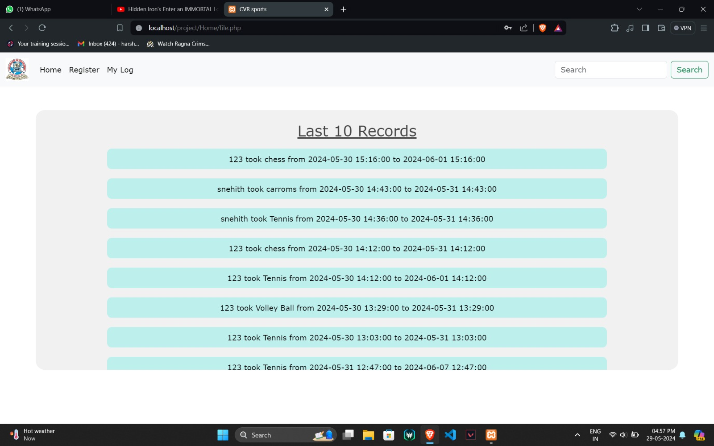

5.2 RESULT AND DISCUSSIONS
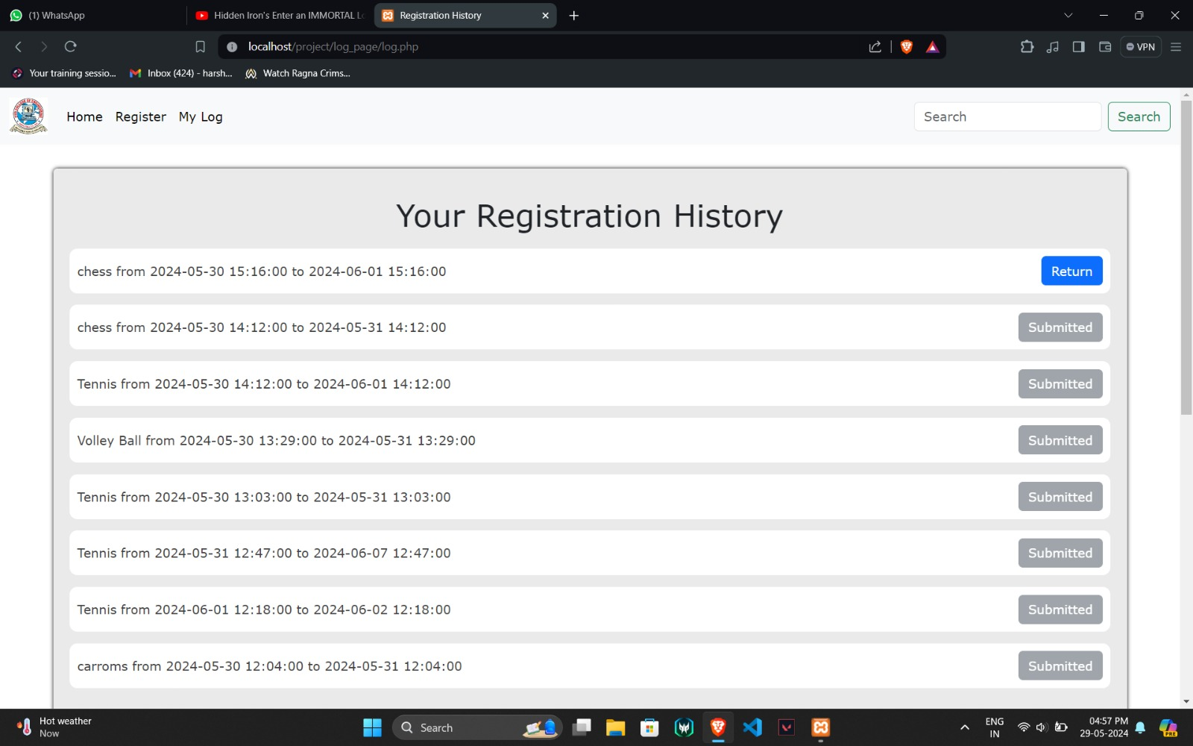
The output shown in the picture contains details about the matter given.

5.3 TESTING
Testing is an integral part of the development process for the Sports Equipment Management application, ensuring that it meets quality standards and performs reliably. Through various testing methodologies such as unit testing, integration testing, user acceptance testing (UAT), performance testing, and security testing, different aspects of the application are evaluated to identify and address potential issues. By implementing a comprehensive testing strategy, the Sports Equipment Management application can be thoroughly evaluated for functionality, usability, performance, and security, resulting in a robust and reliable solution that meets user expectations.

5.4 VALIDATION
Validation is a critical phase in ensuring the effectiveness and reliability of the Sports Equipment Management application. Functional, usability, performance, and security validation processes are conducted to confirm that the application meets its objectives and user expectations across various dimensions. By conducting comprehensive validation processes, the Sports Equipment Management application can be validated effectively, delivering a reliable and user-friendly solution to its users.

6. CONCLUSION
6.1 CONCLUSION
In conclusion, the development of the Sports Equipment Management application offers a valuable solution for organizations to efficiently track and manage their sports equipment inventory. Through the implementation
6.2 FUTURE SCOPE
Looking ahead, the Sport Equipment Management system holds significant potential for further enhancements and expansion to meet evolving user needs and technological advancements. One avenue for future development lies in leveraging advanced analytics and sensor technologies to enable predictive maintenance for sports equipment. By integrating sensors into equipment and leveraging machine learning algorithms, the system can predict potential equipment failures or maintenance needs, allowing for proactive maintenance scheduling and reducing downtime.
Additionally, exploring the integration of augmented reality (AR) or virtual reality (VR) technologies could enhance the user experience and training capabilities associated with sports equipment. AR overlays can provide real-time equipment status information or instructions for maintenance tasks, while VR simulations can offer immersive training experiences for athletes using specialized equipment.
Furthermore, enhancing the system's interoperability with wearable devices and IoT (Internet of Things) sensors can provide valuable insights into equipment usage patterns and athlete performance metrics. By collecting data from wearable sensors and equipment-mounted IoT devices, the system can offer personalized recommendations for equipment usage and training regimes, optimizing athlete performance and injury prevention strategies.
Moreover, considering the growing emphasis on sustainability and eco-friendliness, future iterations of the Sport Equipment Management system could incorporate features for tracking the environmental impact of equipment usage. By monitoring factors such as energy consumption, material usage, and carbon footprint, the system can help organizations make informed decisions about equipment procurement, usage, and disposal, contributing to sustainability initiatives within the sports industry.
Overall, the Sport Equipment Management system holds immense potential for innovation and advancement, with opportunities to leverage emerging technologies such as machine learning, augmented reality, IoT, and sustainability tracking to enhance equipment maintenance, user experience, and performance optimization in the realm of sports equipment management. Continued research and development in these areas can lead to the creation of more intelligent, efficient, and sustainable solutions for managing sports equipment in the future.

