Project Overview
In this course you built three systems that give Claude work that must be right:
- a validated, routed insurance-policy extraction pipeline
- a resilient two-pass mortgage-document extraction system
- a provenance-preserving supply-chain risk investigation
In this project you set up all three systems, run them, break them on purpose, and explain why they behave the way they do. You write no new code. You run the systems and back up their design with your own evidence.
What You'll Do
- Reproduce — install each system and run its full test suite and static checks
- Run — execute each system end to end on its bundled data and save what it produces
- Perturb — break one input per system and record what the safeguard does
- Reflect — answer a short brief, grounding every answer in your own run
What You'll Submit
- An evidence pack — test output, static-check output, and end-to-end runs for all three systems, plus the artifacts they generate (routing decisions, structured extractions, an executive briefing)
- A perturbation log — one experiment per system
- A completed reflection brief
Graded On
- Evidence that all three systems build, run, and pass their checks
- A reflection where every answer cites a real artifact from your run, not a general description
Resources
- The three reference systems (each with a README, spec/, and tests)
- The reflection brief and evidence-pack layout in starter/
- Messages API(opens in a new tab) · Message Batches API
Environment setup
Prerequisites
- Python 3.11+ (python3 --version)
- A terminal and git
- ~300 MB free disk (the supply-chain system downloads a ~90 MB embedding model on first run)
API Access
Most work runs offline with no key:
- All three test suites replay recorded responses
- Mortgage runs offline with --mode replay
- Supply chain runs offline with --offline
- The calibration report is pure Python
One run uses the live API — the policy pipeline command. It needs your Claude API key (the voc- key in Cloud Resources) and the Vocareum base URL. Set both in the terminal you run it from:
export ANTHROPIC_API_KEY="voc-your-key-here"
export ANTHROPIC_BASE_URL="https://claude.vocareum.com"
⚠️ No API access? Use the offline fallback in the Instructions — the policy test suite demonstrates the same routing behavior.
Local Machine Instructions
Set up each project in its own virtual environment. Run from inside each project folder:
python3 -m venv .venv
.venv/bin/pip install -e ".[dev]"
Verify each one:
# policy pipeline
.venv/bin/pytest tests/ -v

# mortgage
.venv/bin/pytest tests/ -v
.venv/bin/mypy mortgage_extractor/
.venv/bin/ruff check mortgage_extractor/ tests/

# supply chain
.venv/bin/pytest tests/ -q
.venv/bin/mypy supply_chain_risk/
.venv/bin/ruff check supply_chain_risk/ tests/
Windows: drop the .venv/bin/ prefix and use .venv\Scripts\.
Optional live runs only:
export ANTHROPIC_API_KEY="voc-your-key-here"
export ANTHROPIC_BASE_URL="https://claude.vocareum.com"
Workspace Instructions
The three project folders and Python 3.11+ are already here. Still create a venv per project.
- Offline first — run the suites and the --offline investigation with no key
- First supply-chain run downloads the embedding model; let it finish
- Capture as you go — tee each run into your evidence pack:
.venv/bin/pytest tests/ -v | tee 01-policy-pipeline/tests.txt
Verify Your Setup
From each project folder:
.venv/bin/pytest tests/ -q
All suites should pass (the policy pipeline reports 45). Without a key, the policy pipeline skips three live tests. Skipped is not failed.
Project Instructions
Do four phases for all three systems: reproduce, run, perturb, reflect. Capture each run into your evidence pack (| tee <path>). Run from each project folder using its .venv. Windows: use .venv\Scripts\.
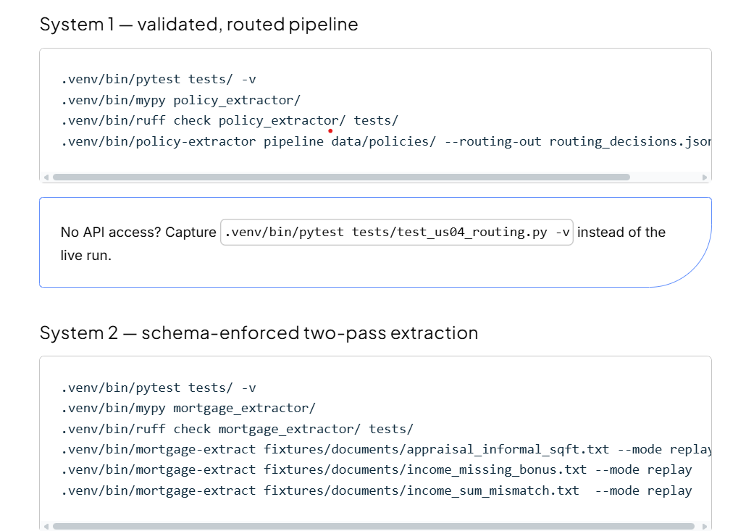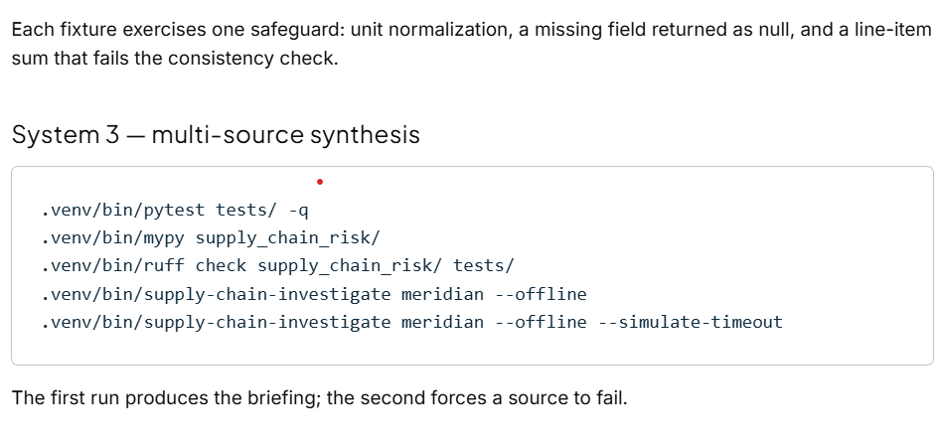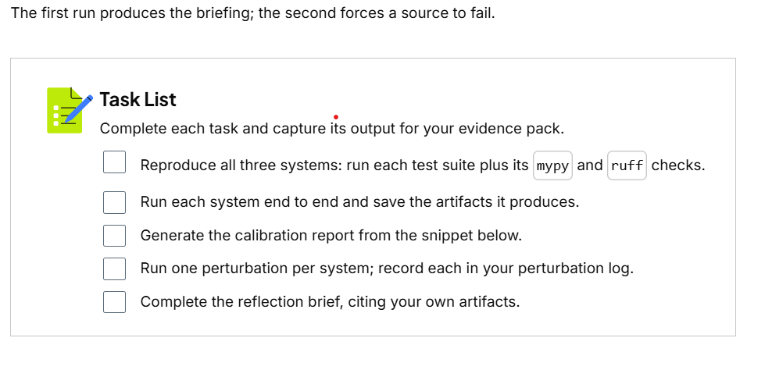
Verify Your Runs
System 1. Test suite: 45 passing. The pipeline run writes routing_decisions.json and prints auto_approve / human_review / spot_check counts.
Generate the calibration report (pure Python, no API):
.venv/bin/python - <<'PY'
from policy_extractor.routing import CalibrationLabel, calibration_report
labels = [
CalibrationLabel(policy_id="POL-1", policy_type="auto", field="premium_amount", predicted_confidence=0.95, correct=True),
CalibrationLabel(policy_id="POL-2", policy_type="auto", field="premium_amount", predicted_confidence=0.95, correct=True),
CalibrationLabel(policy_id="POL-3", policy_type="auto", field="premium_amount", predicted_confidence=0.95, correct=True),
CalibrationLabel(policy_id="POL-4", policy_type="umbrella", field="exclusions", predicted_confidence=0.93, correct=False),
CalibrationLabel(policy_id="POL-5", policy_type="umbrella", field="exclusions", predicted_confidence=0.93, correct=False),
CalibrationLabel(policy_id="POL-6", policy_type="home", field="deductible", predicted_confidence=0.90, correct=True),
]
report = calibration_report(labels)
for (ptype, fname), cell in sorted(report.cells.items()):
print(f"{ptype:9} {fname:15} n={cell.samples} conf={cell.mean_predicted_confidence:.2f} "
f"acc={cell.observed_accuracy:.2f} brier={cell.brier_score:.3f}")
print(f"OVERALL brier={report.overall_brier:.3f}")
PY
Expect the umbrella / exclusions cell at acc=0.00 despite conf=0.93, while the overall number stays moderate. The overall number hides the bad cell.
System 2. Each run prints the document type and the extraction:
- income_sum_mismatch.txt → consistency discrepancy reported
- income_missing_bonus.txt → missing field returns null, not invented
- appraisal_informal_sqft.txt → "about 2,400 sq ft" normalized to an integer
System 3. The briefing has three sections (Well-Established / Contested / Incomplete) and lists the logistics. The on-time-delivery conflict (~95% vs ~78%) appears with both values attributed and dated. --simulate-timeout completes with the failed source marked Incomplete.
Perturbation Starters
One per system (or design your own — your own experiment earns more credit):
- System 1 — run .venv/bin/pytest tests/test_us01_retry.py -v and find the test where a null required field escalates with exactly one API call. With API access: blank a required field in a copied document and run policy-extractor extract.
- System 2 — contrast income_sum_mismatch.txt (flagged) with appraisal_informal_sqft.txt (clean). With API access: edit a stated total and re-run with --mode record.
- System 3 — run with and without --simulate-timeout and compare the Incomplete section.
- Submission Instructions
- Put everything in one folder (or .zip) following the starter README.md layout. Text captures and screenshots both work. One rule: a reviewer must be able to open any artifact you cite and find the value you quoted.
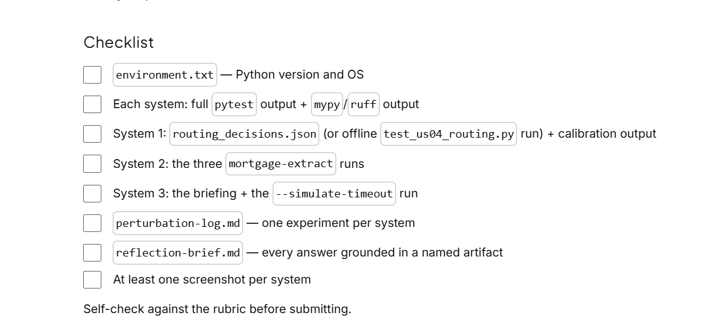
Summary
- Reproduce — prove the systems are healthy
- Run — produce the artifacts
- Perturb — show the safeguards firing
- Reflect — tie each behavior to the decision behind it, in your own words
Submit when your evidence pack and brief tell one story: what you ran, what it did, and why it was built that way.
RUBRIC
Use this project rubric to understand and assess the project criteria.
Reproduce & Verify
Criteria | Submission Requirements
Reproduce and verify reference systems from source | - Evidence pack contains the full test-suite output for all three systems, each showing the passing test count.  - Evidence pack contains the static-analysis output (mypy and ruff) for all three systems with no reported errors.  - A short environment note records the Python version and operating system used for the runs.
Demonstrate Behavior
Criteria | Submission Requirements
Demonstrate validation-driven retry, batch processing, and deterministic human-in-the-loop routing | - Evidence pack contains a full end-to-end pipeline run over the bundled document set and the generated routing-decision output file.  - Evidence pack contains a sliced (policy-type × field) calibration report, produced by running the provided calibration snippet or the routing test that exercises it.  - The reflection identifies, from the learner's own routing output, at least one record routed for human review and names which independent signal drove that decision.
Demonstrate schema-enforced two-pass structured extraction with arithmetic-consistency validation | - Evidence pack contains a run of the extraction tool over at least one document, showing the classified document type and the structured extraction result.  - Evidence pack contains a run in which the consistency validator reports a discrepancy between a line-item sum and a stated total.  - The reflection explains, from the learner's own output, why a missing field returned an empty or null value rather than a fabricated one.
Demonstrate provenance-preserving multi-source synthesis under conflict and source failure | - Evidence pack contains a full investigation run and the generated briefing showing the Well-Established, Contested, and Incomplete sections.  - Evidence pack contains a run executed with the source-failure simulation, showing the run completing with the failed source annotated rather than aborting.  - The reflection quotes one conflicting-metric pair from the learner's own briefing and explains why both values are retained with attribution instead of being reconciled into one.
Stress-Test & Reflect
Criteria | Submission Requirements
Trigger and document targeted edge-case behavior through controlled input perturbation | - A perturbation log records, for each of the three systems, one deliberate change the learner made to an input or configuration, the command run, and the observed result.  - Each perturbation log entry contrasts the observed behavior with what the system does on unperturbed input.
Analyze evaluation, reliability, and observability tradeoffs grounded in observed evidence | - The reflection answers every prompt in the brief, and each answer references a specific artifact from the learner's own evidence pack (a quoted value, a file name, a screenshot, or a log line).  - The reflection includes the synthesis section connecting the three systems to a reliability principle the learner would apply to their own work.
Suggestions to Make Your Project Stand Out
- Regenerate live fixtures. Run one system against the live Anthropic API (set
ANTHROPIC_API_KEY, regenerate recorded responses) and compare a live extraction to the recorded
one. Note any drift and what it implies for observability over time.
- Add your own evaluation slice. Extend the calibration report with a new breakdown dimension,
or add a stratum to the spot-check sampler, and show the new cell surfacing a weakness an
aggregate number hid.
- Adapt one system to your domain. Swap in a small set of documents or sources from a field you
know (your own invoices, tickets, reports — no sensitive data) and report where the schema,
prompts, or conflict rules held up and where they broke.
- Write the on-call note. For one system, write the half-page runbook you would hand a teammate
who has to triage its output at 2 a.m.: what to check first, which signal lies, and what a healthy
run looks like.

