Project Overview
Introduction
Welcome to one of the most practical AI engineering projects you'll build: a production-ready, multi-agent code review system powered by the Claude Agent SDK.
The Scenario: You've just joined DevFlow, a fast-growing startup that's scaling rapidly. Your engineering team is drowning in pull request reviews. Senior developers spend 30% of their time reviewing code, creating a bottleneck that slows down the entire development pipeline. Your tech lead has tasked you with building an AI-powered solution that can provide comprehensive, automated code reviews—freeing up senior engineers to focus on architecture and mentorship.
Your Goal: Build a multi-agent system where specialized AI agents work together to analyze pull requests from multiple angles—code quality, test coverage, and refactoring opportunities—then synthesize their findings into a polished, actionable report.
The Challenge
Manual code reviews are:
- Time-consuming: A thorough review of a 500-line PR can take 30-60 minutes
- Inconsistent: Different reviewers catch different issues
- Limited in scope: Humans often focus on logic, missing security or performance issues
Your task is to build a system that:
- Fetches pull request data from GitHub using MCP (Model Context Protocol)
- Dispatches three specialized subagents to analyze code
- Aggregates their insights into a unified, validated report
- Outputs professional HTML/Markdown/JSON reports
Your Product
The final system architecture:
┌─────────────────────────────────────────────────────────────────┐
│ MAIN ORCHESTRATOR │
│ (Coordinates analysis, aggregates results) │
└───────────────────────────┬─────────────────────────────────────┘
│
┌───────────────────┼───────────────────┐
▼ ▼ ▼
┌───────────────┐ ┌───────────────┐ ┌───────────────┐
│ Code Quality │ │ Test Coverage │ │ Refactoring │
│ Analyzer │ │ Analyzer │ │ Suggester │
│ │ │ │ │ │
│ • Security │ │ • Coverage │ │ • Patterns │
│ • Performance │ │ • Test gaps │ │ • Modernize │
│ • Best practs │ │ • Assertions │ │ • Clean code │
└───────────────┘ └───────────────┘ └───────────────┘
│ │ │
└───────────────────┼───────────────────┘
▼
┌─────────────────────────┐
│ ReviewReport (JSON) │
│ ───────────────── │
│ • File-by-file │
│ • Aggregated scores │
│ • Recommendations │
└─────────────────────────┘
│
┌───────────────────┼───────────────────┐
▼ ▼ ▼
[report.md] [report.html] [report.json]
Key Technologies:
- Claude Agent SDK: Orchestrates agents and handles tool execution
- MCP (Model Context Protocol): Integrates GitHub API and ESLint via standardized protocol
- Zod: Runtime validation of structured outputs
- TypeScript: Type-safe development
- Claude Skills: Reusable domain expertise for specialized code analysis
Deliverables
Your submission must include all of the following:
1. MCP Configuration (src/config/mcp.config.ts)
Configure two MCP servers for external tool integration:
- GitHub MCP server - Enables fetching PR data and repository information
- ESLint MCP server - Provides code linting and style analysis capabilities
2. Three Specialized Subagents (src/agents/)
Code Quality Analyzer (code-quality-analyzer.ts)
- Analyzes code for security vulnerabilities, performance issues, and maintainability concerns
- Configured with appropriate tools for reading and analyzing code files
- Integrates Claude Skills for specialized code analysis (e.g., javascript-best-practices, security-analysis)
Test Coverage Analyzer (test-coverage-analyzer.ts)
- Identifies functions/methods without test coverage
- Suggests specific test cases with meaningful assertions
- Estimates coverage percentage and prioritizes critical untested paths
Refactoring Suggester (refactoring-suggester.ts)
- Identifies opportunities to apply design patterns and modern language features
- Suggests extract method/class candidates
- Identifies dead code or redundant logic
Each agent must:
- Be defined using the AgentDefinition type with clear descriptions
- Set model: 'inherit' to use the orchestrator's model
- Include only the tools necessary for its specific role
- Include the Skill tool to invoke Claude skills
3. Prompt Engineering (src/prompts/)
Create targeted prompts for:
- Orchestrator prompt (orchestrator.prompt.ts) - Instructs the main agent to fetch PR data and coordinate subagent execution
- Code Quality prompt (code-quality-analyzer.prompt.ts) - Specifies security, performance, and best practice evaluation criteria
- Test Coverage prompt (test-coverage-analyzer.prompt.ts) - Defines test completeness assessment approach
- Refactoring prompt (refactoring-suggester.prompt.ts) - Outlines architectural improvement identification
Each prompt must:
- Explicitly instruct the agent on its specific focus area
- Reference the expected output structure (Zod schema requirements)
- Provide clear guidance on when and how to leverage Claude Skills
4. Main Orchestrator (src/orchestrator.ts)
Implement the orchestration logic using Claude Agent SDK's query method:
- Configure with MCP servers (GitHub and ESLint)
- Include the Task tool for spawning subagents
- Register all three subagents in the configuration
- Use outputFormat with zod-to-json-schema for structured outputs
- Aggregate subagent findings into the ReviewReport schema
- Handle potential agent failures gracefully
5. CLI Application (src/main.ts)
Complete the entry point with:
- Command-line argument parsing and validation (owner, repo, PR number)
- Environment variable validation (API credentials, model configuration)
- Orchestrator instantiation and reviewPullRequest invocation
- Report generation using ReportGenerator in three formats (JSON, Markdown, HTML)
- Error handling with meaningful user messages
6. Error Handler (src/utils/error-handler.ts)
Complete the error handling utility:
- Retry logic with exponential backoff - Implement withRetry function that retries failed operations with increasing delays and jitter
- Timeout wrapper - Implement withTimeout function using Promise.race to limit operation duration
- Custom ReviewError class and ErrorCodes enum are provided
7. Rate Limiter (src/utils/rate-limiter.ts)
Complete the rate limiting utility:
- Token bucket algorithm with sliding window - Track requests and tokens used in the last 60 seconds
- Core methods - Implement acquire, canProceed, waitForSlot, waitForRateLimit, and pruneOldRecords
- Concurrent request management - Respect maxConcurrent limit to prevent overwhelming the API
- Interfaces, configuration, and helper methods are provided
8. Comprehensive Testing (tests/)
Implement and pass all tests:
- Schema validation tests (Zod schemas accept valid data, reject invalid data)
- Edge case handling (empty arrays, boundary values)
- JSON schema export validation for SDK structured outputs
- Integration test demonstrating successful PR analysis
9. Final Deliverables: PR Analysis Reports (reports/)
REQUIRED FOR SUBMISSION: Generate comprehensive analysis reports for three specific pull requests from the udacity/cd14715-simple-todo-app repository:
- PR #1: "add clean code fixture" (merged)
- PR #2: "Add search functionality for todos" (open)
- PR #3: "Add premium subscription features" (open)
For each PR, your system must generate all three report formats:
- JSON report (.json) - Structured data matching ReviewReport schema
- Markdown report (.md) - Human-readable formatted report
- HTML report (.html) - Web-viewable styled report
Total required files: 9 reports (3 PRs × 3 formats)
Quality requirements:
- All reports must contain populated data from agent analysis (not empty or undefined)
- Code quality issues must include specific file paths, line numbers, and severity levels
- Test coverage analysis must include specific suggestions for missing tests
- Refactoring suggestions must be actionable with code examples
- Overall scores must be calculated based on aggregated findings
- Reports must be well-formatted and render correctly
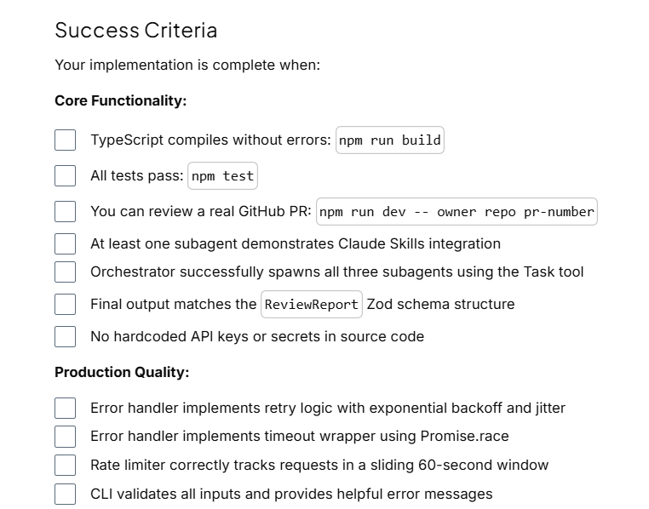
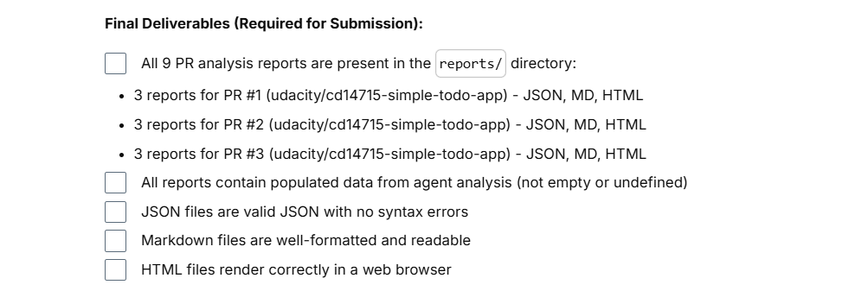
Envirnoment Setup
Clone the project starter repository:
(opens in a new tab)https://github.com/udacity/cd14715-claude-code-classroom/tree/main/project(opens in a new tab)
Vocareum Workspace (Recommended)
Your Vocareum workspace comes pre-configured with Anthropic API credentials. No additional setup is required - you can start coding immediately.
Step 1: Access Your Workspace
- Navigate to the Cloud Resources tab in your Vocareum interface
- Click Start Cloud Resource to start your workspace and then Open Cloud Console to launch your workspace
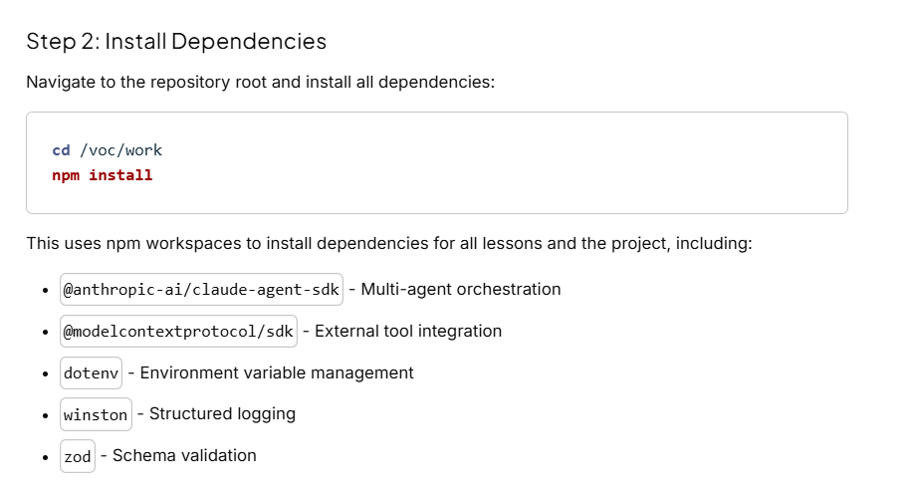
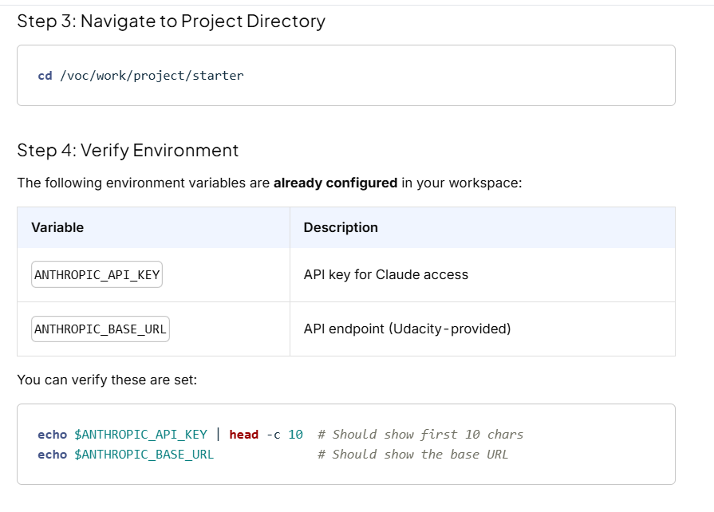
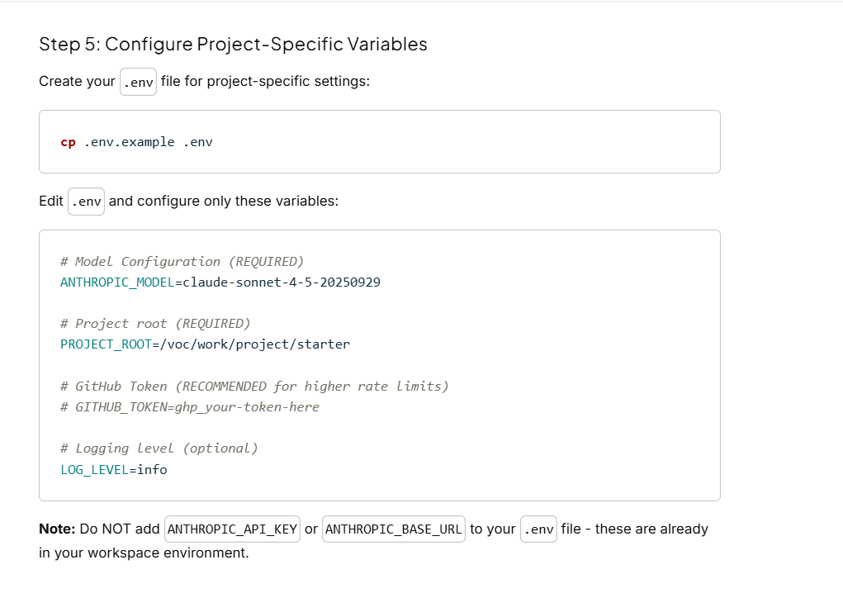
GitHub Token (Recommended)
A GitHub Personal Access Token improves reliability:
- Higher rate limits - More API requests allowed
- Private repository access - Analyze PRs in private repos
To create one:
- Go to https://github.com/settings/tokens(opens in a new tab)
- Generate a new token with scopes: repo, read:org
- Add to your .env: GITHUB_TOKEN=ghp_your-token-here
Without a token: The system works for public repositories, but you may hit rate limits during extended use.

Local Development Setup
If you prefer to work on your local machine, you have two options:
Option A: Use Vocareum-Provided Credentials Locally
You can extract the credentials from your Vocareum workspace and use them locally.
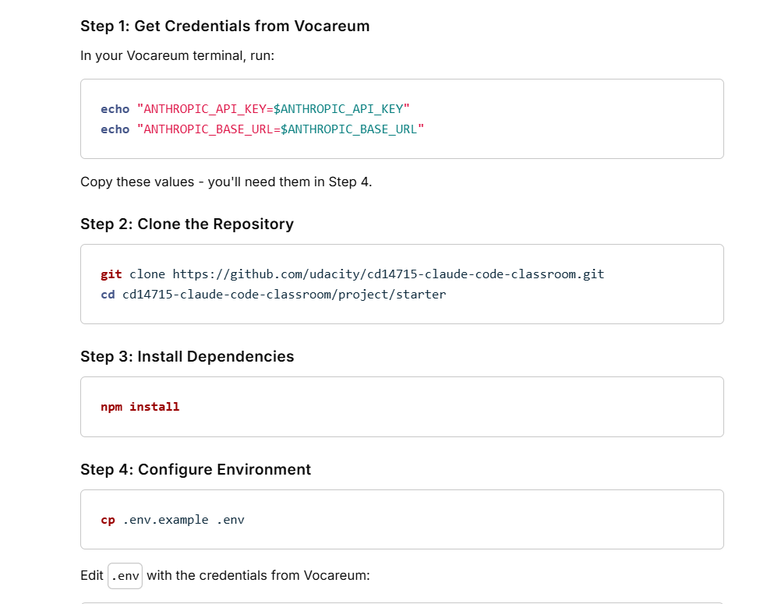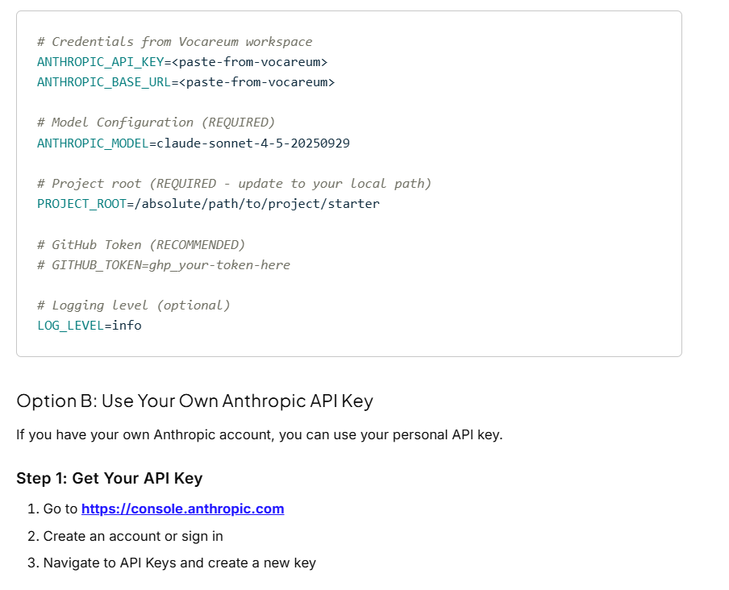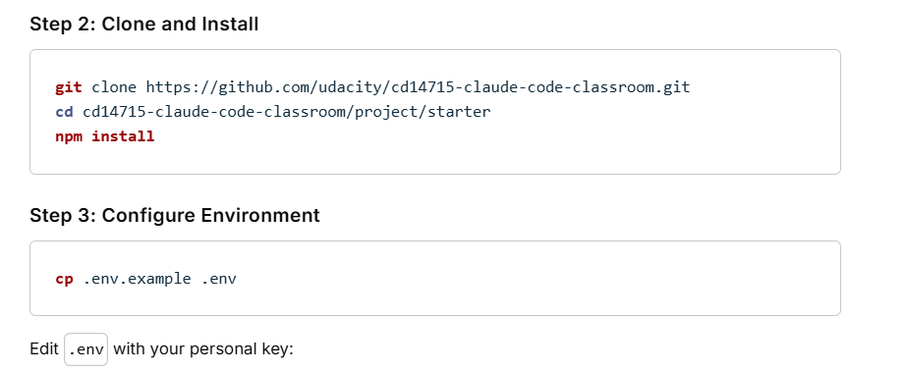
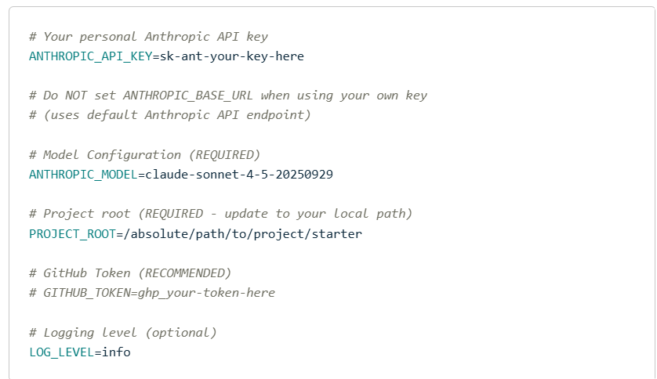
Important: When using your own API key, do NOT set ANTHROPIC_BASE_URL. The SDK will use the default Anthropic API endpoint.

Using Personal API Key in Vocareum Workspace
If you want to use your own Anthropic API key within the Vocareum workspace (instead of the provided credentials), you need to override the pre-configured environment variables.
Add these lines to your .env file:
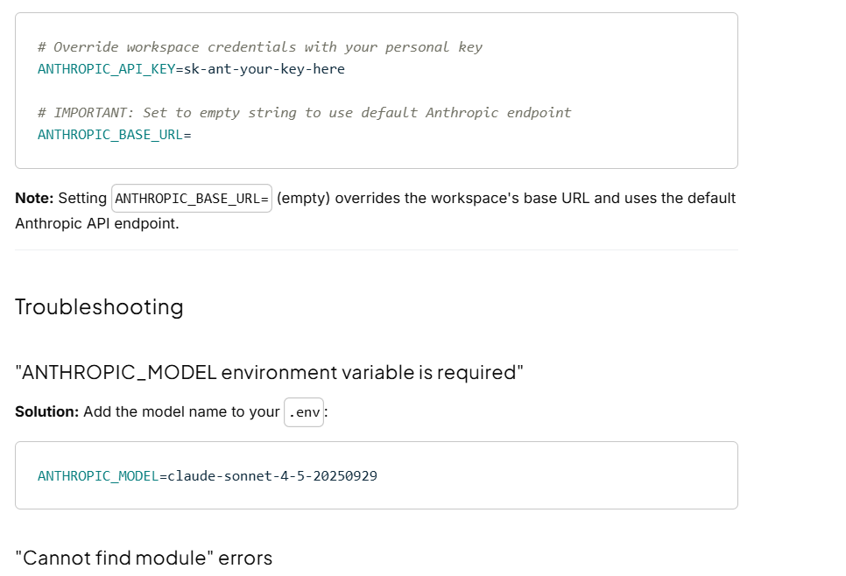
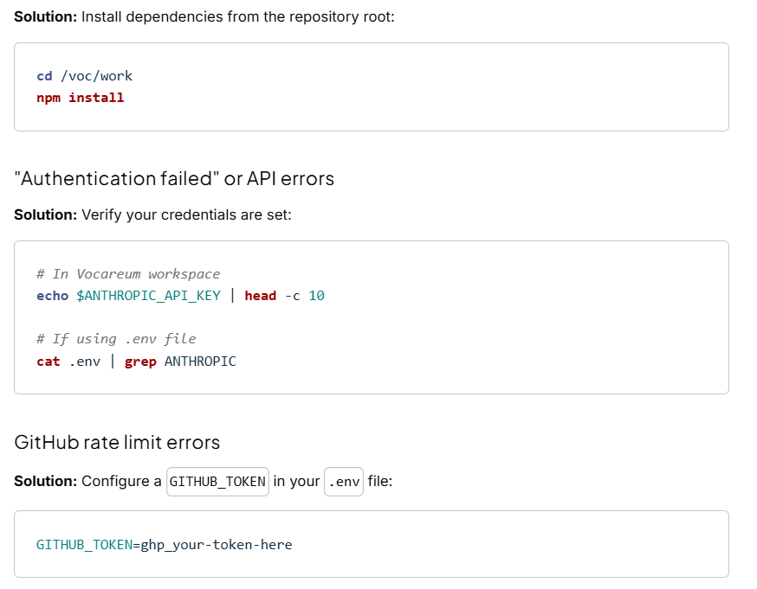
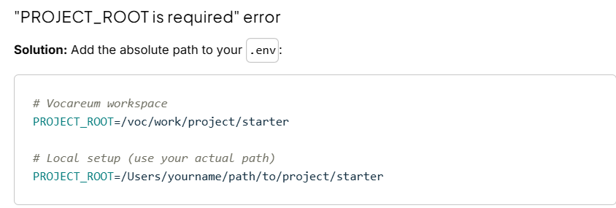
Environment Variables Reference
Variable | Required | Description
ANTHROPIC_API_KEY | Yes* | API key for Claude access
ANTHROPIC_BASE_URL | No | Custom API endpoint (set in Vocareum workspace)
ANTHROPIC_MODEL | Yes | Model to use (e.g., claude-sonnet-4-5-20250929)
PROJECT_ROOT | Yes | Absolute path to project directory
GITHUB_TOKEN | Recommended | GitHub PAT for higher rate limits
LOG_LEVEL | No | Logging verbosity (error, warn, info, debug)
*Already configured in Vocareum workspace environment

Next Steps
With your environment configured, you're ready to begin implementation. Head to the Instructions pages to start building!
Instructions: Core Deliverables
This guide walks you through building the core of your multi-agent code review system. By the end of Part 1, you'll have a minimal working system that can analyze a GitHub pull request using three specialized subagents.
What you'll build in Part 1:
- MCP server configuration for GitHub and ESLint integration
- Three specialized subagents with targeted prompts
- Main orchestrator that coordinates subagents and aggregates results
What comes next in Part 2:
- Production utilities (error handling, rate limiting)
- Complete CLI application with validation
- Comprehensive testing
- Final deliverables (9 PR reports for submission)
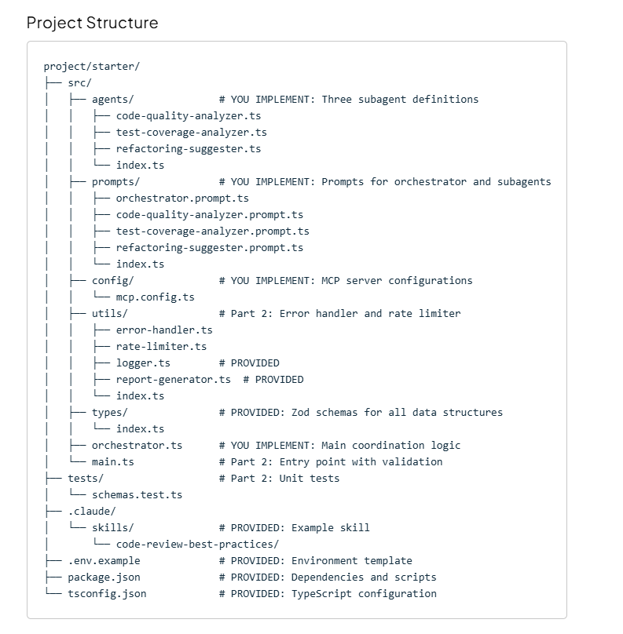
Legend:
- YOU IMPLEMENT (Part 1) - Files covered in this guide
- Part 2 - Files covered in the next guide
- PROVIDED - Files already implemented for you

Phase 1: Foundation & Configuration
Deliverable: MCP Configuration
File to complete: src/config/mcp.config.ts
The MCP configuration file needs two server definitions to enable external tool integration.
Research Questions
Before implementing, answer these questions:
- GitHub MCP Server:
  - What package provides the GitHub MCP server? (Hint: Check the MCP servers repository)
  - What environment variable does it expect for authentication?
  - How do you map your GITHUB_TOKEN from .env to the expected variable name?
- ESLint MCP Server:
  - What package provides the ESLint MCP server?
  - Does it require authentication?
Implementation Guide
Study the TODO comments in src/config/mcp.config.ts. Each MCP server configuration needs:
- type: The transport type (what type of process communication?)
- command: How to run the server (which command lets you run npm packages without installing?)
- args: Arguments to pass to the command
- env: Environment variables the server needs
Resources:
- MCP Servers Repository(opens in a new tab)
- GitHub MCP Documentation(opens in a new tab)

Phase 2: Building the Subagents
Deliverable: Three Specialized Subagents
You need to create three agent definition files in src/agents/. Each agent will be defined using the AgentDefinition type from the Claude Agent SDK.
Understanding Agent Definitions
Before writing code, study the Claude Agent SDK documentation to understand:
- What properties does an AgentDefinition have?
- What does the model: 'inherit' setting mean?
- What's the purpose of the description field? (Hint: How does the orchestrator know when to use each agent?)
- What tools can agents use?
Task 2.1: Code Quality Analyzer
File to create: src/agents/code-quality-analyzer.ts
This agent analyzes code for security vulnerabilities, performance issues, and maintainability concerns.
Questions to Answer:
- What tools does this agent need to analyze code files? (Think about reading files, searching for patterns)
- How can this agent leverage Claude Skills for specialized analysis?
- What should the description say to help the orchestrator understand this agent's purpose?
Key Requirement: This agent must include the Skill tool and be configured to invoke skills like javascript-best-practices or security-analysis.
Expected Output: Look at CodeQualityResultSchema in src/types/index.ts to understand what this agent should return.
Task 2.2: Test Coverage Analyzer
File to create: src/agents/test-coverage-analyzer.ts
This agent evaluates test completeness and suggests specific test cases.
Questions to Answer:
- How can an AI estimate test coverage without running tests? (Think about comparing source files with test files)
- What makes a test suggestion actionable vs. generic?
- What tools does this agent need?
Expected Output: Study TestCoverageResultSchema in src/types/index.ts.
Task 2.3: Refactoring Suggester
File to create: src/agents/refactoring-suggester.ts
This agent identifies opportunities to improve code structure and modernize patterns.
Questions to Answer:
- What types of refactoring should this agent look for? (Modernization, design patterns, code clarity)
- How does this differ from code quality analysis?
- What tools are needed?
Expected Output: Study RefactoringResultSchema in src/types/index.ts.
Task 2.4: Export Your Agents
File to create: src/agents/index.ts
Export all three agents so they can be imported by the orchestrator. Use ES module syntax (.js extensions in import paths).

Deliverable: Prompt Engineering
Create targeted prompts in src/prompts/ for each agent.
Prompt Engineering Principles
Effective prompts must:
- Be specific about the task - What exactly should the agent analyze?
- Reference the output format - How should findings be structured?
- Provide evaluation criteria - What makes an issue "high severity"?
- Give examples - Show what good vs. bad findings look like (optional but helpful)
- Explain tool usage - When to invoke skills, what tools are available
Task 2.5-2.7: Write Agent Prompts
Files to create:
- src/prompts/code-quality-analyzer.prompt.ts
- src/prompts/test-coverage-analyzer.prompt.ts
- src/prompts/refactoring-suggester.prompt.ts
For each prompt, consider:
- What specific issues should this agent look for?
- What severity levels are appropriate? (high/medium/low)
- How should the agent leverage Claude Skills?
- What output format is expected? (Reference the Zod schemas)
Tip: Export each prompt as a string constant. Study the Zod schemas in src/types/index.ts to understand the exact structure agents should return.
Task 2.8: Export Your Prompts
File to create: src/prompts/index.ts
Export all prompts for easy importing.

Phase 3: The Orchestrator Logic
Deliverable: Main Orchestrator Implementation
The orchestrator coordinates all subagents and aggregates their findings into a structured report.
Task 3.1: Orchestrator Prompt
File to create: src/prompts/orchestrator.prompt.ts
This is the most critical prompt. It must instruct the main agent to:
- Fetch PR data using GitHub MCP tools
- Invoke all three subagents for analysis
- Aggregate results into the ReviewReport schema
Key Concept - Explicit Invocation:
To reliably trigger subagents, your prompt should use explicit language like:
- "Use the code-quality-analyzer agent to analyze src/file.ts"
- NOT "The code-quality-analyzer should analyze..."
Questions to Answer:
- Which MCP tool fetches pull request data? (Hint: Check GitHub MCP documentation)
- Should subagents run in parallel or sequentially? Why?
- How should the orchestrator handle if a subagent fails?
- What should the final output structure look like? (Study ReviewReportSchema)
Task 3.2: Implement the Orchestrator Class
File to complete: src/orchestrator.ts
You need to implement a class that uses the query function from the Claude Agent SDK.
Key Implementation Questions:
- Configuration:
  - What should you pass to the agents option?
  - What tools should be in allowedTools? (Critical: Must include Task tool for spawning subagents)
  - Which model should you use? (Hint: Should it be hardcoded?)
  - What's a reasonable maxTurns value for multi-agent coordination?
  - What permissionMode is appropriate for automated CI/CD use?
- Structured Outputs:
  - How do you convert a Zod schema to JSON Schema? (Hint: zod-to-json-schema package)
  - What options are needed for SDK compatibility? (Hint: Check SDK structured outputs documentation)
  - How do you configure outputFormat in the query function?
- Result Processing:
  - The query function returns an async iterable - how do you iterate over it?
  - How do you extract the final structured_output?
  - How do you validate it matches your Zod schema? (Hint: safeParse vs parse)
Resources:
- Claude Agent SDK Documentation(opens in a new tab)
- SDK Subagents Guide(opens in a new tab)
- SDK Structured Outputs
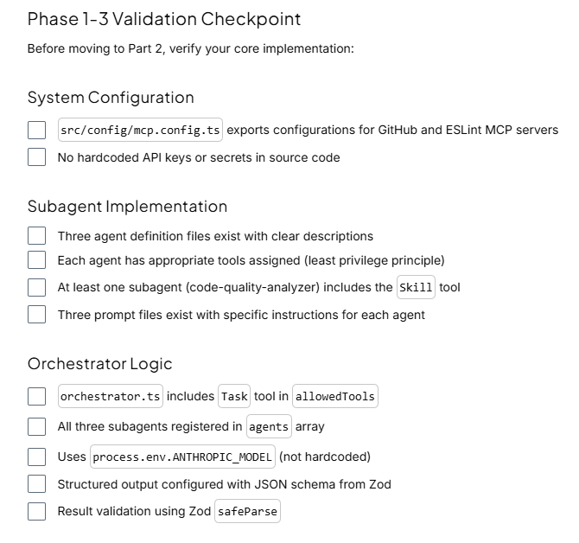
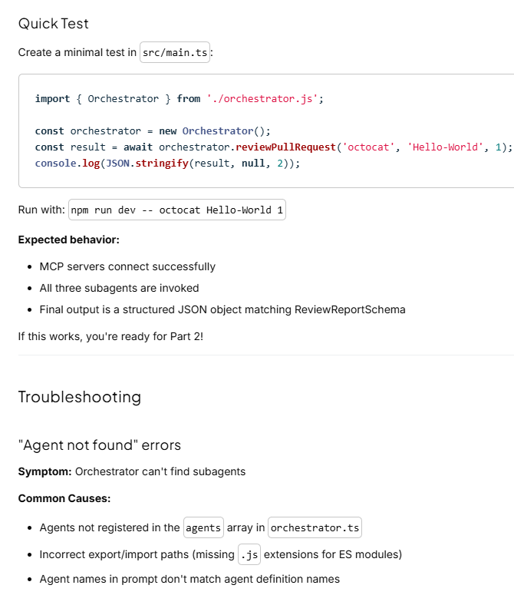
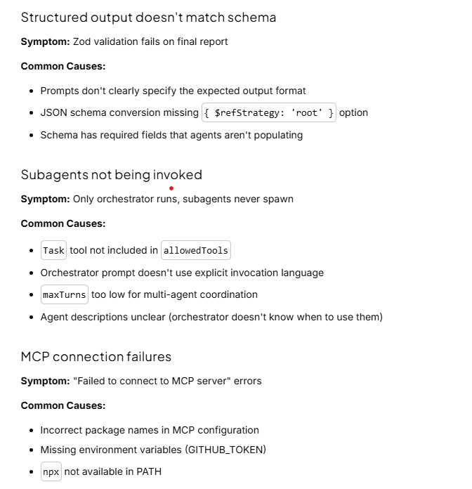
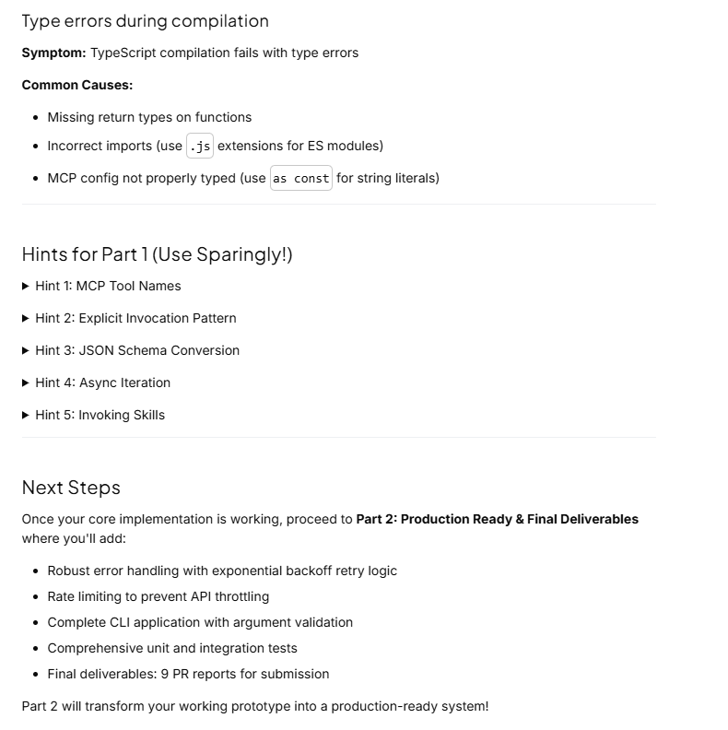
Instructions: Production Ready & Final Deliverables
Welcome to Part 2! You now have a working multi-agent code review system. This guide will help you transform it into a production-ready application with robust error handling, rate limiting, comprehensive testing, and final deliverables for submission.
Prerequisites: Complete Part 1 (Core Implementation) first.
What you'll build in Part 2:
- Production utilities: Error handler with exponential backoff, rate limiter with sliding window
- Complete CLI application with validation and user-friendly error messages
- Comprehensive unit and integration tests
- Final deliverables: 9 PR analysis reports for submission

Phase 4: Production Utilities
Production systems require robust error handling and rate limiting to handle failures gracefully and prevent API throttling.
Deliverable: Error Handler
File to complete: src/utils/error-handler.ts
The error handler provides retry logic with exponential backoff and timeout wrappers.
Task 4.1: Implement Retry Logic
Complete the withRetry function that implements exponential backoff.
Algorithm:
- Try to execute the function
- If it succeeds, return the result
- If it fails and retries remain:
  - Calculate backoff delay: delayMs * 2^(attempt - 1)
  - Add jitter (random 0-100ms) to prevent thundering herd
  - Wait for the calculated duration
  - Retry
- If all retries exhausted, throw ReviewError with RETRY_EXHAUSTED code
Questions to Answer:
- How do you implement exponential backoff in JavaScript?
- Why is jitter important?
- How do you wrap setTimeout in a Promise for async/await?
Task 4.2: Implement Timeout Wrapper
Complete the withTimeout function using Promise.race.
Algorithm:
- Race the provided function against a timeout promise
- The timeout promise should reject after timeoutMs milliseconds
- Whichever completes first wins
Questions to Answer:
- How does Promise.race work?
- How do you create a Promise that rejects after a delay?
- What error code should you use for timeouts?
Resources:
- Promise.race Documentation(opens in a new tab)
- Exponential backoff pattern (search for algorithm examples)

Deliverable: Rate Limiter
File to complete: src/utils/rate-limiter.ts
The rate limiter prevents API throttling using a token bucket algorithm with sliding window.
Understanding the Sliding Window
The sliding window tracks requests made in the last 60 seconds:
- At any moment, only count requests from the past 60 seconds
- As time passes, old requests "fall off" the window
- This provides smooth rate limiting vs. fixed time buckets
Task 4.3: Implement Core Methods
You need to implement five methods. Study the TODO comments in the file for detailed step-by-step hints.
Methods to implement:
- pruneOldRecords() - Start here, it's the simplest
  - Filter requestHistory to keep only records from the last 60 seconds
  - Use Array.filter() and timestamp comparison
- canProceed(estimatedTokens) - Check if request can proceed immediately
  - Call pruneOldRecords() first
  - Check three conditions: concurrent requests, requests per minute, tokens per minute
  - Return true only if all conditions are met
- waitForSlot() - Wait for a concurrent request slot
  - Create a Promise and add its resolve function to waitQueue
  - The resolve will be called later by release()
- waitForRateLimit(estimatedTokens) - Wait until rate limits allow the request
  - Loop while canProceed() returns false
  - Calculate wait time based on when the oldest request expires
  - Sleep and check again
- acquire(estimatedTokens) - Main entry point
  - Wait for concurrent slot (use waitForSlot())
  - Wait for rate limit (use waitForRateLimit())
  - Increment activeRequests
  - Add record to requestHistory
Questions to Answer:
- Why use a sliding window instead of fixed time buckets?
- How does the waitQueue pattern work for managing concurrent requests?
- Why track both requests and tokens separately?
Task 4.4: Integration
Once complete, uncomment the exports in src/utils/index.ts.
Consider integrating the rate limiter with your orchestrator to prevent API throttling during testing.

Phase 5: Complete CLI Application
Transform your working prototype into a production-ready CLI tool.
Deliverable: CLI with Validation
File to complete: src/main.ts
The starter file has detailed TODO comments. Your implementation must:
- Validate Command-Line Arguments:
  - Are all three arguments (owner, repo, prNumber) provided?
  - Is prNumber a valid positive integer?
  - Exit with helpful error messages if validation fails
- Validate Authentication:
  - Is either ANTHROPIC_API_KEY OR AWS credentials (AWS_ACCESS_KEY_ID + AWS_SECRET_ACCESS_KEY) configured?
  - If using AWS, is AWS_REGION set?
  - Log which authentication method is being used
  - Exit with clear instructions if neither method is configured
- Validate ANTHROPIC_MODEL:
  - Is the model environment variable set?
  - Provide helpful error messages showing correct format for both Bedrock and Anthropic API
- Run the Review:
  - Create an Orchestrator instance
  - Call reviewPullRequest(owner, repo, prNumber)
  - Handle errors gracefully (don't just let stack traces print)
- Generate Reports:
  - Use ReportGenerator to create all three formats (Markdown, HTML, JSON)
  - Save to reports/ directory with appropriate filenames
  - Log success messages showing where reports were saved

Deliverable: Comprehensive Testing
Implement and pass all tests to validate your implementation.
Task 5.1: Implement Unit Tests
File to complete: tests/schemas.test.ts
The test file skeleton is provided. You need to implement tests that:
- Test Valid Data:
  - Create valid data objects that match each Zod schema
  - Verify schema.parse(validData) doesn't throw
- Test Invalid Data:
  - Create invalid data (wrong types, missing fields, invalid enum values)
  - Verify schema.parse(invalidData) throws ZodError
- Test Edge Cases:
  - Empty arrays
  - Boundary values (score of 0, score of 100)
  - Optional fields present vs. absent
- Test JSON Schema Export:
  - Verify zodToJsonSchema produces valid JSON schema
  - Verify required properties are marked correctly
Run Tests:
npm test
All tests must pass for successful submission.
Task 5.2: Integration Test
Test your complete system with a real pull request:
npm run dev -- octocat Hello-World 1
What to Verify:

Phase 6: Generate Final Deliverables
REQUIRED FOR SUBMISSION: You must generate analysis reports for three specific pull requests from the test repository and submit all 9 report files with your code.
Test Repository: udacity/cd14715-simple-todo-app
This public repository (github.com/udacity/cd14715-simple-todo-app(opens in a new tab)) contains three pull requests with realistic code changes that your system will analyze. It is public, so no invitation or special access is needed:
- PR #1: "add clean code fixture" (merged)
- PR #2: "Add search functionality for todos" (open)
- PR #3: "Add premium subscription features" (open)
Task 6.1: Analyze All Three Pull Requests
Run your system against each PR and verify the reports are comprehensive:
# PR #1: Clean code fixture
npm run dev -- udacity cd14715-simple-todo-app 1

# PR #2: Search functionality
npm run dev -- udacity cd14715-simple-todo-app 2

# PR #3: Premium subscription features
npm run dev -- udacity cd14715-simple-todo-app 3
Task 6.2: Organize Report Files
After running all three analyses, you should have 9 report files total (3 PRs × 3 formats each):
reports/
├── udacity_cd14715-simple-todo-app_1.json
├── udacity_cd14715-simple-todo-app_1.md
├── udacity_cd14715-simple-todo-app_1.html
├── udacity_cd14715-simple-todo-app_2.json
├── udacity_cd14715-simple-todo-app_2.md
├── udacity_cd14715-simple-todo-app_2.html
├── udacity_cd14715-simple-todo-app_3.json
├── udacity_cd14715-simple-todo-app_3.md
└── udacity_cd14715-simple-todo-app_3.html
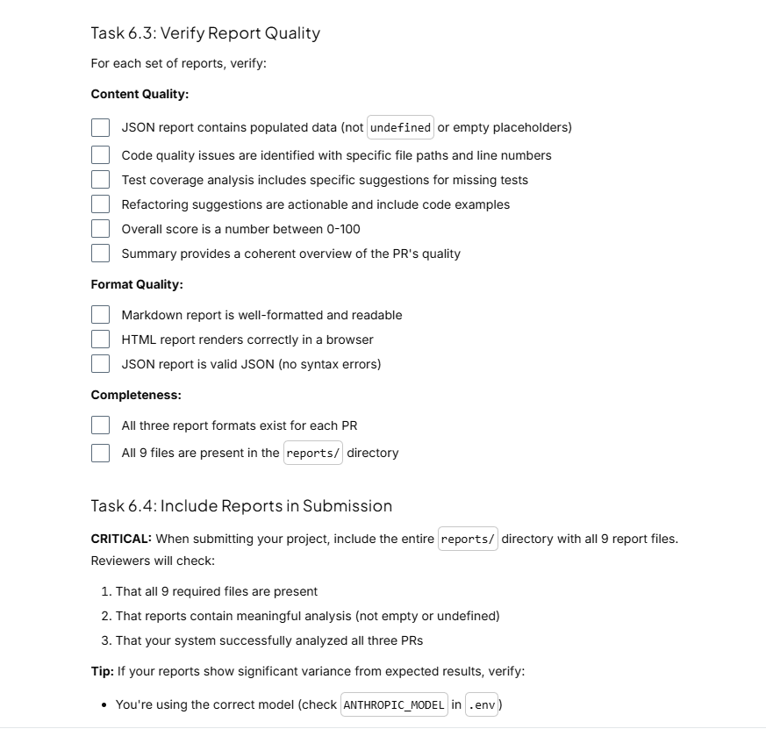
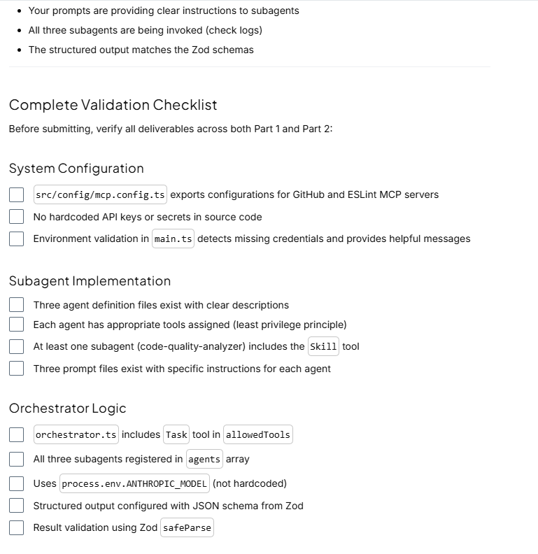
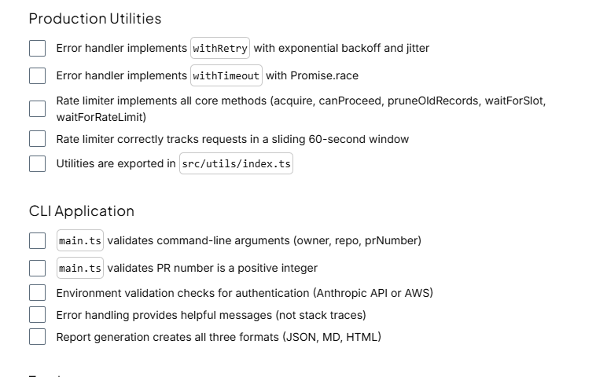
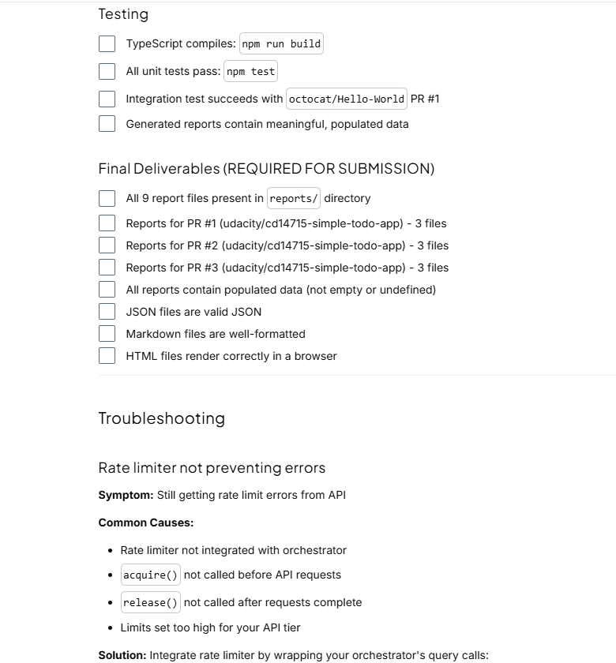
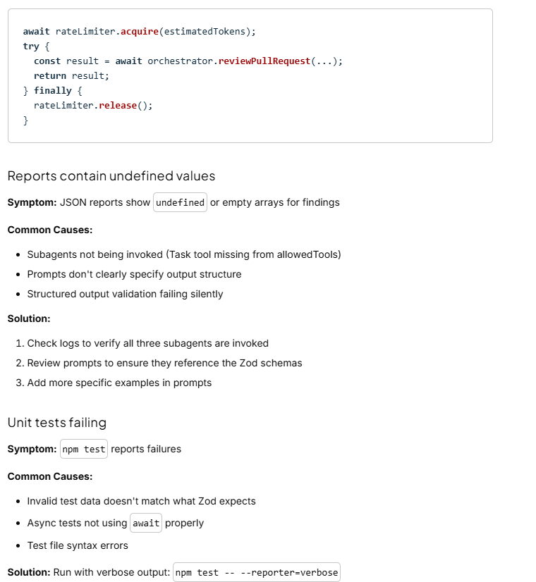
CLI validation rejecting valid input
Symptom: Valid arguments cause validation errors
Common Causes:
- Off-by-one errors in process.argv indexing (remember: argv[0] is node, argv[1] is script)
- Integer parsing issues (using Number() instead of parseInt())
- Environment variable checks using wrong logic (AND vs. OR)
Solution: Add debug logging to see what values are being checked

Hints for Part 2 (Use Sparingly!)
Hint 6: Exponential Backoff
const backoff = delayMs * Math.pow(2, attempt - 1);
const jitter = Math.random() * 100;
await new Promise(resolve => setTimeout(resolve, backoff + jitter));
Hint 7: Sliding Window Pruning
const oneMinuteAgo = Date.now() - 60000;
this.requestHistory = this.requestHistory.filter(r => r.timestamp > oneMinuteAgo);
Hint 8: Promise.race for Timeout
return Promise.race([
fn(),
new Promise((_, reject) =>
setTimeout(() => reject(new ReviewError('Timeout', ErrorCodes.AGENT_TIMEOUT)), timeoutMs)
)
]);
Hint 9: Command-Line Argument Parsing
// process.argv = ['node', 'main.js', 'owner', 'repo', '123']
const [owner, repo, prNumberStr] = process.argv.slice(2);
const prNumber = parseInt(prNumberStr, 10);

if (!owner || !repo || !prNumberStr) {
console.error('Usage: npm run dev -- <owner> <repo> <pr-number>');
process.exit(1);
}

if (isNaN(prNumber) || prNumber <= 0) {
console.error('PR number must be a positive integer');
process.exit(1);
}
Hint 10: Authentication Validation
const hasAnthropicAPI = !!process.env.ANTHROPIC_API_KEY;
const hasAWSCredentials = !!(
process.env.AWS_ACCESS_KEY_ID &&
process.env.AWS_SECRET_ACCESS_KEY &&
process.env.AWS_REGION
);

if (!hasAnthropicAPI && !hasAWSCredentials) {
console.error('Authentication required. Set one of:');
console.error(' - ANTHROPIC_API_KEY, or');
console.error(' - AWS_ACCESS_KEY_ID + AWS_SECRET_ACCESS_KEY + AWS_REGION');
process.exit(1);
}

console.log(`Using ${hasAnthropicAPI ? 'Anthropic API' : 'AWS Bedrock'} authentication`);

Success!
Once all validation checkpoints pass and you have all 9 report files, you've successfully built a production-ready multi-agent code review system!
Your implementation demonstrates:
- Multi-agent orchestration using Claude Agent SDK
- External integrations via Model Context Protocol
- Structured outputs with Zod validation
- Production practices like error handling, rate limiting, logging, and testing
- Real-world AI engineering skills applicable to industry
This is a portfolio-quality project showcasing your expertise in agentic AI systems.
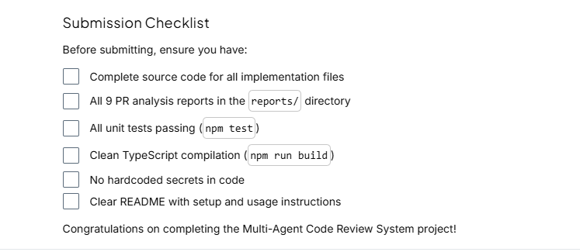
Rubric
Use this project rubric to understand and assess the project criteria.
System Configuration
Criteria | Submission Requirements
Setup environment variables and manage authentication securely | - The project reads sensitive credentials (API keys, GitHub tokens) from environment variables (process.env) and does not contain hardcoded secrets in the source code.  - The application validates the presence of required environment variables (e.g., GITHUB_TOKEN, ANTHROPIC_API_KEY or AWS credentials) on startup in src/main.ts or src/config/env.ts.
Configure MCP servers to enable external tool integration | - The src/config/mcp.config.ts file exports configurations for both the GitHub MCP server and ESLint MCP server.  - Each configuration includes:  - The transport type (stdio)\n\n• The correct command (npx)  - The appropriate arguments (e.g., -y, @modelcontextprotocol/server-github for GitHub)  - Required environment variables (e.g., GITHUB_PERSONAL_ACCESS_TOKEN mapped from GITHUB_TOKEN)
Subagent Implementation
Criteria | Submission Requirements
Define specialized subagents with distinct roles and responsibilities | - Three distinct agent definitions exist in src/agents/: code-quality-analyzer.ts, test-coverage-analyzer.ts, and refactoring-suggester.ts.  - Each agent is defined using the AgentDefinition type (or equivalent SDK structure) with a clear description field that helps the orchestrator understand when to use it.  - The model property for subagents is set to 'inherit' (or a specific model is justified), and appropriate tools (e.g., file reading, web search) are assigned to the agents that require them.  - The Tools property for the subagents includes Skill tool. This allows the subagents to read from Claude skills library.
Design specific prompts for each subagent to ensure structured analysis | - Prompt templates are created in src/prompts/ for all three subagents.  - The prompts explicitly instruct the agents on their specific focus areas (e.g., the Code Quality prompt mentions security/performance; Test Coverage mentions assertions/gaps).  - The prompts reference the expected output structure or Zod schema requirements to ensure the orchestrator can parse the response.
Integrate Claude Skills for specialized code analysis | - At least one subagent is configured to invoke Claude Skills from the .claude/skills/ directory.  - The skills invoked are appropriate for the agent's analysis tasks (e.g., javascript-best-practices, typescript-patterns, python-code-review, or security-analysis for code quality analysis).  - The agent's prompt or configuration includes instructions on when and how to leverage skills during analysis.
Orchestrator Logic and Workflow
Criteria | Submission Requirements
Implement the main orchestrator to coordinate multi-agent execution | - The main orchestrator agent in src/orchestrator.ts implements a class or function that utilizes the Claude Agent SDK's query (or equivalent unstable V2 client) method.  - The orchestrator is configured with the allowedTools derived from the connected MCP servers (GitHub/ESLint).  - The orchestrator is configured with the Task tool, this is an out of the box tool that spawns subagents.  - All three subagents are registered in the agents array of the query configuration.  - The orchestrator prompt (src/prompts/orchestrator.prompt.ts) explicitly instructs the model to fetch PR data and then invoke the subagents.
Aggregate and validate agent results into a structured report | - The orchestrator aggregates findings from the subagents into a single data structure that matches the ReviewReport Zod schema.  - The orchestrator.ts logic uses the outputFormat option with zod-to-json-schema to enforce the final JSON output structure (accept alternative validation schemas, i.e. non-Zod).  - The system handles potential failures gracefully (e.g., if one agent fails, the report is still generated, or a clear error is thrown).
Production Deliverables
Criteria | Submission Requirements
Generate comprehensive review reports in multiple formats | The src/main.ts file successfully invokes the ReportGenerator to create three distinct files in the reports/ directory: report.json, report.md, and report.html.  The generated reports contain data populated from the agents' analysis (e.g., lists of issues, test coverage, refactoring suggestions).
Verify system functionality through testing | Unit tests in tests/ are implemented and pass (npm test exits successfully).  The tests cover at least the Schema validation (ensuring the Zod schemas accept valid data) and basic utility functions.  The submission includes evidence (in code logic or comments) that the system handles the integration test case (fetching a real PR, e.g., octocat/Hello-World).
Implement error handling with retry logic and timeout wrappers | - The src/utils/error-handler.ts file is complete with implementations of withRetry and withTimeout functions.  - The retry function implements exponential backoff to handle transient failures.  - The timeout function limits operation duration and prevents hanging requests.  - Error handling utilities are integrated where appropriate (e.g., orchestrator, API calls).
Implement rate limiting to prevent API throttling | - The src/utils/rate-limiter.ts file is complete with working rate limiter implementation.  - The rate limiter tracks requests and tokens in a sliding time window.  - Core methods (acquire, canProceed, pruneOldRecords) are implemented.  - The system respects configured limits for requests per minute, tokens per minute, and concurrent requests.
Implement CLI entry point with argument validation and error handling | - The src/main.ts file parses command-line arguments (owner, repo, PR number) from process.argv  - The application validates that all three arguments are provided and exits with a usage message if any are missing  - The application validates that the PR number is a valid positive integer  - The main.ts instantiates the Orchestrator, calls reviewPullRequest(), and invokes ReportGenerator to save all three report formats  - Error messages are user-friendly and actionable (not raw stack traces or error objects)",
Code Quality and Best Practices
Criteria | Submission Requirements
Write code that is readable, type-safe, and modular | The code uses TypeScript features correctly (interfaces, types) and avoids excessive use of any.  Variable and function names are descriptive and follow standard conventions (camelCase).  The project structure is organized, with clear separation between agents, config, prompts, and main logic.
Suggestions to Make Your Project Stand Out
Automated PR Commenting: Enhance the orchestrator to not just generate a local report, but actually post the summary as a comment on the GitHub Pull Request using the MCP GitHub tool.
Interactive CLI: Improve the user experience in main.ts by adding a progress bar (e.g., using ora or cli-progress) that updates as each subagent completes its task, giving the user visibility into the "thinking" process.
Regression Testing Suite: Implement a robust evaluation pipeline using a "golden dataset" of PR snapshots with known issues, asserting that your agents consistently detect specific bugs (like SQL injections) to prove reliability.
Agent Execution Traces: Embed a generated Mermaid.js sequence diagram into the final report that maps out exactly which tools each agent triggered and in what order, offering transparency into the AI's decision-making flow.

