Project Overview
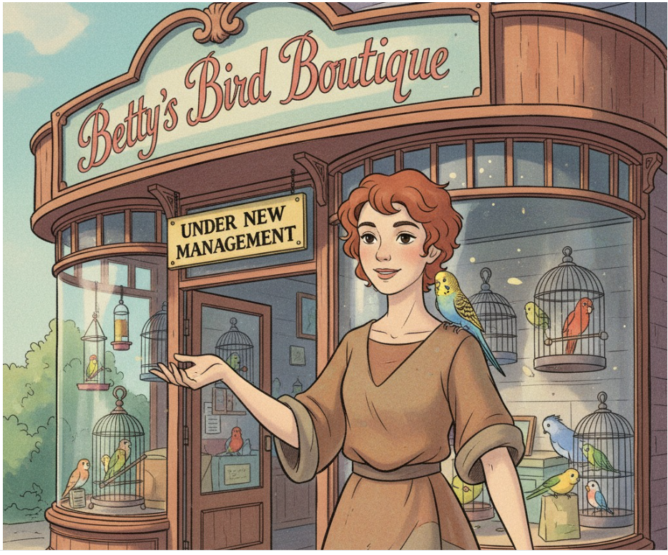
Taking Wing: Building an Agentic Bird Brain
You’re the brand-new owner of Betty’s Bird Boutique, a pet store that caters to people who are buying birds and all the food and accessories they may need. You don’t actually know much about birds, but you have always wanted to own a store, and the opportunity came up.
The Challenge
Unfortunately, the store's website is pretty basic. You want to enhance it by adding an AI agent to answer customer questions about birds in general and what your store offers.
A key requirement is that the agent should not take orders—the goal is to encourage customers to come into the store and establish a good relationship.
The Goal
You will build an agent that can answer questions about your store and birds based on information from three primary sources:
- A price database stored in a relational database.
- PDF or other text files containing information about your store, such as hours of operation and its history.
- Web-sourced information for general questions about birds.
The agent must also have guardrails to avoid answering questions that are unrelated to birds or your store. Before deploying to a live website, you will test and refine the agent in a dedicated development environment.

Project Summary
Using Google’s Agent Development Kit (ADK) and a GCP runtime environment, you will build a simple customer support agent that answers questions topically relevant to your store. It should be able to carry on a multi-turn conversation, remembering facts from previous turns, but it does not need to store information from previous conversations.
The agent should have three tools that it is able to use:
- Look up prices: Connect to a relational database to find the price of a specific item.
- Answer store-specific questions: Use PDF documents as a knowledge base to answer questions about:
  - The store hours
  - The store location
  - The history of the store, the current staff, their birds, etc.
- Answer general questions about birds: Use information from Google Search and the web.
The agent should also have guardrails, implemented through prompt engineering or tools, to avoid answering questions that are not related to birds or your store.
You will develop this project using a workspace where you can run the python script in the “adk web” testing environment. This will allow you to have conversations with your agent, providing a simulation of the customer experience along with valuable debugging feedback.
Accessing Google Cloud Platform Credentials
Launch the GCP (Google Cloud Platform) Web Console
In this course, Udacity offers you a federated user account, a temporary Google Cloud Platform user account with limited permissions. We call it a Cloud Lab. You can use the Cloud Lab for educational purposes only.
Before you begin, be sure to log out of any GCP accounts you may already have running. Next, click on the Cloud Resources tab to generate the temporary GCP credentials (access keys). You can click on the Open Cloud Console button to go to the GCP console.
Ensure that you do not have a pop-up blocker installed; it may prevent the new tab from launching. Please be sure to allow pop-ups from Udacity.
GCP Account Restrictions
1. Session Limit
Note that there is a certain session time limit. If reached, you will automatically be timed out. As long as you have not used your entire allocated budget, your work will be saved. You can re-launch using the same "Launch Cloud Gateway" button in the left navigation menu to return to your session.
3. Budget
All Google services are a pay-as-you-go service. Udacity has set a budget for each student to complete their course work. Please understand that these credits are limited and available for you to use judiciously. The budget for this entire course is $25. Although, we find about $10 sufficient for most to complete this course.
If you hit your budget, your session will time out and your work will be lost and unrecoverable.
4. No Extra Credits
We recommend you shut down/delete every Google Cloud resource (e.g., Vertex AI Endpoints, Vertex AI Search apps, and Cloud SQL instances) immediately after usage or if you are stepping away for a few hours. Otherwise, you will run out of your allocated budget.
Udacity will not provide additional credits. In case you exhaust your credits:
- You will lose your progress on the Google Cloud console.
- You will have to use your personal Google Cloud account to finish the remaining course/program.
To better understand pricing, see the Google Cloud Pricing(opens in a new tab) for all available services.
Instructions
Component Breakdown
We’ll go into details below about each component, but you will be building a root_agent that you will be able to test using the adk web previewer. You’ll also be building three specific tools, using three different tool methods, that the root agent should use:
- Product Database Tool: This tool provides access to product data stored in a relational database (e.g., Cloud SQL for MySQL). To do this, you will configure a connection and tools using Google's MCP Toolbox.
- Document Q&A Tool: Answer questions about topics like hours and staff information from unstructured PDF documents. You will use a Vertex AI Search Datastore to store these documents and the google-cloud-discoveryengine library to query them.
- General Knowledge Tool: Answer all other bird-related questions. For this, you will implement Grounding with Google Search through Gemini.
It is highly recommended that you test your agent incrementally as you build each component. This allows you to evaluate its performance and functionality at each stage of development.
Building the Agent: Step-by-Step Guide 🛠️
Prerequisites
Before you begin, ensure you have completed all instructions from the Environment Setup guide. This includes setting all required values for your Google Cloud project in the .env file.
Part 1: Create the Root Agent
Your first task is to build the basic agent framework. You will work primarily in the agent.py and agent-prompt.txt files. The provided __init__.py file should not require any edits.
- Configure Session Storage: In agent.py, locate the comment prompting you to configure short-term session storage and add the required implementation.
- Add a Guardrail: Edit the agent-prompt.txt file to include a simple guardrail. This should instruct the agent to only answer questions about birds or the store.
- Experiment with Models: This is a good time to test different models to evaluate their performance and speed. Test at a minimum:
  - gemini-2.5-pro
  - gemini-2.5-flash
  - gemini-2.5-flash-lite
- Test the Agent: Run the agent from your command line to ensure it works correctly. Open the URL it provides in your browser to interact with it.
Once the basic agent is working, you can begin adding tools. Remember to re-evaluate your prompt and model selection as you add new capabilities.
Part 2: Add the Product Database Tool
Next, you will connect the agent to your product pricing database using the MCP Toolbox.
- Set Up the Database: If you haven't already, set up your Cloud SQL for MySQL database. Ensure it is running and you have its public IP address.
- Populate the Database: Use the provided betty_db.sql file to create the database schema, create the product table, and populate it with data.
- Configure User Access: Create a MySQL user with read permissions for the database and note the username and password.
- Update Environment File: Add the MySQL connection details (host, username, password, port) to your .env file.
- Define the Tool: Implement a new tool named get-product-price in the. This tool should query the database for a product's price based on its name.
- Run the Toolbox Server:
  - If you haven't downloaded the MCP Database Toolbox server, download and install it(opens in a new tab) for your platform.
  - From the command line, change directories to where your tools.yaml file is located.
  - Make sure the "MYSQL" environment variables are exported in your current command line. If you're using bash, for example, you might do something like export $(grep -v '^#' .env | xargs)
  - Start the server from your command line and add the provided URL to your .env file. /path/to/toolbox --tools-file "tools.yaml" If you need to use another port, you can include a --port parameter
  - Make sure you update the .env file to include the "TOOLBOX_URL" that points at the URL that the toolbox is listening to.
- Integrate with Agent: Update agents.py to access the get-product-price tool through the Toolbox. Adjust your agent's prompt if necessary to make it aware of this new tool.
- Test the Integration: Relaunch your agent and test that it correctly calls the new tool to retrieve product prices.
Part 3: Add the Unstructured Data Tool
Now, integrate a tool that allows the agent to find information in PDF documents using Vertex AI Search.
- Set Up Vertex AI Search: If you have not done so, create a Vertex AI Search Datastore. Connect it to a Google Cloud Storage (GCS) bucket where you will upload your documents.
- Upload Documents: Upload the provided PDF documents to your GCS bucket. Verify in the Vertex AI Search console that the documents have been successfully indexed and are available for search.
- Update Environment File: Add your Datastore configuration information to the .env file.
- Create the Tool: Implement the search functionality in the datastore.py file.
  - Use the imported discoveryengine library from Google.
  - Complete the provided search() function template, experimenting with parameters to find the best results.
  - Create a tool function that calls your search() function.
- Integrate with Agent: Update agents.py to add this new tool. Adjust your agent's prompt to guide it on when to use this document search capability.
- Test the Tool: Test your agent again. Ask questions that can only be answered using the information in the PDF documents to confirm the tool is working correctly.
Part 4: Add the Grounding with Google Search Tool
Finally, add a tool that can answer general knowledge questions by using a model with Grounding with Google Search enabled.
- Implement the AgentTool: Create this tool as an AgentTool. You can use the search_agent.py file as a starting point.
- Configure the Grounded Model: Remember that this tool uses a separate model configuration from the root agent. You will need to define a new agent with its own prompt and model settings specifically for this search task.
- Integrate with Agent: Update the main agents.py file one last time to add this final tool. Adjust the root agent's prompt as needed to help it delegate appropriate questions to this tool.
Assessment Instructions 📋
To complete your assessment, you will test your fully-integrated agent by engaging it in a conversation. You must capture and submit screenshots of this interaction as evidence of its functionality.
Testing Requirements
Your test conversation must demonstrate that the agent can correctly use all of its tools to answer a series of related questions.
- Start a new conversation with your agent in the web previewer.
- Ask questions that follow this sequence, adapting your phrasing as needed based on the agent's responses:
  - Test the Vertex AI Search Datastore tool:
    - When are you open on Thursday?
    - Who is Betty?
  - Test the Grounding with Google Search tool:
    - What kind of bird did she own?
    - What do they eat?
  - Test the Product Database tool:
    - Can I buy that from you?
- Take screenshots that capture the entire conversation, clearly showing both your prompts and the agent's full responses for each step.
Submission Guidelines
- Include the screenshots of your conversation as part of your final project submission.
- For detailed evaluation criteria, refer to the official Project Rubric.
Next Steps: Further Enhancements 🚀
- Expand the Product Info: To answer more user questions, add documents to your datastore—like return policy, holiday hours, sales, or your own staff bio—and test the agent’s responses before and after adding new information.
- Make the Agent Date-Aware: Build a tool to give the agent the current date and day, so it can answer questions like “Are you open today?” accurately.
- Boost Product Search: Create a tool that pulls the full product list so the agent can suggest matching items, even with typos. You can also try Vertex AI Search for structured data and compare which approach gives better results.
- Environment Setup
Project Environment
This project is built on a modern, cloud-native stack that combines local Python development with powerful Google Cloud Platform (GCP) services. You will use the Google Agent Development Kit (ADK) to orchestrate these components and build a sophisticated AI agent.
The core components of the environment are:
- Google Cloud Platform (GCP): The backbone of the project, providing AI, database, and search capabilities.
  - Vertex AI: For running powerful Gemini family models that give the agent its intelligence.
  - Cloud SQL for MySQL: A managed relational database for storing structured product data.
  - Vertex AI Search: A search engine for querying unstructured data from PDF documents.
  - IAM & Admin: For securely managing access to your GCP resources via a Service Account.
- Python 3: The programming language used for all the agent's logic and tool integrations.
- Google Agent Development Kit (ADK): The central framework you will use to define, configure, and run the agent and its tools.
Local Machine Instructions
To run this project on your local machine, you will need to configure your environment to connect securely to Google Cloud.
1. Install Dependencies: First, you need to install all the required Python libraries. You can do this using pip and the requirements.txt file provided in the workspace:
pip install -r requirements.txt
2. Configure Environment Variables (.env file): A critical part of your setup is the .env file. This file keeps sensitive information (like API keys and passwords) and environment-specific settings out of your code. You will need to create this file in the /project/ directory and populate it with the following variables:
- GOOGLE_CLOUD_PROJECT: The unique ID of your Google Cloud project.
- GOOGLE_CLOUD_LOCATION: The GCP region for your resources (e.g., global or us-central1).
- DATASTORE_PROJECT_ID: The project ID where your Vertex AI Search app is located.
- DATASTORE_ENGINE_ID: The unique ID generated for your Vertex AI Search app.
- MYSQL_HOST: The public IP address of your Cloud SQL for MySQL instance.
- MYSQL_USER & MYSQL_PASSWORD: The username and password for your MySQL database.
- GOOGLE_APPLICATION_CREDENTIALS: The absolute file path to your downloaded service account JSON key.
Workspace Instructions
The project workspace is structured to be modular and easy to navigate. Here are the key files and directories you will be working with:
- agent.py: The main file where you will define and configure your root agent.
- datastore.py, search_agent.py: Files where you will implement specific tools for searching documents and the web.
- tools.yaml: The configuration file for the MCP Toolbox, which defines how your agent connects to the MySQL database.
- requirements.txt: A list of all the Python libraries required for the project, including:
  - google-adk: The core library for the Agent Development Kit.
  - google-cloud-discoveryengine: The Python client for interacting with Vertex AI Search.
  - toolbox-core: The Python client for the MCP Toolbox.
- /docs/: This folder contains supplementary materials, including the database schema (betty_db.sql) and the PDF documents (bettys-history.pdf, etc.) that you will use to populate your Vertex AI Search datastore.
Use this project rubric to understand and assess the project criteria.
Root Agent
Criteria | Submission Requirements
Create and configure a root agent. | - An agent object of type `Agent` is created in the `agent.py` file.  - The agent object is configured with a `name` and `description` suitable for a bird shop customer service agent.  - The agent is configured with an `instruction` parameter that reads from the `agent-prompt.txt` file.  - The agent is configured with all required tools (database, datastore search, and web search).
Configure the agent's session storage and select an appropriate LLM. | - An `InMemorySessionService` is properly imported and instantiated in the `agent.py` file.  - A gemini model is specified for the agent.  - A comment in the `agent.py` file justifies the model selection.
Design and implement an effective agent prompt. | - The agent-prompt.txt file defines a clear persona for the bird shop customer service agent.  - The prompt includes explicit guidelines for when and how the agent should use its tools (database for product pricing, datastore for store info, web search for current trends).  - The prompt sets clear boundaries that the agent should focus on bird-related topics and Betty's Bird Boutique operations.
Demonstrate successful agent execution and tool usage. | - The submission includes screenshots of conversations with the agent showing session IDs.  - Screenshots demonstrate the agent successfully using all three tools (database, datastore search, and web search) in a single conversation.  - For each tool call, screenshots show the detailed request and response, including any tool-specific outputs
Product databases through MCP Toolbox
Criteria | Submission Requirements
Configure database source and implement secure SQL tool. | - The tools.yaml file contains a source with a clear, descriptive name that identifies the data source.  - Source specifies kind: mysql and uses environment variables for host, port, user, and password with ${VAR_NAME} notation.  - Tool has appropriate name with kind: mysql-sql and clear description for querying product pricing.  - Tool has one string parameter with relevant name and description.  - SQL statement uses LIKE comparison with wildcards and positional parameter (?) to search product names in the products table.
Implement ToolboxSyncClient to load database tool. | - Imports ToolboxSyncClient from toolbox_core.  - Uses os.environ.get("TOOLBOX_URL", "http://127.0.0.1:5000(opens in a new tab)") for toolbox URL (no trailing slash).  - Creates ToolboxSyncClient with the URL.  - Loads database tool using db_client.load_tool() and includes in agent's tools list.
Demonstrate successful database tool usage in agent conversations. | - Screenshots show conversations with the agent successfully using the database tool.  - Screenshots capture both user requests for product information and agent responses with database results.  - Tool calls show detailed request and response information including successful product queries and appropriate handling of not-found scenarios.
Search Tools (Vertex AI & Datastore)
Criteria | Submission Requirements
Implement search() function using discoveryengine library with proper configuration and attribution. | - The "datastore.py" file contains updates to the search() function using the discoveryengine library from Google.  - Uses object classes from google.cloud.discoveryengine_v1 library OR documents which alternative classes are used.  - If code is based on Google sample, must state so and explain choices.  - Request object (type SearchRequest) contains minimum attributes: serving config, query parameter, and content search spec of appropriate type.  - Should include other search specification parameters for fine-grained results.
Create properly documented Vertex AI Search Tool function with environment variables and result processing. | - Converts search results to list of strings using appropriate iteration and content extraction.  - Separate tool function calls search function with appropriate parameters and returns processed results.  - Tool definition uses docstring comments.  - Project ID, engine ID, and location read from environment variables with appropriate defaults.  - Tool function takes search query parameter and calls search with environment configuration values.
Code demonstrating datastore tool integration | The code in "agent.py" imports the tool defined in "datastore.py" and makes this tool available to the root agent.  The datastore search tool must be defined in the same file as search() which should be "datastore.py".  The "agent.py" file must import the tool function from "datastore.py" and include it in the list of tools to be sent to the root agent constructor.
Demonstrate operation of the datastore tool as part of a conversation with the agent. | - Screenshots from conversations with the agent illustrating successful tool calls.  - Screenshots should capture details of both the request and the response.  - The response is not expected to answer the question, but should contain part of the source document that will.
Grounding with Google Search
Criteria | Submission Requirements
Code demonstrating an agent tool that uses Grounding with Google Search to answer questions and correct the incorporation of this tool as part of the root agent configuration. | • Code in "search_agent.py" file creates an Agent object with appropriate name and description for search functionality.  • Agent includes google_search tool imported from google.adk.tools in its tools list.  • Creates AgentTool wrapper around the search agent for integration with root agent.  • Root agent imports and includes the search agent tool in its tools list.
Demonstrate evaluation and selection of an appropriate model and prompt for the search agent. | • Search agent uses an appropriate Gemini 2.0 or 2.5 family model with comments explaining the choice.  • Model selection considers performance requirements for search functionality.  • The prompt in "search-prompt.txt" contains an appropriate prompt for the search agent's role.  • Prompt design is suitable for handling search-related queries.
Demonstrate operation of the search tool as part of a conversation with the agent. | • Screenshots from conversations with the agent illustrating successful searches using the Google Search grounding tool.  • Screenshots should capture details of both the request and the response.  • Evidence shows the agent using web search to answer questions requiring external or real-time information.  • Search responses include visible attribution or sources indicating grounded search results.
General coding best practices
Criteria | Submission Requirements
Demonstrate proper division of tasks into different tools and splitting of tools into appropriate functions. | - Tool-related functions are defined in separate files (e.g., datastore.py, search_agent.py) and imported into agent.py.  - Helper functions are co-located in the same file as the tool functions that use them.  - Variable and function names are descriptive and follow a discernible naming convention (e.g., snake_case).  - The code includes comments and docstrings at appropriate places.
Suggestions to Make Your Project Stand Out
1. Expand Your Knowledge Base
Consider adding more documents that describe the store. What other information might customers want to know about the store or birds?
Some suggestions to try:
- Return policy
- Special holiday hours
- Promotions or sales
- Staff bios (insert yourself!)
Test conversations both before and after adding new information to see how the agent's responses improve.
2. Add Date Awareness
Although you have store hours, the agent doesn't know today's date, so it can't answer "Are you open today?". Create a tool that provides the current date and day of the week**.**
3. Improve Product Matching
The database currently requires fairly exact product name matching. You can improve this in two ways:
- Vertex AI Search approach: Use Vertex AI Search with structured data.
- Product list approach: Create a tool that retrieves all product names and embeds them in the conversation for similarity matching.
Try both approaches and compare:
- Which gives better results with typos or partial names?
- What are the performance trade-offs?
- How do they handle edge cases?

