# DAY-02

21.Write a LEX specification file to take input C program from a .c file and count the number of characters, number of lines & number of words.

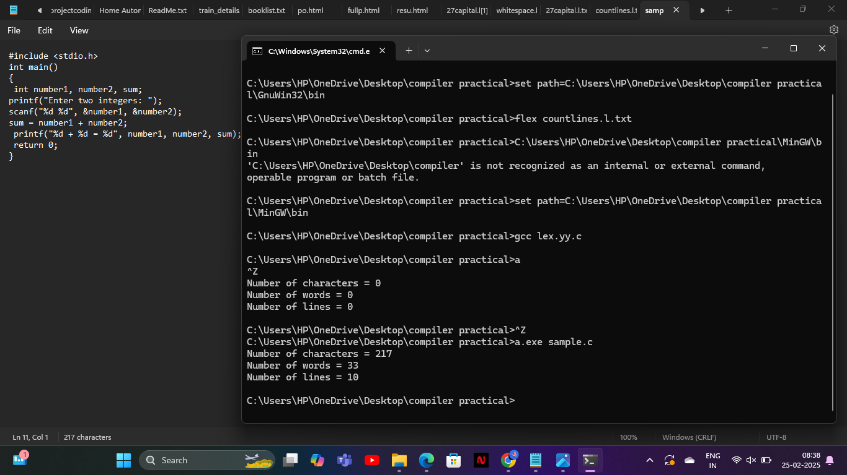

22. Write a LEX program to print all the constants in the given C source program file

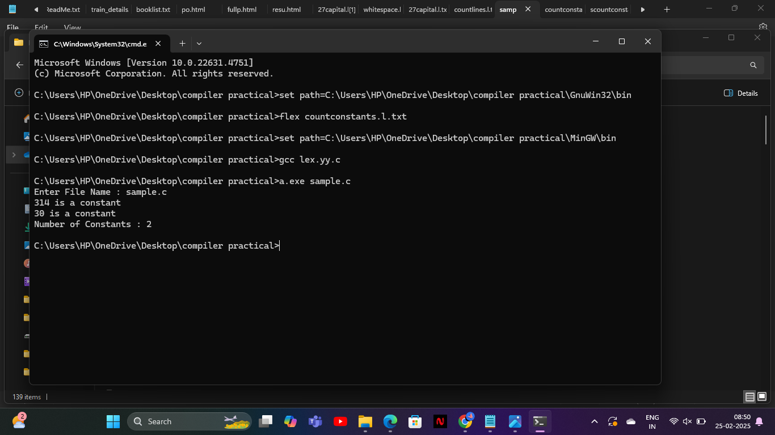

23. Write a LEX program to count the number of Macros defined and header files included in the C program

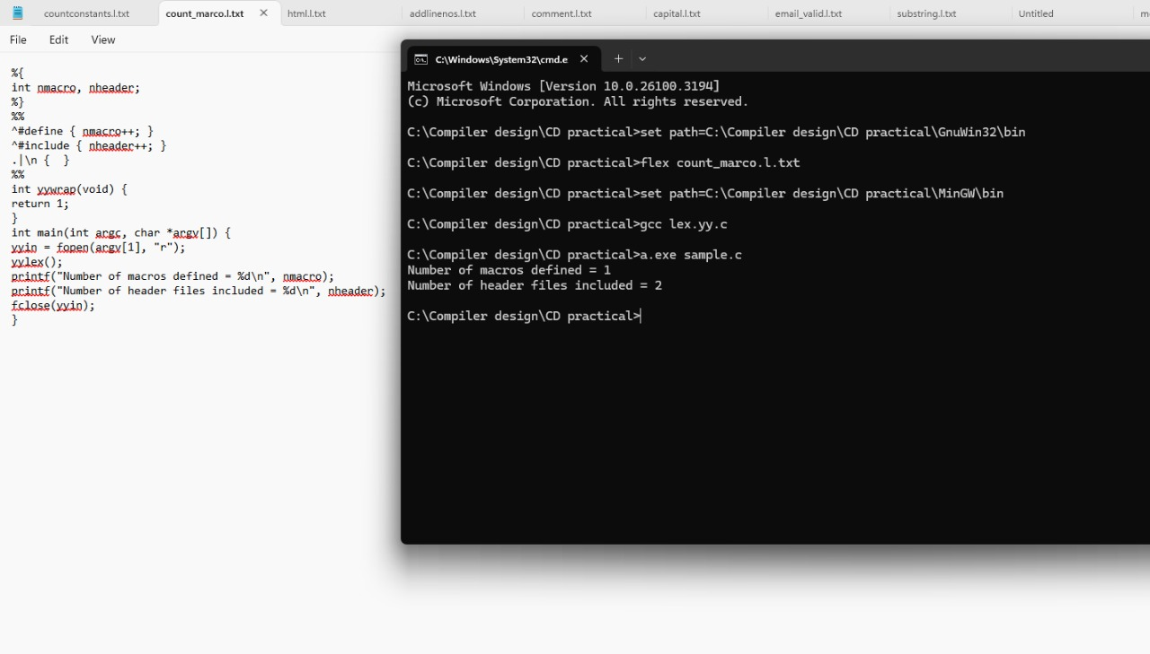

24. Write a LEX program to print all HTML tags in the input file

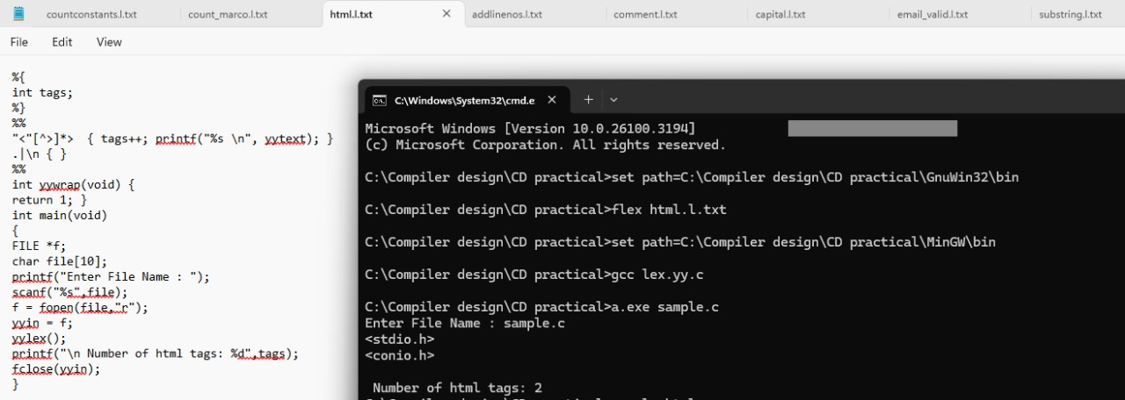

25. Write a LEX program which adds line numbers to the given C program file and display the same in the standard output.

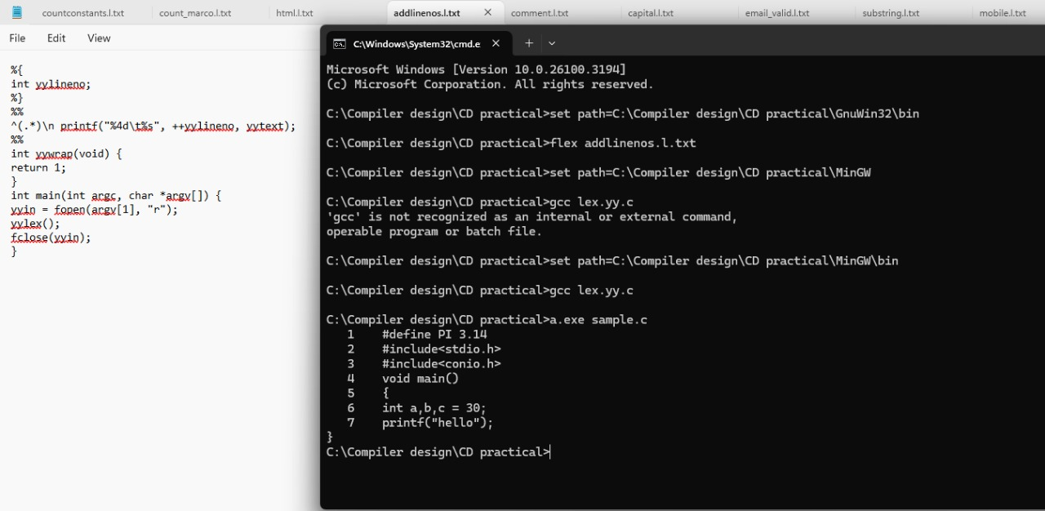

26. Write a LEX program to count the number of comment lines in a given C program and eliminate them and write into another file.

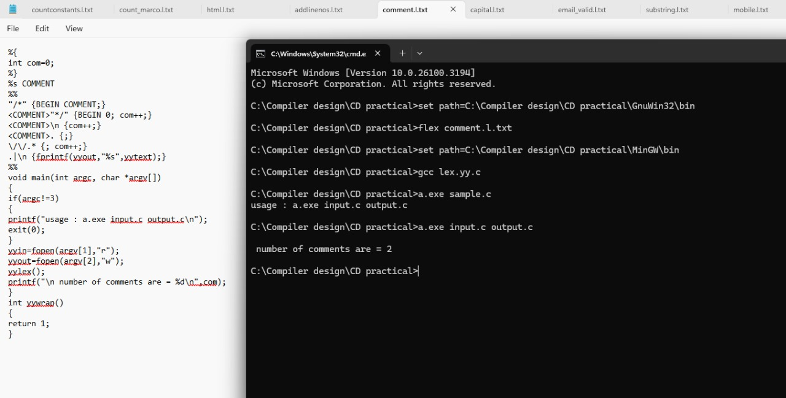

27. Write a LEX program to identify the capital words from the given input.

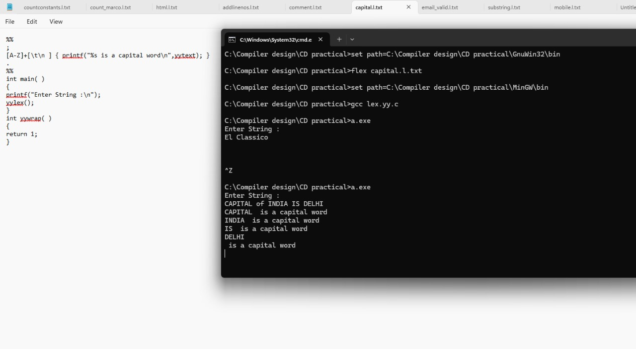

28. Write a LEX Program to check the email address is valid or not.

