ENTERPRISE CONTEXT BRAIN (ECB)
Product Requirements Document — GenAI Decision Intelligence Platform
Version 2.0 | 22 August 2026 | High-Potential GenAI Product Baseline
Document ID | Status | Depends On
ECB-PRD-02 | Architecture/Product Review | Source ECB PRD v1.0; TRS-02; UX-02; FLOW-02; DATA-02; PLAN-02
Source boundary: this suite preserves the user-provided ECB product baseline and explicitly labels new technology/design recommendations as proposed architecture. The source baseline defines a governed organizational-memory and agentic decision-intelligence platform, with Manager/Project/Risk/Decision capabilities, evidence, temporal context, MCP, human approval and an MVP using Jira-like tickets, project docs/ADRs and Git. fileciteturn2file1

Table of Contents
- 1 Executive Product Thesis
- 2 Market & Competitive Position
- 3 Personas
- 4 Product Experience
- 5 Requirements / MoSCoW
- 6 GenAI Product Architecture
- 7 Success Metrics
- 8 Rollout
- 9 Risks
- 10 Cross-document traceability
- Appendix References

1 Executive Product Thesis
ECB should be positioned as an enterprise context operating system for agentic work: not another chatbot, not document-only RAG, and not an autonomous automation bot. Its moat is a governed context layer that combines temporal organizational memory, evidence provenance, permissions, contradiction handling and controlled action.

1.1 North-star experience
ASK → UNDERSTAND CONTEXT → VERIFY EVIDENCE → EXPLAIN → RECOMMEND → GOVERN → ACT → LEARN
- The source PRD identifies the core problem as fragmented organizational context across tickets, documents, meetings, code and operational systems. fileciteturn2file11
- The MVP remains one representative/synthetic project with Jira-like tickets, project docs/ADRs, Git, Manager + Project/Risk/Decision capabilities, one actionable MCP integration and one human approval flow. fileciteturn2file1

2 Market & Competitive Position
Category | Typical approach | ECB differentiation
Enterprise search | Find documents | Finds context + entities + decisions + changes.
RAG assistant | Retrieve top-k chunks | Context planning, temporal memory, authority and contradiction handling.
Copilot | Assist within one workflow | Cross-system organizational memory.
Agent platform | Tools + reasoning | Governed enterprise action with evidence and policy.
Knowledge graph | Relationships | Hybrid relational/vector/context graph without requiring a graph-only architecture.
Strategic timing: current agent platforms increasingly emphasize tools, handoffs, guardrails, tracing and evaluation. OpenAI's current Agents SDK direction explicitly supports tool use, memory, sandboxed work and long-running tasks, while MCP's 2026 specification adds a stateless core, tasks, cacheable list results and stronger authorization. citeturn0search0turn0search14

3 Personas
Persona | Job | Top questions | Design priority
Project Manager | Portfolio execution | Why delayed? What changed? What needs attention? | P0
Engineering Lead | Technical context | Why was this architecture chosen? What dependencies changed? | P0
Data/AI Lead | Data/model/platform | What changed in pipelines/models? | P1
Operations Lead | Incidents/SLA | What is current operational risk? | P1
Executive | Decision compression | What needs attention now? | P1

4 Product Experience
Capability | Definition of done
Context intelligence | Identifies intent/entities/time and creates a context plan before retrieval.
Hybrid retrieval | Combines lexical/semantic/entity/metadata signals with reranking.
Evidence | Every material claim can be inspected to source, timestamp, authority and permission.
Temporal memory | Current, historical and superseded records are distinguished.
Conflict | Contradictions are surfaced rather than silently merged.
Agentic action | Recommendation is separated from execution; high-impact action is approval-gated.
Learning | Outcomes and feedback become governed memory/evaluation signals.

5 Functional Requirements / MoSCoW
Priority | Requirements
MUST | Ingest Jira-like, project docs/ADRs and Git; normalize canonical entities; hybrid retrieval; permission filtering; evidence; freshness; conflict detection; Manager/Project/Risk/Decision agents; one MCP action; approval; audit; trace.
SHOULD | Proactive briefings; change detection; historical learning; saved investigations; evaluation dashboard; source-health dashboard; memory feedback.
COULD | Multi-project portfolio intelligence; natural-language workflow builder; MCP Apps; agent marketplace; multimodal evidence.
WON'T MVP | Unrestricted autonomous production changes; organization-wide autonomous agent fleet; provider-specific lock-in; graph database as mandatory core.

6 GenAI Product Architecture
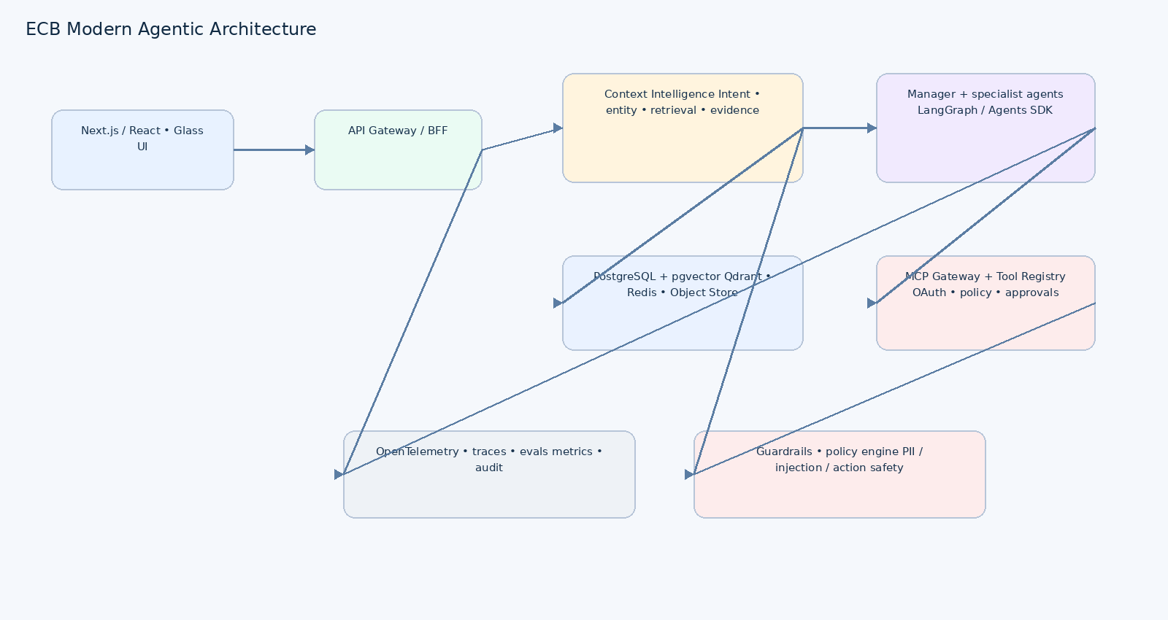
Figure 1. Proposed product architecture. The source architecture is retained while modernizing the agent/runtime layer.

6.1 GenAI design choices
Decision | Recommendation | Rationale
Model gateway | Provider-neutral abstraction with OpenAI Responses/Agents SDK-compatible adapter plus alternate model adapters | Avoid application lock-in; enable model routing/evaluation.
Agent runtime | LangGraph for durable stateful workflows OR OpenAI Agents SDK for model-native orchestration; choose one primary runtime in ADR | Current agent platforms emphasize tracing, guardrails, handoffs and long-running execution. citeturn0search1turn0search0
Memory | PostgreSQL canonical store + Qdrant/pgvector retrieval + mem0-style durable memory pattern | Separate source-of-truth entities from semantic memory.
MCP | MCP gateway with registry, policy, OAuth and approval | MCP is now a mature agent/tool integration standard with tasks and enterprise authorization. citeturn0search14
Safety | Policy engine + guardrail model + deterministic authorization | LLM confidence must never be security authorization.
Evaluation | Trace-linked datasets, retrieval metrics, groundedness, tool correctness, safety regression | Agent quality must be measured continuously.

7 Success Metrics
Metric | MVP target | Measurement
Evidence-backed answers | >95% | Human/eval-set claim verification
Context API availability | ≥99.9% | 30-day synthetic + production telemetry
Retrieval P95 | <500ms | Load test
Standard answer P95 | ≤10s excluding model generation variance | Representative workload
Unauthorized access | 0 | Security/e2e tests
Unapproved critical actions | 0 | Policy audit
Action audit coverage | 100% | Audit reconciliation
Primary workflow success | >98% | E2E task telemetry
User trust | ≥4/5 | Pilot survey on evidence/clarity
Time-to-insight | ≥50% reduction vs baseline | Controlled user study

8 Rollout
Phase | Outcome | Gate
0 Discovery | Gold questions, personas, source contracts | Signed PRD
1 Context MVP | Ingestion + canonical model + retrieval | Evidence quality gate
2 Agent UX | Manager/Project/Risk/Decision + modern UI | Workflow success gate
3 Governed Action | MCP + policy + approval + audit | Zero unsafe-action gate
4 Pilot | Realistic workload + evaluation | SLO/security gate
5 Scale | More sources, projects, agents | Cost/quality regression gate

9 Risks
Risk | Mitigation
Hallucination | Evidence requirement + claim-level citations + evals
Stale context | Source freshness SLA + temporal validity
Prompt injection | Treat retrieved content as untrusted; sanitize + tool isolation + policy
Agent overreach | Read/recommend/execute separation + approval
Model drift | Model gateway + versioned eval sets
Cost explosion | Context budgets, caching, model routing, token telemetry
UX trust failure | Evidence-first UI, explicit uncertainty, traceable actions

10 Cross-document Traceability
PRD | TRS | FLOW | UX | DATA | PLAN
FR-04 Context planning | TRS-AI-01 | FLOW-CTX-01 | UX-AI-01 | DATA-EVID-01 | PLAN-EPIC-03
FR-07 Evidence | TRS-RET-02 | FLOW-EVID-01 | UX-EVID-01 | DATA-EVID-01 | PLAN-EPIC-04
FR-09 MCP action | TRS-MCP-01 | FLOW-ACT-01 | UX-ACT-01 | DATA-ACT-01 | PLAN-EPIC-06
FR-10 Approval | TRS-POL-01 | FLOW-POL-01 | UX-APP-01 | DATA-AUD-01 | PLAN-EPIC-06

Appendix – References
OpenAI Agents SDK / agent tooling — https://openai.com/index/the-next-evolution-of-the-agents-sdk/
OpenAI agent tools — https://openai.com/index/new-tools-for-building-agents/
MCP 2026 specification — https://blog.modelcontextprotocol.io/posts/2026-07-28/
AWS GenAI architecture guidance — https://docs.aws.amazon.com/prescriptive-guidance/latest/gen-ai-lifecycle-operational-excellence/preprod-architecting.html
W3C WCAG 2.2 — https://www.w3.org/TR/WCAG22/
NIST AI RMF — https://www.nist.gov/itl/ai-risk-management-framework

