ENTERPRISE CONTEXT BRAIN (ECB)
Technical Requirements Specification — GenAI Platform
Version 2.0 | 22 August 2026 | High-Potential GenAI Product Baseline
Document ID | Status | Depends On
ECB-TRS-02 | Architecture/Product Review | PRD-02; DATA-02; FLOW-02
Source boundary: this suite preserves the user-provided ECB product baseline and explicitly labels new technology/design recommendations as proposed architecture. The source baseline defines a governed organizational-memory and agentic decision-intelligence platform, with Manager/Project/Risk/Decision capabilities, evidence, temporal context, MCP, human approval and an MVP using Jira-like tickets, project docs/ADRs and Git. fileciteturn2file1

Table of Contents
- 1 Architecture
- 2 Technology Stack
- 3 GenAI Runtime
- 4 Data Plane
- 5 API/MCP
- 6 Security
- 7 Reliability
- 8 Performance
- 9 Environments
- 10 Testing
- 11 ADRs
- Appendix

1 Architecture
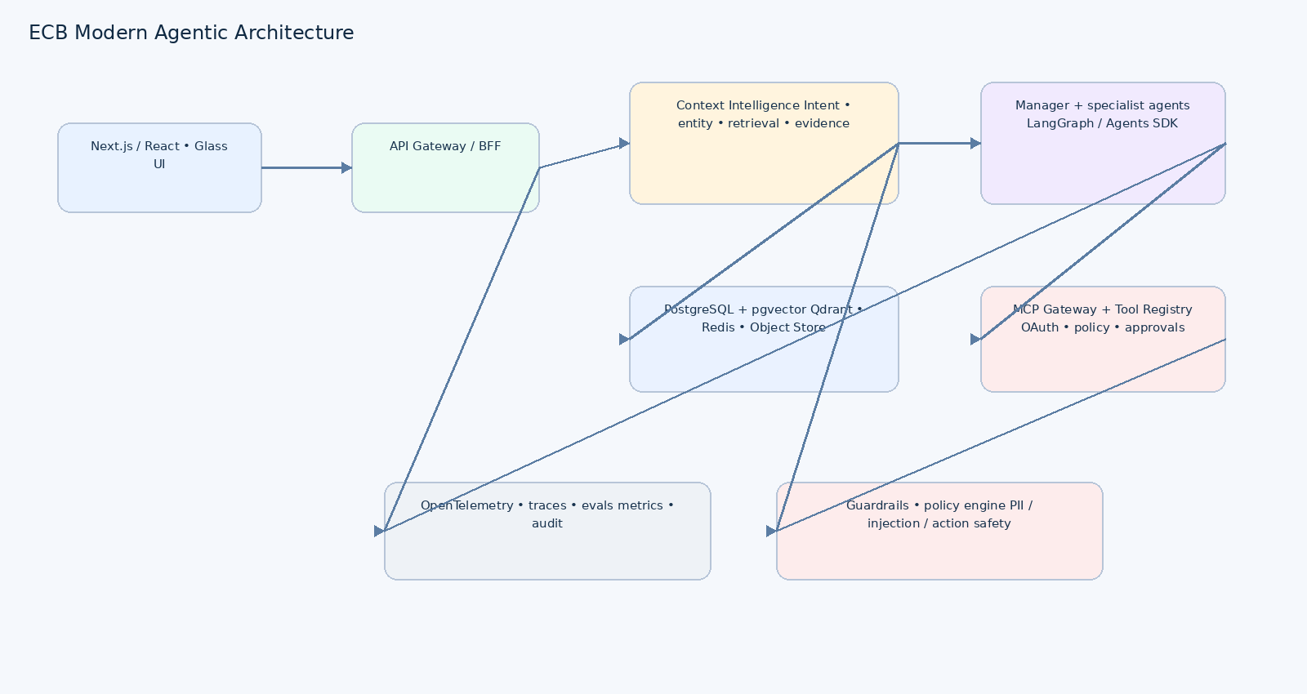
Architecture principle: separate the memory/data plane from the agent/tool control plane. This is consistent with the existing ECB technical baseline. fileciteturn2file18
Layer | Technology | Requirement
Web | Next.js + React + TypeScript | SSR/streaming where useful; design tokens; accessible components.
API | FastAPI + Python 3.12+ | Async I/O, OpenAPI-first, typed DTOs.
Agent runtime | LangGraph or OpenAI Agents SDK | Durable state, tracing, guardrails, handoffs; final choice via ADR.
LLM gateway | Provider abstraction | Model routing, budgets, retries, fallbacks, versioning.
Context | Context Planning Service | Intent/entity/time/scope/retrieval plan.
Retrieval | Qdrant + PostgreSQL/pgvector | Hybrid search, metadata filtering, reranking.
Canonical DB | PostgreSQL | Strong consistency, RLS, JSONB, relational entities.
Cache | Redis | Hot context, session/workflow metadata, rate limits.
Object storage | S3-compatible | Raw docs, exports, large artifacts.
Messaging | Kafka/SQS/Redis Streams depending deployment | Async ingestion, actions, evaluations.
MCP | MCP Gateway + Registry | Tool/resource access, auth, policy and tasks.
Observability | OpenTelemetry + Prometheus/Grafana or managed equivalent | Trace every request/agent/tool path.
Deployment | Docker + Kubernetes/ECS approved platform | Horizontal scaling and controlled releases.

2 Technology Selection Rationale
AWS guidance recommends evolving GenAI systems from simple prompting to RAG when proprietary/up-to-date knowledge is required, and to agentic systems when multi-step tool interaction is required. It also recommends validating retrieval quality, embeddings, vector stores and chunking rather than assuming the model solves these concerns. citeturn0search9

3 GenAI Runtime Requirements
ID | Requirement
AI-01 | All model calls pass through a gateway with model/version/token/cost metadata.
AI-02 | Context budget is computed before generation; no dependency on maximum context window.
AI-03 | Every retrieval run records query, filters, candidate count, reranking and evidence IDs.
AI-04 | Tool calls are schema validated and policy checked before execution.
AI-05 | High-impact mutations require explicit approval state.
AI-06 | Agent workflows are resumable and idempotent.
AI-07 | Evaluation datasets and trace IDs are linked to release versions.
AI-08 | Retrieved content is treated as untrusted input for prompt-injection defense.

4 Security Architecture
Control | Specification
Identity | OIDC/OAuth2 + MFA through enterprise IdP
Authorization | RBAC + ABAC + source-level permissions + row-level security
Encryption | TLS 1.2+ in transit; AES-256-class encryption at rest; KMS-managed keys where available
Secrets | Runtime secret manager; never in source or prompts
Tool isolation | Allowlist tools and destinations; scoped service identities
Prompt injection | Content isolation, untrusted-content labeling, input/output/tool guardrails
PII | Detect/mask/classify before persistence where policy requires
Audit | Append-only action/security events with actor, policy decision, trace and outcome
Supply chain | SBOM, signed artifacts, dependency scanning, provenance
AI governance | NIST AI RMF/GenAI profile + OWASP LLM/agentic practices

5 Performance & Scalability
Metric | Target | Scale strategy
Context API P95 | <300ms before model | Horizontal API scaling + Redis
Retrieval P95 | <500ms | ANN/vector indexes + metadata prefilter + cache
Standard E2E answer | ≤10s excluding generation variance | Parallel retrieval + streaming + model routing
Near-real-time freshness | <5min where source supports it | Incremental events + priority queues
Availability | ≥99.9% Context API | Multi-instance + health checks
Load | 2x baseline without >1pp error-rate regression | Autoscaling + queue backpressure
Long jobs | Async/task model | MCP Tasks / workflow state

6 Environments
Env | Purpose | Controls
Local | Developer iteration | Docker Compose, synthetic data, mock IdP/tools
Dev | Shared integration | Feature flags, ephemeral test data
Staging | Production-like validation | Realistic dataset, security/eval/load tests
Production | Pilot/enterprise | Private networking, HA, backups, audit, change control

7 Resilience
- Timeouts on every network/model/tool call.
- Exponential backoff with jitter only for retry-safe operations.
- Circuit breakers and bulkheads around model providers and enterprise systems.
- Idempotency keys for mutations.
- Dead-letter queue for failed ingestion/actions.
- Checkpoint agent state before approval and before external mutation.
- Restore drills and schema-compatible rollback strategy.

8 Observability
trace_id → request → context_plan → retrieval → rerank → model → policy → MCP → outcome
Signal | Examples
Traces | agent_run, retrieval, model_call, policy_check, tool_call
Metrics | latency, token usage, retrieval recall proxy, tool success, approval rate
Logs | Structured JSON with correlation IDs; no secrets
Quality | Groundedness, citation correctness, answer usefulness, conflict handling
Cost | Tokens by model/agent/user/project; cache hit rate
Security | Denied access, injection flags, tool policy violations

9 Testing
Layer | Gate
Unit | Critical business/policy/retrieval logic covered
Integration | DB, vector store, identity, MCP and model gateway pass
Contract | OpenAPI + MCP schema compatibility
E2E | All MUST user journeys
AI eval | Groundedness, retrieval, citation, refusal, tool correctness
Security | 0 critical findings; authz bypass = 0
Load | Declared latency/error targets met
Chaos | Worker/connector/model failure recovers
DR | Restore and state recovery verified

10 Architecture Decision Records
ADR | Decision
ADR-001 | LangGraph vs Agents SDK as primary workflow runtime
ADR-002 | Qdrant + pgvector division of responsibility
ADR-003 | Model routing/fallback strategy
ADR-004 | Event bus selection
ADR-005 | MCP gateway and registry topology
ADR-006 | Memory write policy and consent
ADR-007 | Multi-tenant isolation model

Appendix – References
OpenAI Agents SDK — https://openai.com/index/the-next-evolution-of-the-agents-sdk/
MCP 2026 — https://blog.modelcontextprotocol.io/posts/2026-07-28/
AWS GenAI production architecture — https://docs.aws.amazon.com/prescriptive-guidance/latest/gen-ai-lifecycle-operational-excellence/preprod-architecting.html
OpenTelemetry — https://opentelemetry.io/docs/
Kubernetes — https://kubernetes.io/docs/
OWASP LLM Top 10 — https://owasp.org/www-project-top-10-for-large-language-model-applications/
NIST AI RMF — https://www.nist.gov/itl/ai-risk-management-framework

