ENTERPRISE CONTEXT BRAIN (ECB)
Application Flow & Agentic Workflow Specification
Version 2.0 | 22 August 2026 | High-Potential GenAI Product Baseline
Document ID | Status | Depends On
ECB-FLOW-02 | Architecture/Product Review | PRD-02; TRS-02; UX-02; DATA-02
Source boundary: this suite preserves the user-provided ECB product baseline and explicitly labels new technology/design recommendations as proposed architecture. The source baseline defines a governed organizational-memory and agentic decision-intelligence platform, with Manager/Project/Risk/Decision capabilities, evidence, temporal context, MCP, human approval and an MVP using Jira-like tickets, project docs/ADRs and Git. fileciteturn2file1

Table of Contents
- 1 Flow Model
- 2 Primary Journey
- 3 Agent State Machine
- 4 Use Cases
- 5 Decision Trees
- 6 System Interactions
- 7 Failure/Recovery
- 8 Async Tasks
- 9 Acceptance

1 Flow Model
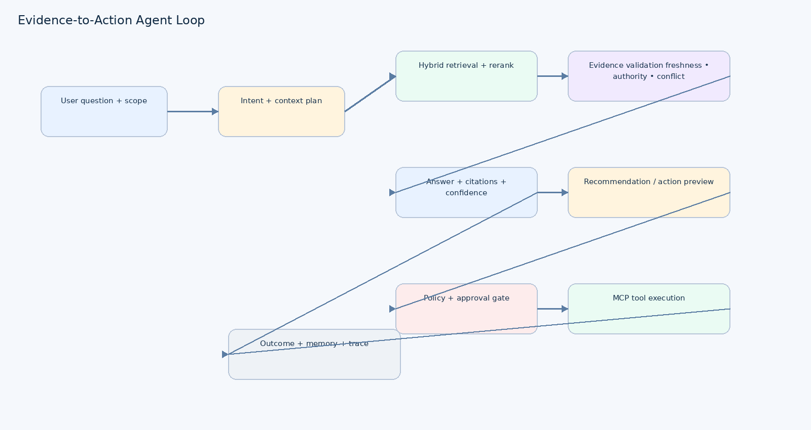
Figure 1. Evidence-to-action loop. It makes the critical product distinction between answering, recommending and executing.

2 Primary Journey — 'Why is the project delayed?'
- User selects project and optional time range.
- UI sends question + explicit scope to Context API.
- Context planner resolves intent, entities, time and required evidence types.
- Authorization filter removes inaccessible sources before ranking.
- Hybrid retrieval retrieves lexical, semantic, entity and temporal candidates.
- Reranker scores authority, freshness, relevance and contradiction risk.
- Evidence validator groups supporting/conflicting/superseded evidence.
- Manager Agent synthesizes answer with citations and confidence.
- If action is useful, agent produces recommendation and action preview.
- Policy engine classifies action; high-impact action enters approval state.
- User approves/rejects; approved action executes through MCP gateway.
- Tool outcome, audit event, trace and relevant memory/evaluation signal are persisted.

3 Agent State Machine
RECEIVED → AUTHORIZED → CONTEXT_PLANNING → RETRIEVING → VALIDATING → REASONING → RESPONDING →
RECOMMENDATION_READY → [NO_ACTION | POLICY_CHECK] → [APPROVAL_REQUIRED | EXECUTING | BLOCKED] →
[SUCCESS | FAILED | CANCELLED] → AUDITED
State | Entry | Exit
CONTEXT_PLANNING | Authorized request | Plan ready / clarification
RETRIEVING | Plan ready | Candidates / timeout
VALIDATING | Candidates | Evidence set / conflict
REASONING | Evidence set | Answer
APPROVAL_REQUIRED | Policy says human | Approved/rejected/expired
EXECUTING | Approval satisfied | Tool result
FAILED | Tool/model/system failure | Retry/compensate/escalate

4 Use Case Flows
Use case | Special flow
Project health | Aggregate current state + dependencies + risks + changes
Root cause | Timeline reconstruction + evidence conflict analysis
Decision intelligence | Decision memory + alternatives + rationale + supersession
Change detection | Compare temporal snapshots; prioritize material changes
Risk intelligence | Risk extraction + ranking + owner/evidence
Historical learning | Retrieve analogous prior issues and outcomes
Proactive briefing | Scheduled context plan → digest → user review
Action recommendation | Recommendation → policy → approval → MCP action

5 Decision Trees
Can ECB answer?
├─ sufficient evidence → answer
├─ partial evidence → answer with limitation + missing context
├─ conflicting evidence → surface conflict + latest/authority comparison
└─ no reliable evidence → ask clarification / state unable to establish
Can action execute?
├─ read-only → execute if authorized
├─ low impact → policy-approved execution
├─ high impact → approval required
├─ prohibited → block
└─ uncertain/unsafe → block + explain

6 System Interactions
Step | Producer | Consumer | Contract
Question | UI | API | POST /query
Context plan | API | Context service | Typed context plan
Evidence | Retriever | Agent | Evidence IDs + metadata
Action preview | Agent | Policy | Action schema
Approval | UI | Policy | Approval command
Execution | Policy | MCP gateway | Tool schema + idempotency key
Outcome | MCP | Audit + UI | Action result
Evaluation | Trace | Eval service | Run + dataset + scores

7 Failure & Recovery
Failure | User experience | System recovery
LLM timeout | Show retry + preserved question | Fallback model / retry-safe call
Retriever timeout | Partial answer or retry | Degrade to indexed source
Source unavailable | Mark source unavailable | Use cached/other evidence
Conflict | Show disagreement | Do not collapse into false consensus
Tool failure | Action failed; no success claim | Retry if safe; compensate/escalate
Approval expired | Action remains unexecuted | Return to approval queue
Permission denied | No protected content exposed | Audit denial
Prompt injection | Explain blocked content/action if safe | Isolate content; deny unsafe tool call

8 Async Tasks
Use durable task semantics for long-running ingestion, evaluations and multi-step tool workflows. MCP's 2026 specification formalizes tasks and states such as working, input_required, completed, failed and cancelled; it also introduces a stateless core suitable for ordinary HTTP infrastructure. citeturn0search14turn0search2

9 Acceptance
Criterion | Pass
All primary journeys | 100% executable in staging
Approval | 0 high-impact actions bypass approval
Evidence | Every final answer has inspectable supporting evidence or explicit limitation
Recovery | Retry/cancel paths preserve state correctly
Trace | Every agent/tool run has correlation/trace ID
Conflict | Known conflict fixtures are surfaced
Permissions | Unauthorized fixtures never appear

