ENTERPRISE CONTEXT BRAIN (ECB)
UI/UX PRODUCT DESIGN & DESIGN SYSTEM — v2.1
Complete modern GenAI application design specification | 22 August 2026

1. Executive Design Direction
ECB is designed as a premium enterprise AI operating console rather than a chat screen with a sidebar. The visual language combines restrained glassmorphism, spatial depth, ambient gradients and high-information enterprise density. The glass layer communicates hierarchy; it never replaces semantic structure, contrast or accessibility.
Source-derived product constraints: ECB is a governed organizational-memory and agentic decision-intelligence platform with Manager/Project/Risk/Decision capabilities, evidence, temporal context, MCP, human approval and an MVP around Jira-like tickets, project docs/ADRs and Git. fileciteturn3file2

2. Personas & Journey Map
Persona | Primary goal | Critical moment | Design response
Project Manager | Understand status/risk quickly | 'Why are we delayed?' | Dashboard → Ask ECB → evidence → recommendation
Engineering Lead | Understand technical rationale | 'Why was this architecture chosen?' | Decision timeline + ADR evidence
Data/AI Lead | Understand pipeline/model changes | 'What changed?' | Change timeline + source freshness
Operations Lead | Identify current operational risk | 'What needs action now?' | Risk matrix + governed actions
Executive | Compress context into decisions | 'What needs attention?' | Executive summary + confidence + evidence
Journey stage | UI behavior
Intent | Prompt + scope chips
Context | Project/date/source context visible
Evidence | Citation + authority + freshness
Insight | Answer with confidence and limitations
Recommendation | Separate from execution
Govern | Policy/risk preview
Approve | Explicit human action
Act | MCP execution progress
Outcome | Result + audit + trace

3. Information Architecture
Dashboard → Command Center → Projects → Risks → Decisions → Evidence → Approvals → Agent Trace → Settings
Global ⌘/Ctrl+K command palette provides cross-product navigation and scoped AI queries. The primary information architecture remains aligned with the existing ECB UX baseline. fileciteturn3file13

4. Visual Design System
Token group | Design specification
Canvas | #07111F / #0D1B2A deep navy; ambient blue-violet radial gradients
Glass | rgba(255,255,255,.06–.12); 18–28px backdrop blur; 1px translucent border
Primary | #5CA8FF electric blue
AI accent | #9B7CFF violet; cyan reserved for active intelligence state
Success | #35D07F
Warning | #F7B955
Error | #FF6B7A
Typography | Inter or Geist; 12/14/16/20/24/32/48 scale
Radius | 10–14px controls; 12–20px cards; 24px hero surfaces
Grid | 4px base spacing; 8/12/16/24/32/48 composition rhythm
Elevation | Soft layered shadow + inner highlight; no heavy neumorphism
The token-first approach follows established enterprise design-system practice: Atlassian describes design tokens as the single source of truth for UI decisions and its foundations explicitly cover color, spacing, typography, iconography, elevation, borders and radius. citeturn1search6turn1search12

5. Glassmorphism Rules
- Use glass for hierarchy: app shell, KPI cards, context drawers, evidence surfaces and AI response containers.
- Do not place dense data tables or small text over heavy blur.
- Provide opaque surfaces when transparency harms readability or performance.
- Use one dominant focal surface per viewport; avoid competing translucent layers.
- Keep semantic states visible through text/icon plus color.
- Treat glass as progressive enhancement, not a functional dependency.

6. Complete Key-Screen Mockups
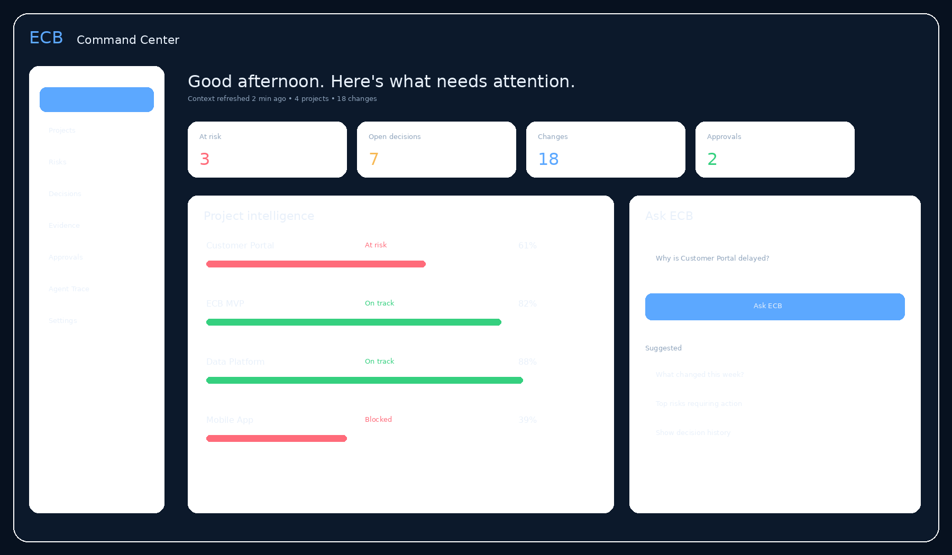
Figure 1 — Command Center: portfolio health, changes, approvals and AI entry point.
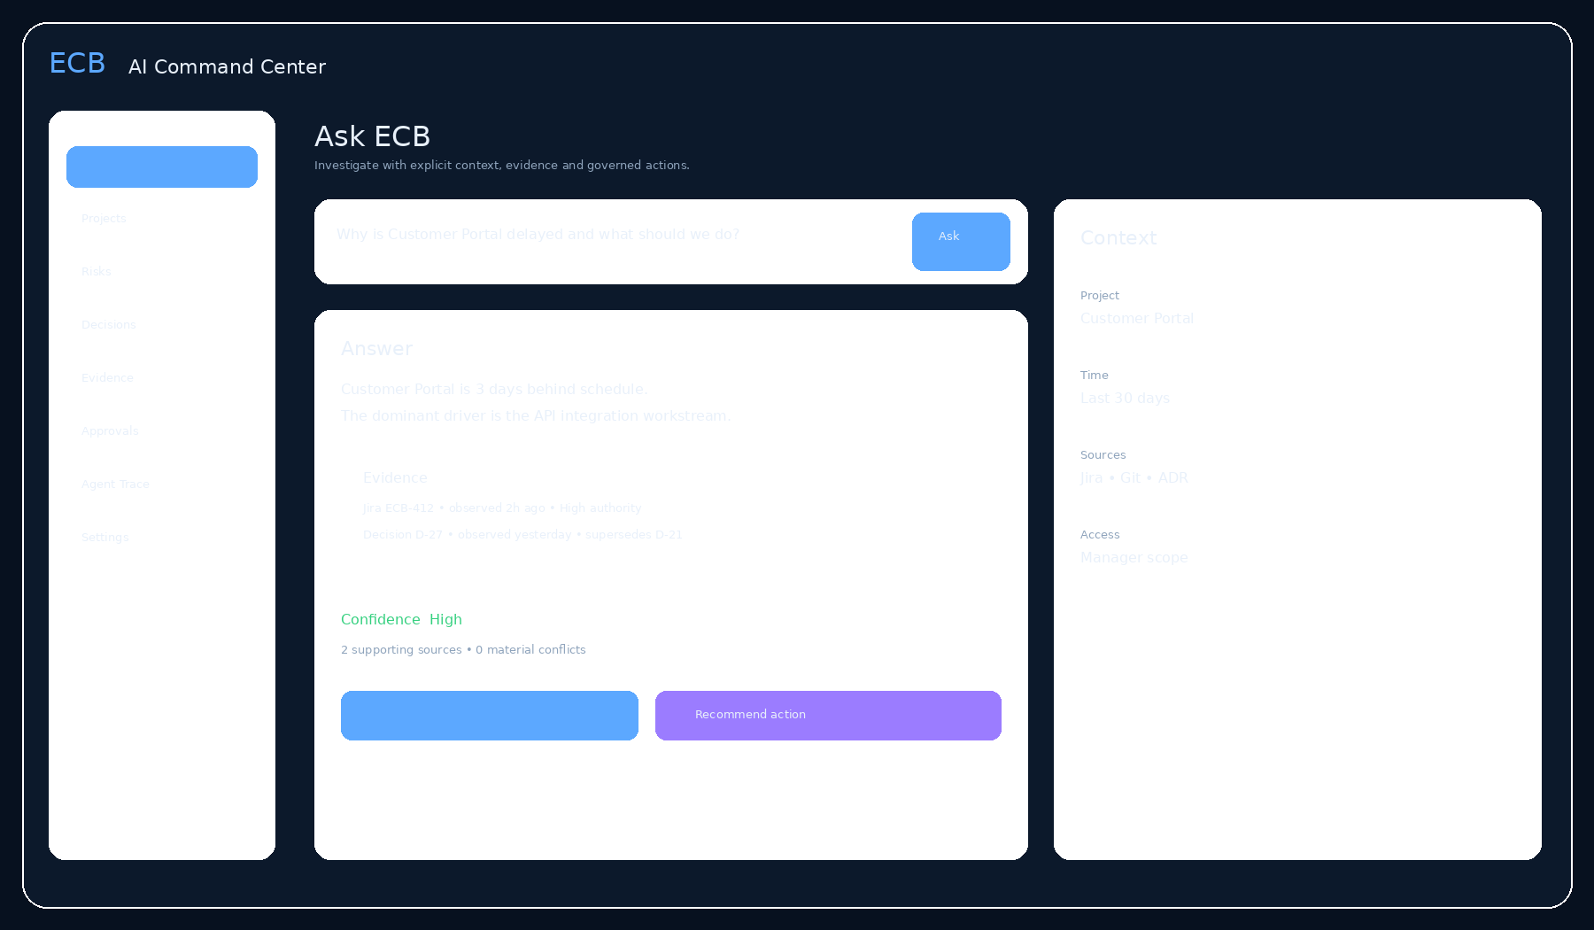
Figure 2 — AI Command Center: streaming answer, evidence rail and explicit context.
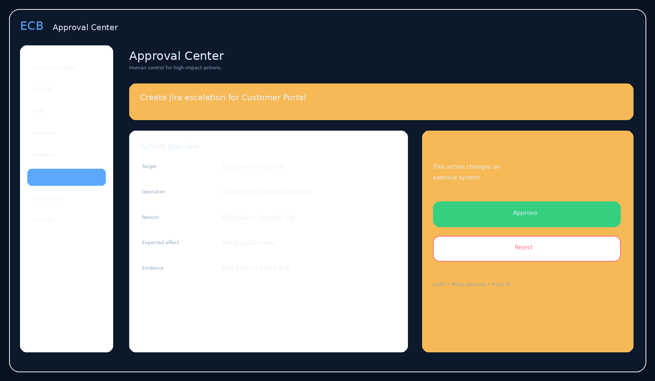
Figure 3 — Approval Center: high-impact action preview and human decision.
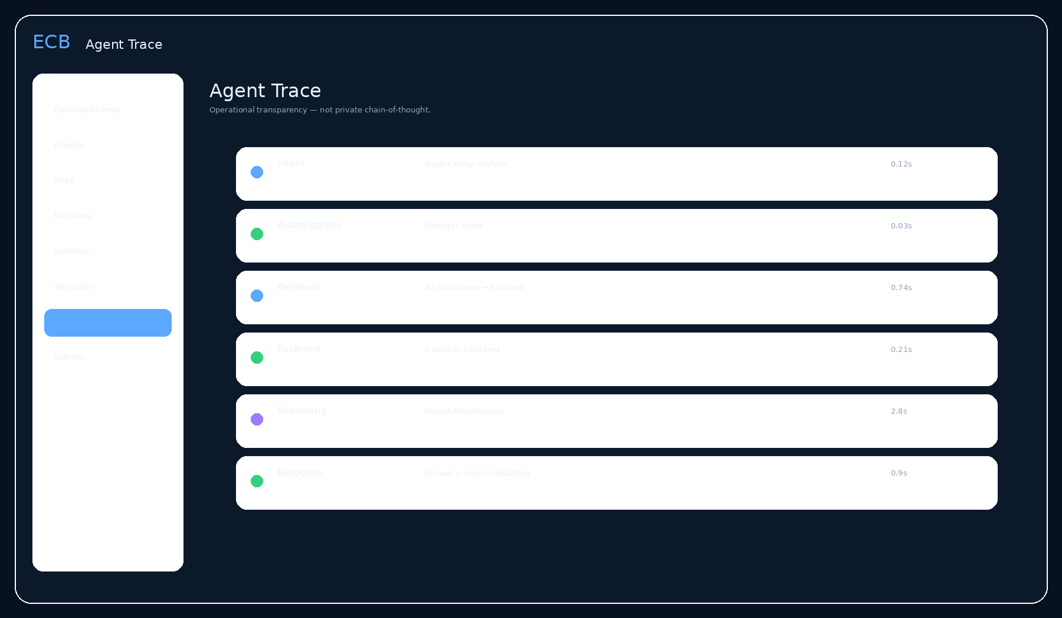
Figure 4 — Agent Trace: operational transparency, latency and tool stages.

7. Screen Specifications
Screen | Core layout | Key states
Command Center | Hero greeting + KPI glass cards + project health + Ask ECB | Loading, healthy, at-risk, blocked, empty
AI Command Center | Prompt canvas + answer canvas + evidence/context rail | Streaming, complete, partial, conflict, no evidence, error
Project Intelligence | Health hero + timeline + dependencies + risks | Current, stale, superseded, blocked
Risk Intelligence | Risk matrix + ranked cards + evidence | New, escalating, mitigated, stale
Decision Intelligence | Decision timeline + rationale + alternatives | Current, superseded, disputed
Evidence Explorer | Search/filter rail + evidence grid | Fresh, stale, conflicting, unauthorized
Approval Center | Action preview + risk + evidence + approve/reject | Pending, approved, rejected, expired, failed
Agent Trace | Execution timeline + tool/service nodes | Running, success, failed, cancelled
Settings | Identity, sources, notifications, accessibility | Saved, unsaved, error

8. Component Library
Component | Variants | States / behavior
Button | Primary / Secondary / Ghost / Danger | hover, focus, pressed, disabled, loading
Prompt Composer | Compact / Expanded / Command palette | empty, typing, attachment, submitting, streaming
Context Chip | Project / Time / Source / User | selected, removable, overflow
KPI Card | Metric / Trend / Health | loading, stale, alert
Evidence Card | Source / Decision / Event / Document | fresh, stale, conflicting, expanded
Confidence | High / Moderate / Limited | text + evidence count; never color-only
Action Preview | Read / Recommend / Mutate | policy result, approval required
Approval Drawer | Approve / Reject | focus trapped, keyboard complete
Agent Trace Step | Intent / Retrieval / Model / Tool / Policy | queued, running, success, failed
Toast | Success / Info / Warning / Error | persistent when critical
Skeleton | Card / Table / Answer | replaced by final content
Empty State | No data / No permission / Not connected | recovery action

9. Interaction & Motion System
Interaction | Specification
Hover/press | 50–150ms; subtle opacity/scale/border changes
Small popup | 150ms enter; 100ms exit
Modal/drawer | 200–250ms; ease-out enter, ease-in exit
Large transition | 250–400ms; only when spatial movement adds comprehension
AI streaming | Progressive content reveal; no distracting cursor effects
Agent progress | Stage changes + elapsed time; animation communicates status
Success | Immediate confirmation + subtle 200–250ms flourish
Error | Immediate; never delay critical feedback
Reduced motion | Instant or near-instant; preserve all functionality
These timings are informed by Atlassian's current motion system, which recommends short interaction durations around 50–150ms, transitions around 150–400ms, purposeful motion, and reduced-motion support. citeturn1search0turn1search4

10. AI-Native Feedback
State | User-facing feedback
Understanding | 'Understanding your project context…'
Retrieving | 'Checking Jira, Git and project decisions…'
Validating | 'Comparing source freshness and authority…'
Generating | 'Building an evidence-backed answer…'
Approval | 'Waiting for your approval before changing Jira.'
Executing | 'Creating Jira escalation…'
Success | 'Jira escalation created — ECB-431.'
Failure | 'The Jira action did not complete. Nothing was marked successful.'
Show operational stages, not private chain-of-thought. The product should expose what the system is doing, what evidence it used, what policy decision occurred and what tool executed.

11. Responsive Design
Breakpoint | Layout | Priority
≥1440px | 12-column grid; persistent navigation; evidence rail | Desktop primary
1200–1439px | 12-column; collapsible context rail | Desktop
1024–1199px | 8-column; drawers replace side rails | Tablet landscape
768–1023px | 8-column; navigation rail/drawer | Tablet
<768px | 4-column; single-column; bottom sheets | Mobile
WCAG 2.2 requires reflow without loss of information/functionality at narrow widths and prohibits unnecessary two-dimensional scrolling; this is a design constraint, not merely a QA check. citeturn1search3turn1search5

12. Accessibility — WCAG 2.2 AA
Area | Requirement | Validation
Contrast | Text ≥4.5:1; large text ≥3:1; UI components/non-text ≥3:1 | Automated + manual contrast audit
Keyboard | All primary flows keyboard operable | Keyboard-only E2E
Focus | Visible, logical, not obscured | Manual + automated
Screen reader | Semantic headings, labels, landmarks, async announcements | NVDA/VoiceOver/JAWS
Reflow | No functional loss at required reflow conditions | 400% zoom/reflow
Motion | Respect reduced-motion preference | OS/browser test
Dialogs | Accessible name, focus trap, escape, focus return | Manual
AI updates | Status changes announced without overwhelming users | Assistive tech test
WCAG 2.2 explicitly includes focus visibility, focus-not-obscured, reflow, contrast and accessible authentication requirements. citeturn1search3turn1search1turn1search2turn1search7

13. Usability Testing Methodology
Study | Participants | Task | Success criterion
Discovery | 5–8 target users | Describe current investigation workflow | Top tasks and terminology validated
Prototype | 5–8 | Answer project-delay question | ≥80% task completion
Trust | 5–8 | Inspect evidence/freshness/conflict | ≥90% identify source and recency
Approval | 5–8 | Review action and approve/reject | 100% understand target/effect
Accessibility | Representative users | Complete primary workflow with assistive tech | No critical blocker
Performance perception | Representative users | Dashboard + AI query | No avoidable waiting ambiguity
Current document baseline contains design goals around fast context understanding, transparent evidence/uncertainty, progressive disclosure, safe approvals and accessible defaults. fileciteturn3file13

14. Findings / Design Decisions
- Users should not have to ask a second question to discover the project/time/source scope; scope is visible.
- Evidence must sit beside the claim rather than in a distant 'sources' page.
- Recommendations must look different from execution controls.
- High-impact actions require a focused approval surface with target, operation, risk, evidence and consequence.
- Agent trace should be operational and auditable, not a raw reasoning transcript.
- Glassmorphism is valuable for premium hierarchy but must degrade gracefully to opaque surfaces.
- Motion should explain state changes, not decorate them.

15. Style Guide
Category | Rule
Voice | Direct, calm, evidence-first, enterprise-professional
Buttons | Verb-first: Ask ECB, View evidence, Recommend action, Approve, Reject
Errors | State what happened, impact and next recovery step
Dates | Use explicit date/time and timezone when ambiguity matters
Status | Use icon + label + color
Evidence | Always show source + observed time + authority where available
Confidence | Explain confidence using evidence quality, not just a number
Icons | Use one consistent icon family; pair non-obvious icons with labels/tooltips
Charts | Provide text summaries/accessible alternatives
Density | Optimize for scanability; avoid decorative panels without decision value

16. Design Handoff & Engineering Contract
- All colors, spacing, typography and motion are tokenized.
- Every component has loading, empty, error, disabled, focus and responsive states.
- Every screen has desktop/tablet/mobile rules.
- Every AI workflow state has a visual and accessibility treatment.
- Figma/Storybook component names map one-to-one where practical.
- Design changes affecting API states, approval policy or evidence semantics must update FLOW/TRS/DATA.
- Frontend must never infer authorization from visual state; authorization comes from the backend policy decision.

17. References & Research Basis
W3C WCAG 2.2 — https://www.w3.org/TR/WCAG22/
Atlassian Design Foundations — https://atlassian.design/foundations
Atlassian Motion — https://atlassian.design/foundations/motion
AWS Enterprise Agentic Architecture — https://docs.aws.amazon.com/prescriptive-guidance/latest/govern-architect-agentic-ai/enterprise-architecture.html
AWS Agentic AI Security — https://docs.aws.amazon.com/prescriptive-guidance/latest/security-reference-architecture-generative-ai/gen-auto-agents.html
AWS RAG Security — https://docs.aws.amazon.com/prescriptive-guidance/latest/security-reference-architecture-generative-ai/gen-ai-agents.html
NIST GenAI Profile — https://nvlpubs.nist.gov/nistpubs/ai/NIST.AI.600-1.pdf
OpenTelemetry — https://opentelemetry.io/docs/

Appendix A — Cross-Document Dependencies
UX ID | Depends on | Reason
UX-CTX-01 | FLOW-CTX-01 / DATA-EVID-01 | Context chips and evidence scope
UX-EVID-01 | DATA-EVID-01 / TRS-RET-02 | Evidence provenance/freshness
UX-ACT-01 | FLOW-ACT-01 / TRS-MCP-01 | Action preview and execution states
UX-APP-01 | FLOW-POL-01 / DATA-AUD-01 | Approval and audit
UX-TRACE-01 | TRS-OBS-01 / FLOW-AGENT-01 | Operational trace

