ENTERPRISE CONTEXT BRAIN (ECB)
Backend Schema & Data Architecture
Version 2.0 | 22 August 2026 | High-Potential GenAI Product Baseline
Document ID | Status | Depends On
ECB-DATA-02 | Architecture/Product Review | PRD-02; TRS-02; FLOW-02
Source boundary: this suite preserves the user-provided ECB product baseline and explicitly labels new technology/design recommendations as proposed architecture. The source baseline defines a governed organizational-memory and agentic decision-intelligence platform, with Manager/Project/Risk/Decision capabilities, evidence, temporal context, MCP, human approval and an MVP using Jira-like tickets, project docs/ADRs and Git. fileciteturn2file1

Table of Contents
- 1 Data Architecture
- 2 Canonical Model
- 3 ERD
- 4 Memory Model
- 5 Retrieval Schema
- 6 API Contracts
- 7 Caching/Queues
- 8 Security/RLS
- 9 Retention
- 10 Migration
- 11 Validation

1 Data Architecture
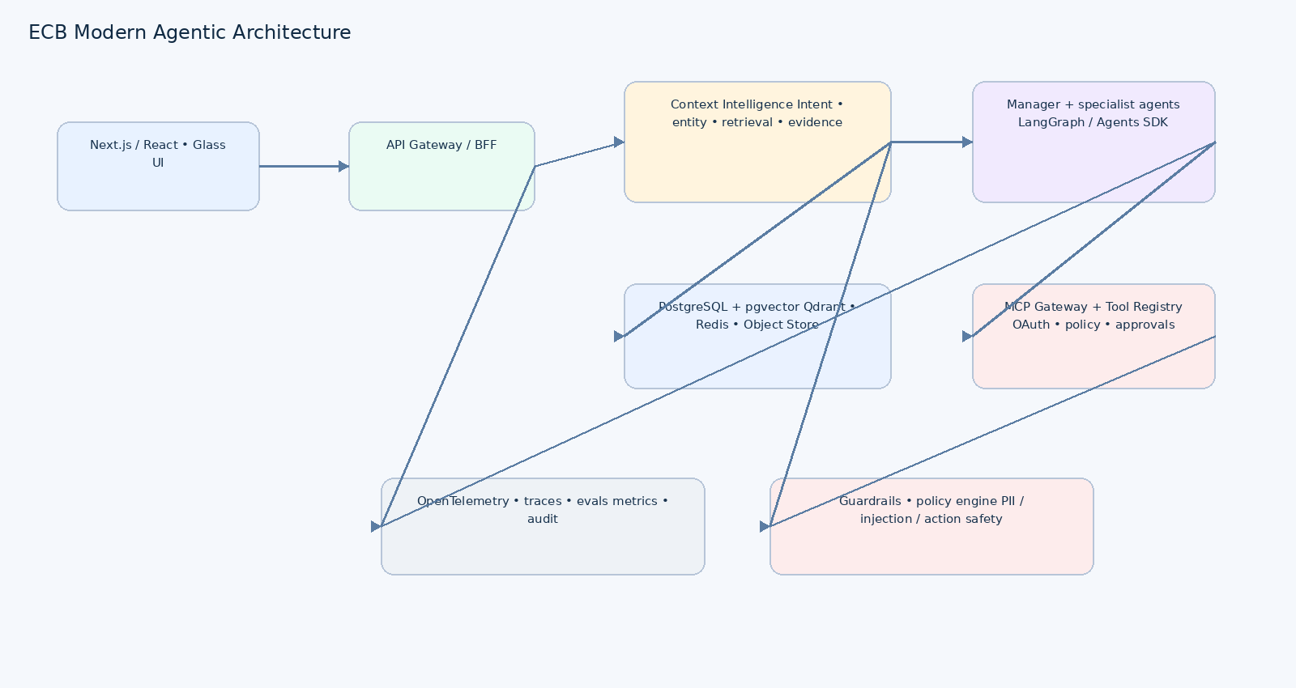

2 Canonical Model
Entity | Purpose | Key fields
organization | Tenant boundary | id, name, policy_profile
user | Human identity | id, external_id, role
project | Project identity | id, org_id, name, status, owner_id
source | Connector/source | id, type, authority, permissions
source_record | Normalized source item | id, source_id, external_id, observed_at, version
document | Document/artifact | id, source_record_id, storage_uri, hash
entity | Canonical entity | id, type, name, aliases
memory_item | Semantic/episodic/procedural/decision/experiential | id, type, validity_from/to, confidence
evidence | Claim-supporting provenance | id, source_record_id, excerpt, authority, freshness
risk | Risk record | id, project_id, severity, probability, impact, owner
decision | Decision record | id, project_id, rationale, status, supersedes_id
agent_run | Agent execution | id, user_id, workflow, status, trace_id
action | Governed action | id, agent_run_id, tool, risk_class, status
approval | Human approval | id, action_id, approver_id, decision
audit_event | Immutable audit | id, actor, action, policy_result, trace_id, created_at

3 ERD
Organization 1—N Project 1—N Risk
Project 1—N Decision → Decision.supersedes_id
Source 1—N SourceRecord 1—N Evidence
SourceRecord → Document
Project/Decision/Risk/Entity ↔ MemoryItem
AgentRun 1—N Action 1—0..1 Approval
AgentRun 1—N AuditEvent

4 Memory Model
Memory | Write policy | Read policy
Semantic | Curated stable facts | High relevance + authority
Episodic | Events/outcomes | Temporal retrieval
Procedural | How-to/workflow knowledge | Task/tool planning
Decision | Decision/rationale/outcome | Decision intelligence
Experiential | Prior issue/outcome | Analogical retrieval
The existing ECB baseline explicitly distinguishes semantic, episodic, procedural, decision and experiential memory. fileciteturn2file1

5 Retrieval Schema
Index | Purpose
B-tree (project_id, observed_at) | Temporal/project filters
GIN/JSONB | Metadata filtering
Full text | Lexical retrieval
Vector HNSW | Semantic retrieval
Composite authority/freshness | Ranking features
External Qdrant collection | Large-scale semantic retrieval and payload filters

6 API Contracts
Method | Endpoint | Purpose
POST | /api/v1/query | Contextual question
GET | /api/v1/projects/{id} | Project overview
GET | /api/v1/projects/{id}/risks | Risk intelligence
GET | /api/v1/projects/{id}/decisions | Decision intelligence
GET | /api/v1/evidence/{id} | Evidence detail
POST | /api/v1/actions | Create action preview
POST | /api/v1/actions/{id}/approve | Approve governed action
GET | /api/v1/agent-runs/{id} | Trace/status
POST /api/v1/query
{
"query": "Why is project X delayed?",
"scope": {"project_id":"p-123","from":"2026-08-01","to":"2026-08-22"},
"response_mode":"evidence_backed"
}
→ {"answer":"...","confidence":"high","evidence":[...],"recommendation":{...},"trace_id":"..."}

7 Cache / Queue / Realtime
Technology | Use
Redis | Hot project summaries, context plans, rate limits
Queue | Ingestion, embedding, evaluation and long-running actions
SSE/WebSocket | Agent progress and approval status
Object storage | Raw docs and large artifacts
Outbox | Reliable publication of DB events to queue

8 Security / RLS
- Every evidence row carries source/tenant scope.
- PostgreSQL RLS enforces tenant/resource access at the data layer.
- Authorization happens before retrieval results are exposed.
- Tool credentials are never stored in agent memory.
- Audit events are append-only and tamper-evident where supported.

9 Retention
Data | Policy
Audit | Organization-defined; never silently delete
Raw source | Source/legal retention
Episodic memory | Policy-driven expiry/archive
Decision memory | Retain history; mark superseded
Embeddings | Rebuild on model/index version change
Agent traces | Evaluation + audit retention policy
PII | Minimize, classify, mask/delete per policy

10 Migration
- Create new schema version in Git.
- Backfill canonical entities with source IDs and hashes.
- Backfill provenance and timestamps.
- Generate embeddings asynchronously with version metadata.
- Reconcile counts, hashes and permission coverage.
- Dual-read if required for migration validation.
- Cut over reads after evaluation gate.
- Retain rollback/forward-fix migration path.

11 Validation
Test | Acceptance
Constraints | FK/unique/check constraints pass
RLS | Unauthorized fixtures return zero rows
Retrieval | Recall/precision benchmarks meet eval target
Migration | No data loss or duplicate canonical entities
Idempotency | Repeated source event produces one logical record
Backup | Restore produces consistent application state
Load | Indexes/query plans remain within latency target

