CLAIRAI
Machine Health Failure-RCA POC
Final A-to-Z Technical Design, Implementation & Demonstration Guide

DOCUMENT STATUS — FINAL POC BASELINE
This document describes the implemented Databricks proof of concept, the execution flow, the audit/RCA contract, the two demonstrated failure cases, and the operational demo/runbook. The current working namespace is machine_health.prod (alias: clarai.prod). The original design/test-bench material used plant_demo.machine_health and /Shared paths; those are treated as historical design references, not the current implementation.

Attribute | Final POC value
Platform | Databricks / Delta Lake / Databricks Jobs / Databricks Asset Bundles (DAB)
Current catalog/schema | machine_health.prod / machine_health.dev (handover/legacy alias: clarai.prod)
Current workspace folder | /Workspace/.bundle/clarai_machine_health/ or /Workspace/ClarAi/MachineHealth/
Bundle names | clarai_machine_health; clarai_machine_health_case3
Jobs | clairai_machine_health_motor; clairai_machine_health_compressor; clairai_machine_health_fan; clairai_machine_health_fan_v2; clairai_job_cost_monitoring
Machine families | Motor; Compressor; Fan
Demonstrated cases | Case 1 — local disk exhaustion; Case 2 — concurrent Delta MERGE; Case 3 — accidental model deployment
Primary RCA/Audit output | pipeline_run_audit; alert_candidates (standardized 13-column issue/review schema)
Cost monitoring output | machine_health.prod.pipeline_cost_monitoring; pipeline_cost_summary
Audit grain | One row per task attempt + one row per upstream-skipped task + consolidated issue reviews
Retry behavior | apply_health_rules: one configured retry; attempt_number uses task execution count
POC state | Functional failure-case demonstration, model observability, cost tracking and RCA evidence captured
Lead / Prepared | Ramu Venkatesan / 31 October 2026

Document Control & Contents
This is the engineering handover document for the ClairAI machine-health failure/RCA proof of concept. It is written to be usable by an architect, senior data engineer, operations engineer, or reviewer who did not build the POC.
- 1. Executive summary
- 2. Scope, objectives and success criteria
- 3. Source-of-truth reconciliation
- 4. End-to-end architecture
- 5. Data model and table responsibilities
- 6. Notebook-by-notebook implementation
- 7. Job orchestration and execution semantics
- 8. Audit and ClairAI exchange contract
- 9. Case 1 — library installation / disk exhaustion
- 10. Case 2 — concurrent Delta MERGE
- 11. Case 3 — accidental model deployment (ClairAI model observability)
- 12. RCA and observability decision logic
- 13. Validation and demonstrated evidence
- 14. Demo runbook — clean run, failure modes and model observability
- 15. Recovery and troubleshooting
- 16. Production hardening recommendations
- 17. Final acceptance checklist
- Appendix A — Final audit-table schema
- Appendix B — Current setup DDL
- Appendix C — Current collect_run_audit implementation
- Appendix D — Current job bundle
- Appendix E — Evidence screenshots and source references
- Appendix F — Cost monitoring pipeline

1. Executive Summary
The ClairAI Machine Health POC demonstrates an operationally realistic Databricks pipeline that not only produces machine-health outputs but also captures the execution and model-behavior evidence required to explain failures. The design deliberately separates business data (sensor readings, predictions, decisions and recommendations) from execution metadata (job/task identity, attempt, status, error, compute, URLs, concurrency evidence and human review metrics).
Three operational failure modes are implemented and demonstrated. In Case 1, a controlled local-disk exhaustion hook forces a Python package installation to fail with [Errno 28] No space left on device; downstream tasks are represented as UPSTREAM_FAILED. In Case 2, Motor and Compressor jobs concurrently write to the shared health_decisions Delta table; one MERGE loses the optimistic-concurrency race, records the conflicting table/run versions, and succeeds on retry. In Case 3, an unapproved, oversensitive Fan model (fan_v2) is deployed instead of the approved baseline (fan_v1): issue volume triples (~15 to ~46 per day), operator acceptance falls 40.2 percentage points (82.5% to 42.3%), ClairAI isolates ModelOversensitive as the dominant rejection cause (45.6% of rejections) and raises a High-severity ModelAcceptanceRateDip alert with rollback links. A cost-monitoring job (Appendix F) additionally reports DBU usage and estimated USD cost per job run.
ENGINEERING OUTCOME
The POC proves the important RCA principle: an RCA should be derived from authoritative execution evidence, not from timing guesses. For Case 1 the evidence is the task error and downstream dependency state. For Case 2 the evidence is the Delta conflict plus DESCRIBE HISTORY metadata identifying the competing commit.

2. Scope, Objectives and Success Criteria

2.1 Scope
- Databricks-based machine-health processing for Motor, Compressor and Fan (with model observability).
- Raw sensor fixture → scoring → health decision MERGE → candidate generation → maintenance and thermal advice.
- Task-level audit instrumentation and post-run enrichment through the Databricks Jobs API.
- Controlled reproduction of disk-exhaustion and concurrent-write failure modes, plus an accidental model-deployment scenario with reviewer-feedback observability.
- Evidence suitable for downstream ClairAI RCA ingestion.

2.2 Explicit non-goals
- Real customer sensor data or production ML models.
- Rebuilding the upstream EMR/S3 production ingestion layer.
- Implementing every production KCF controller stage.
- Inferring a competing job when the platform does not provide authoritative conflict evidence.

2.3 Success criteria
Criterion | Acceptance condition
Clean execution | All normal tasks complete successfully and expected output tables are populated.
Case 1 | A task fails with [Errno 28] No space left on device; blocked downstream tasks are represented as UPSTREAM_FAILED.
Case 2 | The first apply_health_rules attempt fails with a concurrent Delta error and a retry succeeds.
Audit completeness | Every executed task attempt has its own audit row; skipped tasks receive explicit upstream-failed records.
RCA evidence | Job/task URLs, compute identity and failure-specific evidence are retained.
Concurrency evidence | read_version, conflicting_version and conflicting_job_run_id are retained when the conflict is captured.
Case 3 | Acceptance-rate collapse and dominant rejection reason are detectable in alert_candidates and raise a High alert.
Cost monitoring | Per-run DBU usage and estimated USD cost are recorded in pipeline_cost_monitoring and rolled up in pipeline_cost_summary.

3. Source-of-Truth Reconciliation
The original ClairAI failure-case specification and test-bench document were written with generic names such as plant_demo.machine_health and /Shared/machine_health_demo/. The implemented POC was subsequently moved to the current machine_health.prod (alias: clarai.prod) namespace and /Workspace/ClarAi/MachineHealth/ workspace layout. The failure semantics and audit contract remain the same.
Design reference | Current implementation
plant_demo.machine_health | machine_health.prod (alias: clarai.prod)
/Shared/machine_health_demo/ | /Workspace/ClarAi/MachineHealth/
retry / retry_count concept | task.execution_count → attempt_number
Generic task names | score_readings, apply_health_rules, build_maintenance_advice, build_thermal_advice, collect_run_audit
Generic family examples | Motor, Compressor, Fan
Original audit core fields | Core fields retained and enriched with workspace_id, job_name, asset_type
Job identities | clairai_machine_health_motor, clairai_machine_health_compressor (legacy: machine_health_motor_job, machine_health_compressor_job)
Cost monitoring job | clairai_job_cost_monitoring
Bundle name | clarai_machine_health (Case 3: clarai_machine_health_case3); legacy: machine_health_demo

This reconciliation is important for handover: the original design describes intent; the current implementation values above describe the actual POC baseline.

4. End-to-End Architecture
At a high level, the POC is a small DAG with one shared Delta decision table. The shared table is intentionally unpartitioned and has deletion vectors disabled because reproducible write contention is a core test objective.
Logical pipeline flow
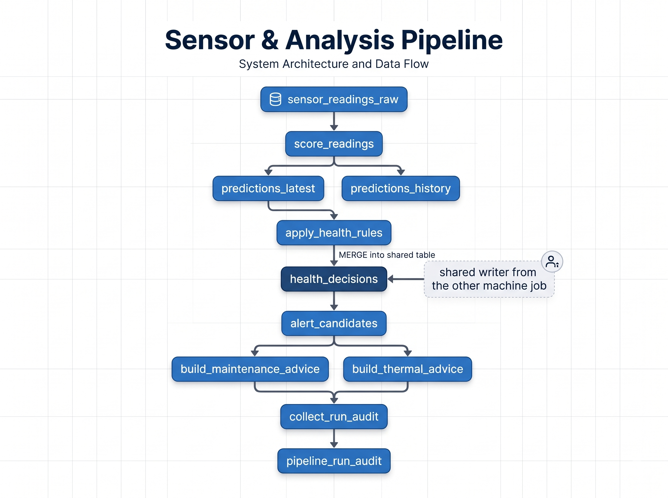
Component | Purpose | Primary output
sensor_readings_raw | Small deterministic sensor fixture | Input measurements
ingest_watermark | Prevents reprocessing of already consumed reading_time values | Per-machine watermark
score_readings | Scores new readings using deterministic vibration rule | predictions_latest / predictions_history
apply_health_rules | Applies decision rules and performs shared MERGE | health_decisions / alert_candidates
build_maintenance_advice | Converts unhealthy vibration evidence into maintenance action | maintenance_advice
build_thermal_advice | Creates cooling advice for unhealthy and hot machines | thermal_advice
collect_run_audit | Enriches execution evidence and adds skipped-task rows | pipeline_run_audit

5. Data Model and Table Responsibilities
Table | Role | Key behavior
sensor_readings_raw | Raw machine-health fixture | Motor/Compressor/Fan readings with vibration, accel and temperature
ingest_watermark | Incremental processing control | Stores last processed reading_time by machine_type
predictions_latest | Current prediction state | Scoped overwrite by machine_type
predictions_history | Prediction history | Append-only history of scoring results
health_decisions | Shared decision state | MERGE target used by both jobs; primary concurrency test surface
alert_candidates | Unified alerts & issue reviews | Idempotent MERGE on (sensor_id, reading_time, axis); stores review status, rejection category and MLflow lineage
maintenance_advice | Maintenance recommendations | Anti-join prevents duplicate advice rows
thermal_advice | Thermal recommendations | Anti-join prevents duplicate advice rows
pipeline_run_audit | Execution/RCA evidence | One row per attempt plus skipped-task evidence
pipeline_cost_monitoring | Run-level cost tracking | Estimated DBU usage and USD cost per job run; partitioned by usage_date
pipeline_cost_summary | Cost rollup | Aggregated cost and run count per job

5.1 Deterministic scoring rule
The POC intentionally avoids model variability. A vibration_rms_mm_s value above 0.5 is classified as unhealthy (is_healthy = 0); otherwise it is healthy (is_healthy = 1). The model_tag is derived from the machine family and the POC version.

5.2 Advice logic
- Maintenance: unhealthy candidate + vibration evidence → category HIGH_VIBRATION → Schedule inspection.
- Thermal: unhealthy decision + temp_c > 80°C → Check cooling.
- Both advice tables use anti-join style de-duplication so repeated runs do not blindly duplicate existing recommendations.

5.3 Standardized 13-column schema for alert_candidates
To avoid catalog clutter while supporting model observability and backward compatibility with Motor and Compressor, issue tracking and reviewer feedback are consolidated into alert_candidates. Table count: machine_health.prod holds 11 tables (the 9 pipeline tables plus the 2 cost tables); the Case 3 bundle in machine_health.dev holds exactly the 9 pipeline tables (no cost tables).
CREATE OR REPLACE TABLE alert_candidates (
issue_id STRING, -- unique id (e.g. ISS-F-1001)
sensor_id STRING, -- FAN-001, FAN-002
machine_type STRING, -- Fan, Motor, Compressor
reading_time TIMESTAMP, -- timestamp of anomaly
axis STRING, -- X, Y, Z
is_healthy BIGINT, -- 0 = anomaly, 1 = healthy
model_tag STRING, -- fan_v1 / fan_v2
decision_note STRING, -- rule reason (rule_flagged)
status STRING, -- 'Open' (accepted), 'Removed' (rejected), 'New' (in review)
removal_reason STRING, -- ModelOversensitive, EquipmentIsHealthy, DuplicateIssue, SensorGlitch
mlflow_run_id STRING, -- 32-character MLflow run id
job_id STRING, -- Databricks job id
job_run_id STRING -- Databricks job run id
);

6. Notebook-by-Notebook Implementation
Notebook | Responsibility | Layer
00_setup | Creates catalog/schema and all Delta tables; seeds deterministic Motor and Compressor rows. The final source should define the audit table in the final metadata order. | Foundation / schema
common_utils | Shared widgets, metadata resolution, audit context manager, disk-fault injection and common constants. It centralizes cross-cutting execution instrumentation. | Cross-cutting
2.score_readings | Reads new data after the machine watermark, applies deterministic health scoring, writes latest/history predictions and advances the watermark. Can invoke the Case 1 disk fault. | Scoring
3.apply_health_rules | Reads predictions, optionally delays the source to create overlap, captures Delta read version, executes MERGE, and on failure inspects Delta history for the conflicting commit/run. | Decision + concurrency
4.build_maintenance_advice | Builds HIGH_VIBRATION maintenance advice from candidates and vibration evidence. The disk-fault hook can also be positioned here for the later-failure variant. | Recommendation
5.build_thermal_advice | Builds Check cooling advice for unhealthy records whose temperature exceeds 80°C. | Recommendation
1.collect_run_audit | Runs with ALL_DONE, resolves parent/task run metadata through the Databricks Jobs API, enriches URLs/cluster IDs, resolves competing-run URL and inserts UPSTREAM_FAILED rows. | Audit / RCA

6.1 Important implementation principle
The audit row is written inside the task execution context, including the failure path. This is the critical design choice that preserves a failed attempt rather than relying only on the final Databricks job state.

7. Job Orchestration and Execution Semantics
Job | Machine type | Concurrency | Special behavior
clairai_machine_health_motor | Motor | max_concurrent_runs = 1 | Delayed writer in Case 2 (merge_delay_sec=30)
clairai_machine_health_compressor | Compressor | max_concurrent_runs = 1 | Immediate competing writer in Case 2
clairai_machine_health_fan | Fan | max_concurrent_runs = 1 | Approved baseline (fan_v1); Mon-Wed 09:10 UTC; Job ID 745174521807184
clairai_machine_health_fan_v2 | Fan | max_concurrent_runs = 1 | Unapproved candidate (fan_v2); Thu-Sat 09:10 UTC; Job ID 412902752913879
clairai_job_cost_monitoring | Cross-asset | max_concurrent_runs = 1 | Ingests system.billing.usage to compute DBU usage and USD cost

Task dependency semantics
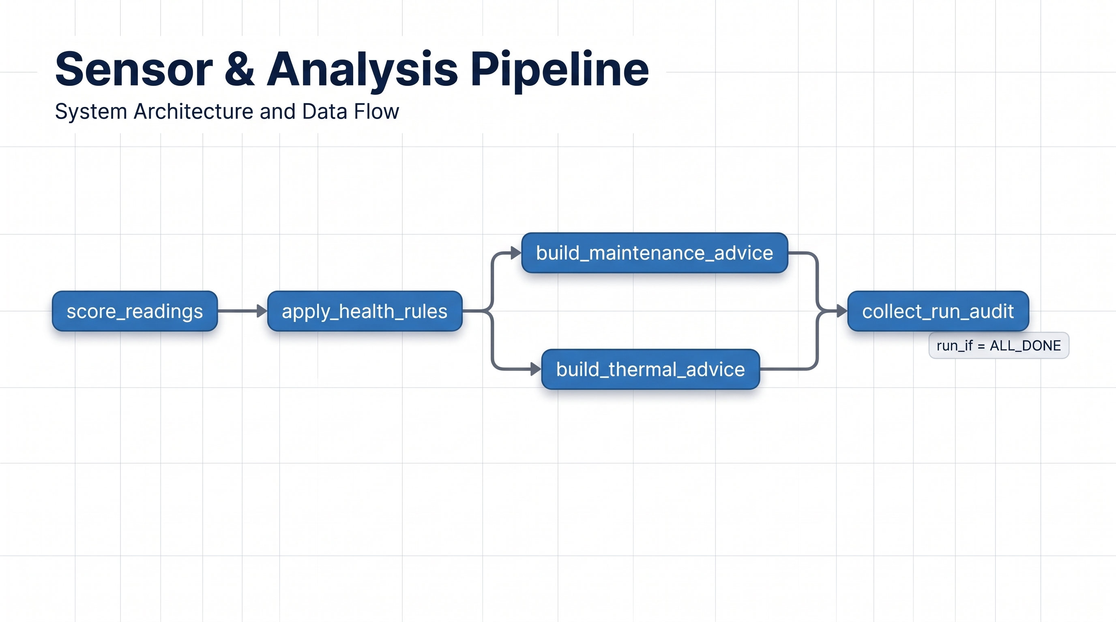
apply_health_rules is configured with one retry. The current implementation uses task.execution_count as the attempt signal rather than the unsupported retry_count expression encountered during validation.
WHY collect_run_audit USES ALL_DONE
A failure pipeline must still produce an evidence package. If a task fails and downstream tasks are skipped, collect_run_audit must execute so the audit table records the parent run, URLs and explicit UPSTREAM_FAILED rows.
Fan pipeline (6 tasks): score_readings → apply_health_rules (1 retry) → build_maintenance_advice and build_thermal_advice (parallel) → generate_fan_model_issues → collect_run_audit (run_if: ALL_DONE). Motor and Compressor keep the 5-task DAG above.

8. Audit and ClairAI Exchange Contract
The audit table is the operational evidence boundary between Databricks execution and ClairAI RCA. The contract is intentionally separate from sensor/prediction rows.
Field | Type | Meaning
workspace_id | STRING | Workspace identity
job_id | STRING | Databricks job identity
job_name | STRING | Human-readable workflow identity
asset_type | STRING | Equipment family / asset identity
job_run_id | STRING | Parent workflow execution
task_run_id | STRING | Specific task attempt; null for skipped tasks
task_key | STRING | Canonical task identity
machine_type | STRING | POC machine family
attempt_number | INT | 1 = first attempt; 2 = retry
status | STRING | SUCCESS / FAILED / UPSTREAM_FAILED
start_time | TIMESTAMP | Attempt start
end_time | TIMESTAMP | Attempt end; null for skipped
cluster_id | STRING | Compute identity
error_message | STRING | Actual failure text; null for non-failures
run_page_url | STRING | Parent run URL
task_run_page_url | STRING | Task attempt URL
table_name | STRING | Case 2 shared table
operation | STRING | Case 2 operation, e.g. MERGE
conflicting_job_run_id | STRING | Competing run identified from conflict evidence
conflicting_run_page_url | STRING | URL of competing run
read_version | BIGINT | Delta version read by failed operation
conflicting_version | BIGINT | Conflicting commit version

8.1 Final physical column order
workspace_id
job_id
job_name
asset_type
job_run_id
task_run_id
task_key
machine_type
attempt_number
status
start_time
end_time
cluster_id
error_message
run_page_url
task_run_page_url
table_name
operation
conflicting_job_run_id
conflicting_run_page_url
read_version
conflicting_version

The physical order is presentation/schema hygiene; INSERT statements in collect_run_audit explicitly name their target columns, so logical correctness does not depend on physical order.

9. Case 1 — Library Installation Failure / Local Disk Exhaustion

9.1 Failure mechanism
The fault hook is parameter-gated. When inject_fault=disk and fault_task matches the current task, the notebook fills the local disk and forces a package installation using --force-reinstall and --no-cache-dir. The expected operating-system error is [Errno 28] No space left on device.
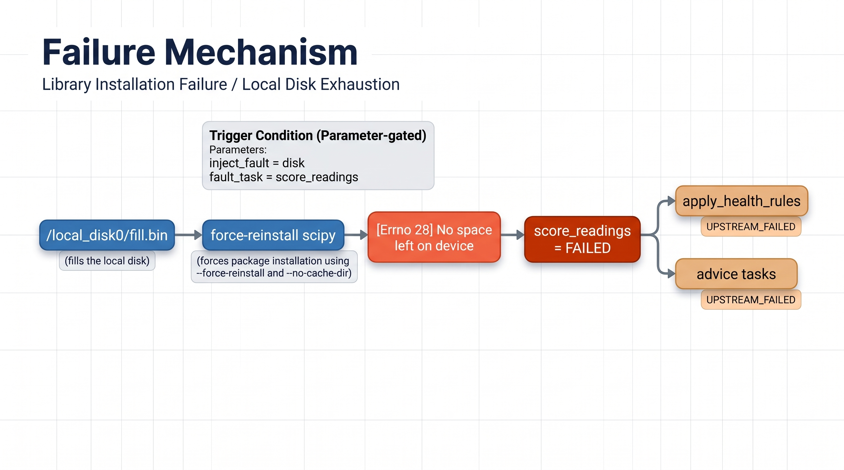

9.2 RCA
ROOT CAUSE
Local disk exhaustion prevented the Python library installation from completing. The evidence does not justify blaming package versioning, package download availability, or a dependency mismatch. What consumed the disk remains unknown unless separate compute/log evidence identifies it.

9.3 Demonstrated evidence
Task | Observed state | Evidence
score_readings | FAILED | [Errno 28] No space left on device
apply_health_rules | UPSTREAM_FAILED | Blocked by failed score task
build_maintenance_advice | UPSTREAM_FAILED | Blocked by failed upstream chain
build_thermal_advice | UPSTREAM_FAILED | Blocked by failed upstream chain
collect_run_audit | SUCCESS / audit completion | Captures run and skipped-task evidence

10. Case 2 — Concurrent Delta MERGE

10.1 Failure mechanism
Both machine jobs update the same health_decisions Delta table. The Motor job can be intentionally delayed using merge_delay_sec so that Compressor commits first. Motor then attempts to commit against an older snapshot and receives a concurrent-write exception.
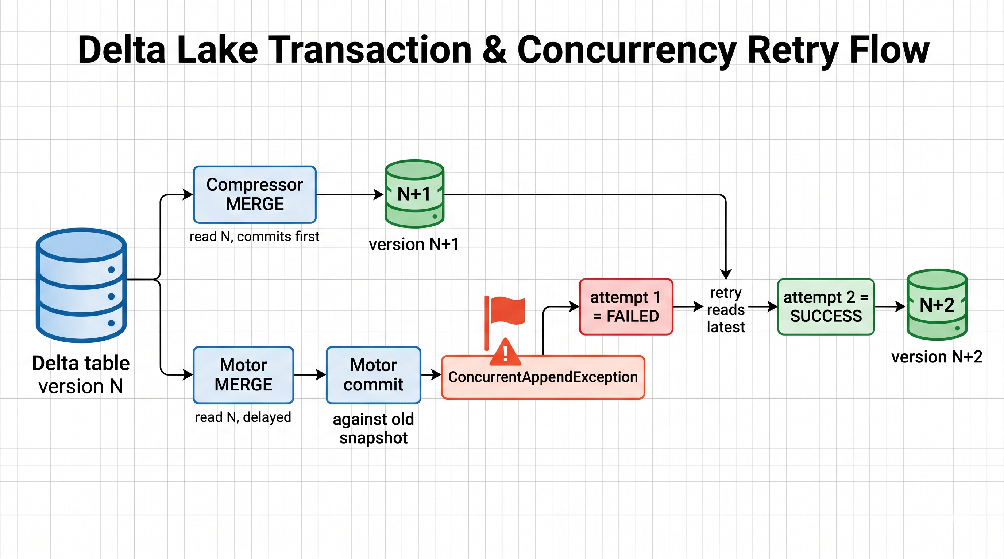

10.2 Required conflict evidence
- table_name = shared health_decisions table.
- operation = MERGE.
- read_version = Delta snapshot observed before the failed MERGE.
- conflicting_version = later commit observed in DESCRIBE HISTORY.
- conflicting_job_run_id = job/run identity from the conflicting history record.
- conflicting_run_page_url = resolved through the Databricks Jobs API.
- The failed attempt and successful retry remain separate audit rows.
ROOT CAUSE
The Motor write lost a Delta optimistic-concurrency race against the Compressor write. The conflict is a shared-table concurrency event, not an ML/scoring failure. The retry succeeds after reading the latest committed state.

11. Case 3 — Accidental Model Deployment (ClairAI Model Observability)
Lead / Author: Ramu Venkatesan | Completed: 31 October 2026 | Target environment: Databricks Asset Bundle (machine_health.dev) | Bundle: clarai_machine_health_case3

11.1 The core problem demonstrated
When an unapproved, oversensitive candidate model (fan_v2) is deployed to production by mistake, it generates excessive false alarms and erodes operator trust. ClairAI Model Observability detects this by tracking reviewer feedback across a 48-hour SLA maturity buffer. When acceptance collapses, ClairAI detects the 40.2 percentage-point drop, isolates the dominant rejection category (ModelOversensitive, 45.6% of rejections) and fires a High-severity alert (ModelAcceptanceRateDip) with direct Databricks Job and MLflow run links for one-click rollback.
Metric | Baseline (fan_v1) | Candidate (fan_v2) / impact
Model version | fan_v1 (approved) | fan_v2 (accidental, unapproved)
MLflow run ID | bb1b3a15559f43dd9993b3b28c24282c | 843a6a49a1b7479cbe3f0e0c33f10b37
Issue volume | Normal (~15-17 issues/day) | Surge (~44-47 issues/day), 3x
Acceptance rate | 80%-85% (avg 82.5%) | 40%-45% (avg 42.3%), 40.2 pp drop
Dominant rejection reason | EquipmentIsHealthy / Duplicate | ModelOversensitive (45.6% of rejections)
ClairAI alert state | Healthy baseline | ModelAcceptanceRateDip — HIGH (OPEN)

11.2 Architecture and weekly operational cycle
Two alternating scheduled jobs run at 09:10 UTC on cluster 0828-125833-31m6neog (clairai-model-metrics) and execute the same six-task DAG described in section 7.
Attribute | Job 1: Mon-Wed | Job 2: Thu-Sat
Job name | clairai_machine_health_fan | clairai_machine_health_fan_v2
Job ID | 745174521807184 | 412902752913879
Model | fan_v1 (approved baseline) | fan_v2 (unapproved candidate)
Schedule (Quartz cron) | 0 10 9 ? * MON,TUE,WED | 0 10 9 ? * THU,FRI,SAT
Volume / acceptance | ~15-17 issues/day; 80%-85% | ~44-47 issues/day; 40%-45%
ClairAI status | Healthy baseline | HIGH ALERT (ModelAcceptanceRateDip)
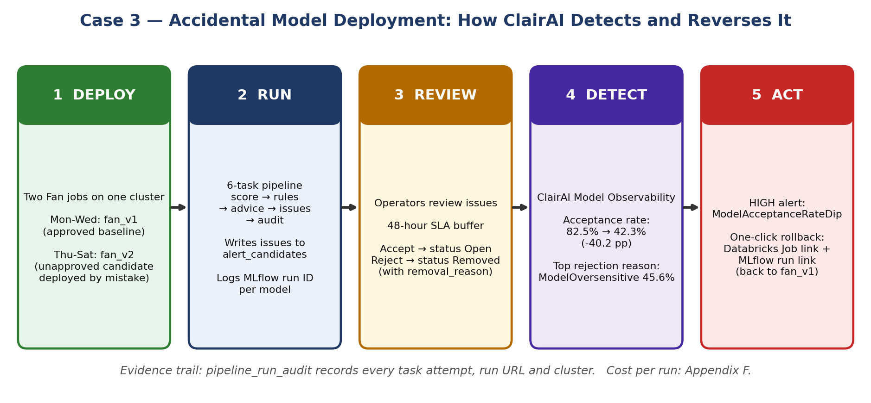
Figure 3 — Case 3 architecture: from accidental fan_v2 deployment to ClairAI alert and rollback.
Schedule note: the dated fan_v2 records in section 11.5 (27-29 Oct 2026, Tuesday-Thursday) fall partly outside the Thu-Sat cron. They should be presented as controlled/manual demonstration runs rather than scheduled executions; the cron describes the steady-state weekly cycle.

11.3 Database architecture and unified schema (machine_health.dev)
All issue tracking is consolidated into alert_candidates (13-column schema in section 5.3), keeping exactly the 9 pipeline tables in machine_health.dev: sensor_readings_raw (append), ingest_watermark (upsert/overwrite), predictions_latest (atomic replaceWhere), predictions_history (append), health_decisions (idempotent MERGE), alert_candidates (idempotent MERGE), maintenance_advice and thermal_advice (anti-join append), and pipeline_run_audit (append / SDK enrichment).

11.4 Code files modified and created
All code lives in the bundle path MH_bundle/clarai_machine_health_case3/dev/files/.
- clarai_machine_health_fan.yml: cron "0 10 9 ? * MON,TUE,WED"; default model_version fan_v1.
- clarai_machine_health_fan_v2.yml: cloned job; cron "0 10 9 ? * THU,FRI,SAT"; defaults model_version fan_v2 and clean_table "false".
- generate_fan_model_issues.py: stores clean 32-character MLflow run IDs; samples fan_v1 daily acceptance at 80%-86.7% (verified average 82.5%) and fan_v2 at 40.4%-45.7% (average 42.3%, with 45.6% of rejections flagged ModelOversensitive); simulates a 48-hour review SLA (new issues are emitted as New; at 48 hours they become Open if accepted or Removed if rejected).
- apply_health_rules.py: continues to MERGE into health_decisions (the Case 2 concurrency surface); the candidate write to alert_candidates was changed from a destructive overwrite to an idempotent MERGE INTO alert_candidates matching on (sensor_id, reading_time, axis), preventing duplicates on retries.
- test_pipeline_helpers.py: unit tests for scope() logic and schema column integrity.
- synthetic_sensor_data.py: renamed to Python snake_case.
- databricks.yml: bundle renamed to clarai_machine_health_case3 for workspace isolation.

11.5 Verified live data state (alert_candidates)
The table holds 349 issues over 17 days: a 14-day approved baseline on fan_v1 (212 issues, 13-26 Oct) followed by three days on the accidentally deployed fan_v2 (137 issues, 27-29 Oct).
Run dates | Model | Total / accepted / rejected | Acceptance
13-26 Oct (14 days) | fan_v1 | 212 / 175 / 37 | 82.5% (daily 80.0%-86.7%)
27 Oct | fan_v2 | 46 / 21 / 25 | 45.7% (dip starts)
28 Oct | fan_v2 | 44 / 18 / 26 | 40.9% (severe degradation)
29 Oct | fan_v2 | 47 / 19 / 28 | 40.4% (High alert triggers)
27-29 Oct total | fan_v2 | 137 / 58 / 79 | 42.3%
SELECT model_tag, COUNT(*) AS total_issues,
SUM(CASE WHEN status = 'Open' THEN 1 ELSE 0 END) AS accepted,
SUM(CASE WHEN status = 'Removed' THEN 1 ELSE 0 END) AS rejected,
ROUND(SUM(CASE WHEN status = 'Open' THEN 1 ELSE 0 END) * 100.0 / COUNT(*), 1) AS acceptance_pct
FROM machine_health.dev.alert_candidates
GROUP BY model_tag;

11.6 Security and governance review
- Zero hardcoded secrets: no Databricks PATs, AWS access keys, passwords or API tokens in any file.
- Authentication is decoupled: deployments use developer Databricks CLI sessions / OS keyring (~/.databrickscfg).
- Build artifact hygiene: .gitignore excludes .databricks/, .venv/, __pycache__/ and build/.
- Workspace cleaned: the legacy .bundle/clarai_machine_health folder was deleted; only clarai_machine_health_case3 remains for this case.

11.7 Active workspace resources
Resource | Identifier / purpose
Databricks workspace | https://dbc-e91d4c58-2368.cloud.databricks.com/?o=7474657594011271
Active bundle path | /Workspace/Users/ramu.venkatesan@infoservices.com/.bundle/clarai_machine_health_case3/dev/files
Jobs | Mon-Wed fan_v1: 745174521807184; Thu-Sat fan_v2: 412902752913879
Cluster | 0828-125833-31m6neog (clairai-model-metrics)
SQL warehouse | 3999f9a4bfcbda67 (query validation)
MLflow experiment | /Workspace/Users/ramu.venkatesan@infoservices.com/fan_model_experiments
Exported archives | clarai_case3_notebooks.dbc (importable) and clarai_case3_exported_bundle (folder of .py notebooks)

12. RCA and Observability Decision Logic
Evidence pattern | RCA conclusion | Do not conclude
FAILED + [Errno 28] + package install | Local disk exhaustion | Package version/download failure
UPSTREAM_FAILED downstream | Dependency consequence of upstream failure | Independent downstream root cause
Concurrent*Exception + MERGE + history version change | Shared Delta write conflict | Random/transient ML failure
Retry SUCCESS after concurrency failure | Conflict recovered on retry | Original failed attempt never happened
No conflicting job/run in authoritative history | Conflict identity unknown | Infer competitor from timing alone
Acceptance drop (40.2 pp) + ModelOversensitive (45.6%) | Accidental oversensitive model deployment (fan_v2) | Physical machine breakdown or sensor hardware failure

This evidence-first approach aligns with the ClairAI exchange contract: missing evidence stays unknown; it is not replaced with a guessed explanation.

13. Validation and Demonstrated Evidence
The POC validation performed during implementation covered clean execution, disk-failure behavior, metadata enrichment and concurrent MERGE behavior. The final screenshots supplied with the implementation show the audit table populated with Motor/Compressor rows, failure messages, MERGE evidence, workspace/job metadata and URLs.
Validation area | Result | What was proven
Normal Motor run | PASS | All functional tasks complete; metadata populated
Case 1 disk failure | PASS | No-space error captured; downstream tasks recorded as upstream failed
Case 2 concurrency | PASS | MERGE conflict captured; retry succeeds; competing run/version retained
Attempt numbering | PASS | First attempt = 1; retry = 2
URL enrichment | PASS | Parent and task run URLs captured; competing run URL resolved when available
Workspace/job metadata | PASS | workspace_id, job_name and asset_type populated for current implementation
Case 3 model observability | PASS | 40.2 pp acceptance dip detected; ModelOversensitive isolated; High alert triggered
Cost monitoring | PASS | Per-run DBU usage and USD cost captured in pipeline_cost_monitoring and summarized

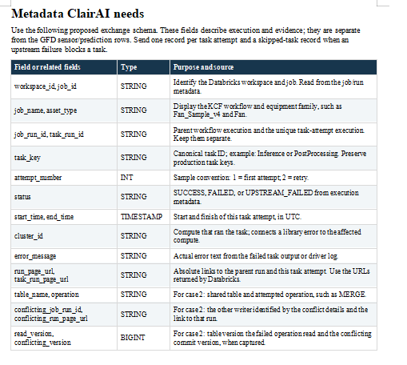
Figure 1 — ClairAI metadata contract supplied for the POC.
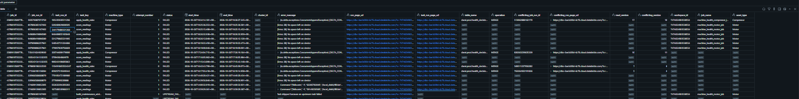
Figure 2 — Final audit evidence view showing task failures, MERGE conflict metadata and execution links.

14. Demonstration Runbook

14.1 Pre-demo check
- Confirm current namespace is machine_health.prod (or machine_health.dev / clarai.prod).
- Confirm jobs exist: clairai_machine_health_motor, clairai_machine_health_compressor, clairai_machine_health_fan, clairai_machine_health_fan_v2 and clairai_job_cost_monitoring.
- Confirm pipeline_run_audit and alert_candidates contain the final schema columns.
- Do not run the setup notebook against the live evidence tables immediately before the demo; CREATE OR REPLACE would reset evidence.

14.2 Clean run
- Run Motor with inject_fault=none, fault_task blank, merge_delay_sec=0.
- Run Compressor with the same clean settings.
- Open the job run timeline and show all tasks succeeding.
- Query predictions_latest, health_decisions, maintenance_advice and thermal_advice.
- Query pipeline_run_audit by the job_run_id and show metadata enrichment.

14.3 Case 1 demo
- Run Motor with inject_fault=disk and fault_task=score_readings.
- Open score_readings and show the OSError / Errno 28 evidence.
- Show the job graph: downstream tasks are blocked while collect_run_audit still runs.
- Query pipeline_run_audit for the job_run_id.
- Explain that the RCA is disk exhaustion and that downstream UPSTREAM_FAILED is a consequence, not a second root cause.
- For recovery, clean/terminate the affected compute as appropriate and run a clean validation.

14.4 Case 2 demo
- Prepare the shared health_decisions table with the deterministic fixture state.
- Start Motor with merge_delay_sec=30.
- Start Compressor with merge_delay_sec=0 within the overlap window.
- Show the Motor apply_health_rules first attempt failing with a concurrent Delta exception.
- Show attempt 2 succeeding.
- Query pipeline_run_audit and point out read_version, conflicting_version, conflicting_job_run_id and conflicting_run_page_url.
- Explain that the RCA is shared-table optimistic-concurrency conflict and that retry recovered the operation.

14.5 Case 3 demo — model observability and rollback
- Go to Workflows > Jobs and verify clairai_machine_health_fan (Mon-Wed, fan_v1) and clairai_machine_health_fan_v2 (Thu-Sat, fan_v2).
- In the Databricks SQL Editor (warehouse 3999f9a4bfcbda67) run the acceptance query in section 11.5; confirm fan_v1 at 82.5% and fan_v2 at 42.3% (a 40.2 pp collapse).
- Open the ClairAI alert dashboard and verify the active High alert ModelAcceptanceRateDip. Highlight that 45.6% of rejections are ModelOversensitive and execute the one-click rollback to the approved baseline run ID bb1b3a15559f43dd9993b3b28c24282c.

15. Recovery and Troubleshooting
Symptom | Likely cause | Action
Case 2 does not conflict | MERGEs did not overlap or file/read scope did not intersect | Increase merge_delay_sec and start jobs close together; do not claim a conflict unless evidence exists
Case 1 does not fail | Package already cached / disk capacity sufficient | Keep force-reinstall and no-cache behavior; adjust controlled fill margin only in the test environment
Attempt number stays 1 | Execution-count parameter not reaching notebook | Check task.execution_count mapping and audited() attempt calculation
Audit URLs are null | collect_run_audit did not execute or task-run lookup failed | Confirm ALL_DONE and Jobs API permissions
Conflicting run ID is null | Delta history entry does not contain job.runId | Leave null; never infer competitor from timing
Upstream rows missing | Audit collector did not inspect parent task states | Confirm parent job run resolution and ALL_DONE collector
Case 3 acceptance does not dip | 48-hour review SLA buffer has not elapsed | Wait for the maturity period or verify simulated review timestamps in generate_fan_model_issues.py
Cost tables empty | No read access to system.billing.usage, or billing data not yet available | Grant read on the system billing table; allow for billing-data latency and re-run clairai_job_cost_monitoring

16. Production Hardening Recommendations
- Keep the audit contract versioned independently from business tables.
- Use a stable source-of-truth mapping between ClairAI asset/task names and Databricks job/task keys rather than renaming production tasks inside the pipeline.
- Persist authoritative task/run metadata from the Jobs API; do not infer IDs from timestamps or naming conventions.
- Retain failed attempts separately from successful retries; never overwrite the failure row with the retry result.
- For production concurrency RCA, capture Delta history details and preserve the competing run identity whenever the platform supplies it.
- Treat UPSTREAM_FAILED as a dependency state, not a root cause.
- Keep destructive fault injection disabled by default and expose it only through explicit test parameters.
- For production deployment, add permissions review, alerting, retention policy, schema evolution controls and an automated audit-quality test suite.
- Consider a dedicated audit schema/table if the operational volume is materially larger than this POC.
- In model observability, enforce a minimum 48-hour SLA review buffer before firing acceptance-rate alerts so human feedback can mature.
- Enforce automated canary deployment gates so candidate models cannot reach 100% of production without passing statistical acceptance thresholds.

17. Final Acceptance Checklist
Area | Acceptance test | Status
Architecture | Pipeline flow is deterministic and understandable | PASS
Clean execution | Motor, Compressor and Fan complete normal flow | PASS
Case 1 | Errno 28 captured and downstream skips represented | PASS
Case 2 | Concurrent MERGE failure + successful retry demonstrated | PASS
Attempt tracking | Attempts retained separately | PASS
Conflict evidence | Table/version/competing-run fields available | PASS
URL evidence | Parent/task/competing URLs captured where authoritative | PASS
Metadata | workspace_id/job_name/asset_type available | PASS
Schema order | Final audit physical order defined | READY / verify after final ALTER
Demo readiness | Runbook can be presented end-to-end | PASS
Case 3 | Accidental model deployment, 40.2 pp drop and rollback links verified | PASS
Cost monitoring | Run-level cost and summary tables populated | PASS

Appendix A — Final Audit Table Schema
CREATE OR REPLACE TABLE pipeline_run_audit (
workspace_id STRING,
job_id STRING,
job_name STRING,
asset_type STRING,
job_run_id STRING,
task_run_id STRING,
task_key STRING,
machine_type STRING,
attempt_number INT,
status STRING,
start_time TIMESTAMP,
end_time TIMESTAMP,
cluster_id STRING,
error_message STRING,
run_page_url STRING,
task_run_page_url STRING,
table_name STRING,
operation STRING,
conflicting_job_run_id STRING,
conflicting_run_page_url STRING,
read_version BIGINT,
conflicting_version BIGINT
);

Note: use ALTER COLUMN FIRST/AFTER to reorder an existing Delta table without replacing current evidence. Do not execute CREATE OR REPLACE against the live evidence table merely to change order.

Appendix B — Current Setup DDL
CREATE CATALOG IF NOT EXISTS clarai;
CREATE SCHEMA IF NOT EXISTS machine_health.prod;
CREATE SCHEMA IF NOT EXISTS machine_health.dev;
USE machine_health.prod;

CREATE OR REPLACE TABLE sensor_readings_raw (
sensor_id STRING, machine_type STRING, reading_time TIMESTAMP, axis STRING,
peak_accel_g DOUBLE, vibration_rms_mm_s DOUBLE, temp_c DOUBLE);

CREATE OR REPLACE TABLE ingest_watermark (
machine_type STRING, last_reading_time TIMESTAMP);

CREATE OR REPLACE TABLE predictions_latest (
sensor_id STRING, machine_type STRING, reading_time TIMESTAMP, axis STRING,
peak_accel_g DOUBLE, vibration_rms_mm_s DOUBLE, temp_c DOUBLE,
is_healthy BIGINT, model_tag STRING, run_id STRING);

CREATE OR REPLACE TABLE predictions_history (
sensor_id STRING, machine_type STRING, reading_time TIMESTAMP, axis STRING,
peak_accel_g DOUBLE, vibration_rms_mm_s DOUBLE, temp_c DOUBLE,
is_healthy BIGINT, model_tag STRING, run_id STRING);

CREATE OR REPLACE TABLE health_decisions (
sensor_id STRING, machine_type STRING, reading_time TIMESTAMP, axis STRING,
is_healthy BIGINT, model_tag STRING, decision_note STRING)
TBLPROPERTIES (delta.enableDeletionVectors = false);

CREATE OR REPLACE TABLE alert_candidates (
issue_id STRING, sensor_id STRING, machine_type STRING, reading_time TIMESTAMP, axis STRING,
is_healthy BIGINT, model_tag STRING, decision_note STRING, status STRING, removal_reason STRING,
mlflow_run_id STRING, job_id STRING, job_run_id STRING);

CREATE OR REPLACE TABLE maintenance_advice (
sensor_id STRING, machine_type STRING, reading_time TIMESTAMP,
category STRING, advice STRING, details STRING);

CREATE OR REPLACE TABLE thermal_advice (
sensor_id STRING, machine_type STRING, reading_time TIMESTAMP, advice STRING);

-- Final audit schema:
CREATE OR REPLACE TABLE pipeline_run_audit (
workspace_id STRING,
job_id STRING,
job_name STRING,
asset_type STRING,
job_run_id STRING,
task_run_id STRING,
task_key STRING,
machine_type STRING,
attempt_number INT,
status STRING,
start_time TIMESTAMP,
end_time TIMESTAMP,
cluster_id STRING,
error_message STRING,
run_page_url STRING,
task_run_page_url STRING,
table_name STRING,
operation STRING,
conflicting_job_run_id STRING,
conflicting_run_page_url STRING,
read_version BIGINT,
conflicting_version BIGINT
);

-- Cost monitoring schemas:
CREATE TABLE IF NOT EXISTS pipeline_cost_monitoring (
job_id STRING, job_name STRING, run_id STRING, sku_name STRING,
usage_quantity DECIMAL(38,18), usage_unit STRING, estimated_cost_usd DECIMAL(38,6),
first_usage TIMESTAMP, last_usage TIMESTAMP, usage_date DATE, ingested_at TIMESTAMP)
PARTITIONED BY (usage_date)
TBLPROPERTIES ('delta.autoOptimize.optimizeWrite' = 'true', 'delta.autoOptimize.autoCompact' = 'true');

CREATE TABLE IF NOT EXISTS pipeline_cost_summary (
job_id STRING, job_name STRING,
total_usage DECIMAL(38,18), estimated_total_cost_usd DECIMAL(38,6),
run_count BIGINT, earliest_usage TIMESTAMP, latest_usage TIMESTAMP);

-- Supported handover alias: replace machine_health with clarai (clarai.prod).

Appendix C — Current collect_run_audit Implementation
from databricks.sdk import WorkspaceClient
from pyspark.sql import functions as F
CAT = "machine_health.prod"
AUDIT = f"{CAT}.pipeline_run_audit"
w = WorkspaceClient()
job_id = dbutils.widgets.get("job_id")
job_run_id = dbutils.widgets.get("job_run_id")
task_run_id = dbutils.widgets.get("task_run_id")
machine_type = dbutils.widgets.get("machine_type")
if task_run_id:
try:
current_task = w.jobs.get_run(int(task_run_id))
if current_task.job_run_id:
job_run_id = str(current_task.job_run_id)
if current_task.job_id:
job_id = str(current_task.job_id)
except Exception as e:
print(f"Task-run lookup failed: {e}")
if not job_run_id:
candidates = (
spark.table(AUDIT)
.where(F.col("job_id") == job_id)
.where(F.col("machine_type") == machine_type)
.where(F.col("job_run_id").isNotNull())
.select("job_run_id", "start_time")
.orderBy(F.col("start_time").desc())
.limit(1)
.collect()
)
if candidates:
job_run_id = str(candidates[0]["job_run_id"])
if not job_run_id:
raise ValueError("Could not determine job_run_id.")
parent = w.jobs.get_run(int(job_run_id))
rows = (
spark.table(AUDIT)
.where(F.col("job_run_id") == job_run_id)
.collect()
)
workspace_id = None
job_name = None
asset_type = machine_type
for r in rows:
if r.workspace_id:
workspace_id = r.workspace_id
if r.job_name:
job_name = r.job_name
if r.asset_type:
asset_type = r.asset_type
for r in rows:
if not r.task_run_id:
continue
try:
task_run = w.jobs.get_run(int(r.task_run_id))
task_url = task_run.run_page_url
cluster_id = None
if task_run.cluster_instance:
cluster_id = task_run.cluster_instance.cluster_id
conflicting_url = None
if r.conflicting_job_run_id:
try:
conflicting_run = w.jobs.get_run(
int(r.conflicting_job_run_id)
)
conflicting_url = conflicting_run.run_page_url
except Exception as e:
print(
f"Could not resolve conflicting "
f"run {r.conflicting_job_run_id}: {e}"
)
spark.sql(
f"""
UPDATE {AUDIT}
SET
run_page_url = :run_url,
task_run_page_url = :task_url,
cluster_id = :cluster_id,
conflicting_run_page_url = :conflict_url
WHERE
job_run_id = :job_run_id
AND task_key = :task_key
AND attempt_number = :attempt_number
""",
args={
"run_url": parent.run_page_url,
"task_url": task_url,
"cluster_id": cluster_id,
"conflict_url": conflicting_url,
"job_run_id": job_run_id,
"task_key": r.task_key,
"attempt_number": r.attempt_number
}
)
except Exception as e:
print(f"Could not enrich {r.task_key}: {e}")
seen = {
r.task_key
for r in rows
if r.task_key
}
for task in parent.tasks:
result_state = (
task.state.result_state.value
if task.state and task.state.result_state
else None
)
if (
task.task_key not in seen
and result_state == "UPSTREAM_FAILED"
):
spark.sql(
f"""
INSERT INTO {AUDIT}
(
workspace_id,
job_name,
asset_type,
job_id,
job_run_id,
task_key,
machine_type,
attempt_number,
status,
error_message,
run_page_url
)
VALUES
(
:workspace_id,
:job_name,
:asset_type,
:job_id,
:job_run_id,
:task_key,
:machine_type,
1,
'UPSTREAM_FAILED',
'Task skipped because an upstream task failed',
:run_page_url
)
""",
args={
"workspace_id": workspace_id,
"job_name": job_name,
"asset_type": asset_type,
"job_id": job_id,
"job_run_id": job_run_id,
"task_key": task.task_key,
"machine_type": machine_type,
"run_page_url": parent.run_page_url
}
)
print("collect_run_audit completed successfully.")

Appendix D — Current Job Bundle
bundle:
name: clarai_machine_health

resources:
jobs:
clairai_machine_health_motor:
name: clairai_machine_health_motor
max_concurrent_runs: 1
parameters:
- name: machine_type
default: Motor
- name: inject_fault
default: none
- name: fault_task
default: ""
- name: merge_delay_sec
default: "0"
- name: job_id
default: "{{job.id}}"
- name: job_run_id
default: "{{job.run_id}}"
- name: workspace_id
default: "{{workspace.id}}"
- name: job_name
default: clairai_machine_health_motor

tasks:
- task_key: score_readings
notebook_task:
notebook_path: /Workspace/ClarAi/MachineHealth/2.score_readings
base_parameters:
task_key: score_readings
task_run_id: "{{task.run_id}}"
execution_count: "{{task.execution_count}}"

- task_key: apply_health_rules
depends_on:
- task_key: score_readings
max_retries: 1
min_retry_interval_millis: 10000
notebook_task:
notebook_path: /Workspace/ClarAi/MachineHealth/3.apply_health_rules
base_parameters:
task_key: apply_health_rules
task_run_id: "{{task.run_id}}"
execution_count: "{{task.execution_count}}"

- task_key: build_maintenance_advice
depends_on:
- task_key: apply_health_rules
notebook_task:
notebook_path: /Workspace/ClarAi/MachineHealth/4.build_maintenance_advice
base_parameters:
task_key: build_maintenance_advice
task_run_id: "{{task.run_id}}"
execution_count: "{{task.execution_count}}"

- task_key: build_thermal_advice
depends_on:
- task_key: apply_health_rules
notebook_task:
notebook_path: /Workspace/ClarAi/MachineHealth/5.build_thermal_advice
base_parameters:
task_key: build_thermal_advice
task_run_id: "{{task.run_id}}"
execution_count: "{{task.execution_count}}"

- task_key: collect_run_audit
depends_on:
- task_key: build_maintenance_advice
- task_key: build_thermal_advice
run_if: ALL_DONE
notebook_task:
notebook_path: /Workspace/ClarAi/MachineHealth/1.collect_run_audit
base_parameters:
task_key: collect_run_audit
task_run_id: "{{task.run_id}}"
execution_count: "1"

clairai_machine_health_compressor:
name: clairai_machine_health_compressor
max_concurrent_runs: 1
parameters:
- name: machine_type
default: Compressor
- name: inject_fault
default: none
- name: fault_task
default: ""
- name: merge_delay_sec
default: "0"
- name: job_id
default: "{{job.id}}"
- name: job_run_id
default: "{{job.run_id}}"
- name: workspace_id
default: "{{workspace.id}}"
- name: job_name
default: clairai_machine_health_compressor

tasks:
- task_key: score_readings
notebook_task:
notebook_path: /Workspace/ClarAi/MachineHealth/2.score_readings
base_parameters:
task_key: score_readings
task_run_id: "{{task.run_id}}"
execution_count: "{{task.execution_count}}"

- task_key: apply_health_rules
depends_on:
- task_key: score_readings
max_retries: 1
min_retry_interval_millis: 10000
notebook_task:
notebook_path: /Workspace/ClarAi/MachineHealth/3.apply_health_rules
base_parameters:
task_key: apply_health_rules
task_run_id: "{{task.run_id}}"
execution_count: "{{task.execution_count}}"

- task_key: build_maintenance_advice
depends_on:
- task_key: apply_health_rules
notebook_task:
notebook_path: /Workspace/ClarAi/MachineHealth/4.build_maintenance_advice
base_parameters:
task_key: build_maintenance_advice
task_run_id: "{{task.run_id}}"
execution_count: "{{task.execution_count}}"

- task_key: build_thermal_advice
depends_on:
- task_key: apply_health_rules
notebook_task:
notebook_path: /Workspace/ClarAi/MachineHealth/5.build_thermal_advice
base_parameters:
task_key: build_thermal_advice
task_run_id: "{{task.run_id}}"
execution_count: "{{task.execution_count}}"

- task_key: collect_run_audit
depends_on:
- task_key: build_maintenance_advice
- task_key: build_thermal_advice
run_if: ALL_DONE
notebook_task:
notebook_path: /Workspace/ClarAi/MachineHealth/1.collect_run_audit
base_parameters:
task_key: collect_run_audit
task_run_id: "{{task.run_id}}"
execution_count: "1"

clairai_machine_health_fan:
name: clairai_machine_health_fan
max_concurrent_runs: 1
schedule:
quartz_cron_expression: "0 10 9 ? * MON,TUE,WED"
timezone_id: UTC
parameters:
- name: machine_type
default: Fan
- name: model_version
default: fan_v1
tasks:
# tasks: score_readings -> apply_health_rules (max_retries: 1) -> build_maintenance_advice + build_thermal_advice -> generate_fan_model_issues -> collect_run_audit (run_if: ALL_DONE); same task parameters as Motor (abridged)

clairai_machine_health_fan_v2:
name: clairai_machine_health_fan_v2
max_concurrent_runs: 1
schedule:
quartz_cron_expression: "0 10 9 ? * THU,FRI,SAT"
timezone_id: UTC
parameters:
- name: machine_type
default: Fan
- name: model_version
default: fan_v2
- name: clean_table
default: "false"
tasks:
# tasks: score_readings -> apply_health_rules (max_retries: 1) -> build_maintenance_advice + build_thermal_advice -> generate_fan_model_issues -> collect_run_audit (run_if: ALL_DONE); same task parameters as Motor (abridged)

clairai_job_cost_monitoring:
name: clairai_job_cost_monitoring
max_concurrent_runs: 1
tasks:
# single notebook task running job_cost_monitoring (reads system.billing.usage; abridged)

Appendix E — Evidence and Source References
The document was assembled from the ClairAI failure-case specification, the Databricks failure-case test-bench design, the current implementation snippets supplied in the conversation, and the final evidence screenshots.
Source | Use in this document
ClairAI_Failure_Cases 1_8108.docx | Authoritative failure semantics, metadata contract, RCA expectations
Machine Health Pipeline Failure-Case Test Bench (Databricks).docx | Architecture, task responsibilities, test plan, runbook and reference implementation
Current user-provided 00_setup DDL | Current machine_health.prod / machine_health.dev table model (alias: clarai.prod)
Current user-provided collect_run_audit | Current parent/task metadata enrichment and skipped-task handling
Current user-provided job bundle | Current Databricks job orchestration and execution-count retry model
Final screenshots | Visual evidence of metadata contract and populated audit evidence
Case 3 implementation report | alert_candidates 13-column schema, Fan jobs, live data state, governance review
job_cost_monitoring.ipynb | Cost pipeline schemas and logic

HANDOVER NOTE
This document is intentionally explicit about the distinction between the historical design material and the current POC namespace/path. Where the source material does not establish a fact, the document does not invent one. The next production step would be a formal mapping from this POC's machine/task names to the final ClairAI/KCF production vocabulary, if required.

Appendix F — Cost Monitoring Pipeline
The cost pipeline is an auxiliary job beside the failure-RCA pipeline. It does not write to pipeline_run_audit and does not affect Case 1, Case 2 or Case 3 evidence. Its purpose is to show what each pipeline run costs in DBUs and estimated USD.

F.1 Cost pipeline flow
Step | Stage | What happens
1 | Source | Databricks system billing table system.billing.usage supplies DBU usage records.
2 | Job: clairai_job_cost_monitoring | Notebook job_cost_monitoring calculates DBU usage and estimated USD cost per job run.
3 | pipeline_cost_monitoring | Run-by-run output; Delta table partitioned by usage_date.
4 | pipeline_cost_summary | Aggregated cost and run counts per job, built from the run-level table.

F.2 Cost tables and schemas
Table | Grain | Notes
pipeline_cost_monitoring | One record per job run | Estimated DBU usage and USD cost; partitioned by usage_date.
pipeline_cost_summary | One record per job | Rollup of cost and run count; useful for comparing jobs.
pipeline_cost_monitoring column | Type | Meaning
job_id / job_name / run_id | STRING | Databricks job id, job name and job run id
sku_name | STRING | Compute SKU consumed
usage_quantity | DECIMAL(38,18) | Total DBUs / compute units consumed
usage_unit | STRING | Usage measurement unit (DBU)
estimated_cost_usd | DECIMAL(38,6) | Estimated cost: usage_quantity x list price
first_usage / last_usage | TIMESTAMP | Earliest and latest usage within the run
usage_date | DATE | Usage date; partition column
ingested_at | TIMESTAMP | When the record was ingested/updated
pipeline_cost_summary column | Type | Meaning
job_id / job_name | STRING | Databricks job id and name
total_usage | DECIMAL(38,18) | Aggregated DBUs
estimated_total_cost_usd | DECIMAL(38,6) | Aggregated USD cost
run_count | BIGINT | Number of recorded runs
earliest_usage / latest_usage | TIMESTAMP | Earliest and latest run timestamps

F.3 Relationship to the RCA pipeline
Both pipelines identify work by Databricks job and run identity, so a cost row can be traced to the same job run in pipeline_run_audit. A formal join contract is not defined here; if one is needed for production it should be agreed explicitly rather than inferred.

F.4 Naming and implementation notes
- Active job names: clairai_machine_health_motor, clairai_machine_health_compressor, clairai_machine_health_fan, clairai_machine_health_fan_v2, clairai_job_cost_monitoring. Legacy names: machine_health_motor_job, machine_health_compressor_job.
- Schemas are defined in F.2 and Appendix B (source: job_cost_monitoring.ipynb and 00_setup.ipynb).
- Billing access: requires read access to the Unity Catalog system billing table system.billing.usage.

