**Bus Seat Booking System - Code Explanation**

**Header Files and Constants**

#include <stdio.h>

#include <stdlib.h>

#define ROWS 5

#define COLS 4

* stdio.h is included for input/output functions.
* stdlib.h is included for general functions like file handling.
* ROWS and COLS define the number of rows and columns (seats) in the bus.

**Seat Array**

char seats[ROWS][COLS];

* This 2D array represents the seats. Each seat is either 'A' (Available) or 'B' (Booked).

**Functions**

1. **initializeSeats()**

void initializeSeats() {

for(int i = 1; i <= ROWS; i++)

for(int j = 1; j <= COLS; j++)

seats[i][j] = 'A';

}

* Initializes all seats to 'A' (Available).
* **Mistake:** In C, arrays start at 0. It should loop from 0 to < ROWS and < COLS.

1. **displaySeats()**

void displaySeats() {

printf("\nSeat Map of the bus shown below !!\n(A=Available, B=Booked):\n\n");

printf(" ");

for (int j = 1; j <= COLS; j++) printf(" %d ", j);

printf("\n");

for (int i = 1; i <= ROWS; i++) {

printf("Row %d:", i);

for (int j = 1; j <= COLS; j++) {

printf(" [%c]", seats[i][j]);

}

printf("\n");

}

}

* Displays seat arrangement with rows and columns.

1. **saveBookingsToFile()**

void saveBookingsToFile() {

FILE *fp = fopen("bookings.txt", "w");

if (fp == NULL) {

printf("Error opening file.\n");

return;

}

for(int i = 1; i <= ROWS; i++) {

for(int j = 1; j <= COLS; j++) {

fprintf(fp, "%c ", seats[i][j]);

}

fprintf(fp, "\n");

}

fclose(fp);

printf("Bookings saved to file.\n");

}

* Saves the current booking status to a file named bookings.txt.

1. **bookSeat(int row, int col)**

void bookSeat(int row,int col) {

if (row > ROWS || col > COLS || row < 0 || col < 0) {

printf("Invalid seat position.\n");

return;

}

if (seats[row][col] == 'B') {

printf("Seat already booked.\n");

} else {

seats[row][col] = 'B';

printf("Seat booked successfully.\n");

}

}

* Books a seat if available. Otherwise, informs if already booked or invalid.

1. **cancelSeat(int row, int col)**

void cancelSeat(int row, int col) {

if (row > ROWS || col > COLS || row < 0 || col < 0) {

printf("Invalid seat position.\n");

return;

}

if (seats[row][col] == 'A') {

printf("Seat is already available.\n");

} else {

seats[row][col] = 'A';

printf("Seat booking cancelled.\n");

}

}

* Cancels a booked seat if it is already booked.

**Main Function**

int main() {

int choice, row, col;

initializeSeats();

printf("BUS SEAT BOOKING SYSTEM\n");

while (1) {

displaySeats();

printf("\n1. Book Seat\n2. Cancel Seat\n3. Save to File\n4. Exit\nEnter your choice: ");

scanf("%d", &choice);

switch (choice) {

case 1:

printf("Enter row to book (1-%d): ", ROWS);

scanf("%d", &row);

printf("Enter col to book (1-%d):", COLS);

scanf("%d", &col);

bookSeat(row, col);

break;

case 2:

printf("Enter row to cancel (1-%d): ", ROWS);

scanf("%d", &row);

printf("Enter column to cancel (1-%d):", COLS);

scanf("%d", &col);

cancelSeat(row, col);

break;

case 3:

saveBookingsToFile();

break;

case 4:

printf("Thanks for visiting our panel");

printf("Exiting...\n");

return 0;

default:

printf("Invalid choice.\n");

}

}

return 0;

}

* Main driver of the program. Shows menu, takes input, and calls appropriate functions.

**Important Points:**

* Indexing error: Arrays in C are **zero-indexed**. Looping from 1 to ROWS/COLS causes memory issues.
* Should use 0-based indexing or define size as [ROWS+1][COLS+1].

**Example Walkthrough:**

1. Program Starts -> All seats are Available.
2. User chooses Option 1 (Book Seat)
   * Inputs row=2, col=3
   * Seat (2,3) is booked.
3. User chooses Option 1 again
   * Inputs row=2, col=3
   * Program says "Seat already booked."
4. User chooses Option 2 (Cancel Seat)
   * Inputs row=2, col=3
   * Seat booking cancelled (Seat becomes available again).
5. User chooses Option 3 (Save to File)
   * Booking details saved to bookings.txt file.
6. User chooses Option 4 (Exit)
   * Program ends.

Source code:

#include <stdio.h>

#include <stdlib.h>

#define ROWS 5

#define COLS 4

char seats[ROWS][COLS];

void initializeSeats() {

    for(int i = 1; i <=ROWS; i++)

        for(int j = 1; j <= COLS; j++)

            seats[i][j] = 'A';

}

void displaySeats() {

    printf("\nSeat Map of the bus shown below !!\n(A=Available, B=Booked):\n\n");

    printf("      ");

    for (int j = 1; j <= COLS; j++) {

        printf("  %d ", j);

    }

    printf("\n");

    for (int i = 1; i <= ROWS; i++) {

        printf("Row %d:", i);

        for (int j = 1; j <= COLS; j++) {

            printf(" [%c]", seats[i][j]);

        }

        printf("\n");

    }

}

void saveBookingsToFile() {

    FILE *fp = fopen("bookings.txt", "w");

    if (fp == NULL) {

        printf("Error opening file.\n");

        return;

    }

    for(int i = 1; i <=ROWS; i++) {

        for(int j = 1; j <= COLS; j++) {

            fprintf(fp, "%c ", seats[i][j]);

        }

        fprintf(fp, "\n");

    }

    fclose(fp);

    printf("Bookings saved to file.\n");

}

void bookSeat(int row,int col) {

    if (row >ROWS || col >COLS || row < 0 || col < 0) {

        printf("Invalid seat position.\n");

        return;

    }

    if (seats[row][col] == 'B') {

        printf("Seat already booked.\n");

    } else {

        seats[row][col] = 'B';

        printf("Seat booked successfully.\n");

    }

}

void cancelSeat(int row, int col) {

    if (row > ROWS || col > COLS || row < 0 || col < 0) {

        printf("Invalid seat position.\n");

        return;

    }

    if (seats[row][col] == 'A') {

        printf("Seat is already available.\n");

    } else {

        seats[row][col] = 'A';

        printf("Seat booking cancelled.\n");

    }

}

int main() {

    int choice, row, col;

    initializeSeats();

         printf("BUS SEAT BOOKING SYSTEM\n");

    while (1) {

          displaySeats();

        printf("\n1. Book Seat\n2. Cancel Seat\n3. Save to File\n4. Exit\nEnter your choice: ");

        scanf("%d", &choice);

        switch (choice) {

            case 1:

                printf("Enter row  to book (1-%d): ",ROWS);

                scanf("%d", &row);

                printf("Enter col to book (1-%d):",COLS);

                scanf("%d",&col);

                bookSeat(row, col);

                break;

            case 2:

                printf("Enter row to cancel (1-%d): ",ROWS);

                scanf("%d", &row);

                printf("Enter column to cancel (1-%d):",COLS);

                scanf("%d",&col);

                cancelSeat(row, col);

                break;

            case 3:

                saveBookingsToFile();

                break;

            case 4:

                  printf("Thanks for visiting our panel");

                printf("Exiting...\n");

                return 0;

            default:

                printf("Invalid choice.\n");

        }

    }

    return 0;

}

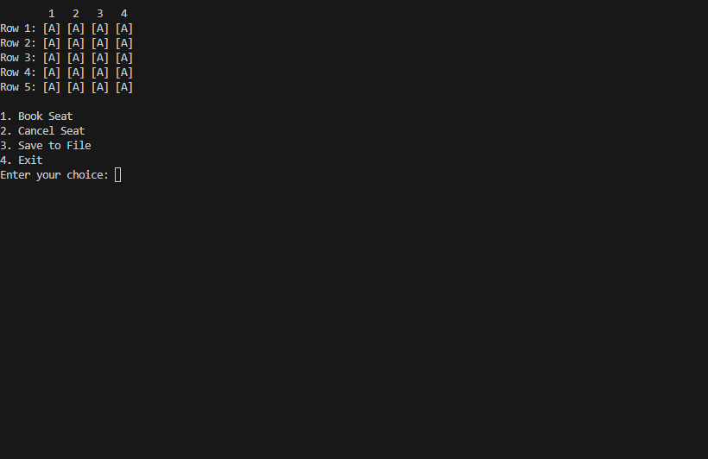Output:

