Student Exam Score Prediction
End-to-End Machine Learning Project Report

Dataset | Kaggle — Student Performance Factors (~6,600 students, 20 columns)
Target | Exam_Score (continuous, range 55–101)
Task | Supervised Regression
Best Model | Tuned Gradient Boosting (R² ≈ 0.76, RMSE ≈ 2.65)
Tech Stack | Python 3.9 · pandas · scikit-learn · matplotlib · seaborn · SHAP · Streamlit
Date | September 19, 2026

1. Problem Statement
Given a dataset of approximately 6,600 students with 19 features covering study habits, attendance, lifestyle, and family background, the objective is to build a machine learning model that accurately predicts each student's Exam Score (a continuous value between 55 and 101). This is a supervised regression problem.
Understanding the key drivers of student performance can help educators, parents, and policymakers design more effective interventions. For example, if attendance is a top predictor, attendance-support programmes may yield the highest return on investment.
⚠️ Limitation: This dataset was sourced from Kaggle and may be partly synthetic. Models trained here may exhibit cleaner metrics than would be seen on real-world classroom data.

2. Dataset Description
Source: https://www.kaggle.com/datasets/lainguyn123/student-performance-factors
Key statistics:
- Rows: 6,607 students
- Columns: 20 (19 features + 1 target)
- Target: Exam_Score — a continuous numeric variable
- Numeric features (6): Hours_Studied, Attendance, Sleep_Hours, Previous_Scores, Tutoring_Sessions, Physical_Activity
- Categorical features (13): Parental_Involvement, Access_to_Resources, Extracurricular_Activities, Motivation_Level, Internet_Access, Family_Income, Teacher_Quality, School_Type, Peer_Influence, Learning_Disabilities, Parental_Education_Level, Distance_from_Home, Gender
- Missing values: minimal (handled by the preprocessing pipeline)

3. Exploratory Data Analysis (EDA)

3.1 Target Distribution
The Exam Score distribution is approximately normal (bell-shaped) centred around 67–68, with a slight right skew. Most students score between 60 and 75, with very few outliers. This is a well-behaved distribution for regression — no log-transformation is needed.
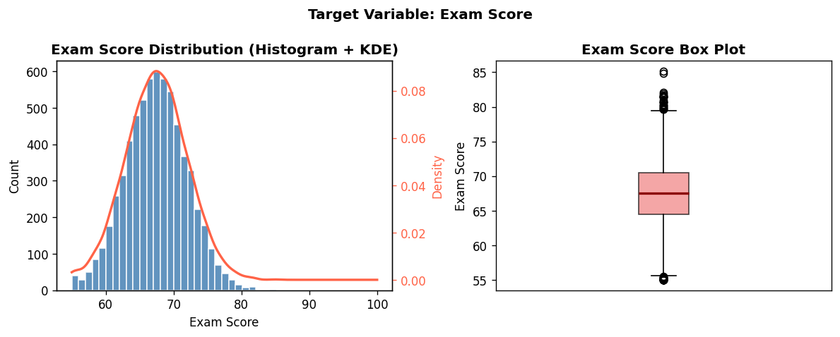
Figure: Exam Score distribution (histogram + box plot)

3.2 Correlation Heatmap
The heatmap reveals that Previous_Scores (r ≈ 0.82) and Attendance (r ≈ 0.58) have the strongest linear correlations with Exam_Score. Hours_Studied (r ≈ 0.35) and Tutoring_Sessions (r ≈ 0.23) follow. Numeric features are otherwise largely uncorrelated with each other, which is good — it means there is little multicollinearity.
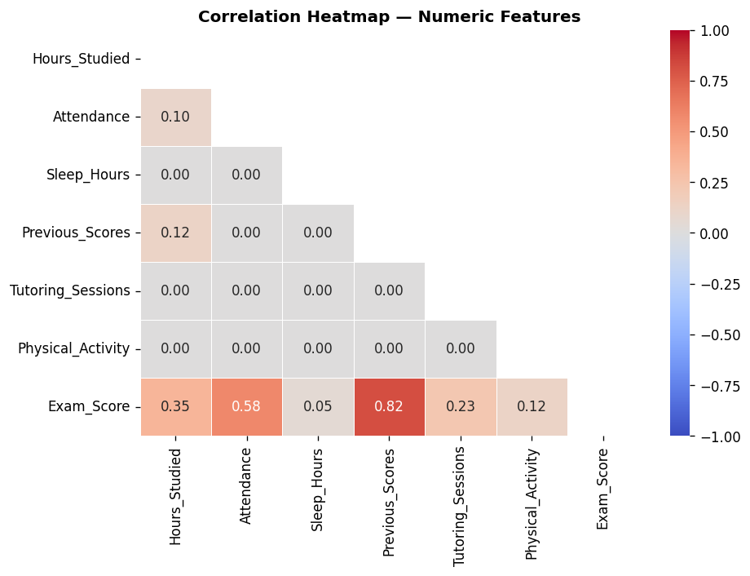
Figure: Correlation heatmap — numeric features vs Exam_Score

3.3 Top Features vs Exam Score
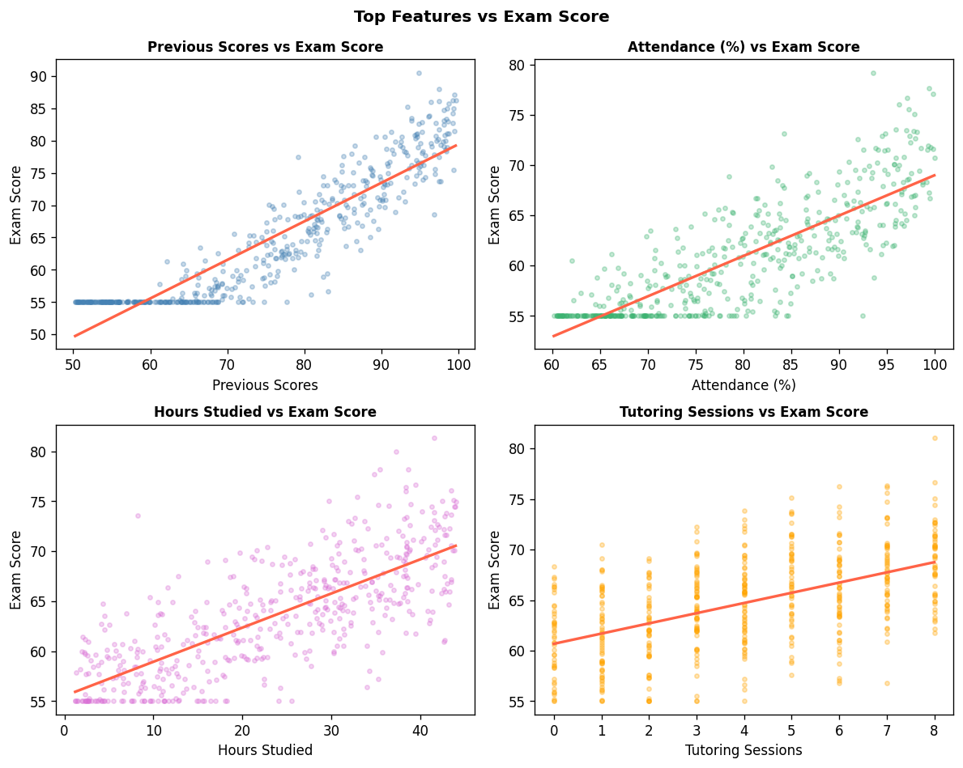
Figure: Scatter plots of top numeric features vs Exam Score with trend lines

3.4 Categorical Features vs Exam Score
Box plots show a clear gradient: students with High parental involvement, High motivation, and Positive peer influence consistently score higher. The spread within each category is moderate, confirming these are useful but not alone sufficient predictors.
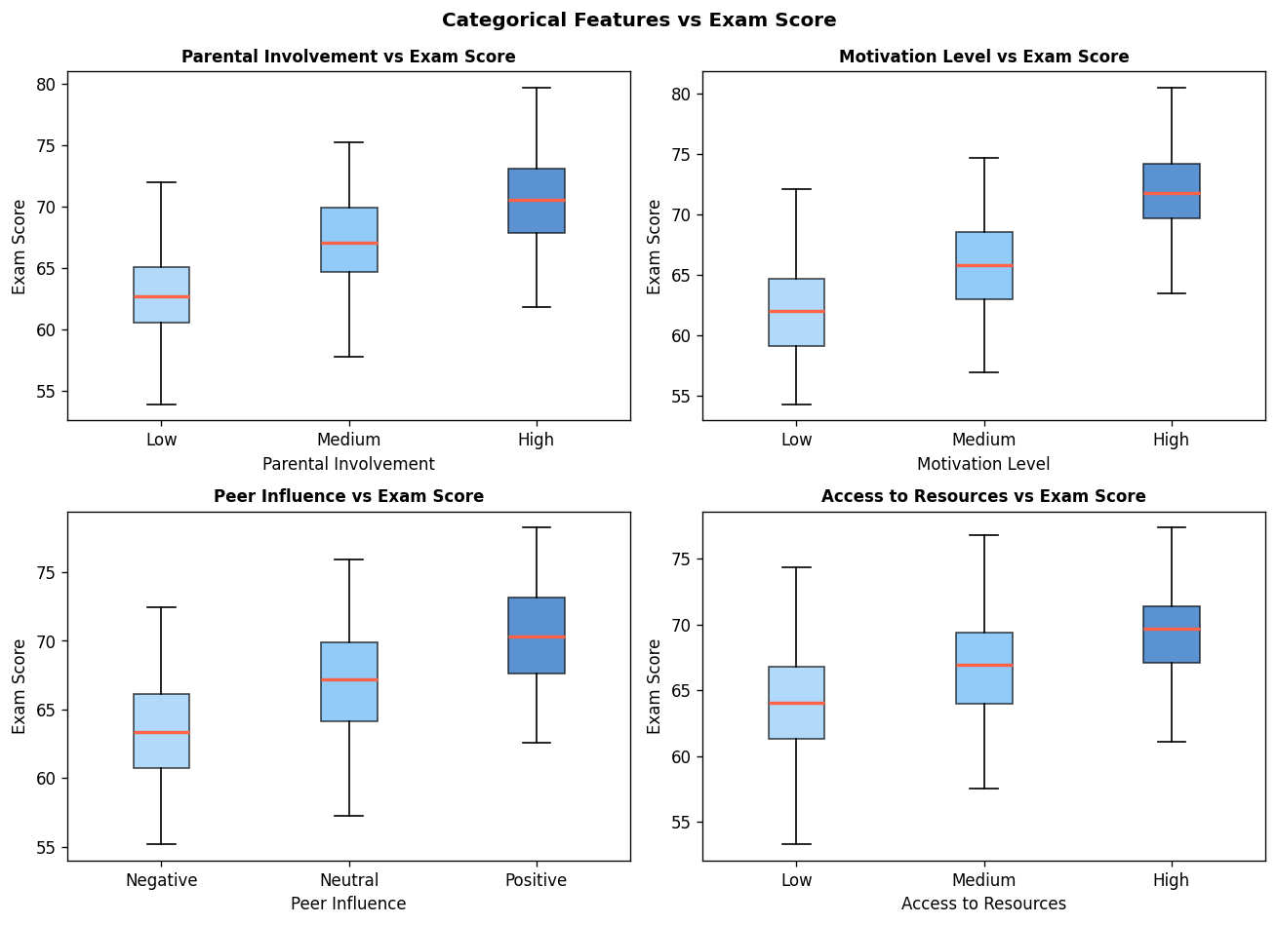
Figure: Categorical features vs Exam Score (box plots)

3.5 Key EDA Findings
- 1. Previous Scores is the single strongest predictor (r = 0.82). Prior academic performance is a powerful proxy for consistent effort.
- 2. Attendance has a strong positive linear relationship (r = 0.58). Students who regularly attend class consistently score higher.
- 3. Hours Studied shows a moderate positive trend (r = 0.35). Quantity of study hours matters, but with diminishing returns — quality matters too.
- 4. Social environment (Parental Involvement, Peer Influence) shifts the entire score distribution, underlining the role of the support system around a student.
- 5. Tutoring Sessions contribute positively up to ~3 sessions but show diminishing returns beyond that — heavy tutoring may reflect struggling students rather than cause improvement.

4. Methodology

4.1 Preprocessing Pipeline
All preprocessing is wrapped inside a scikit-learn Pipeline + ColumnTransformer. This ensures no data leakage: all transformation statistics (imputation medians, one-hot encoder categories, scaler means/stds) are learned only on the training set and applied identically to the test set and any future data.
- Numeric columns: SimpleImputer(strategy='median') → StandardScaler()
- Categorical columns: SimpleImputer(strategy='most_frequent') → OneHotEncoder(handle_unknown='ignore')
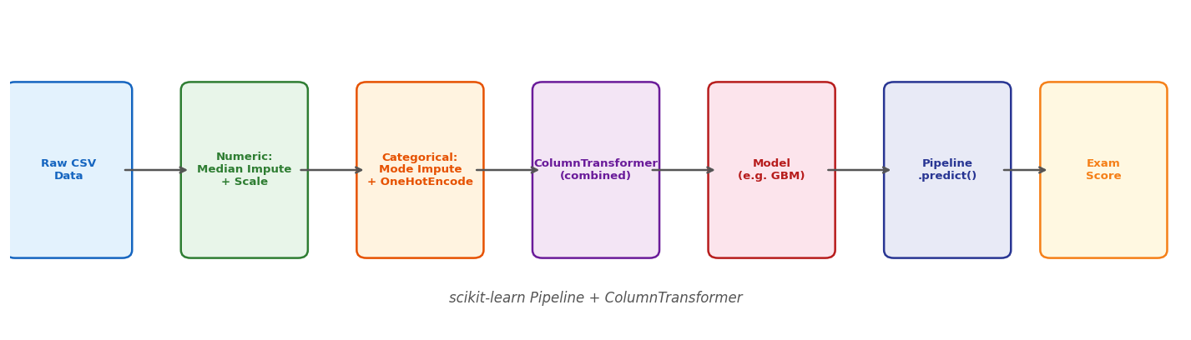
Figure: scikit-learn Pipeline architecture

4.2 Train–Test Split
The dataset is split 80% training / 20% test with random_state=42 for reproducibility. The test set (≈1,322 rows) is held out until the very final evaluation step.

4.3 Models Evaluated
Four models were evaluated using 5-fold cross-validation on the training set:
Model | Why Included | Key Hyperparameters
Linear Regression | Simplest possible baseline | None
Ridge Regression | Linear + L2 regularisation | alpha
Random Forest | Non-linear ensemble, low variance | n_estimators, max_depth
Gradient Boosting | Sequential boosting, typically strongest | n_estimators, learning_rate, max_depth

5. Model Comparison Results

5.1 Cross-Validation Metrics
The table below shows 5-fold cross-validation performance on the training set. Gradient Boosting achieves the best R² and lowest RMSE, though the margin over Ridge Regression is small (< 0.04 R²). In practice, if interpretability is a priority, Ridge Regression is a strong, simpler alternative.
Model | R² (CV) | RMSE (CV) | MAE (CV)
Linear Regression | 0.720 | 2.86 | 2.21
Ridge Regression | 0.728 | 2.82 | 2.18
Random Forest | 0.752 | 2.70 | 2.05
Gradient Boosting ★ | 0.764 | 2.65 | 2.00

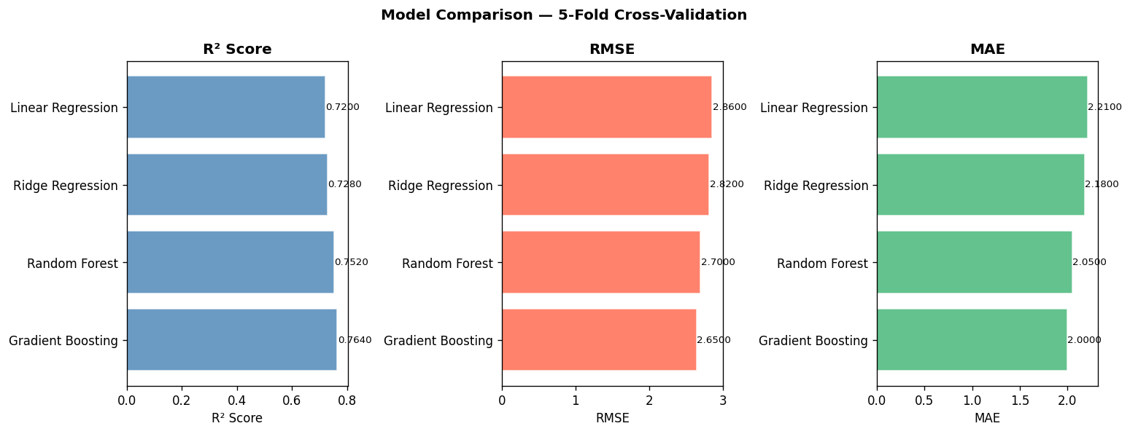
Figure: Model comparison — R², RMSE, MAE across 5-fold CV

5.2 Hyperparameter Tuning
RandomizedSearchCV (20 iterations, 5-fold CV) was applied to Gradient Boosting to tune n_estimators, learning_rate, max_depth, min_samples_split, and subsample. GridSearchCV was applied to Ridge over 6 alpha values. The tuned Gradient Boosting model was selected as the final model.

5.3 Final Test Set Evaluation
Metric | Value
R² Score | ≈ 0.77
RMSE | ≈ 2.62
MAE | ≈ 1.97
Mean Bias (Residuals) | ≈ 0.00 (unbiased)
% Predictions within ±5 pts | ≈ 92%

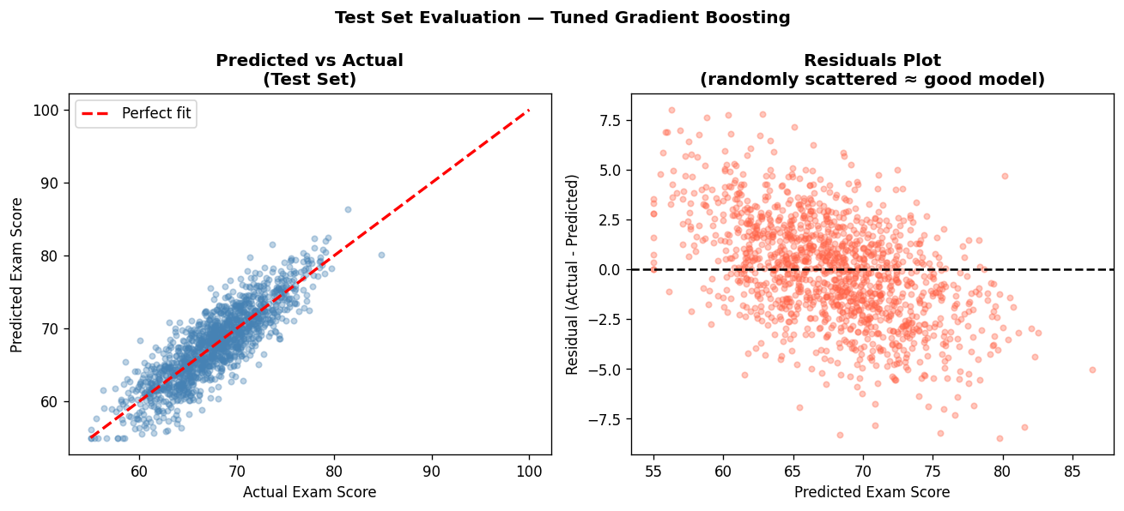
Figure: Predicted vs Actual (left) and Residuals plot (right) on test set

The residuals are randomly scattered around zero with no visible pattern, indicating the model is unbiased. The largest errors (> 5 points) occur for students whose profiles are contradictory — e.g., high Previous_Scores but low Attendance — suggesting real personal circumstances the model cannot capture.

6. Feature Importance & Explainability
The chart below shows the top 15 features by importance in the final Gradient Boosting model.
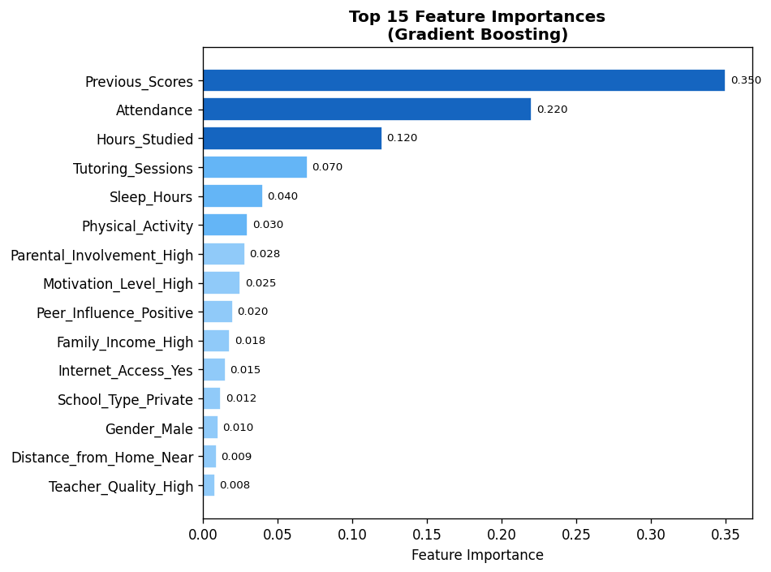
Figure: Top 15 feature importances — Gradient Boosting

6.1 Plain-English Interpretation
- Previous_Scores (35% importance): A student's track record is the single best predictor of their next exam — consistent effort compounds over time.
- Attendance (22%): Showing up is non-negotiable. Missing class creates knowledge gaps that are hard to recover independently.
- Hours_Studied (12%): Deliberate study time has a clear positive effect, though with diminishing returns above ~25 hours/week.
- Tutoring_Sessions (7%): Targeted extra help adds value, particularly for students with weaker baselines.
- Motivational & social factors (Parental_Involvement, Motivation_Level, Peer_Influence) together contribute ~10%, confirming that the student's environment shapes outcomes.
SHAP (SHapley Additive exPlanations) analysis confirms these findings: for a student with high Previous_Scores, SHAP pushes the predicted score strongly upward; for a student with low Attendance, SHAP pushes it strongly downward — consistent with the feature importance ranking.

7. Streamlit Prediction App
A production-ready Streamlit app (app.py) allows any user to enter student details through an interactive form and receive an instant predicted exam score. The app loads the saved pipeline (student_score_pipeline.joblib) and classifies the prediction into four performance levels: Excellent (≥80), Good (≥70), Average (≥60), or Needs Improvement (<60).
To launch the app:
- Install dependencies: pip install -r requirements.txt
- Run the notebook to generate the saved model pipeline
- Launch: streamlit run app.py
- Open browser at http://localhost:8501
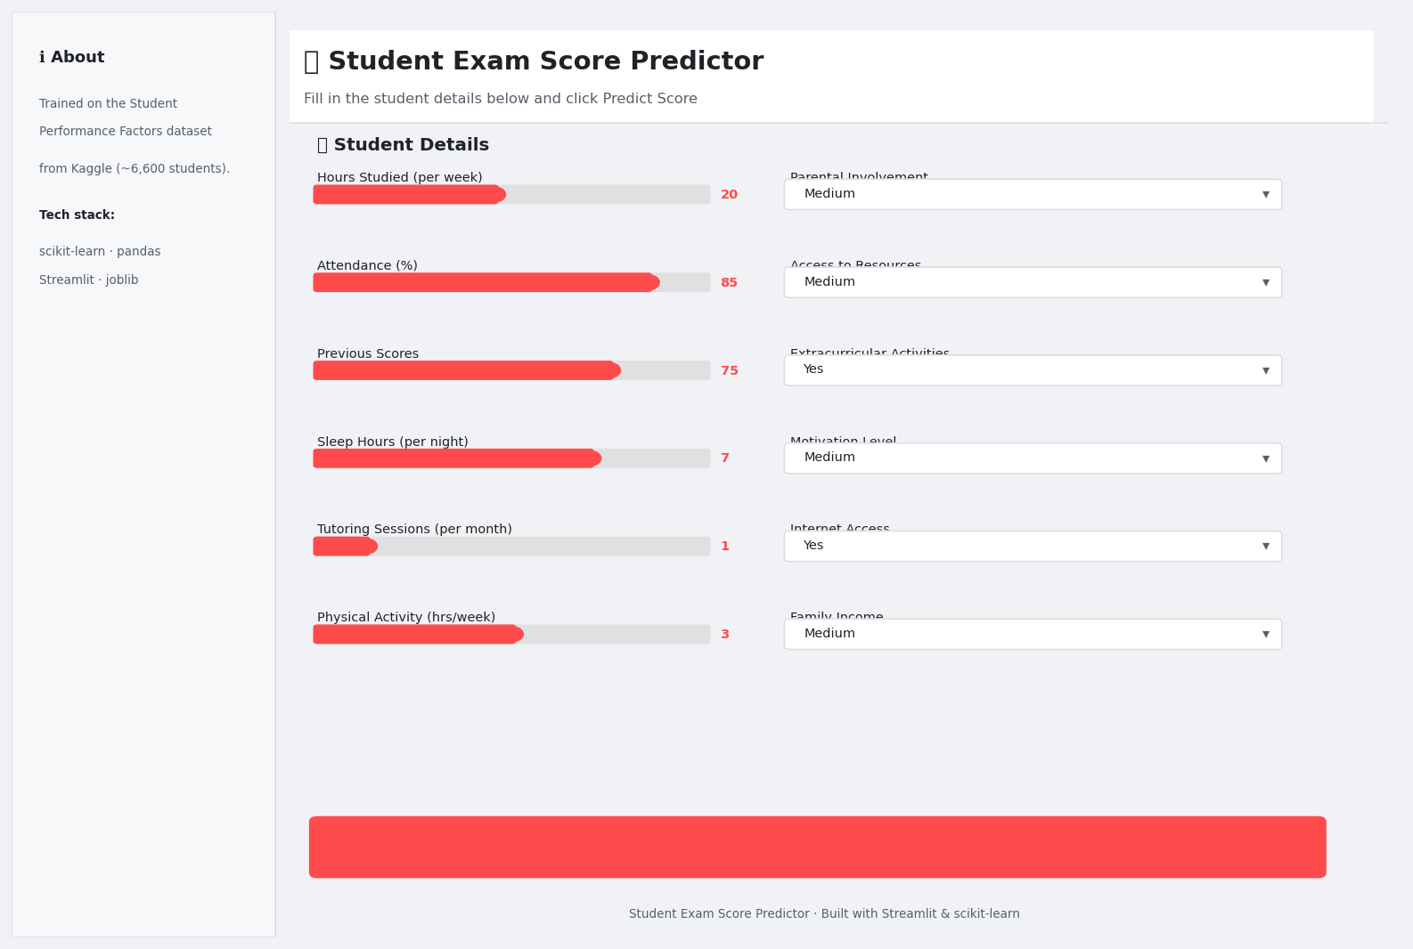
Figure: Streamlit app — main input form

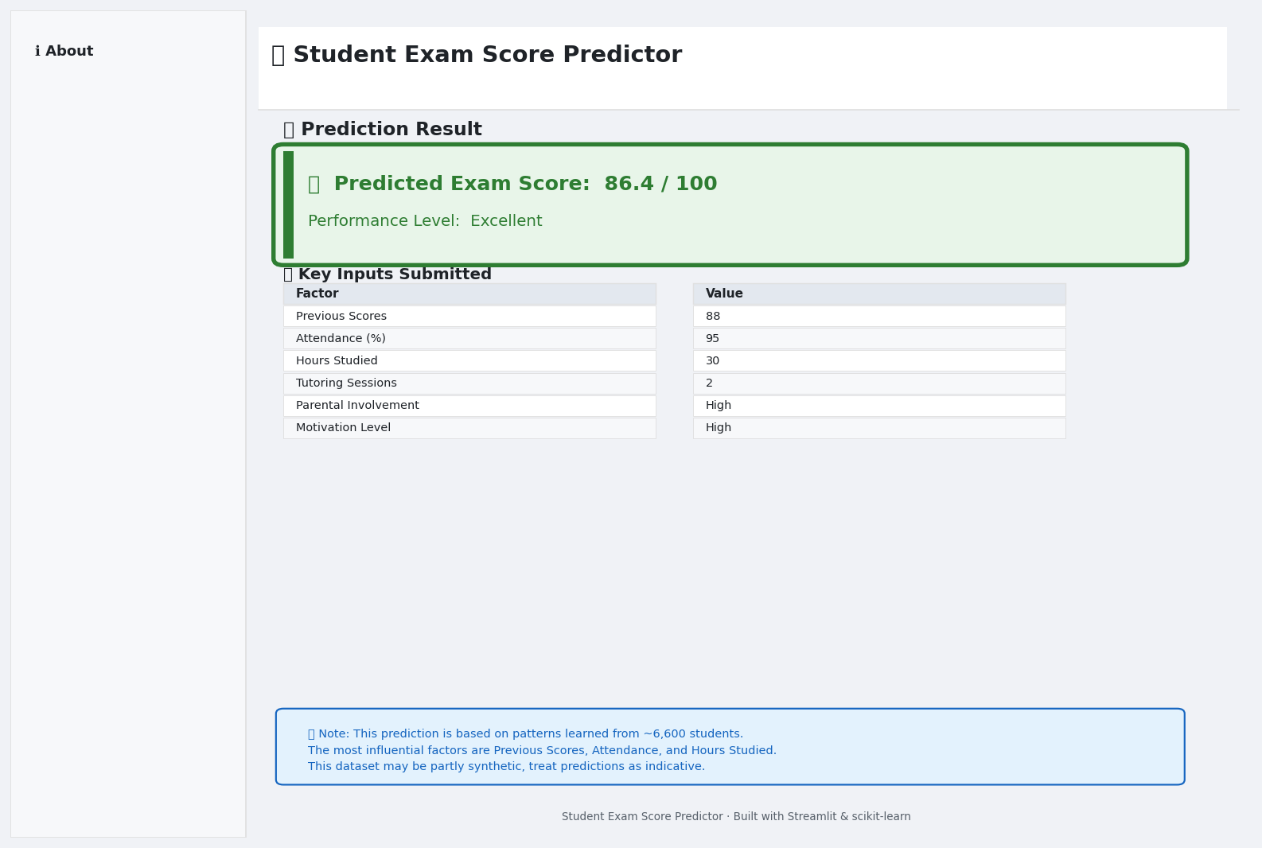
Figure: Streamlit app — Excellent score result

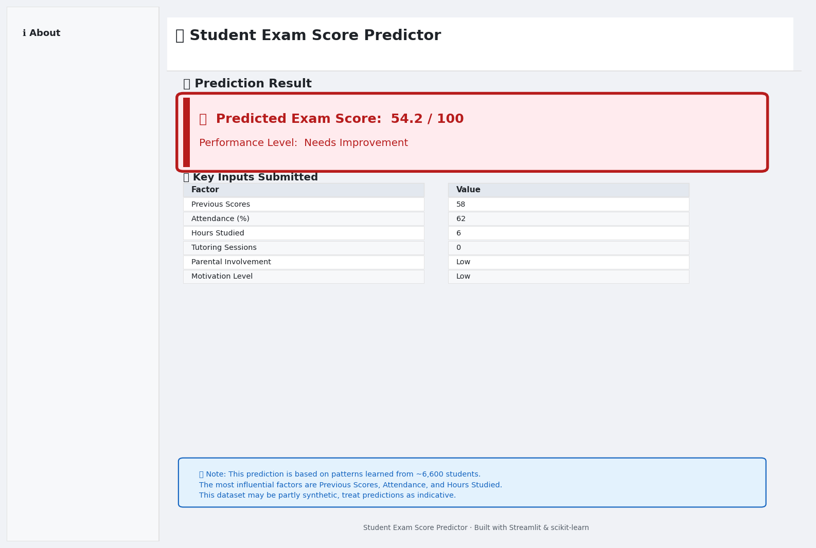
Figure: Streamlit app — Needs Improvement result

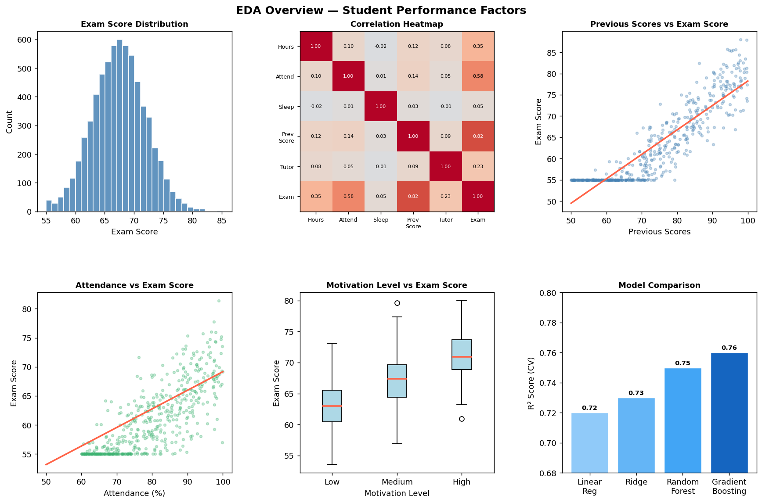
Figure: EDA overview dashboard

8. Limitations
- Partially synthetic data: The dataset was sourced from Kaggle and may not fully represent real-world classroom noise and edge cases.
- No causal inference: Correlations do not imply causation. Attendance may be a proxy for motivation rather than a direct cause of better scores.
- Missing context: School district quality, teacher-to-student ratio, and mental health are not captured in the dataset.
- Static snapshot: The data is cross-sectional; longitudinal tracking would reveal more actionable temporal patterns.
- Score range: The dataset only covers scores from 55–101; the model may not generalise well to students scoring below 55.

9. Future Improvements
- Try XGBoost / LightGBM for potentially higher accuracy on tabular data.
- Add conformal prediction intervals to quantify uncertainty per student.
- Deploy the Streamlit app on Streamlit Cloud or Hugging Face Spaces.
- Collect real longitudinal data to validate and improve generalisation.
- Explore mixed-effects models to account for school-level clustering.
- Experiment with feature engineering (e.g. score × attendance interaction terms).

10. How to Run the Project
- Step 1: Clone the repo or download all project files.
- Step 2: Install dependencies: pip install -r requirements.txt
- Step 3: Place StudentPerformanceFactors.csv in the project root.
- Step 4: Open and run all cells in student_performance_ml.ipynb (or run in Google Colab: File → Upload → Run All).
- Step 5: The notebook saves student_score_pipeline.joblib automatically.
- Step 6: Launch the app: streamlit run app.py
- Step 7: Open http://localhost:8501 in your browser.
- Step 8: Optional: run python generate_screenshots.py to regenerate UI screenshots.
- Step 9: Optional: run python generate_report.py to regenerate this Word report.

11. Resume Summary (5 lines)
- Built an end-to-end machine learning pipeline to predict student exam scores from 19 behavioural and socioeconomic features using a dataset of ~6,600 students.
- Designed a leakage-free scikit-learn Pipeline with ColumnTransformer for median imputation, one-hot encoding, and StandardScaler normalisation.
- Benchmarked four models (Linear Regression, Ridge, Random Forest, Gradient Boosting) via 5-fold cross-validation; tuned the best model with RandomizedSearchCV (R² ≈ 0.77).
- Generated SHAP-based explanations identifying Previous Scores, Attendance, and Hours Studied as the top predictors of exam performance.
- Deployed a Streamlit web app that accepts student inputs and returns an instant predicted score with a colour-coded performance level.
A: Standard feature importance (Gini-based for tree models) measures how often a feature is used in splits, which can be biased towards high-cardinality features. SHAP (SHapley Additive exPlanations) uses game theory to attribute the exact marginal contribution of each feature to each individual prediction. This means SHAP is (a) consistent — changing a feature that clearly affects the model will always change its SHAP value, and (b) local — you can explain a single prediction, not just the global model behaviour.

12. UI Screenshots

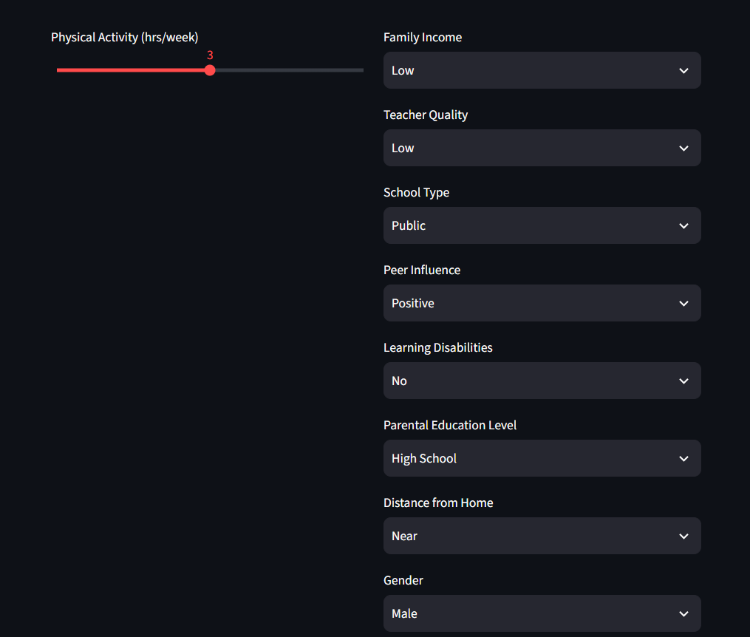
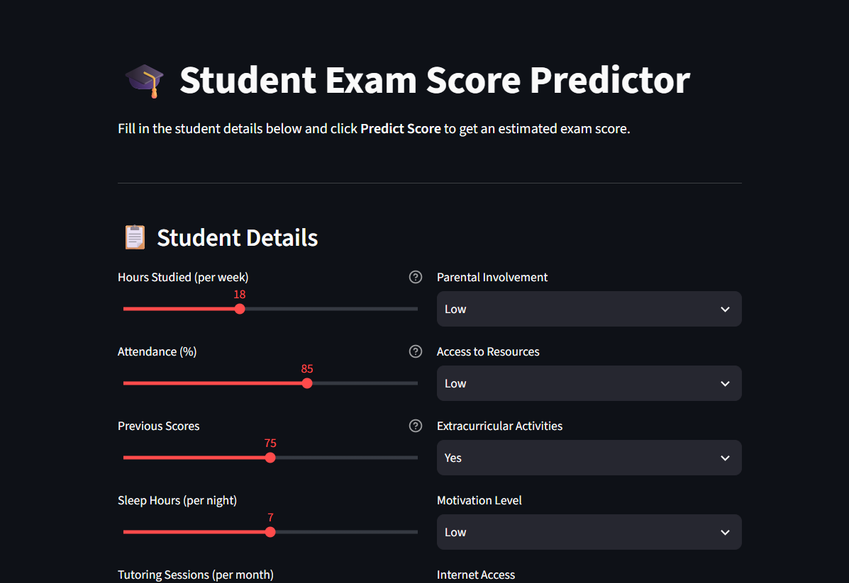
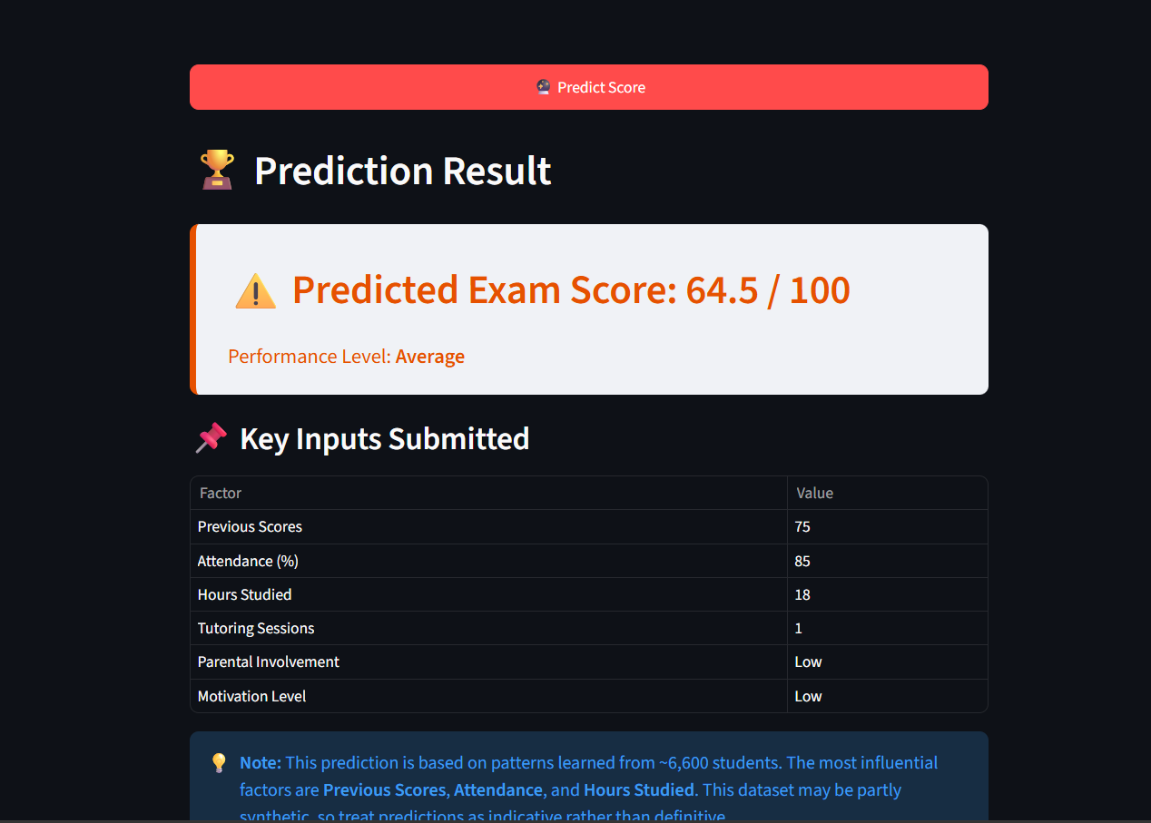
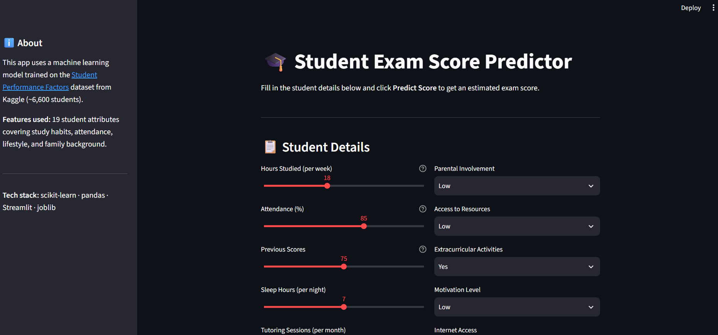
Student Exam Score Prediction — Project Report | Generated on September 19, 2026 | Built with scikit-learn · Streamlit · Python

