Road Accident Prediction — India
This report summarises the end-to-end Machine Learning project for predicting road accidents across Indian States/UTs using time-slot data (2001–2014).

1. Dataset Overview
Field | Detail
Source | Synthetic data based on only_road_accidents_data3.csv schema
Rows | 490
States / UTs | 35
Year range | 2001 – 2014
Target column | Total
Features | 0-3 hrs. (Night), 3-6 hrs. (Night), 6-9 hrs (Day), 9-12 hrs (Day), 12-15 hrs (Day), 15-18 hrs (Day), 18-21 hrs (Night), 21-24 hrs (Night)

2. ML Pipeline
- Load & clean — drop NaN rows
- Label encode — STATE/UT → integer (LabelEncoder)
- Feature engineering — NIGHT_TOTAL, DAY_TOTAL, PEAK_RATIO
- Model comparison — Random Forest, Gradient Boosting, Ridge Regression
- Best model auto-selected by R² on 20% hold-out: Ridge Regression
- 5-fold CV R²: 1.0000 ± 0.0000
- Artefacts saved: rf_model.pkl, label_encoder.pkl, feature_stats.json

3. Model Performance
Metric | Value | Notes
Best model | Ridge Regression | Auto-selected
Test R² | 1.0000 | 20% hold-out
5-fold CV R² | 1.0000 ± 0.0000 | Full dataset

4. Exploratory Data Analysis
The following charts show national trends, the states with the highest cumulative accident totals, average accidents by time slot, feature relationships, and the distribution of recorded totals.
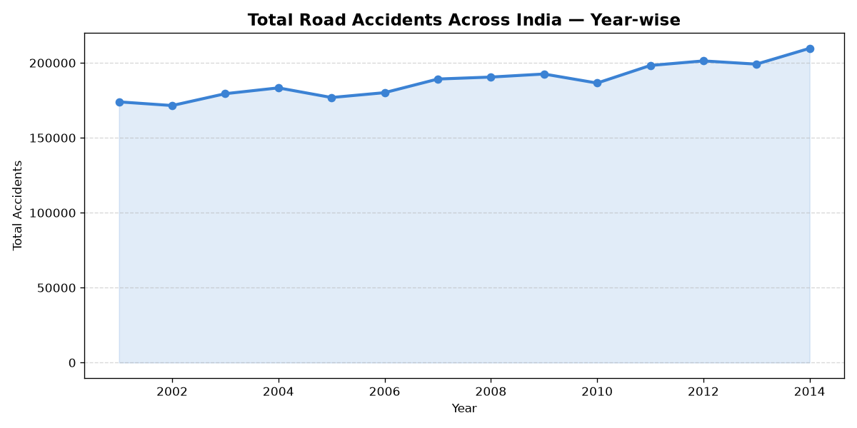
Figure 1. Total accidents by year.
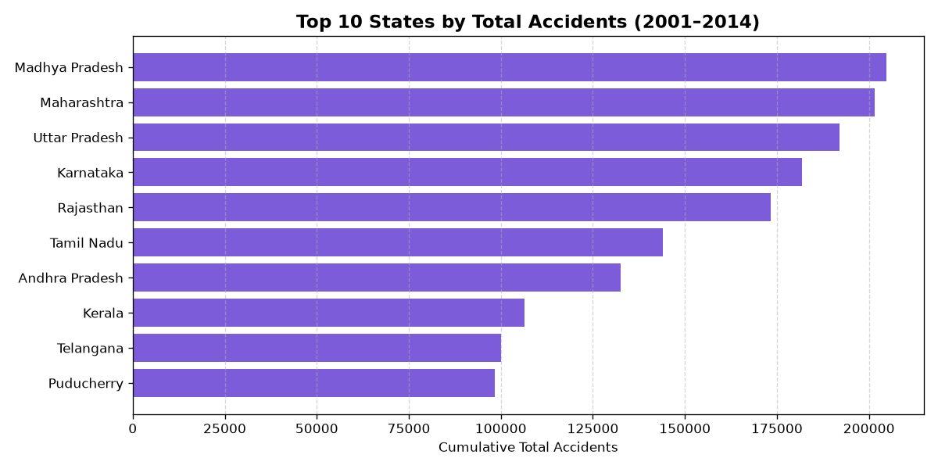
Figure 2. Ten states/UTs with the highest cumulative totals.
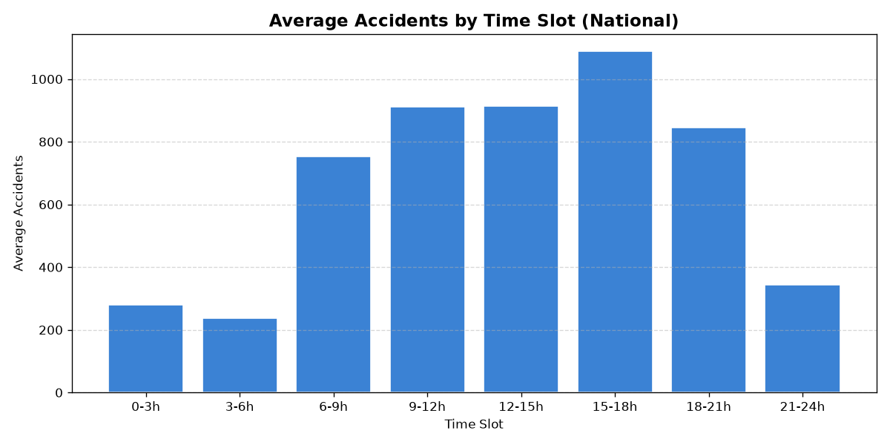
Figure 3. Average accidents by time slot.

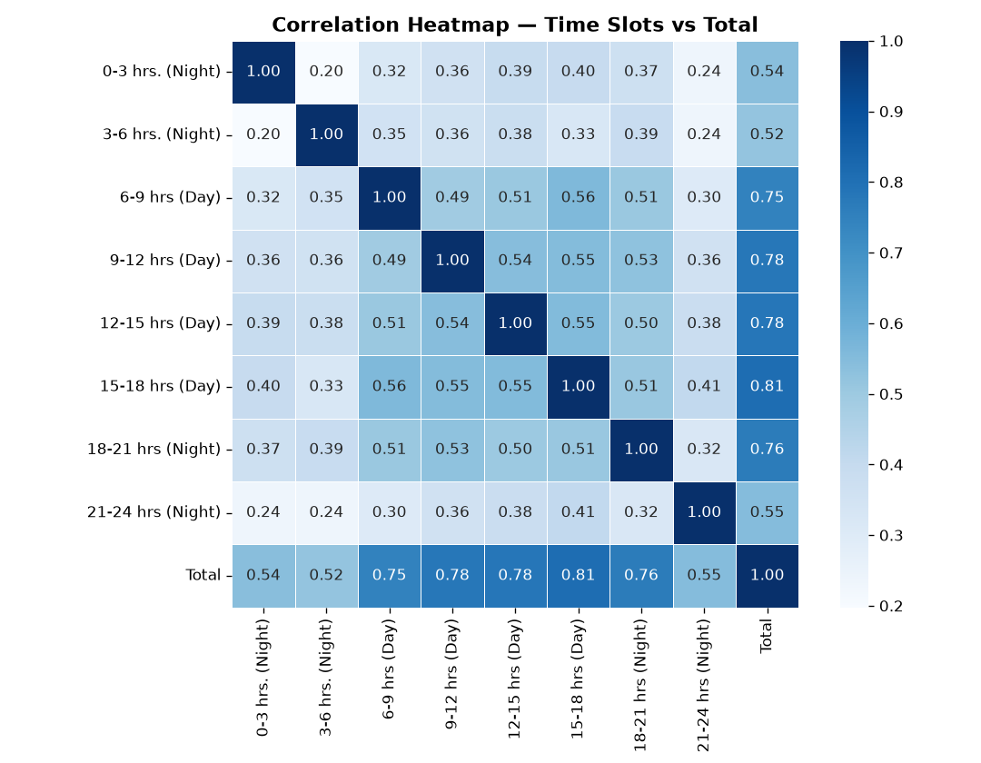
Figure 4. Correlation heatmap of numeric features.
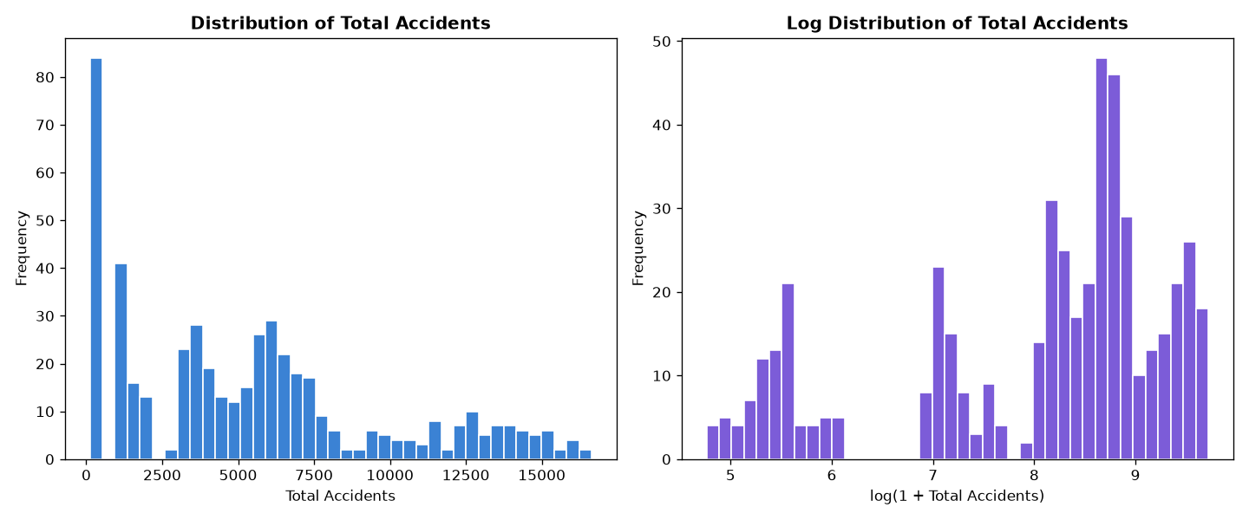
Figure 5. Distribution of total accident counts.

5. Summary Tables
The tables below provide a compact view of the largest state totals and annual national totals.
Rank | State / UT | Cumulative accidents
1 | Madhya Pradesh | 204,699
2 | Maharashtra | 201,453
3 | Uttar Pradesh | 192,068
4 | Karnataka | 181,757
5 | Rajasthan | 173,344
6 | Tamil Nadu | 144,108
7 | Andhra Pradesh | 132,456
8 | Kerala | 106,354
9 | Telangana | 100,053
10 | Puducherry | 98,389

Year | National total | Year-over-year change
2001 | 173,976 | —
2002 | 171,531 | -1.4%
2003 | 179,431 | +4.6%
2004 | 183,319 | +2.2%
2005 | 176,883 | -3.5%
2006 | 180,127 | +1.8%
2007 | 189,209 | +5.0%
2008 | 190,527 | +0.7%
2009 | 192,563 | +1.1%
2010 | 186,523 | -3.1%
2011 | 198,256 | +6.3%
2012 | 201,310 | +1.5%
2013 | 199,153 | -1.1%
2014 | 209,695 | +5.3%

6. Application Pages
- 🏠 Home — KPI cards — total accidents, avg/year, highest-risk state, peak slot
- 🔮 Predict — Time-slot inputs → ML prediction + historical comparison chart
- 📊 EDA — Trend lines, state breakdown, correlation heatmap, scatter plot
- 📋 Dataset — Filterable raw data table with CSV download
- ℹ️ About — Architecture, pipeline details, run instructions

7. API-backed Frontend (ui.py)
The ui.py file is a Streamlit frontend that communicates with the Flask backend through the ACCIDENT_API_URL setting. It provides four views:
- Overview — Displays dataset KPIs, model R², and a national accident trend chart.
- Predict — Sends state, year, and time-slot values to POST /api/predict.
- Dataset — Loads and filters dataset rows through GET /api/dataset.
- Project report — Displays backend health, model metadata, and dataset summary.
The frontend uses GET /api/health and GET /api/model during startup. The Flask API runs on port 5000 and the Streamlit UI runs on port 8502 by default.

8. User Interface Preview

Figure 6. Traffic-light visual used by the Streamlit navigation.
The standalone app presents KPI cards, interactive Plotly charts, state and year inputs, a prediction result, EDA views, a filterable dataset table, and project information. The API-backed interface mirrors the main workflows while keeping data and predictions behind Flask endpoints.

9. How to Run
python _complete_project.py # setup data + train model
python eda.py # generate EDA plots
streamlit run app.py # launch Streamlit UI
python backend.py # optional: Flask API
streamlit run ui.py # optional: API-backed UI

