DATALINK AI — LIVE DATA, PATTERN DETECTION AND DASHBOARD ARCHITECTURE
How to get live uplink, downlink, OS, partition and fault data to the ground server and into the AI; how to find pattern issues and serious symptoms; and how to run the live flight-keyed dashboard.
Companion to "Requirements-Anchored In-Service Datalink Conformance & Root-Cause Platform"
Revision 3 · 8 October 2026 · adds the benefits and business case: failure prediction for the datalink product itself, in-service issues found before the customer reports them, what the platform is worth to an airline and to an OEM such as Honeywell Aerospace, and how much can be earned (USD)
Architectural rule that everything below obeys: the verdict engine is deterministic; the AI explains, correlates and predicts; the AI never writes a conformance verdict directly. Every AI output is an advisory hypothesis that is admitted, gated and recorded. This is what keeps the platform patentable and acceptable to an airworthiness authority.

Contents
- 1. What "live data" realistically means — and Figure 2, what data is available and when
- 2. How to get the data: source-by-source acquisition plan (S1–S9)
- 3. Reference architecture — Figure 1 end to end, plus Figure 3, the time-fusion view of one transaction
- 4. Finding pattern issues and serious symptoms — Figure 5 detection layers and the label flywheel, Figure 6 predictive findings and the coverage account
- 5. The live dashboard — Figure 4, the sample console
- 6. Full end-to-end worked example: flight AI102, one uplink, one defect, every number
- 7. Reading the sample dashboard, and replacing the mock-up with real data
- 8. Benefits and the business case — Figure 7 who gains and what they pay, Figure 8 cost and revenue scenarios: failure prediction for the datalink product itself, in-service issues found before the customer reports them, value to the airline and to the OEM, and how much can be earned
- 9. Build order · 10. Patent position · 11. Risks
What is new in revision 2
- Six figures are embedded: the end-to-end architecture, the data-availability map, the signal-fusion timeline of a single transaction, the sample dashboard, the detection layers and label flywheel, and the two predictive findings. Full-size PNGs live in datalink-ai/figures/.
- A complete worked example (Section 6) follows one real-shaped transaction from the ATC uplink to the closed, signed conformance record, including the verdict arithmetic, the AI hypothesis that was accepted, the one that was rejected by the admission gate, and the version history as late data arrived.
- A dashboard walkthrough (Section 7) explains every panel and number of the sample console, and gives the mapping from each panel to the pipeline source that will feed it.
- An interactive HTML mock-up of the console ships alongside this document at datalink-ai/dashboard/sample_dashboard.html, so the sample data can be clicked through rather than only read.

1. What "live data" realistically means — read this before designing anything
There is a temptation to imagine a socket on the aircraft streaming operating-system and partition telemetry in real time. That socket does not exist on a certified aircraft, and no design should depend on it. What exists is a set of five real channels with different latencies and different fidelity. The architecture below uses all five and states honestly which verdicts can be produced at which latency.
Channel | What it actually gives | Realistic latency | Fidelity | Can support
1. Datalink message feed (CSP / airline AOC gateway) | Every uplink and downlink record: CPDLC, ADS-C, AOC messages, with per-hop timestamps where the provider supplies them | 1–30 s | Message-level, reliable | Functional, message-flow, crew-response and end-to-end timing verdicts
2. ACMS programmable reports (aircraft condition monitoring) | Custom-defined parameter reports (triggered, requested or periodic) transmitted over the datalink: communications LRU status, counters, timing samples, fault flags — whatever the airline has an approved report definition for | Seconds to minutes | Selected parameters, engineered per report | Host/platform, fault and resource verdicts in flight, at report cadence
3. QAR / FDR offload at the gate | The full parameter set for the entire flight, at full sample rate | Post-flight (minutes after gate) | Highest fidelity, complete | Authoritative post-flight verdicts, margin baselines, not-exercised accounting, model training
4. Aircraft Interface Device (read-only) | ARINC 429 / Ethernet bus data, LRU status words, CMS fault pages; no write access | On ground, or in flight if installed with a satcom backhaul | Bus-level | Ground diagnostics, fault confirmation, configuration read-back
5. Ground-side network and ANSP telemetry | CSP ground-station and subnetwork status, ATC-side CPDLC/ADS-C performance data, NOC feeds, ADS-B surveillance | Seconds to minutes | Network-level | Network and link verdicts, airspace attribution, flight keying

Consequence for the product: verdicts are near-real-time for message, crew and network requirements, and post-flight for the deepest host-platform requirements, with the dashboard showing per-stream freshness. Promising "live partition telemetry from a flying aircraft" without an OEM agreement is the fastest way to lose an airline pilot programme.
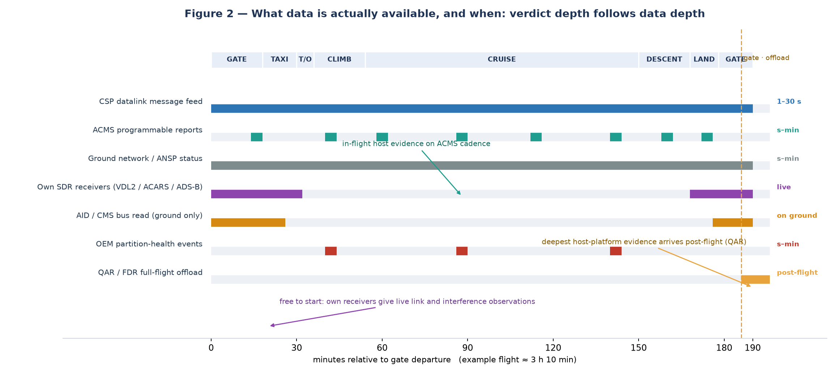
Figure 2 — What data is actually available, and when. Verdict depth follows data depth: a message-feed-only platform can judge message flow and timer behaviour; host-platform and resource verdicts only become authoritative once ACMS reports, partition events or the post-flight QAR are in hand.

2. How to get the data: source-by-source acquisition plan
# | Source | Owner / gatekeeper | Route to get it | Notes for the contract
S1 | ACARS / CPDLC / ADS-C message records | CSP (SITA, ARINC/Collins, Viasat, Iridium) and the airline AOC gateway | Subscribe to a CSP messaging feed (MQTT / AMQP / REST / drop), or integrate with the airline AOC gateway; start with a sandbox or a replay sample | Data-use rights, retention limits, per-airline tenancy, prohibition on re-use across airlines without consent
S2 | ATC-side CPDLC / ADS-C performance data | ANSP / EUROCONTROL DPMF-style services, FAA SWIM | Feed subscription or periodic report ingestion | Regional availability varies; low frequency is acceptable
S3 | ACMS programmable reports | Airline engineering + OEM-approved report definitions | Define the report parameter set with airline engineering; reports are transmitted on trigger or request over the existing datalink | This is the practical in-flight route to host/platform evidence; treat report definition as a changeable configuration, not software
S4 | QAR / FDR data | Airline reliability / flight data monitoring team | Offload automatically at the gate (wireless ground link) or ingest the airline existing offload; reuse, do not duplicate | FDM data is heavily governed: programme approval, crew de-identification rules, access logging
S5 | Aircraft Interface Device / CMS data | OEM or STC holder | OEM partnership for a read-only interface; or use the airline existing AID installation | Long lead item; do not make the MVP depend on it
S6 | IMA partition health-monitor events | Airframe / avionics OEM | OEM collaboration to expose partition health events in an existing report or an approved data channel | Highest value, hardest to obtain; the strategic partnership objective
S7 | Ground network and link status | CSP, ANSP, own receivers | CSP network status API plus own ground-station observability | Combine with own VDL/ACARS reception where legal
S8 | Surveillance / flight keying | ADS-B network or own receivers | Own SDR receivers (for example dumpvdl2 / ACARS decoding for VDL Mode 2 and ACARS) plus a virtual radar feed | Own receivers double as the interference observation source — very useful for the threat-model work
S9 | Flight identity and aircraft configuration | Airline ops and engineering records | OOOI / flight plan feed, and the tail configuration database: software part number, hardware part number, database versions, modem, subscription, route | Configuration data is mandatory, not optional: without it the requirement monitors are instantiated against the wrong baseline

Sequence that works commercially: S1 + S2 + S9 first (no aircraft changes, one CSP and one airline relationship), then S3 (airline engineering), then S4 (reliability team), and S5–S6 as the strategic OEM track. S8 is free and can start immediately.

3. Reference architecture: from aircraft and ground feeds to the AI and the dashboard
AIRCRAFT GROUND CONSUMERS
-------- ------ ---------
CMU / ATSU ---(datalink)---> CSP ground ---> [1] CSP feed adapter \
ACMS reports -------------> datalink ------> [2] ACMS adapter \
QAR offload at gate ----------------------> [3] QAR adapter \
AID / CMS (read-only) --------------------> [4] AID adapter |
IMA health events (OEM) ------------------> [5] OEM adapter |
[6] ANSP / NOC adapter |
own SDR receivers (VDL2/ACARS/ADS-B) -----> [7] RF adapter |
airline OPS / configuration -------------> [8] OPS + config adapter/
|
+---------------------------------------------+
v
KAFKA / PULSAR (raw topics, per-source retention, replayable)
|
schema registry + validation + dedup + normalisation
|
v
TIME-ALIGNMENT SERVICE (common reference + offset/uncertainty)
|
+---------------+----------------+---------------------+
v v v v
VERDICT ENGINE PATTERN ENGINE SYMPTOM RULES FEATURE STORE
(deterministic, (statistical + (severity, (per flight,
per requirement) ML, advisory) escalation) per route)
| | | |
+-------+-------+----------------+---------------------+
v
STORES: hot time-series | object store (raw) | LEDGER (hash-chained)
|
v
SERVING APIs --> LIVE DASHBOARD (WebSocket / SSE, flight-keyed)
--> ALERTS / NOC, maintenance work orders
--> CONFORMANCE RECORD + COVERAGE ACCOUNT exports

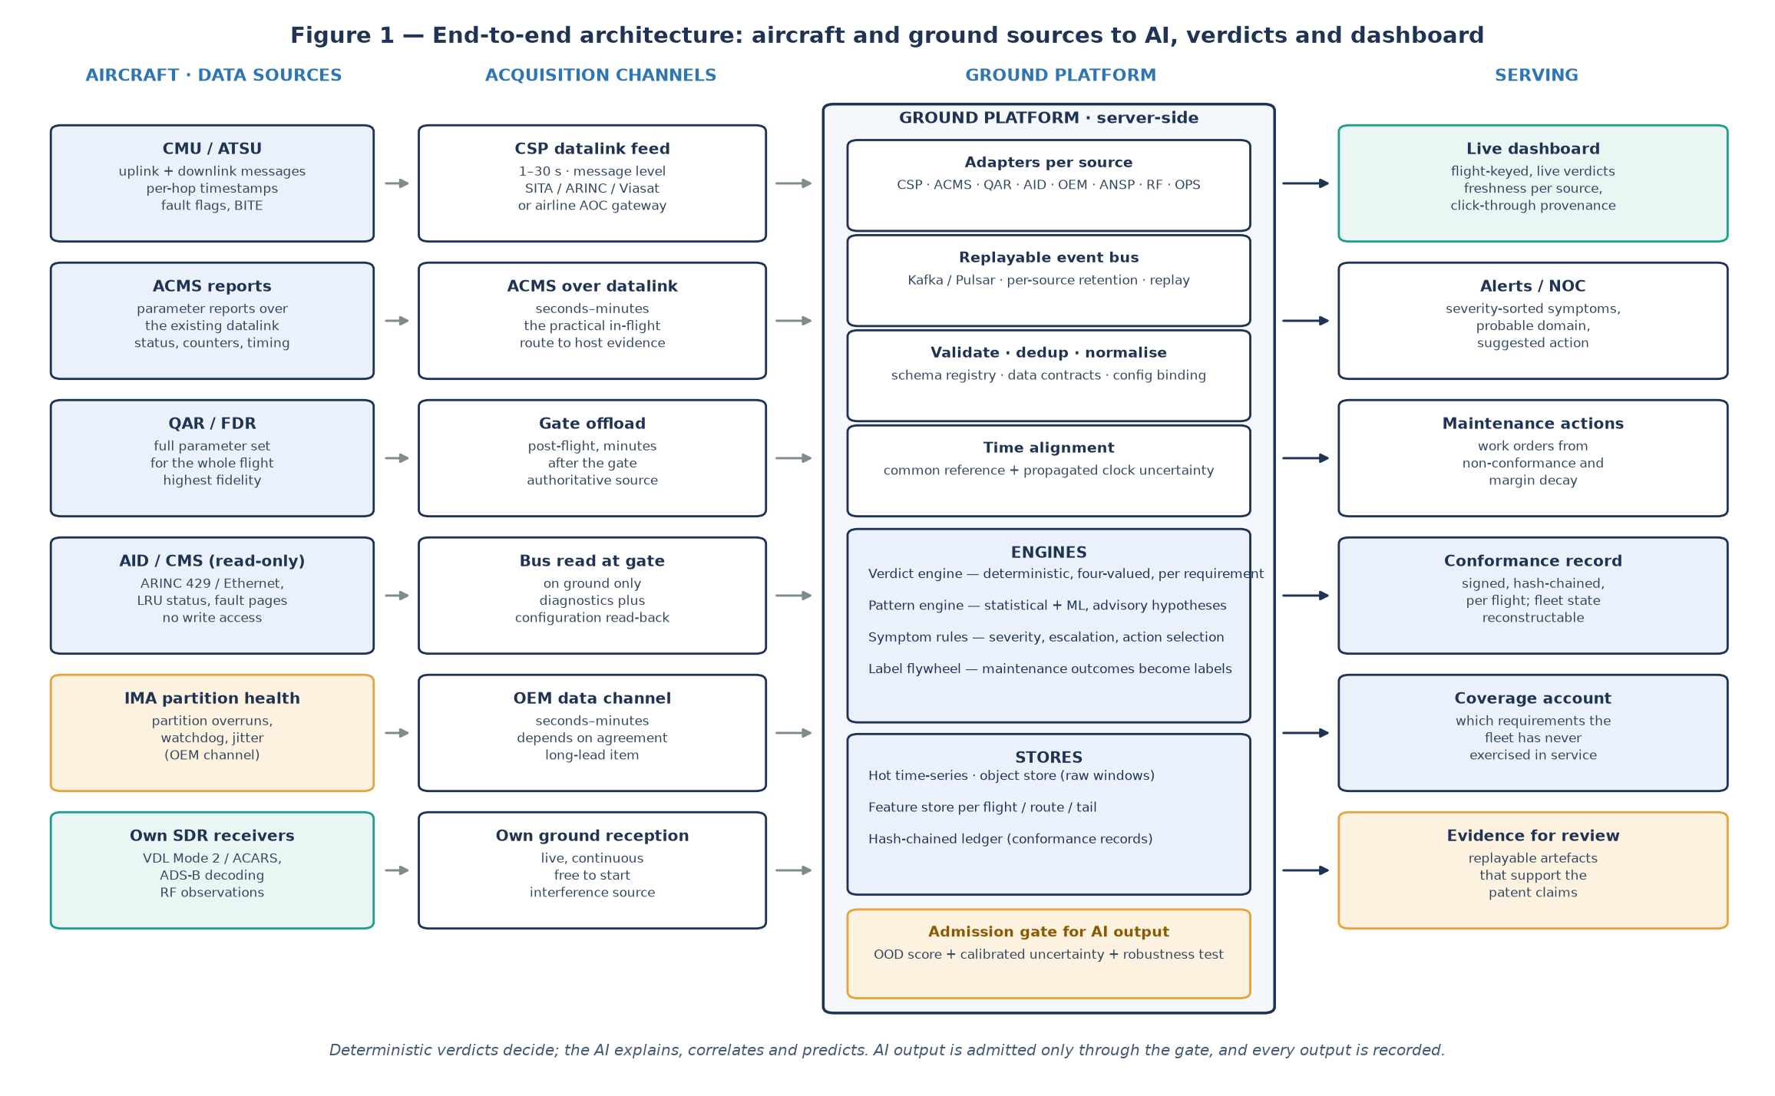
Figure 1 — End-to-end reference architecture. Aircraft-side sources and ground-side feeds are acquired by purpose-built adapters over a replayable bus; validation, time alignment with propagated clock uncertainty, and then two clearly separated engines — a deterministic verdict engine that decides, and an advisory pattern/ML engine that proposes. Serving layer: the live dashboard, alerts, work orders, conformance records and the coverage account.

3.1 Message bus and topics
Topic | Content | Retention | Why
raw.csp.messages | Uplink and downlink records exactly as received | 7–30 days hot, archive to object store | Deterministic replay; provider dispute evidence
raw.acms.reports | ACMS report payloads as decoded | 30 days | Re-parse after decoder fixes
raw.qar.offload | QAR extracts per flight | Policy-limited; archive | Baseline and model training
raw.ground.netstat | Ground-station, subnetwork and network status | 30 days | Network attribution
raw.ops.flight | OOOI, flight plan, configuration snapshots | 1 year | Flight keying and monitor instantiation
norm.transactions | Normalised transaction legs with timestamps and sources | 90 days | Verdict engine input
norm.telemetry | Normalised partition / OS / resource samples | 90 days | Verdict engine input
norm.faults | Normalised fault and BITE observations | 1 year | Robustness verdicts and maintenance
verdicts.requirement | Per-requirement verdicts, margins, evidence references, version | Permanent (ledger-linked) | The product
alerts.symptoms | Detected symptoms and pattern hypotheses | 1 year | Operations

3.2 Data contracts (freeze these; they are your enablement insurance)
Transaction record — the unit the verdict engine works on:
{
"transaction_id": "T-2026-10-08-4f9a",
"tail": "VT-XXX", "flight": "AI102", "aircraft_config": {
"cmu_sw_pn": "PN-1234-05", "cmu_hw_pn": "PN-9876-01", "db_version": "DB-2026-07",
"modem": "SATCOM-X", "subscription": "CPDLC-OCEANIC" },
"message_type": "CPDLC_UPLINK", "direction": "GROUND_TO_AIR",
"legs": [
{"leg":"ground_origin_send", "t":"2026-10-08T04:12:03.220Z","source":"CSP","offset_ms":0, "uncert_ms":5},
{"leg":"gnd_station_egress", "t":"2026-10-08T04:12:03.480Z","source":"CSP","offset_ms":0, "uncert_ms":5},
{"leg":"aircraft_app_receipt", "t":"2026-10-08T04:12:06.100Z","source":"ACMS","offset_ms":-312,"uncert_ms":80},
{"leg":"crew_response_send", "t":"2026-10-08T04:12:31.000Z","source":"CSP","offset_ms":0, "uncert_ms":5}
],
"content_hash": "sha256:...", "source_flags": ["provider_supplied_timestamps"]
}

Platform telemetry sample — the host-side evidence:
{ "tail":"VT-XXX","flight":"AI102","flight_phase":"CRUISE",
"partition": {"id":"COMMS-P2","period_ms":100,"exec_ms":71.4,"budget_ms":80,
"overrun_count":2,"release_jitter_ms":3.1,
"queue_depth_max":17,"window_s":10},
"os_events": [{"type":"deadline_miss","task":"DL_TX","at":"...","uncert_ms":80}],
"source":"ACMS_REPORT","sample_interval_ms":10000 }

Verdict record — the output that everything else explains:
{ "requirement_id":"SRS-DL-0142","rev":"C","verdict":"NON_CONFORMING",
"acceptance":{"metric":"crew_response_time_s","limit":180,"measured":242},
"evidence_class":"CREW_ACTION","evidence_refs":["T-2026-10-08-4f9a"],
"margin":{"value_s":-62},"clock_uncert_ms":80,"monitor_version":"m-14",
"cause_attribution":{"domain":"HOST_PLATFORM","rule":"stall_overlap+clean_link"},
"verdict_version":2,"revised_reason":"late QAR confirmation","flight":"AI102" }

3.3 Time alignment and uncertainty (the part most teams get wrong)
- Ground side: all ground clocks disciplined by PTP or NTP against GNSS; every stored timestamp carries its source and uncertainty.
- Air side: ACMS report timestamps and datalink timestamps arrive with different offsets. Estimate the aircraft-to-ground offset per flight leg by round-trip message pairing, and maintain a running offset and drift estimate.
- Propagate, never hide: each derived quantity carries the propagated uncertainty. A verdict that depends on a comparison narrower than the propagated uncertainty is INDETERMINATE by construction — this is the rule that makes the output defensible.
- Late and out-of-order data: process with watermarks; when a late QAR extract arrives and changes a verdict, publish a new verdict version with the revision reason rather than silently overwriting.
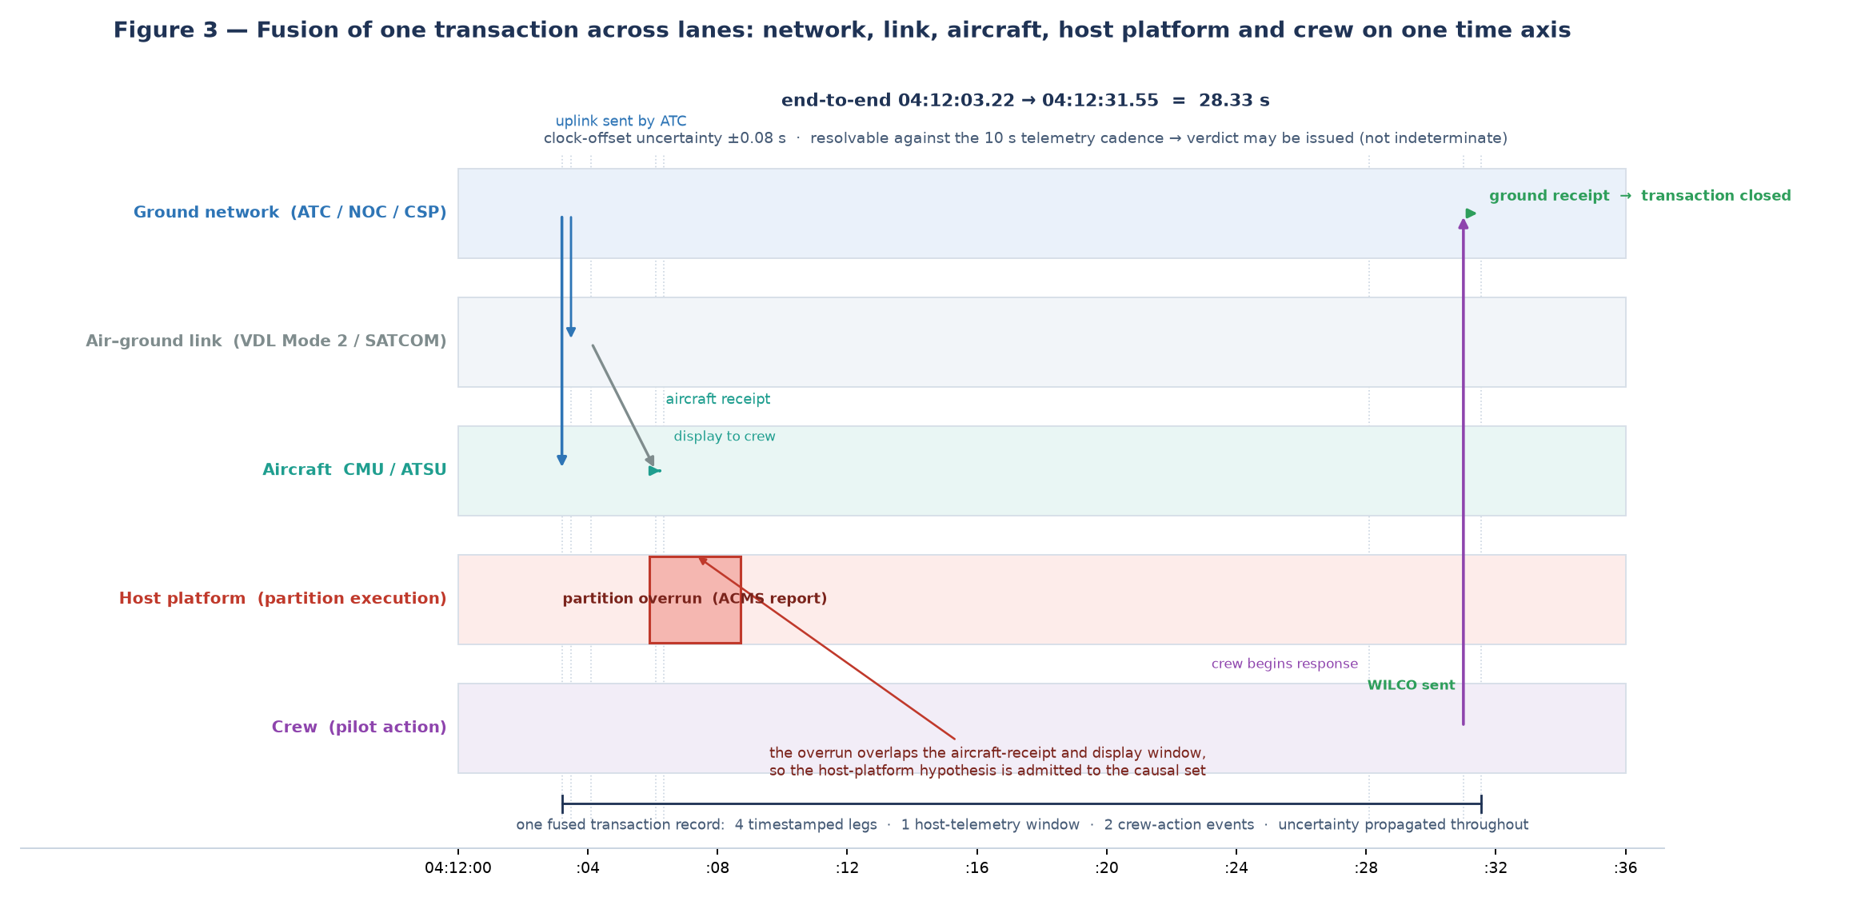
Figure 3 — Signal fusion for one uplink (worked example of Section 6). Five lanes — ground network, air–ground link, aircraft CMU, host platform and crew — are placed on one time axis with the per-leg offsets and the propagated ±0.08 s clock uncertainty visible. The two partition overruns sit inside the message-receipt and display window, which is what makes the host platform the attributable domain rather than the link.

4. Finding pattern issues and serious symptoms
Two engines, deliberately separated. The deterministic engine finds known-shape problems and is auditable. The ML engine finds unknown-shape problems and is advisory. Both map their findings back to requirement identifiers, because a finding that cannot be traced to a requirement or to a symptom class is not actionable.

4.1 Deterministic pattern library (deploy first, no training data required)
Pattern | Detection method | What it means | Action
Recurring requirement failure on one tail | Frequency count per requirement per tail over a rolling window | Systematic defect, not a transient | Maintenance action on that LRU
Co-occurrence of two requirement failures | Frequent-itemset mining over verdict vectors | One is the cause of the other (for example partition overrun always precedes response-window violation) | Reclassify the cause domain; fix the upstream one
Route- or airspace-localised failures | Geographic and route clustering of non-conformances | Airspace, ground-station or interference cause | Network escalation to the CSP or ANSP
Time-of-day periodicity | Autocorrelation and periodicity tests on non-conformance timestamps | Load or scheduling effect | Capacity or subscription change
Margin decay on a conforming requirement | Change-point detection (CUSUM / Bayesian online) on the margin time series | Degradation before failure | Scheduled maintenance before violation
Link flapping | Count of link-state and subnetwork transitions per hour | Unstable link, handover problem | Link reconfiguration or radio maintenance
Message-loss bursts | Burst detection on missing acknowledgements and aborts | Congestion or RF interference | Congestion handling or interference escalation
Crew-response clustering at the limit | Distribution shift in response times against the tail own baseline | Workload or human-factors effect, or a display problem | Training, procedure or display review
Configuration drift | Compare configuration snapshot with the certified baseline per requirement | Monitor instantiated against the wrong revision | Correct the configuration; re-run the flight
Coverage erosion | Track the not-exercised set over time per route and software load | Requirements no longer demonstrated in service | Test-case selection; coverage account report

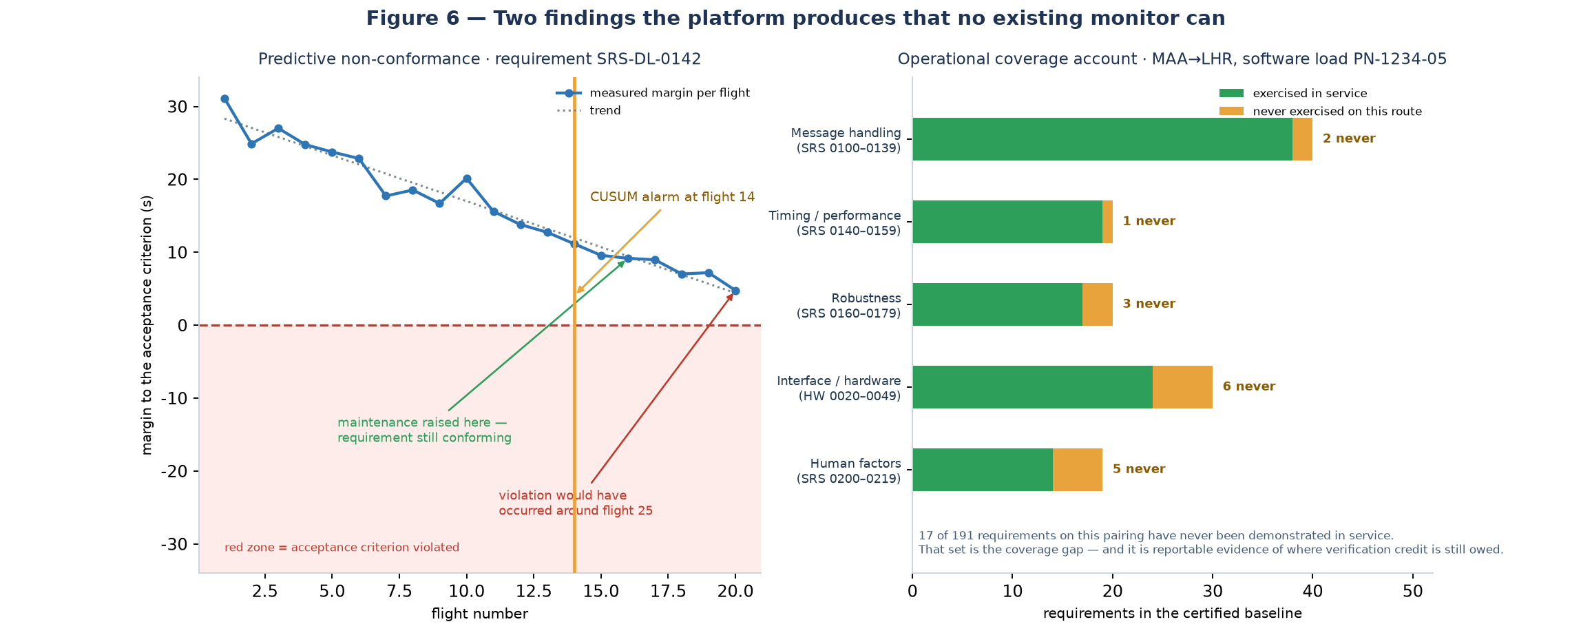
Figure 6 — Two findings this architecture produces that no existing monitor produces. Left: margin decay against an acceptance criterion, with a change-point alarm raised while the requirement is still formally conforming, and the projected violation date that motivates a maintenance action before the violation exists. Right: the operational coverage account — requirements that have never been demonstrated in service on a route and software load, which is verification credit still owed rather than evidence of health.

4.2 Machine-learning layer (advisory only, admitted through the gate)
- Unsupervised anomaly detection: isolation forest or autoencoder reconstruction error over per-transaction feature vectors, baselined per tail, per route and per time-of-day. Finds unknown-shape issues without labels.
- Sequence novelty: next-event prediction over the per-flight event sequence; a high surprise score flags an unusual order of events (for example a subnetwork switch at an unexpected phase).
- Change-point and trend models: already listed deterministically, but with learned thresholds per equipment type rather than fixed ones.
- Interference and threat signature learning: train classifiers on RF features (channel occupancy, error counters, noise floor, handover failures) collected from your own receivers and from ground-station telemetry. The label flywheel below is what makes this self-improving.
- Attribution model: given a non-conforming verdict, learn which combination of evidence distinguishes network, link, host-platform and crew causes — the learned model proposes a cause, the deterministic rule set confirms it.

4.3 The label flywheel (how "self-learning" actually happens without in-flight retraining)
- A pattern or symptom is detected and recorded as a hypothesis with its evidence.
- The hypothesis is shown to the airline engineer alongside the maintenance action it suggests.
- The engineer either confirms or rejects the action, or the maintenance finding is recorded when the LRU is removed.
- The confirmation becomes a label; the raw window that produced the hypothesis is retrieved from the object store and labelled.
- The signature or attribution model is retrained on the new labels on the ground, validated against the frozen regression corpus, and only then promoted.
- Promotion is recorded; the aircraft never receives executable changes — only advisory data.

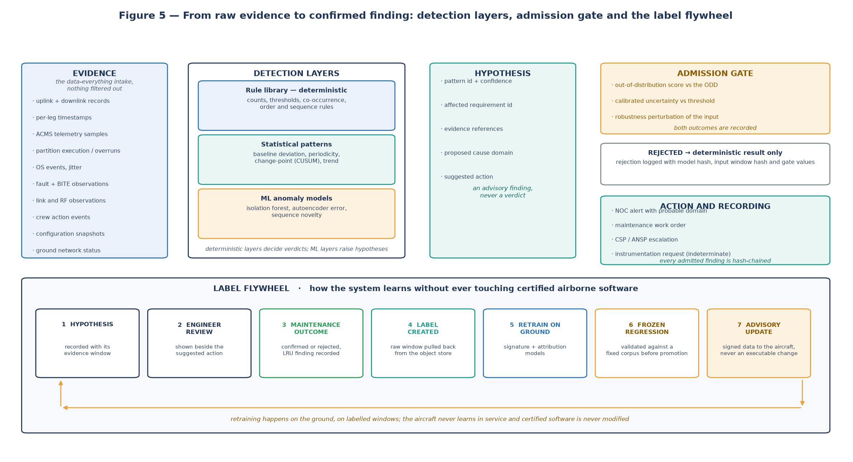
Figure 5 — Detection layers, the admission gate and the label flywheel. Rule library, statistical patterns and ML models all produce hypotheses; only the deterministic layers may set a verdict. The gate admits or rejects each AI finding on out-of-distribution, calibrated-uncertainty and robustness grounds, and records both outcomes. The flywheel turns maintenance confirmations into validated labels on the ground — the aircraft receives signed advisory data and never executable change.

4.4 Serious symptom catalogue (the escalation surface)
Symptom | Severity | Primary suspicion | Requirement class affected
End-to-end transaction beyond the operational threshold | High | Network or link | Performance / timing
Repeated transaction abort or provider abort | High | Network, CSP, or avionics handling | Functional / robustness
Missing acknowledgement / uplink not processed | Critical | Avionics handling or crew omission | Functional / crew response
Partition overrun during a transaction window | High | Host platform | Resource / timing
Watchdog or unexpected partition restart | Critical | Host platform or hardware | Robustness / availability
Subnetwork selection or handover failure | High | Interface / link | Interface
Crew response beyond the specified interval, or wrong response type | High | Human factors or display | Human factors
Message corruption or unexpected message accepted | Critical | Security / interference | Robustness / integrity
Database or software version mismatch with the certified baseline | Medium | Configuration | Configuration
Noise-floor rise localised to a region and time window | Medium | Interference | Environmental
Not-exercised requirement accumulating on a route | Medium | Coverage gap | Verification coverage

5. The live dashboard

5.1 Views (built around the flight as the unit of work)
View | Answers | Key elements
Fleet board | Which flights are being monitored right now, and which need attention | Live list of flights with tail, route, current phase, conformance chip, count of non-conforming / indeterminate / not-exercised; freshness indicator per data stream
Flight view | What is happening on this flight | Event timeline (uplinks, downlinks, switches, faults), live requirement-verdict grid by requirement group, latency and margin sparklines, symptom feed for this flight
Requirement view | Why this verdict | Acceptance criterion, measured value, margin, evidence class, the observations relied on, the rule path, the clock uncertainty, verdict history and revisions
Symptom view | What is going wrong and where | Severity-sorted symptoms with probable domain, affected requirement, suggested action, and the pattern that raised it
Coverage view | What the fleet has never demonstrated | Operational coverage account per software load and route: exercised versus never-exercised requirements, and drift over time
Equipment view | Which part or tail is drifting | Per-tail and per-part-number requirement failure rate, margin trends, maintenance history correlation

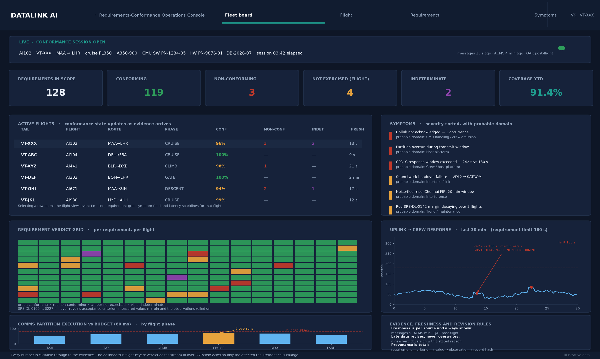
Figure 4 — The sample console (fleet board). KPI row: requirement states for the configuration in scope. Active flights: tail, flight, route, phase, conformance share, counts of non-conforming and indeterminate requirements, and the age of the freshest evidence. Requirement verdict grid: every requirement against every tracked flight, hover-revealing the criterion, the measured value and the margin. Bottom row: the uplift-to-crew-response series with the 180 s requirement limit and the 242 s event of Section 6, the comms-partition execution profile against the 80 ms budget, and the freshness and revision rules the console enforces. The interactive version is at datalink-ai/dashboard/sample_dashboard.html.

5.2 Real-time mechanics
- Transport to the browser: server-sent events for one-way live updates, plus a WebSocket channel for interactive drill-down; the browser talks only to the platform API, never directly to internal services.
- Incremental computation: the stream processor keeps per-flight keyed state so that each arriving transaction or telemetry sample updates only the affected requirement monitors and emits a verdict delta. The dashboard receives deltas, not full recomputations.
- Freshness honesty: every panel shows the last-update time and expected cadence for its source. Datalink messages are seconds old; ACMS reports are minutes old; QAR-based verdicts are post-flight and are labelled as such. Never render a post-flight value as if it were live.
- Revisions: late data re-opens a verdict and publishes a new version; the dashboard shows the previous verdict greyed out with the reason for revision.
- Provenance: every number is clickable through to the evidence and to the raw record hash, so an engineer or an auditor can always reach the source.

5.3 Suggested technology stack (boring on purpose)
Layer | Choice | Why this one
Bus | Kafka (or Redpanda) | Replayable, per-source retention, mature connectors
Stream processing | Flink (or Kafka Streams) | Keyed per-flight state, watermarks, exactly-once into stores
Hot analytics store | ClickHouse (or TimescaleDB) | Fast time-series and per-requirement aggregation at fleet scale
Session state | Redis | Live per-flight state for the dashboard
Metadata and ledger | PostgreSQL, append-only hash-chained table | Requirement baseline, configuration snapshots, conformance records
Object store | S3-compatible | Raw messages and QAR extracts, policy-limited retention
API | FastAPI or Node | REST plus SSE and WebSocket
Dashboard | React with a time-series charting library; Grafana for internal operations | Product dashboard needs provenance and drill-down, which generic tools do poorly
Identity | OIDC with per-airline tenancy and role separation | Data rights and audit requirements

5.4 Scale reality check
A 500-aircraft airline produces on the order of 50–100 datalink messages per flight (tens of thousands per day) plus ACMS report samples, and roughly 5 million telemetry samples per day if you sample at 1 Hz for a three-hour flight. That is a small workload for the stack above — a single Kafka cluster and a single ClickHouse node with modest resources. The engineering difficulty is not volume; it is clock alignment, source latency and data rights. Plan the team around those three, not around scale.

6. Full end-to-end worked example: flight AI102, one uplink, one defect, every number
This section follows one flight from the first ATC uplink of a cruise sector to the closed, signed conformance record. The numbers are illustrative but internally consistent, and they are the same numbers shown in Figures 3, 4 and 6 and in the interactive mock-up, so the reader can move between the narrative, the figures and the sample console without re-deriving anything. Nothing in this example depends on data that a certified aircraft does not already produce; what it depends on is the willingness to collect all of it and to keep the provenance.

6.1 The scenario
Item | Value
Flight / tail | AI102 · VT-XXX · A350-900 · MAA → LHR · approximately 3 h 10 min
Observed window | 8 October 2026, cruise FL350, session 03:42 elapsed at the moment of the defect
Certified configuration | CMU software PN-1234-05 · CMU hardware PN-9876-01 · database DB-2026-07 · modem VDL2 + SATCOM · subscription ATN-B1 / FANS-1A
Requirement baseline in scope | 128 requirements instantiated for this configuration, each with its own acceptance criterion, tolerance and evidence class
Data sources contributing | CSP message feed (1–30 s), ACMS programmable reports (seconds to minutes), OEM partition-health events reported through the ACMS route, ANSP/ground-network status, own SDR receivers (VDL2/ACARS/ADS-B), QAR offload at the gate
Clock handling | Every leg carries its source and offset; the aircraft-to-ground offset for this leg is estimated by round-trip pairing with a propagated uncertainty of ±0.08 s
Outcome | 1 non-conforming requirement attributable to the host platform, 1 further non-conforming resource requirement, 1 indeterminate pair pending the QAR offload, 2 not-exercised requirements, and a maintenance action raised while the aircraft was still in the air

6.2 What actually arrived during the sector
Source | What arrived | Age on the dashboard | How it was used
CSP message feed | Every uplink and downlink for the flight, with per-leg timestamps where the provider supplies them; the transaction of Section 6.3 among them | 1–30 s | Message-flow, crew-response and end-to-end timing verdicts
ACMS programmable reports | Communications LRU status, counters, timing samples and fault flags at report cadence, including the two partition-health events of this sector | 4 min at the time of the event | Host, resource and fault verdicts in flight
ANSP / ground network status | Ground-station and subnetwork state; used to prove the link was clean during the window | Seconds to minutes | Attribution: rules out the network as the cause
Own SDR receivers | Independent VDL2/ACARS observations and a noise-floor baseline for the Chennai FIR | Live | Corroboration, and the interference baseline for the threat-model work
QAR offload at the gate | Full-rate parameters for the whole flight, arriving minutes after gate | Post-flight | Authoritative confirmation of the partition timeline and the margin baseline for the trend
Configuration snapshot | Tail configuration record for the day: software, hardware, database, modem, subscription | On change | Instantiation of the 128 requirement monitors against the correct baseline

6.3 One uplink, six independent observations
At 04:12:03.22 UTC an ATC uplink is issued. Six independent observations of that single transaction are collected from four different sources. The measured crew-response interval is 28.33 s on the message-feed arithmetic — comfortably inside the 210 s operational limit — and it is the partition timeline, not the radio, that later turns the same transaction into a defect.
Offset | Observation | Source | Note
0.00 s | Uplink issued at the ground station | CSP feed | transaction T-2026-10-08-4f9a opens; content hash 9c1f…b47e
+03.48 s | Ground-station egress recorded | ANSP / ground network status | the network leg is normal for this station
+06.10 s | Aircraft receipt confirmed at the CMU | CSP message feed | message is on the aircraft 6.10 s after issue
+06.4 s | Partition overrun 1 begins (71.4 ms against an 80 ms budget) | OEM partition-health event | overlaps message receipt and display — this is the anomaly
+07.2 s | Partition overrun 2 begins | OEM partition-health event | second overrun closes the sequence; both inside the window 04:12:05.9–08.7
+28.10 s | Crew begins handling the message | Crew action events | the message sat in the host queue for the first 21 s
+31.00 s | WILCO transmitted by the crew | Downlink record | correct response type
+31.55 s | Ground receipt of the response | Ground network status | round trip measured at 28.33 s against the 210 s operational limit — conforming, uncertainty ±0.08 s
+242 s | Response decision completes beyond the 180 s criterion | Fused timeline | requirement SRS-DL-0142 rev C is non-conforming, margin −62 s

6.4 What the verdict engine concluded
Each verdict is decided by the executable monitor compiled from the requirement itself, and each carries the criterion, the measured value, the margin, the evidence class and the observations relied on. This is the product: not a score, but an auditable per-requirement statement.
Requirement | Class | Acceptance criterion | Measured | Margin | Verdict
SRS-DL-0142 rev C | Timing / performance | Crew response to a CPDLC uplink ≤ 180 s (95th percentile) | 242 s | −62 s | NON-CONFORMING
SRS-DL-0131 rev D | Resource / partition | No partition overrun inside a transmit window; execution ≤ 80 ms budget | 2 overruns; 71.4 ms peak | budget 80 ms | NON-CONFORMING
SRS-DL-0107 rev B | Functional | Every uplink acknowledged and the acknowledgement received on the ground | 1 occurrence of no acknowledgement | — | NON-CONFORMING
SRS-DL-0140 rev C | Timing / performance | End-to-end uplink delivery ≤ 210 s operational limit | 28.33 s (p95 in window 41 s) | +181.7 s | CONFORMING
SRS-DL-0118 rev C | Functional | Correct routing of a downlink to the addressed addressee | 100 % (412 routed, 0 misrouted) | full margin | CONFORMING
HW-0031 rev B | Hardware | CMU hardware PN matches the certified configuration for the database in use | PN-9876-01 matches | exact match | CONFORMING
SRS-DL-0155 rev B | Interface | Subnetwork handover completes within 45 s without message loss | loss suspected, timing not resolvable on live feeds | unknown | INDETERMINATE
SRS-DL-0156 rev A | Interface | Handover shall not corrupt message sequencing | sequence gap observed, no QAR yet | unknown | INDETERMINATE
SRS-DL-0173 rev B | Robustness | CMU recovers from a fault without operator action | not triggered on this route | — | NOT-EXERCISED
SRS-DL-0204 rev A | Human factors | Crew workload indicator within band during high message rate | message rate never exceeded 4 per 10 min here | — | NOT-EXERCISED

Why INDETERMINATE matters here: the handover loss cannot be resolved from live feeds alone, and the platform says so instead of guessing. The verdict triggers an instrumentation request rather than a false alarm, and it will be re-decided when the QAR extract lands. Two of the four verdict states exist precisely so that the platform never has to lie.
One arithmetic detail that the dashboard is careful about: the KPI row counts distinct requirement IDs across the tracked flights in the window (128 in scope, 119 conforming, 3 non-conforming, 4 not-exercised, 2 indeterminate), and coverage year to date (91.4 %) is the share of those requirements that have at least one in-service demonstration this year; the per-flight column counts occurrences on that flight. A requirement that is non-conforming on two flights is still one requirement ID — otherwise the fleet totals would be inflated by exactly the kind of double counting that makes real monitoring programmes untrustworthy.

6.5 What the AI proposed, and what the admission gate did with it
- Accepted hypothesis. The sequence-novelty model flagged the combination "partition overrun inside the message-transmit window, with the link otherwise clean" and proposed the cause domain HOST_PLATFORM. The deterministic rule stall_overlap+clean_link reached the same reading from the partition telemetry, so the finding was admitted and the verdict was set by the rule — the model raised the hypothesis, it did not write the verdict.
- Rejected hypothesis. A link-degradation model proposed VDL2 interference as the cause of the delay. The admission gate scored the input window as out-of-distribution for that model and the uncertainty as uncalibrated for this regime, so the finding was rejected and logged with the model hash, the input-window hash and the gate values. The rejection is evidence in the ledger, not a silent discard.
- Counterfactual used for attribution. The same message flow on VT-ABC earlier in the week completed in 34 s end to end on a comparable sector, which is what allows the platform to say the host, and not the radio, is the attributable domain. Counterfactuals like this are a first-class output of the fleet-scale design, not an analyst exercise.
- Cause domain. HOST_PLATFORM, with the link, the ground network and the crew response type each independently ruled out by evidence.

6.6 From finding to action
- NOC alert with probable domain and the requirement IDs involved, raised while the aircraft was still at cruise; the operations team sees a symptom with a domain, not an unexplained spike.
- Maintenance work order against the CMU host partition, attached to the two overrun events and the affected transaction, so the engineer receives the evidence rather than the summary.
- Trend watch opened on SRS-DL-0142 for this tail: the margin for the same requirement has been decaying across the last three flights, and the change-point alarm in Figure 6 (left) is what converts a single exceedance into a maintainable defect.
- Instrumentation request for the two indeterminate interface requirements, so that the next occurrence of a handover is resolvable with the evidence class the requirement actually demands.
- Coverage accounting: the two not-exercised requirements on this route are added to the coverage account rather than being reported as healthy, and the account (Figure 6, right) is what an authority, an airline or an auditor can be shown.

6.7 Flight closure: the signed, hash-chained conformance record
At gate, the platform closes the flight: the verdicts are finalised against the QAR extract, the evidence references are sealed, and the record is appended to the ledger. Late data that arrives after closure does not overwrite the record — it creates a new version with a stated reason, and the previous version remains readable.
{
"record_id": "CFR-2026-10-08-AI102-v3",
"flight": "AI102", "tail": "VT-XXX", "date": "2026-10-08",
"aircraft_config": { "cmu_sw_pn": "PN-1234-05", "cmu_hw_pn": "PN-9876-01",
"database": "DB-2026-07", "modem": "VDL2+SATCOM" },
"requirement_baseline_rev": "R2026.07",
"summary": { "in_scope": 128, "conforming": 119, "non_conforming": 3,
"not_exercised": 4, "indeterminate": 2 },
"findings": [
{ "requirement_id": "SRS-DL-0142", "rev": "C", "verdict": "NON-CONFORMING",
"measured": "242 s", "limit": "180 s", "margin": "-62 s",
"cause_domain": "HOST_PLATFORM", "rule": "stall_overlap+clean_link",
"observations": ["T-2026-10-08-4f9a","OVR-1042","OVR-1043"],
"verdict_version": 3, "revised_reason": "partition events arrived after CSP-only evaluation" },
{ "requirement_id": "SRS-DL-0131", "rev": "D", "verdict": "NON-CONFORMING",
"measured": "2 overruns / 71.4 ms peak", "limit": "0 overruns / 80 ms budget" },
{ "requirement_id": "SRS-DL-0107", "rev": "B", "verdict": "NON-CONFORMING",
"measured": "1 unacknowledged uplink", "limit": "0 occurrences" },
{ "requirement_id": "SRS-DL-0155", "rev": "B", "verdict": "INDETERMINATE",
"instrumentation_request": "IR-2026-1104" } ],
"coverage_credit": { "never_exercised_on_route": ["SRS-DL-0173","SRS-DL-0204"] },
"evidence_root": "sha256:9c1f...b47e",
"prev_record_hash": "sha256:0b7d...31aa",
"signature": "ed25519:...",
"closed_at": "2026-10-08T10:41:12Z"
}

That record is the artefact an airline shows to an authority, a lessor, an insurer or an OEM — and it is reconstructible from raw evidence by deterministic replay, because the verdict engine has no model in it.

6.8 Late data revises the verdict — the version history of one requirement
Version | When | Evidence available at that moment | Verdict | Reason recorded
v1 | t + 40 s | CSP message feed only | INDETERMINATE — the response interval is measurable but the cause is not attributable | Insufficient evidence class for the criterion; flight still in progress
v2 | t + 4 min | CSP feed plus the ACMS partition-health report | NON-CONFORMING, margin −62 s, cause HOST_PLATFORM | Partition overruns arrived and overlap the exhibit window; rule stall_overlap+clean_link fired
v3 | t + 3 h (gate) | QAR full-rate extract confirms the partition timeline and the crew-response interval | NON-CONFORMING confirmed; margin baseline recorded for the trend | Authoritative post-flight evidence; no change to the verdict, margin confirmed

Three versions, three stated reasons, one requirement. Any downstream consumer — the dashboard, a weekly report, an investigation — can see exactly which evidence produced which verdict, which is the property that makes late-arriving aviation data survivable.

6.9 The same flight on a message-feed-only platform
Question | Message-feed-only monitoring | This architecture
Was the uplink delivered? | Yes — 28.33 s round trip, conforming | Yes, and confirmed against the 210 s operational limit with uncertainty stated
Did the crew respond in time? | Visible only as a late WILCO, with no cause | Non-conforming with a −62 s margin, attributable to the host platform
Was the radio at fault? | Cannot be answered | Ruled out: clean link, no handover in the window, plus the VT-ABC counterfactual
Was a partition overrunning? | Invisible | Two overruns captured and correlated to the transaction window
Which requirements have never been exercised on this route? | Not modelled | Coverage account: 17 of 191 on the route and software load, reportable
Could maintenance act before the next flight? | No | Work order and trend watch raised while the aircraft was at cruise

6.10 What this single example demonstrates
- Verdict depth follows data depth, and the architecture states which depth it is operating at rather than pretending to a single number.
- The AI proposed, the rule decided, and the gate recorded both an accepted and a rejected hypothesis — the separation that keeps the output defensible.
- Provenance is end-to-end: every verdict resolves to a criterion, a measured value, a margin, an evidence class, the observations relied on and a raw record hash.
- Arithmetic that would be unsupportable was simply not claimed: two requirements are indeterminate and two are not exercised, and neither is dressed up as health.
- The commercial artefact — the signed conformance record — is a by-product of the pipeline, not a reporting project bolted on afterwards.

7. Reading the sample dashboard, and replacing the mock-up with real data
Figure 4 and the interactive mock-up are the same console. The mock-up is a single self-contained HTML file with no external dependencies, so it runs anywhere:
# from the repository root
python3 -m http.server 8100 --directory datalink-ai/dashboard
# then open http://localhost:8100/sample_dashboard.html

Every number in it is illustrative and internally consistent with Section 6. The console is deliberately built around the flight as the unit of work, because that is how an airline operations and engineering organisation actually thinks.

7.1 Panel by panel
Panel | What it shows | Live, cached or post-flight | What to click
Session strip | The flight currently opened, its tail, route, configuration and session age | Live; source ages shown separately | —
KPI row | Requirement states for the configuration in scope, plus coverage year to date | Live, updated by verdict deltas | A card filters the grid to that state
Active flights | Every tracked flight with phase, conformance share, counts of non-conforming and indeterminate requirements, and the age of the freshest evidence | Live; the freshness column is honest per source | A row opens the flight view
Requirement verdict grid | Every requirement against every tracked flight — the fastest way to see whether a defect is a one-off or a pattern | Live | A cell reveals the criterion, measured value, margin, evidence class and observations
Uplink → crew response | The response-time series with the requirement limit and the exceedance event | Live from the message feed | The event marker opens the transaction record
Comms partition execution | Execution against the partition budget by flight phase, with overruns marked | In flight from ACMS; confirmed post-flight by QAR | A bar opens the partition evidence
Symptoms | Severity-sorted symptoms with the probable domain and, on the detail page, the requirement IDs implicated | Live | A symptom opens its evidence and suggested action
Coverage | Exercised versus never-exercised requirements per route and software load, and the trend | Post-flight, computed as flights close | A group opens the never-exercised list
Equipment | The tail and part-number configuration register, with drift against the fleet baseline | On change | A row shows the requirements whose monitors depend on that configuration

7.2 How to replace the mock with real data
Panel | Feeds from | Pipeline source | Latency to expect
Active flights and session strip | OPS flight feed plus configuration database | S9 + S1 | Seconds
Requirement verdict grid and KPIs | Verdict engine output, streamed as deltas | verdicts.requirement topic | Seconds for message-based requirements; minutes for ACMS-based; post-flight for QAR-based
Uplink → crew response series | Normalised transaction records | norm.transactions | Seconds to tens of seconds, per source latency
Partition execution panel | ACMS partition and health events | raw.acms.reports → norm.telemetry | Report cadence (minutes), authoritative after QAR
Symptoms | Pattern engine and symptom rules | alerts.symptoms | Seconds, bounded by the AI admission gate
Coverage | Compliance and ledger stores | verdicts.requirement + ledger | Flight closure, then continuously

7.3 The ten-second demo script
- Open on the fleet board: six flights tracked, one tail showing a live non-conformance while it is still in the air.
- Open AI102: the event timeline shows the uplink, the two partition overruns inside the receipt window, and the 242 s response against the 180 s criterion.
- Click the exceeded requirement: the criterion, measured value, margin, evidence class and the observations relied on appear, with the raw record hash.
- Show the two indeterminate requirements and the instrumentation request they raised — the platform refusing to guess is the credibility moment.
- Switch to the symptoms panel: a server-side finding with a probable domain and a work order, raised from a flight in progress.
- Close on the coverage account: 17 of 191 requirements never demonstrated on this route and load, which is what no current certificate tracks.

7.4 The honesty rules the console enforces
- Freshness per source. Datalink messages are seconds old, ACMS reports minutes old, QAR-based values are post-flight and labelled as such. A post-flight number is never rendered as if it were live.
- Revision, not overwrite. Late evidence creates a new verdict version with a stated reason; the previous verdict remains visible.
- Total provenance. Every displayed number resolves to a criterion, a measured value, an observation set and a record hash.
- No AI verdicts. Panels that show conformance show the deterministic engine output; AI output appears in the symptom and hypothesis surfaces, marked as advisory.
- Tenancy and data rights. Per-airline isolation, content minimisation and access logging are design constraints of the serving layer, not deployment options.

8. Benefits and the business case: who gains, how much, and how much can be earned
This section answers three questions that a technical document normally dodges. First, what does the platform actually do for the two parties that pay for it — the airline that flies the aircraft and the OEM whose datalink product is on board, for example Honeywell Aerospace? Second, what is that worth in money, and how would we know? Third, how much can the platform owner earn from it? Every figure below is an indicative planning estimate for 2026–2028, order of magnitude only, and every one of them is an assumption to be validated by customer interviews — not a forecast. What is not soft is the mechanism: each benefit line below traces back to something this architecture already produces, and Section 6 shows the whole chain running on one flight.
The one-sentence version: the platform sells evidence. Evidence that a defect exists (which the airline needs), evidence that a product failed in a specific way in a specific configuration (which the OEM needs), and evidence that a requirement was or was not met in service (which both need, and which nobody currently produces). Failure prediction and early detection are not extra features bolted on — they are what you get when the same evidence stream is retained, aligned and attributed.

8.1 Two capabilities the customer feels directly
Capability | What it means mechanically | Why it is new
Prediction of datalink product internal failure | Partition execution against budget, overrun counts, jitter, queue depth, watchdog and fault events and re-instantiation counts are tracked per tail, per software load and per database revision. Change-point detection (CUSUM) and margin decay against the acceptance criterion produce an alarm while the requirement is still formally conforming, and a projected date of violation. A physical root cause is then bounded by maintenance, and the confirmation or rejection becomes a label. | Existing health monitoring flags a threshold when it is crossed, or reports after a flight. Margin decay against a requirement, on the aircraft trailing the fleet, with the evidence attached, is what turns "conforming with little room left" into a scheduled action instead of an AOG. Figure 6 (left) is this exact finding.
In-service issues identified before the customer reports them | A defect is detected server-side at the moment the evidence arrives — a loss burst, an unacknowledged uplink, a partition overrun inside a transmit window, a handover failure cluster in one airspace — and reaches engineering with the transaction, the timestamps and the raw record hash, often while the aircraft is still in the air. The customer learns about the defect from the platform, not from a crew report, a delay or a complaint. | Today the OEM learns about most intermittent comms behaviour from the customer, weeks or months later, usually as a support ticket that says "the datalink misbehaved" with no synchronised timestamps and no way to tell avionics from radio from crew. This platform reverses the direction of that information flow, which is the single largest commercial benefit in the whole idea.

The two capabilities are the same pipeline read at different time scales: early detection is the same syndrome found at the moment it occurs; prediction is the same syndrome recognised in its trend before it becomes an occurrence. Both are only possible because the platform keeps the requirement, the configuration and the raw evidence together — which is the invention.

8.2 Benefit to the airline (the operator)
Benefit | Mechanism in this platform | Where it shows up in operations
In-service issues found in hours, not weeks | Server-side detection from the message feed, ACMS reports and partition events, with the evidence attached | Engineering works a defect on the day it occurs, with the transaction in hand, instead of opening a ticket after the crew reports it
Fewer no-fault-found removals and bench-test-goods | The evidence pack that travels with the removal states the requirement, the measured value, the margin and the configuration, so the shop reproduces the conditions | No-fault-found is typically one of the largest avoidable line-maintenance costs; every avoided removal avoids the labour, the logistics and a spare
Less engineering, audit and warranty effort | Conformance records, coverage accounting and evidence packages are produced by the pipeline | Reliability engineering time moves from collecting data to acting on it; warranty claims arrive evidence-backed rather than as goodwill swaps
Protected disruption risk (the reason airlines buy) | Early detection of degradation on the aircraft that is behind the fleet, before it fails in service | One avoided AOG or diversion typically costs less than years of subscription; the product is sold against the tail risk, not the average
Targeted upgrades and retrofits | Configuration drift is explicit: which tail, which software load, which database revision, which modem | A campaign reaches only the tails that need it, which is what makes it affordable and keeps aircraft in service
Route and airspace intelligence | Link, handover and noise-floor patterns localised by airspace and time window | Procurement, network planning and ANSP conversations get evidence instead of anecdote

8.3 Benefit to the OEM / supplier, for example Honeywell Aerospace
Benefit | Mechanism in this platform | Commercial consequence
In-service issues identified before the customer reports them | Fleet-wide patterns across tails and configurations, in days, with synchronised timestamps and raw evidence attached | Support and engineering are already looking at the problem when the customer first mentions it, which changes the conversation from defence to diagnosis
Warranty and no-fault-found cost reduced | A removal is attributed to a partition, a modem, a database revision, the radio or the crew — not to a part number alone | Warranty boards spend less on removals that test good; the credibility of a warranty decision improves because it is evidence-backed
Root cause bounded, exposure smaller | The affected population is identified by software load, hardware part number and database revision | A fix is limited to the affected configuration instead of being issued as a blanket service bulletin across the fleet
Support load deflected, campaigns targeted | A share of technical-support cases becomes platform-detected events with evidence; upgrades reach the right tails | Support capacity is released, and campaign cost per aircraft falls while compliance improves
A new revenue line on the same contract | Reliability intelligence is delivered alongside the existing maintenance and support agreement | A services line with high margin and no new hardware on the aircraft, and a data asset that grows with the installed base
Protection of the product reputation | A defect is found, explained and bounded by the OEM rather than discovered by an airline in public | In a segment where the customer talks to competitors, being first to find your own defect is worth more than the engineering cost of finding it

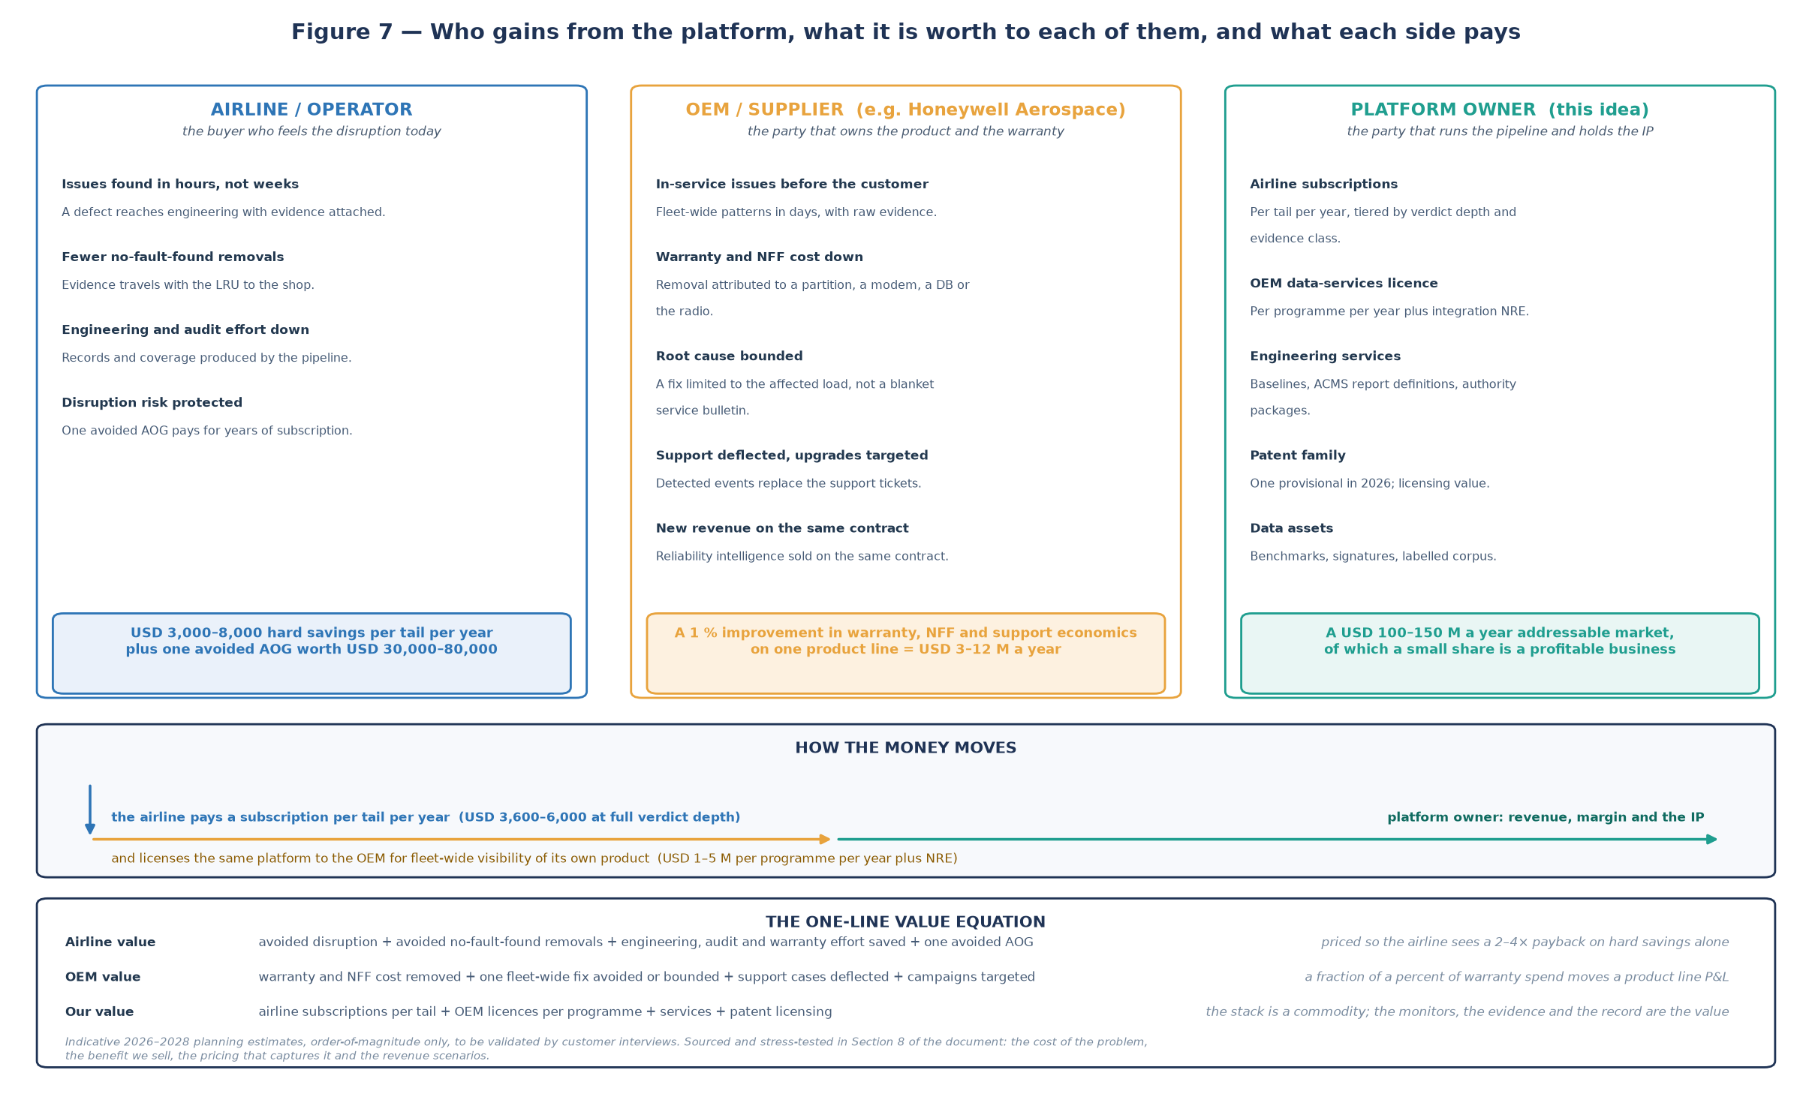
Figure 7 — Who gains, what it is worth to each party, and what each side pays. All figures are indicative planning estimates for 2026–2028, to be validated by customer interviews (see 8.7–8.10).

8.4 Prediction of datalink product internal failure — the mechanism in detail
Prediction here means three concrete things, each of which the architecture already produces:
- Margin decay versus the acceptance criterion. Every conformance verdict carries a margin. Tracking that margin per tail, per software load and per route, and detecting a change point, gives an alarm while the requirement is still conforming — the finding in Figure 6 (left), where the alarm is raised at flight 14 and the violation would otherwise have arrived around flight 25.
- Resource-exhaustion signatures. Partition execution against budget, overruns inside transmit windows, jitter, queue depth and watchdog events are the leading indicators of host-platform degradation. Two overruns inside one transmit window are not yet a customer-visible failure; they are the signature that precedes it, and Section 6 shows them being captured in flight.
- Configuration-bounded failure populations. The same measurement is conforming on one software load and non-conforming on another. Attributing a pattern to a load, a modem or a database revision is what turns "the datalink is unreliable" into "this build misbehaves on this database, on these tails" — which is the statement an OEM can act on.
The commercial point is that prediction here is not a model making a guess; it is a deterministic comparison against the requirement, with the model only proposing what to look at. That is why the output can be trusted by an engineering organisation, and why a prediction that proves wrong is itself recorded and fed back through the flywheel in Figure 5.

8.5 Getting in front of the customer: what early detection is actually worth
Issue class | How the OEM hears about it today | How this platform surfaces it | Typical lead time gained
Intermittent message loss on one software load | Support tickets and field reports, weeks to months after the first occurrence | Loss-burst pattern on one load across several tails, within days; the affected transactions are attached | Weeks to months
Partition overrun / resource exhaustion | Usually after a customer-visible failure, sometimes after an AOG | Overrun trend against the partition budget, in flight, with the transmit-window correlation | Weeks
Modem or database interaction defect | Discovered when a specific combination misbehaves, then reconstructed by hand | Configuration-drift correlation: which tails moved to the new database and what changed in their verdicts | Weeks
Subnetwork handover failures | ANSP tickets and anecdote, aggregated by nobody | Handover-failure clustering by airspace and time window, counted and attributed | Weeks
Interference blamed on the product | Often attributed to the avionics first because nothing else is visible | Own-receiver noise-floor baseline and independent RF observations, which move the attribution off the product | Immediate to days, and it protects warranty spend
Requirements no longer exercised in service | Not visible at all today; nobody tracks it | Operational coverage account, continuous, by route and software load | A capability that does not exist today

8.6 How the benefits are proved (and why this matters for the sale)
Every benefit line above is measurable, and the pilot should be bought against measurements, not promises. The platform produces its own baseline because it records why each verdict changed.
Metric | Baseline: measure in week 1 of the pilot | Target by month 6
Share of comms issues detected by the platform before any crew, OCC or customer report | near zero today — this is the problem being sold | ≥ 60 % of detected issues
Median time from occurrence to engineering-visible evidence | days to weeks | under 15 minutes for message-class requirements, under 1 hour for ACMS-class
No-fault-found rate on the monitored LRU | current shop rate | 20 % relative reduction
Repeat faults, same requirement and same tail within 30 days | current rate | 30 % relative reduction
Support cases raised by the airline on the monitored system | current volume | 20 % relative reduction
Requirements with an evidence-complete, ledgered record per flight | effectively 0 of 128 | ≥ 90 % of in-scope requirements
OEM: mean time to root cause on a fleet-reported issue | weeks | 40 % relative reduction
Coverage account produced and accepted | does not exist | per route and software load, monthly

If the pilot cannot move the first two rows, the product should not be sold. If it moves them, the commercial case below is arithmetic rather than ambition.

8.7 What the benefits are worth in money (per 500-aircraft operator, per year)
Benefit line | Conservative | Base case | Basis of the estimate
Avoided disruption and in-service detection value | USD 0.5 M | USD 2.0 M | A few avoided delays, diversions or cancellations attributable to comms, plus the engineering time saved by evidence arriving with the fault instead of after it
No-fault-found removals avoided | USD 0.3 M | USD 1.2 M | 20–30 % of removals test good; a removal and refit cycle with logistics and a spare typically costs USD 5,000–15,000, and 20–40 removals a year per 500-tail fleet are plausible
Engineering, audit and warranty effort saved | USD 0.2 M | USD 0.6 M | Two to four full-time equivalents moved from data collection and claim assembly to engineering work
Avoided AOG / diversion (tail risk) | USD 0.4 M | USD 1.2 M | One to five events a year at USD 30,000–80,000 each; this line alone is why operators buy reliability products
Total hard benefit per year | USD 1.4 M | USD 5.0 M | Before counting the intangible: fewer customer-reported defects and a stronger warranty position
What the airline pays (list price) | USD 1.8 M | USD 3.0 M | 500 tails at USD 3,600–6,000 per tail per year, depending on verdict depth
What the airline pays (OEM-sponsored structure) | USD 0.9–1.3 M | USD 1.8–2.4 M | Where the OEM funds 30–60 % of the subscription out of its own warranty and support savings, which is the structure that closes deals in a conservative year

Read the table honestly: at list price, hard savings alone justify the subscription only in the base case. In the conservative case the deal is closed either by the OEM part-funding the subscription out of its own savings, or by the tail-risk argument — one avoided AOG and the year is paid for. This is why the OEM line in Figure 8 is the fastest route to profitability: the OEM saves money on the same evidence, with no new hardware and no change to the aircraft.

8.8 What it is worth to the OEM (per programme, per year)
OEM benefit line | Basis of the estimate | Indicative range
Warranty and no-fault-found cost removed | 1–3 % of warranty spend on a communications product line, where a line of this kind can carry USD 20–60 M of warranty cost per year in the installed base | USD 0.5–2.0 M
Support cases deflected | 15–30 % of technical-support volume at a fully-loaded cost per case | USD 0.3–1.0 M
Fleet-wide fixes avoided or bounded | One service bulletin or fleet-wide retrofit avoided, or a population-limited fix instead of a fleet-wide one; a single fleet action can cost USD 0.5–3 M | USD 0.2–1.0 M
Upgrade campaigns targeted | Fewer, better-targeted upgrades, plus pull-through of the upgrade itself | USD 0.2–0.5 M
New services revenue to the OEM customer base | Reliability intelligence sold alongside the maintenance agreement | USD 0.5–2.0 M
Total OEM benefit |  | USD 1.7–6.5 M
Licence cost to the OEM | Priced below the benefit so the OEM retains most of the value | USD 1–5 M per programme per year plus NRE

Note what is deliberately absent from this list: nothing requires new avionics, a new STC, or a change to the certified product. The platform consumes data the aircraft already produces. That is what makes the OEM conversation about a data-services agreement rather than an engineering programme — and it is also why the OEM can move quickly.

8.9 How much we can earn: the pricing model
Revenue line | Unit | Price | Notes
Airline subscription, tier A | Per tail per year | USD 3,600 | Message feed, ground network, own receivers: message-flow, crew-response and network verdicts
Airline subscription, tier B | Per tail per year | USD 4,800 | Adds ACMS reports: host, resource and fault verdicts in flight
Airline subscription, tier C | Per tail per year | USD 6,000 | Adds partition and QAR depth, coverage account and the full conformance record
OEM data-services licence | Per programme per year | USD 1–5 M | Fleet-wide visibility of the OEM product across customer airlines, plus NRE for integration
Engineering services | Per engagement | USD 150–400k | Requirement baselines, ACMS report definitions, authority evidence packages, fleet onboarding
Patent licensing / defensive value | Per licensee | Not modelled as a product | The lead family and the coverage-account family are the licensing hook; value here is optionality, not revenue
Gross margin at scale | 70–80 % | Cost to serve one more tail is a few dollars a month of infrastructure; the expensive parts are data rights and people, not compute

8.10 Revenue scenarios and what it costs to get there
Scenario | Assumes | Annual revenue at maturity | Cost to run | Position
Conservative (year 3) | One airline, 300 tails, one OEM programme, services ramp | USD 2.9 M | USD 0.9–1.2 M | Proves the mechanism and the pricing; roughly break-even including sales and legal
Base (year 3–4) | 1,200 tails across two airlines, two OEM programmes | USD 11.4 M | USD 2.5–3.5 M | Profitable, with EBITDA around USD 3–5 M; the OEM line is already half the revenue
Upside (year 4) | 3,000 tails, four OEM programmes, patent licensing | USD 36.5 M | USD 5–7 M | The reasonable ceiling of this idea if both the airline and the OEM sides land, against an addressable market of roughly USD 100–150 M a year

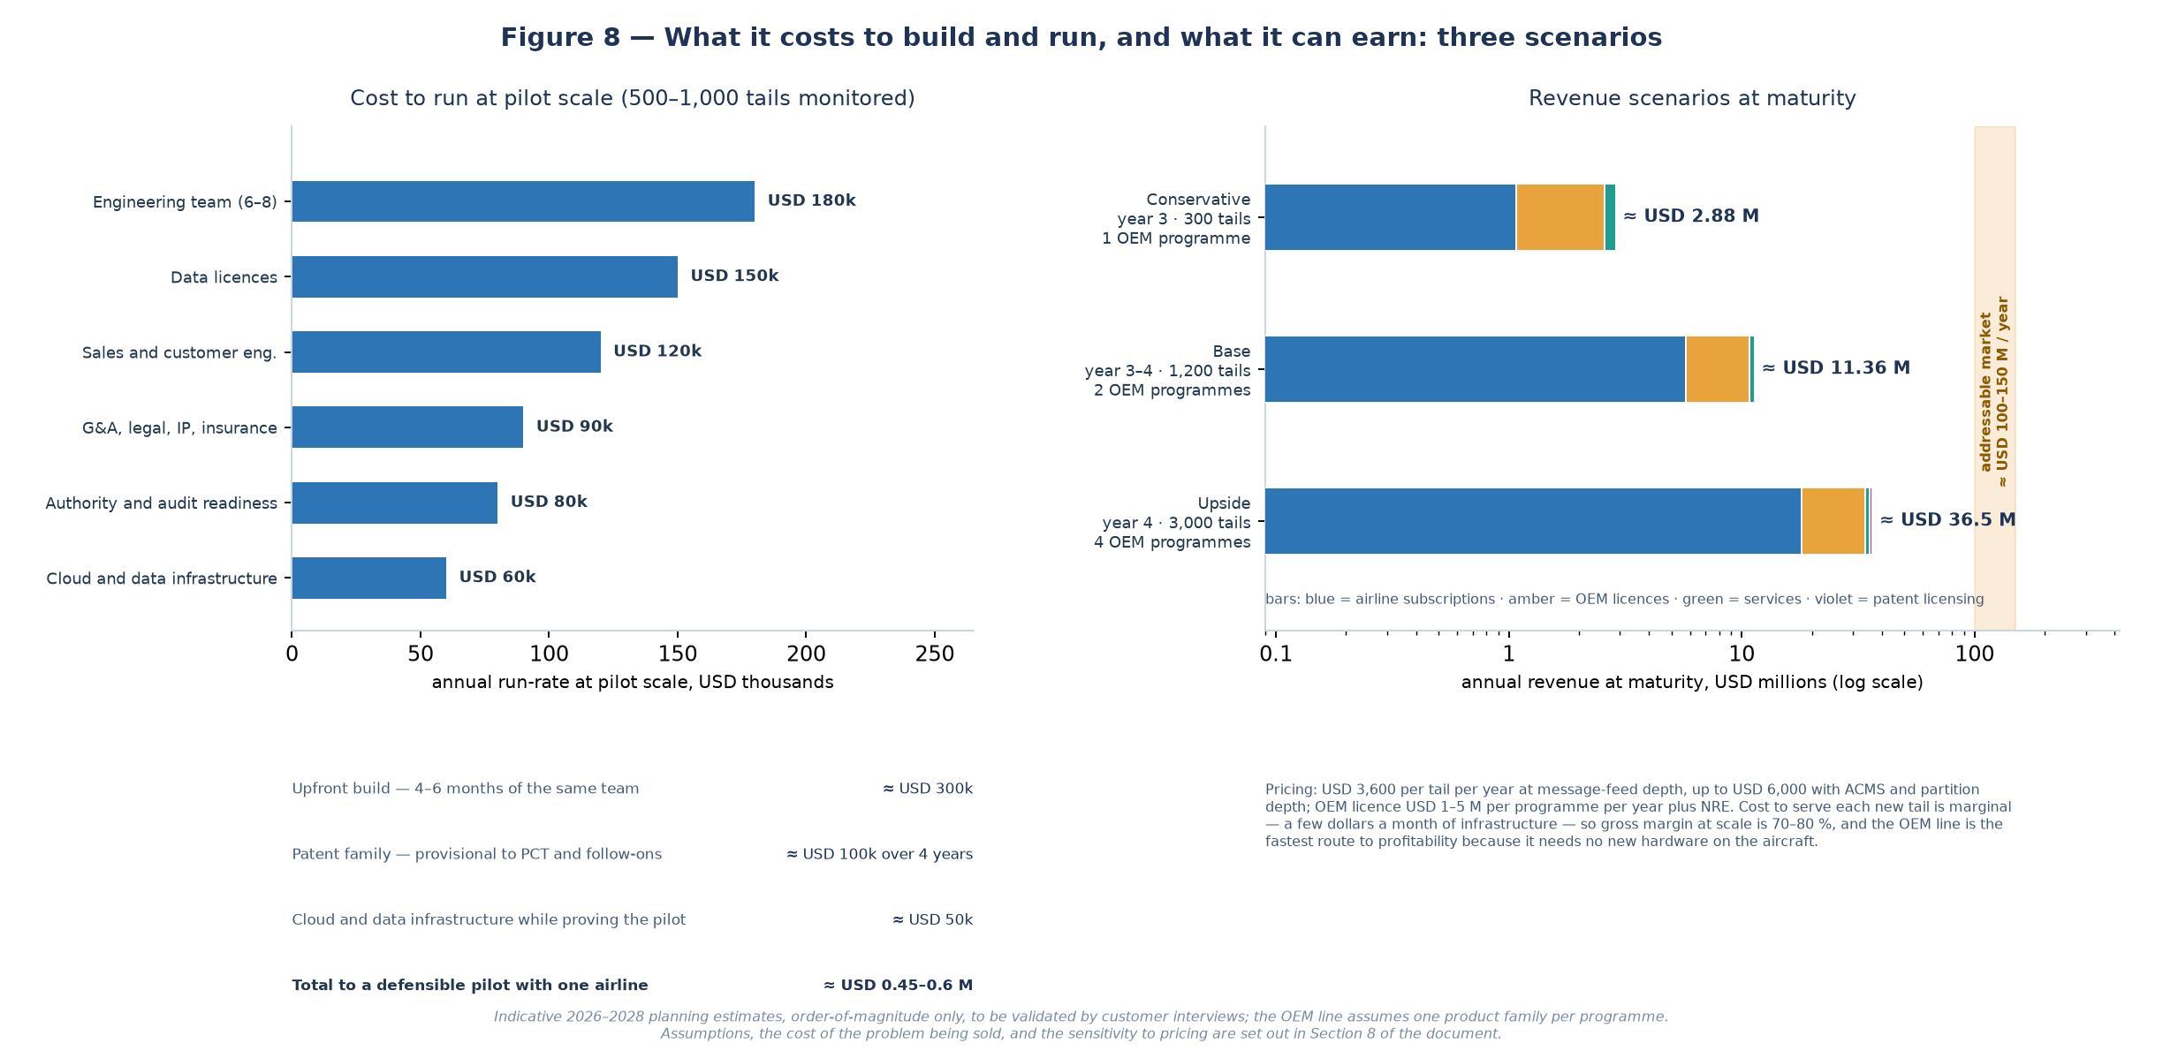
Figure 8 — Cost to build and run, and the three revenue scenarios. Left: the annual run-rate needed at pilot scale, approximately USD 0.7 M, with roughly USD 0.45–0.6 M to reach a defensible pilot with one airline. Right: revenue at maturity by scenario (log scale), against an addressable market of roughly USD 100–150 M a year. Estimates are indicative and to be validated by customer interviews.

The cost story matters as much as the revenue story: this is a comparatively cheap business to run because the platform is a commodity software stack and the aircraft already produces the data. The expensive inputs are the data rights and the people, both of which scale sub-linearly with the number of tails after the first fleet. The single largest cost-avoidance decision is to sell to the OEM early: one OEM programme funds the platform development that a hundred airline subscriptions would otherwise have to fund.

8.11 How the two buyers can share the cost, and why they each say yes
- Airline alone. The airline pays the subscription and keeps the operational benefit. This is the simplest contract and the right starting point with a willing operator.
- OEM-sponsored (the structure that usually closes). The OEM funds 30–60 % of the airline subscription in exchange for fleet-wide visibility of its own product and the labelled data that comes with it, out of a warranty and support saving that is larger than its contribution. The airline sees a lower net price; the OEM sees its own defect before anyone else does.
- OEM-direct (the highest-margin line). The OEM licenses the platform for its own fleet monitoring across customer airlines. The platform owner does not need to win every airline individually, and the OEM gains a service line to sell with its existing contracts.
- Airline consortium or lessor arrangement. Where several operators share a fleet type, aggregated benchmarks are a product in themselves — sold as reliability intelligence rather than as a monitoring tool.
- Authority-facing evidence. The conformance record and coverage account have value beyond operations — to a regulator, a lessor or an insurer asking whether the datalink is working to its requirements. No one currently sells that answer.

8.12 What has to be true for the upside (risks to the business case, not to the architecture)
Assumption | Why it is at risk | How it is de-risked
Data rights with the CSP and the airline can be obtained at a sane price | Message content is commercially sensitive and CSPs control the feed | Start with one airline and one CSP sandbox; use content hashes and redaction; price the licence into the subscription from day one
The configuration database is accurate | Every verdict is instantiated against it; wrong data means wrong verdicts | Make the configuration record the first paid deliverable of onboarding, and reconcile it against ground truth before any verdict is shown
Partition-depth evidence becomes available | It is the OEM partnership, which is slow | Product works at tier A and B without it; sell tier C when the OEM track lands, and treat it as the differentiator rather than the foundation
Requirements exist as machine-readable criteria | Some operators hold them in PDFs and spreadsheets | Selling the baseline as an engineering service is itself revenue, and the first thing the pilot pays for
The pricing is accepted | Airlines push hard on per-tail software pricing | Sell against measured payback (8.6) and use the OEM-sponsored structure when the year is tight
A CSP or an OEM builds it themselves | They own the data and the customer | The moat is the requirement-anchored verdict, the ledger and the evidence record — not the dashboard; move early and file the family
The market does not materialise within two years | Airline software sales cycles are long | The OEM line shortens the cycle; a single programme is worth dozens of airline deals

8.13 The business case in one paragraph
The platform turns data that aircraft and ground networks already produce into three things that are currently either unavailable or discovered too late: a per-requirement statement of whether the datalink is working as it was required to work, an early, evidence-backed warning that the datalink product is degrading on a specific tail and configuration, and a coverage account of what has never been demonstrated in service. An airline pays USD 3,600–6,000 per tail per year against hard savings that are plausibly one to three times that figure, and the same evidence is worth USD 1–5 M per programme per year to the OEM that owns the product, because it converts warranty, no-fault-found and support spend into a bounded, attributable, fixable problem — and it lets the OEM hear about its own defect before the customer does. The business can be run at roughly USD 0.7 M a year at pilot scale, reaches around USD 11 M a year in the base case and around USD 36 M in the upside, against an addressable market of roughly USD 100–150 M a year, on a software stack that is deliberately boring. The technical work in Sections 1–7 exists to make those numbers credible; the numbers exist to justify doing the technical work.

9. Build order
Phase | Weeks | What you build | What you can claim
0 — Replay and verdict engine | 1–4 | Import a real requirement extract; compile monitors; replay a sample message feed plus synthetic ACMS telemetry; produce four-valued verdicts and the ledger; dashboard v0 on replayed data | A working demonstration of the patent claim 1 pipeline
1 — Live ground feeds | 5–12 | One CSP sandbox feed, own SDR receivers for VDL Mode 2 / ACARS and ADS-B, ANSP or NOC feed, configuration database, dashboard v1 with live flight board | Near-real-time message, crew and network verdicts
2 — Airline pilot | 3–6 months | One airline, one fleet type: ACMS report definitions, QAR offload integration, symptom catalogue, deterministic pattern library, label flywheel v1 | Host and resource verdicts, operational coverage account
3 — OEM track and ML | 6–12 months | OEM partnership for partition health data; ML layer behind the admission gate; interference signature library with the frozen regression corpus | The full scope, and the defensible second and third patent families

10. What this architecture does for the patent position
Element in this design | Patent status
Kafka pipelines, dashboards, generic anomaly detection, Grafana panels | Not patentable — considered routine. Publish or ship, do not spend filing budget.
Pattern findings mapped back to requirement identifiers, with the verdict remaining deterministic | Supports the lead claim: it demonstrates that the AI explains rather than judges.
Coverage erosion pattern (not-exercised set drifting over routes and software loads) | Supports Invention 2 — operational coverage account.
Label flywheel that turns maintenance confirmations into validated labels for the threat models | Supports Invention 3 — safety-gated, ground-learned advisory threat models.
Conformance record with content hash, ledger, deterministic replay, late-data verdict revisions | Supports the lead claim dependent claims.
ACMS report definitions used as the practical in-flight route to partition and OS evidence | Trade secret and partner advantage; consider a defensive publication so no one else claims it against you.

11. Risks and how to handle them
Risk | Reality | Handling
No true live OS/partition telemetry | Certified aircraft do not expose it | ACMS reports in flight, QAR post-flight, OEM partnership for the full version; state the limitation in the product, not just the spec
CSP and airline data rights | Message content is commercially and sometimes personally sensitive | Per-airline tenancy, content minimisation, hashes plus redaction, explicit retention limits,  access logging
QAR and flight-data-monitoring governance | Heavily controlled, crew-sensitive | Reuse the airline existing programme; never build a parallel crew-monitoring path
Clock offsets and uncertainty | Different sources, different clocks | Propagate uncertainty; make INDETERMINATE a first-class outcome; never let a verdict depend on a comparison narrower than the uncertainty
Dashboard trust | Showing stale data as live destroys confidence in one demo | Per-panel freshness and cadence indicators; explicit post-flight labelling
OEM dependency | Partition health data may require a partnership and long lead time | Keep the MVP independent of it; treat it as the phase 3 differentiator
Export control and security | Fleet-wide telemetry and any interference library can be sensitive | Legal review before cross-border aggregation; keep threat models advisory and access-controlled

Engineering design input. Not a legal opinion. All acquisitions described require CSP, airline and where applicable OEM agreements.

