Coverity Tool User Manual
Version 6.6 | Updated 2026-08-31 | Detailed workflow instructions with tool screenshots

1. Data Required Before You Start
Item | Typical value | Where used
Coverity host | coverity-er.honaero.com | Commit, Pull, Push dialogs
Port | 443 | Commit, Pull, Push dialogs
Credentials | Corporate username/password or auth key | Connection and upload actions
Project | Program project in Coverity | Pull and push scoping
Stream | Target stream in project | Commit target and pull scope
Source root | Local source tree for the same baseline | Setup and results verification
Output folder | Local writable path | Generated CSV and logs

2. End-to-End Workflow
1) If defects are not in Coverity Connect, use Commit Defects dialog first.
2) Pull defects from server to create structured Excel input.
3) Run analysis and review each finding in Results and Detail windows.
4) Push final decisions using CSV Push dialog or Direct Push dialog.

3. Setup Page
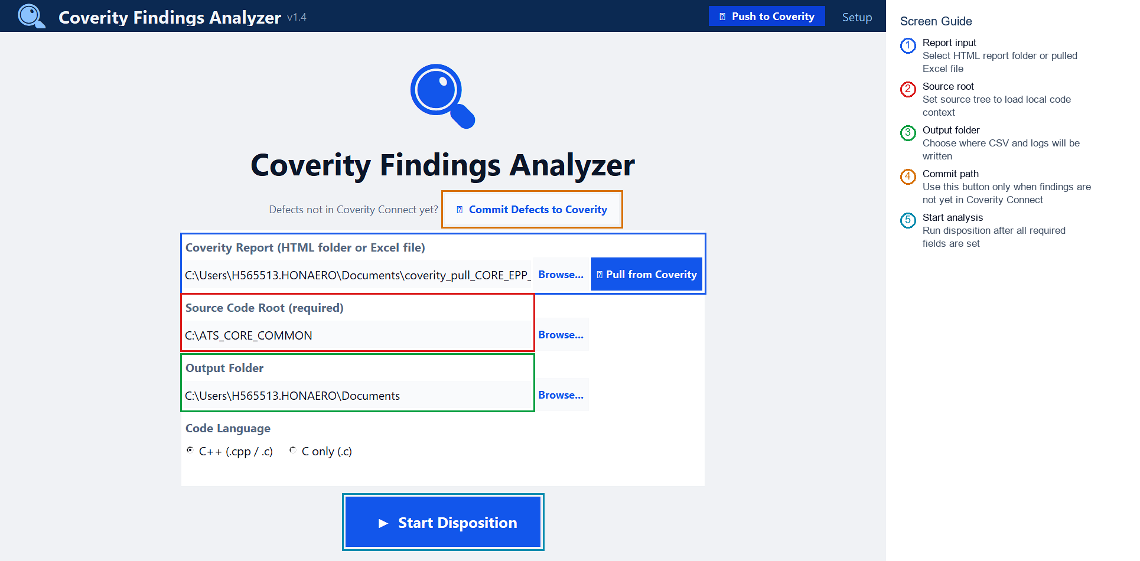
Figure 1: 01_setup_live.png
Purpose and review guidance:
- Use this screen to define the full run context: report, source root, and output folder.
- If findings are not yet in Coverity Connect, use Commit Defects first, then return to Pull Defects.
- Source Code Root should match the code revision that produced the report.
- Start Disposition only after all required fields are populated.
How to use this screen:
Step | User action | What to enter or check | Expected result
1 | Select input | Browse to the pulled Excel file or HTML report folder. | The selected path appears in the Coverity Report field.
2 | Select source root | Browse to the matching source checkout. | The tool can show source context during review.
3 | Select output folder | Choose a writable folder for generated CSV and logs. | All analysis outputs are saved in one known location.
4 | Start analysis | Click Start Disposition after fields are complete. | The analysis progress screen opens.

4. Commit Defects Dialog
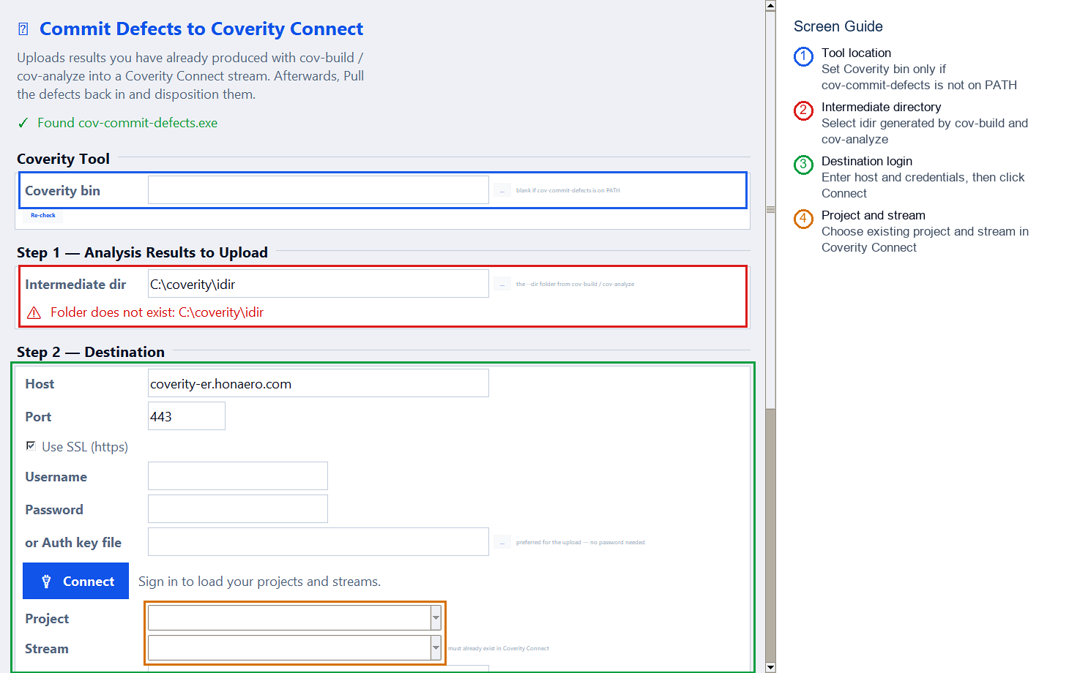
Figure 2: 02_commit_live.png
Purpose and review guidance:
- Commit is used only when you already have a Coverity intermediate directory (idir).
- Connect first to load valid project and stream values from server.
- Resolve all validation warnings before clicking Commit to Coverity.
- Use the output pane to troubleshoot tool-path, auth, and stream issues.
How to use this screen:
Step | User action | What to enter or check | Expected result
1 | Set Coverity tools | Point to Coverity bin only when commands are not already on PATH. | The tool can find cov-commit-defects.
2 | Choose idir | Select the intermediate directory created by Coverity analysis. | The commit source is ready for upload.
3 | Connect | Enter server, port, and credentials, then connect. | Project and stream selections become available.
4 | Commit | Select project and stream, review readiness, then commit. | Defects are uploaded to Coverity Connect.

5. Pull Defects Dialog - Connection and Output Setup
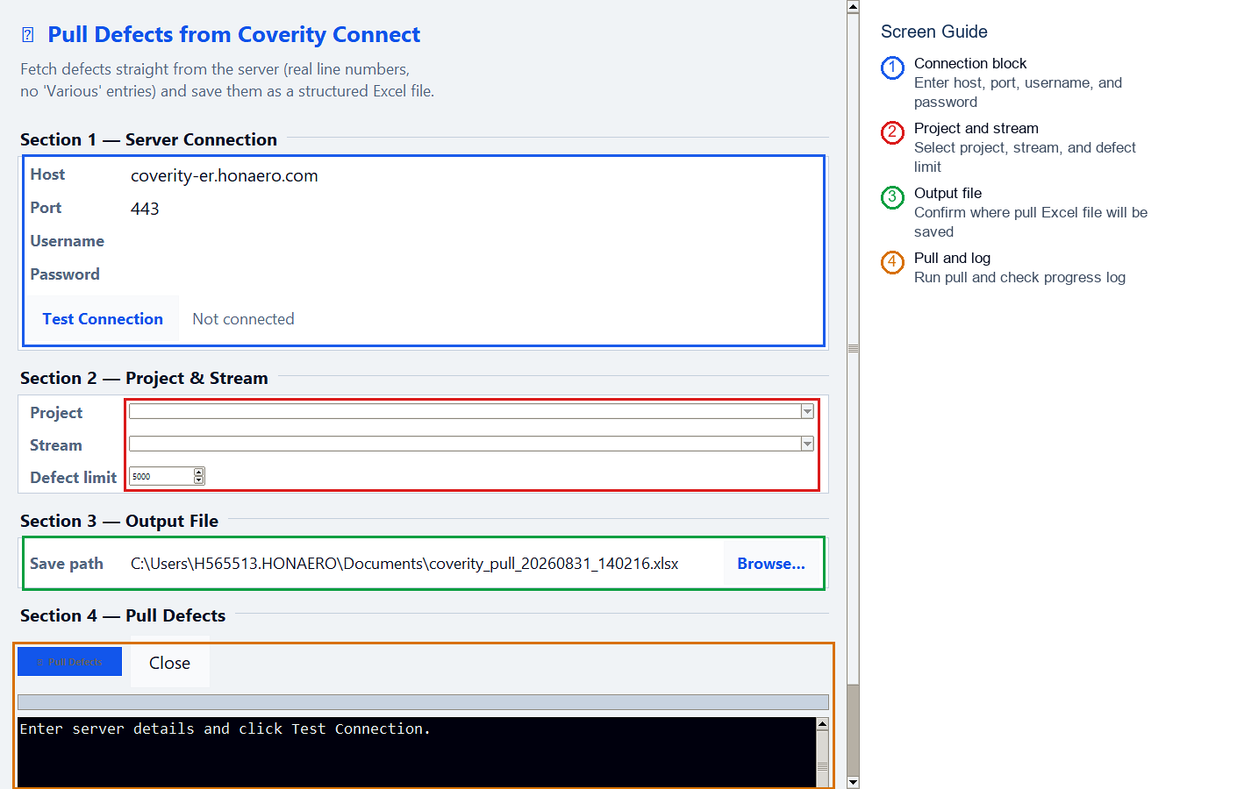
Figure 3: 03a_pull_top_live.png
Purpose and review guidance:
- Pull fetches defects directly from Coverity Connect and creates a structured Excel input.
- Run Test Connection before selecting project and stream.
- Set a practical defect limit for initial pull and increase later if needed.
- Keep the generated pull Excel path; this becomes the Setup input.
How to use this screen:
Step | User action | What to enter or check | Expected result
1 | Connect | Enter host, port, username, and password, then test connection. | Project and stream lists load from server.
2 | Select scope | Choose project, stream, and defect limit. | The pull is restricted to the intended Coverity data set.
3 | Choose output | Confirm the Excel save path. | The pulled report location is known before download.

6. Pull Defects Dialog - Pull Action and Log
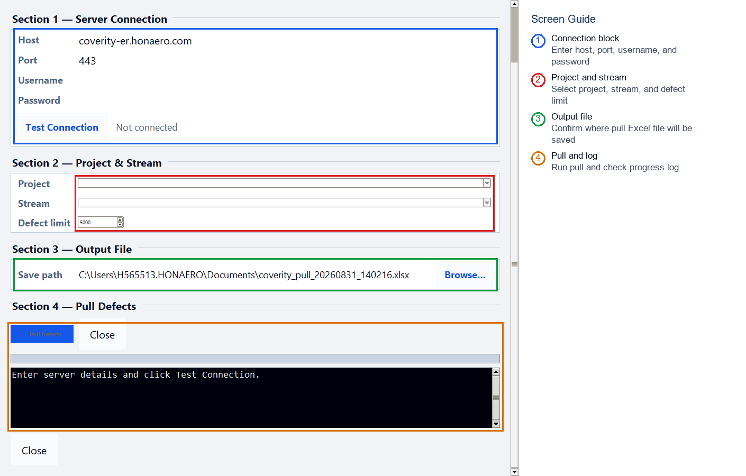
Figure 4: 03b_pull_bottom_live.png
Purpose and review guidance:
- The lower part of the Pull dialog contains the action button, progress bar, and run log.
- Use this area to confirm the pull started and completed successfully.
- If the pull fails, copy the visible log message and check server, credential, or permission setup.
How to use this screen:
Step | User action | What to enter or check | Expected result
1 | Start pull | Click Pull Defects after connection and stream selection are valid. | Download begins and progress updates.
2 | Watch log | Read the black log area for server or permission messages. | Successful completion confirms the Excel file is ready.
3 | Close dialog | Close after the generated file is available. | Return to Setup and use the Excel file as input.

7. Analysis Progress
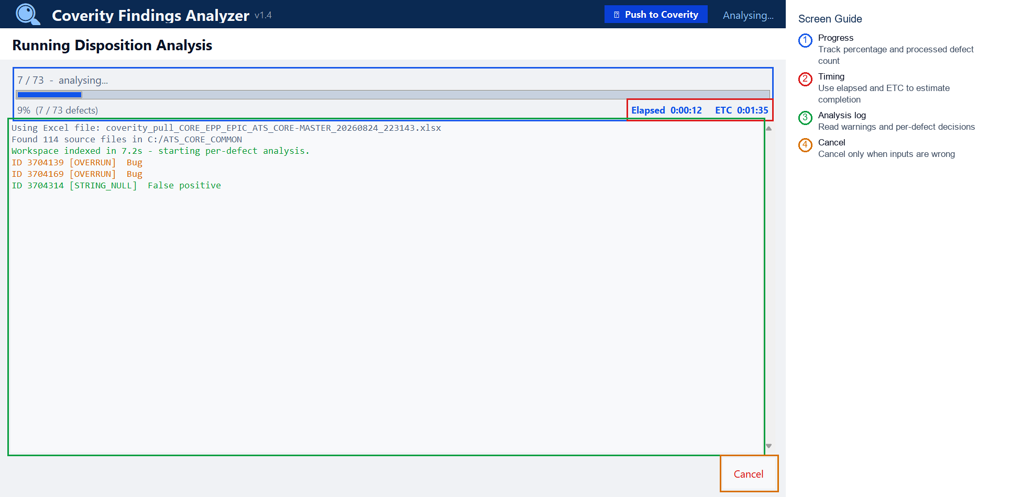
Figure 5: 04_analysis_live.png
Purpose and review guidance:
- Progress area shows processed defects, percentage, elapsed time, and ETC.
- Log panel reports file loading, indexing, and per-defect classification traces.
- Warnings in red or yellow should be reviewed before final push.
- Cancel should be used only when wrong input/source path is selected.
How to use this screen:
Step | User action | What to enter or check | Expected result
1 | Monitor progress | Watch processed count, percentage, elapsed time, and ETC. | You know whether the run is moving normally.
2 | Review messages | Read the analysis log while the run proceeds. | Input, source, and classification warnings are visible.
3 | Let it finish | Avoid cancelling unless the wrong input was selected. | Results open after analysis completes.

8. Disposition Results
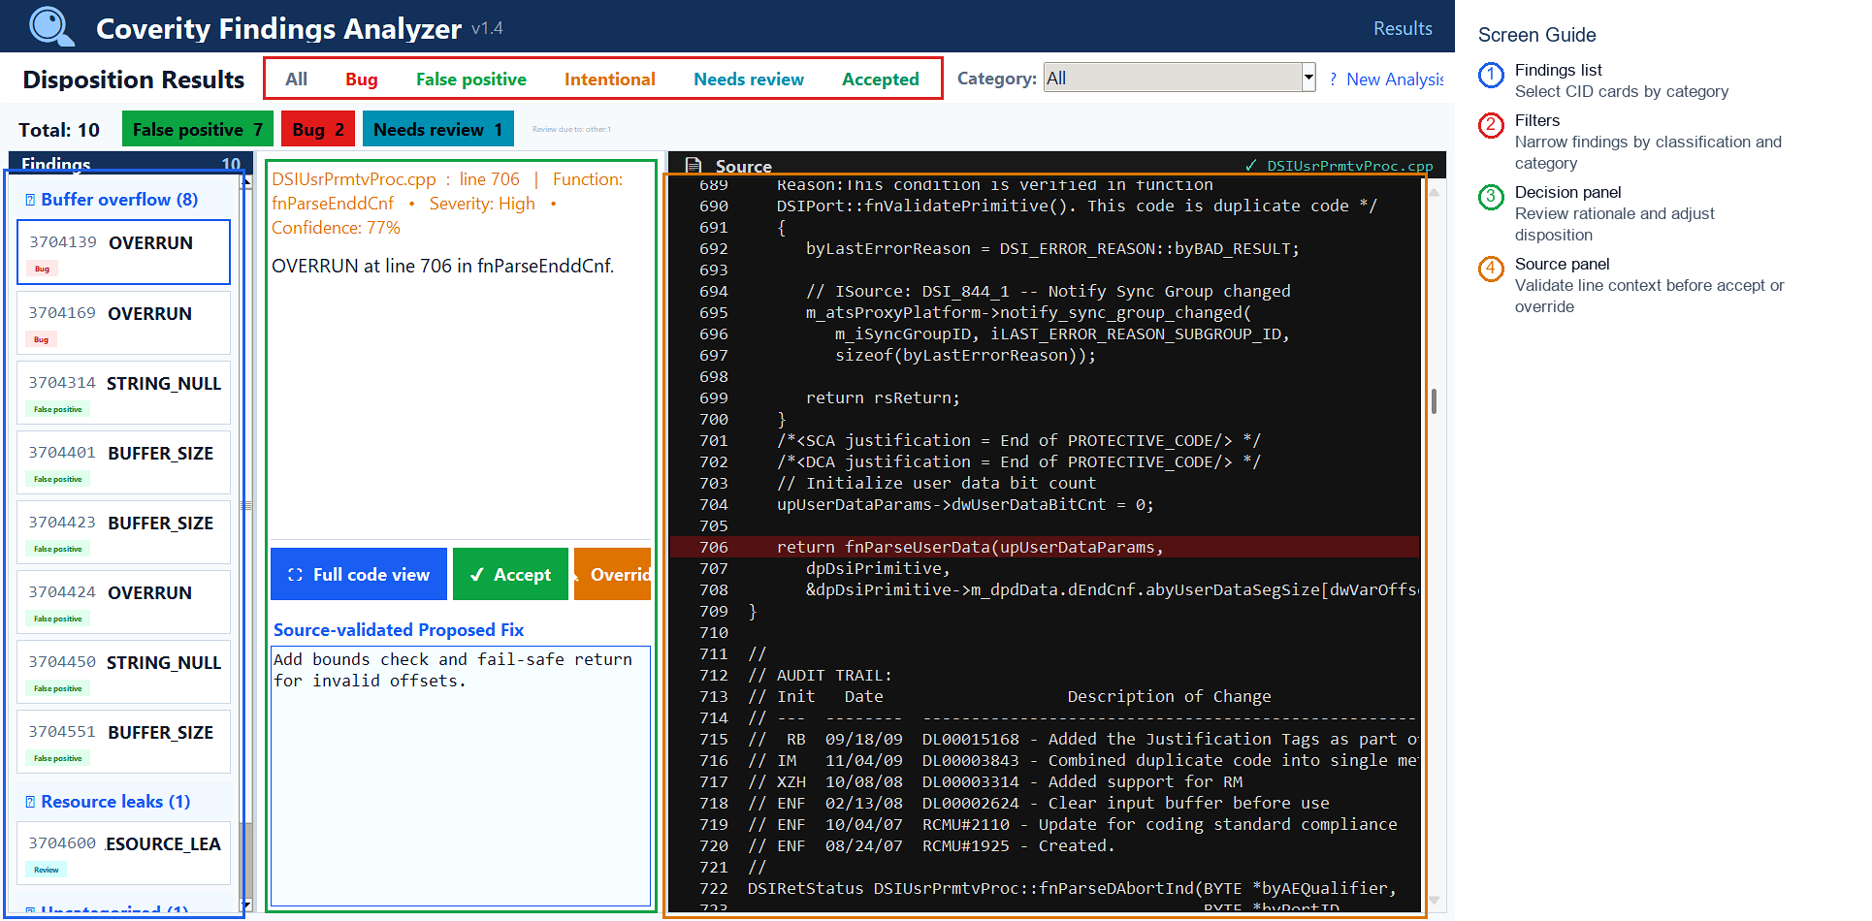
Figure 6: 05_results_live.png
Purpose and review guidance:
- Left panel is your CID work queue; select one finding at a time.
- Top filters reduce review scope by classification and category.
- Center panel contains disposition rationale, proposed fix, and actions.
- Right panel verifies exact code context before acceptance or override.
How to use this screen:
Step | User action | What to enter or check | Expected result
1 | Filter work queue | Use status/category filters to focus review. | Only relevant CIDs remain visible.
2 | Review one CID | Select a finding and read disposition, rationale, and source panel. | Reviewer understands why the tool suggested that decision.
3 | Accept or override | Accept valid suggestions or override with a reviewer decision. | Final decision is captured for export or push.
4 | Open details | Use the full detail window for complex findings. | More source and evidence are available.

9. Full Detail Window
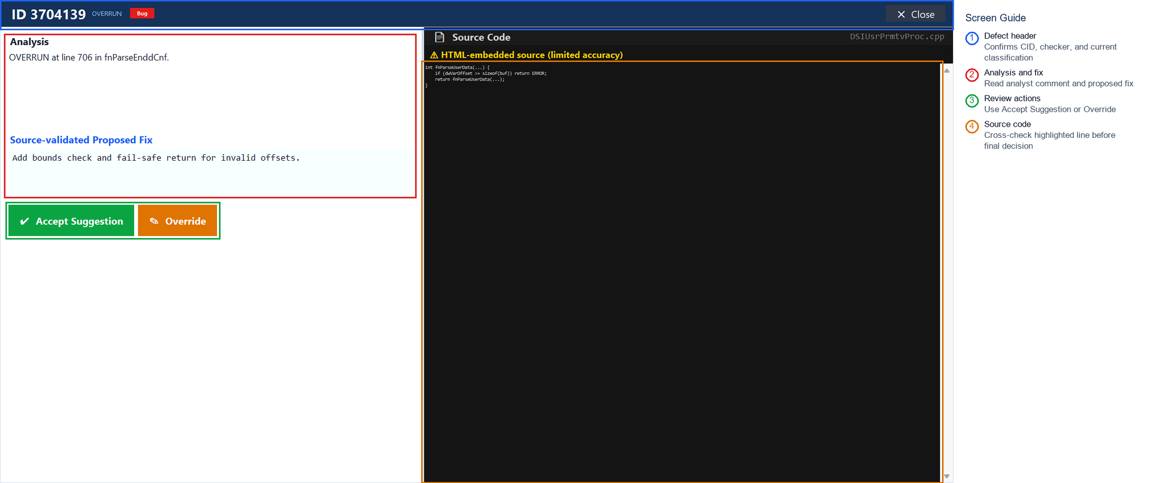
Figure 7: 06_detail_live.png
Purpose and review guidance:
- Use this window for high-confidence review of one CID with full source context.
- Read Analysis and Source-validated Proposed Fix before changing disposition.
- Accept Suggestion records the current recommendation as final.
- Override is for reviewer-driven corrections with explicit rationale.
How to use this screen:
Step | User action | What to enter or check | Expected result
1 | Confirm identity | Check CID, checker, and classification in the header. | You are reviewing the intended finding.
2 | Read evidence | Review analysis text and source-validated proposed fix. | Decision is based on recorded evidence.
3 | Check source | Compare the highlighted source context with the finding. | Wrong-source or stale-code issues are detected.
4 | Decide | Accept suggestion or override with reviewer judgement. | The decision returns to the results workflow.

10. Push Dispositions (CSV) - Connection and CSV Review
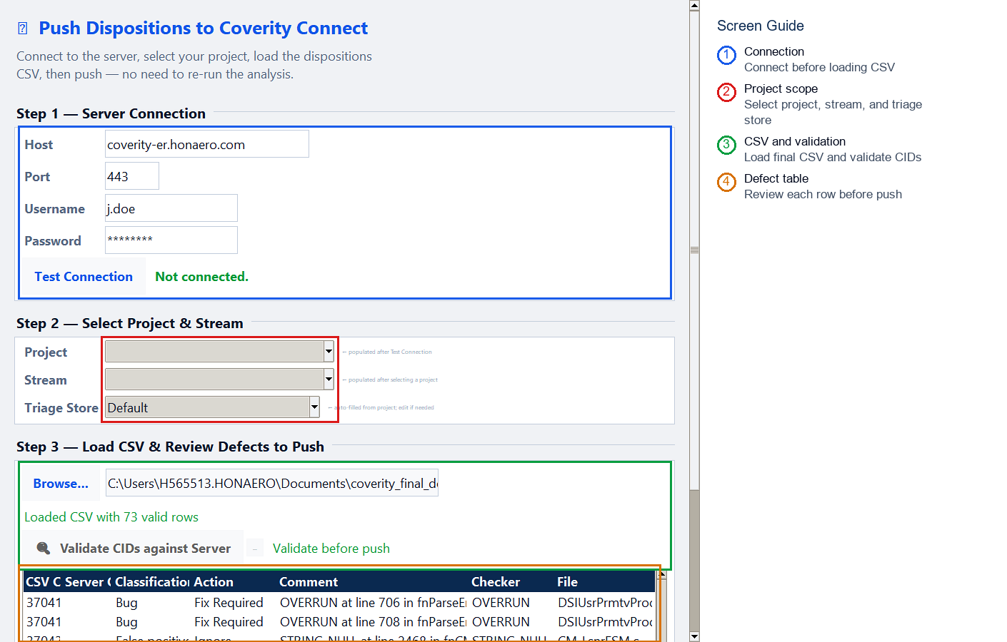
Figure 8: 07a_push_csv_top_live.png
Purpose and review guidance:
- Use this dialog when pushing decisions from coverity_final_decisions.csv.
- Connect and select correct project, stream, and triage store first.
- Validate CIDs against server to detect stale or wrong-project entries.
- Push only after validation is clean and table rows are reviewed.
How to use this screen:
Step | User action | What to enter or check | Expected result
1 | Connect | Enter server details and connect. | Project, stream, and triage store can be selected.
2 | Load CSV | Select coverity_final_decisions.csv from the output folder. | Rows appear in the push table.
3 | Validate CIDs | Run validation before push. | Invalid or mismatched CIDs are detected before upload.

11. Push Dispositions (CSV) - Validation and Push Controls
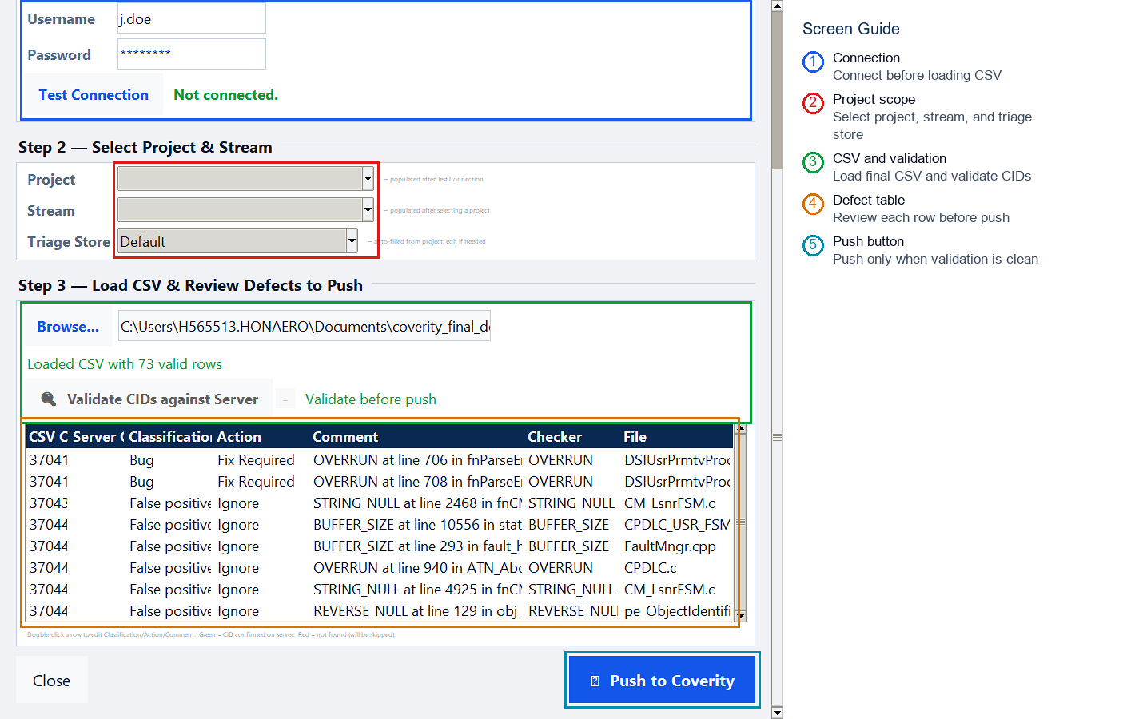
Figure 9: 07b_push_csv_bottom_live.png
Purpose and review guidance:
- The lower CSV Push view shows the defect rows and final push buttons.
- Review the validation status and table rows before uploading dispositions.
- Use Dry Run when you need a pre-flight check without changing Coverity triage state.
How to use this screen:
Step | User action | What to enter or check | Expected result
1 | Review rows | Check CID, server CID, classification, action, comment, checker, and file. | Only intended dispositions are queued.
2 | Dry run | Use Dry Run when required by team process. | The tool checks what would be pushed.
3 | Push | Push only after validation and row review are complete. | Final decisions are submitted to Coverity.

12. Direct Push Results - Connection and Push Mode
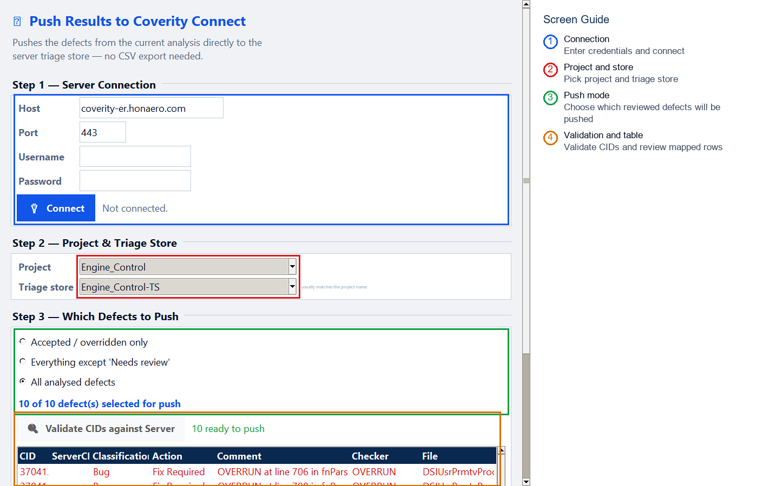
Figure 10: 08a_direct_push_top_live.png
Purpose and review guidance:
- Use direct push to submit in-memory review results without CSV export.
- Choose push mode based on policy: accepted only, decided only, or all analysed defects.
- Run CID validation before push so unmatched CIDs are excluded.
- Dry run is useful for pre-flight checks in controlled environments.
How to use this screen:
Step | User action | What to enter or check | Expected result
1 | Connect | Enter server credentials and connect. | Coverity project and triage store are available.
2 | Select mode | Choose accepted only, decided only, or all analysed defects. | The push set matches review policy.
3 | Validate | Validate CIDs against the server before upload. | Only server-matched CIDs are ready.

13. Direct Push Results - Validation and Push Controls
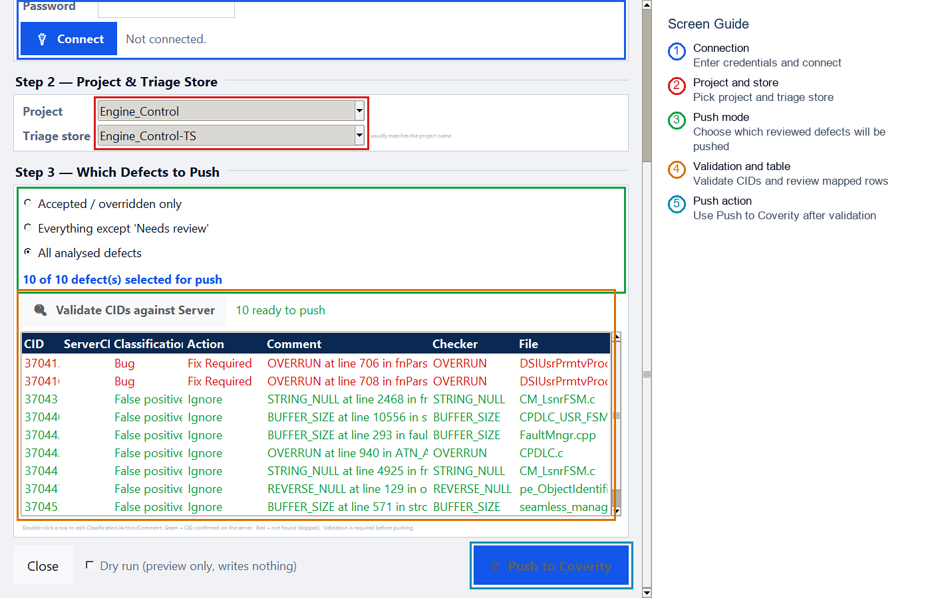
Figure 11: 08b_direct_push_bottom_live.png
Purpose and review guidance:
- The lower Direct Push view shows matched rows, status, and the final push controls.
- Only validated server CIDs should be pushed.
- After push, review the result message and any failed rows before closing the dialog.
How to use this screen:
Step | User action | What to enter or check | Expected result
1 | Review selected rows | Confirm each mapped CID and action before upload. | Wrong findings are caught before server update.
2 | Dry run | Run a dry push first when you need confirmation. | No Coverity data is changed.
3 | Push direct | Submit current in-memory decisions. | Results are pushed without using a CSV file.

11. Files Produced by the Tool
File | Content | Use
coverity_pull_<stream>_<timestamp>.xlsx | Pulled findings from Coverity | Input for analysis
coverity_dispositions.csv | Initial classification suggestions | Review and QA
coverity_final_decisions.csv | Final reviewer decisions | Push source
audit.jsonl | Decision evidence log | Traceability and audit
*_pull_log.txt | Pull diagnostics | Connection and fetch troubleshooting

12. Troubleshooting
- Application does not open: keep CoverityTool.exe and _internal folder together.
- Cannot connect: verify host, port, credentials, and network/VPN path.
- No streams visible: user account may lack stream permissions in selected project.
- No local code in Results: verify Source Root points to matching code baseline.
- Push failures: validate CIDs, then check triage store and stream selection.

