COVERITY FINDINGS ANALYZER
Automated Defect Triage for Coverity & Coverity Connect

Detailed User Guide • Version 1.4 • Expert CWE Edition
Version:  1.4 (Expert CWE) | Date:  19-Aug-2026 | Audience:  Engineering Teams
Local • Privacy-Preserving • No Source Upload • Tree-sitter + Z3 + CWE/CERT/OWASP

What’s Inside This Guide

- How to install & run (EXE one-click vs Python venv) — p.3
- What counts as valid INPUT (HTML folder / Excel / Server Pull) — p.4-5
- Where OUTPUT goes & exact CSV/JSON formats — p.6
- Click-by-click GUI tour with highlighted screenshots — p.7-14
- How to read Bug / False positive / Intentional / Needs review — p.15
- Pull from & Push to Coverity Connect — p.16-18
- Troubleshooting, Security, Checker/CWE Reference — p.19-21
⚠ Source code never leaves your machine. All analysis is local.
Generated for cross-team testing • For questions contact: Tool Owner (Coverity Findings Analyzer)

Table of Contents
# | Section | Page
1 | Overview — What the Tool Does & 5-Step Workflow | 3
2 | System Requirements & Installation (EXE vs Python) | 3
3 | Folder Structure — What to Ship to Other Teams | 4
4 | Input Criteria — HTML Report / Excel / Server Pull (with expected formats) | 4
5 | Source Code Root & Output Folder — Rules | 5
6 | The Analysis Engine — What Happens Under the Hood | 6
7 | GUI Tour 1: Setup Page (every field explained) | 7
8 | GUI Tour 2: Analysis Page (progress, Elapsed/ETC, log) | 8
9 | GUI Tour 3: Results Page (filters, tree, details, code viewer) | 9
10 | Detail Window — Full Code View & Accept/Override | 10
11 | Understanding Dispositions — Bug / False positive / Intentional / Needs review | 11
12 | Output Files — CSV / JSON / Breakdown (exact columns) | 12
13 | Pull Defects from Coverity Connect — Server → Excel | 13
14 | Push Dispositions to Coverity — CSV → Server | 14
15 | Decision Engine — Confidence, CWE/CERT/OWASP | 15
16 | Troubleshooting & Performance Notes | 16
17 | Security & Privacy | 16
18 | Appendix A: Supported Checkers & CWE/CERT/OWASP Map | 17
19 | Appendix B: Quick Start TL;DR | 18
20 | Appendix C: EXE Build & Setup Instructions | 18
Tip: Images in this guide have numbered red callouts. Match the numbers to the tables below each image.

1. Overview — What the Tool Does
Coverity Findings Analyzer is a local desktop decision assistant for Coverity (STATIC) and Coverity Connect. It does not upload source code. It enriches each Coverity defect with the exact C/C++ function (tree-sitter), applies deterministic rules per checker (+ Z3/path-prover/flow-analysis where available), and proposes a triage: Bug / False positive / Intentional / Needs review, with confidence %, CWE/CERT/OWASP citation, and a code-exact Proposed Fix.
Step | Where | Result
1. Get defects | HTML folder, Excel export, or ⬇ Pull from Coverity Connect | Defect list: checker, file, line, type, severity
2. Analyse | Tree-sitter (once per file, cached) + rule engine per checker | coverity_dispositions.csv (comment/fix/confidence/CWE)
3. Review | Results page → double-click row | Events, source function, suggestion
4. Decide | ✓ Accept Suggestion or ✎ Override | coverity_final_decisions.csv
5. Push back | ⬆ Push to Coverity (header) | Server triage store updated
Output files (in your chosen Output Folder):
- coverity_dispositions.csv — machine suggestions (CID, Checker, Type, File, Line, Function, Classification, Comment, Fix, Timestamp, Category, CWE-url)
- audit.jsonl — full log (events, reasoning, confidence, context hash) — for audit
- coverity_final_decisions.csv — engineer-approved (Accepted/Overridden) — this is what Push uses
- needs_review_breakdown.txt — why Needs review (by reason/checker/category)
- coverity_pull_*.xlsx + _pull_log.txt — when you Pull from server

2. System Requirements & Installation

2.1 For the Ready-Made EXE (recommended for testers)
- Windows 10/11 64-bit, no Python needed
- Unzip Coverity-Tool-Setup.zip (see §3) → double-click CoverityTool.exe (or run_tool.bat)
- If Windows SmartScreen warns, click More info → Run anyway (exe is unsigned)
- First run may trigger antivirus scan — allow

2.2 For Python Run (developers)
Prerequisites: Python 3.10+ (python --version), C/C++ build tools only if a wheel fails (tree-sitter ships wheels). On Linux install tkinter: sudo apt install python3-tk
python -m venv .venv
.\.venv\Scripts\Activate.ps1 # Windows
# source .venv/bin/activate # Linux/macOS
pip install -r requirements.txt
python -c "import bs4,lxml,openpyxl,zeep,tree_sitter_c; print('ok')"
python local_gui.py # MAIN GUI
# python coverity_triage.py --report <path> --src-root <path> --language cpp # CLI

3. Folder Structure — What to Ship
Unzip and ship the entire setup folder. Do NOT move the exe out of its folder — it needs the _internal/ libs folder beside it (PyInstaller one-folder mode for faster start).
Coverity-Tool-Setup/
├── CoverityTool.exe ← double-click here (or run_tool.bat)
├── _internal/ ← Python libs, tree-sitter, z3 — do not delete
├── run_tool.bat ← sets Tcl/Tk paths and launches exe (use if exe fails)
├── run_tool.ps1 ← PowerShell launcher
├── docs/
│ ├── Coverity_Tool_User_Guide.docx ← this file
│ └── images/ ← screenshots used in this guide
├── sample_report/ ← optional: tiny HTML report for quick demo
├── sample_src/ ← optional: 2-3 .c files to test source loading
└── README.txt ← 5-line quick start
If you build the EXE yourself, see Appendix C: double-click build_exe.bat (needs PyInstaller) → dist/CoverityTool.exe

4. Input Criteria — What Counts as Valid Input
The tool accepts exactly three kinds of input. It auto-detects which you gave. Nothing else is accepted.
Input Type | How to Select | Expected Format | What Happens If Wrong
HTML Report Folder | Browse for FILE → pick any .html, or Browse for FOLDER → must contain index.html | Coverity HTML export: folder with index.html + Code/*.html detail pages (or single .html). Parser tolerates any column order, finds CID/checker/file/line/type/severity by content. | No table found in index.html → fix: open index.html, find table tag or provide sample
Excel Export | Browse → pick .xlsx / .xls | Coverity/Black Duck Excel export. Required columns (fuzzy matched): CID/Defect ID, File, Checker/Type, plus optional Line, Function, Severity. Line = 'Various' → handled as function-scoped (see below). | Could not find CID/Defect ID column → Headers: [...] — rename header to CID
Pull from Coverity Connect (Server) | Setup → ⬇ Pull from Coverity → fill Host/Port/User/Pass → Test Connection → Project → Stream → Pull | Live server defect list via SOAP v9 + REST v2. Produces coverity_pull_<stream>_<stamp>.xlsx with integer Line (never Various) + pull log with _merged_line/_inst_line. | SOAP Fault: Missing element sortAscending → fixed (v2025.9 pageSpec). If still fails, copy log's [shape,pageSize=] line
About 'Various' line numbers (Excel only): For function-scoped checkers (CHECKED_RETURN, UNUSED_VALUE, DEADCODE, MISSING_BREAK, INTEGER_OVERFLOW, ARRAY_VS_SINGLETON, STRING_NULL, etc.) the tool analyses the whole function and caps confidence. For memory-safety checkers (OVERRUN, BUFFER_SIZE, FORWARD_NULL) it asks you to provide the exact line rather than guess — those go to Needs review until you enter the line.

5. Source Code Root & Output Folder — Rules
- Source Code Root (required): folder containing your .c/.cpp/.h/.hpp files. The tool refuses to use the report folder itself as source root. If index.html is inside, it warns.
- It walks the tree once (cached) → extracts the exact function with tree-sitter (not regex). Files >500 KB and build folders (.git, build, out, node_modules, .venv) are skipped for speed.
- Output Folder: where coverity_dispositions.csv, audit.jsonl, coverity_final_decisions.csv, needs_review_breakdown.txt go. Defaults to Documents; each new run starts a fresh coverity_final_decisions.csv.
- Code Language: C++ (.cpp/.c) vs C only (.c) — picker on Setup page. Use C++ for mixed projects or run twice.
✔ Tip: Point Source Root at the repo root (e.g., C:\\src\\myproj). The tool finds files by suffix-score, so Coverity absolute paths like /build/myproj/src/foo.c are resolved automatically.

6. The Analysis Engine — Under the Hood (for curious testers)
- 1) parse_index_only() → light defect dicts (CID, checker, file, line, function, detail_file)
- 2) warm_workspace_index() — one-time call-site index (scan once, not per defect) + tree-sitter parse cache by mtime
- 3) For each defect: extract_enclosing_function() → build_defect_context() (callees/callers via workspace_indexer) → analyze_defect() dispatch per checker → DecisionAgent weighted evidence (Bug vs FP) + Z3/path_prover/flow_analysis where available → render_example_comment() → CWE/CERT/OWASP footer
- 4) Confidence: dominance + margin + strongest-signal tie-break; caps for Various / fallback code
- 5) Performance: indexing shows Elapsed/ETC separately; per-file semgrep cached & disabled by default (COVERITY_ENABLE_SEMGREP=1); concurrent REST discovery (8 workers, 3s) vs old 200s sequential
Security: verify_ssl=True by default (secure); checkbox Allow self-signed (insecure) for corporate certs. Passwords never logged; source never uploaded.

7. GUI Tour 1: Setup Page — Every Field Explained
Launch: double-click CoverityTool.exe (or run_tool.bat) or python local_gui.py. You always start here.
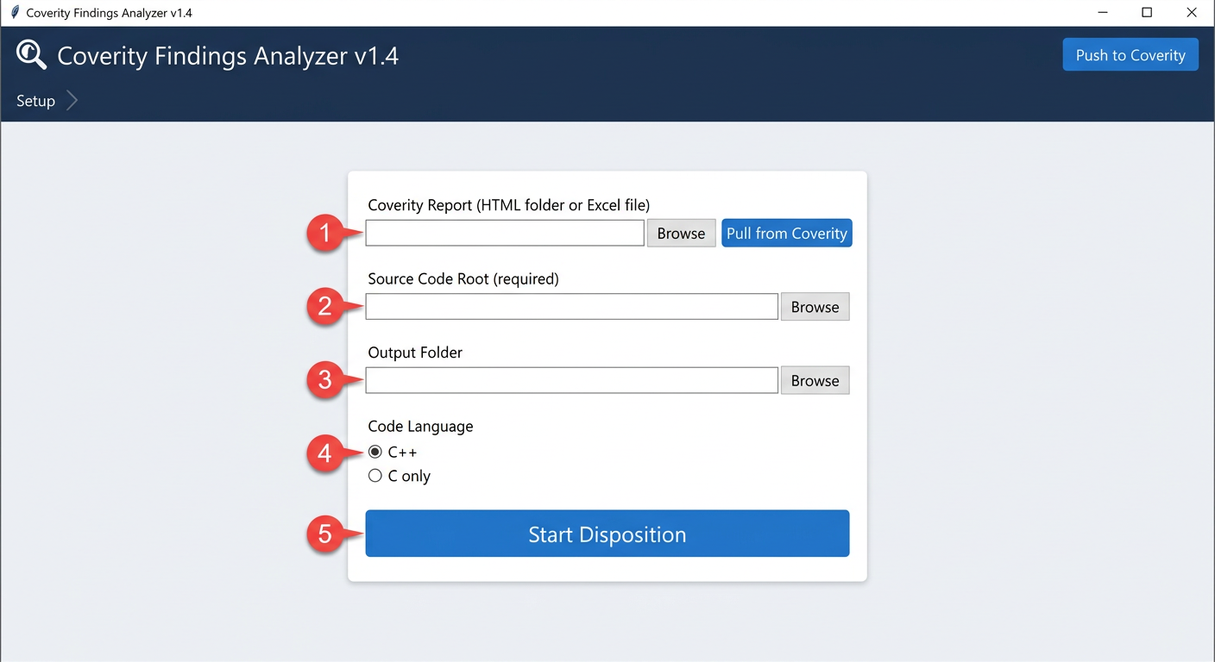
Figure 1 — Setup Page. Inputs are validated before Start.
# | Highlight | What to Do
1 | Coverity Report (HTML folder or Excel file) | Browse for file (.html/.xlsx) or folder (must contain index.html). Blue ⬇ Pull from Coverity opens server pull dialog (§13).
2 | Source Code Root (required) | Browse to repo root with .c/.cpp/.h. Tool checks for ≥5 source files; warns if you picked report folder.
3 | Output Folder | Where CSVs go. Defaults to Documents. Each new run clears coverity_final_decisions.csv.
4 | Code Language | C++ for .cpp/.c mixed, C only for pure C. Affects tree-sitter parser.
5 | ▶ Start Disposition | Validates inputs → moves to Analysis page. Pre-flight errors show as popups + log.
If You See... | Do This
No index.html found in ... | Pick the folder that contains index.html, not its parent. Check Coverity export completed.
Source Code Root cannot be same as input report | Pick your repo root (with .c files), not the report.
Selected Source Root contains index.html | You picked the report folder by mistake. Pick the source folder.
No C/C++ source files found | Check the path; ensure .c/.cpp/.h exist. The tool will still run but all go to Needs review.

8. GUI Tour 2: Analysis Page — Progress, Elapsed/ETC, Log
After Start, the Analysis page runs in a background thread (UI stays responsive). Do not close the window until Done.
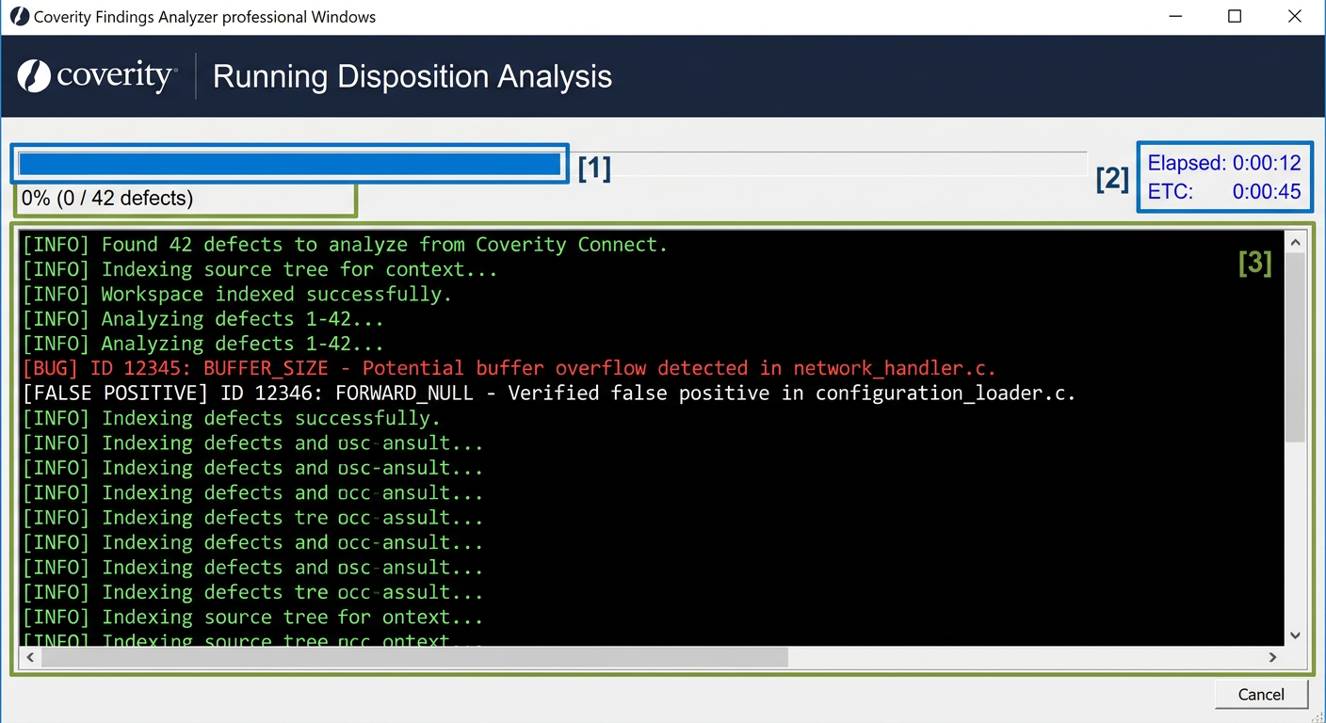
Figure 2 — Analysis Page. Indexing is separate from per-defect ETA.
# | Highlight | What to Do
1 | Reading index.html... → Found 42 defects | First line: parse_index_only() quick scan. If 0 defects → Report is invalid.
2 | Progress bar + 0% (0/42 defects) | Switches from indeterminate (indexing) to determinate (per-defect) after ready.
3 | Elapsed 0:00:12 ETC 0:00:45 (blue, top-right) | Fixed: Elapsed includes indexing (not reset to 0). ETC is per-defect only (realistic). If >50ms/defect warning → source not loading.
4 | Log console (black) | Live: Indexing source tree once (cached)... → Workspace indexed in 1.2s → ID 12345 [BUFFER_SIZE] Bug ... . Watch [Source] Loading: lines to see which file/checker is slow.
5 | Cancel | Sets stop_evt; current defect finishes (semgrep up to 10s) then returns to Setup without saving.

Performance notes (what makes it fast now)
- One-time workspace index (call-site + tree-sitter parse cache by mtime) — not per defect. Second run is fast.
- Skips build folders (.git, build, node_modules, .venv) and files >500 KB.
- Per-file semgrep cached & OFF by default (set COVERITY_ENABLE_SEMGREP=1 to enable). Previously 1000 defects ×10s = stuck.
- REST discovery concurrent (8 workers, 3s) vs old 40×5s = 200s stall.

9. GUI Tour 3: Results Page — Filters, Tree, Details, Code Viewer
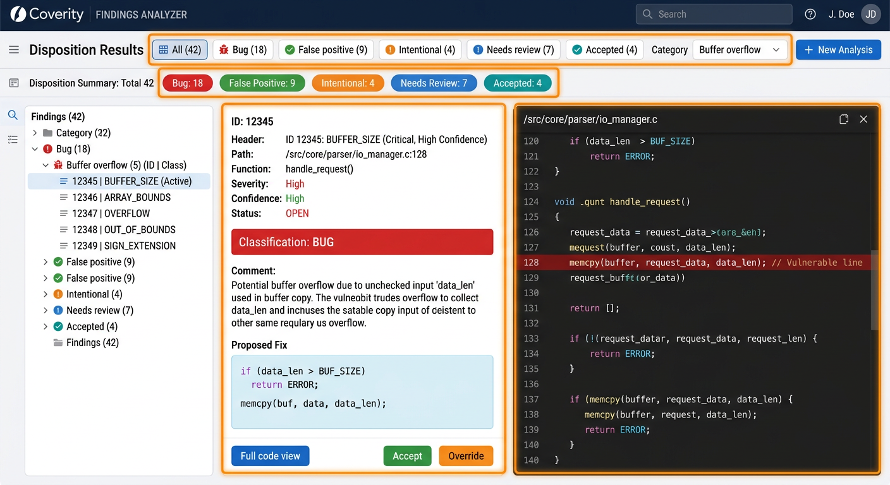
Figure 3 — Results Page. 3-column paned window: tree | details | code.
# | Highlight | What to Do
1 | Top toolbar: Disposition Results + filter chips | Click All/Bug/False positive/Intentional/Needs review/Accepted to filter. Category dropdown (Buffer overflow, Null pointer...) filters orthogonally. Count chips show totals.
2 | Left tree (ID + Class) grouped by Category | Categories in CATEGORY_ORDER, Uncategorized last. Expand/collapse: click header. Double-click row → Detail Window. Tags: pushed=green, push_fail=red, conf_high/med/low.
3 | Middle details panel | ID 12345 — BUFFER_SIZE (Buffer overflow) + File:line + Function | Severity | Confidence 85% (color by 0.8/0.6 thresholds) + Classification big colored + Comment paragraph (CWE/CERT footer) + Proposed Fix light-blue box (code-exact, // CWE tag) + buttons.
4 | Right code viewer (dark #1E1E1E) | VS Code theme via Pygments. Line numbers gray, error line #5A1D1D red. Source origin banner: ✓ Local source file (green), ⚠ HTML-embedded (yellow), ✗ No source (red).
5 | Bottom buttons: Full code view | Accept | Override | Accept → status Accepted (green), writes coverity_final_decisions.csv. Override → dialog to pick classification + comment.
Tip: Use the filter drop-down to work the most important tail first (Bug → Needs review → False positive). The tree updates live.
Field in Middle Panel | Meaning | Action
ID 12345 — BUFFER_SIZE (Buffer overflow) | CID + checker + category | Unique ID for Coverity
File: C:/.../foo.c : line 37 | Function: bar | Severity: High | Confidence: 85% | Metadata + evidence strength | Confidence ≥0.85 green, 0.6-0.8 orange, <0.6 red
Classification: Bug (big colored) | Machine suggestion: Bug / False positive / Intentional / Needs review → Accepted after you click | Read color: Bug red #DC2626, FP green #16A34A, Intentional orange #D97706, Needs review blue #0891B2
Comment paragraph | Expert narrative: root cause → taint → guard → impact, with CWE-... (CERT ..., OWASP ...) footer | Copy with Ctrl+C even when disabled; Select all Ctrl+A
Proposed Fix (light-blue Consolas box) | Code-exact fix with real variables, e.g., strncpy(buf,input,sizeof(buf)-1); buf[sizeof(buf)-1]='\0'; // CWE-120 | Only for Bug/Needs review; Not shown for No fix required
Source code viewer (right) | Dark theme, error line red, origin banner | Scroll to error line auto-centered; Copy works on disabled text

10. Detail Window — Full Code View & Accept/Override
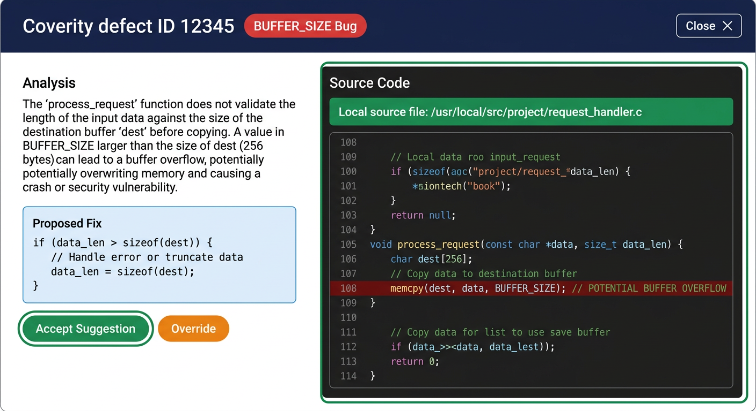
Figure 4 — Detail Window (double-click row). Full-screen, VS Code theme, same Accept/Override logic.
# | Highlight | What to Do
1 | Top bar: ID 12345 BUFFER_SIZE Bug badge | Color = classification; shows Accepted by user@time if already accepted
2 | Left: Analysis + Proposed Fix + buttons | Accept Suggestion → Accepted, Override → dialog (pick Bug/FP/Intentional/Needs review + comment)
3 | Right: Source Code dark viewer | Full function, not just snippet. Banner green/yellow/red for local/html/none. Line numbers + red error line + syntax. Tabs = 4 spaces.
4 | Copy | Ctrl+C copies selected text even on disabled widgets; Ctrl+A selects all
Flow: Review → Accept (writes to coverity_final_decisions.csv immediately, summary chips update) or Override → Save Override (choose classification, add comment) → Close → Next defect via tree or filter.

11. Understanding Dispositions — What Each Means
Disposition | Meaning | When Tool Gives It | Reviewer Action
Bug  (red) | Real defect at flagged location | Evidence strongly for bug (dominance ≥0.62, margin ≥0.12, or critical label like strcpy without bounds, confirmed OOB) | Fix it (see Proposed Fix) or confirm and Accept
False positive  (green) | Rule inspected trace and concluded benign | Guard dominates all paths (if(buf && idx<MAX)), or bounded API with sizeof-1 + explicit NUL, or caller bounds proven | Accept (no fix)
Intentional  (orange) | Code consciously does this | (void) cast, ignore comment, #if 0, documented fallthrough, etc. | Accept (no fix)
Needs review  (blue) | Honest 'I don't know' | No source/function, checker has no rule, or truly conflicting evidence, or line Various for memory-safety checker | Manual review; add line number if Various
Accepted  (teal) | You accepted suggestion | After you click Accept | Already recorded in coverity_final_decisions.csv
Confidence: ≥0.85 High (green) → auto-close after sanity check; 0.65-0.85 Moderate (orange) → quick walkthrough; <0.65 Low (red) → manual walkthrough. The phrase “High confidence” etc. is also the first sentence in the Comment.

12. Output Files — Where to Find What (in Output Folder)
Default Output Folder: Documents (you pick on Setup). All CSVs are UTF-8, overwrite per run except coverity_final_decisions.csv which dedupes by CID (last write wins).
File | Exact Columns / Format | Used For
coverity_dispositions.csv | CID, Checker, Type, Severity, File, Line, Function, Classification, Comment, Fix, Timestamp, Category, CWE-url (added in v7) | Machine suggestions for every defect; import to Excel; feed to Push dialog
audit.jsonl | One JSON per line: {cid, checker, events, reasoning[], confidence, context_hash, code_start_line} — full evidence | Audit trail, debugging, re-triage
coverity_final_decisions.csv | CID, Checker, File, Line, FinalClassification, FinalComment, Fix, Reviewer, Timestamp, Status (Accepted/Overridden), Category | Engineer-approved; this is what Push pushes; deduped by CID
needs_review_breakdown.txt | Classification counts: Bug:12, ...\nNeeds review rows: 8\n by reason: no_code:3, line_various:2...\n by checker: OVERUN:4...\n by category: Buffer overflow:5... | Quick why-Needs-review summary without re-running
coverity_pull_<stream>_<stamp>.xlsx | Sheet Coverity: CID | Checker | Subtype | Severity | File | Line (integer, never Various) | Function | Events Summary | Structured pull output — directly re-importable as Excel input; also shows pull correctness
coverity_pull_*_pull_log.txt | Pull log: Stream, Defects, Line numbers resolved, Events fetched, REST correction count, SOAP field dump (_merged_line/_inst_line/_main_event_line), per-CID final vs sources, 5 events each | Post-pull diagnosis; attach when filing bug about wrong line numbers

Example coverity_dispositions.csv row (Excel view)
CID | Checker | Line | Classification | Confidence | Comment (truncated)
12345 | BUFFER_SIZE | 37 | Bug | 85% | strncpy() size equals destination (64==64) — no room for NUL; buf is stack 64 bytes. Coverity trace: dest 64, copy 64. CWE-120...

13. Pull Defects from Coverity Connect — Server → Excel (no 'Various')
Why Pull? Excel exports from the Coverity web UI often show Line = 'Various' (the defect spans multiple lines/macro). The server knows the current line (mainEventLineNumber). Pull fetches that via SOAP v9 + REST v2 and writes a clean Excel with integer lines.
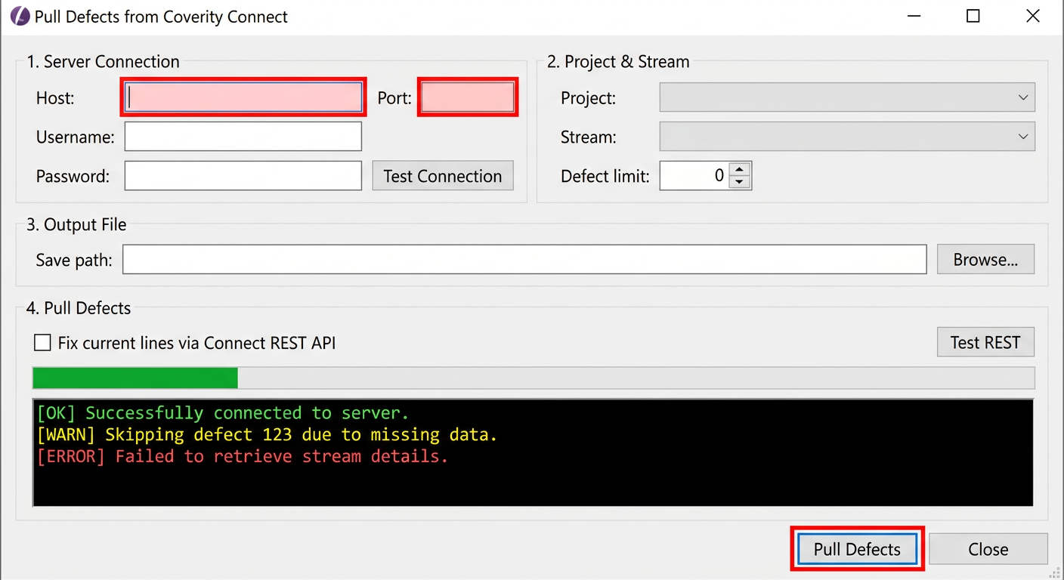
Figure 5 — Pull Dialog (4 Sections). REST is tried first, SOAP is fallback.
# | Highlight | What to Do
1 | Section 1 — Server Connection | Host (e.g., coverity-er.honaero.com), Port 443, Username, Password → Test Connection. Toggle: Allow self-signed certificate (insecure — verify off) → checked for corporate self-signed, unchecked for production valid cert.
2 | Section 2 — Project & Stream | Project dropdown (populated after Test Connection) → Stream dropdown (All streams in project + each stream). Defect limit spinner (100-50000, default 5000).
3 | Section 3 — Output File | Save path: coverity_pull_<stream>_<stamp>.xlsx (auto in Output Folder, Browse to change). Read-only, pre-filled.
4 | Section 4 — Pull Defects | Check Fix current lines via Connect REST API (recommended — overlays mainEventLineNumber) → Test REST (probes /api/v2/streams with concurrent 8 workers) → ⬇ Pull Defects (progress bar + log). Log shows Line numbers resolved: 42/42 | Events fetched + REST current-line correction count.

Pull steps
- 1. Setup → ⬇ Pull from Coverity → fill Host/Port/User/Pass → Test Connection (should show ✓ Connected (X projects found))
- 2. Pick Project → Stream (pick single stream for fastest; All streams aggregates and dedupes by CID)
- 3. Leave Fix current lines via REST checked (it corrects SOAP's stale lineNumber with REST's mainEventLineNumber)
- 4. Click ⬇ Pull Defects → watch log: Trying REST API… → REST(POST /issues/search): 42 defects fetched → Fetching events… 42/42 → Writing Excel… → Saved : ...xlsx + Log: ...pull_log.txt
- 5. If REST unavailable (log: REST unavailable (...), falling back to SOAP…), SOAP still works — lines come from defectInstance.lineNumber (last history instance) matching web UI
- 6. On Done, dialog stays open so you can read log → Close → Setup's Coverity Report field is auto-filled with the generated Excel path → ▶ Start Disposition
Note: REST discovery is now concurrent (8 workers, 3s timeout) vs old 40×5s sequential = 200s stall. The first Pull after Test Connection may still take 5-10s to probe /connect, /ngweb, 443/8443 ports — this is cached as _rest_base_discovered for the session.

14. Push Dispositions to Coverity — CSV → Server
Push writes your Accepted/Overridden decisions back to the Coverity triage store (Classification + Comment). It is available from the header ⬆ Push to Coverity at any time — you don't need to re-run analysis.
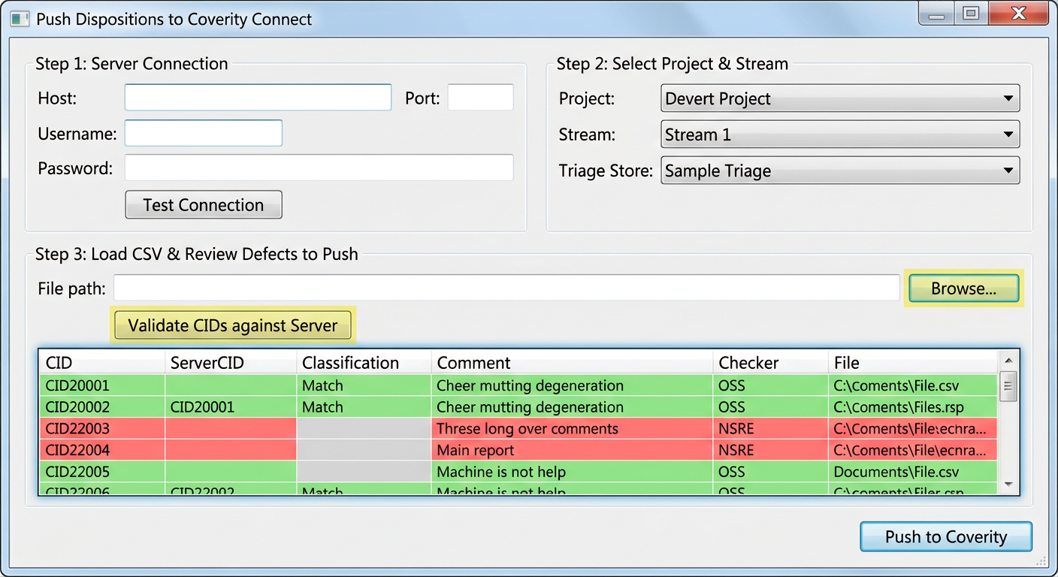
Figure 6 — Push Dialog (3 Steps). Validates CIDs exist in target project.
# | Highlight | What to Do
1 | Step 1 — Server Connection | Same Host/Port/User/Pass + Allow self-signed toggle → Test Connection → Connected (X projects found)
2 | Step 2 — Project & Stream + Triage Store | Project dropdown → Stream dropdown → Triage Store (auto-filled as <project>-TS, editable; usually matches project name, not Default)
3 | Step 3 — Load CSV & Review | Browse… → pick coverity_dispositions.csv or coverity_final_decisions.csv (CID + Classification required) → table shows CID | ServerCID | Classification | Comment (trunc) | Checker | File — double-click row to edit Classification/Comment before pushing
4 | Validate CIDs against Server | 🔍 Validate fetches all defects for the project and matches CSV CIDs by CID or (checker, basename). Green = matched, Red = NOT FOUND (removed — belongs to other project). Auto-validates after load.
5 | ⬆ Push to Coverity | Pushes in batches of 100 CIDs via updateTriageForCIDsInTriageStore → shows Succeeded/Failed + first error + tip: Try triage store = '<project>'
- 1. Header → ⬆ Push to Coverity → fill Host/Port/User/Pass → check Allow self-signed if needed → Test Connection
- 2. Pick Project → Stream → verify Triage Store (if push fails, try store = project name, not Default; use ... button to list DefectService SOAP methods for debugging)
- 3. Step 3 → Browse… → pick your CSV (the tool accepts both dispositions.csv and final_decisions.csv layouts, dedupes by CID keeping last)
- 4. Wait for auto-validate (or click 🔍 Validate) → green rows = ready to push, red rows auto-removed
- 5. Double-click any row to edit Classification/Comment if needed → then ⬆ Push to Coverity → watch Pushing 1/12… → Push Complete: Succeeded: 12, Failed: 0
- 6. If Failed >0 and error is Triage Store, change store and retry; if CID NOT FOUND, you picked wrong project

15. Decision Engine — Confidence, CWE/CERT/OWASP
The engine is not ML — it is weighted evidence with Z3/path-prover/flow-analysis where available. Every disposition cites CWE as primary taxonomy.
Classification | What It Means | Confidence & Evidence
Bug | Real defect | Confidence = 0.55+winner*0.22+dominance*0.15 etc. → capped. High ≥0.85 → close after sanity check.
False positive | Guard dominates all paths, or bounded API with sizeof-1 + NUL, or caller bounds proven | Critical FP labels (guard_dominates_all_paths, safe_bounded_api_with_sizeof) +0.15 if bug<0.3
Intentional | Deliberately ignored: (void) cast, ignore comment, #if 0, fallthrough annotation | Only for CHECKED_RETURN, DEADCODE, NO_BREAK, etc. — not for BUFFER_SIZE
Needs review | Honest 'I don't know' — no source/function, or conflicting evidence, or line Various | Honest fallback; reason shown in needs_review_breakdown.txt
CWE example: BUFFER_SIZE → CWE-120 Buffer Copy without Checking Size (CERT STR31-C, A03:2021 Injection, CVSS 8.1, https://cwe.mitre.org/data/definitions/120.html). The Comment paragraph starts with CWE-120 and ends with Reference: CWE-120 | ... | URL. Proposed Fix is code-exact (e.g., strncpy(buf,src,sizeof(buf)-1); buf[sizeof(buf)-1]='\0'; // CWE-120) — just suggestion, copy-pasteable with real variables.

16. Troubleshooting & Performance
Symptom | Fix
Tool feels slow / stuck at 0 / N analysing... | Indexing source tree once (cached) — wait for 'Workspace indexed in Xs — starting per-defect analysis.' ETA is per-defect only (indexing excluded) so it is realistic. Second run is fast. Per-file semgrep is OFF by default (COVERITY_ENABLE_SEMGREP=1 to enable).
No table found in index.html | HTML layout differs. Open index.html, find <table>, adjust html_report_parser.py or provide sample.
File not found for source files | Coverity report paths must match on-disk layout. Set Source Code Root correctly; tool also searches by suffix-score and basename.
Tree-sitter fails to parse my C++ code | Use C++ (.cpp/.c) language option. For mixed projects run twice.
Pull fails with SOAP Fault | Copy log's [shape,pageSize=] line. Missing element sortAscending is now handled (all pageSpec shapes include sortAscending with exact casing).
Pull REST 0 defects but SOAP has defects | REST base discovery probed ports/roots concurrently (8 workers, 3s). If REST unavailable, it falls back to SOAP and overlays REST lines if Pull dialog's Fix current lines is checked.
Push: 0 Succeeded, Failed: N, First error: Triage Store | Try store = project name (e.g., MyProject-TS), not Default. Use ... to list getTriageStores().
Needs review for everything | Intended for checkers with no rule yet or line Various. Add rule in heuristic_analyzer.py dispatch or provide concrete line.
Analysis completed very quickly (<50ms/defect) | Source files not loading. Check Source Root path; watch log for [Source] Loading: lines.

Performance numbers (post-fix v7)
- Workspace call-site index: built once, O(files) not O(defects). Before: per-defect full-tree walk → stuck on large reports. After: one walk, cached.
- Per-file tree-sitter parse cache keyed by mtime → defects in same file don't re-parse.
- Workspace symbol index (_INDEX_CACHE) cached per src_root+language.
- File content LRU (500 files, skip >1MB) → ~25 MB cap, no OOM.
- Skip build dirs (.git, build, node_modules, .venv) and >500 KB files.

17. Security & Privacy
- Source code never leaves your machine. Pull/Push only sends defects (CID, file, line, checker) and your triage decisions (Classification, Comment) to your Coverity Connect server.
- verify_ssl=True by default (secure). For corporate self-signed certs, check Allow self-signed certificate (insecure — verify off) in Pull/Push dialogs. Do not use insecure for production with valid cert.
- Passwords/tokens are held in memory only, never logged. The log shows _merged_line/_inst_line etc., not credentials.
- InsecureRequestWarning is suppressed only for the session with verify off, not globally.

Appendix A: Supported Checkers & CWE/CERT/OWASP Map
Categories (checker_categories.py CATEGORY_ORDER): Buffer overflow, Memory - corruptions, Memory - illegal accesses, Null pointer dereferences, Integer handling, Resource leaks, Error handling, Control flow / code quality, Uncategorized (fallback).
Category | Checker | CWE | CERT
Buffer overflow | BUFFER_SIZE | CWE-120 Buffer Copy without Checking Size of Input | STR31-C
Buffer overflow | BUFFER_SIZE_WARNING | CWE-120 Buffer Copy without Checking Size of Input | STR31-C
Buffer overflow | OVERRUN | CWE-125 Out-of-bounds Read | ARR30-C
Buffer overflow | OVERRUN_STATIC | CWE-787 Out-of-bounds Write | ARR30-C
Buffer overflow | OVERRUN_DYNAMIC | CWE-787 Out-of-bounds Write | ARR30-C
Buffer overflow | STRING_OVERFLOW | CWE-120 Buffer Copy without Checking Size of Input | STR31-C
Buffer overflow | STRING_NULL | CWE-170 Improper Null Termination | STR32-C
Buffer overflow | TAINTED_STRING | CWE-20 Improper Input Validation | STR31-C
Buffer overflow | WRAPPER_OVERRUN | CWE-787 Out-of-bounds Write | ARR30-C
Memory - corruptions | DOUBLE_FREE | CWE-415 Double Free | MEM31-C
Memory - corruptions | FREE_RETURNS | CWE-416 Use After Free | MEM30-C
Memory - corruptions | SIZEOF_MISMATCH | CWE-467 Use of sizeof() on a Pointer Type | ARR01-C
Memory - corruptions | WRAPPER_ESCAPE | CWE-416 Use After Free | MEM30-C
Memory - illegal accesses | ARRAY_VS_SINGLETON | CWE-131 Incorrect Calculation of Buffer Size | ARR36-C
Memory - illegal accesses | UNINIT | CWE-457 Use of Uninitialized Variable | EXP33-C
Memory - illegal accesses | UNINIT_CTOR | CWE-457 Use of Uninitialized Variable | EXP33-C
Memory - illegal accesses | UNREACHABLE | CWE-561 Dead Code | MSC12-C
Memory - illegal accesses | USE_AFTER_FREE | CWE-416 Use After Free | MEM30-C
Memory - illegal accesses | NULL_RETURNS | CWE-690 Unchecked Return Value to NULL Pointer Dereference | EXP34-C
Null pointer dereferences | FORWARD_NULL | CWE-476 NULL Pointer Dereference | EXP34-C
Null pointer dereferences | REVERSE_INULL | CWE-476 NULL Pointer Dereference | EXP34-C
Null pointer dereferences | NULL_DEREF | CWE-476 NULL Pointer Dereference | EXP34-C
Integer handling | CONSTANT_EXPRESSION_RESULT | CWE-570 Expression is Always False | MSC12-C
Integer handling | DIVIDE_BY_ZERO | CWE-369 Divide By Zero | INT33-C
Integer handling | INTEGER_OVERFLOW | CWE-190 Integer Overflow or Wraparound | INT32-C
Integer handling | SHIFT_OVERFLOW | CWE-758 Reliance on Undefined, Unspecified, or Implementation-Defined Behavior | INT34-C
Integer handling | SIGN_EXTENSION | CWE-194 Unexpected Sign Extension | INT31-C
Resource leaks | RESOURCE_LEAK | CWE-401 Missing Release of Memory after Effective Lifetime | MEM31-C
Resource leaks | UNRELEASED_RESOURCE | CWE-404 Improper Resource Shutdown or Release | FIO42-C
Error handling | CHECKED_RETURN | CWE-703 Incorrect Check or Handling of Exceptional Conditions | EXP12-C
Error handling | NEGATIVE_RETURNS | CWE-20 Improper Input Validation | ERR33-C
Error handling | NEGATIVE_RELEASE | CWE-404 Improper Resource Shutdown or Release | FIO42-C
Error handling | MISSING_LOCK | CWE-412 Unrestricted Externally Accessible Lock | CON32-C
Control flow / code quality | DEADCODE | CWE-561 Dead Code | MSC12-C
Control flow / code quality | UNUSED_VALUE | CWE-563 Assignment to Variable without Use | MSC13-C
Control flow / code quality | MISSING_BREAK | CWE-484 Omitted Break Statement in Switch | MSC17-C
Control flow / code quality | NO_BREAK | CWE-484 Omitted Break Statement in Switch | MSC17-C
Control flow / code quality | IDENTICAL_BRANCHES | CWE-561 Dead Code | MSC12-C

Appendix B: Quick Start TL;DR
python -m venv .venv
.\.venv\Scripts\Activate.ps1 # Windows
pip install -r requirements.txt
python local_gui.py
1. Point Coverity Report at index.html folder (or ⬇ Pull from Coverity)
2. Set Source Code Root to your C/C++ sources (repo root)
3. ▶ Start Disposition → wait → double-click and Accept / Override each finding
4. ⬆ Push to Coverity to write decisions back, or Export to Excel
* Source code never leaves your machine *

Appendix C: EXE Build & Setup Instructions
For teams without Python, ship the EXE one-folder build. Build on Windows (PyInstaller needs Windows to make .exe).
File in Setup Folder | Purpose
build_exe.bat | Double-click to build: creates venv, pip install, pyinstaller CoverityTool.spec → dist/CoverityTool/CoverityTool.exe
CoverityTool.spec | PyInstaller spec (one-folder, --windowed, hidden imports: zeep, lxml, tree_sitter, z3, etc., datas: tcl/tk)
run_tool.bat / run_tool.ps1 | Launchers that set TCL_LIBRARY/TK_LIBRARY and run exe; use if direct exe fails with _tkinter error
requirements.txt | Pinned versions (lxml==5.2.2, zeep==4.2.1, z3-solver==4.12.6.0, tree-sitter==0.23.2...)
README.txt | 5-line quick start for testers (unzip → double-click)
Build steps on Windows: 1) Install Python 3.10+ from python.org (check Add to PATH) 2) Unzip Coverity-Tool-Setup.zip 3) Double-click build_exe.bat → wait 2-4 min → dist/CoverityTool/CoverityTool.exe appears. Ship the whole dist/CoverityTool folder (exe + _internal) as a zip. Testers just unzip and double-click CoverityTool.exe — no Python needed.

