|  |  |
| --- | --- |
| **Greenleafhopper** | **Spiny_beetle** |
| **Horn_caterpillar** | **Beetle** |

Training the data with yolov5s.pt model and result will be save in last.pt model having the p value=0.94 and R value=55

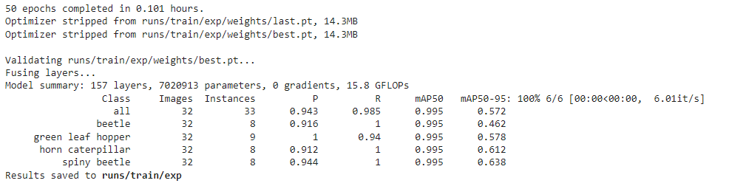

#label the data using makesense to make data yolov5 format

