**Name:** Rakesh Jadhav

**USN:** 1BM20CS122

**MACHINE LEARNING LAB OBSERVATION**

**Date:** 1-04-2023

**Lab 1:** Exploring Datasets

**IRIS DATASET:**

from sklearn.datasets import load_iris

iris = load_iris()

iris

{'data': array([[5.1, 3.5, 1.4, 0.2], [4.9, 3. , 1.4, 0.2], [4.7, 3.2, 1.3, 0.2], [4.6, 3.1, 1.5, 0.2], [5. , 3.6, 1.4, 0.2], [5.4, 3.9, 1.7, 0.4], [4.6, 3.4, 1.4, 0.3], [5. , 3.4, 1.5, 0.2], [4.4, 2.9, 1.4, 0.2], [4.9, 3.1, 1.5, 0.1], [5.4, 3.7, 1.5, 0.2], [4.8, 3.4, 1.6, 0.2], [4.8, 3. , 1.4, 0.1], [4.3, 3. , 1.1, 0.1], [5.8, 4. , 1.2, 0.2], [5.7, 4.4, 1.5, 0.4], [5.4, 3.9, 1.3, 0.4], [5.1, 3.5, 1.4, 0.3], [5.7, 3.8, 1.7, 0.3], [5.1, 3.8, 1.5, 0.3], [5.4, 3.4, 1.7, 0.2], [5.1, 3.7, 1.5, 0.4], [4.6, 3.6, 1. , 0.2], [5.1, 3.3, 1.7, 0.5], [4.8, 3.4, 1.9, 0.2], [5. , 3. , 1.6, 0.2], [5. , 3.4, 1.6, 0.4], [5.2, 3.5, 1.5, 0.2], [5.2, 3.4, 1.4, 0.2], [4.7, 3.2, 1.6, 0.2], [4.8, 3.1, 1.6, 0.2], [5.4, 3.4, 1.5, 0.4], [5.2, 4.1, 1.5, 0.1], [5.5, 4.2, 1.4, 0.2], [4.9, 3.1, 1.5, 0.2], [5. , 3.2, 1.2, 0.2], [5.5, 3.5, 1.3, 0.2], [4.9, 3.6, 1.4, 0.1], [4.4, 3. , 1.3, 0.2], [5.1, 3.4, 1.5, 0.2], [5. , 3.5, 1.3, 0.3], [4.5, 2.3, 1.3, 0.3], [4.4, 3.2, 1.3, 0.2], [5. , 3.5, 1.6, 0.6], [5.1, 3.8, 1.9, 0.4], [4.8, 3. , 1.4, 0.3], [5.1, 3.8, 1.6, 0.2], [4.6, 3.2, 1.4, 0.2], [5.3, 3.7, 1.5, 0.2], [5. , 3.3, 1.4, 0.2], [7. , 3.2, 4.7, 1.4], [6.4, 3.2, 4.5, 1.5], [6.9, 3.1, 4.9, 1.5], [5.5, 2.3, 4. , 1.3], [6.5, 2.8, 4.6, 1.5], [5.7, 2.8, 4.5, 1.3], [6.3, 3.3, 4.7, 1.6], [4.9, 2.4, 3.3, 1. ], [6.6, 2.9, 4.6, 1.3], [5.2, 2.7, 3.9, 1.4], [5. , 2. , 3.5, 1. ], [5.9, 3. , 4.2, 1.5], [6. , 2.2, 4. , 1. ], [6.1, 2.9, 4.7, 1.4], [5.6, 2.9, 3.6, 1.3], [6.7, 3.1, 4.4, 1.4], [5.6, 3. , 4.5, 1.5], [5.8, 2.7, 4.1, 1. ], [6.2, 2.2, 4.5, 1.5], [5.6, 2.5, 3.9, 1.1], [5.9, 3.2, 4.8, 1.8], [6.1, 2.8, 4. , 1.3], [6.3, 2.5, 4.9, 1.5], [6.1, 2.8, 4.7, 1.2], [6.4, 2.9, 4.3, 1.3], [6.6, 3. , 4.4, 1.4], [6.8, 2.8, 4.8, 1.4], [6.7, 3. , 5. , 1.7], [6. , 2.9, 4.5, 1.5], [5.7, 2.6, 3.5, 1. ], [5.5, 2.4, 3.8, 1.1], [5.5, 2.4, 3.7, 1. ], [5.8, 2.7, 3.9, 1.2], [6. , 2.7, 5.1, 1.6], [5.4, 3. , 4.5, 1.5], [6. , 3.4, 4.5, 1.6], [6.7, 3.1, 4.7, 1.5], [6.3, 2.3, 4.4, 1.3], [5.6, 3. , 4.1, 1.3], [5.5, 2.5, 4. , 1.3], [5.5, 2.6, 4.4, 1.2], [6.1, 3. , 4.6, 1.4], [5.8, 2.6, 4. , 1.2], [5. , 2.3, 3.3, 1. ], [5.6, 2.7, 4.2, 1.3], [5.7, 3. , 4.2, 1.2], [5.7, 2.9, 4.2, 1.3], [6.2, 2.9, 4.3, 1.3], [5.1, 2.5, 3. , 1.1], [5.7, 2.8, 4.1, 1.3], [6.3, 3.3, 6. , 2.5], [5.8, 2.7, 5.1, 1.9], [7.1, 3. , 5.9, 2.1], [6.3, 2.9, 5.6, 1.8], [6.5, 3. , 5.8, 2.2], [7.6, 3. , 6.6, 2.1], [4.9, 2.5, 4.5, 1.7], [7.3, 2.9, 6.3, 1.8], [6.7, 2.5, 5.8, 1.8], [7.2, 3.6, 6.1, 2.5], [6.5, 3.2, 5.1, 2. ], [6.4, 2.7, 5.3, 1.9], [6.8, 3. , 5.5, 2.1], [5.7, 2.5, 5. , 2. ], [5.8, 2.8, 5.1, 2.4], [6.4, 3.2, 5.3, 2.3], [6.5, 3. , 5.5, 1.8], [7.7, 3.8, 6.7, 2.2], [7.7, 2.6, 6.9, 2.3], [6. , 2.2, 5. , 1.5], [6.9, 3.2, 5.7, 2.3], [5.6, 2.8, 4.9, 2. ], [7.7, 2.8, 6.7, 2. ], [6.3, 2.7, 4.9, 1.8], [6.7, 3.3, 5.7, 2.1], [7.2, 3.2, 6. , 1.8], [6.2, 2.8, 4.8, 1.8], [6.1, 3. , 4.9, 1.8], [6.4, 2.8, 5.6, 2.1], [7.2, 3. , 5.8, 1.6], [7.4, 2.8, 6.1, 1.9], [7.9, 3.8, 6.4, 2. ], [6.4, 2.8, 5.6, 2.2], [6.3, 2.8, 5.1, 1.5], [6.1, 2.6, 5.6, 1.4], [7.7, 3. , 6.1, 2.3], [6.3, 3.4, 5.6, 2.4], [6.4, 3.1, 5.5, 1.8], [6. , 3. , 4.8, 1.8], [6.9, 3.1, 5.4, 2.1], [6.7, 3.1, 5.6, 2.4], [6.9, 3.1, 5.1, 2.3], [5.8, 2.7, 5.1, 1.9], [6.8, 3.2, 5.9, 2.3], [6.7, 3.3, 5.7, 2.5], [6.7, 3. , 5.2, 2.3], [6.3, 2.5, 5. , 1.9], [6.5, 3. , 5.2, 2. ], [6.2, 3.4, 5.4, 2.3], [5.9, 3. , 5.1, 1.8]]), 'target': array([0, 0, 0, 0, 0, 0, 0, 0, 0, 0, 0, 0, 0, 0, 0, 0, 0, 0, 0, 0, 0, 0, 0, 0, 0, 0, 0, 0, 0, 0, 0, 0, 0, 0, 0, 0, 0, 0, 0, 0, 0, 0, 0, 0, 0, 0, 0, 0, 0, 0, 1, 1, 1, 1, 1, 1, 1, 1, 1, 1, 1, 1, 1, 1, 1, 1, 1, 1, 1, 1, 1, 1, 1, 1, 1, 1, 1, 1, 1, 1, 1, 1, 1, 1, 1, 1, 1, 1, 1, 1, 1, 1, 1, 1, 1, 1, 1, 1, 1, 1, 2, 2, 2, 2, 2, 2, 2, 2, 2, 2, 2, 2, 2, 2, 2, 2, 2, 2, 2, 2, 2, 2, 2, 2, 2, 2, 2, 2, 2, 2, 2, 2, 2, 2, 2, 2, 2, 2, 2, 2, 2, 2, 2, 2, 2, 2, 2, 2, 2, 2]), 'frame': None, 'target_names': array(['setosa', 'versicolor', 'virginica'], dtype='<U10'), 'DESCR': '.. _iris_dataset:\n\nIris plants dataset\n--------------------\n\n**Data Set Characteristics:**\n\n :Number of Instances: 150 (50 in each of three classes)\n :Number of Attributes: 4 numeric, predictive attributes and the class\n :Attribute Information:\n - sepal length in cm\n - sepal width in cm\n - petal length in cm\n - petal width in cm\n - class:\n - Iris-Setosa\n - Iris-Versicolour\n - Iris-Virginica\n \n :Summary Statistics:\n\n ============== ==== ==== ======= ===== ====================\n Min Max Mean SD Class Correlation\n ============== ==== ==== ======= ===== ====================\n sepal length: 4.3 7.9 5.84 0.83 0.7826\n sepal width: 2.0 4.4 3.05 0.43 -0.4194\n petal length: 1.0 6.9 3.76 1.76 0.9490 (high!)\n petal width: 0.1 2.5 1.20 0.76 0.9565 (high!)\n ============== ==== ==== ======= ===== ====================\n\n :Missing Attribute Values: None\n :Class Distribution: 33.3% for each of 3 classes.\n :Creator: R.A. Fisher\n :Donor: Michael Marshall ([MARSHALL%PLU@io.arc.nasa.gov](mailto:MARSHALL%25PLU@io.arc.nasa.gov))\n :Date: July, 1988\n\nThe famous Iris database, first used by Sir R.A. Fisher. The dataset is taken\nfrom Fisher\'s paper. Note that it\'s the same as in R, but not as in the UCI\nMachine Learning Repository, which has two wrong data points.\n\nThis is perhaps the best known database to be found in the\npattern recognition literature. Fisher\'s paper is a classic in the field and\nis referenced frequently to this day. (See Duda & Hart, for example.) The\ndata set contains 3 classes of 50 instances each, where each class refers to a\ntype of iris plant. One class is linearly separable from the other 2; the\nlatter are NOT linearly separable from each other.\n\n.. topic:: References\n\n - Fisher, R.A. "The use of multiple measurements in taxonomic problems"\n Annual Eugenics, 7, Part II, 179-188 (1936); also in "Contributions to\n Mathematical Statistics" (John Wiley, NY, 1950).\n - Duda, R.O., & Hart, P.E. (1973) Pattern Classification and Scene Analysis.\n (Q327.D83) John Wiley & Sons. ISBN 0-471-22361-1. See page 218.\n - Dasarathy, B.V. (1980) "Nosing Around the Neighborhood: A New System\n Structure and Classification Rule for Recognition in Partially Exposed\n Environments". IEEE Transactions on Pattern Analysis and Machine\n Intelligence, Vol. PAMI-2, No. 1, 67-71.\n - Gates, G.W. (1972) "The Reduced Nearest Neighbor Rule". IEEE Transactions\n on Information Theory, May 1972, 431-433.\n - See also: 1988 MLC Proceedings, 54-64. Cheeseman et al"s AUTOCLASS II\n conceptual clustering system finds 3 classes in the data.\n - Many, many more ...', 'feature_names': ['sepal length (cm)', 'sepal width (cm)', 'petal length (cm)', 'petal width (cm)'], 'filename': 'iris.csv', 'data_module': 'sklearn.datasets.data'}

type(iris)

sklearn.utils.Bunch

iris.keys()

dict_keys(['data', 'target', 'frame', 'target_names', 'DESCR', 'feature_names', 'filename', 'data_module'])

n_samples, n_features = iris.data.shape

print("number of samples:",n_samples)

print("number of features:",n_features)

print(iris.data[0])

number of samples: 150

number of features: 4

[5.1 3.5 1.4 0.2]

iris.data[[12,26,89,114]]

array([[4.8, 3. , 1.4, 0.1], [5. , 3.4, 1.6, 0.4], [5.5, 2.5, 4. , 1.3], [5.8, 2.8, 5.1, 2.4]])

print(iris.data.shape)

print(iris.target.shape)

(150, 4)

(150,)

print(iris.target)

[0 0 0 0 0 0 0 0 0 0 0 0 0 0 0 0 0 0 0 0 0 0 0 0 0 0 0 0 0 0 0 0 0 0 0 0 0

0 0 0 0 0 0 0 0 0 0 0 0 0 1 1 1 1 1 1 1 1 1 1 1 1 1 1 1 1 1 1 1 1 1 1 1 1

1 1 1 1 1 1 1 1 1 1 1 1 1 1 1 1 1 1 1 1 1 1 1 1 1 1 2 2 2 2 2 2 2 2 2 2 2

2 2 2 2 2 2 2 2 2 2 2 2 2 2 2 2 2 2 2 2 2 2 2 2 2 2 2 2 2 2 2 2 2 2 2 2 2

2 2]

import numpy as np

np.bincount(iris.target)

array([50, 50, 50])

print(iris.target_names)

['setosa' 'versicolor' 'virginica']

**WINE DATASET:**

from sklearn.datasets import load_wine

wine = load_wine()

wine

{'data': array([[1.423e+01, 1.710e+00, 2.430e+00, ..., 1.040e+00, 3.920e+00, 1.065e+03], [1.320e+01, 1.780e+00, 2.140e+00, ..., 1.050e+00, 3.400e+00, 1.050e+03], [1.316e+01, 2.360e+00, 2.670e+00, ..., 1.030e+00, 3.170e+00, 1.185e+03], ..., [1.327e+01, 4.280e+00, 2.260e+00, ..., 5.900e-01, 1.560e+00, 8.350e+02], [1.317e+01, 2.590e+00, 2.370e+00, ..., 6.000e-01, 1.620e+00, 8.400e+02], [1.413e+01, 4.100e+00, 2.740e+00, ..., 6.100e-01, 1.600e+00, 5.600e+02]]), 'target': array([0, 0, 0, 0, 0, 0, 0, 0, 0, 0, 0, 0, 0, 0, 0, 0, 0, 0, 0, 0, 0, 0, 0, 0, 0, 0, 0, 0, 0, 0, 0, 0, 0, 0, 0, 0, 0, 0, 0, 0, 0, 0, 0, 0, 0, 0, 0, 0, 0, 0, 0, 0, 0, 0, 0, 0, 0, 0, 0, 1, 1, 1, 1, 1, 1, 1, 1, 1, 1, 1, 1, 1, 1, 1, 1, 1, 1, 1, 1, 1, 1, 1, 1, 1, 1, 1, 1, 1, 1, 1, 1, 1, 1, 1, 1, 1, 1, 1, 1, 1, 1, 1, 1, 1, 1, 1, 1, 1, 1, 1, 1, 1, 1, 1, 1, 1, 1, 1, 1, 1, 1, 1, 1, 1, 1, 1, 1, 1, 1, 1, 2, 2, 2, 2, 2, 2, 2, 2, 2, 2, 2, 2, 2, 2, 2, 2, 2, 2, 2, 2, 2, 2, 2, 2, 2, 2, 2, 2, 2, 2, 2, 2, 2, 2, 2, 2, 2, 2, 2, 2, 2, 2, 2, 2, 2, 2, 2, 2]), 'frame': None, 'target_names': array(['class_0', 'class_1', 'class_2'], dtype='<U7'), 'DESCR': '.. _wine_dataset:\n\nWine recognition dataset\n------------------------\n\n**Data Set Characteristics:**\n\n :Number of Instances: 178 (50 in each of three classes)\n :Number of Attributes: 13 numeric, predictive attributes and the class\n :Attribute Information:\n \t\t- Alcohol\n \t\t- Malic acid\n \t\t- Ash\n\t\t- Alcalinity of ash \n \t\t- Magnesium\n\t\t- Total phenols\n \t\t- Flavanoids\n \t\t- Nonflavanoid phenols\n \t\t- Proanthocyanins\n\t\t- Color intensity\n \t\t- Hue\n \t\t- OD280/OD315 of diluted wines\n \t\t- Proline\n\n - class:\n - class_0\n - class_1\n - class_2\n\t\t\n :Summary Statistics:\n \n ============================= ==== ===== ======= =====\n Min Max Mean SD\n ============================= ==== ===== ======= =====\n Alcohol: 11.0 14.8 13.0 0.8\n Malic Acid: 0.74 5.80 2.34 1.12\n Ash: 1.36 3.23 2.36 0.27\n Alcalinity of Ash: 10.6 30.0 19.5 3.3\n Magnesium: 70.0 162.0 99.7 14.3\n Total Phenols: 0.98 3.88 2.29 0.63\n Flavanoids: 0.34 5.08 2.03 1.00\n Nonflavanoid Phenols: 0.13 0.66 0.36 0.12\n Proanthocyanins: 0.41 3.58 1.59 0.57\n Colour Intensity: 1.3 13.0 5.1 2.3\n Hue: 0.48 1.71 0.96 0.23\n OD280/OD315 of diluted wines: 1.27 4.00 2.61 0.71\n Proline: 278 1680 746 315\n ============================= ==== ===== ======= =====\n\n :Missing Attribute Values: None\n :Class Distribution: class_0 (59), class_1 (71), class_2 (48)\n :Creator: R.A. Fisher\n :Donor: Michael Marshall ([MARSHALL%PLU@io.arc.nasa.gov](mailto:MARSHALL%25PLU@io.arc.nasa.gov))\n :Date: July, 1988\n\nThis is a copy of UCI ML Wine recognition datasets.\nhttps://archive.ics.uci.edu/ml/machine-learning-databases/wine/wine.data\n\nThe data is the results of a chemical analysis of wines grown in the same\nregion in Italy by three different cultivators. There are thirteen different\nmeasurements taken for different constituents found in the three types of\nwine.\n\nOriginal Owners: \n\nForina, M. et al, PARVUS - \nAn Extendible Package for Data Exploration, Classification and Correlation. \nInstitute of Pharmaceutical and Food Analysis and Technologies,\nVia Brigata Salerno, 16147 Genoa, Italy.\n\nCitation:\n\nLichman, M. (2013). UCI Machine Learning Repository\n[<https://archive.ics.uci.edu/ml>]. Irvine, CA: University of California,\nSchool of Information and Computer Science. \n\n.. topic:: References\n\n (1) S. Aeberhard, D. Coomans and O. de Vel, \n Comparison of Classifiers in High Dimensional Settings, \n Tech. Rep. no. 92-02, (1992), Dept. of Computer Science and Dept. of \n Mathematics and Statistics, James Cook University of North Queensland. \n (Also submitted to Technometrics). \n\n The data was used with many others for comparing various \n classifiers. The classes are separable, though only RDA \n has achieved 100% correct classification. \n (RDA : 100%, QDA 99.4%, LDA 98.9%, 1NN 96.1% (z-transformed data)) \n (All results using the leave-one-out technique) \n\n (2) S. Aeberhard, D. Coomans and O. de Vel, \n "THE CLASSIFICATION PERFORMANCE OF RDA" \n Tech. Rep. no. 92-01, (1992), Dept. of Computer Science and Dept. of \n Mathematics and Statistics, James Cook University of North Queensland. \n (Also submitted to Journal of Chemometrics).\n', 'feature_names': ['alcohol', 'malic_acid', 'ash', 'alcalinity_of_ash', 'magnesium', 'total_phenols', 'flavanoids', 'nonflavanoid_phenols', 'proanthocyanins', 'color_intensity', 'hue', 'od280/od315_of_diluted_wines', 'proline']}

type(wine)

sklearn.utils.Bunch

wine.keys()

dict_keys(['data', 'target', 'frame', 'target_names', 'DESCR', 'feature_names'])

print(wine.target_names)

['class_0' 'class_1' 'class_2']

n_samples,n_features = wine.data.shape

print("Number of samples:",n_samples)

print("Number of features:",n_features)

print(wine.data[1])

Number of samples: 178

Number of features: 13

[1.32e+01 1.78e+00 2.14e+00 1.12e+01 1.00e+02 2.65e+00 2.76e+00 2.60e-01

1.28e+00 4.38e+00 1.05e+00 3.40e+00 1.05e+03]

wine.data[[15,177,13,45]]

array([[1.363e+01, 1.810e+00, 2.700e+00, 1.720e+01, 1.120e+02, 2.850e+00, 2.910e+00, 3.000e-01, 1.460e+00, 7.300e+00, 1.280e+00, 2.880e+00, 1.310e+03], [1.413e+01, 4.100e+00, 2.740e+00, 2.450e+01, 9.600e+01, 2.050e+00, 7.600e-01, 5.600e-01, 1.350e+00, 9.200e+00, 6.100e-01, 1.600e+00, 5.600e+02], [1.475e+01, 1.730e+00, 2.390e+00, 1.140e+01, 9.100e+01, 3.100e+00, 3.690e+00, 4.300e-01, 2.810e+00, 5.400e+00, 1.250e+00, 2.730e+00, 1.150e+03], [1.421e+01, 4.040e+00, 2.440e+00, 1.890e+01, 1.110e+02, 2.850e+00, 2.650e+00, 3.000e-01, 1.250e+00, 5.240e+00, 8.700e-01, 3.330e+00, 1.080e+03]])

print(wine.data.shape)

print(wine.target.shape)

(178, 13)

(178,)

import numpy as np

np.bincount(wine.target)

array([59, 71, 48])

print(wine.target_names)

['class_0' 'class_1' 'class_2']

print(wine.target)

[0 0 0 0 0 0 0 0 0 0 0 0 0 0 0 0 0 0 0 0 0 0 0 0 0 0 0 0 0 0 0 0 0 0 0 0 0

0 0 0 0 0 0 0 0 0 0 0 0 0 0 0 0 0 0 0 0 0 0 1 1 1 1 1 1 1 1 1 1 1 1 1 1 1

1 1 1 1 1 1 1 1 1 1 1 1 1 1 1 1 1 1 1 1 1 1 1 1 1 1 1 1 1 1 1 1 1 1 1 1 1

1 1 1 1 1 1 1 1 1 1 1 1 1 1 1 1 1 1 1 2 2 2 2 2 2 2 2 2 2 2 2 2 2 2 2 2 2

2 2 2 2 2 2 2 2 2 2 2 2 2 2 2 2 2 2 2 2 2 2 2 2 2 2 2 2 2 2]

print(wine.feature_names)

['alcohol', 'malic_acid', 'ash', 'alcalinity_of_ash', 'magnesium', 'total_phenols', 'flavanoids', 'nonflavanoid_phenols', 'proanthocyanins', 'color_intensity', 'hue', 'od280/od315_of_diluted_wines', 'proline']

**Date:** 15/04/2023

**Lab 2:** FIND-S ALGORITHM

Implement and demonstrate the FIND-S algorithm for finding the most specific hypothesis based on a given set of training data samples. Read the training data from a .CSV file Data set:Enjoysport

**Dataset:**

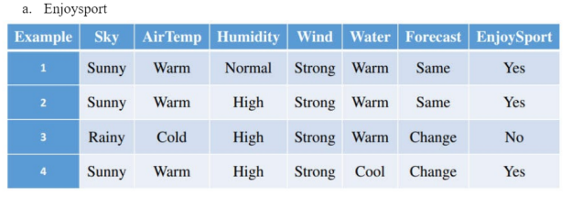

**Algorithm:**

1. Initialize the hypothesis with the attribute values from the first positive training sample.
2. For each subsequent positive training sample:
   * Compare each attribute value in the hypothesis with the corresponding attribute value in the sample.
   * If the attribute values differ, update the hypothesis attribute value to **?**.
3. Return the final hypothesis.

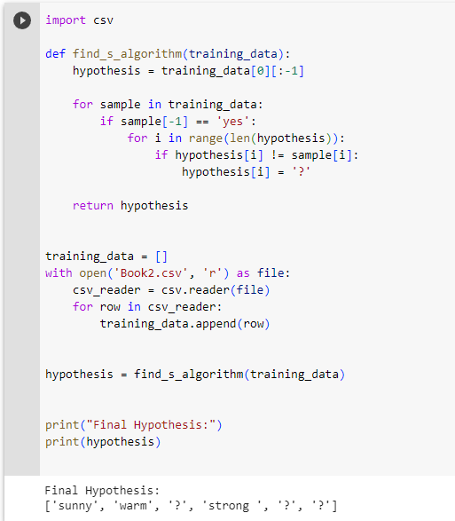**Code:**

**Observation:**

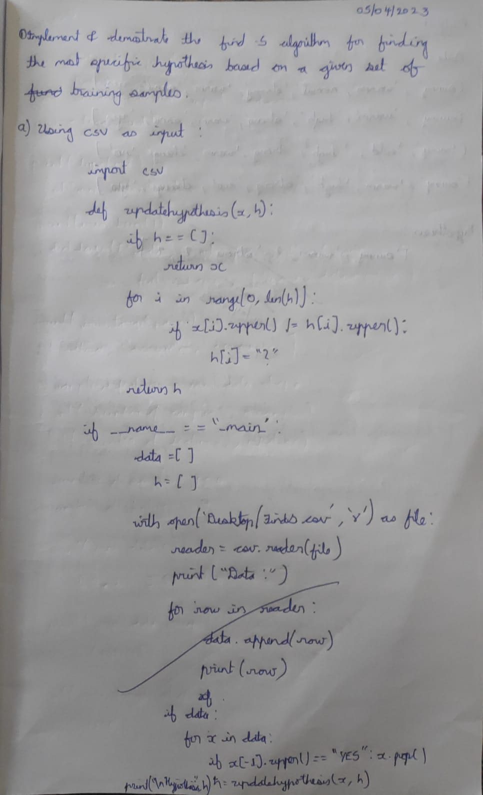

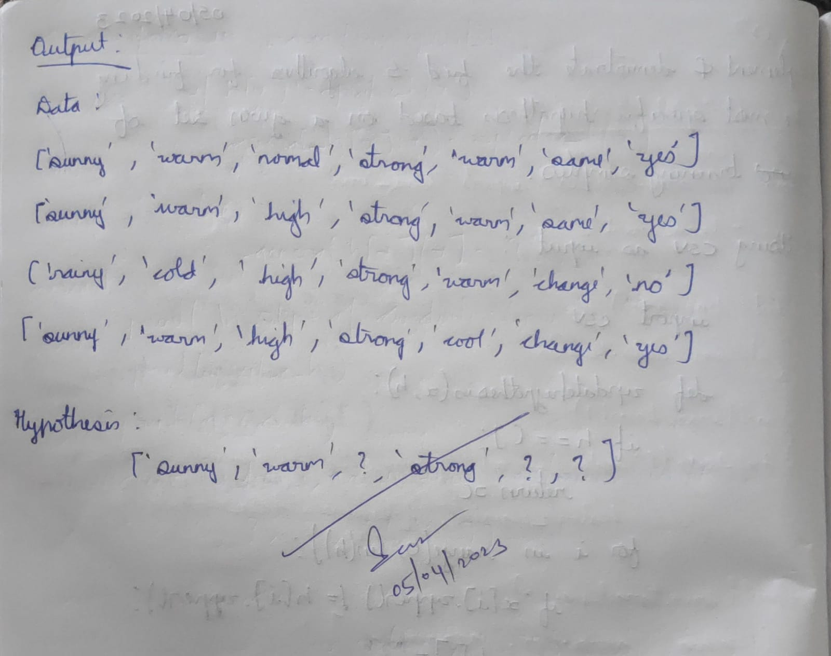

**DATE:** 15/04/2023

**LAB 3:** CANDIDATE- ELIMINATION

For a given set of training data examples stored in a .CSV file, implement and demonstrate the Candidate-Elimination algorithm to output a description of the set of all hypotheses consistent with the training examples. Data set:Enjoysport

**Dataset:**



**Algorithm:**

1. Initialize G to the set of maximally general hypotheses in H.
2. Initialize S to the set of maximally specific hypotheses in H.
3. For each training example d:
   * If d is a positive example:
     + Remove from G any hypothesis inconsistent with d.
     + For each hypothesis s in S that is not consistent with d:
       - Remove s from S.
       - Add to S all minimal generalizations h of s that are consistent with d and some member of G is more general than h.
       - Remove from S any hypothesis that is more general than another hypothesis in S.
   * If d is a negative example:
     + Remove from S any hypothesis inconsistent with d.
     + For each hypothesis g in G that is not consistent with d:
       - Remove g from G.
       - Add to G all minimal specializations h of g that are consistent with d and some member of S is more specific than h.
       - Remove from G any hypothesis that is less general than another hypothesis in G.

**Code:**

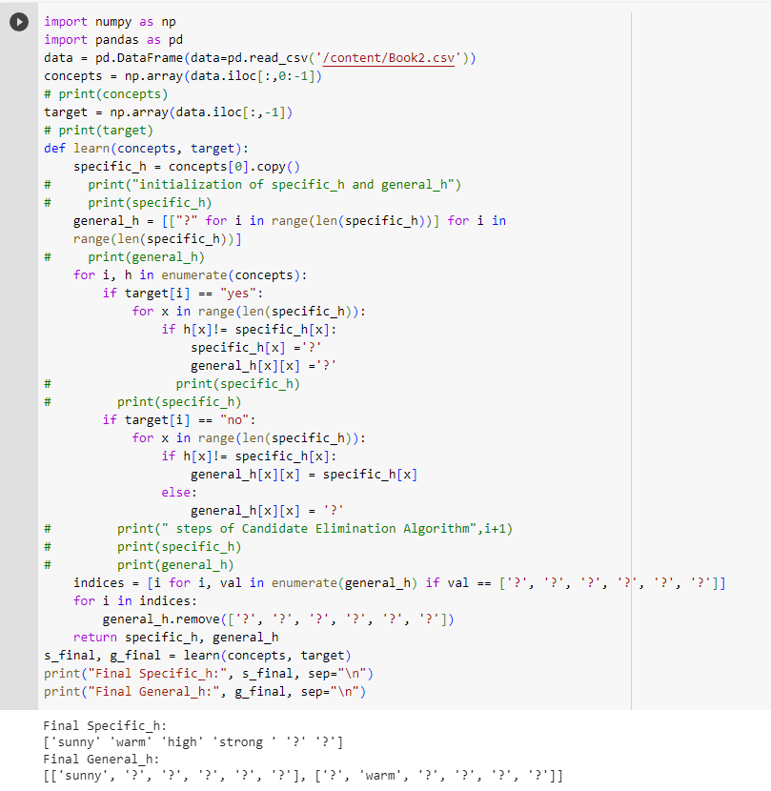

**Observation:**

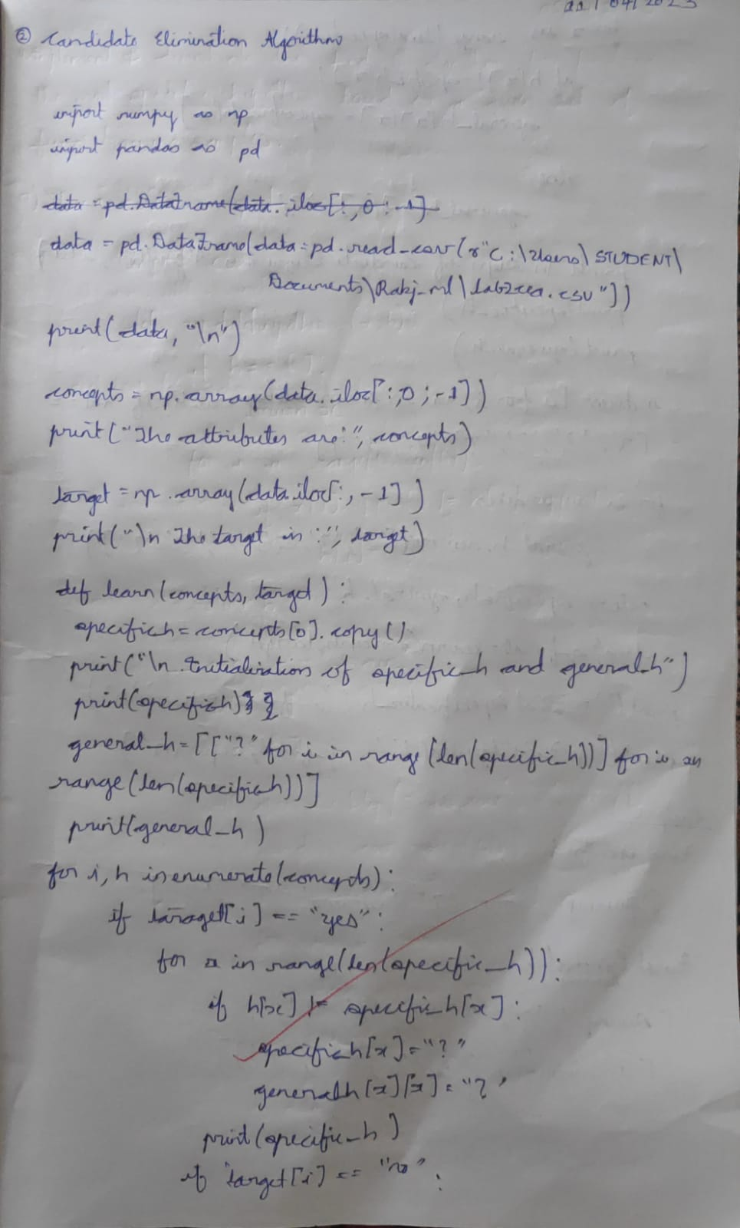

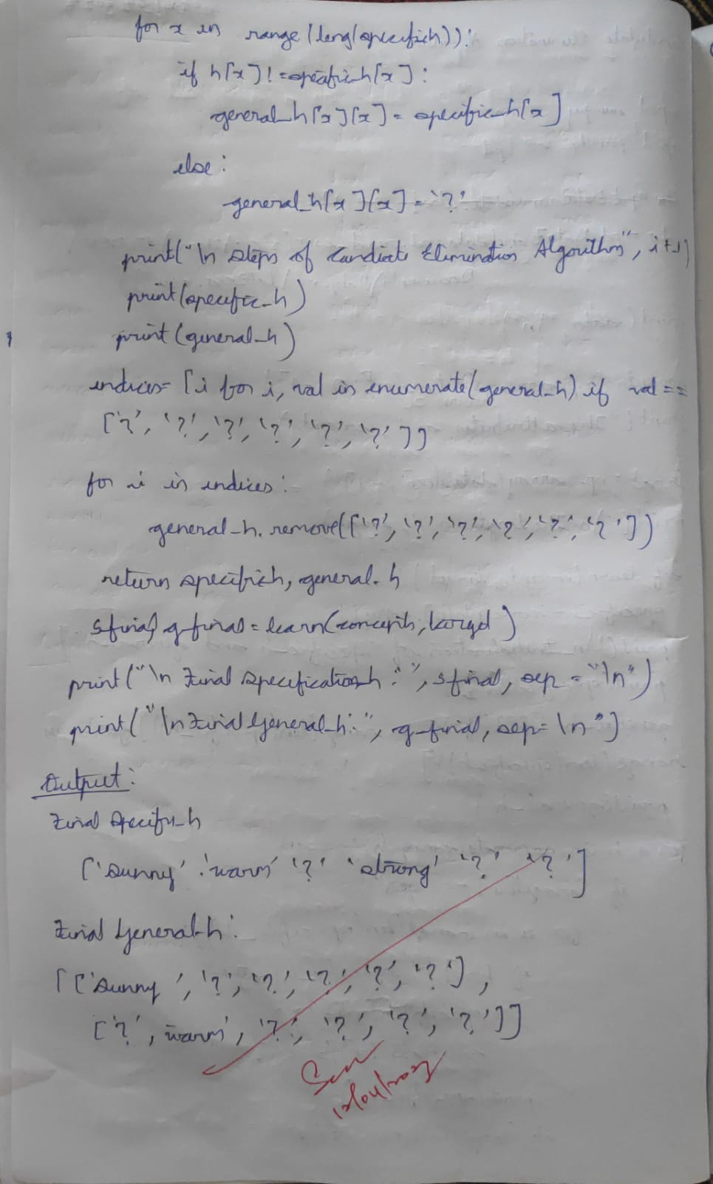

**DATE:** 03/05/2023

**LAB 4:** ID3 ALGORITHM

Write a program to demonstrate the working of the decision tree based ID3 algorithm. Use an appropriate data set for building the decision tree and apply this knowledge to classify a new sample.

**Dataset:**

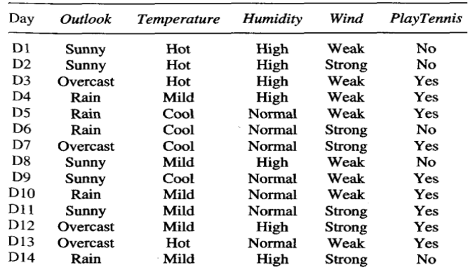

**Algorithm:**

1. Create a root node for the decision tree.
2. If all examples belong to the same class, return a leaf node with that class label.
3. If there are no more attributes to consider, return a leaf node with the majority class label of the examples.
4. Select the attribute that best classifies the examples using the information gain or another criterion.
5. Create a decision node for the selected attribute.
6. For each possible value of the selected attribute:
   * Create a new branch below the decision node.
   * Filter the examples that have the selected attribute value.
   * If the filtered examples are empty, add a leaf node with the majority class label of the examples.
   * Otherwise, recursively apply the ID3 algorithm to the filtered examples using the remaining attributes.
7. Return the root node of the decision tree.

**Code:**

**import** pandas **as** pd

**import** math

**import** numpy **as** np

data **=** pd**.**read_csv("/kaggle/input/id3hhhh/id3.csv")

features **=** [feat **for** feat **in** data]

features**.**remove("Answer")

**class** Node:

**def** __init__(self):

self**.**children **=** []

self**.**value **=** ""

self**.**isLeaf **=** **False**

self**.**pred **=** ""

**def** entropy(examples):

pos **=** 0.0

neg **=** 0.0

**for** _, row **in** examples**.**iterrows():

**if** row["Answer"] **==** "yes":

pos **+=** 1

**else**:

neg **+=** 1

**if** pos **==** 0.0 **or** neg **==** 0.0:

**return** 0.0

**else**:

p **=** pos **/** (pos **+** neg)

n **=** neg **/** (pos **+** neg)

**return** **-**(p **\*** math**.**log(p, 2) **+** n **\*** math**.**log(n, 2))

**def** info_gain(examples, attr):

uniq **=** np**.**unique(examples[attr])

*#print ("\n",uniq)*

gain **=** entropy(examples)

*#print ("\n",gain)*

**for** u **in** uniq:

subdata **=** examples[examples[attr] **==** u]

*#print ("\n",subdata)*

sub_e **=** entropy(subdata)

gain **-=** (float(len(subdata)) **/** float(len(examples))) **\*** sub_e

*#print ("\n",gain)*

**return** gain

**def** ID3(examples, attrs):

root **=** Node()

max_gain **=** 0

max_feat **=** ""

**for** feature **in** attrs:

*#print ("\n",examples)*

gain **=** info_gain(examples, feature)

**if** gain **>** max_gain:

max_gain **=** gain

max_feat **=** feature

root**.**value **=** max_feat

*#print ("\nMax feature attr",max_feat)*

uniq **=** np**.**unique(examples[max_feat])

*#print ("\n",uniq)*

**for** u **in** uniq:

*#print ("\n",u)*

subdata **=** examples[examples[max_feat] **==** u]

*#print ("\n",subdata)*

**if** entropy(subdata) **==** 0.0:

newNode **=** Node()

newNode**.**isLeaf **=** **True**

newNode**.**value **=** u

newNode**.**pred **=** np**.**unique(subdata["Answer"])

root**.**children**.**append(newNode)

**else**:

dummyNode **=** Node()

dummyNode**.**value **=** u

new_attrs **=** attrs**.**copy()

new_attrs**.**remove(max_feat)

child **=** ID3(subdata, new_attrs)

dummyNode**.**children**.**append(child)

root**.**children**.**append(dummyNode)

**return** root

**def** printTree(root: Node, depth**=**0):

**for** i **in** range(depth):

print("\t", end**=**"")

print(root**.**value, end**=**"")

**if** root**.**isLeaf:

print(" -> ", root**.**pred)

print()

**for** child **in** root**.**children:

printTree(child, depth **+** 1)

**def** classify(root: Node, new):

**for** child **in** root**.**children:

**if** child**.**value **==** new[root**.**value]:

**if** child**.**isLeaf:

print ("Predicted Label for new example", new," is:", child**.**pred)

exit

**else**:

classify (child**.**children[0], new)

root **=** ID3(data, features)

print("Decision Tree is:")

printTree(root)

print ("------------------")

new **=** {"Outlook":"sunny", "Temperature":"hot", "Humidity":"normal", "Wind":"strong"}

classify (root, new)

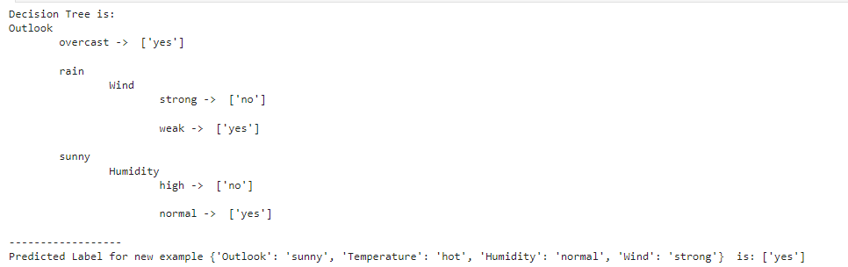

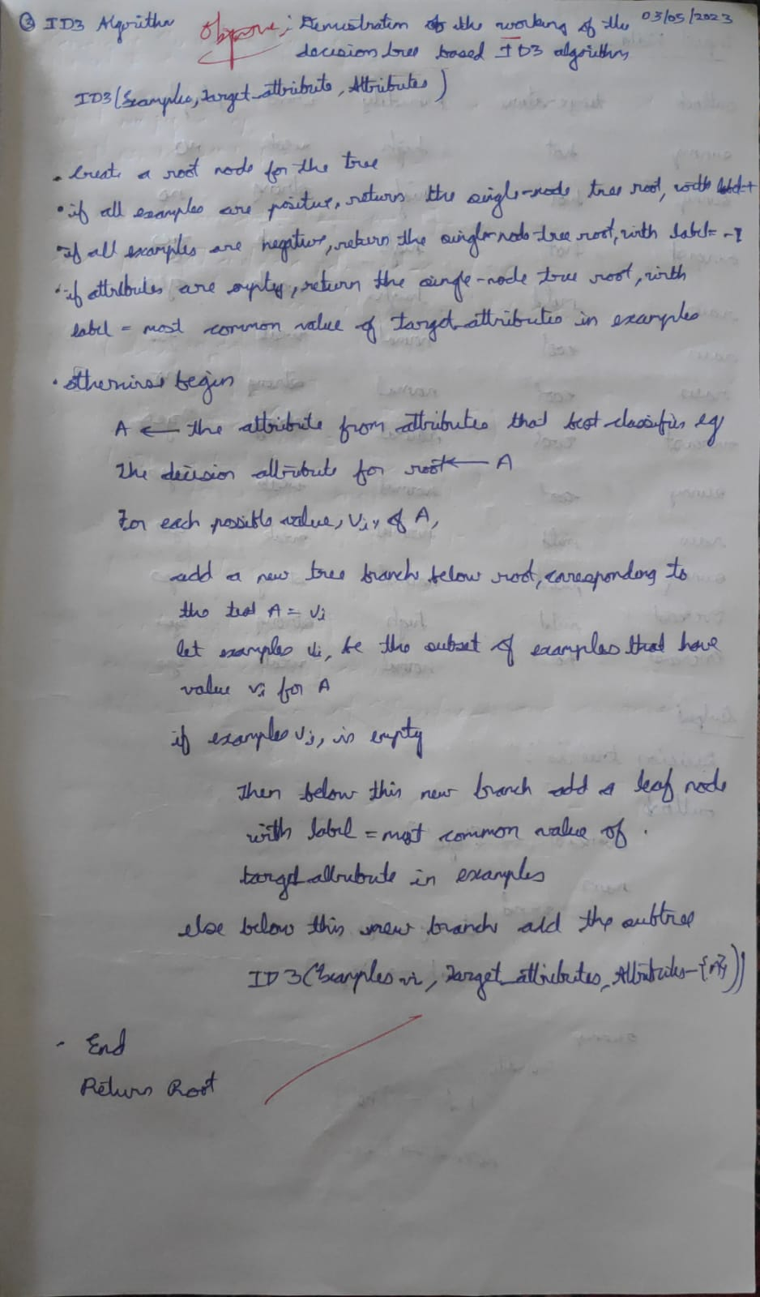**Observation:**

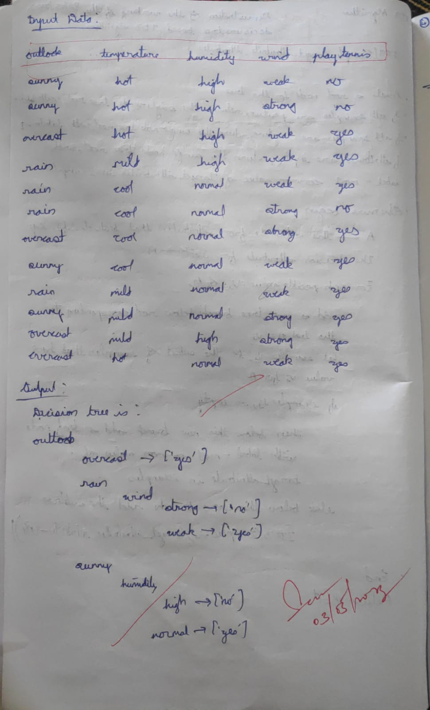

**DATE:** 17/05/2023

**LAB 5:** BAYESIAN CLASSIFIER

Write a program to demonstrate the working of the decision tree based ID3 algorithm. Use an appropriate data set for building the decision tree and apply this knowledge to classify a new sample.

**Dataset:**

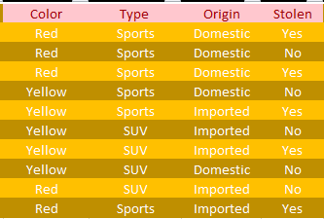

**Algorithm:**

1. Collect all words, punctuation, and other tokens that occur in the training examples. This forms the vocabulary, which is the set of all distinct words and tokens present in any document in the training examples.
2. Calculate the required probability terms:
   * For each target value vj in the set of target values V:
     + Select the subset of documents docs_j from the training examples for which the target value is vj.
     + Calculate the prior probability P(vj) as the number of documents in docs_j divided by the total number of training examples.
     + Create a text document Text_j by concatenating all the documents in docs_j.
     + Calculate the total number of distinct word positions n in Text_j.
     + For each word wk in the vocabulary:
       - Count the number of times word wk occurs in Text_j and store it as nk.
       - Calculate the conditional probability P(wk|vj) as (nk + 1) / (n + |Vocabulary|), where |Vocabulary| is the total number of distinct words in the vocabulary.
3. To classify a new document Doc:
   * Identify the positions in Doc that contain tokens found in the vocabulary. These are the relevant word positions.
   * For each target value vj in the set of target values:
     + Calculate the posterior probability P(vj|Doc) using the formula: P(vj|Doc) = P(vj) * ∏(P(ai|vj) for ai in relevant word positions)
   * Return the estimated target value for the document Doc as VNB, where VNB is the value of vj that maximizes P(vj|Doc).

**Code:**

**import** numpy **as** np

**import** math

**import** csv

**import** pdb

**def** read_data(filename):

**with** open(filename,'r') **as** csvfile:

datareader **=** csv**.**reader(csvfile)

metadata **=** next(datareader)

traindata**=**[]

**for** row **in** datareader:

traindata**.**append(row)

**return** (metadata, traindata)

**def** splitDataset(dataset, splitRatio):

trainSize **=** int(len(dataset) **\*** splitRatio)

trainSet **=** []

testset **=** list(dataset)

i**=**0

**while** len(trainSet) **<** trainSize:

trainSet**.**append(testset**.**pop(i))

**return** [trainSet, testset]

**def** classify(data,test):

total_size **=** data**.**shape[0]

print("\n")

print("training data size=",total_size)

print("test data size=",test**.**shape[0])

countYes **=** 0

countNo **=** 0

probYes **=** 0

probNo **=** 0

print("\n")

print("target count probability")

**for** x **in** range(data**.**shape[0]):

**if** data[x,data**.**shape[1]**-**1] **==** 'Yes':

countYes **+=**1

**if** data[x,data**.**shape[1]**-**1] **==** 'No':

countNo **+=**1

probYes**=**countYes**/**total_size

probNo**=** countNo **/** total_size

print('Yes',"\t",countYes,"\t",probYes)

print('No',"\t",countNo,"\t",probNo)

prob0 **=**np**.**zeros((test**.**shape[1]**-**1))

prob1 **=**np**.**zeros((test**.**shape[1]**-**1))

accuracy**=**0

print("\n")

print("instance prediction target")

**for** t **in** range(test**.**shape[0]):

**for** k **in** range (test**.**shape[1]**-**1):

count1**=**count0**=**0

**for** j **in** range (data**.**shape[0]):

*#how many times appeared with no*

**if** test[t,k] **==** data[j,k] **and** data[j,data**.**shape[1]**-**1]**==**'No':

count0**+=**1

*#how many times appeared with yes*

**if** test[t,k]**==**data[j,k] **and** data[j,data**.**shape[1]**-**1]**==**'Yes':

count1**+=**1

prob0[k]**=**count0**/**countNo

prob1[k]**=**count1**/**countYes

probno**=**probNo

probyes**=**probYes

**for** i **in** range(test**.**shape[1]**-**1):

probno**=**probno**\***prob0[i]

probyes**=**probyes**\***prob1[i]

**if** probno**>**probyes:

predict**=**'No'

**else**:

predict**=**'Yes'

print(t**+**1,"\t",predict,"\t ",test[t,test**.**shape[1]**-**1])

**if** predict **==** test[t,test**.**shape[1]**-**1]:

accuracy**+=**1

final_accuracy**=**(accuracy**/**test**.**shape[0])**\***100

print("accuracy",final_accuracy,"%")

**return**

metadata,traindata**=** read_data("naive.csv")

splitRatio**=**0.6

trainingset, testset**=**splitDataset(traindata, splitRatio)

training**=**np**.**array(trainingset)

print("\n The Training data set are:")

**for** x **in** trainingset:

print(x)

testing**=**np**.**array(testset)

print("\n The Test data set are:")

**for** x **in** testing:

print(x)

classify(training,testing)

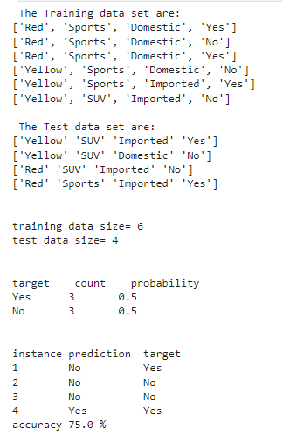

**Observation:**

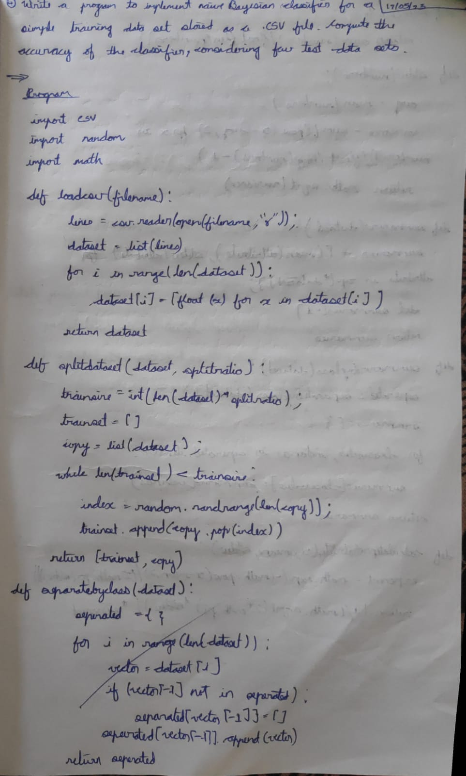

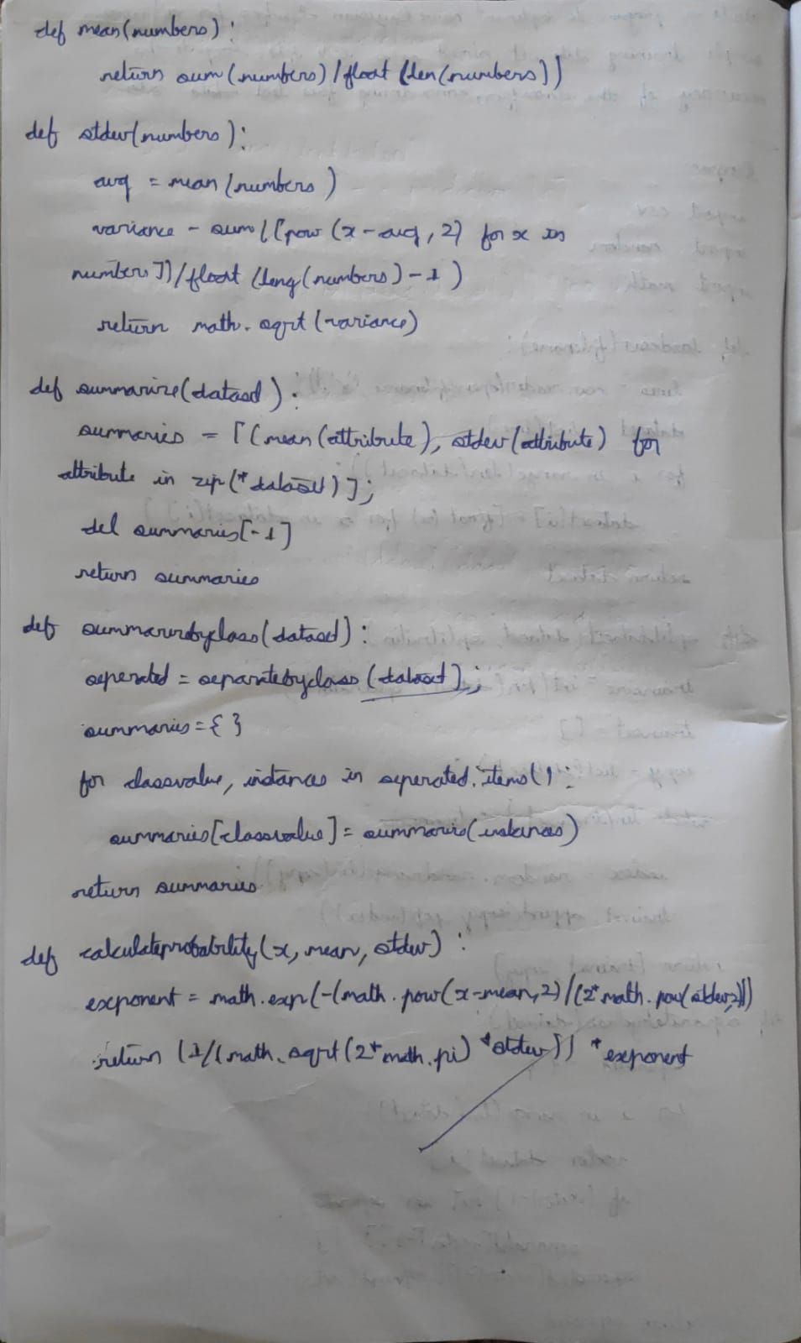

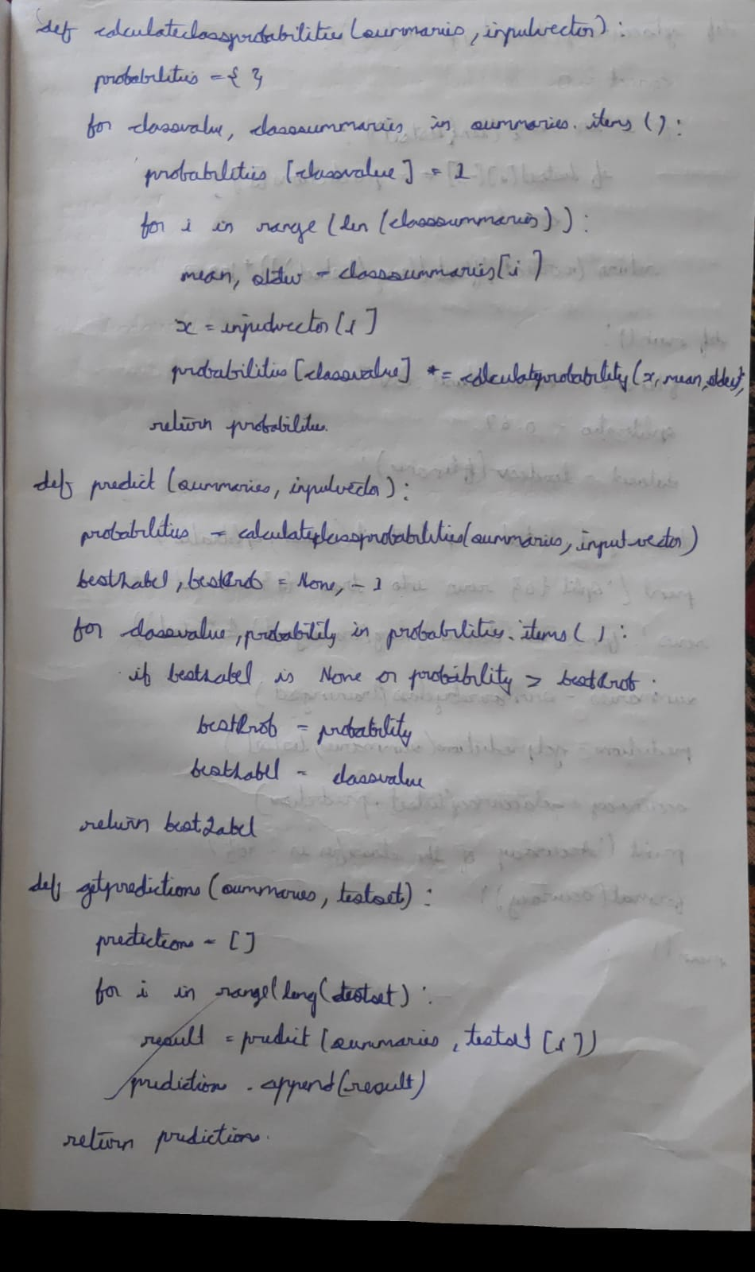

**DATE:** 24/05/2023

**LAB 6:** BAYESIAN NETWORK

Write a program to construct a Bayesian network considering training data. Use this model to make predictions.

**Dataset:**

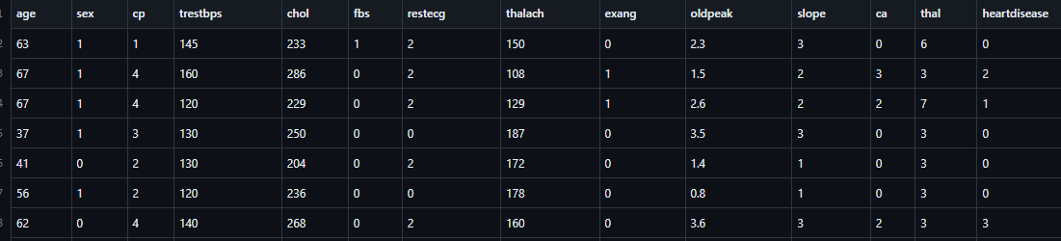

**Algorithm:**

1. Define the Bayesian network structure: Specify the variables and their dependencies by defining the directed acyclic graph (DAG) structure of the Bayesian network.
2. Assign probability distributions: Assign probability distributions to each variable in the network based on prior knowledge or data. This involves specifying the conditional probability tables (CPTs) for each variable given its parents in the DAG.
3. Query and evidence variables: Identify the variables of interest for inference and set any observed evidence variables to their observed values.
4. Variable elimination:
   * Order the variables in a way that respects the network structure and ensures that parents are eliminated before their children.
   * For each variable in the elimination order, eliminate the variable by summing out or maximizing over its possible values.
   * Update the probability distributions of the remaining variables based on the eliminated variables and the evidence.
5. Perform inference: Calculate the desired probabilities or make predictions based on the updated probability distributions.

**Code:**

import numpy as np

import pandas as pd

import csv

from pgmpy.estimators import MaximumLikelihoodEstimator

from pgmpy.models import BayesianModel

from pgmpy.inference import VariableElimination

heartDisease = pd.read_csv('/content/sample_data/heart.csv')

heartDisease = heartDisease.replace('?',np.nan)

print('Sample instances from the dataset are given below')

print(heartDisease.head())

print('\n Attributes and datatypes')

print(heartDisease.dtypes)

model= BayesianModel([('age','heartdisease'),('sex','heartdisease'),('exang','heartdisease'),('cp','heartdisease'),('heartdisease','restecg'),('heartdisease','chol')])

print('\nLearning CPD using Maximum likelihood estimators')

model.fit(heartDisease,estimator=MaximumLikelihoodEstimator)

print('\n Inferencing with Bayesian Network:')

HeartDiseasetest_infer = VariableElimination(model)

print('\n 1. Probability of HeartDisease given evidence= restecg')

q1=HeartDiseasetest_infer.query(variables=['heartdisease'],evidence={'restecg':1})

print(q1)

print('\n 2. Probability of HeartDisease given evidence= cp ')

q2=HeartDiseasetest_infer.query(variables=['heartdisease'],evidence={'cp':2})

print(q2)

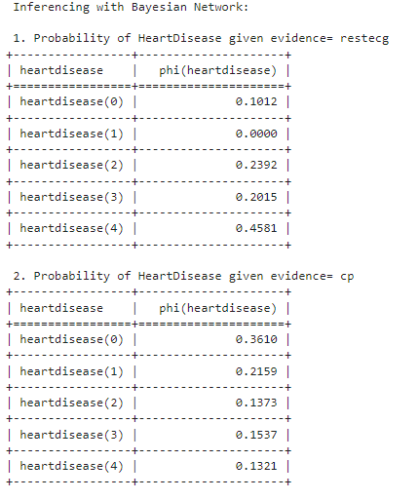

**Observation:**

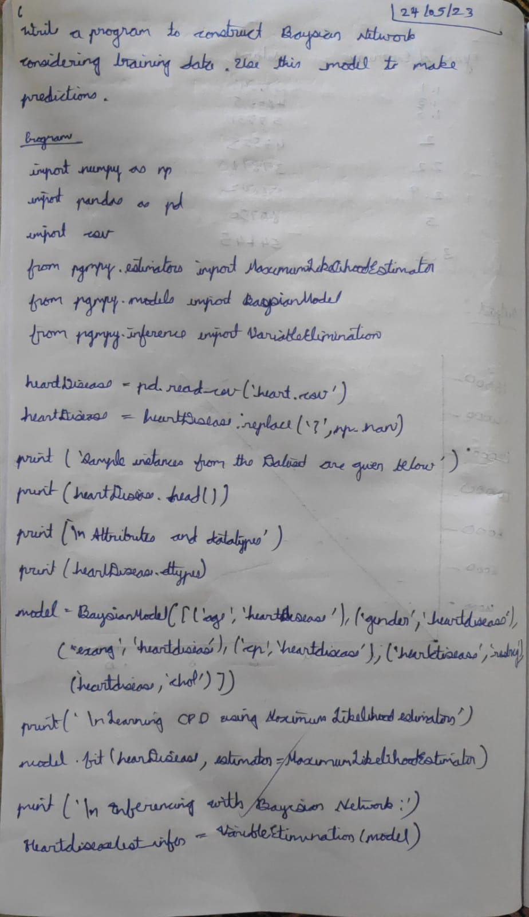

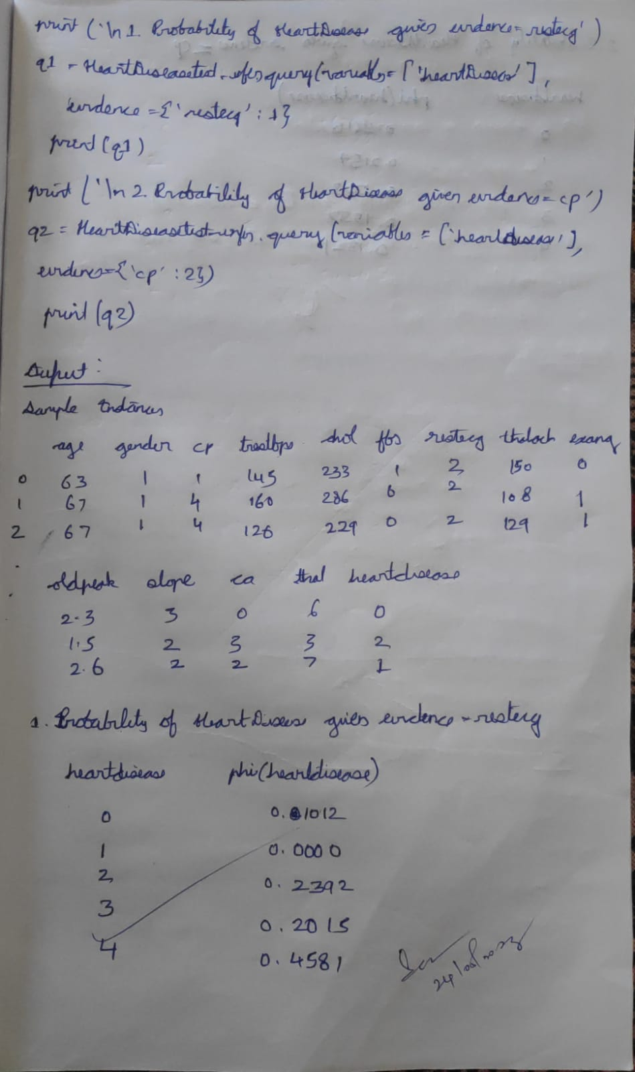

**DATE:** 07/06/2023

**LAB 7:** k-MEANS

Apply k-Means algorithm to cluster a set of data stored in a .CSV file.

**Dataset:**

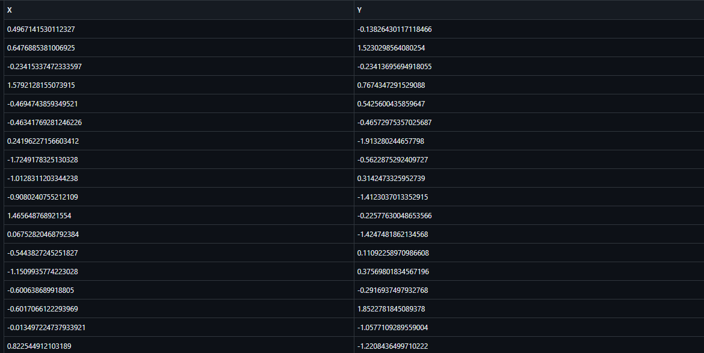

**Algorithm:**

1. Initialize: Randomly select K data points from the dataset as initial cluster centroids.
2. Assign data points to clusters: For each data point, calculate its distance to each centroid and assign it to the cluster with the nearest centroid.
3. Update cluster centroids: Recalculate the centroids of each cluster by taking the mean of the data points assigned to that cluster.
4. Repeat steps 2 and 3 until convergence: Iterate steps 2 and 3 until the cluster assignments no longer change significantly or a maximum number of iterations is reached.
5. Output: Return the final cluster assignments and centroids.

**Code:**

**import** numpy **as** np

**import** pandas **as** pd

**import** matplotlib.pyplot **as** plt

**def** kmeans(X, K, max_iters**=**100):

*# Randomly initialize centroids*

centroids **=** X[np**.**random**.**choice(range(len(X)), size**=**K, replace**=False**)]

**for** _ **in** range(max_iters):

*# Assign each data point to the nearest centroid*

clusters **=** [[] **for** _ **in** range(K)]

**for** x **in** X:

distances **=** [np**.**linalg**.**norm(x **-** centroid) **for** centroid **in** centroids]

cluster_index **=** np**.**argmin(distances)

clusters[cluster_index]**.**append(x)

*# Update centroids*

new_centroids **=** []

**for** cluster **in** clusters:

**if** cluster:

new_centroids**.**append(np**.**mean(cluster, axis**=**0))

**else**:

*# If a centroid has no assigned points, keep the previous centroid value*

new_centroids**.**append(centroids[clusters**.**index(cluster)])

*# Check for convergence*

**if** np**.**allclose(centroids, new_centroids):

**break**

centroids **=** new_centroids

**return** centroids, clusters

*# Load data from CSV file*

data **=** pd**.**read_csv('/kaggle/working/data.csv')

*# Convert data to numpy array*

X **=** data**.**values

*# Perform k-means clustering*

K **=** 3

centroids, clusters **=** kmeans(X, K)

*# Convert centroids list to numpy array*

centroids **=** np**.**array(centroids)

*# Plot the clusters and centroids*

colors **=** ['r', 'g', 'b']

**for** i, cluster **in** enumerate(clusters):

**for** point **in** cluster:

plt**.**scatter(point[0], point[1], c**=**colors[i])

plt**.**scatter(centroids[:, 0], centroids[:, 1], c**=**'k', marker**=**'x')

plt**.**show()

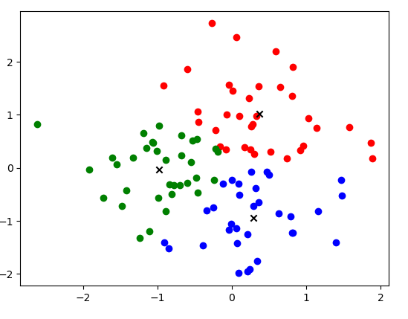

**Observation:**

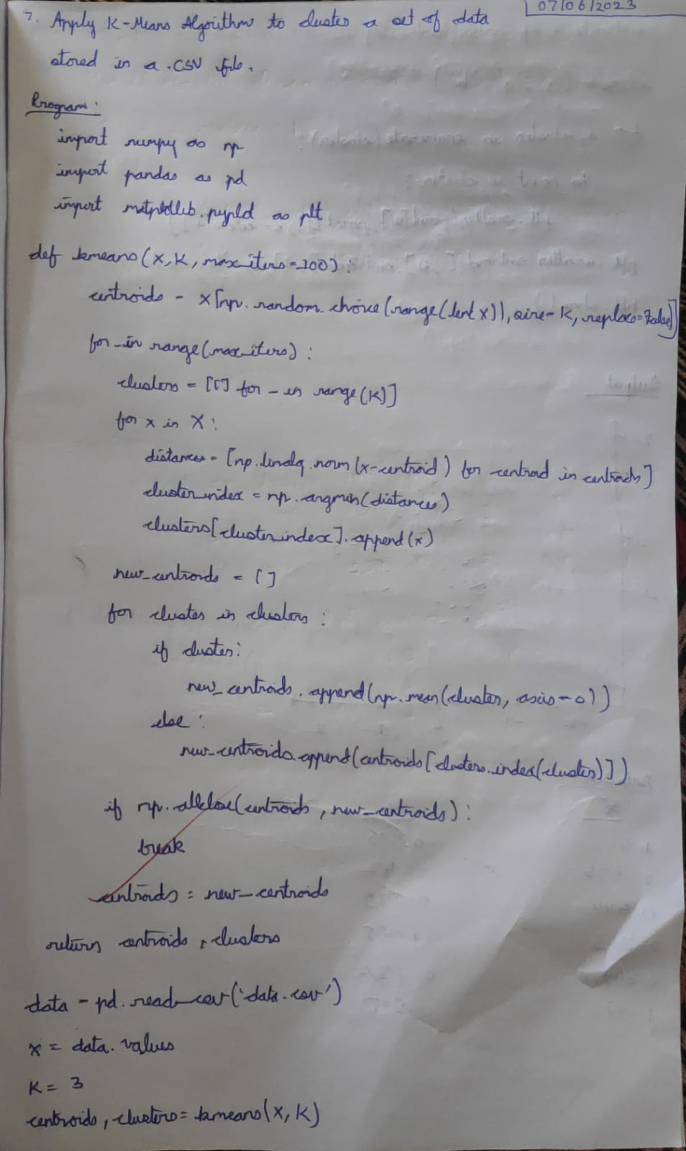

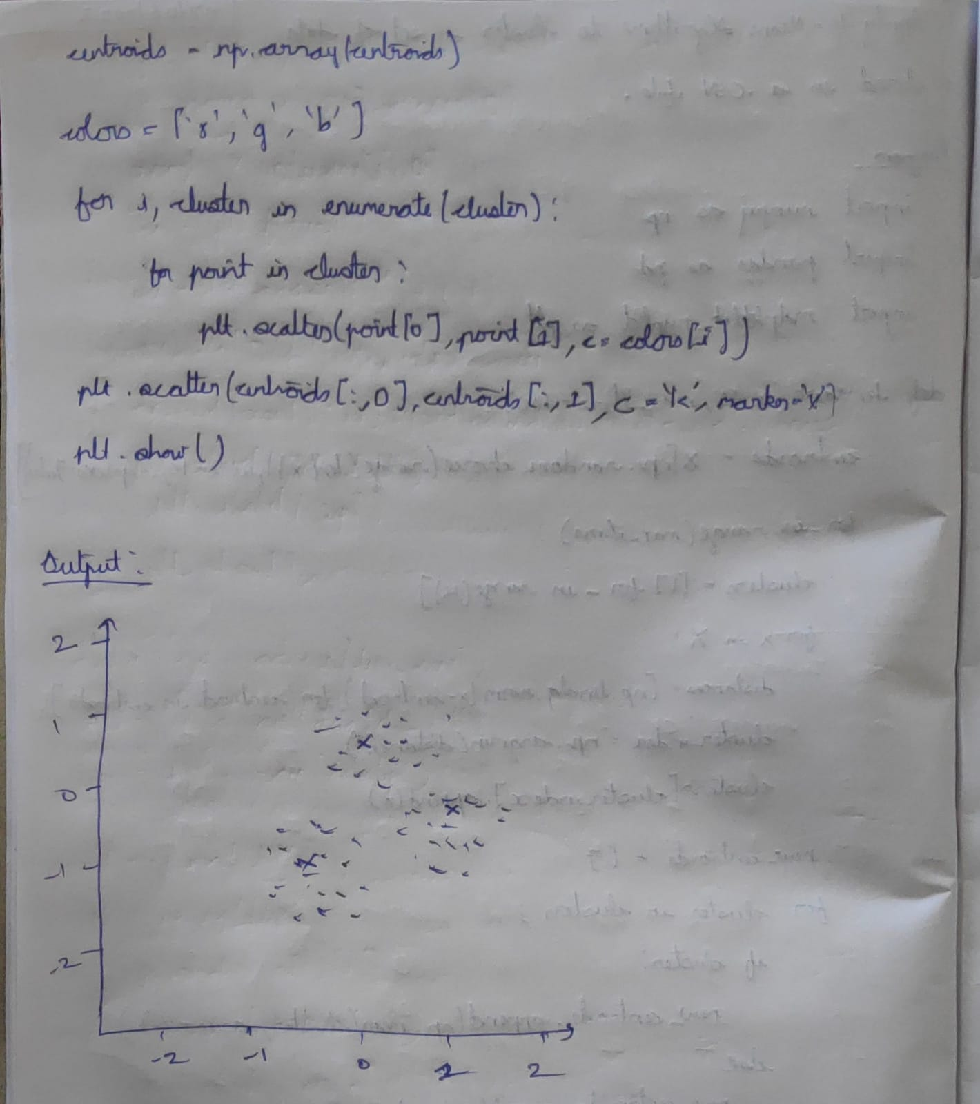

**DATE:** 14/06/2023

**LAB 8:** k-MEANS

Apply EM algorithm to cluster a set of data stored in a .CSV file. Compare the results of k-Means algorithm and EM algorithm.

**Dataset:**

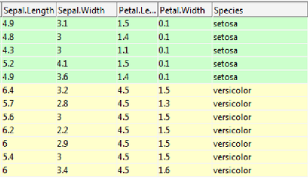

**Algorithm:**

1. Initialize: Choose initial values for the model parameters.
2. Expectation step (E-step):
3. Compute the expected values of the missing or unobserved data given the current parameter estimates.
4. Calculate the posterior probabilities or responsibilities for each data point or latent variable.
5. Maximization step (M-step):
6. Update the model parameters by maximizing the expected log-likelihood (or another objective function) based on the completed data, incorporating the estimated values from the E-step.
7. Evaluate convergence: Check if the change in the model parameters or the log-likelihood is below a specified threshold. If not, go back to step 2.
8. Repeat steps 2-4 until convergence is achieved.
9. Output: Return the estimated model parameters as the final result.

**Code:**

**import** matplotlib.pyplot **as** plt

**from** sklearn **import** datasets

**from** sklearn.cluster **import** KMeans

**import** sklearn.metrics **as** sm

**import** pandas **as** pd

**import** numpy **as** np

iris **=** datasets**.**load_iris()

X **=** pd**.**DataFrame(iris**.**data)

X**.**columns **=** ['Sepal_Length','Sepal_Width','Petal_Length','Petal_Width']

y **=** pd**.**DataFrame(iris**.**target)

y**.**columns **=** ['Targets']

model **=** KMeans(n_clusters**=**3)

model**.**fit(X)

plt**.**figure(figsize**=**(14,7))

colormap **=** np**.**array(['red', 'lime', 'black'])

*# Plot the Original Classifications*

plt**.**subplot(1, 2, 1)

plt**.**scatter(X**.**Petal_Length, X**.**Petal_Width, c**=**colormap[y**.**Targets], s**=**40)

plt**.**title('Real Classification')

plt**.**xlabel('Petal Length')

plt**.**ylabel('Petal Width')

*# Plot the Models Classifications*

plt**.**subplot(1, 2, 2)

plt**.**scatter(X**.**Petal_Length, X**.**Petal_Width, c**=**colormap[model**.**labels_], s**=**40)

plt**.**title('K Mean Classification')

plt**.**xlabel('Petal Length')

plt**.**ylabel('Petal Width')

print('The accuracy score of K-Mean: ',sm**.**accuracy_score(y, model**.**labels_))

print('The Confusion matrixof K-Mean: ',sm**.**confusion_matrix(y, model**.**labels_))

**from** sklearn **import** preprocessing

scaler **=** preprocessing**.**StandardScaler()

scaler**.**fit(X)

xsa **=** scaler**.**transform(X)

xs **=** pd**.**DataFrame(xsa, columns **=** X**.**columns)

*#xs.sample(5)*

**from** sklearn.mixture **import** GaussianMixture

gmm **=** GaussianMixture(n_components**=**3)

gmm**.**fit(xs)

y_gmm **=** gmm**.**predict(xs)

*#y_cluster_gmm*

plt**.**subplot(2, 2, 3)

plt**.**scatter(X**.**Petal_Length, X**.**Petal_Width, c**=**colormap[y_gmm], s**=**40)

plt**.**title('GMM Classification')

plt**.**xlabel('Petal Length')

plt**.**ylabel('Petal Width')

print('The accuracy score of EM: ',sm**.**accuracy_score(y, y_gmm))

print('The Confusion matrix of EM: ',sm**.**confusion_matrix(y, y_gmm))

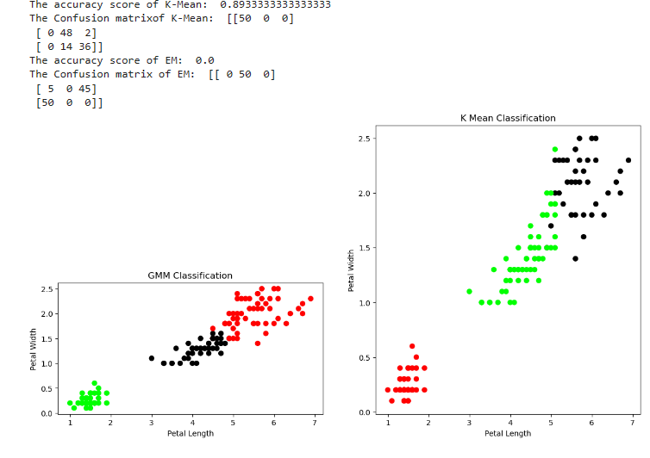

**Observation:**



**DATE:** 14/06/2023

**LAB 9:** k-NN

Write a program to implement k-Nearest Neighbour algorithm to classify the iris data set. Print both correct and wrong predictions.

**Dataset:**



**Algorithm:**

1. Load the training dataset: Prepare the dataset with labeled instances, where each instance consists of a set of features and a corresponding class label (for classification) or target value (for regression).
2. Select the value of K: Determine the number of nearest neighbors, K, that will be considered for making predictions.
3. Normalize the feature values (optional): If the features have different scales or units, it is often beneficial to normalize them to ensure they contribute equally to the distance calculations.
4. Prepare a test instance: Obtain the instance for which you want to make a prediction. This instance should contain the same set of features as the training instances.
5. Calculate distances: Compute the distance between the test instance and all the training instances using a distance metric such as Euclidean distance or Manhattan distance. The distance metric determines how similarity is measured in the feature space.
6. Find K nearest neighbors: Select the K training instances with the shortest distances to the test instance.
7. Make predictions:
   * For classification: Determine the majority class label among the K nearest neighbors and assign it as the predicted class label for the test instance.
   * For regression: Calculate the average or weighted average of the target values of the K nearest neighbors and assign it as the predicted target value for the test instance.
8. Output: Return the predicted class label (for classification) or target value (for regression) as the final result.

**Code:**

import numpy as np

from collections import Counter

class KNN:

def __init__(self, k):

self.k = k

def fit(self, X, y):

self.X_train = X

self.y_train = y

def euclidean_distance(self, x1, x2):

return np.sqrt(np.sum((x1 - x2)**2))

def predict(self, X):

y_pred = [self._predict(x) for x in X]

return np.array(y_pred)

def _predict(self, x):

distances = [self.euclidean_distance(x, x_train) for x_train in self.X_train]

k_indices = np.argsort(distances)[:self.k]

k_nearest_labels = [self.y_train[i] for i in k_indices]

most_common = Counter(k_nearest_labels).most_common(1)

return most_common[0][0]

knn = KNN(k=3) *# Specify the value of K (number of neighbors)*

from sklearn.datasets import load_iris

data = load_iris()

X = data.data

y = data.target

*# train test split*

from sklearn.model_selection import train_test_split

X_train,X_test,y_train,y_test = train_test_split(X,y,test_size=0.2,random_state=1)

knn.fit(X_train,y_train)

y_pred_test = knn.predict(X_test)

y_pred_train = knn.predict(X_train)

*# Plotting scatter plot for the training data*

import matplotlib.pyplot as plt

plt.scatter(X_train[:, 0], X_train[:, 1], c=y_train, cmap='viridis')

plt.xlabel('Sepal Length')

plt.ylabel('Sepal Width')

plt.title('KNN - Training Data')

plt.show()

*# Plotting scatter plot for the testing data*

plt.scatter(X_test[:, 0], X_test[:, 1], c=y_test, cmap='viridis')

plt.xlabel('Sepal Length')

plt.ylabel('Sepal Width')

plt.title('KNN - Testing Data')

plt.show()

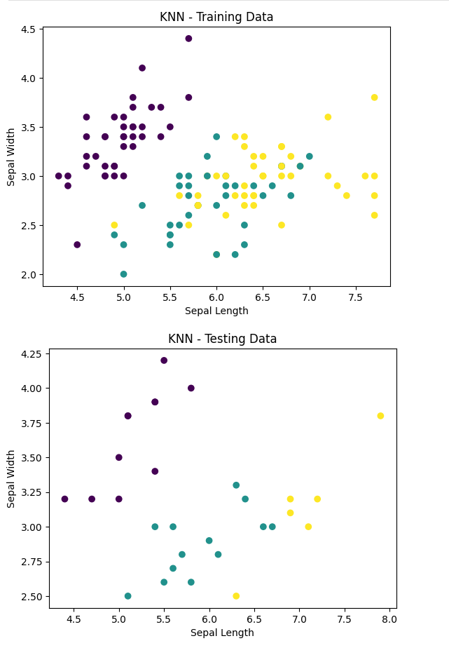

**Observation:**

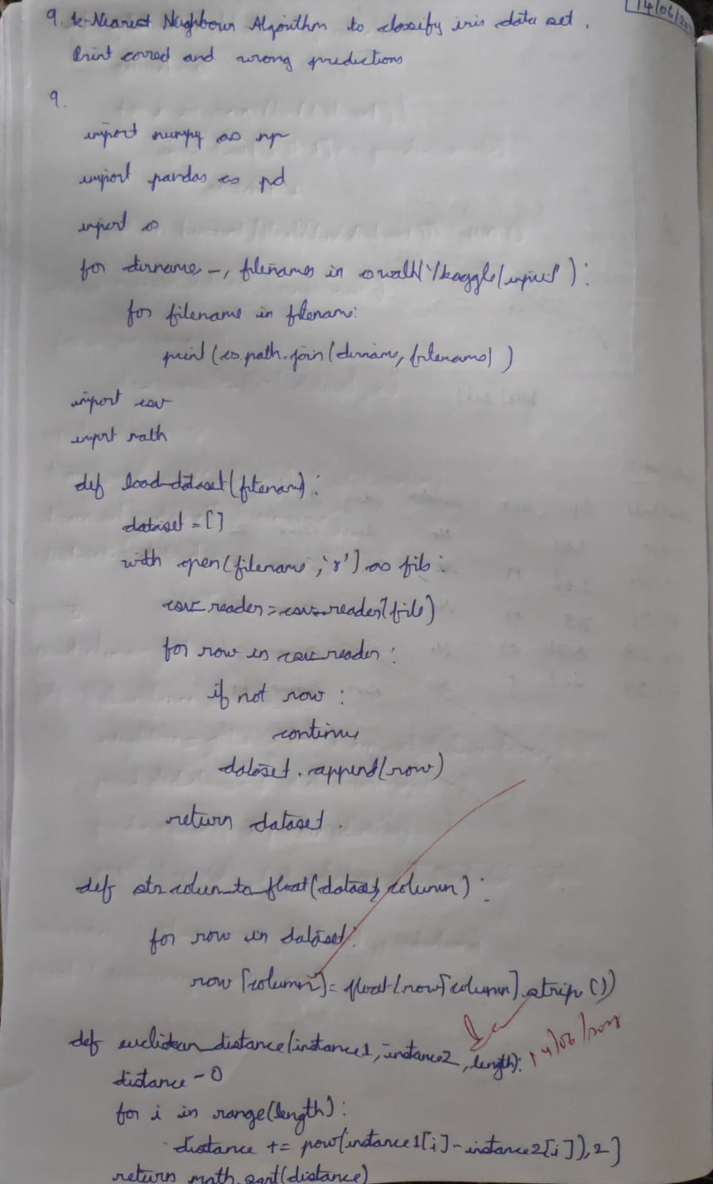

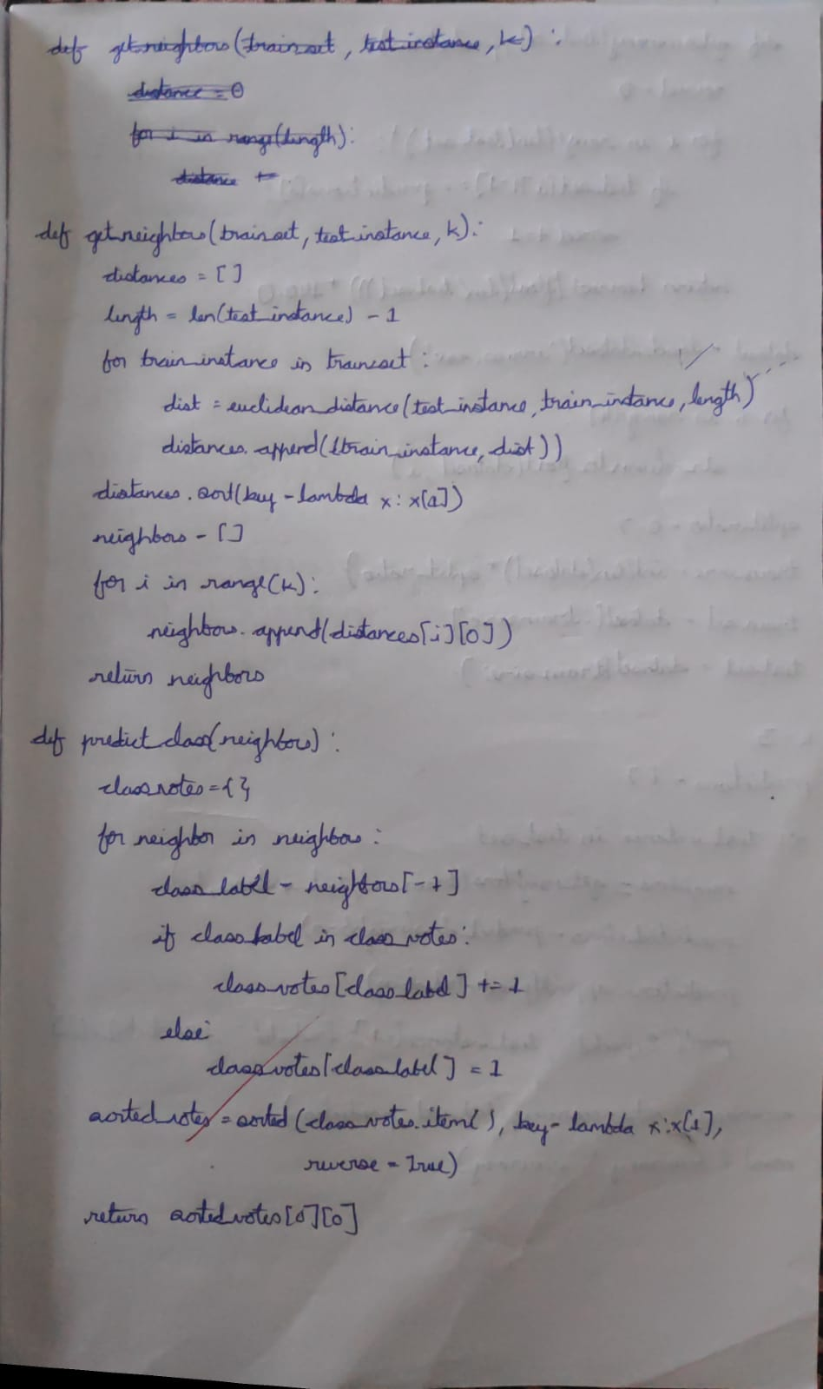

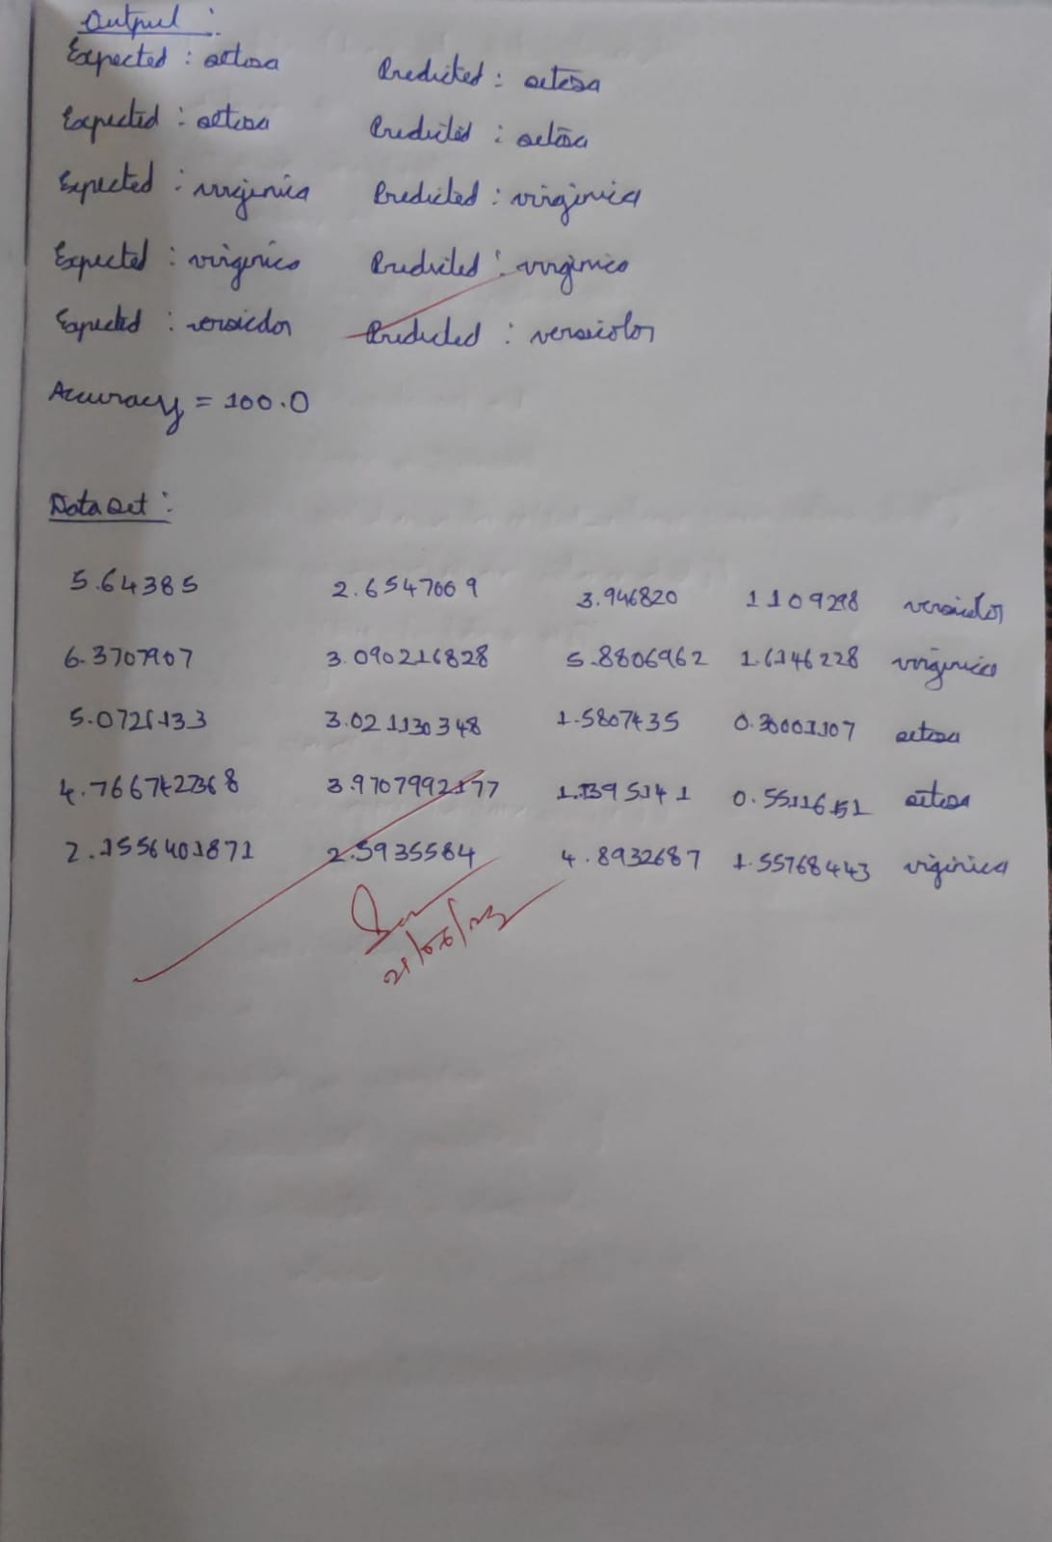

**DATE:** 14/06/2023

**LAB 10:** LINEAR REGRESSION

Implement the Linear Regression algorithm in order to fit data points. Select appropriate data set for your experiment and draw graphs.

**Dataset:**

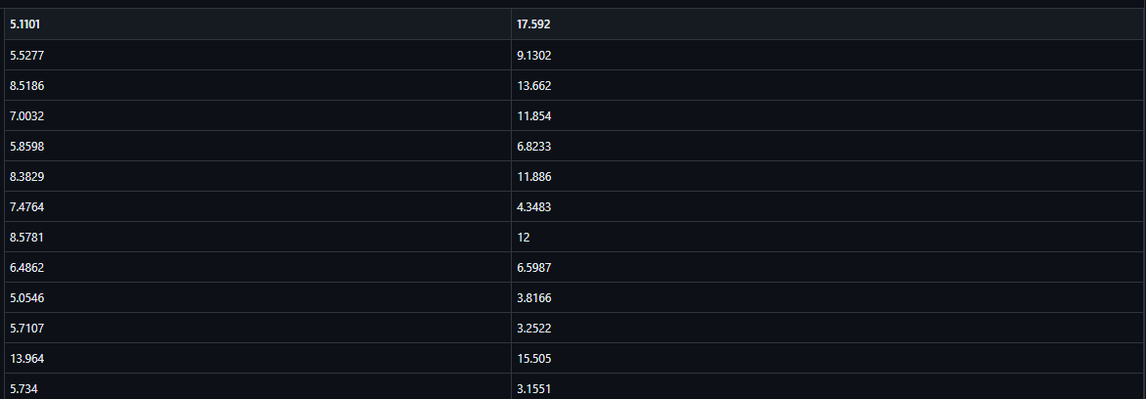

**Algorithm:**

1. Load the training dataset.
2. Normalize the feature values (optional).
3. Define the hypothesis function as a linear combination of the input features.
4. Initialize the weights.
5. Define the cost function (e.g., Mean Squared Error).
6. Optimize the weights using gradient descent:
   * Iterate through the training data.
   * Update the weights in the direction that minimizes the cost function.
   * Adjust the weights using the gradient and the learning rate.
7. Repeat the gradient descent process until convergence or a maximum number of iterations.
8. Return the learned weights as the coefficients of the linear regression equation.

**Code:**

**import** pandas **as** pd

**import** numpy **as** np

**import** matplotlib.pyplot **as** plt

plt**.**rcParams['figure.figsize'] **=** (12.0, 9.0)

*# Preprocessing Input data*

data **=** pd**.**read_csv('example_data.csv')

X **=** data**.**iloc[:, 0]

Y **=** data**.**iloc[:, 1]

plt**.**scatter(X, Y)

plt**.**show()

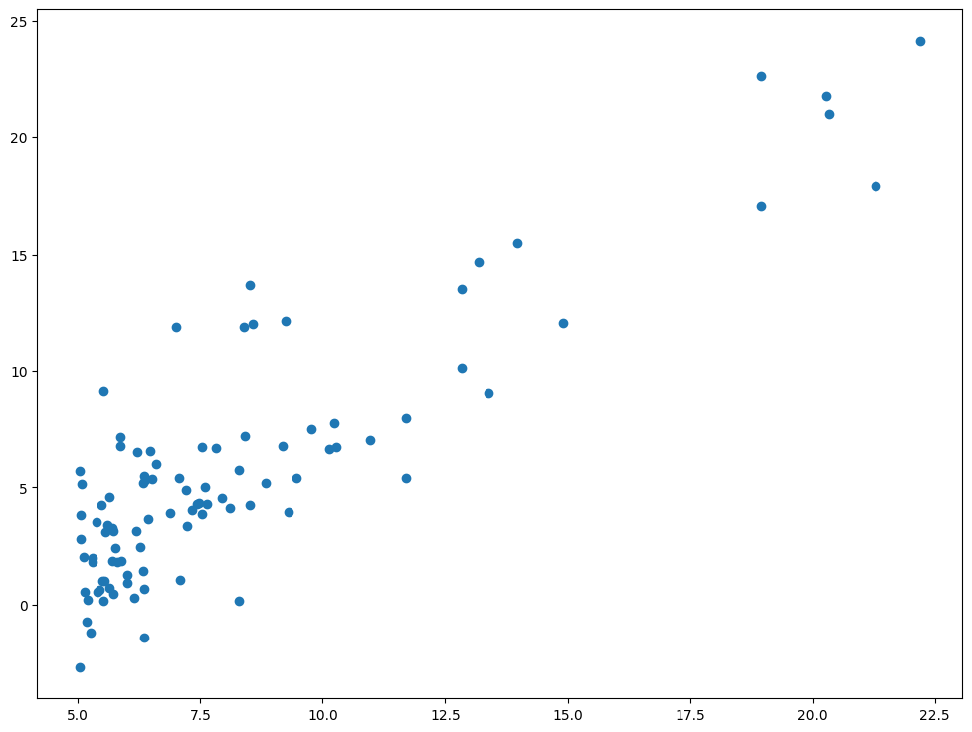

*# Building the model*

X_mean **=** np**.**mean(X)

Y_mean **=** np**.**mean(Y)

num **=** 0

den **=** 0

**for** i **in** range(len(X)):

num **+=** (X[i] **-** X_mean)**\***(Y[i] **-** Y_mean)

den **+=** (X[i] **-** X_mean)**\*\***2

m **=** num **/** den

c **=** Y_mean **-** m**\***X_mean

print (m, c)

1.210073946912064 -4.150315520211127

*# Making predictions*

Y_pred **=** m**\***X **+** c

plt**.**scatter(X, Y) *# actual*

*# plt.scatter(X, Y_pred, color='red')*

plt**.**plot([min(X), max(X)], [min(Y_pred), max(Y_pred)], color**=**'red') *# predicted*

plt**.**show()

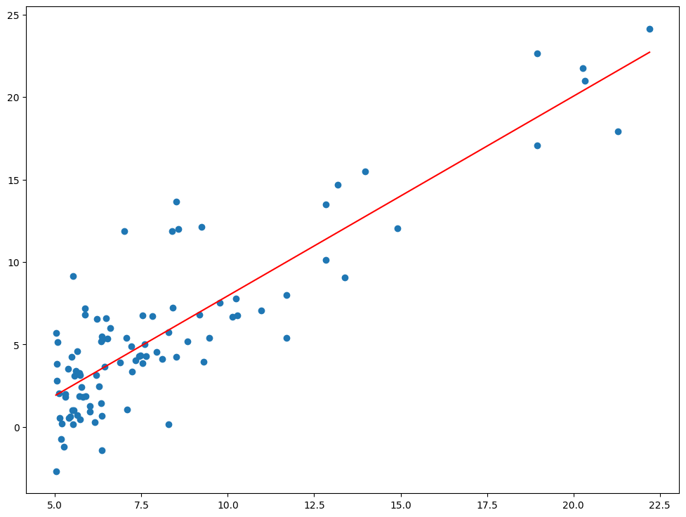

**Observation:**

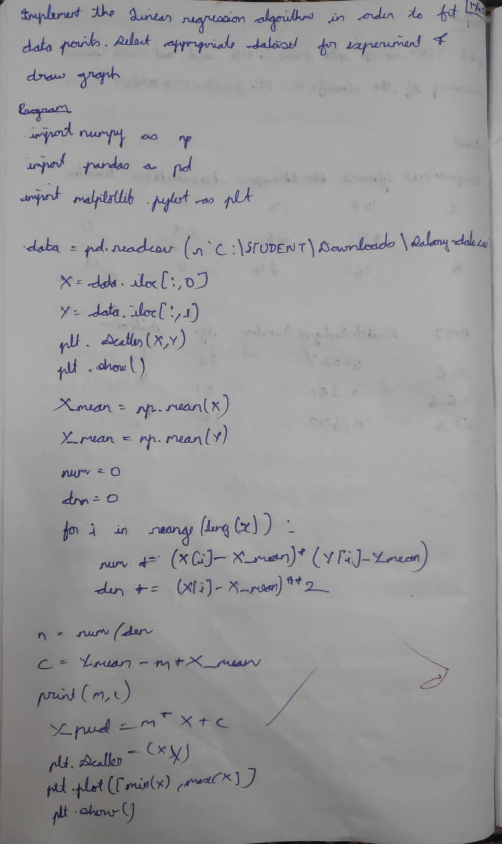

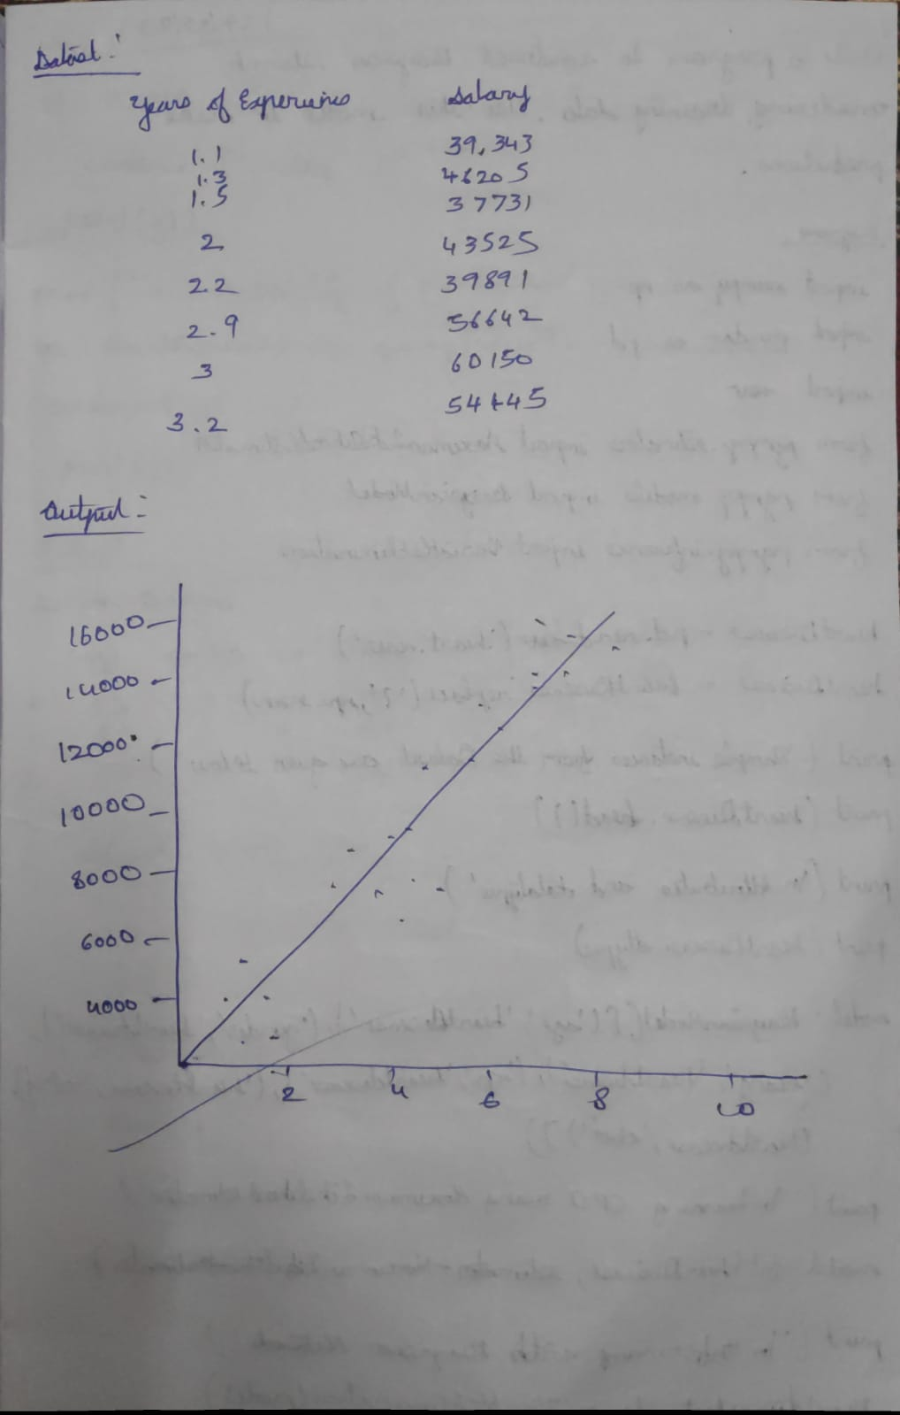

**DATE:** 14/06/2023

**LAB 11:** LOCALLY WEIGHTED REGRESSION

Implement the non-parametric Locally Weighted Regression algorithm in order to fit data points. Select appropriate data set for your experiment and draw graphs.

**Dataset:**

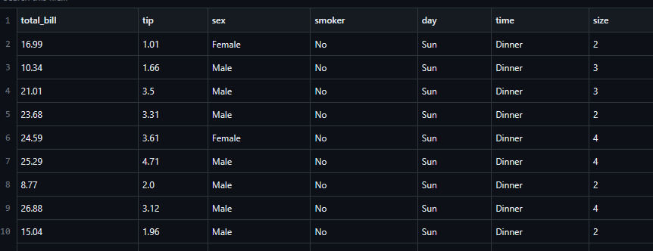

**Algorithm:**

1. Load the training dataset.
2. Normalize the feature values (optional).
3. Prepare a test instance for which you want to make a prediction.
4. Choose the bandwidth parameter (tau) that controls the weighting of training instances.
5. Calculate weights for each training instance based on its distance from the test instance and the chosen bandwidth.
6. Fit a regression model using the weighted training instances.
7. Make predictions by applying the fitted regression model to the test instance.
8. Return the predicted target value as the final result.

**Code:**

import matplotlib.pyplot as plt

import pandas as pd

import numpy as np

def kernel(point,xmat, k):

m,n = np.shape(xmat)

weights = np.mat(np.eye((m))) *# eye - identity matrix*

for j in range(m):

diff = point - X[j]

weights[j,j] = np.exp(diff*diff.T/(-2.0*k**2))

return weights

def localWeight(point,xmat,ymat,k):

wei = kernel(point,xmat,k)

W = (X.T*(wei*X)).I*(X.T*(wei*ymat.T))

return W

def localWeightRegression(xmat,ymat,k):

m,n = np.shape(xmat)

ypred = np.zeros(m)

for i in range(m):

ypred[i] = xmat[i]*localWeight(xmat[i],xmat,ymat,k)

return ypred

def graphPlot(X,ypred):

sortindex = X[:,1].argsort(0) *#argsort - index of the smallest*

xsort = X[sortindex][:,0]

fig = plt.figure()

ax = fig.add_subplot(1,1,1)

ax.scatter(bill,tip, color='green')

ax.plot(xsort[:,1],ypred[sortindex], color = 'red', linewidth=5)

plt.xlabel('Total bill')

plt.ylabel('Tip')

plt.show();

*# load data points*

data = pd.read_csv('tips.csv')

bill = np.array(data.total_bill) *# We use only Bill amount and Tips data*

tip = np.array(data.tip)

mbill = np.mat(bill) *# .mat will convert nd array is converted in 2D array*

mtip = np.mat(tip)

m= np.shape(mbill)[1]

one = np.mat(np.ones(m))

X = np.hstack((one.T,mbill.T)) *# 244 rows, 2 cols*

*# increase k to get smooth curves*

ypred = localWeightRegression(X,mtip,3)

graphPlot(X,ypred)

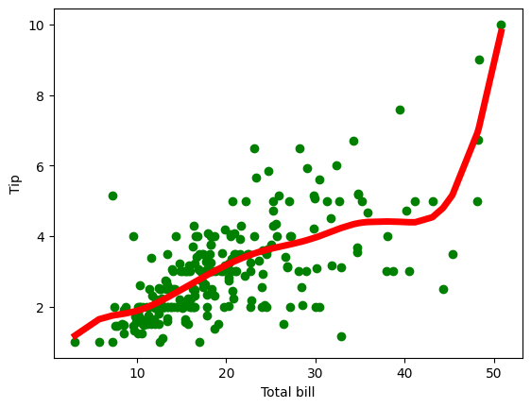

**Observation:**

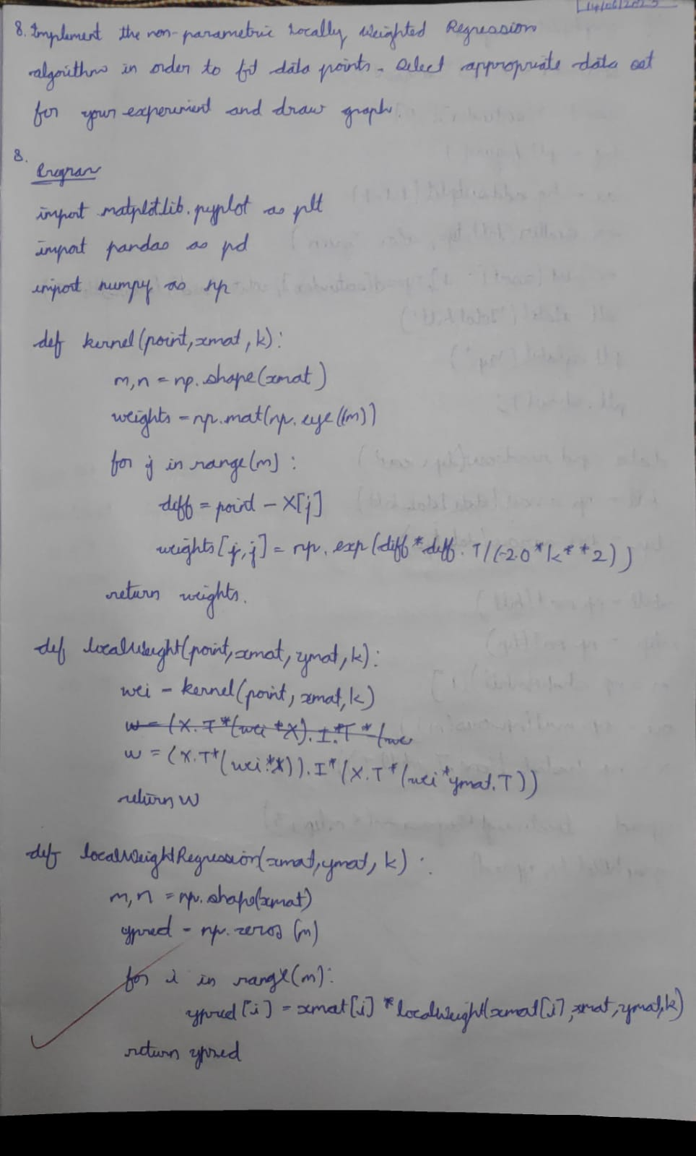

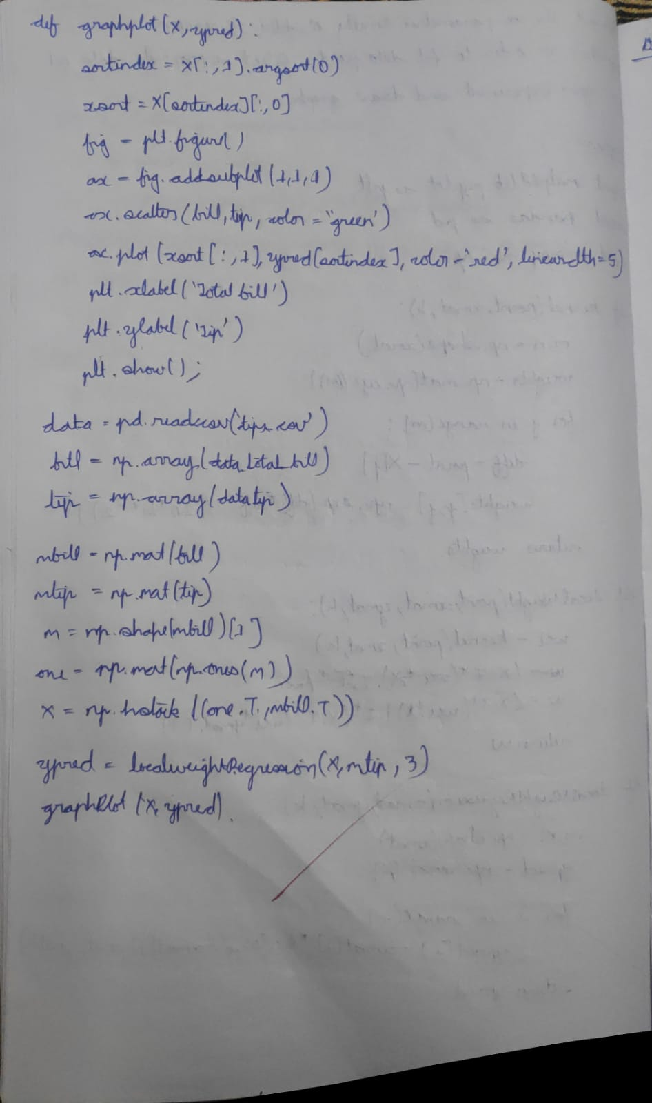

S

