The Battle of Neighborhoods

**Finding a Suitable Neighborhood**

**NAME: K SAI RAKESH**

**1 .Introduction**

In this project unsupervised machine learning K-means clustering algorithm is used for analysis. Unsupervised learning is a part of machine learning where no response variable is present to provide guidelines in the learning process and data is analyzed by algorithms itself to identify the trends. K-means clustering algorithm is one of the most popular and simplest algorithms. Collection of data points aggregated together because of certain similarities is referred to as clusters. The target number k refers to the number of centroids required in the dataset. A centroid is the imaginary or real location representing the center of the cluster. Every data point is allocated to each of the clusters through reducing the in-cluster sum of squares. While keeping the centroids as small as possible, K-means algorithm identifies k number of centroids, and then allocates every data point present to the nearest cluster. The ‘means’ in the K-means refers to averaging of the data which is finding the centroid. Unsupervised K-means clustering is an extensively used algorithm for data cluster analysis.

**2. Problem description**

To understand the similarities and differences of neighborhoods between Queens borough in New York City and Scarborough borough in Toronto, also selecting the best and suitable neighborhood for a X company to open a new branch based on the different types of venues in the two places considering the quality of life and also the optimum living standards for its employees assuming the other conditions for opening a new branch of the company are met in the places under study.

**3. Objective of the study**

Using Foursquare collect the top venues of the neighbourhoods under study and then use the unsupervised k-means clustering algorithm to categorise the venues of the neighbourhoods under study. Obtain insights into the neighbourhoods by identifying the similarities and differences between Scarborough and Queens neighbourhoods.

**Locations under study:**

Scarborough borough in Toronto

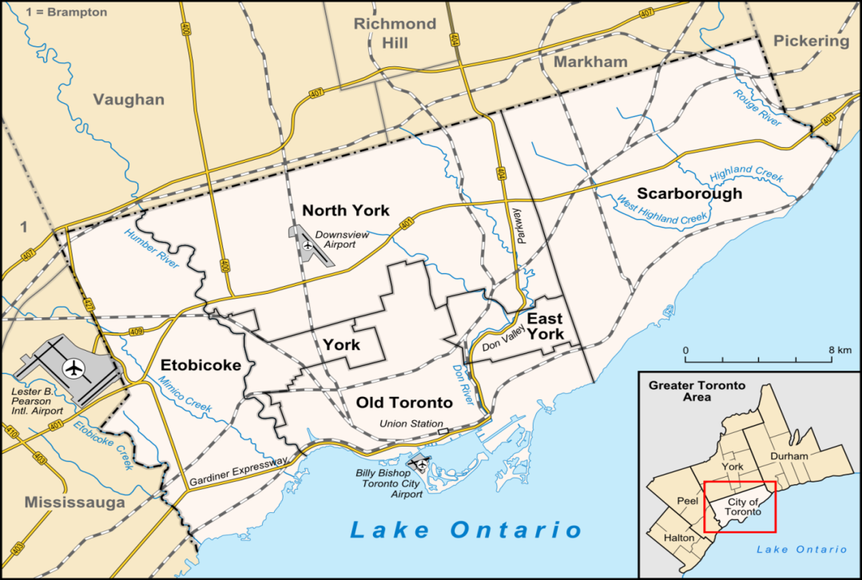

Queens borough in New York City

