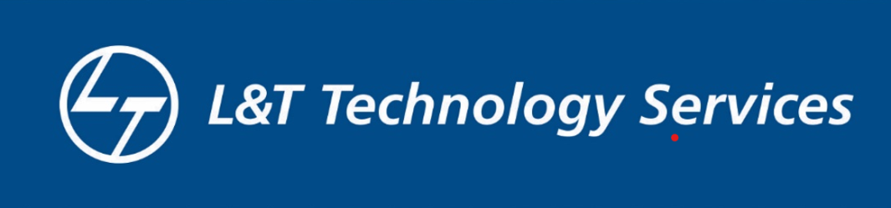

Report:

**Railway Management System**

**Prepared by**

**Koruprolu Siva Rakesh**

**09-02-2022**

**LTTS**

**Description of Project:**

In Railway Management System, we need to sort the various train details into a particular order in order to maintain it in a organised form. So firstly we take all the input details required from the passengers and then sort all the details accordingly. First module includes sorting train numbers using bubble sort. Second module includes sorting train names using selection sort. Third module includes sorting passenger names using insertion sort. And last module includes sorting PNR numbers using quick sort.

# Research Objectives:

# The purpose of this project is to develop “Railway Management System” which takes all the customer details and travel details as input and sorts all the information using various sort to arrange them in an organized manner. This code is basically written as a solution to the drawbacks of existing problems of arranging things in a particular order. This application can be used as a real world application and by any organization.

**Conclusion:**

Railways department is the central government department which provides various opportunities for the travellers and employees too. Indian railways had provided the reservation system on different trains to different places. By reserving our ticket you can get the seat of your choice and can book the ticket before the anyone can . Reservation is very helpful during the festival seasons because at that time it is very crowdy and we cannot take a ticket too. For old people the reservation helps a lot and can get the food in the compartment itself. Reservation system helps you not to stand in a queue to get the ticket..