1. **INRODUCTION**

An introduction section promotes then descriptive representation of the project, and also what is the project and how it works, it also gives clear picture of how the existing system works and its importance.

* 1. **General Information**

The main aim of “Hungry Hearts” is to share the food for the needed people. Hungry Hearts acts as bridges between food donors and food recipients. Hungry Hearts maintains the documentation of all the donors and the recipients.

* 1. **Statement of the Problem**
* The web application is developed to focus on problem of food wastage.
* It act as a bridge between food donor and food recipients.
  1. **Scope and Limitations**

**Scope**

The web application is developed to focus on difficulty faced by the poor needy hearts. The main aim of the project is to be in a social platform that brings to gather volunteers and donors interested in donating food for the propose of eliminating food wastage .Using excess cooked food to feed the hungry and needy. Connects individuals interested in procure as well as donate food at different establishments with a network of indusial community origination by distribute food to those who really need it. Finally the project is very user friendly for both donors and recipients. It had huge future enhancement.

**Limitations**

* If we need to test the usage of this application the person should have knowledge of internet.
* Internet connection is must and should.
* Smartphones are required as this application is based on Content Delivery Network [CDN] like bootstrap, jQuery.

**1.4 Objectives of the Study**

* Hungry Hearts acts as bridges between food donors and food recipients.
* It really becomes very hectic to avoid the wastage of food around us. We with the help of this project tries to avoid the wastage of food
* This web application saves both donors and recipients time as donors can donate the food and recipient can be able to receive food within small span of time
* Ensure efficient and reliable communication between the donor and recipient.
* Enable easy and fast communication with the help of admin.

**1.5 Software and Hardware Requirements**

* **Software Requirements**
* IDE :- Visual Studio 2013
* Operating system :- windows 2000/win xp/win 7
* Web programming language :- c#.net ,XHTML, CSS, JQuery
* Back end tool :- SQL Server 2008R2
* Screen resolution :- 1028X786 pixels
* Color depth :- 32 bit(true color)
* **Hardware Requirements**
* Processor :- Pentium III and above
* RAM :- 512 MB and above Ram
* Hard disk :- 80 GB hard disk (min)
* Keyboard :- Any compatible

**2. SYSTEM REQUIREMENT SPECIFICATION**

This section explains the software requirement specification require for our project. This document also specifies the various sections required to be implemented in this system and the constraints in which the system is expected to work.

**2.1 Functional Requirements**

Functional requirements define the fundamental action that system must perform. These are statements of services the system should provide, how the system should react to particular inputs and how the system should behave in particular situations. In some cases, the functional requirements may also explicitly state what the system should not do.

The functional requirements for a system describe what the system should do. These requirements depend on the type of software being developed, the expected users of the software and general approach taken by the organization when writing requirements. When expressed as user requirements, the requirements are usually described in fairly abstract way. However functional system requirements describe the system function in detail, its inputs and outputs, exceptions, and so on. Functional requirements for a software system may be expressed in a number of ways. In our project the following modules are used:

**Donor:**

1. Login:

* Donor must login with his user name and password

1. Add Donor:

* In this section donor can add new donates.
* Add Food Details:
* In this section the food available to donate can added.
* Registration:
* In this section the donor must register to donate.

**Recipient:**

1. Login:

* Recipient must login with his user name and password

1. Add Recipient:

* In this section Recipient can available food details.

1. Get Food :

* With the help of admin Recipient can get the food.

1. Filtering:

* Here admin can filter the registered users by date, contact details.
* Login/logout:
* Users and admin can be able to login or logout through their perspective user name and password.

**2.2 Non-Functional Requirements**

Non-Functional requirements define the needs in terms of performance, logical database requirements, design constraints, standard compliance, reliability, availability, security, maintainability and portability.

|  |  |
| --- | --- |
| Understandability: | The success of an application relies mostly on user satisfaction, which can be achieved through well-designed software. The user interface is being designed in a way that all functions are easily understood. Anybody can work on the application with ease. |
| Reliability: | It is the degree with which system operates without any failure under the given condition during the period of time the proposed system should be reliable without causing failure to the working system |
| Usability: | Appropriate message will be displayed to user for the action performed |
| Flexibility: | The application developed will gives us perfect report to know about details of subscription |

**3. SYSTEM ANALYSIS**

System analysis is the another important phase where the analysis is done to identify the drawbacks of our project that is already developed and what exactly should be overcome in the existing system that leads to proposed system which is shown in the following

**3.1 Existing System**

Till today there are many applications existing, provide services through their experiences, but their service are not applicable to a students and all information about institute so all fall under this website. Whenever the students want to have the communication with institute, they have to look up the corresponding records. It will easy to have the records in the way of login and logout process.

**3.2 Limitations of Existing System**

* We don’t have facility to create dynamic pages for each pages.
* In current project we don’t have separate module to intimate/inform to service provider.
* Our project supports IEs and above.

**3.3 Proposed System**

* We are service provider’s experts in providing services such as notes, tutorials, course details, event etc.
* We intend to provide our best services through our experienced, skilled and disciplined employees at normal prices
* We bring on-time services in regarding daytime need of students.
* In comparison to the current system and proposed system will be less time consuming and it is more efficient.

**4. DESIGN**

* In detailed design how the LEO database is designed shown it also represent the overall relationship of the entity and its importance with in this chapter LEO tables are described to show the data type and key constraints.

**4.1 E-R Diagram**

* Below shown entity relationship diagram shows the relationship between the students and the creating register entity which have user name and password attributes at the user entity and file name at the user entity and file name category attribute the create file entity.

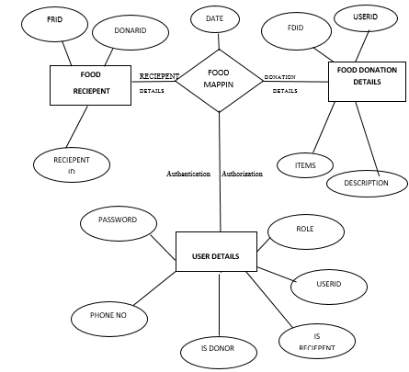

**4.2 Data Flow Diagram**

A data flow diagram (DFD) is a graphical representation of the “flow” of through an information

.system, modeling its process aspects often they are a preliminary step used. To create an overview of the system which can later be elaborated.

# 

**4.3 Use Case Diagram**

# 

**5.2 Table Description**

Below mentioned table shows the schema of table.

**4.2.1 Table of Contact**

|  |  |  |
| --- | --- | --- |
| **Column Name** | **Data Type** | **Constraints** |
| ContId | Int | Primary key |
| Name | Varchar (30) | Not null |
| Phone No | Bigint | null |
| Date | Varchar (30) | Null |
| Query | Nvarchar (100) | Not null |
| Viwed | Tinyint | Null |

**4.2.2 Table of User**

|  |  |  |
| --- | --- | --- |
| Column Name | Data Type | Constraints |
| Userid | Int | Primary key |
| Name | Varchar (30) | Not null |
| Phone | Varchar (30) | Not null |
| Address | Varchar (100) | Not null |
| Mai lid | Varchar (30) | Null |
| Password | Varchar (20) | Not null |
| Date | Nvarchar (20) | Null |
| Is active | Tinyint | Not null |
| Is donor | Tinyint | Not null |
| Is Recipient | Tinyint | Not null |
| Role | Varchar (20) | Null |

**4.2.3 Table of Recipient**

|  |  |  |
| --- | --- | --- |
| Column Name | Data Type | Constraints |
| FRID | Int | Not null |
| Donor id | Int | Not null |
| Recipient | Int | Not null |
| Date | Nvarchar (20) | Null |
| Description | Nvarchar (max) | Null |
| Constraint | int | Primary key |

**4.2.4 Table of Donor**

|  |  |  |
| --- | --- | --- |
| Column Name | Data Type | Constraints |
| FDID | Int | Not null |
| User id | Int | Not null |
| Date | nvarchar(20) | Null |
| Quantity | Int | Null |
| Items | nvarchar (Max) | Null |
| Description | nvarchar (Max) | Null |
| Isactive | tinyint | Null |
| Constraint | Int | Primary Key |

**4.4 Class Diagram**

**Tbl Contact**

ContId

Name

PhoneNo

Date

Query

**Tbl Register**

Regid

Name

PhoneNo

MailId

City

isactive

Date

Password

Role

**Tbl Donor**

Id

Name

isactive

**Tbl Recipient**

Id

Name

isActive

**5 IMPLEMENTATION**

**5.1 Technology Used**

* **Microsoft.NET Framework**

The .NET framework is a new computing platform that simplifies application development in the highly distributed environment of the Internet. The .NET framework is designed to fulfill the following objectives:

* To provide a consistent object-oriented programming environment whether object code is stored and executed locally, executed locally but internet-distributed, or executed remotely.
* To provide a code-execution environment that minimizes software deployment and versioning conflicts.
* To provide a code-execution environment that guarantees safe execution of codes, including code created by an unknown or semi-trusted third party.

To provide a code-execution environment that eliminates the performance problem of scripted or interpreted environments.

* **ASP.Net MVC**
* **Server Application Development**

Server-side applications in the managed world are implemented through runtime hosts. Unmanaged application host the common language runtime, which allows custom managed code to control the behavior of the server. This model provides you with all the features of the common language runtime and class library while gaining the performance and scalability of the host server.

* **Server-side managed code**

ASP.Net is the hosting environment that enables developers to use the .NET framework to target web-based applications. However, ASP.NET is more than just a runtime host; it is a complete architecture for developing web sites and Internet-distributed objects using managed code. Both web forms and XML web services use IIS and ASP.NET as the publishing mechanism for applications, and both have a collection of supporting classes

* **Active Server Pages.NET**

ASP.NET is a programming framework built on the common language runtime that can be used on a server to build powerful web applications. ASP.NET offers several important advantages over previous web development models in the .NET framework

**5.1.1 Language Used**

With the help ASP.NET platform it has been successful to implement the work done management and result analysis application. Here we have used c# programming language, because of security and this language has flexibility.

* **CSS**: Cascading Style Sheets (CSS) is a style sheet language used for describing the presentation semantics (the look and formatting) of a document written in a markup language.CSS is designed primarily to enable the separation of document content (written in HTML or a similar markup language) from document presentation, including elements such as the layout, colors, and fonts.CSS can also allow the same markup page to be presented in different styles for different rendering methods.
* **Microsoft Visual Studio**: It is an integrated development environment (IDE) from Microsoft. It is used to develop console and interface applications along with Windows Forms applications, web sites, web applications, and web services in both native code together with managed code for all platforms supported by Microsoft Windows, Windows Mobile, Windows CE, .NET Framework, .NET Compact Framework and Microsoft Silver light.
* **Microsoft SQL Server**: It is a relational database management system developed by Microsoft. As a database, it is a software product whose primary function is to store and retrieve data as requested by other software applications, be it those on the same computer or those running on another computer across a network (including the Internet).
* **JQuery**: JQuery is great library for developing Ajax based application. JQuery is great library for the JavaScript programmers, which simplifies the development of web 2.0 applications. You can use JQuery to develop cool web 2.0 applications. JQuery helps the programmers to keep code simple and concise. The JQuery library is designed to keep the things very simple and reusable. JQuery library simplifies the process of traversal of HTML DOM tree.
* **ADO. Net**: ADO .NET stands for ActiveX data object. Dataset is an in-memory content of the Ado. Net and is disconnected architecture of Ado .Net. The connection between back end (database) and front end (dataset) is called as data adaptor. In back end creates a table with table name and column and required data types.

**Sample code**

**Home.cshtml**

@{

ViewBag.Title = "Index";

Layout = "~/Views/Shared/Master.cshtml";

}

<div class="row">

<div class="col-lg-12" style="padding:0px;">

<div id="idpoemgallery" class="carousel slide" data-ride="carousel" data-interval="5000">

<div class="carousel-inner">

<div class="item active">

<img src="~/Images/hh1.jpg" class="img-responsive” />

</div>

<div class="item">

<img src="~/Images/hh2.png" class="img-responsive" />

</div>

<div class="item">

<img src="~/Images/hh4.jpg" class="img-responsive" />

</div>

<div class="item">

<img src="~/Images/hh.jpg" class="img-responsive" />

</div>

<a href="#idpoemgallery" class="carousel-control left" data-slide="prev">

<span class="glyphicon glyphicon-chevron-left"></span>

</a>

<a href="#idpoemgallery" class="carousel-control right" data-slide="next">

<span class="glyphicon glyphicon-chevron-right"></span>

</a>

</div>

</div>

</div>

<br />

<div class="row" style="background-color:#2C3E50 ">

@*1F3A93*@

<p class="opinion" style="font-size:20px;color:white;font-family:'Gill Sans', 'Gill Sans MT', Calibri, 'Trebuchet MS', sans-serif">Hungry Heart's Message</p>

<div class="col-lg-6">

<p class="opinion" style="font-size:18px;color:white">Purpose</p>

<p style="text-indent:25px;font-size:18px;color:white">

An introduction section promotes then descriptive representation of the project,

and also what is the project and how it works;

it also gives clear picture of how the existing system works and its importance.<a

<span style="color:red">read more [+]</span>

</a>

</p>

</div>

<div class="col-lg-6">

<p class="opinion" style="font-size:18px;color:white">Scope</p>

<p style="text-indent:25px;font-size:18px;color:white">

The web application is developed to focus on difficulty faced by the poor needy hearts.

The main aim of the project is to be in a social platform that brings to gather volunteers

and donors interested in donating food for the propose of eliminating food wastage .<a href="@Url.Action("About", "Home")#pnlScope">

<span style="color:red">read more [+]</span>

</a>

</p>

</div>

</div>

**Stored Procedure:**

USE [HH]

GO

SET ANSI_NULLS ON

GO

SET QUOTED_IDENTIFIER ON

GO

CREATE PROCEDURE [dbo].[SP_FOODRECEIPENTINSERTDELETEDISPLAY]

(

@FRID INTEGER,

@DONARID INTEGER,

@RECEIPENTID INTEGER,

@DATE NVARCHAR(100),

@DESCRIPTION NVARCHAR(MAX),

@STATEMENTTYPE NVARCHAR(20) = ''

)

AS

BEGIN

IF @STATEMENTTYPE = 'INSERT'

BEGIN

INSERT INTO TBL_FOODRECEIPENTDETAILS

VALUES(@DONARID,@RECEIPENTID,@DATE,@DESCRIPTION)

END

IF @STATEMENTTYPE = 'SELECT'

BEGIN

SELECT * FROM TBL_FOODRECEIPENTDETAILS

END

IF @STATEMENTTYPE = 'EDIT'

ELSE IF @STATEMENTTYPE = 'DELETE'

BEGIN

DELETE FROM TBL_FOODRECEIPENTDETAILS WHERE FRID = @FRID

END

END

GO

**6. TESTING**

Testing only the validation for nonfunctional requirements as the software as the software has to be executed to see how it behaves. The testing process focuses on the logical internal of the software, ensuring that algorithm have been tested and on the external function

* **Software testing**
* **Introduction**

Testing is the process of detecting errors. Testing performs a very critical role for quality assurance and for ensuring the reliability of software. The results of testing are used later on during maintenance also.

* The process of executing a system with the intent of finding an error
* Testing is defined as the process in which defects are identified, isolated, subjected for rectification and ensured that product is defect free in order to produce the quality product and hence customer satisfaction.
* Quality is defined as justification of the requirements
* Defect is nothing but deviation from the requirements
* Defect is nothing but bug
* Testing--- The presence of bugs
* Testing can demonstrate the presence of bugs, but not their absence
* Debugging and Testing is not the same thing!
* Testing is a systematic attempt to break a program or the AUT
* **Testing Objectives**

The main objective of testing is to uncover a host of errors, systematically and with minimum effort and time. Stating formally, we can sat,

* Testing is a process of executing a program with the intent of finding an error.
* A successful test is one that uncovers an as yet undiscovered error.
* A good test case is one that has a high probability of finding error, if it exists.
* The tests are inadequate to detect possibly present errors.

# The software more or less confirms to the quality and reliable standards.

**6.1 Test cases**

|  |  |  |  |  |
| --- | --- | --- | --- | --- |
| **SI.NO** | **Description** | **Expected Result** | **Actual Result** | **Status** |
| TC1 | Enter Login details and click on login | Validate and go to home page | Validated and Redirected to home page | Pass |
| TC2 | Details and click on cancel Enter | Clears text boxes | Cleared text boxes | Pass |
| TC3 | Validation is added to enter the details in add contact | Validate details and move to corresponding page | Validate details and moved to corresponding page | Pass |
| TC4 | Validation is added to enter the details in add registration | Validate details and move to corresponding page | Validate details and moved to corresponding page | Pass |
| TC5 | Validation is added to enter the details in add degree | Validate details and move to corresponding page | Validate details and moved to corresponding page | Pass |
| TC6 | Validation is added to enter the details in add employee | Validate details and move to corresponding page | Validate details and moved to corresponding page | Pass |

Note: TC stands for Test Case

**7. Screen Shots**

**7.1 Login Page**

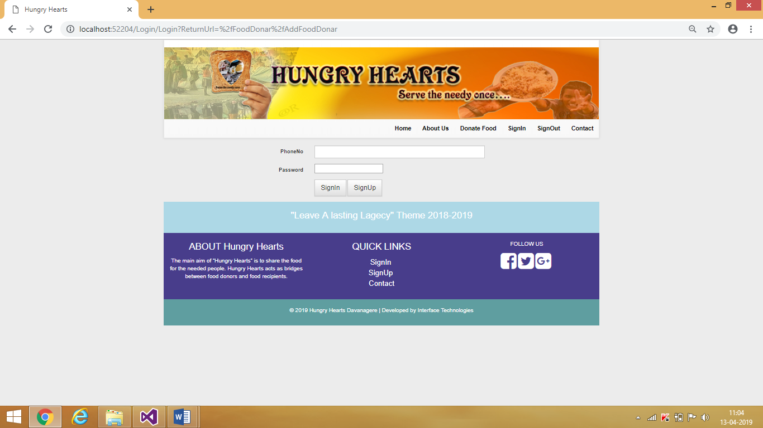

**7.2 Home Page**

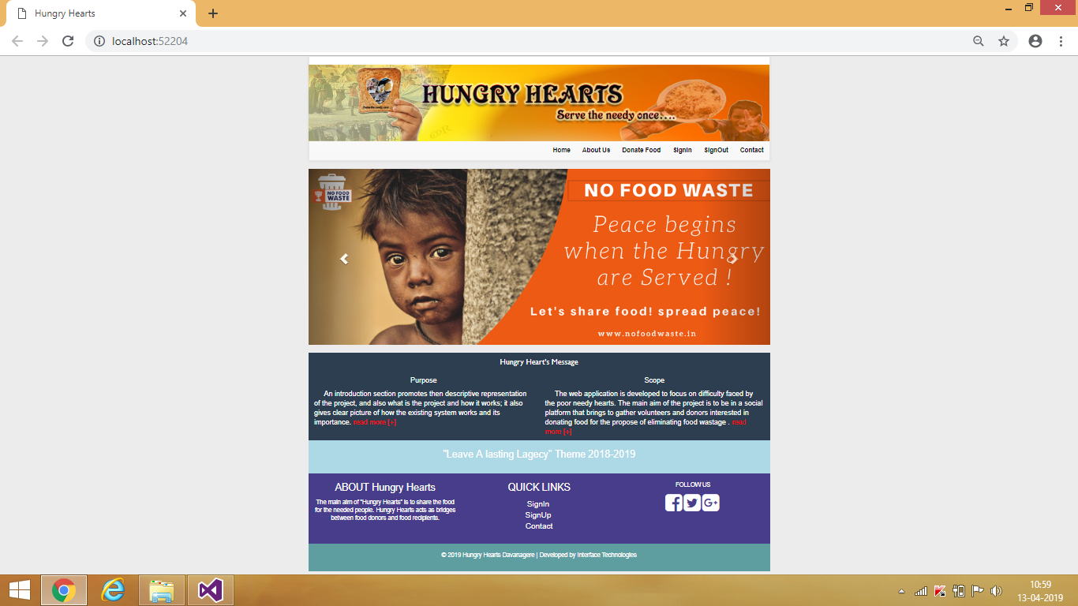

**7.3 About Us**

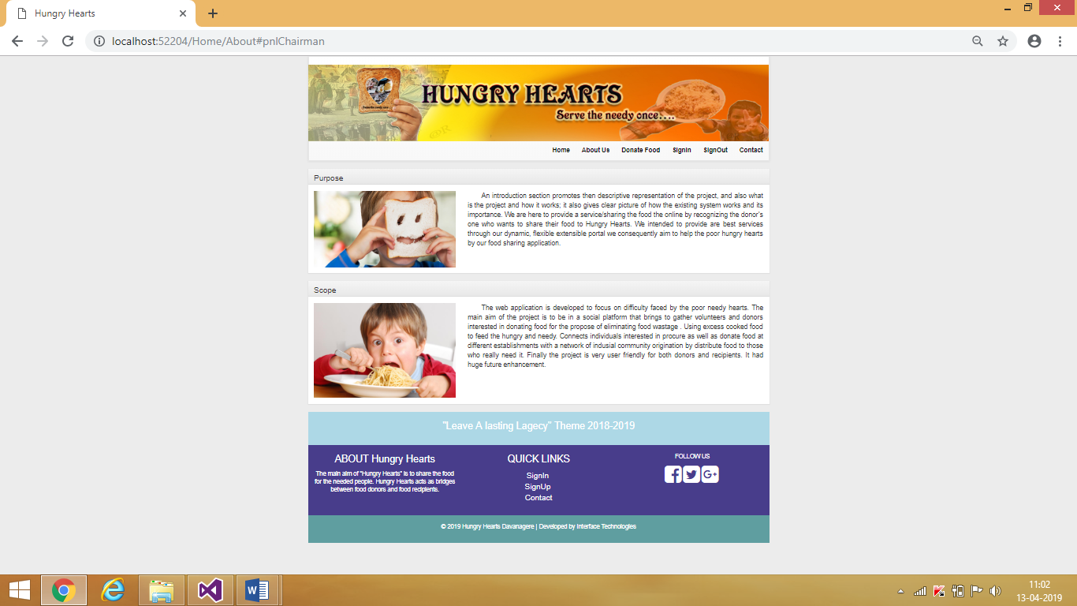

**7.4 Donor/Recipient Mapping Page**

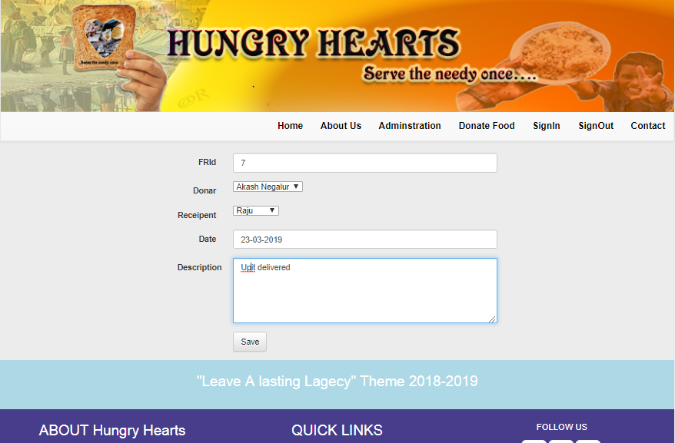

**7.5 Registered successfully message**

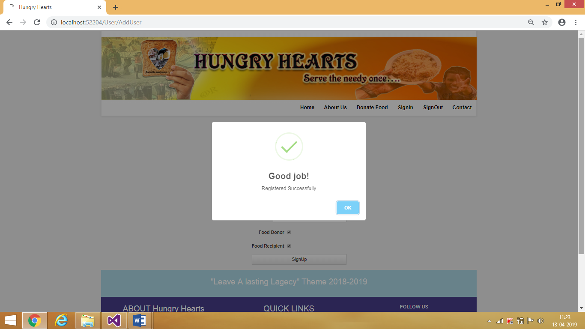

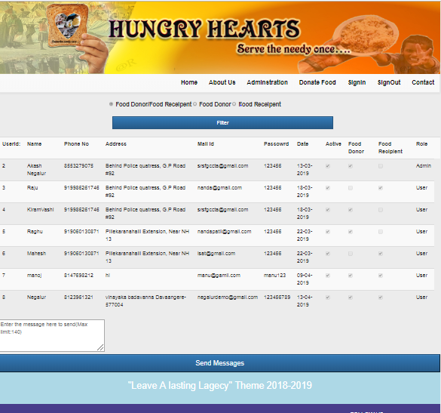

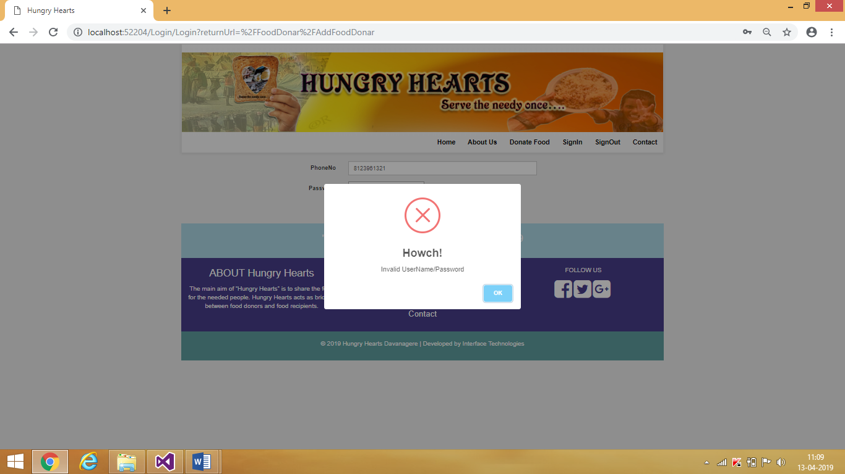**7.6 Validation for invalid username/password Message**

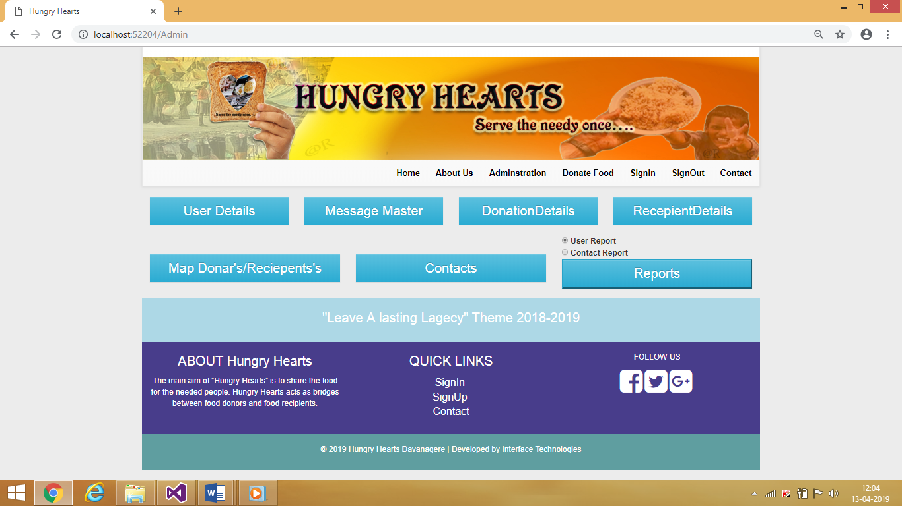**7.7 Admin’s Dashboard Page**

**8. CONCLUSION**

By Understandings the importance for healthy food for every person in society. To fulfilling the eagerness of the donor one who wants to share their food which is excess to them. Our project motto is to feed the hungry once by the voluntaries.

Product maintains about all the data regarding donors, description of food and the recipients.

**9. FUTURE ENHANCEMENT**

This his web application can enhance with the following features including:

* Services are offered across various Recipient of different sectors.
* Large online management team will handle it.
* Experienced management team will handle it.
* In future it can be developed in to android application.

**10. BIBLIOGRAPHY**

* A press Building an ASP.NET- Intranet eBook-LiB.
* Beginning.SQL.Server.2005.Programming
* Web Programming- ASP.NET website programming, C Sharp Edition.
* Wiley-Professional.ASP.NET.2.0.2006
* Wrox.Begining.Ajax.with.ASP.NET.Sep.2006.
* Addison Wesley- Essential ASP.NET with Examples in Csharp
* ASP.NET 2.0 MVP Hacks and Tips-Wrox
* Professional visual studio 2017 by Bruce Johnson
* Beginning ASP.NET 4.5.1 C# and VB by Imar Spaanjaars
* Learning ASP.NET core 2.0