Microservices Flight App
Screenshots
Rakesh Teja P V

Sonar Cloud

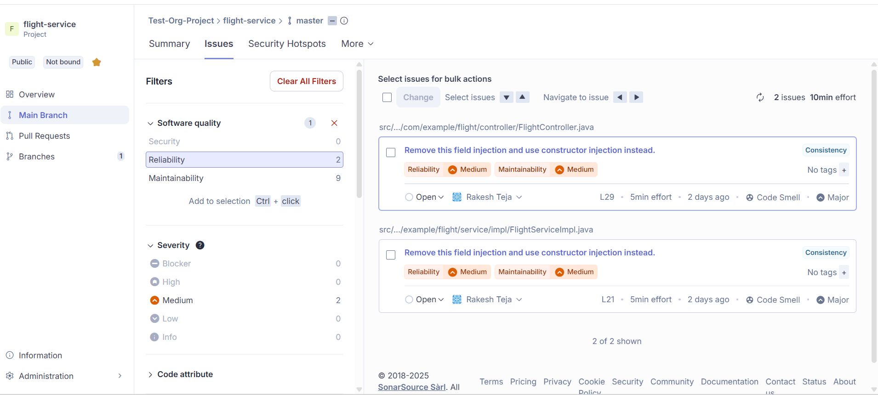

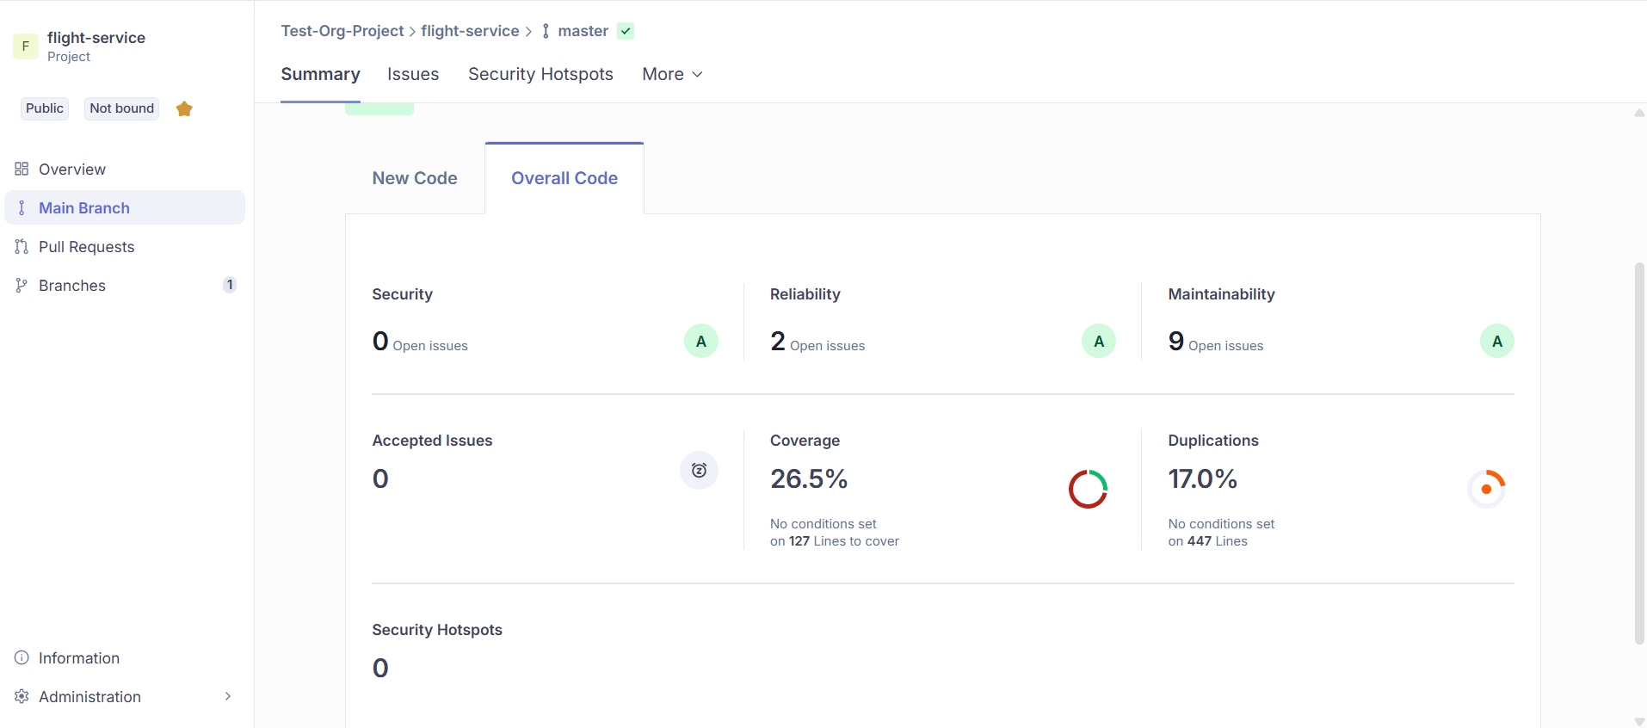

After Implementing sonar cloud suggestions:

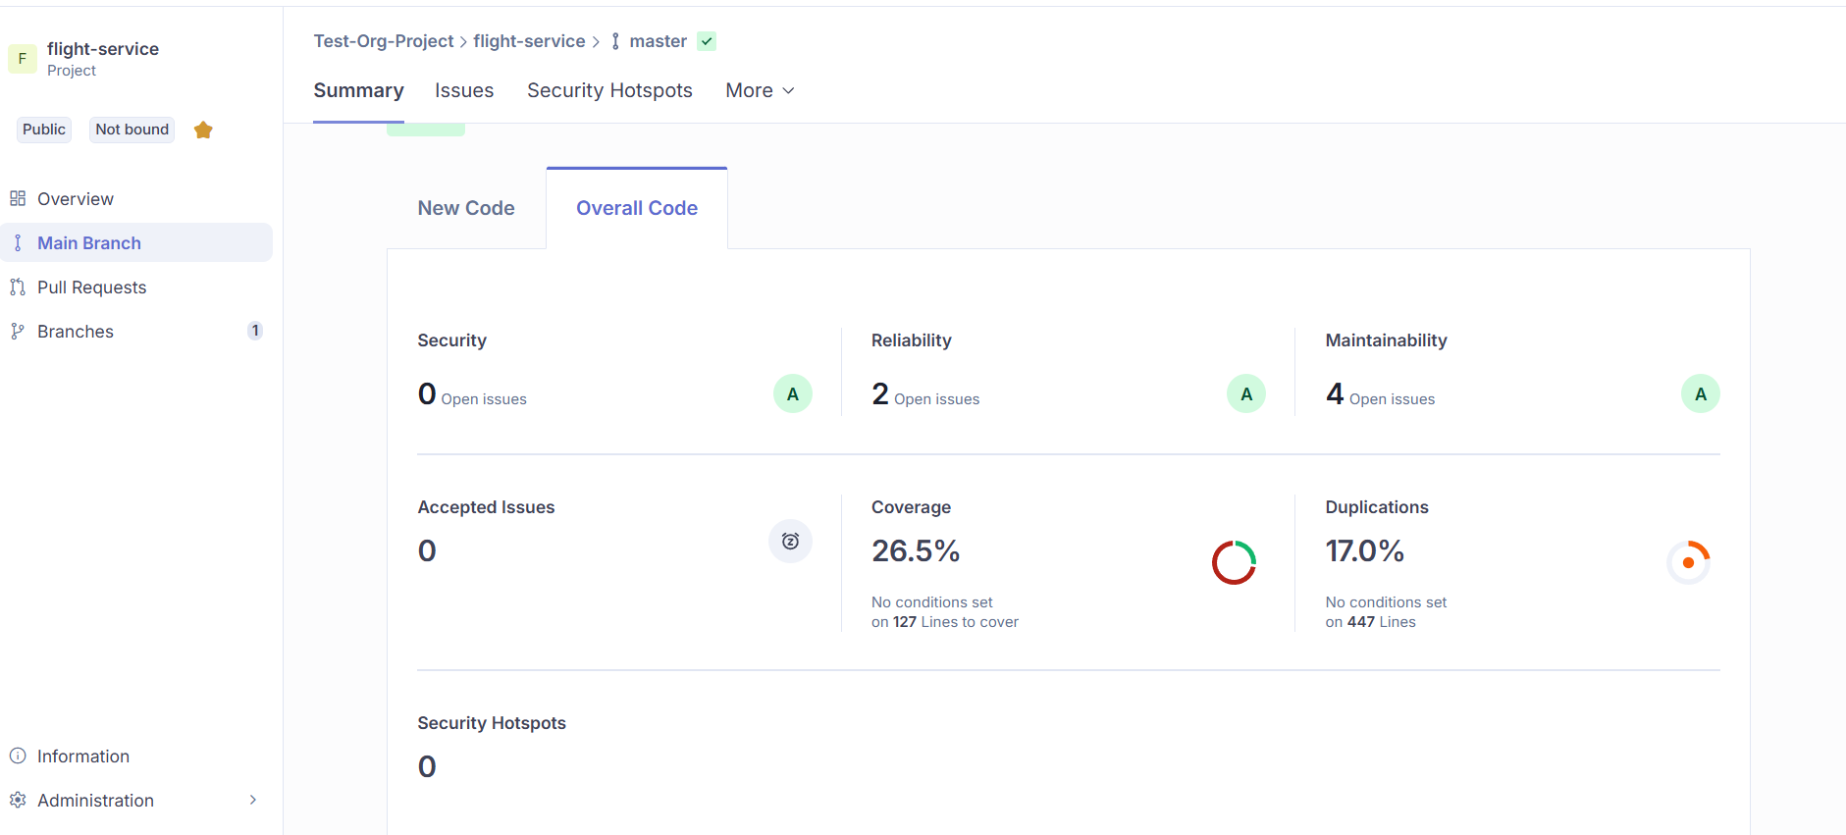
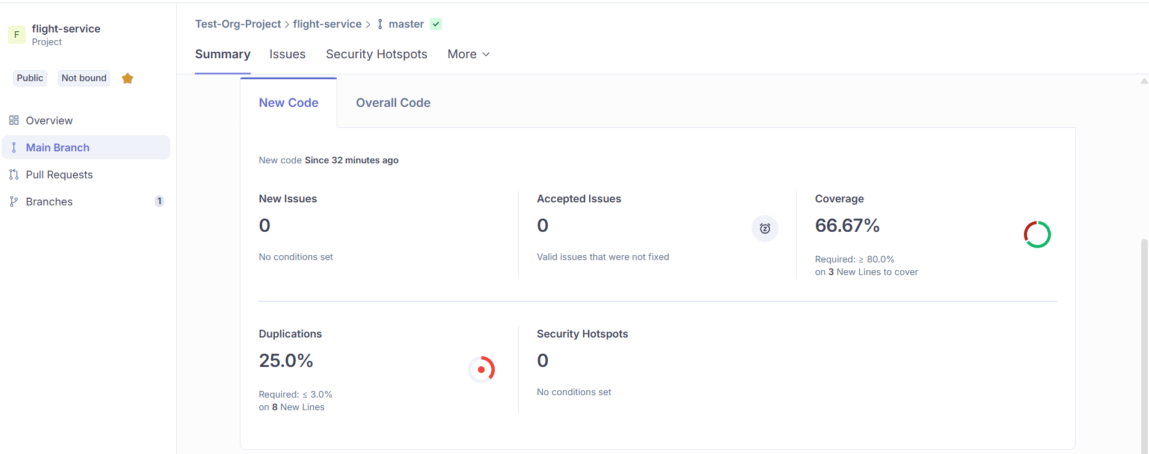

Jmeter Testing

Add and Search Flights:

20 Users

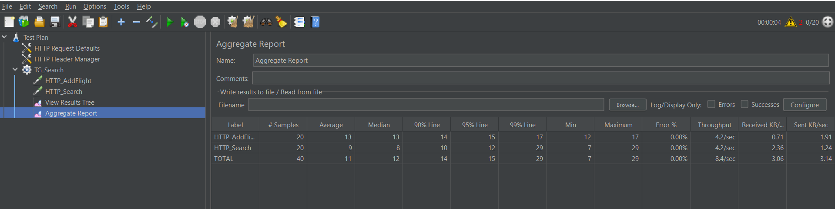

50 Users

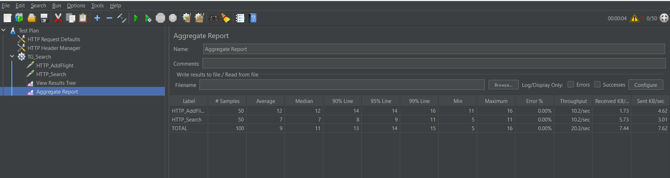

100 Users

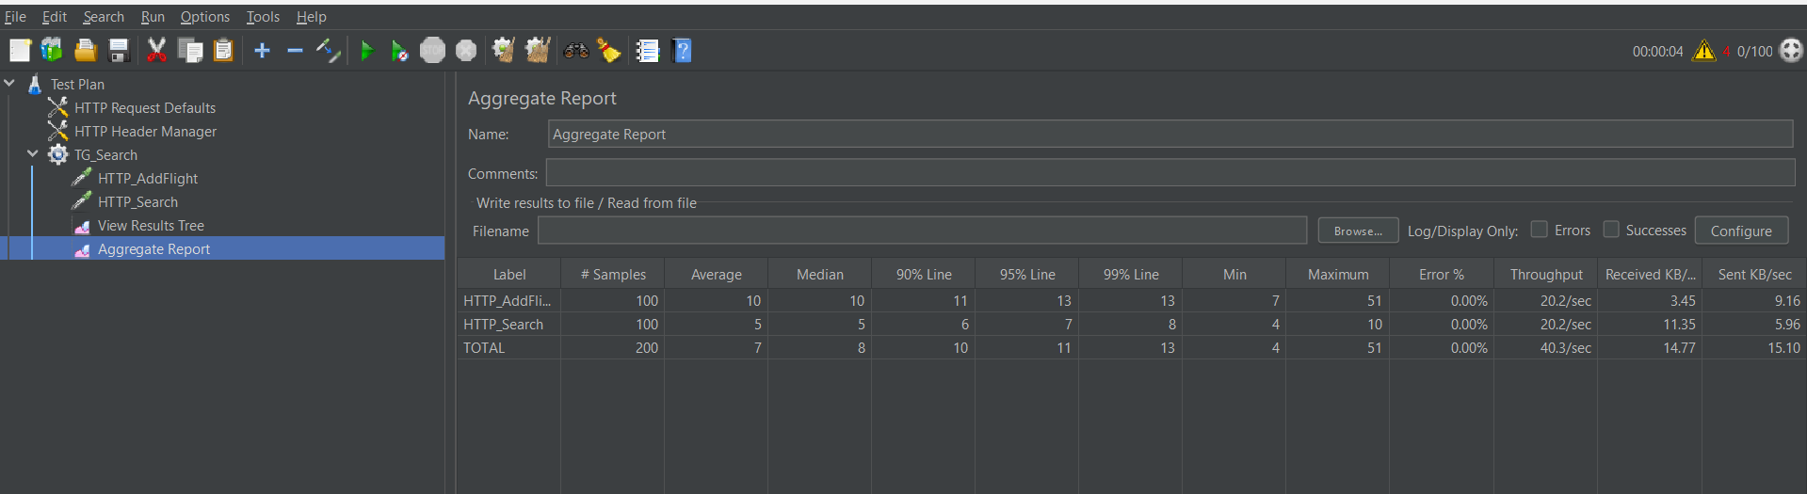

Book Ticket, View Ticket, Booking History

20 Users

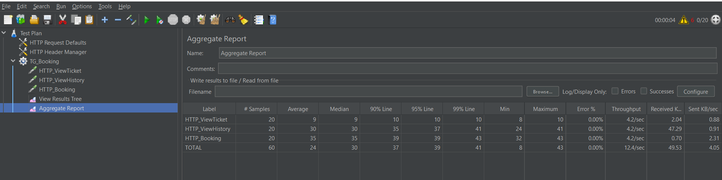

50 Users

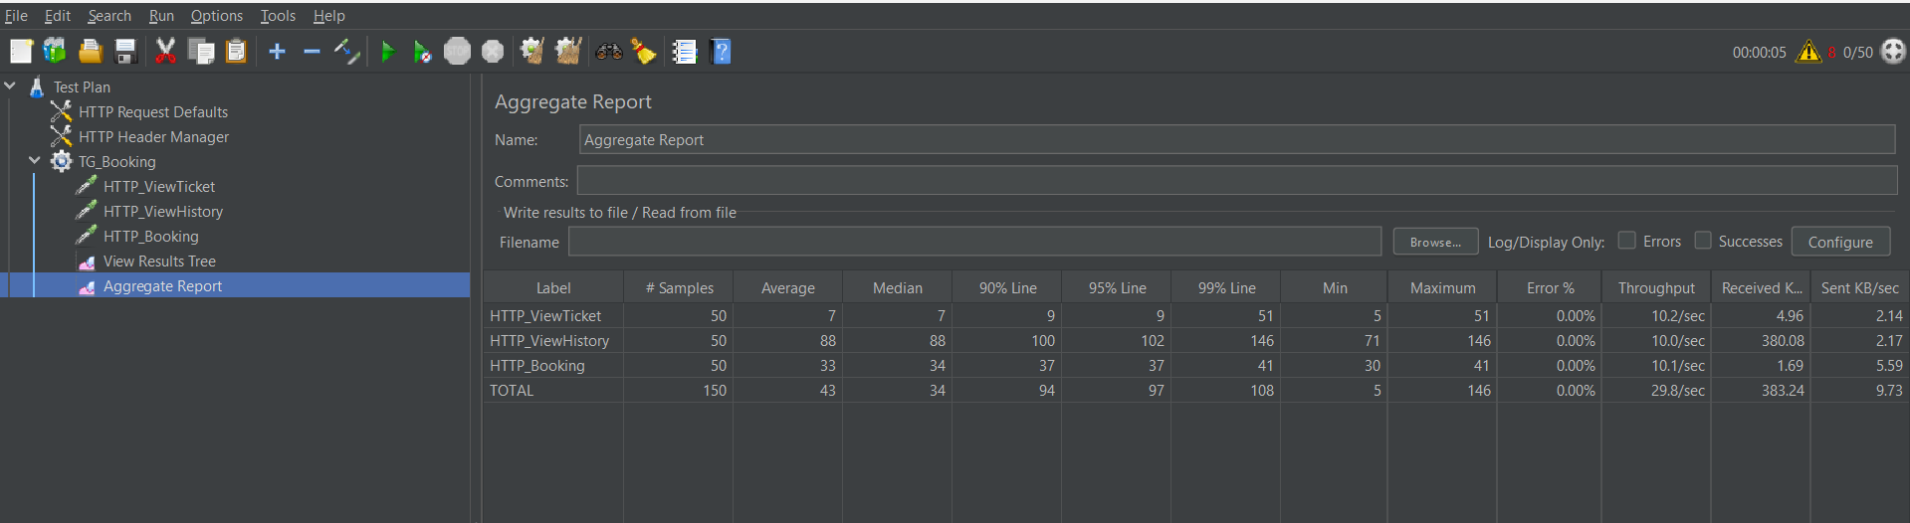
100 Users

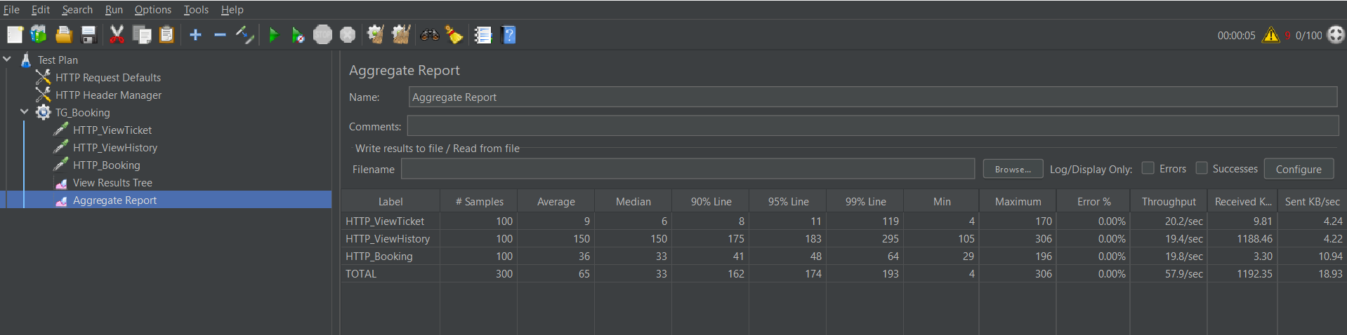

Postman

Add Flight

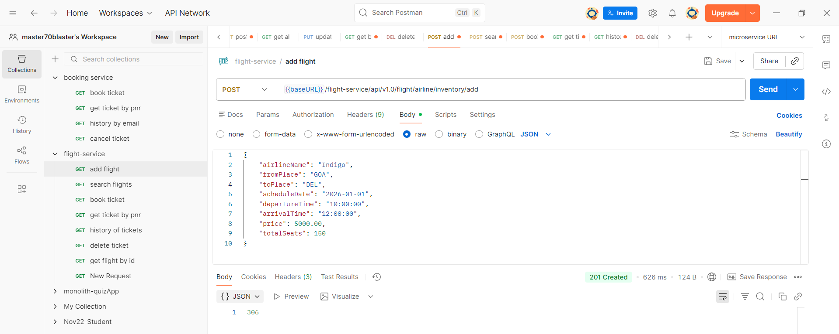
Search Flight

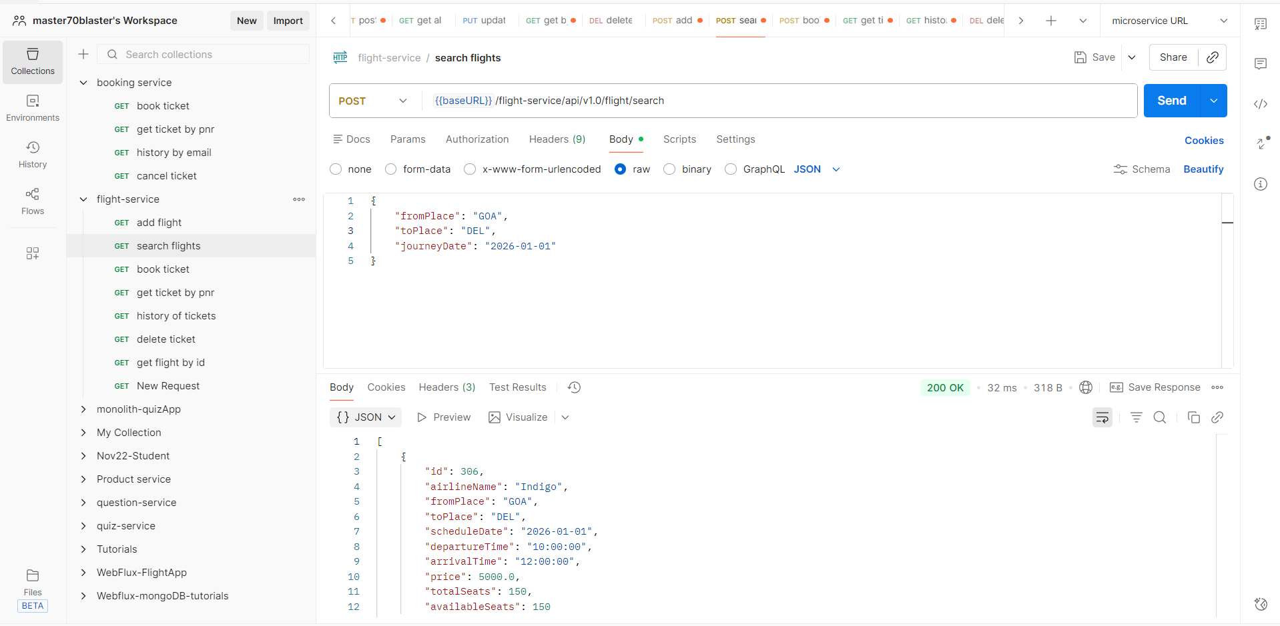

Book Ticket

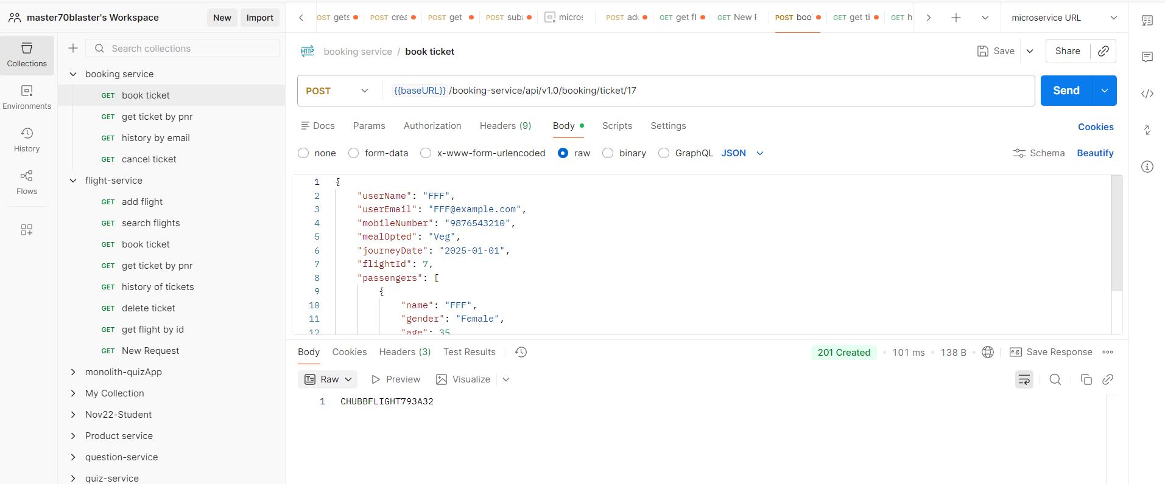

View Ticket

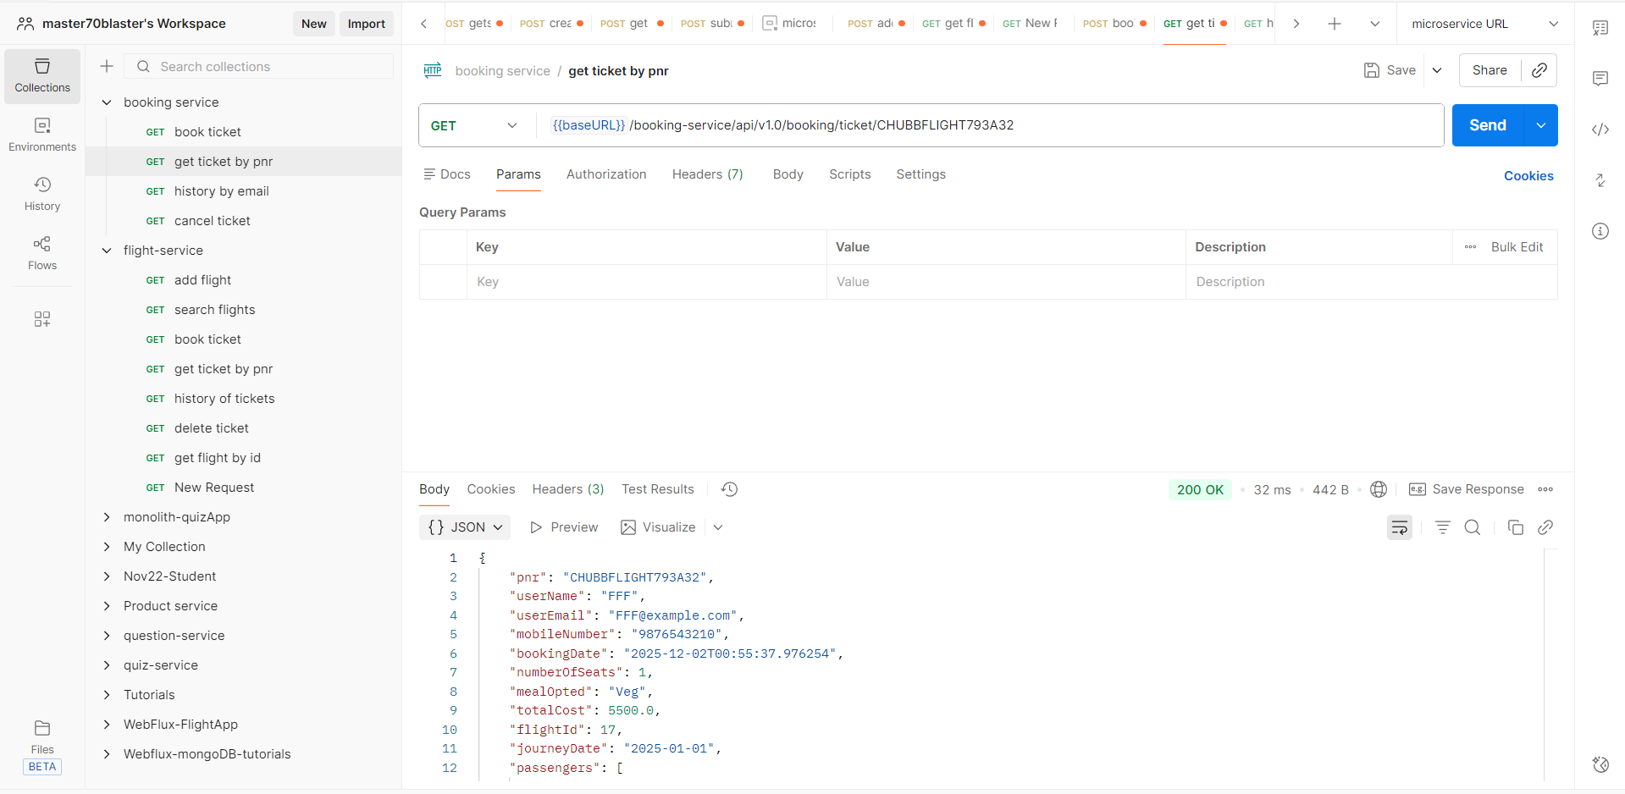

View Booking History

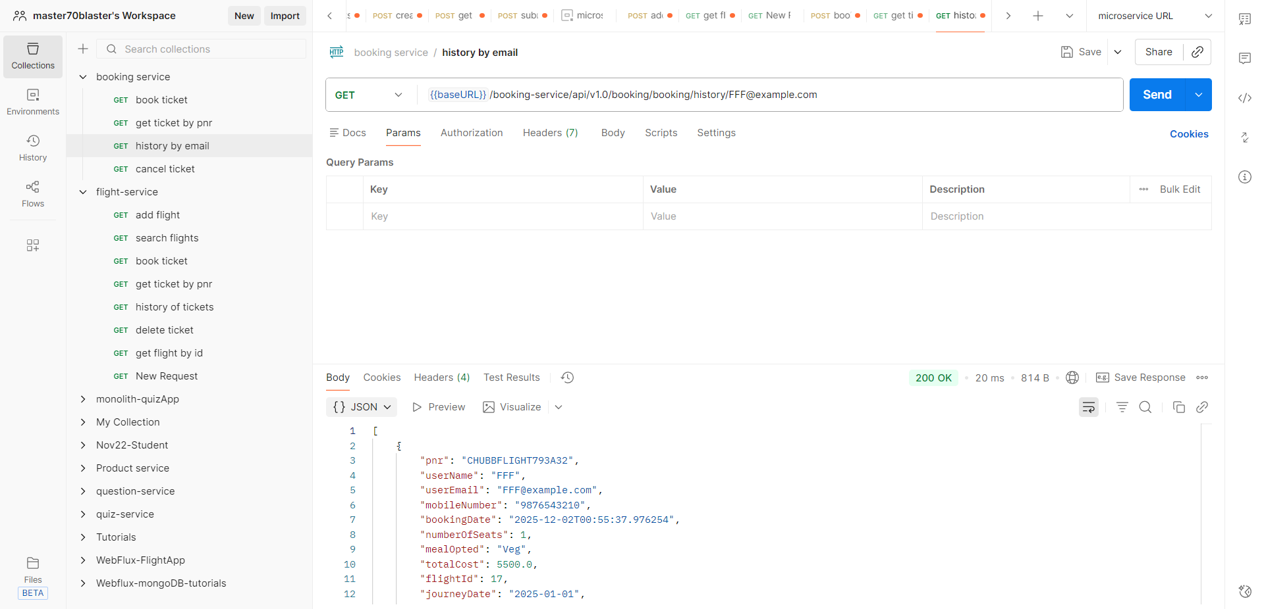

Cancel Ticket

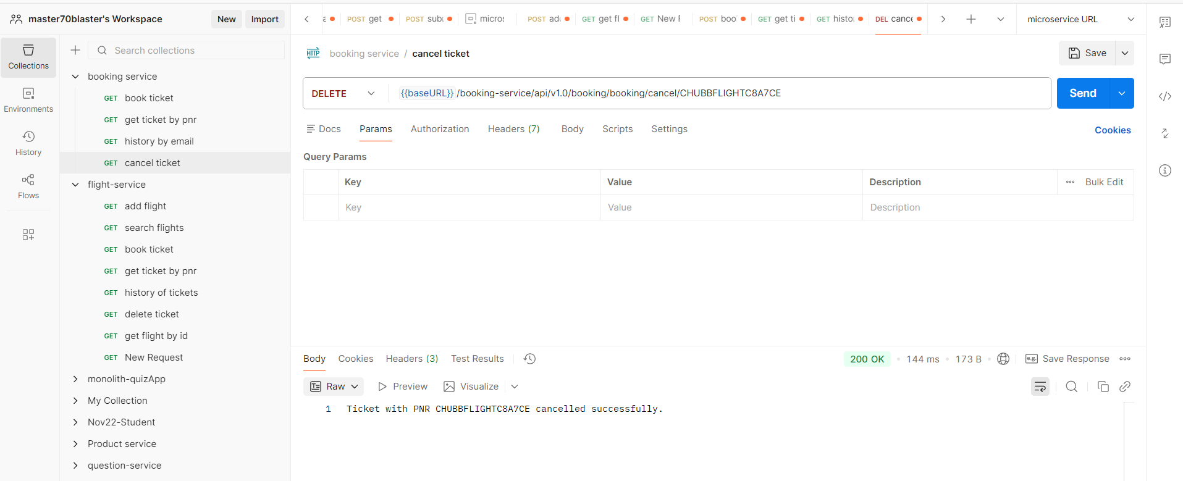

Circuit Breaker

