FLIGHT BOOKING APP – WEBFLUX

SCREENSHOTS

- Rakesh Teja P V

Initial Sonar Cloud Analysis:
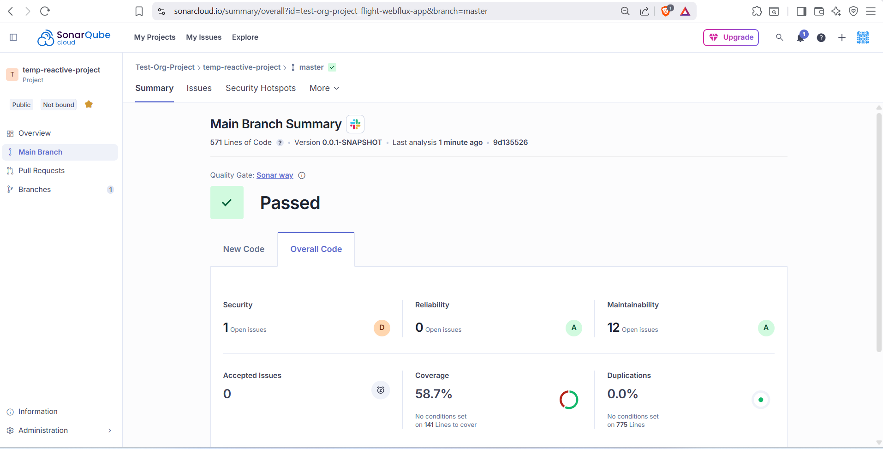

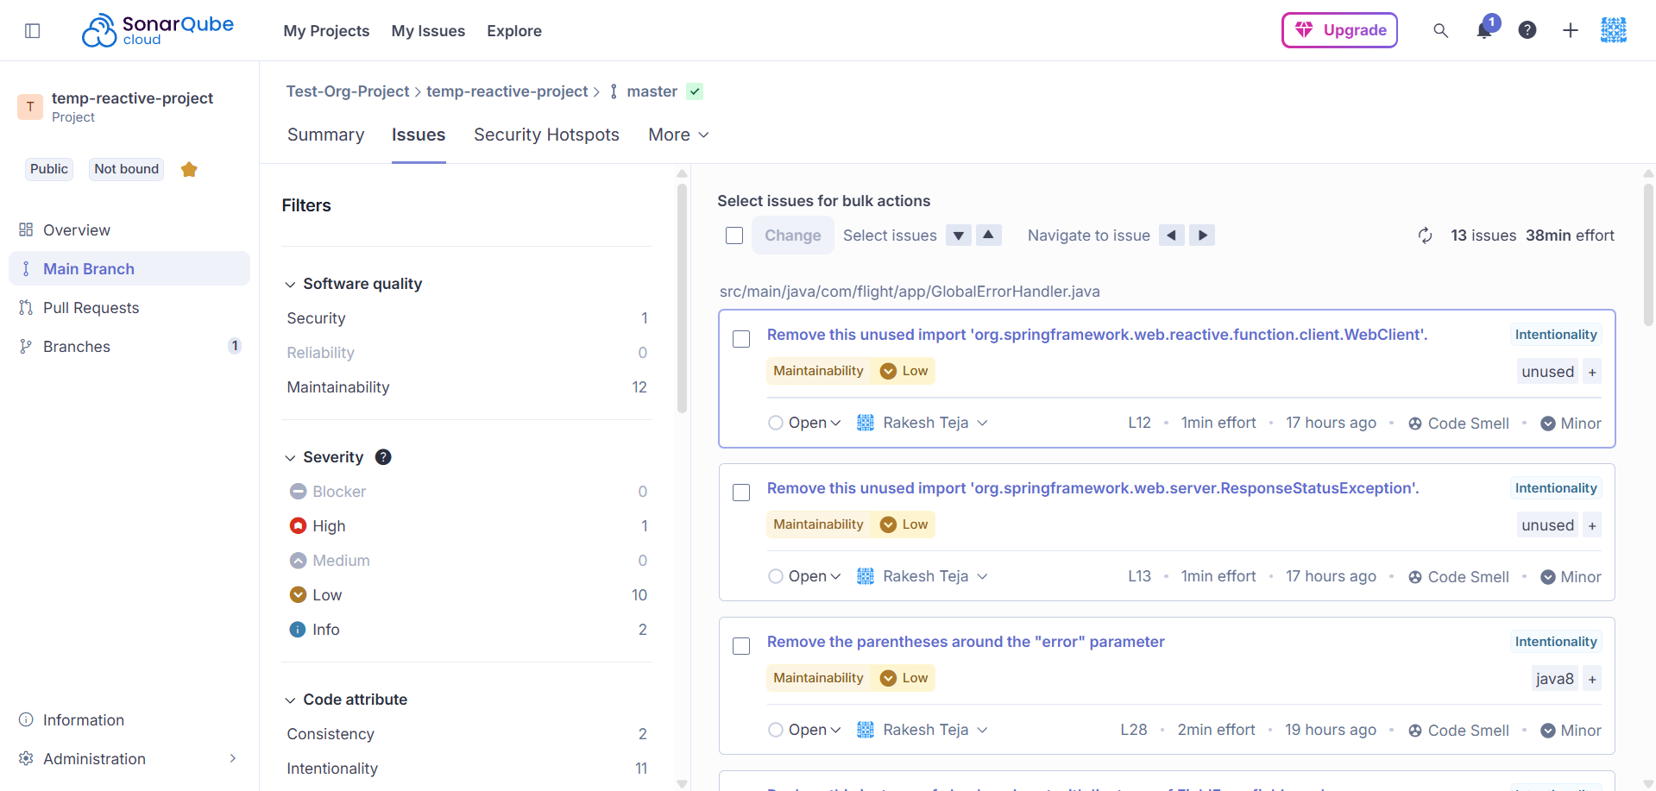

After implementing sonar cloud suggestions

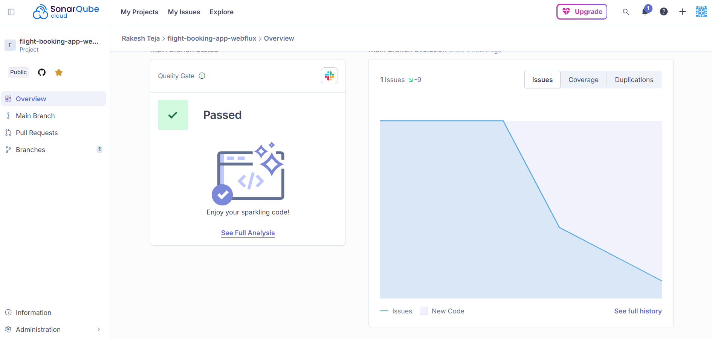

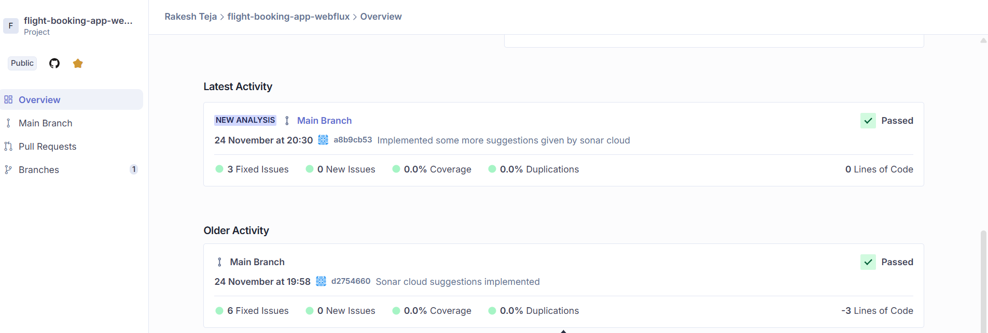

Jmeter Load Testing

Search Flights – This API can potentially be used by a lot of people. So Stress testing is mandatory for this endpoint

20 Users

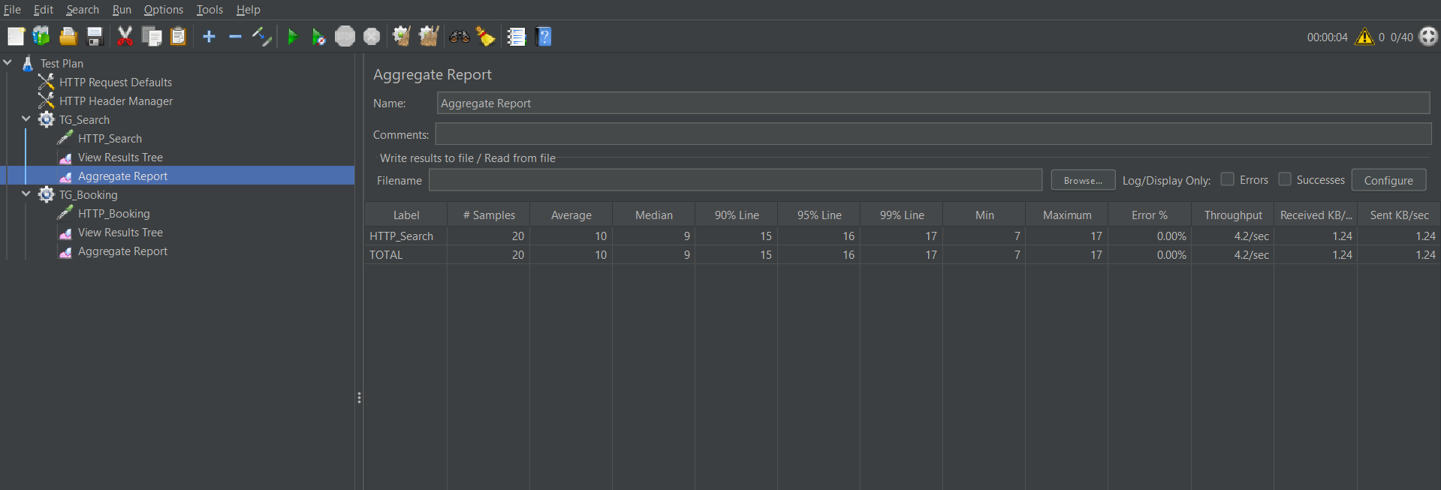

50 Users

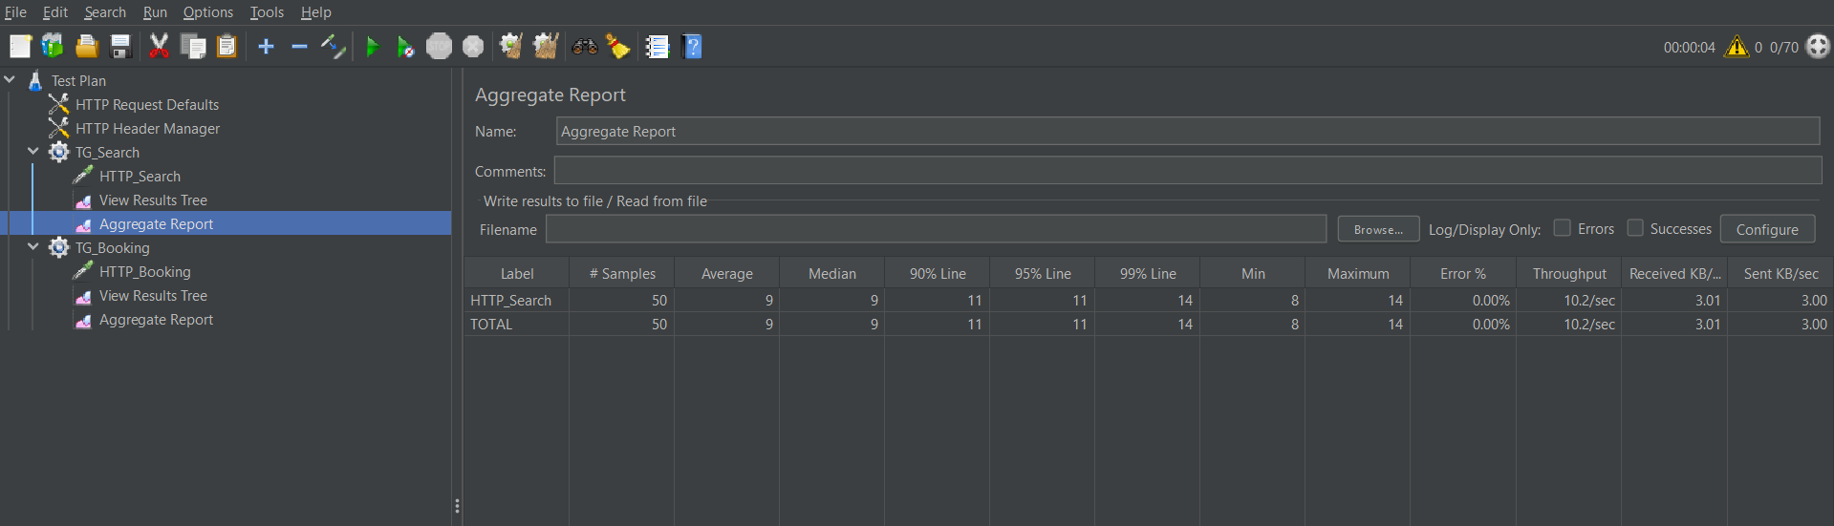

100 Users

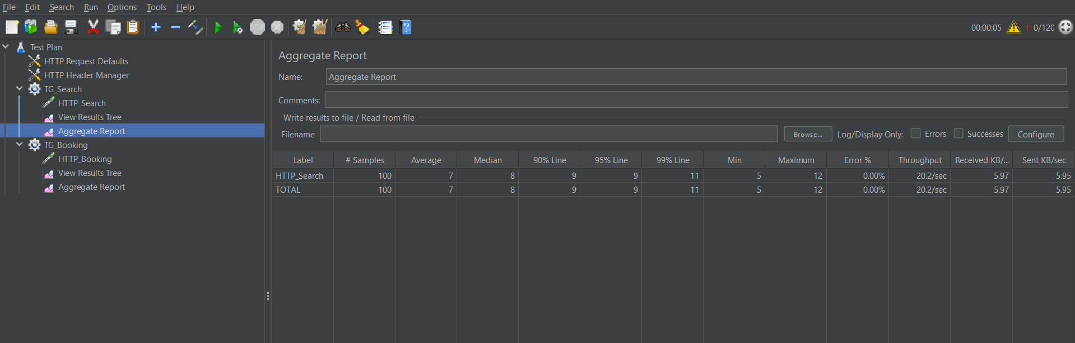

Book Ticket – This API can also be used by a lot of people.

20 users

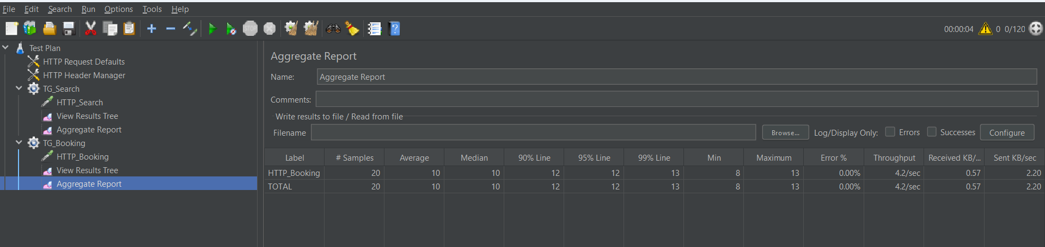

50 users

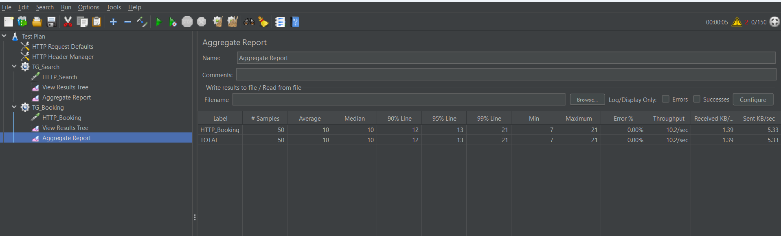

100 users

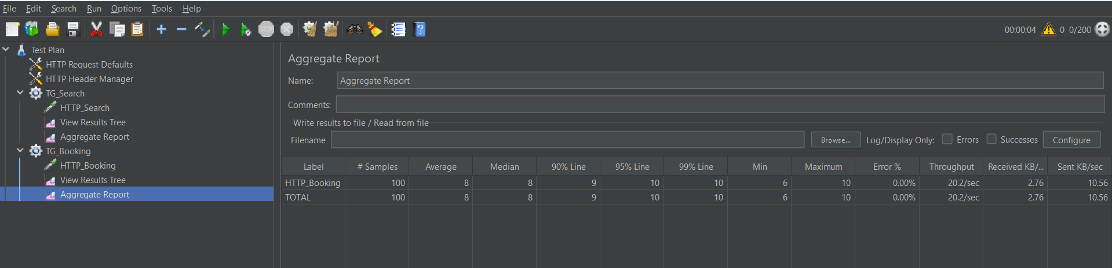

Other Endpoints

20 users

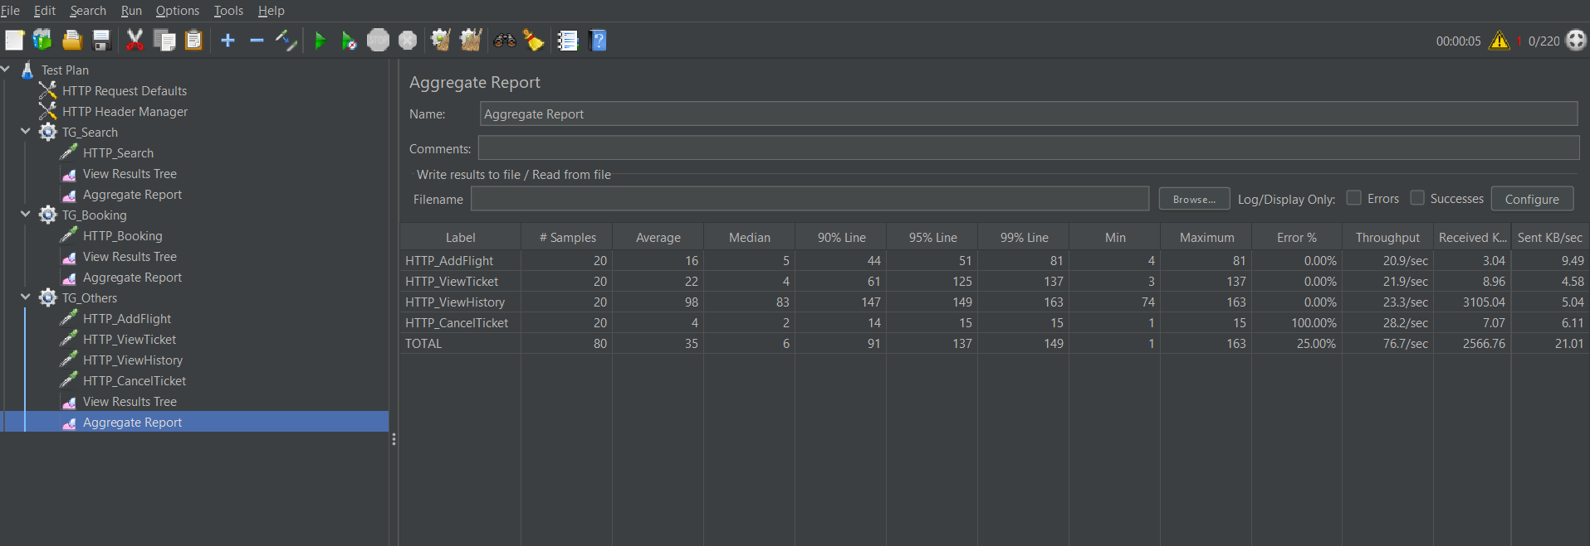

50 users

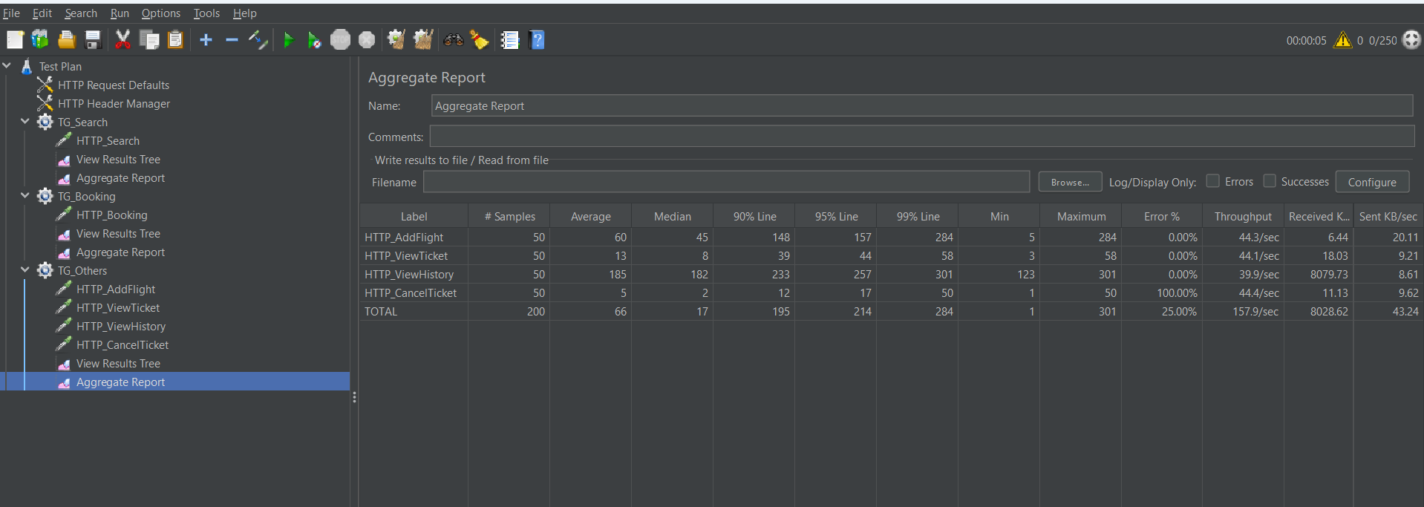
100 users

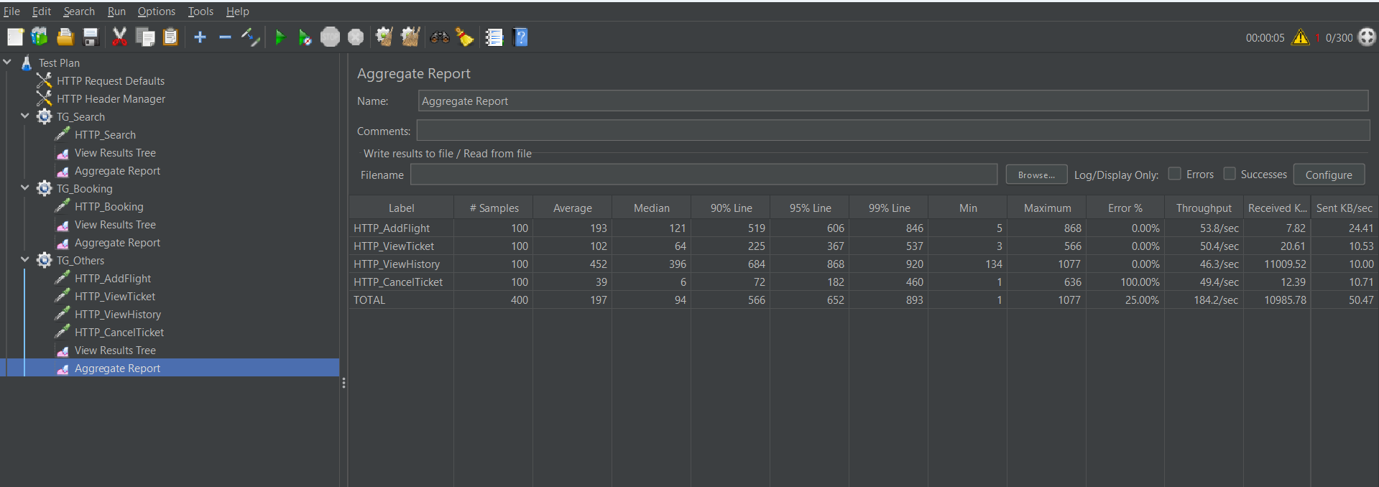

Post man Screenshots

Add flight

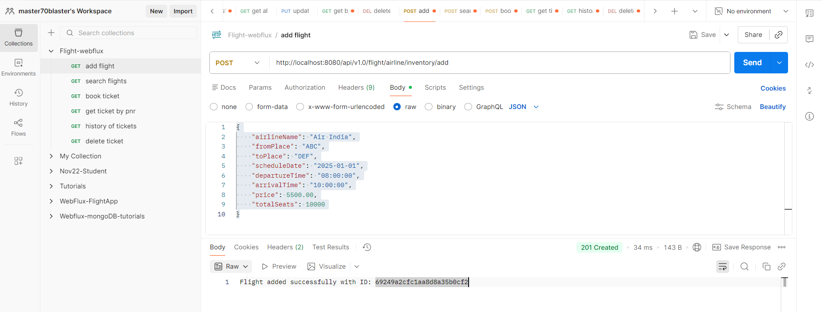

Search Flight

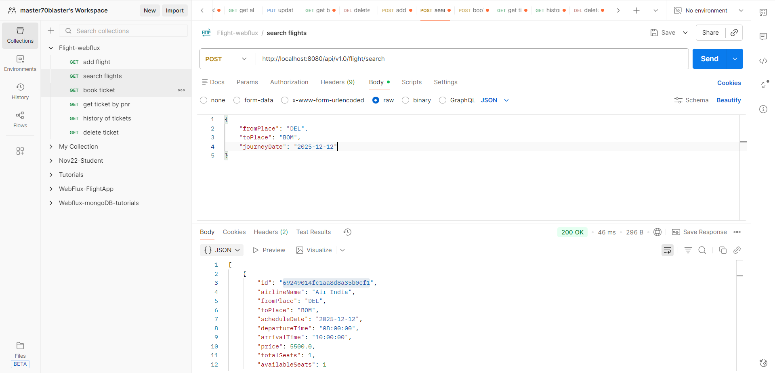

Book Ticket

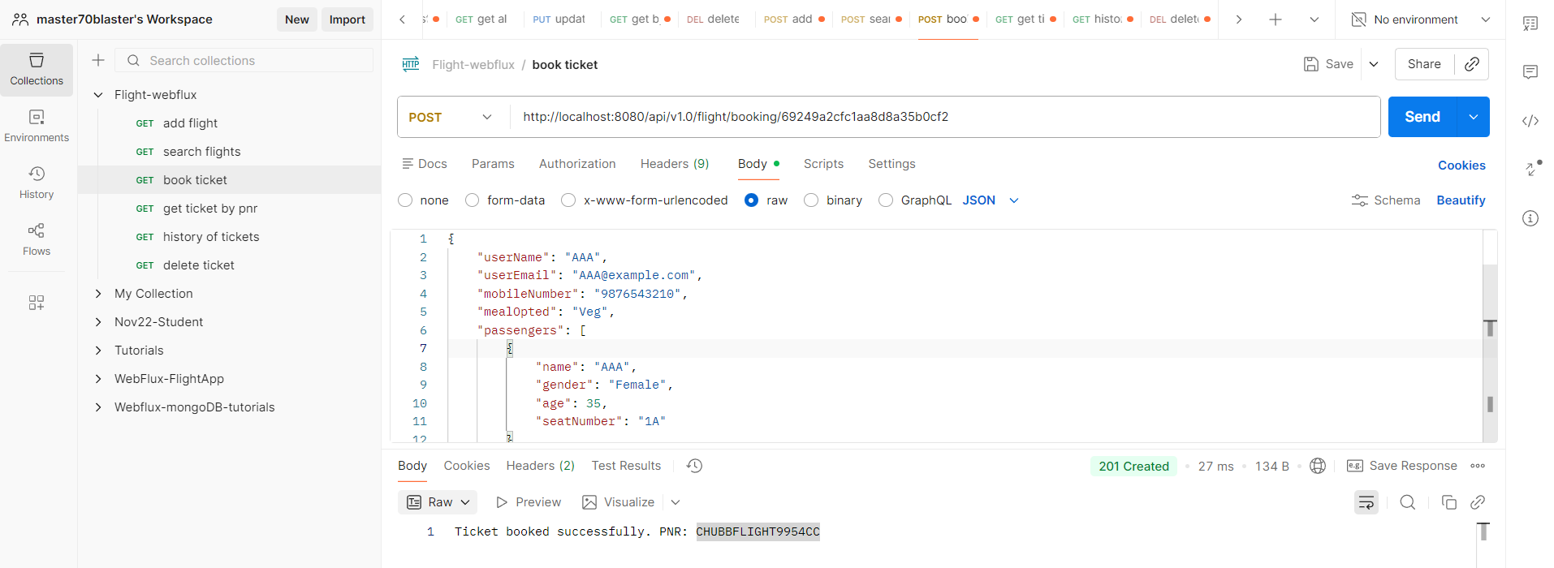

Get Ticket by PNR

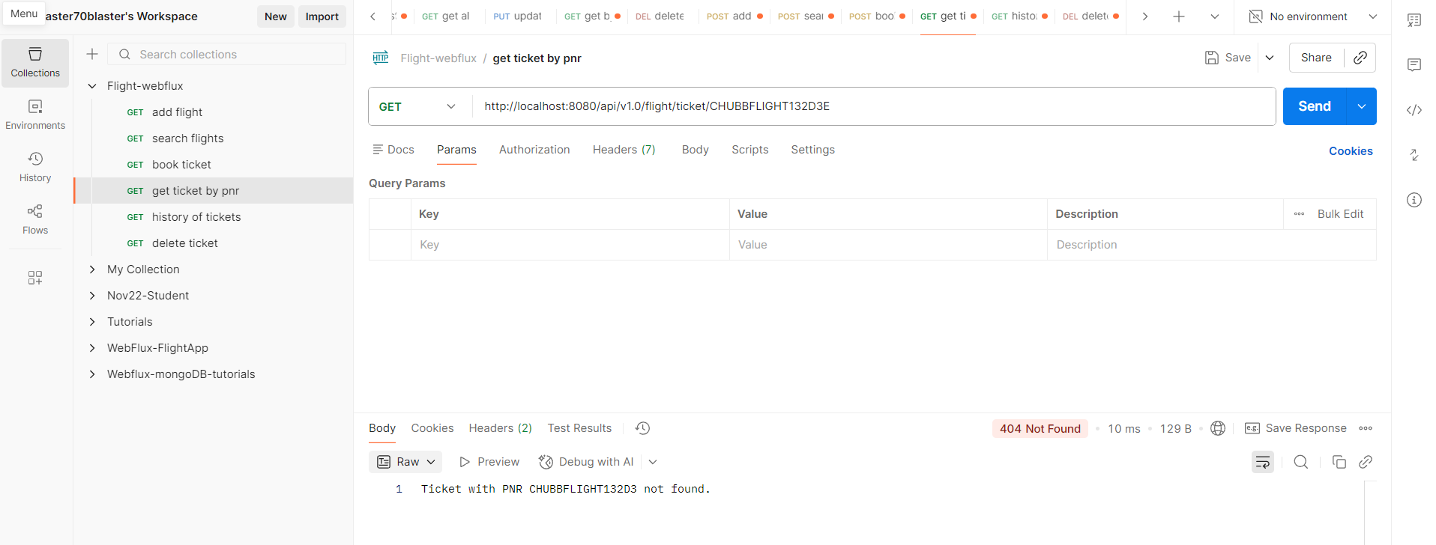

View History of Booking

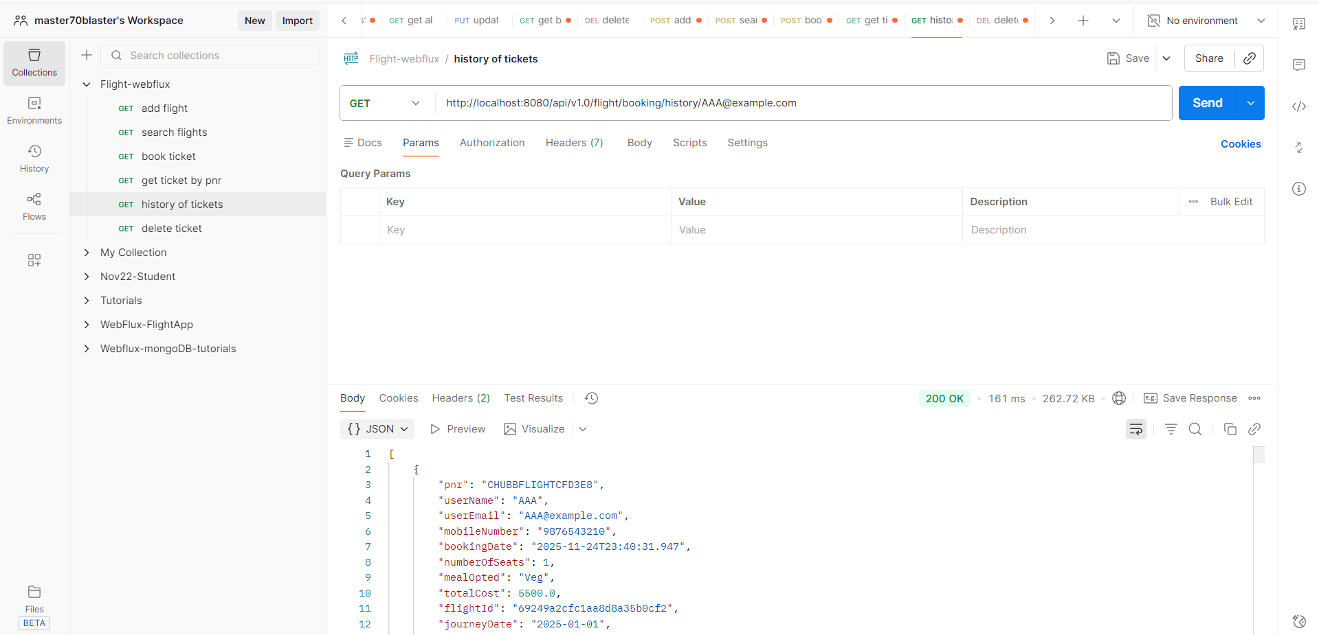

Cancel Ticket

