Healthcare Data Preprocessing
Data Cleaning and Preparation Methodology Using Python
Practical Guide for Healthcare Analytics Projects

Project Type | Healthcare Analytics – Data Preprocessing
Primary Tools | Python, Pandas, NumPy
Focus Areas | Missing values, anomalies, duplicates, categorical data, outliers, normalization
Deliverables | Methodology, pseudocode, data-quality discussion, summary table, workflow flowchart

1. Executive Summary
Healthcare datasets commonly contain incomplete, inconsistent, duplicated, incorrectly formatted, or clinically implausible records. Examples include missing laboratory measurements, inconsistent gender or diagnosis labels, impossible ages or vital-sign values, duplicate patient encounters, and extreme measurements that may represent either genuine clinical events or data-entry errors. A systematic preprocessing workflow is therefore required before statistical analysis, machine learning, visualization, or reporting.
This methodology presents a reproducible approach using Python, with Pandas for tabular data handling and NumPy for numerical operations. The workflow begins with data understanding and profiling, followed by validation, missing-value treatment, duplicate removal, categorical standardization, anomaly and outlier management, normalization or scaling, and final quality assurance. The guiding principle is that healthcare data should not be altered merely to make it look cleaner: every transformation must be justified, documented, reproducible, and checked against the clinical meaning of the field.

2. Objectives
- Assess the completeness, consistency, validity, uniqueness, and plausibility of a healthcare dataset.
- Identify missing values, duplicates, inconsistent categories, invalid ranges, and anomalous observations.
- Design defensible strategies for imputation, removal, correction, flagging, and transformation.
- Prepare numerical and categorical variables for downstream analytics or machine learning.
- Use normalization/scaling when appropriate without destroying clinically meaningful information.
- Create a documented and reproducible preprocessing workflow using Pandas and NumPy.
- Provide validation checks that confirm the cleaned dataset remains structurally and clinically coherent.

3. Example Healthcare Dataset and Data Dictionary
For illustration, assume a patient/encounter dataset containing demographic, clinical, laboratory, and outcome variables. The exact fields should be adapted to the real project and its data dictionary.
Field | Type | Example | Quality Risk | Treatment
Patient_ID | String | P00125 | Duplicates / format issues | Validate uniqueness and format
Age | Numeric | 54 | Missing / impossible values | Range validation + imputation if justified
Gender | Categorical | Female | Different labels | Standardize labels
Admission_Date | Date | 2026-03-12 | Invalid formats / missing | Parse and validate
Blood_Pressure | Numeric | 128 | Outliers / unit differences | Validate units and clinical plausibility
Diagnosis | Categorical | Diabetes | Spelling / synonyms | Controlled mapping
Lab_Result | Numeric | 5.8 | Missing / extreme values | Validate units, flag and handle outliers
Outcome | Categorical | Recovered | Class imbalance / inconsistent labels | Standardize and document

4. Initial Assessment of Data Quality

4.1 Structural Assessment
The first step is to understand the dataset before changing any values. Record the number of rows and columns, column names, data types, memory usage, unique counts, and the meaning of each field.
Pseudocode:
LOAD dataset
DISPLAY number_of_rows, number_of_columns
DISPLAY column_names and data_types
DISPLAY sample records
COMPARE columns with the approved data dictionary
IDENTIFY candidate identifiers, dates, categorical fields, and numerical measurements

4.2 Missing-Value Assessment
Calculate missing counts and percentages for every variable. Missingness should also be examined by patient group, hospital, date, department, or outcome when such information is available. A missing value can be random, related to another variable, or informative in itself.
Pseudocode:
FOR each column:
count missing values
calculate missing percentage
report groups with unusually high missingness
IF missingness is extreme:
investigate why the field is missing
decide whether to retain, impute, flag, or exclude the field

4.3 Duplicate Assessment
Duplicates may be exact row duplicates or logical duplicates, such as repeated records for the same patient and encounter. A patient can legitimately appear multiple times, so Patient_ID alone should not normally be used as a duplicate key. A composite key such as Patient_ID + Encounter_ID + Date may be more appropriate.

4.4 Range and Validity Checks
Each clinical field should be checked against its data dictionary and appropriate domain knowledge. For example, negative age is invalid; an admission date after a discharge date is inconsistent; and a laboratory result recorded in the wrong unit may appear to be an extreme outlier even though the underlying measurement is valid.

5. Data Cleaning Methodology

5.1 Data Ingestion and Reproducibility
Load the raw file without overwriting it. Preserve an immutable raw copy and create a separate cleaned dataset. Record source filename, extraction date, schema version, and preprocessing version.
Pseudocode:
KEEP raw_data unchanged
LOAD raw_data into a working dataframe
STANDARDIZE column names
STORE preprocessing metadata and assumptions

5.2 Data Type Correction
Convert columns to their intended types before performing analysis. Dates should be parsed as dates, numeric measurements as numeric values, and categorical variables as standardized text or categorical types. Invalid parsing should be reported rather than silently converted to plausible values.

5.3 Handling Missing Values
The treatment depends on the variable's meaning, missingness rate, and analytical objective.
- Numerical variables: consider median imputation for skewed clinical measurements when justified; mean imputation may be reasonable for approximately symmetric variables.
- Categorical variables: use the most appropriate category only when defensible; otherwise use an explicit 'Unknown' or 'Not recorded' category.
- Time-series or longitudinal data: interpolation may be considered only when the measurement process and time spacing justify it.
- Critical clinical variables: avoid automatic imputation when a missing value carries important clinical meaning. Preserve a missingness indicator when appropriate.
- High-missingness fields: consider removing the variable only after investigating whether the missingness is systematic and whether the field is analytically essential.
Pseudocode:
FOR each variable:
measure missingness
determine clinical meaning and missingness mechanism
IF numeric and imputation is justified:
impute using selected strategy
ELSE IF categorical:
standardize missing label or use documented category
ELSE:
retain missingness or remove field/record based on documented rule
CREATE missingness flag when clinically/analytically useful
DOCUMENT method and reason

5.4 Duplicate Removal
Remove exact duplicate rows after verifying that they are accidental. For logical duplicates, define a business/clinical key and a record-selection rule. For example, if two records represent the same encounter, retain the record with the most complete information or the authoritative source timestamp, rather than arbitrarily keeping the first row.

5.5 Categorical Data Issues
Categorical variables often contain spelling variations, differences in capitalization, trailing spaces, abbreviations, and legacy labels. These should be mapped to a controlled vocabulary.
Pseudocode:
TRIM whitespace
STANDARDIZE case where appropriate
MAP known synonyms to canonical labels
FLAG unknown/unmapped labels
VALIDATE final category list against data dictionary
Example mapping:
"F", "Female", "female" -> "Female"
"M", "Male", "male" -> "Male"
"DM", "Diabetes Mellitus" -> "Diabetes
For machine-learning models, categorical values may be encoded using one-hot encoding, ordinal encoding when the categories truly have an order, or another appropriate encoding strategy. Encoding must not create a false numerical relationship between nominal categories.

5.6 Anomaly and Outlier Management
An outlier is an observation that is unusually distant from the rest of the data. In healthcare, an extreme value is not automatically an error: it may represent a genuine severe clinical condition. Therefore, outlier handling must combine statistical detection with domain validation.

Statistical detection approaches
- IQR method: flag values below Q1 − 1.5×IQR or above Q3 + 1.5×IQR.
- Z-score: flag unusually large standardized deviations when distributional assumptions are appropriate.
- Percentile rules: flag values outside selected percentiles for exploratory review.
- Robust methods: use median and MAD when distributions are strongly skewed.

Decision framework
- Check whether the value violates a hard data constraint or clinical plausibility rule.
- Check units and measurement scale before declaring it erroneous.
- Compare against related variables and surrounding observations.
- If confirmed as an entry or measurement error, correct from a trusted source if possible.
- If valid but extreme, retain it and consider a flag rather than deleting it.
- Use capping/winsorization only when the analytical objective justifies it and the decision is documented.

5.7 Normalization and Scaling
Normalization/scaling changes the numerical scale of variables so that algorithms are not dominated by features with larger units. It is especially relevant for distance-based methods, clustering, k-nearest neighbors, neural networks, and many optimization-based models. Tree-based models generally do not require feature scaling.

Common approaches
- Min-Max scaling: transforms values to a fixed interval, commonly 0 to 1.
- Standardization: centers a variable around its mean with unit standard deviation.
- Robust scaling: uses median and interquartile range and can be less sensitive to extreme observations.
- Log transformation: useful for strongly right-skewed positive measurements when scientifically appropriate.
For predictive modeling, fit the scaler only on the training data and apply the learned transformation to validation and test data. This prevents data leakage.

5.8 Date and Time Processing
- Parse dates consistently and verify invalid or ambiguous dates.
- Check chronological relationships such as admission date ≤ discharge date.
- Create useful derived variables such as length of stay, year, month, weekday, or time since previous encounter.
- Preserve the original timestamp when it is required for auditability.
- Consider timezone and daylight-saving implications for multi-location datasets.

6. Role of Pandas and NumPy
Library | Typical Use | Example Pseudocode
Pandas | Load, inspect, filter, join, deduplicate, transform | read data → inspect → clean → validate
NumPy | Numerical calculations, arrays, conditional operations | calculate statistics → transform values
Pandas + NumPy | Vectorized preprocessing | apply masks/conditions without row-by-row loops
Pandas is the primary tool for tabular healthcare data because DataFrames support column-level operations, missing-value analysis, grouping, merging, reshaping, and date handling. NumPy provides efficient numerical operations and conditional logic. The preprocessing should favor vectorized operations and clear, testable transformations rather than opaque chains of undocumented steps.

7. Potential Healthcare Data Quality Issues
Issue | Why It Matters | Recommended Response
Missing clinical measurements | Lab or vital-sign values may be absent because the test was not ordered, not recorded, or unavailable. | Investigate missingness; impute only when justified; retain flags where useful.
Incorrect units | mg/dL vs mmol/L or other unit mismatches can create false outliers. | Validate units against metadata and convert to a common standard.
Impossible values | Negative age or invalid date relationships may indicate entry/system errors. | Apply hard validation rules and correct from source where possible.
Extreme but valid values | Severe illness can produce genuine extremes. | Do not automatically delete; investigate and flag.
Duplicate encounters | Repeated imports or records can inflate patient counts. | Use documented business/clinical keys and source priority.
Inconsistent categories | Different labels may represent the same category. | Map to a controlled vocabulary.
Class imbalance | Rare outcomes may be underrepresented. | Document imbalance; use suitable modeling/evaluation methods rather than deleting observations.
Temporal leakage | Future information may accidentally enter predictor variables. | Build features only from information available at prediction time.
Patient privacy risk | Direct identifiers or quasi-identifiers may expose individuals. | Minimize access, follow governance rules, and remove/de-identify fields when appropriate.

8. Data Cleaning Steps and Justifications
Step | Action | Justification
Profile dataset | Understand structure, types, missingness and distributions | Prevents inappropriate transformations
Validate schema | Align fields with data dictionary | Ensures semantic correctness
Fix data types | Convert dates/numbers/categories correctly | Enables valid calculations
Assess missingness | Measure rate and pattern | Supports defensible imputation decisions
Handle missing values | Impute, flag, retain or remove as justified | Preserves information while reducing bias
Remove duplicates | Eliminate accidental duplicate records | Prevents double-counting
Standardize categories | Map inconsistent labels | Improves grouping and modeling
Validate ranges/units | Detect impossible or mis-scaled values | Prevents false conclusions
Investigate outliers | Distinguish errors from true extremes | Protects clinical signal
Normalize/scale | Put features on suitable numerical scales | Improves appropriate ML algorithms
Final validation | Recheck row counts, ranges, missingness and distributions | Confirms cleaning did not introduce errors
Document lineage | Record every rule and transformation | Supports reproducibility and auditability

9. Detailed Data Cleaning Workflow Flowchart
The following workflow shows the recommended sequence. If a quality issue is discovered, the process should return to the relevant cleaning step rather than silently discarding the observation.
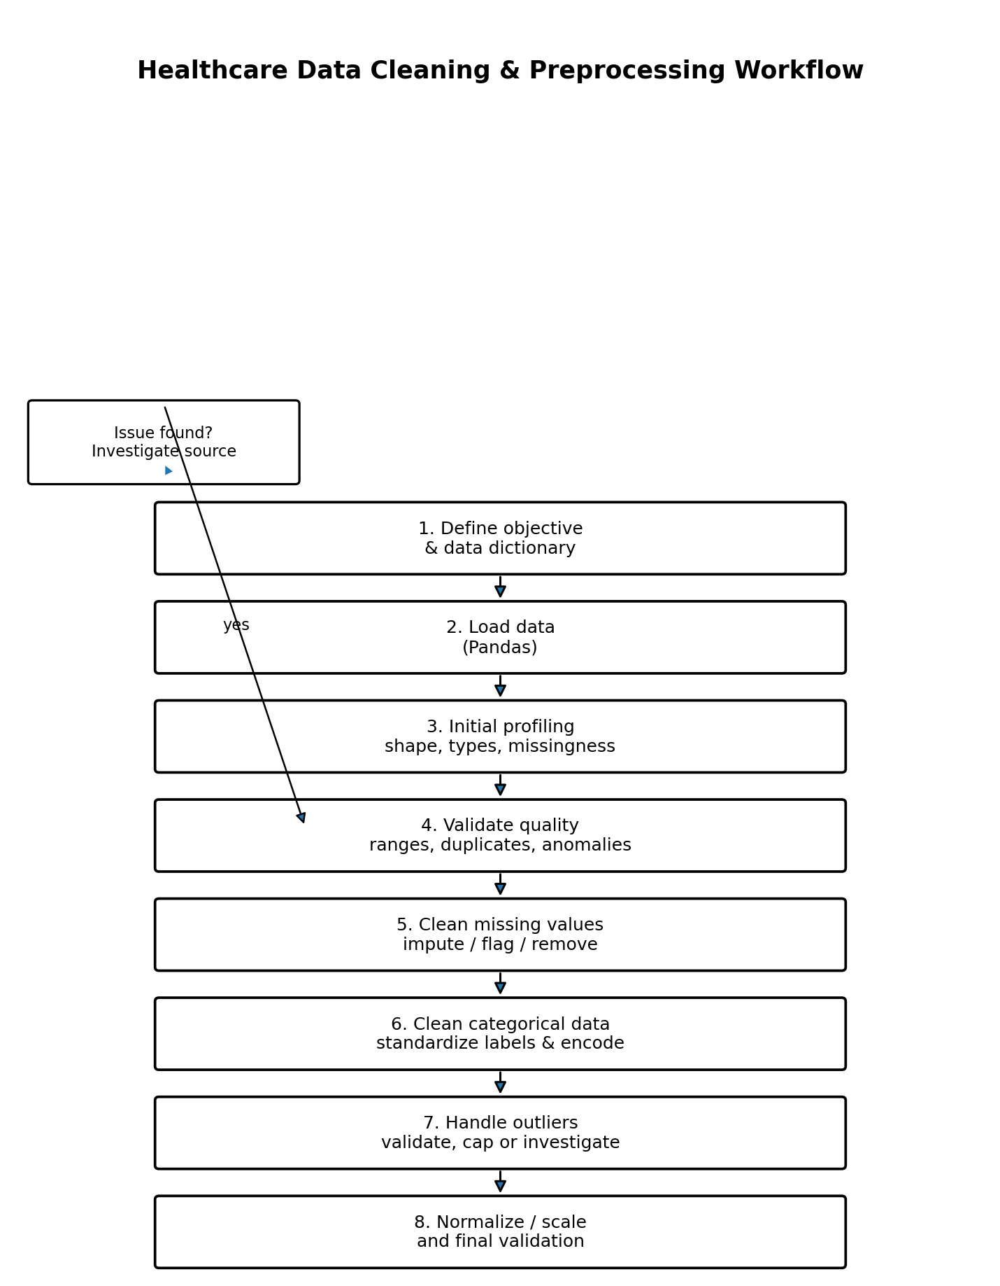

10. Final Validation and Quality Assurance
After preprocessing, perform a second quality assessment. At minimum:
- Compare row and column counts before and after cleaning.
- Confirm that required identifiers remain unique where uniqueness is expected.
- Recalculate missing-value percentages.
- Verify categorical values against the approved vocabulary.
- Recheck minimum/maximum values and date relationships.
- Compare distributions before and after imputation or outlier treatment.
- Check that no unintended type conversions occurred.
- Confirm that derived variables are mathematically consistent.
- For machine learning, verify that preprocessing is learned from training data only.
- Create a preprocessing log containing rule, reason, affected fields, and number of affected records.

11. End-to-End Pseudocode
BEGIN
Preserve immutable raw dataset
Load working dataset with Pandas
Load/confirm data dictionary
Profile rows, columns, data types, unique values, and missingness
Standardize column names
Convert data types
Parse and validate dates
Check exact duplicates
Check logical duplicates using approved business/clinical keys
Validate categorical labels
Map synonyms and flag unknown values
Validate ranges and units
Identify anomalies and statistical outliers
Investigate whether extremes are errors or genuine observations
For each variable with missing values:
assess missingness pattern
select documented imputation/retention/removal strategy
add missingness indicator when useful
Apply suitable transformations
Normalize/scale only where required by the analytical method
Run final validation
Compare pre/post distributions and counts
Record all transformations and assumptions
Save cleaned dataset and preprocessing report
END

12. Practical Recommendations
- Never overwrite the raw healthcare dataset.
- Do not delete outliers simply because they are inconvenient for an analysis.
- Use clinical/domain knowledge together with statistical tests.
- Document every cleaning rule, including the reason for the rule.
- Prefer reproducible transformations over manual spreadsheet edits.
- Treat missingness as information when the fact that a measurement is missing may itself be meaningful.
- Check units before outlier treatment.
- Avoid data leakage when preparing datasets for predictive modeling.
- Use controlled vocabularies for clinical categories whenever available.
- Maintain a data-quality report so another analyst can reproduce and audit the preprocessing.

13. Conclusion
Healthcare data preprocessing is a quality-control process as much as it is a technical transformation process. A reliable workflow starts by understanding the source data and its clinical meaning, then systematically addresses missingness, duplicates, inconsistent categories, invalid values, anomalies, outliers, and numerical scaling. Pandas and NumPy provide a strong foundation for implementing these operations in a reproducible way. The most important principle is to preserve valid clinical information while making errors and assumptions explicit. A well-documented preprocessing pipeline improves the reliability, reproducibility, and interpretability of all downstream healthcare analytics.

14. Suggested Public Python Resources
The methodology can be implemented using public Python libraries and their official documentation. Recommended resources include the Pandas documentation for DataFrame operations and missing-data handling, NumPy documentation for numerical operations, and scikit-learn documentation for scaling and preprocessing when machine learning is part of the project.
- Pandas: data loading, DataFrames, missing values, grouping, merging, categorical handling, and date operations.
- NumPy: numerical arrays, conditional selection, mathematical operations, and summary statistics.
- scikit-learn: StandardScaler, MinMaxScaler, RobustScaler, encoders, and pipeline-based preprocessing for ML workflows.

